# Pipeline analysis

This analysis aims to improve our insight into how our opportunities move through the sales cycle. It adds more context to some of the numbers that we already have (e.g. in the board document, …) as well as creates a baseline for new metrics to add.

We start with pipeline generation and progress into every step of the sales cycle. Note that we’ll use the word “pipeline” as all open opportunities. When we report to the board, pipeline actually means opportunities 40% and higher, so in this case, we’re also including opportunities 20%, unless otherwise specified. For this analysis, we’re using the FY16 dataset and compare those numbers with current data.

## Executive Summary / Key Observations

1. Early stage pipeline looks to be in good shape (growing steadily and improving / stagnant conversion rates)
2. Mid to late stage pipeline is not in good shape as conversion rates are dropping, which indicates an increase loss / deferred / stalled opportunities. Possible reasons:
   1. Overconfidence from the Sales Reps / Lack of involvement of Sales Management / Lack of Sales Management activities to cross check qualification criteria and validate that we went through every step of the sales cycle.
   2. Insufficient consultative selling to create the business case. Often times budget is only secured late in the sales cycle as we’re being used to sell DG internally.
   3. Impact of the new pricing model. The higher the cost of software, the lower the velocity and conversion rate.
   4. Sales Reps being spread too thin
   5. Increased competition / lack of understanding of competitive differentiators
3. It’s noteworthy that Inside Sales has a huge impact on the drop in conversion rates, they are responsible for more than ⅓ in the drop (they are only 3 out of our 20 reps)
4. It’s noteworthy that Sales Reps with a good territory have, on average, a larger dropout, which is a signal to hire.
5. The number of Existing Business opportunities is steadily growing
6. Upsell data is all over the place, from upsells in a couple of months to upsells after 2 years. We can say that:
   1. An upsell most often happens in 7 months after the initial purchase, which is a lot faster than we thought. The number of data points we have is rather low.
   2. There’s no correlation between the number of days it takes to upsell and the size of the upsell opportunity (in % of the initial value).

## Pipeline Generation Analysis

The following metrics are key to measure our pipeline generation engine:

* # of Leads
  + Marketing sourced our generated leads are labeled with a number of lead sources, including but not limited to “Website”, “Webinar”, “Seminar/Conference”, “Content Syndication”, …
  + Sales sourced leads are mostly generated by the SDR’s and are tagged with the lead source “Rep Sourced Social”, “External Referral”, “Database” e.g. RainKing, ... Partners and Sales Reps typically immediately create opportunities and are therefore excluded from this.
* Sales Qualified Leads[1]
  + Definition: leads that have been qualified for basic interest and accepted by the Sales Reps as an opportunity 20%.
  + In practise, this means that further qualification is needed but we think there will be an initiative that starts in the next 6 months.

In the chart below, you can see that we’re currently generating around 60 sales qualified leads, the vast majority of those are sourced from Marketing.

In February, we created 70 opportunities 20% so that is steadily growing.

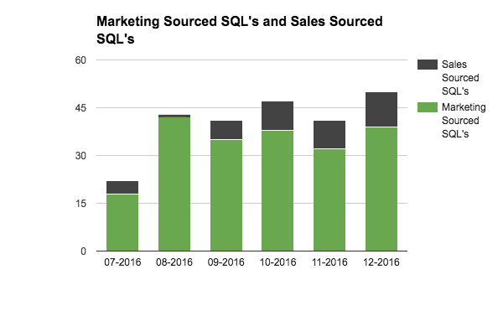

At the top of the funnel (Prospect, Qualified and Buying Process Id.), the number of Qualified Opportunities (20%) has slowly been increasing in the later part of FQ1-2017 after taking a slight dip at the start of the quarter.

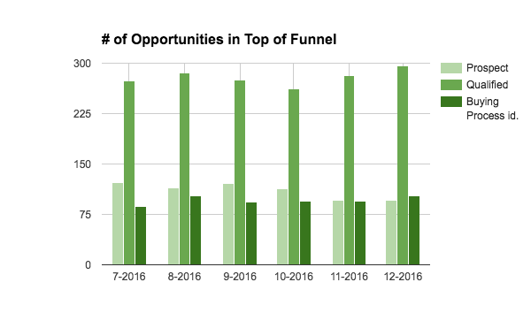

The growth or lack of growth in the total number of opportunities in a stage indicates that the amount of opportunities going into the funnel is more or less equal to the amount that’s moving out. The conversion rates for 20% to 40%, which we will be discussing in great detail later are increasing, which indicates that more opportunities are moving forward.

At the middle and bottom of the funnel (Short List, Chosen Vendor, Negotiation / Review and PO in Progress), the total number are growing, however, the conversion rates going down (we’ll discuss later in this report what this could mean).

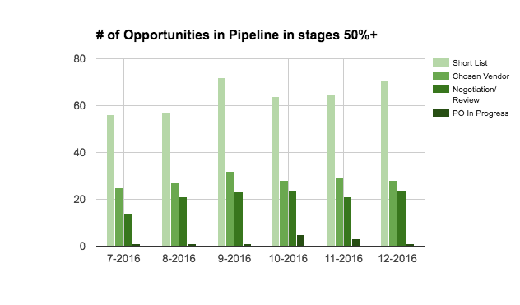

## Pipeline Analysis

### Q: What’s the % of Existing Business opportunities in the pipeline?

Volume by Type - New Business make up the majority of all our open opportunities.

|  |  |  |
| --- | --- | --- |
| Type | # Opportunities | % of Total |
| New Business | 779 | 80% |
| Existing Business | 193 | 20% |

### Q: Is the volume of Existing Business opportunities growing?

Below are the quarterly trends by opportunity type: it looks like Existing Business made up 20% of opportunities and is now rising to 25%. This second chart shows that, since FQ2-2016, the relative number of Existing Business opportunities has increased. Note: we don’t have a formal process in place for existing business opportunities. Our gut feel from the field is that these only get added in SFDC later.

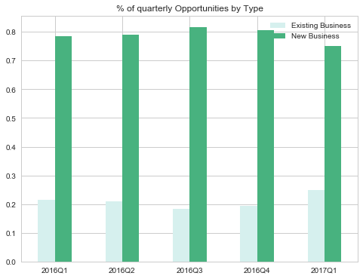

This second chart shows that since FQ2-2016 the relative number of open Existing Business opportunities has increased.

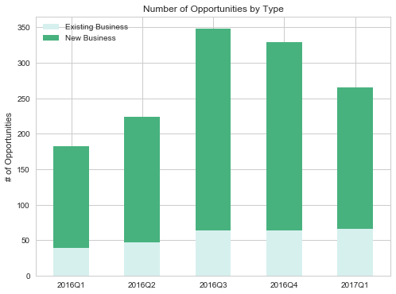

### Q: Do Existing Business opportunities close faster?

When removing outliers, New Business opportunities convert slower than existing business opportunities (7.7 months for new business vs. 7.3 for existing business).

When including outliers (opportunities where stage duration is more than 160 days), New Business opportunities convert faster than Existing Business (8.5 months for new business vs. 9.3 months for existing business).

**AVERAGE DAYS IN STAGE Without Outliers With Outliers**

|  |  |  |  |  |
| --- | --- | --- | --- | --- |
| Old Stage, New Stage | Existing Business | New Business | Existing Business | New Business |
| ('Prospect', 'Qualified') | 46 | 26 | 53 | 29 |
| ('Qualified', 'Buying Process id.') | 33 | 41 | 43 | 48 |
| ('Buying Process id.', 'Short List') | 37 | 34 | 51 | 36 |
| ('Short List', 'Chosen Vendor') | 36 | 42 | 43 | 54 |
| ('Chosen Vendor', 'Negotiation/Review') | 20 | 33 | 43 | 34 |
| ('Negotiation/Review', 'PO In Progress') | 28 | 40 | 28 | 41 |
| ('PO In Progress', 'Closed Won') | 19 | 15 | 18 | 15 |
| ***Total Days - Without Prospect*** | ***172 days*** | ***205 days*** | ***226 days*** | ***229 days*** |
| Total Days - With Prospect | 219 (7.3 months) | 230 (7.7 months) | 280 (9.3 months) | 258 (8.5 months) |

Conclusion:

Average stage durations change depending on the time period selected for the data sample - for example, the older an opportunity is, the more likely it is to have a high stage duration. While we attempted to calculate the stage duration in several different ways, we found that opportunities tend to move up and down often, there is no strict process around reopening opportunities from Closed Deferred, some opportunities also move back down to qualified before a new sales cycle starts - these all contribute to high variance in average stage durations when looking at different time periods.

### Q: What is the percent of opportunities going to Closed Deferred by Opportunity Type?

Of all New Business opportunities 60% go to Closed Deferred and these represent over 85% of all Closed Deferred opportunities. Existing Business opportunities have a less structured process (e.g they get created very late) and only make up 12% of total Closed Deferred.

|  |  |  |
| --- | --- | --- |
| Opportunity Type | Existing Business | New Business |
| Closed Deferred % of all opportunities | 12% | 88% |
| Closed Deferred % of opportunities by Type | 34% | 62% |

### Q: What is the trend in opportunities going to Closed Deferred and Closed Lost?

The number of New Business opportunities going to Closed Deferred has been decreasing each quarter, however, Existing Business to Closed Deferred has increased slightly. The majority of these opportunities are in the Qualified stage. In FQ3-2016 there were a large number of stalled opportunities in the 20% stage that were getting cleaned-up.

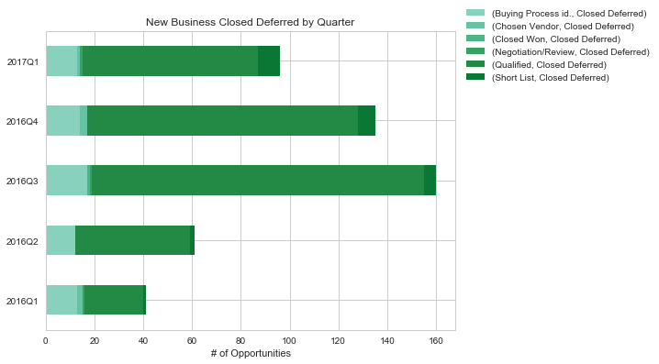

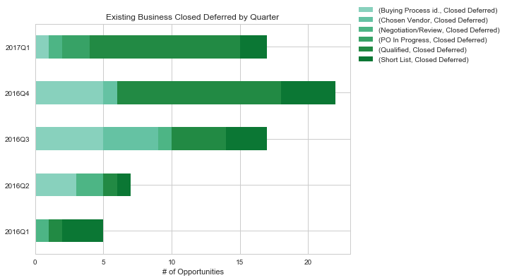

New Business opportunities that have been marked as “Closed Lost” have decreased, however, Existing Business opportunities marked as “Closed Lost” has increased.

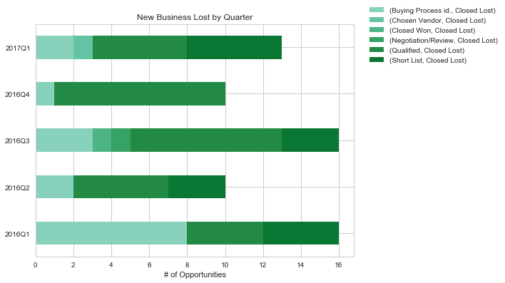

### Q: How long does it typically take to do an upsell into an account.

On average it takes 7 months for an opportunity to upsell in an account, but there are less than 20 data points so this number is not very reliable and we think this is actually longer. The below chart that there is no correlation between the time it takes to upsell into an account and the new ARR upsell:

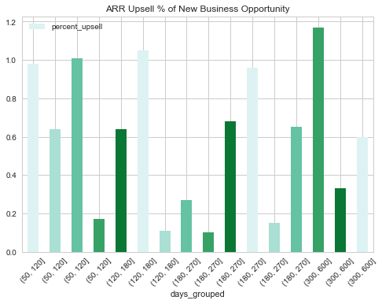

### Q: How are opportunities converting throughout the sales cycle?

We analyze this through conversion rates, which are calculated on a weekly basis for “New Business” opportunities. We take a sample of 9 months worth of data that we give 3 months to convert, so basically it has a 1 year lagging factor.

By looking at the average monthly conversion rates for each stage, we can see two big drops in rates in opportunities going from Short List to Chosen Vendor and from Chosen Vendor to Negotiation/Review.

|  |  |  |  |  |  |  |
| --- | --- | --- | --- | --- | --- | --- |
| Stage | Jul-16 | Aug-16 | Sep-16 | Oct-16 | Nov-16 | Dec-16 |
| Qualified to Buying Process Id. | 24.63% | 26.08% | 27.21% | 28.98% | 29.40% | 28.29% |
| Buying Process Id. to Short List | 30.83% | 30.97% | 32.59% | 34.64% | 37.66% | 36.72% |
| Short List to Chosen Vendor | 47.76% | 48.02% | 46.34% | 46.59% | 44.78% | 41.82% |
| Chosen Vendor to Negotiation/Review | 70.17% | 68.91% | 71.51% | 71.15% | 64.79% | 59.75% |
| Negotiation/Review to PO In Progress | 81.80% | 82.94% | 82.18% | 84.01% | 83.25% | 82.69% |
| PO In Progress to Closed Won | 95.02% | 95.23% | 95.65% | 96.15% | 90.45% | 91.91% |

By taking the product of each stage to Closed Won, we calculate the Closed Won conversion rates for each stage:

|  |  |  |  |  |  |  |
| --- | --- | --- | --- | --- | --- | --- |
| Stage | Jul-16 | Aug-16 | Sep-16 | Oct-16 | Nov-16 | Dec-16 |
| Qualified to Closed Won | 1.98% | 2.11% | 2.31% | 2.69% | 2.42% | 1.97% |
| Buying Process Id. To Closed Won | 8.03% | 8.10% | 8.49% | 9.27% | 8.23% | 6.97% |
| Short List to Closed Won | 26.05% | 26.14% | 26.05% | 26.77% | 21.84% | 18.99% |
| Chosen Vendor to Closed Won | 54.54% | 54.43% | 56.21% | 57.47% | 48.78% | 45.41% |
| Negotiation/Review to Closed Won | 77.73% | 78.98% | 78.60% | 80.78% | 75.30% | 76.00% |
| PO In Progress to Closed Won | 95.02% | 95.23% | 95.65% | 96.15% | 90.45% | 91.91% |

If we look at the most recent data, we can see that.

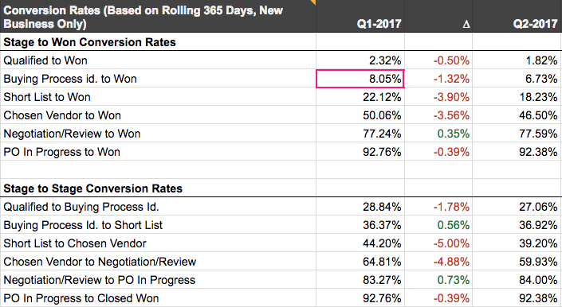

If we look at the preliminary data from FQ2-2017, we can see that the biggest drop is in Short List to Chosen Vendor and Chosen Vendor to Negotiation/Review. This could indicate a number of things:

* Overconfidence from the Sales Reps / Lack of Sales Management activities to cross check qualification criteria and validate that we went through every step of the sales cycle.
* Insufficient consultative selling to create the business case. Often times budget is only secured late in the sales cycle as we’re being used to sell DG internally.
* Impact of the pricing model? The higher the cost of software, the lower the velocity and conversion rate.
* Sales Reps being spread too thin
* Increased competition?

### Q: Why is the Short List conversion rate dropping?

When looking at the opportunities that did not convert from “Short List” and compare these to the current data, we can see that over 40% of the opportunities are in Closed Deferred while 25% of them are still stuck in Short List. These opportunities were given at least 3 months since they were created or last modified to convert.

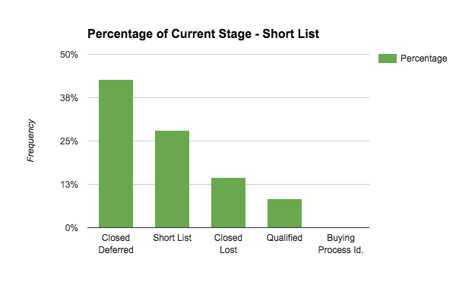

A deeper look at the opportunities that did not convert in Short List shows us that many opportunities attribute “Unresponsive and “Lost Budget” as the top reasons for an opportunity being placed in Closed Deferred.

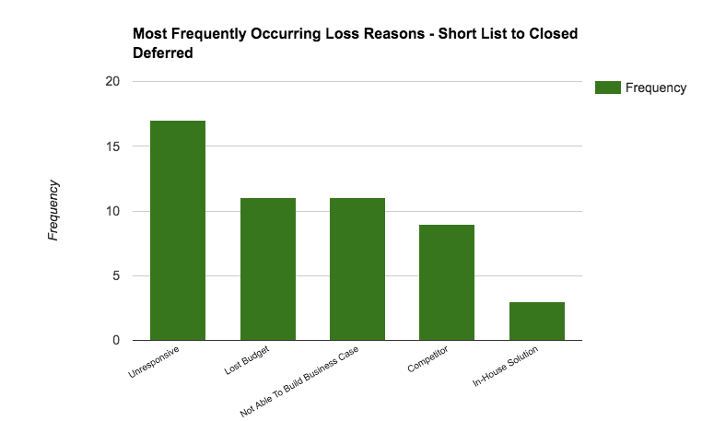

Over 40% of the Unconverted opportunities in Short List were assigned to Regional: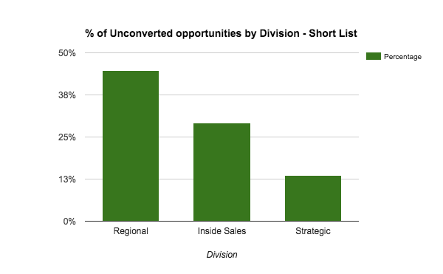

When taking into account the number of opportunities that didn’t convert by Division and the number of reps in each division, on average Inside Sales had the most unconverted number of opportunities:

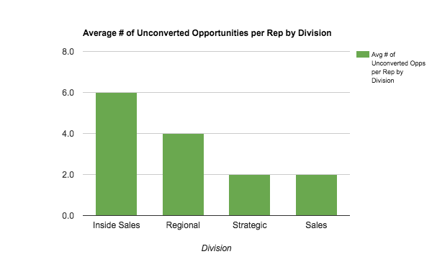

### Q: Why is the Chosen Vendor conversion rate dropping?

In the case of opportunities that did not convert in the last 6 months within a 9 month time frame from Chosen Vendor, majority of them are still in Chosen Vendor or have gone to Closed Deferred.

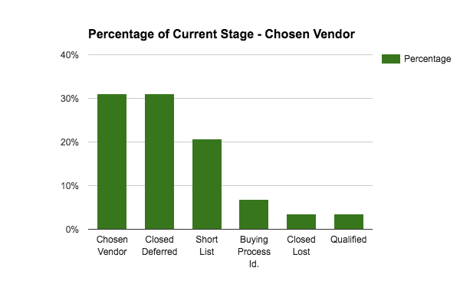

When looking at the opportunities that were in Chosen Vendor and that went to Closed Deferred the top reasons are “Lost Budget”, “Not able to build a business case” and “Unresponsive”:

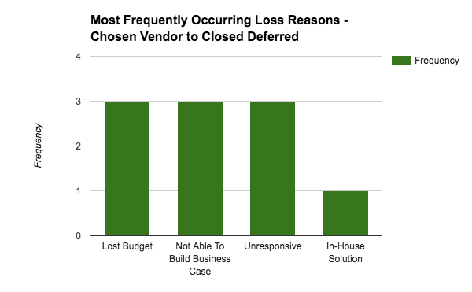

In contrast to opportunities not converting from Short List, the unconverted opportunities from Chosen Vendor

are 50% from Inside Sales team:

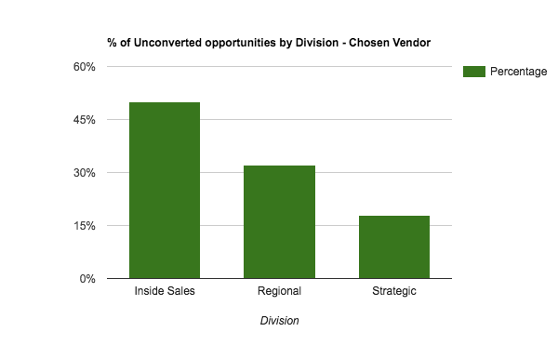

On average, Inside Sales Reps had 3 unconverted opportunities in Chosen Vendor while Regional and Strategic Reps had 1:

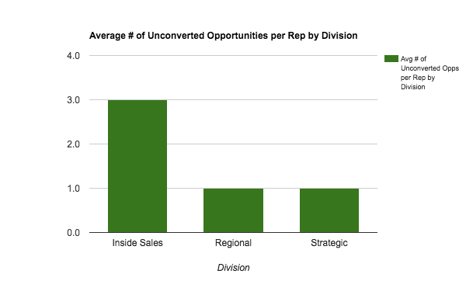

1. We’ve agreed with marketing that this will be called “Sales Accepted Leads” as from FQ3-2017 (FQ3 = CQ2). “Sales Qualified Leads” will from that point on be opportunities 40%, which requires the Sales Rep to understand the buying process, as well as the authority, need and budget.