PAPER TITLE
Authors - Mioara POPA, Radu IONESCU,
Scientific Coordinator – Andrei MARIN
Abstract:…………………………………………………………………………….. ……………………………………………………………………………..……………………………………………………………………………..……………………………………………………………………………..……………………………………………………………………………..
In the abstract, the author(s) will specify the original aspects of the paper: personal achievements, original approach of a theme, a.s.o. The abstract (no more than 100 words) must be written in Romanian, English and the paper original language, if it is other than English.
The abstract will be written in italics(10pts), centered left – right 1cm with Format – Paragraph.
Keywords: words which are representative for the paper.
1. Introduction
The title, “Introduction”, will be numbered; it will be written in small characters (12 pts), bold, centered.
In the introduction to the paper, the author(s) will specify the present stage of the branch researches (by quoting the adequate bibliography) and will specify the purpose of the paper.
2. Paper contents
The chapter titles will be numbered, if necessary, and will be written in small characters (12 pts), bold.
The presentation will be clear and concise and the symbols used therein will be specified in a symbol list (if necessary). In the paper it will be used the measurement units International System. In the paper, there will be no apparatus or installation descriptions.

3. Equations
The equations will be aligned to the right and written with the equations editor; set size 12, 10, 7, 18, 12; style: italics variable, LC Greek, italics.

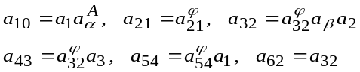 (1)

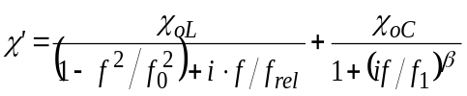, (2)

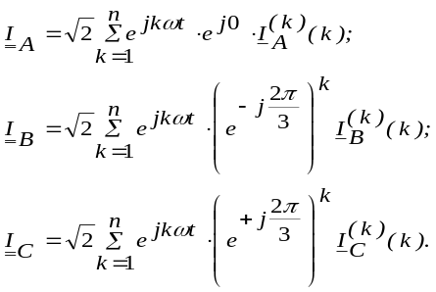 (3)
4. Tables
The table will be written in small characters (10 pts). The table title will be centered, bold and its name will be written in italics (10 pts), aligned to the right.

Table 1
Melting points and elemental analyses
Compound | Mp(⁰C) | Formula | N(%)
Compound | Mp(⁰C) | Formula | Calc. | Found
3A | 178 | C₂₉H₃₄N₂O | 6.57 | 6.70
3B | 264 | C₂₉H₃₃N₃O₃ | 8.92 | 8.85
3C | 232 | C₂₉H₃₂N₄O₅ | 10.85 | 10.78
5A | 185 | C₂₉H₃₄N₂O | 6.56 | 6.41
5B | 242 | C₂₉H₃₃N₃O₃ | 8.92 | 8.87
5C | 245 | C₂₉H₃₂N₄O₅ | 10.85 | 10.63

5. Figures
The Figs will be centered. The legend will be written with 10 pts characters.

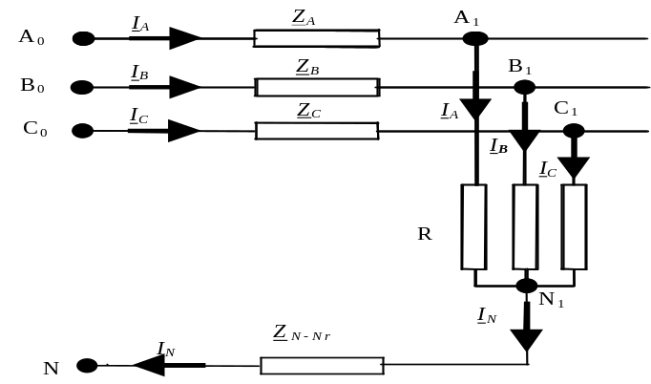

Fig. 1. The Figs will have a centered legend (10 pts)
6. Conclusions
The paper will end with a conclusion paragraph in which the author (s) will specify the original results obtained and their possible applications (if any).
The title “Conclusions” will be numbered, it will be written in small characters (12 pts), bold, centered.
R E F E R E N C E S
The bibliography will respect the quotation within the text it will be numbered currently and the text quotations will be made in square brackets, e.g. [1].
In the bibliography the author (s) will make the following compulsory specifications: their first name initials and their family name, the title of the book, the printing house, the place and the year of the periodical in which it was published, the number (month), the volume (bold), the year, the paper first and last page. the author (s) first and family name will be written in italics (10 pts).
The books and articles published in Romanian will be written in Romanian and translated in English between parantheses.

[1]. Cristina Soviany, Embedding Data and Task Parallelism in Image Processing Applications, PhD Thesis, Technische Universiteit Delft, 2003
[2]. A.Mauthe,D.Hutchison, G.Coulson and S.Namuye,“Multimedia Group Communications Towards New Services”, in Distributed Systems Eng., vol. 3, no. 3, Sept. 1996, pp. 197-210
[3]. V. I. Arnold, Metodele matematice ale mecanicii clasice (Mathematical methods of classic mechanics) , Editura Ştiinţifică şi Enciclopedică, Bucureşti, 1980.
[4]. V. Gioncu, M. Ivan, Teoria comportării critice şi postcritice a structurilor elastice, Editura Academiei, Bucureşti, 1984.
[5]. *** COSMOS/M – Finite Element System, User Guide, 1995.

Student, group 1211E, Faculty of Engineering in Foreign Languages, e-mail:
Student, group 1220F, Faculty of Engineering in Foreign Languages
Prof., Department of Engineering in Foreign Languages

