Taskmate – Software Design Document

- Introduction
TaskMate is a task management application designed to help users organize, manage, and track their tasks efficiently. The system aims to provide a clear and user-friendly interface through which users can manage their tasks and access the features required for their workflow.

The purpose of this Software Design Document is to describe the design of TaskMate based on the requirements, user stories, and wireframes developed during Digital Assignment 1. It presents the high-level architecture, user interface design, and key design decisions made during the development of the system.

The design emphasizes abstraction, modularity, cohesion, and low coupling. These principles help organize the application into components with clear responsibilities, reduce unnecessary dependencies, and make the system easier to maintain and extend. The document also explains how the interface supports usability and how the selected design decisions accommodate potential future enhancements.

- Design Principles Applied
The design of TaskMate follows four important software design principles: abstraction, modularity, cohesion, and low coupling. These principles help create a system that is understandable, organized, and easier to maintain. They also provide a foundation for extending the application with additional features in the future.

  - Abstraction

Abstraction involves hiding unnecessary implementation details and exposing only the functionality required by other parts of the system. In TaskMate, the user interface should present simple actions for managing tasks without requiring users to understand the internal processing behind those actions.

For example, a task creation function can accept task information and handle the creation process internally. This separates the user's interaction from the underlying implementation details.

async function fetchTasks() {

const response = await fetch("/api/tasks");

if (!response.ok) {

throw new Error("Failed to fetch tasks");

}

return response.json();

}

This function illustrates abstraction by hiding the details of the HTTP request and response handling behind a simple function. The component that needs task data can call fetchTasks() without duplicating the request logic. The endpoint shown is illustrative and should be replaced with the actual backend route used by TaskMate.

2.2 Modularity
Modularity involves dividing a software system into smaller components with clearly defined responsibilities. TaskMate can be organized into components for user interface handling, task management, and data handling, according to the application's actual implementation.

This organization makes the system easier to understand and maintain. Changes to one component can be made with fewer unnecessary changes to other components, provided that their interfaces remain consistent.

export function createTask(task) {
return fetch("/api/tasks", {
method: "POST",
headers: {
"Content-Type": "application/json"
},
body: JSON.stringify(task)
}).then(response => {
if (!response.ok) {
throw new Error("Failed to create task");
}

return response.json();
});
}

This example illustrates modularity by placing task-creation communication inside a dedicated function that can be imported wherever it is needed. Keeping this operation separate from the user interface reduces duplicated code and makes the task-creation behavior easier to maintain. The example assumes that the backend exposes a compatible task-creation endpoint.

2.3 Cohesion
Cohesion refers to how closely related the responsibilities within a module are. A highly cohesive module focuses on a specific area of functionality.

For example, task-related operations such as creating, updating, retrieving, and deleting tasks can be grouped within a task management module. Keeping related operations together improves code organization and makes task-related functionality easier to locate and maintain.

export function validateTask(task) {
const errors = {};

if (!task.title?.trim()) {
errors.title = "Task title is required";
}

if (task.title && task.title.length > 100) {
errors.title = "Task title is too long";
}

return errors;
}

This example illustrates cohesion because the function focuses on one closely related responsibility: validating task information. Keeping task validation in a dedicated function makes the rules easier to locate, test, and update without mixing them into unrelated presentation code. The validation rules are illustrative and should match TaskMate's actual requirements.

2.4 Low Coupling
Low coupling means minimizing unnecessary dependencies between modules. In TaskMate, the user interface, task management logic, and data handling should interact through clearly defined interfaces wherever the implementation supports this separation.

This reduces the impact of changes. For example, modifying the appearance of a task screen should not require rewriting the task management logic when the underlying interface between the components remains unchanged.

function TaskItem({ task, onComplete }) {
return (
<div className="task-item">
<span>{task.title}</span>

<button onClick={() => onComplete(task.id)}>
Mark Complete
</button>
</div>
);
}

export default TaskItem;

This example illustrates low coupling by making the TaskItem component responsible for displaying a task and notifying its parent when the user selects the completion action. The component does not directly manage backend requests; the parent or another dedicated module can handle that responsibility. This separation makes the component easier to reuse and test. The example assumes that the task object contains an identifier and title.

2.5 Benefits of Applying These Principles
Applying abstraction, modularity, cohesion, and low coupling helps improve the overall structure of TaskMate. These principles support readability, maintainability, testing, and future development. They also make it easier to identify the responsibilities of different components and reduce the complexity involved in extending the application.

- High-Level Architecture
TaskMate uses a frontend–backend architecture in which the user interface and server-side processing have separate responsibilities. The frontend is developed using React and Vite, while the backend uses Node.js and JavaScript. This separation helps organize the application into components that can be developed, maintained, and extended independently.

  - Architectural Structure

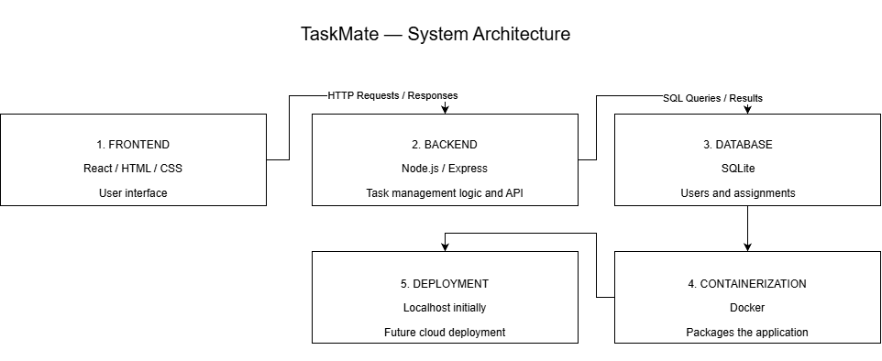

Fig 1. High-Level Architecture of TaskMate.

Frontend — React and Vite
The frontend provides the user interface through which users interact with TaskMate. React supports the development of reusable interface components, while Vite provides the development and build environment. The frontend displays task information, collects user input, and responds to user actions.

Backend — Node.js
The backend uses Node.js to execute server-side JavaScript and handle requests from the frontend. It processes application operations and returns the appropriate responses. Communication between the frontend and backend allows user actions to be translated into application operations.

Communication Between Components
The frontend communicates with the backend through the application's request and response mechanism. This separates presentation responsibilities from server-side processing and allows each part to focus on its designated role.

3.2 Architectural Style and Rationale
TaskMate uses a client–server style of architecture, with React/Vite serving as the frontend client and Node.js providing server-side functionality. This style is appropriate because it separates user interaction from backend processing and provides a clear boundary between the two parts of the application.

The separation allows the user interface to evolve without necessarily requiring changes to server-side logic. Similarly, backend functionality can be extended while preserving the frontend's expected communication interface.

3.3 Maintainability and Future Changes
The architecture supports maintainability by assigning different responsibilities to the frontend and backend. React components can be updated to improve the user experience, while backend operations can be modified to support new requirements.

Maintaining clear communication interfaces between the two parts helps reduce unnecessary dependencies. As TaskMate evolves, this structure can support additional features and improvements without requiring the entire application to be redesigned.

- User Interface Design
The user interface of TaskMate is designed to make task management clear, accessible, and straightforward. The design is based on the user stories and wireframes developed during Digital Assignment 1 and aims to provide a consistent experience across the application's screens.

4.1 Design Approach
The interface uses a consistent visual style and layout to help users understand the application and navigate between its features. Related elements are grouped together so that users can locate relevant information and actions without unnecessary effort.

Clear labels and meaningful button text help communicate the purpose of available actions. Consistent spacing, typography, and component styling improve readability and make the screens feel like parts of one application.

4.2 Usability Considerations
The interface design considers the following usability principles:

- Consistency: Reusing visual styles and interface patterns across screens helps users recognize familiar elements.
- Clarity: Meaningful labels and straightforward navigation help users understand available actions.
- Readability: Appropriate text sizes, spacing, and visual hierarchy make information easier to scan.
- Efficiency: Organizing related task information and actions together helps users complete common workflows.
- Maintainability: Reusable React components can help maintain a consistent interface and reduce duplicated UI code.

4.3 Screen Design
TaskMate contains six interface screens developed in Figma. Each screen represents part of the intended user experience and should correspond to the application's requirements.

The screens will be presented below with screenshots and short descriptions of their purposes. Together, they demonstrate the visual structure, navigation, and interaction patterns of the application.

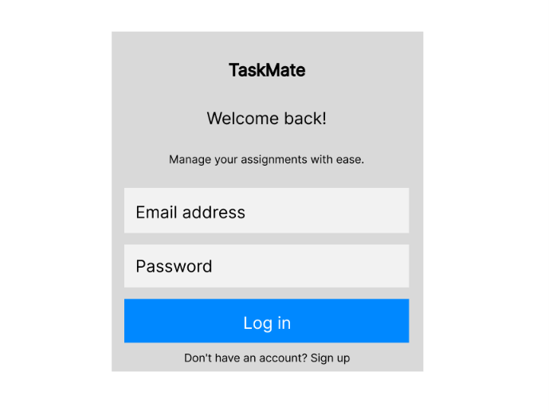
Fig 2. Login Page: The login screen provides the entry point to the application, presenting a clear interface for users to access their accounts.

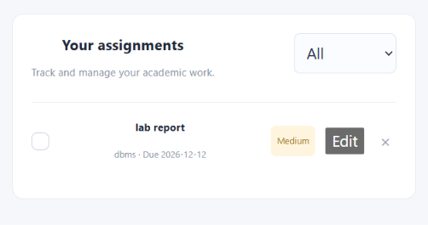
Fig 3. Assignments: The task list presents tasks in an organized format, helping users review their current tasks and identify relevant actions.

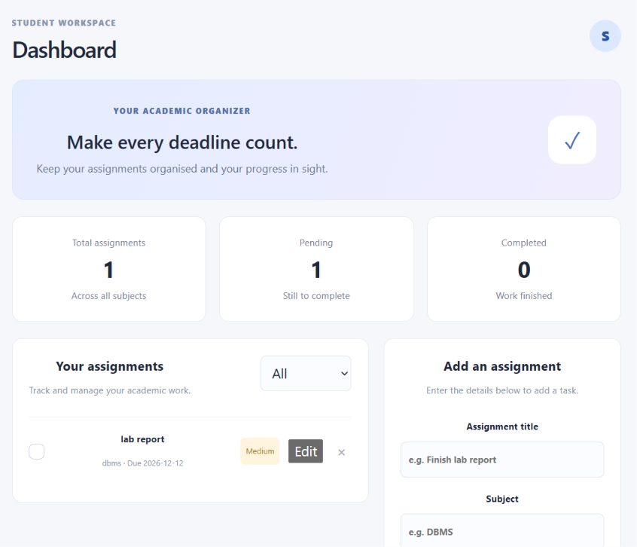
Fig 4. Dashboard: The dashboard provides an overview of relevant task information and helps users navigate to the application's main features.

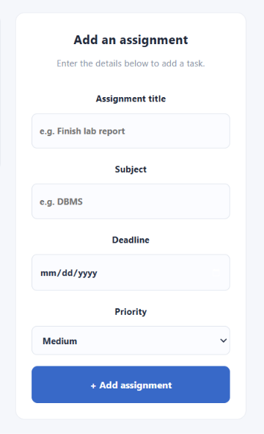
Fig 5. Add Assignment: This screen provides an interface for entering or modifying task information using clearly labelled fields.

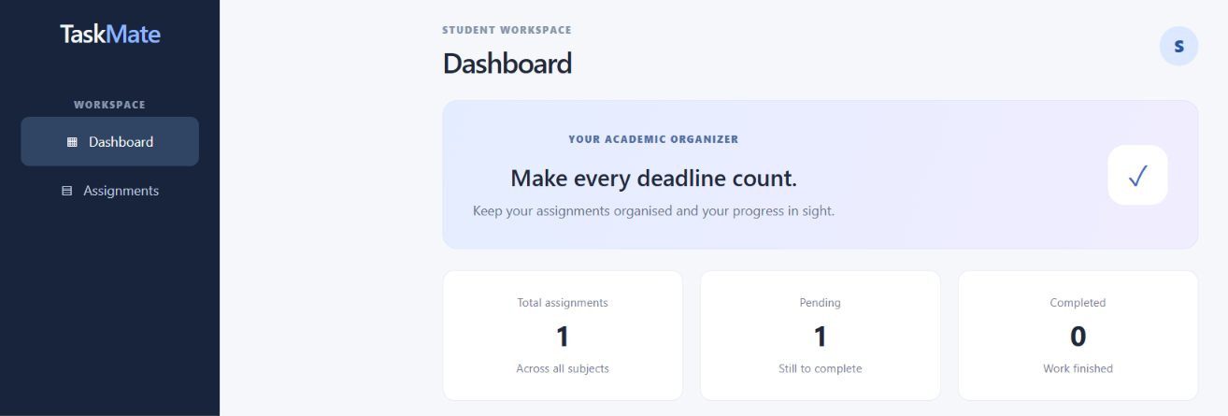
Fig 6. Profile/Settings: This screen provides access to account information or preferences supported by the application's requirements.

4.4 Relationship to the Requirements
The interface design builds on the user stories and wireframes prepared during Digital Assignment 1. This connection helps ensure that the design reflects the intended functionality of TaskMate rather than introducing unrelated features.

The final interface should be checked against the requirements to confirm that the important user workflows are represented and that the screens provide a consistent experience.

- Design Decisions and Rationale
The user keep the application understandable, maintainable, and suitable for future enhancements.

5.1 Separation of Frontend and Backend
- Decision: TaskMate uses React/Vite for the frontend and Node.js for the backend.

- Rationale: Separating the user interface from server-side processing gives each part a distinct responsibility. The frontend can focus on presenting information and handling user interactions, while the backend handles server-side operations.

- Impact: This separation can simplify maintenance because changes to the interface do not necessarily require changes to backend logic, provided that the communication interface remains consistent.

5.2 Component-Based User Interface
- Decision: The frontend is developed using React, which supports organizing the interface into reusable components.

- Rationale: Components allow related interface elements to be organized into manageable units. Common elements can be reused instead of recreated independently on every screen.

- Impact: Reusable components can reduce duplicated code, improve consistency, and make future interface changes easier to implement.

5.3 Clear Separation of Responsibilities
- Decision: Task-related functionality should be organized separately from unrelated interface and application responsibilities.

- Rationale: Keeping related operations together improves cohesion, while avoiding unnecessary dependencies between components supports low coupling.

- Impact: This organization can make the code easier to understand, test, and modify as TaskMate grows.

5.4 Consistent User Interface Design
- Decision: The Figma screens follow a consistent visual style, layout, and navigation approach.

- Rationale: Consistency helps users recognize familiar interface elements and understand how to interact with different parts of the application.

- Impact: A consistent interface can improve usability and make future design changes easier when common styles and components are reused.

5.5 Design for Maintainability and Future Enhancements
- Decision: TaskMate is designed with clearly defined component responsibilities and a structure that can accommodate future changes.

- Rationale: Software requirements may evolve as new features are introduced or existing functionality is improved. A well-organized design helps prevent every change from affecting the entire application.

- Impact: This approach provides a foundation for adding functionality, refining the interface, and maintaining the application over time while minimizing unnecessary changes to existing components.

- Maintainability and Future Enhancements
The user keeps the application understandable, maintainable, and suitable for future enhancements.

Maintainability is an important consideration in the design of TaskMate. The use of React/Vite for the frontend and Node.js for the backend provides a structure in which user interface responsibilities and server-side processing can be managed separately.

6.1 Maintainability
The design principles discussed in this document support the long-term maintenance of the application. Modularity helps organize functionality into manageable parts, while cohesion encourages related responsibilities to remain together. Low coupling reduces unnecessary dependencies between components, and abstraction hides implementation details behind simpler interfaces.

These principles can make the application easier to understand, test, debug, and modify. Maintaining clear boundaries between the frontend and backend also helps reduce the impact of changes when their communication interface remains consistent.

6.2 Future Enhancements
TaskMate may be extended in the future to support additional functionality based on user requirements. Potential improvements include more advanced task filtering, improved task organization, enhanced validation, and additional interface refinements.

Any future enhancements should be introduced in a way that preserves the existing design structure. New functionality should have clearly defined responsibilities and should avoid creating unnecessary dependencies between existing components.

6.3 Conclusion on Maintainability
The design approach provides a foundation for the continued development of TaskMate. By emphasizing clear responsibilities, reusable components, and separation between frontend and backend processing, the application can be maintained and extended more systematically as requirements evolve.

- Conclusion
This Software Design Document presents the design approach adopted for TaskMate based on the requirements and wireframes prepared during Digital Assignment 1. It describes the high-level architecture, user interface design, and key design decisions that guide the organization of the application.
The design emphasizes abstraction, modularity, cohesion, and low coupling to support clear responsibilities and maintainability. The separation between the React/Vite frontend and Node.js backend provides a structure for managing user interaction and server-side processing independently.
The proposed design provides a foundation for maintaining and extending TaskMate as requirements evolve. By following consistent design principles and keeping the interface and application responsibilities organized, future improvements can be introduced in a more systematic manner.
GitHub Repository: https://github.com/Gabz-Unmatched/TaskMate

