Vendor Request Form

1. Is this projected spend with the supplier over 50,000 dollars?This can either be a one time purchase or throughout the business relationship. \* (Yes or No)
2. Is this supplier setup for a one-time payment \* (Yes or No)
3. Enter company code(s) for the supplier \*
4. Legal Supplier Local Name
5. Legal Supplier Name
6. Supplier Contact Person,Email,Phone, Address (house no,Street, line2, line3,city, postalcode,country and region)
7. Please provide the Supplier Bank Details (only pdf files) (file)
8. Please provide a copy of an Invoice to perform Verification (only pdf files) (file)
9. Please choose Tax ID Type \*,
10. Supplier Tax ID Number \* ,
11. Please select Supplier Type \* ,
12. Please select Supplier Industry \*,
13. Please provide reason for this Supplier Setup \*
14. Has this supplier requested payment in the form of check? (Yes or No)
15. Did the supplier agree to the payment terms? \* (Yes or No)
16. Do you have any relationship with supplier? \* (Yes or No)
17. Will the good/services be consumed in the US \* (Yes or No)
18. Is this a US based Supplier \* (Yes or No)
19. Additional Documents (if any / only pdf files) (file)

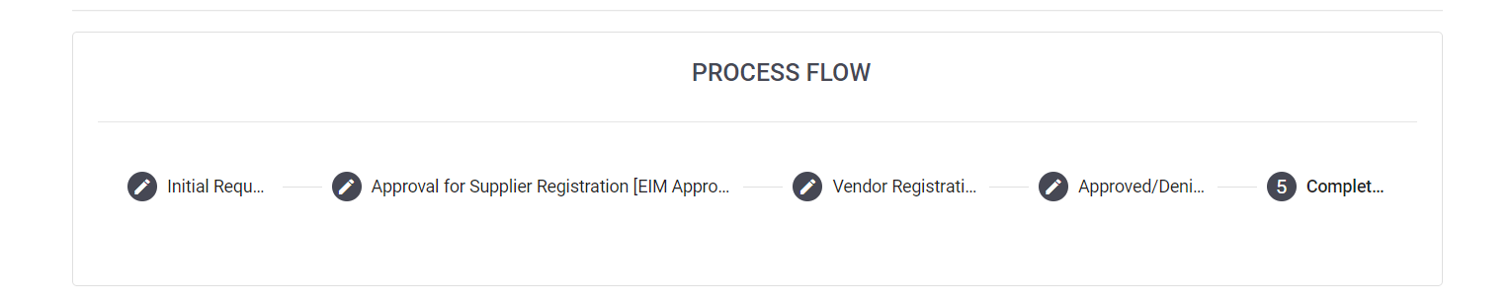Vendor Registration Form

* 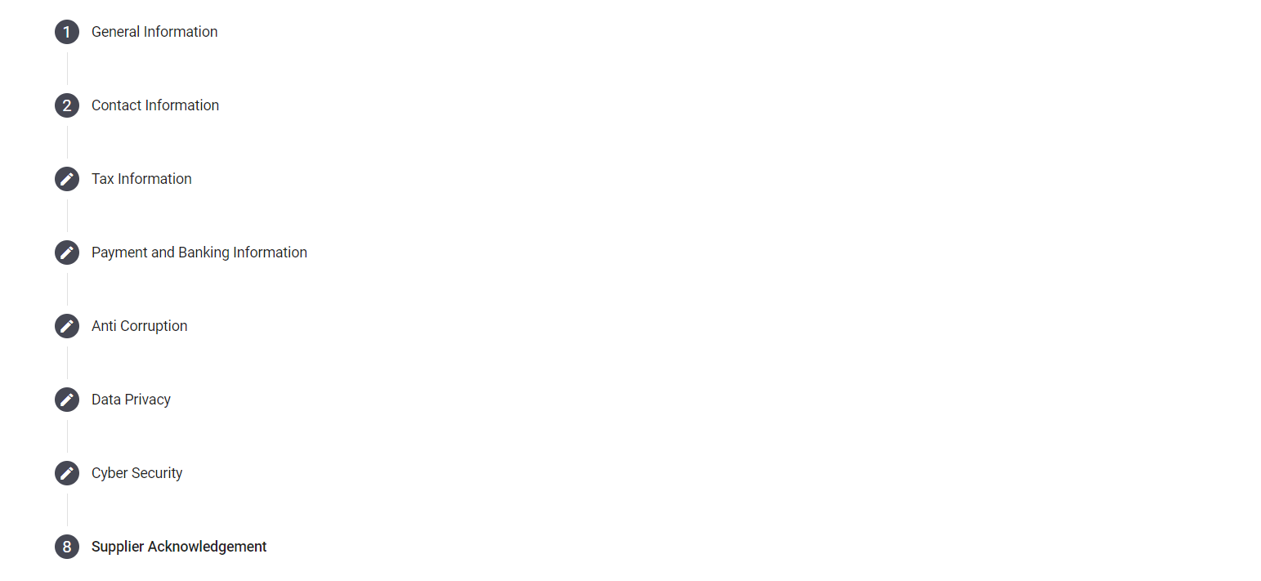5 Steps

