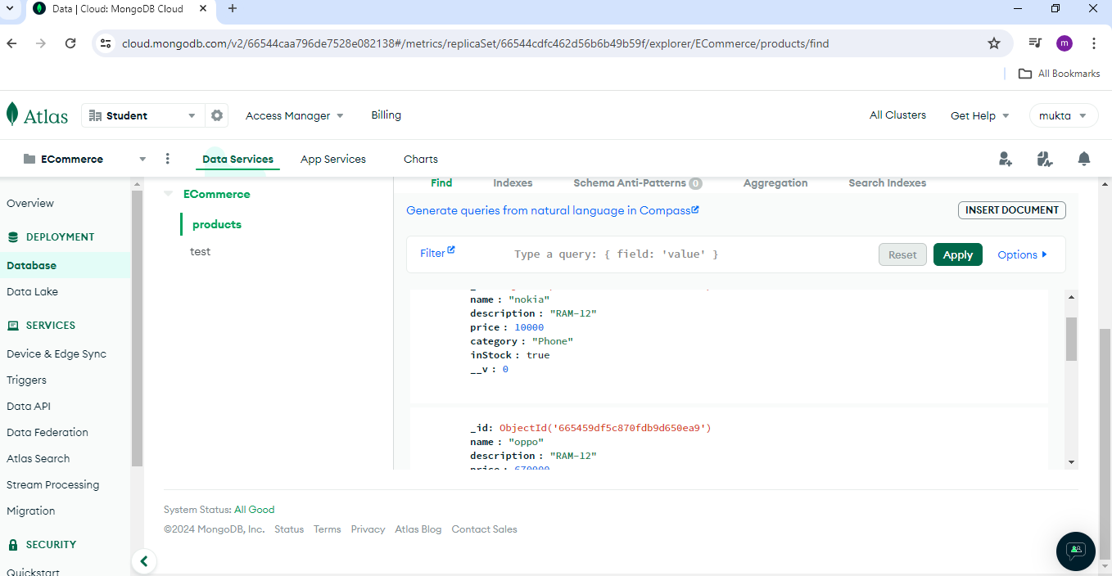

Product Post: <http://localhost:5000/api/products>

POST

Body -raw-json file

{

**name**:"nokia"

**description**:"RAM-12"

**price**:10000

**category**:"Phone"

**inStock**:true

}

Product get

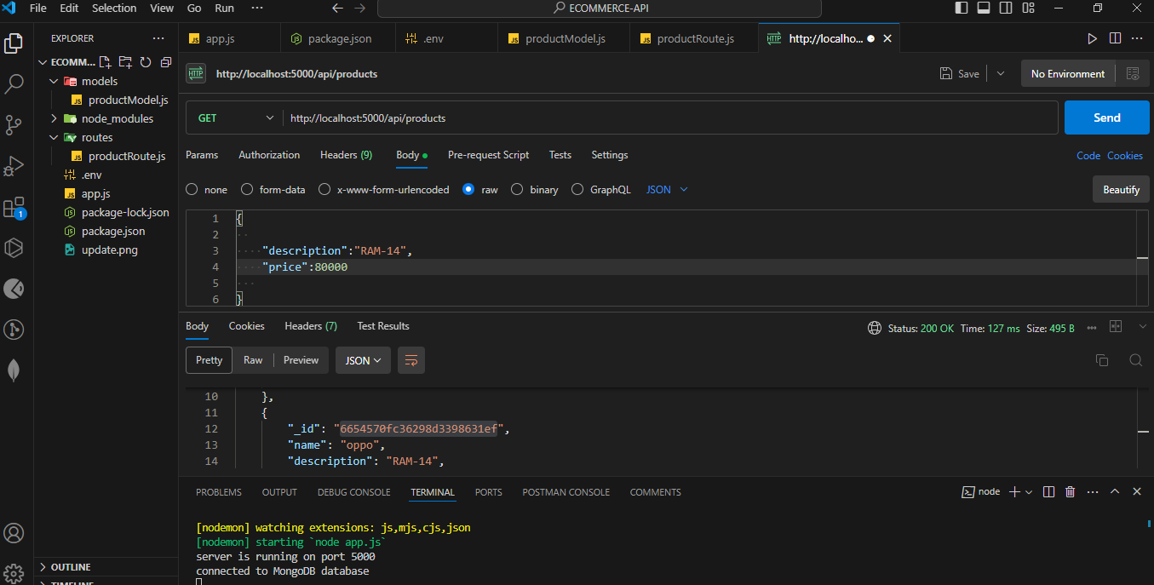

Getbyid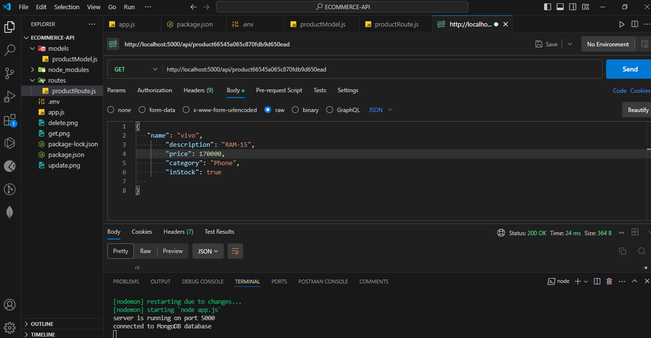

Update by id

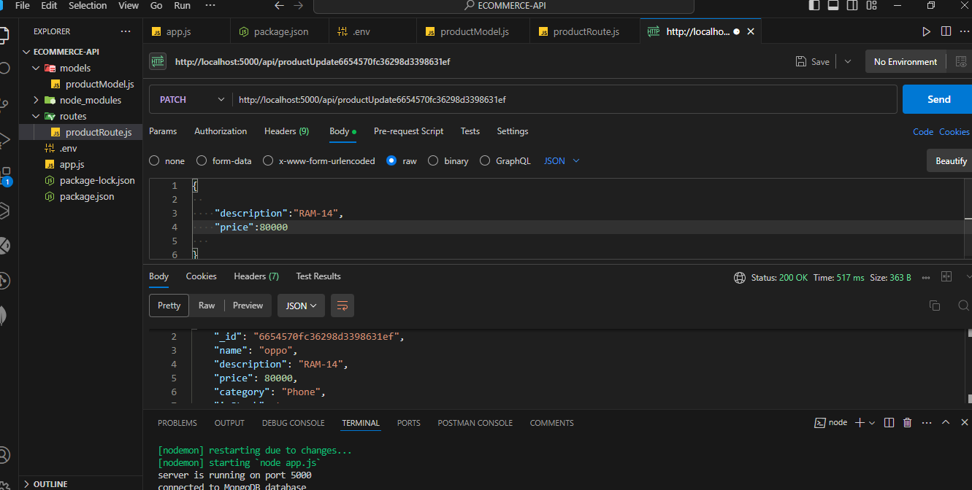

Delete by id

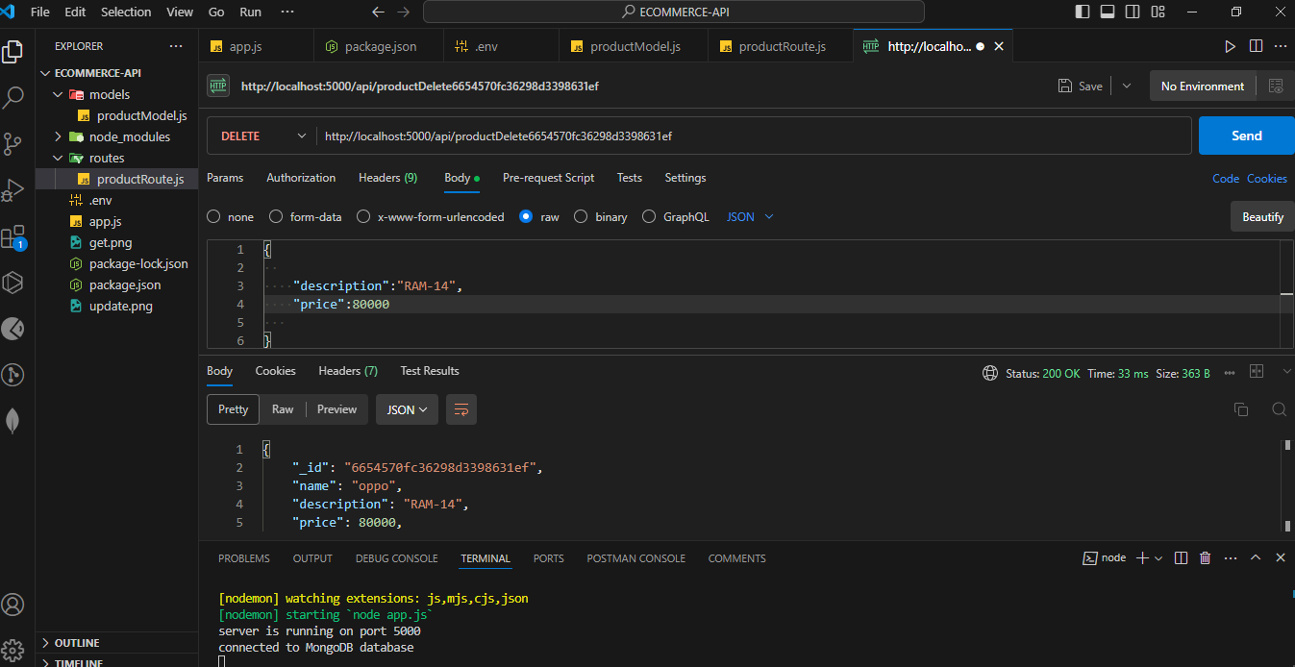

User Models

User register post

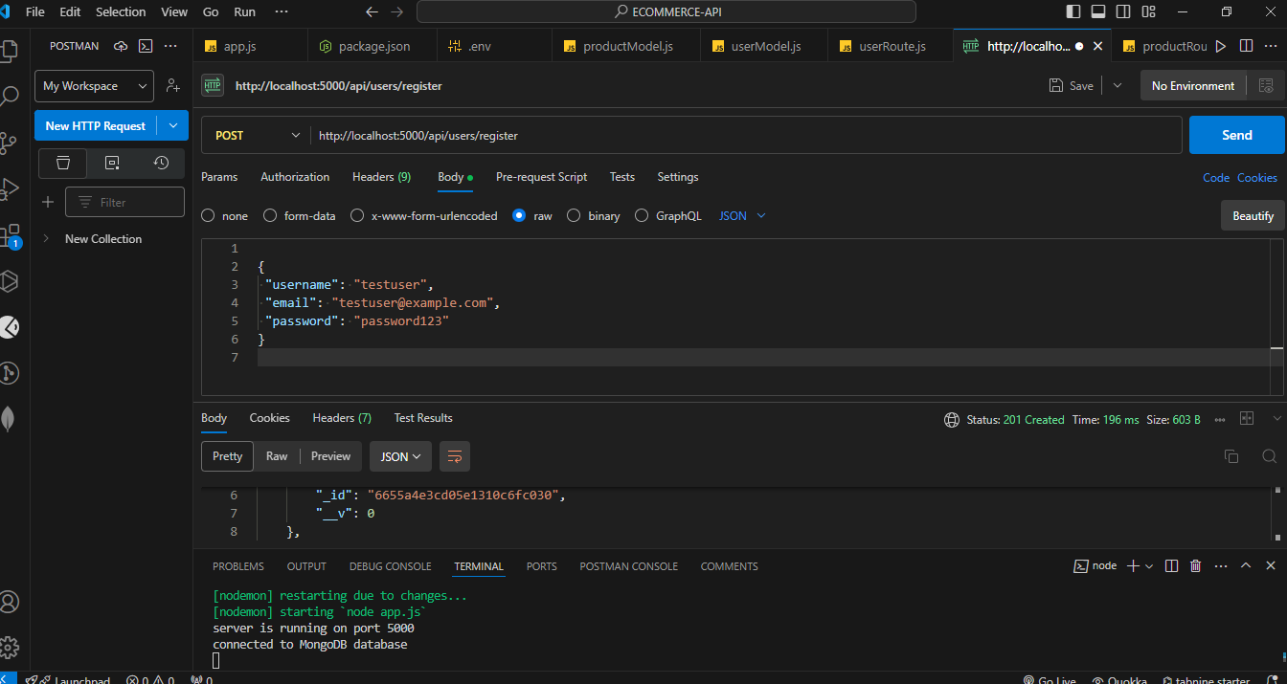

User Login post

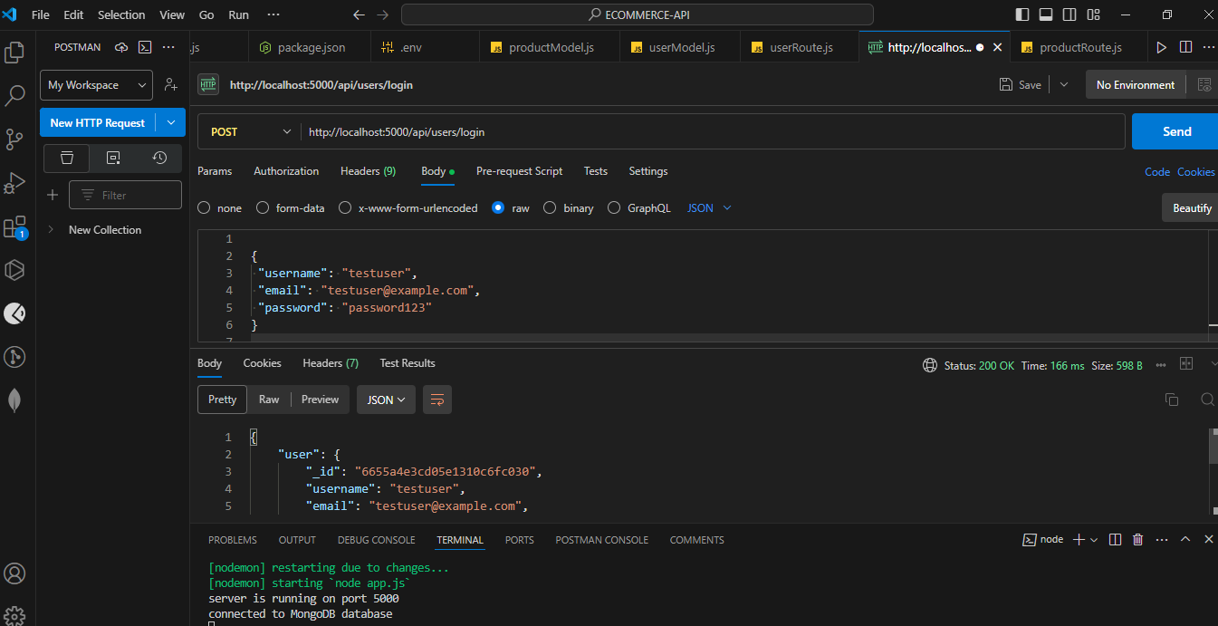

User login with token

