HBase Assignment
Beginner & Intermediate
Individual Practice Task
Overview
In this assignment you will build and query a product inventory system using HBase. You will work with a table called store that holds information about products across two column families.

Table Name | Column Families | Total Records
store | details, inventory | 5 products

Dataset — store Table

Column Family | Columns
details | name, brand, category
inventory | price, quantity, warehouse

Row Key | Name | Brand | Category | Price | Quantity | Warehouse
1 | laptop | dell | electronics | 1200 | 50 | A
2 | phone | samsung | electronics | 800 | 120 | A
3 | desk | ikea | furniture | 300 | 30 | B
4 | chair | ikea | furniture | 150 | 60 | B
5 | tablet | apple | electronics | 600 | 80 | A

Instructions
1. Read each question carefully before writing your command.
2. Write your HBase shell command(s) in the answer box below each question.
3. Test every command in your HBase shell and verify the output before submitting.
4. The dataset above is your only reference — do not use the emp or student tables.
⚠️ Answers are provided at the end of this document. Do not look ahead until you have attempted all questions.

PART A — BEGINNER
Questions 1–6 cover table creation, inserting data, scanning, getting, and filtering.

Q1 Create the store table with two column families: details and inventory.
Your Answer:

hbase(main):001:0> create 'store' , 'details','inventory'

Q2 Insert all 5 rows from the dataset above into the store table. Insert all columns for both column families.
Your Answer:

put 'store','1','details:name','laptop'
put 'store','1','details:brand','dell'
put 'store','1','details:category','electronics'
put 'store','1','inventory:price','1200'
put 'store','1','inventory:quantity','50'
put 'store','1','inventory:warehouse','A'
put 'store','2','details:name','phone'
put 'store','2','details:brand','samsung'
put 'store','2','details:category','electronics'
put 'store','2','inventory:price','800'
put 'store','2','inventory:quantity','120'
put 'store','2','inventory:warehouse','A'
put 'store','3','details:name','desk'
put 'store','3','details:brand','ikea'
put 'store','3','details:category','furniture'
put 'store','3','inventory:price','300'
put 'store','3','inventory:quantity','30'
put 'store','3','inventory:warehouse','B'
put 'store','4','details:name','chair'
put 'store','4','details:brand','ikea'
put 'store','4','details:category','furniture'
put 'store','4','inventory:price','150'
put 'store','4','inventory:quantity','60'
put 'store','4','inventory:warehouse','B'
put 'store','5','details:name','tablet'
put 'store','5','details:brand','apple'
put 'store','5','details:category','electronics'
put 'store','5','inventory:price','600'
put 'store','5','inventory:quantity','80'
put 'store','5','inventory:warehouse','A'

Q3 Scan the entire store table and confirm all 5 rows are present.
Your Answer:

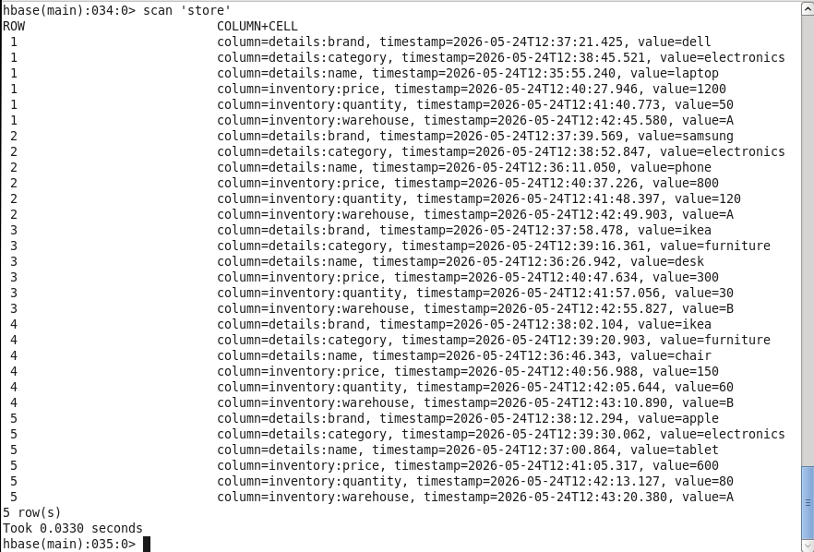

Q4 Retrieve all columns for the product with row key 3 (desk).
Your Answer:

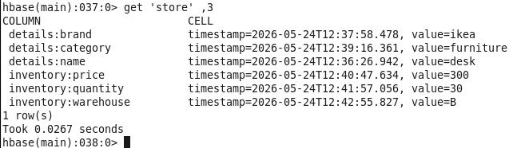

Q5 Retrieve only the inventory:price column for the product with row key 5 (tablet).
Your Answer:

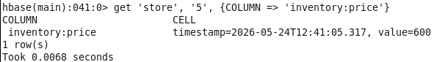

Q6 Use a ValueFilter scan to find all products with warehouse value A.
💡 Hint: Use the COLUMNS and FILTER options together in your scan.
Your Answer:

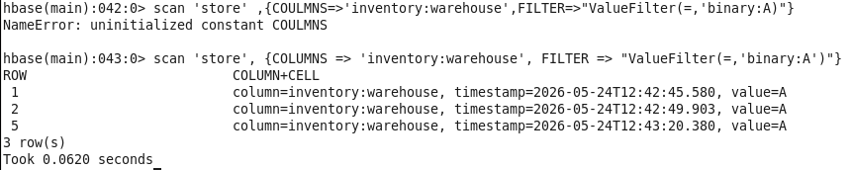

PART B — INTERMEDIATE
Questions 7–12 cover versioning, advanced filters, altering the table, and managing table lifecycle.

Q7 Enable versioning on the inventory column family to store up to 4 versions.
Your Answer:

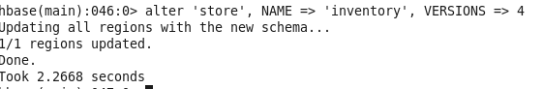

Q8 Update the inventory:quantity for the laptop (row 1) three times: first to 45, then to 40, then to 35. Then retrieve all stored versions of that cell.
💡 Hint: You need to alter versions first — make sure Q7 is done before this.
Your Answer:

hbase(main):049:0> put 'store' ,1, 'inventory:quantity','45'
hbase(main):049:0> put 'store' ,1, 'inventory:quantity','40'
hbase(main):049:0> put 'store' ,1, 'inventory:quantity','35'
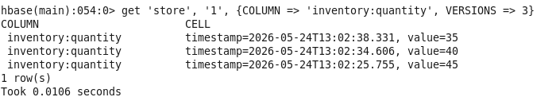

Q9 Use SingleColumnValueFilter to find all products in the furniture category.
Your Answer:

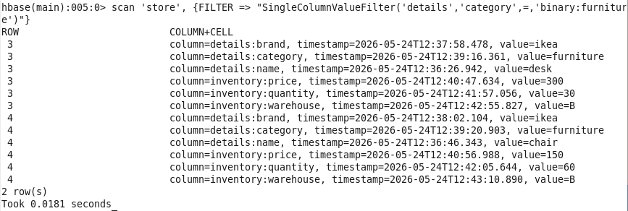

Q10 Use SingleColumnValueFilter to find all products stored in warehouse B.
Your Answer:

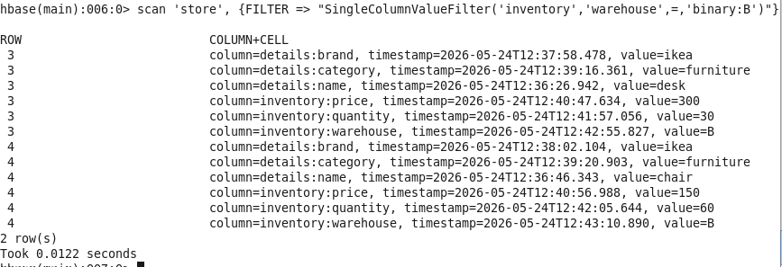

Q11 Add a new column family called supplier to the store table. Then insert supplier:country as egypt for row 1 and supplier:country as korea for row 2. Verify the schema updated correctly.
Your Answer:

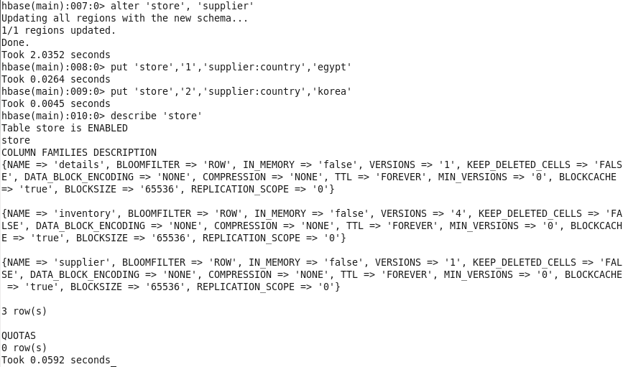

Q12 CHALLENGE 🏆 Write a single scan that returns only products that are in the electronics category AND stored in warehouse A.
💡 Hint: Look up FilterList with MUST_PASS_ALL to combine two SingleColumnValueFilter conditions.
Your Answer:

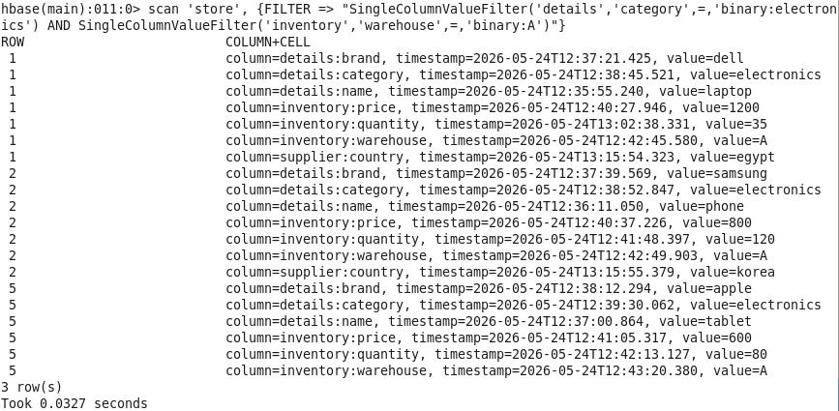

— End of Assignment —

