Task 2: Domain-Specific Sentiment Analysis
  - Financial News Sentiment Classification using TF-IDF, Logistic Regression, SVM and LSTM
Internship project report | October 2026

1. Abstract
This project compares classical machine-learning and neural-network approaches for three-class financial-news sentiment classification. Financial PhraseBank sentences are categorized as negative, neutral or positive. After duplicate removal, 4,838 labelled sentences were evaluated using a fixed stratified 80:20 train/test split. TF-IDF with Logistic Regression and linear Support Vector Machine (SVM) were compared against an LSTM neural network. SVM obtained the highest test accuracy (77.27%) and weighted F1-score (76.58%).

2. Dataset and objective
Dataset: Financial PhraseBank, sentences_50agree configuration. Source: https://huggingface.co/datasets/takala/financial_phrasebank. The source provides 4,846 records; 8 repeated sentences were removed, leaving 4,838 unique sentences. Class labels are 0 = negative, 1 = neutral, 2 = positive.
Class | Samples
Negative | 604
Neutral | 2872
Positive | 1362
Objective: classify the sentiment of domain-specific financial news and compare predictive performance, class-level behavior and training time across three models.

3. Preprocessing and evaluation design
Rows with missing sentences or labels were excluded; sentences were stripped of leading/trailing whitespace; empty sentences and repeated sentence texts were removed. The cleaned dataset contained no missing values. Stratified train/test splitting used test_size=0.20 and random_state=42: 3,870 training sentences and 968 test sentences. The same test partition was used for all three models. Weighted precision, recall and F1-score were calculated along with accuracy and class-specific reports.

4. Model configuration
Logistic Regression: TF-IDF with up to 20,000 features, unigrams and bigrams, min_df=2 and sublinear_tf=True; LogisticRegression(max_iter=1000, random_state=42).
SVM: same TF-IDF configuration, followed by LinearSVC(max_iter=5000, random_state=42).
LSTM: 10% of the training partition was reserved as validation data. A tokenizer trained only on the LSTM training texts used a 20,000-word vocabulary limit and padded sequences to length 100. The network used a 64-dimensional embedding, 64-unit LSTM, dropout layers (0.3 and 0.2), 32-unit dense hidden layer and three-way softmax output. Adam optimizer, categorical cross-entropy, batch size 32, maximum 10 epochs and early stopping on validation loss (patience 2, restore best weights) were used.

5. Test results
Model | Accuracy | Precision | Recall | Weighted F1 | Train time (s)
Logistic Regression | 0.7624 | 0.7747 | 0.7624 | 0.7429 | 2.80
SVM | 0.7727 | 0.7699 | 0.7727 | 0.7658 | 0.87
LSTM | 0.6570 | 0.6462 | 0.6570 | 0.6474 | 54.73
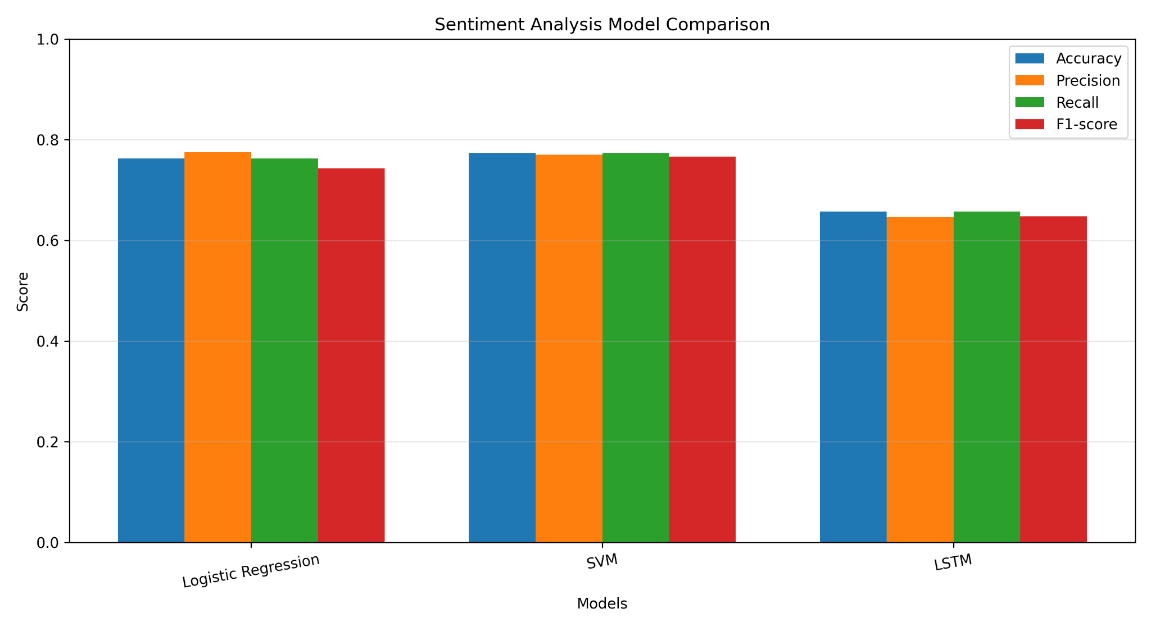
Figure 1. Test-set performance comparison (weighted precision, recall and F1-score).

6. Class-wise evaluation

Logistic Regression
Negative 0.88 0.42 0.57 121
Neutral 0.75 0.95 0.84 575
Positive 0.79 0.51 0.62 272
accuracy 0.76 968
macro avg 0.80 0.63 0.68 968
weighted avg 0.77 0.76 0.74 968

SVM
Negative 0.78 0.61 0.69 121
Neutral 0.78 0.89 0.83 575
Positive 0.74 0.59 0.66 272
accuracy 0.77 968
macro avg 0.77 0.70 0.73 968
weighted avg 0.77 0.77 0.77 968

LSTM
Negative 0.54 0.32 0.40 121
Neutral 0.76 0.83 0.79 575
Positive 0.45 0.45 0.45 272
accuracy 0.66 968
macro avg 0.58 0.53 0.55 968
weighted avg 0.65 0.66 0.65 968

7. Discussion
SVM was the strongest overall method on the held-out test set, achieving 77.27% accuracy and 76.58% weighted F1-score, while Logistic Regression achieved 76.24% accuracy and 74.29% weighted F1-score. The LSTM achieved 65.70% accuracy and 64.74% weighted F1-score. The neutral class was the largest class (2,872 of 4,838), which may contribute to difficulty identifying minority-class sentiment. In the LSTM training plot, validation loss increased after an early minimum while training loss continued decreasing, indicating overfitting; early stopping mitigated this by restoring the best validation weights.
Training-time comparisons reflect this Colab run and hardware conditions rather than general runtime guarantees. Because the corpus is modest in size, the LSTM may need further regularization, tuning or pretrained embeddings to improve generalization. Such changes were not part of the reported experiments.

8. Conclusion
For this Financial PhraseBank experiment, TF-IDF with linear SVM gave the best balance of test performance and training efficiency. The results demonstrate that a classical linear model can outperform a scratch-trained LSTM on a relatively small domain-specific text corpus. Future work could examine class-weighting, cross-validation, pretrained language models and robustness on newer financial news.

9. Submission artifacts
Colab notebook: iNeuBytes_Task2_Sentiment_Analysis.ipynb (export separately from Colab). Generated outputs: task2_model_comparison.csv, task2_classification_reports.txt, task2_model_comparison.png and financial_phrasebank_lstm.keras (if saved in the runtime). Confusion-matrix and training-curve images are present in the notebook outputs; export them separately if required by the internship instructions.

Reference
Malo, P. et al. Financial PhraseBank (financial news sentiment dataset). Dataset hosting: https://huggingface.co/datasets/takala/financial_phrasebank

