Student Exam Score Predictor: A Regression-Based Approach for Early Prediction of Academic Performance
K. Yasaswi  Roll No. 2420030053  Dept. of Computer Science and Engineering  KLH, Bowrampet Campus  Hyderabad, India | G. Poojitha  Roll No. 2420030037  Dept. of Computer Science and Engineering  KLH, Bowrampet Campus  Hyderabad, India | S. Anjana  Roll No. 2420030499  Dept. of Computer Science and Engineering  KLH, Bowrampet Campus  Hyderabad, India
Faculty Guide: Dr. N. Sunanda, Professor, Dept. of Computer Science and Engineering, KLH Bowrampet Campus

Abstract— Academic performance depends on many things at once: how much a student studies, how often they attend class, their earlier results, and the family and school environment around them. These factors are usually examined separately, so students typically learn how they did only after the exam. This paper presents a Student Exam Score Predictor that estimates exam scores from 19 student attributes. We use a public dataset of 6,607 student records, fill the few missing categorical values with the most frequent category, one-hot encode the categorical attributes and explore the data to see which factors matter. Linear Regression and Random Forest Regression (200 trees) are trained on an 80:20 split and compared with Mean Squared Error (MSE), Root Mean Squared Error (RMSE) and R-squared (R²). Linear Regression performs best, with an MSE of 3.256, an RMSE of 1.804 and an R² of 0.770 on the 1,322 test records, against 4.661, 2.159 and 0.670 for Random Forest. The selected model is served through a Flask web application, ScoreSense AI, where a user enters the student details and receives a predicted score. The paper describes the architecture, implementation, results and limitations, and places the work against three recent studies from 2024 and 2025.
Index Terms— Regression Analysis, Linear Regression, Random Forest, Exam Score Prediction, Educational Data Mining, Exploratory Data Analysis, Flask, Academic Performance.
I. INTRODUCTION
A student's exam result is almost never down to one thing. Study habits matter, and so do attendance, earlier results and the situation a student studies in: the resources they can reach, the support they get at home and the school they attend. These factors are usually looked at on their own, if at all. Most students learn how they did only after the paper has been graded, and by then there is little left to change.
Educational Data Mining (EDM) and Learning Analytics try to use the data institutions already hold to predict outcomes instead of only describing them. Regression suits this well. A classifier can only say pass or fail, while a regression model returns an expected score, which helps a student plan revision and helps a teacher decide who needs attention. Recent studies from 2024 and 2025 report very different results for similar models [1]–[3], which suggests that the choice of inputs, the way a model is checked and honest reporting of error matter as much as the algorithm.
In this work we built a Student Exam Score Predictor and tested it end to end. We took a public dataset of 6,607 students with 19 attributes, cleaned it, explored it, trained Linear Regression and Random Forest Regression on the same split, and compared them with MSE, RMSE and R². The best model was saved and connected to a Flask web application, ScoreSense AI, where a user enters the student details and gets a predicted score. All numbers in this paper come from our notebooks and can be reproduced from the project files.
The rest of the paper is organized as follows. Section II reviews three recent studies, Section III states the problem and the research gaps, and Section IV lists the objectives. Section V presents the system architecture. Section VI describes the dataset and preprocessing, Section VII the exploratory analysis and Section VIII the models and metrics. Section IX covers the web application, Section X reports the results, Section XI discusses innovation and novelty, Section XII states the limitations, and Section XIII concludes with future work.
II. LITERATURE SURVEY
Many studies have used statistical and machine-learning models to predict student performance. We focus on three recent ones, published in 2024 and 2025, because they test the kinds of models we use (Linear Regression and Random Forest) and report error in ways we can compare against.
Santiketa et al. [1] studied 853 high-school students on a science-and-mathematics programme and built models for two tasks: GPA prediction (regression) and grade prediction (classification). Experiments were run across five scenarios, one for each semester, using past scores in core subjects. Linear Regression gave the best regression result with an R² of 0.8911. For classification, Random Forest and K-Nearest Neighbors reached 100% accuracy in every scenario, and the other classifiers did better with grid-searched hyperparameters than with defaults. Accuracy this high suggests that the task becomes easy once earlier grades are available. The limits are also clear: the study relies mainly on earlier grades from one programme, and behavioural factors such as study hours and attendance are not part of the inputs.
Polat and Serek [2] tested Linear Regression, Random Forest and K-Nearest Neighbors on 649 records of Portuguese secondary-school students, each with 30 demographic, social and academic attributes, to predict Portuguese language grades. Models were scored with MSE, R² and Mean Absolute Error (MAE). Random Forest matched Linear Regression on error (an MSE of 9.48 and an MAE of 2.34), but its R² was negative (−0.04), which means it did slightly worse than simply predicting the average grade. The authors put this down to irrelevant features and poorly chosen hyperparameters, and they call for more careful feature engineering. This is the main caution for our project: a flexible model does not help much if the inputs are not chosen and tuned with care.
Parrales-Bravo et al. [3] trained a Random Forest regression model with 100 trees on demographic, academic and social attributes to predict the final mathematics grade of secondary-school students, using an 80:20 split. The model reached an MAE of 1.54, an RMSE of 3.02 and an R² of 0.61. What is new in this work is a confidence layer based on neutrosophic logic, which labels each prediction as confident, uncertain or unreliable according to the size of its error, so teachers can see which predictions to trust. The authors admit that the confidence thresholds were set by hand and that learning styles and some socio-economic variables were left out. Behavioural or real-time data and testing in other settings are listed as future work.
Table I summarizes these three studies, along with their methods and the gaps each one leaves open.

TABLE I. SUMMARY OF LITERATURE SURVEY
Ref. | Author(s) / Year | Methodology | Key Inference | Limitation / Future Work
[1] | Santiketa et al. (2024) | Linear Regression (GPA) and classification models (SVM, KNN, Logistic Regression, ANN, Random Forest) on 853 students across five semester scenarios. | Linear Regression gave the best R² (0.8911); Random Forest and KNN reached 100% grade accuracy. | Depends mainly on past scores from one programme; behavioural factors can be added.
[2] | Polat & Serek (2025) | Linear Regression, Random Forest and KNN on 649 records with 30 attributes; scored with MSE, R² and MAE. | Random Forest matched Linear Regression on error (MSE 9.48, MAE 2.34). | Random Forest had a negative R² (−0.04) from irrelevant features and weak tuning; needs better feature engineering.
[3] | Parrales-Bravo et al. (2025) | Random Forest regression (100 trees, 80:20 split) with a neutrosophic confidence rating for each prediction. | MAE 1.54, RMSE 3.02, R² 0.61; the confidence rating flags unreliable predictions. | Thresholds set by hand; learning styles and some socio-economic factors left out; behavioural data left for future work.

Taken together, the three studies point to the same few lessons. Past grades are strong predictors, but a model that leans only on them says little about what a student can change. A more complex model is not automatically a better one: Linear Regression won or tied in two of the three studies, and Random Forest failed to generalize in one when its features and settings were not controlled. The reliability of individual predictions is rarely reported, and none of the three presents a simple tool that a student could use directly. Study hours and attendance, the two inputs a student can actually act on, are not the focus of any of them.
One caution applies when reading these results side by side. The studies use different datasets, different targets (a GPA, a language grade and a mathematics grade) and different metrics, so an R² of 0.8911 in [1], a negative R² in [2] and an R² of 0.61 in [3] cannot be ranked against each other directly. We use them as pointers for design decisions, not as scores to beat.
III. PROBLEM STATEMENT AND RESEARCH GAP
A student's academic performance depends on study habits, attendance, earlier results and the student's background and surroundings. These are rarely analyzed together in a way that allows performance to be predicted in advance, so students usually see their real performance only after the exam, when nothing can be changed. This project builds a regression system that estimates a student's expected exam score from such information and makes it available through a simple web interface.
The studies in Section II leave several gaps that this project addresses:
- Heavy reliance on past grades: [1] depends on earlier scores, and [3] notes that predicting the final grade is harder without the earlier-period grades.
- Limited use of behavioural inputs: study hours and attendance are rarely the core inputs, and behavioural data is left as future work in [1] and [3].
- Weak generalization: Random Forest in [2] scored a negative R² (−0.04) because of irrelevant features and poor tuning.
- No single best model: Linear Regression gave the best R² in [1] and matched Random Forest on error in [2], so models should be compared on the same data and split.
- Unclear reliability of predictions: even the Random Forest in [3] reaches an R² of only 0.61, and its confidence ratings rely on hand-set thresholds.
- Few student-facing tools: the reviewed studies concentrate on model evaluation, and none presents a simple tool for entering details and getting a score.
IV. OBJECTIVES
The project has the following objectives:
1) Collect a dataset of student attributes (study hours, attendance, previous scores, lifestyle, school and family factors) with the exam score as the target.
2) Clean the data, handle missing values and encode the categorical attributes.
3) Carry out exploratory data analysis (EDA) to find the factors that influence the exam score most.
4) Train Linear Regression and Random Forest Regression on the same split.
5) Evaluate both models with MSE, RMSE and R², and select the best one.
6) Deploy the selected model in a web application that returns a predicted score from the details a user enters.
V. SYSTEM ARCHITECTURE
The project is organized as five notebooks and one web application, shown in Fig. 1. Notebook 1 loads the raw dataset and checks its size, data types, missing values and duplicates. Notebook 2 fills the missing values and saves a cleaned file. Notebook 3 explores the cleaned data. Notebook 4 builds the preprocessing and model pipelines, splits the data 80:20 and trains both models. Notebook 5 evaluates the saved best model and produces the comparison plots. The model with the higher R² is saved as best_model.pkl and used by the web application.
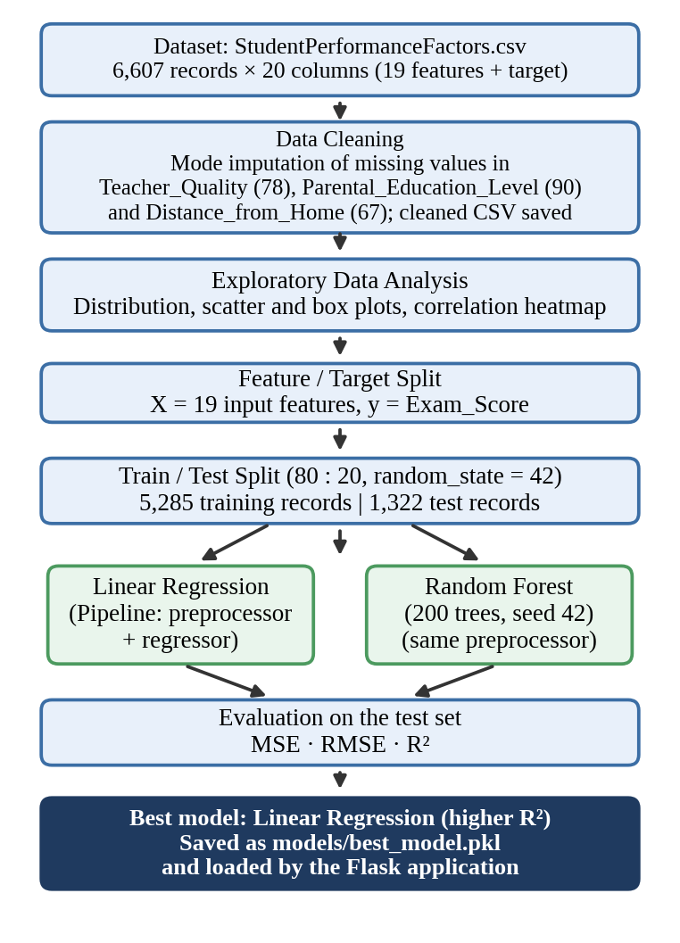
Fig. 1. Overall architecture of the Student Exam Score Predictor pipeline.
Preprocessing is part of the model itself. As Fig. 2 shows, a ColumnTransformer sends the six numeric columns through a median imputer and the 13 categorical columns through a most-frequent imputer followed by one-hot encoding, which gives 40 input features for the regressor. Because this step sits inside a scikit-learn Pipeline, the same transformation is applied automatically when a new student record is predicted, and the imputers learn only from the training data.
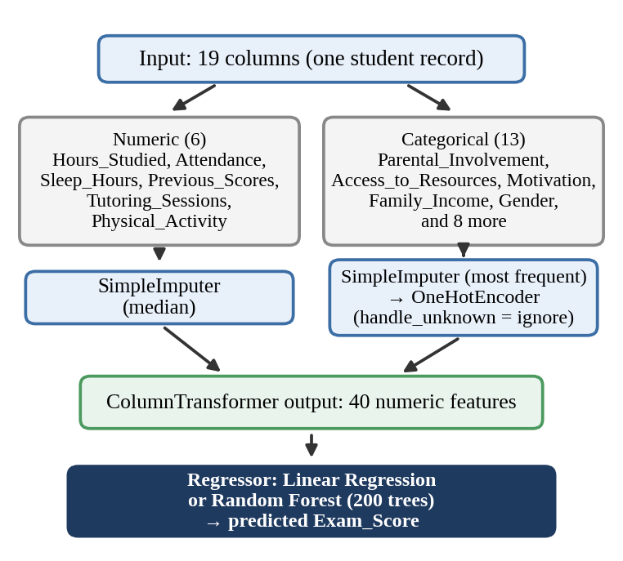
Fig. 2. Structure of the preprocessing and model pipeline.
The deployed system, shown in Fig. 3, has three parts. The browser interface collects the 19 values and sends them as JSON. The Flask server turns them into a one-row table with the same column names used in training and calls the model. The predicted score goes back to the browser as JSON and is shown to the user. Section IX gives the details.

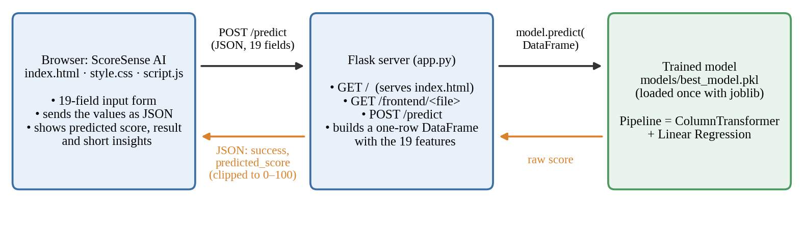
Fig. 3. Architecture of the ScoreSense AI web application.

VI. DATASET AND PREPROCESSING
A. Dataset
The data comes from StudentPerformanceFactors.csv, which has 6,607 student records and 20 columns: 19 input attributes and the target Exam_Score. There are six numeric inputs and 13 categorical inputs, and there are no duplicate rows. Table II lists the attributes with their value ranges. They cover study behaviour (hours studied, attendance, tutoring), earlier performance, lifestyle (sleep, physical activity), the student's own characteristics, the school and its resources, and the family and peers. No names or identification numbers are included.

TABLE II. DATASET ATTRIBUTES
Group | Attributes (values or range) | Type
Study and performance | Hours_Studied (1–44), Attendance (60–100%), Previous_Scores (50–100), Tutoring_Sessions (0–8) | Numeric
Lifestyle | Sleep_Hours (4–10), Physical_Activity (0–6) | Numeric
Student | Gender (Male/Female), Motivation_Level (Low/Medium/High), Learning_Disabilities (Yes/No), Extracurricular_Activities (Yes/No) | Categorical
School and resources | Access_to_Resources (Low/Medium/High), Internet_Access (Yes/No), Teacher_Quality (Low/Medium/High), School_Type (Public/Private), Distance_from_Home (Near/Moderate/Far) | Categorical
Family and peers | Parental_Involvement (Low/Medium/High), Family_Income (Low/Medium/High), Parental_Education_Level (High School/College/Postgraduate), Peer_Influence (Positive/Neutral/Negative) | Categorical
Target | Exam_Score (55–101; mean 67.24, standard deviation 3.89) | Numeric

B. Cleaning and Missing Values
Only three columns contain missing values: Teacher_Quality (78 records), Parental_Education_Level (90) and Distance_from_Home (67), which is 235 missing cells in all. Each was filled with the most frequent value of its column, and the cleaned file was saved as student_data_cleaned.csv. Range checks on the numeric columns showed plausible values. The one exception is Exam_Score, whose maximum of 101 is slightly above 100. We kept that record, and the web application limits predictions to the 0–100 range.
C. Encoding and Scaling
All 13 categorical attributes are one-hot encoded, with unseen categories ignored at prediction time. One-hot encoding avoids assuming that levels such as Low, Medium and High are equally spaced. The numeric features are not standardized. Ordinary least squares gives the same predictions whatever the scale of the inputs, so scaling would only change how the coefficients read, and Random Forest does not need it. A median imputer is kept on the numeric columns as a safeguard, although the cleaned data has no missing numeric values.
D. Train–Test Split
The data is split 80:20 with random_state = 42, which gives 5,285 training and 1,322 test records. Both models are trained on the same training set and scored on the same unseen test set, so the comparison is fair.
VII. EXPLORATORY DATA ANALYSIS
Fig. 4 summarizes the exploratory analysis from the third notebook. Exam scores are tightly grouped (mean 67.24, standard deviation 3.89), with most students between 60 and 75 and only a thin tail above 80 (48 of 6,607 records).

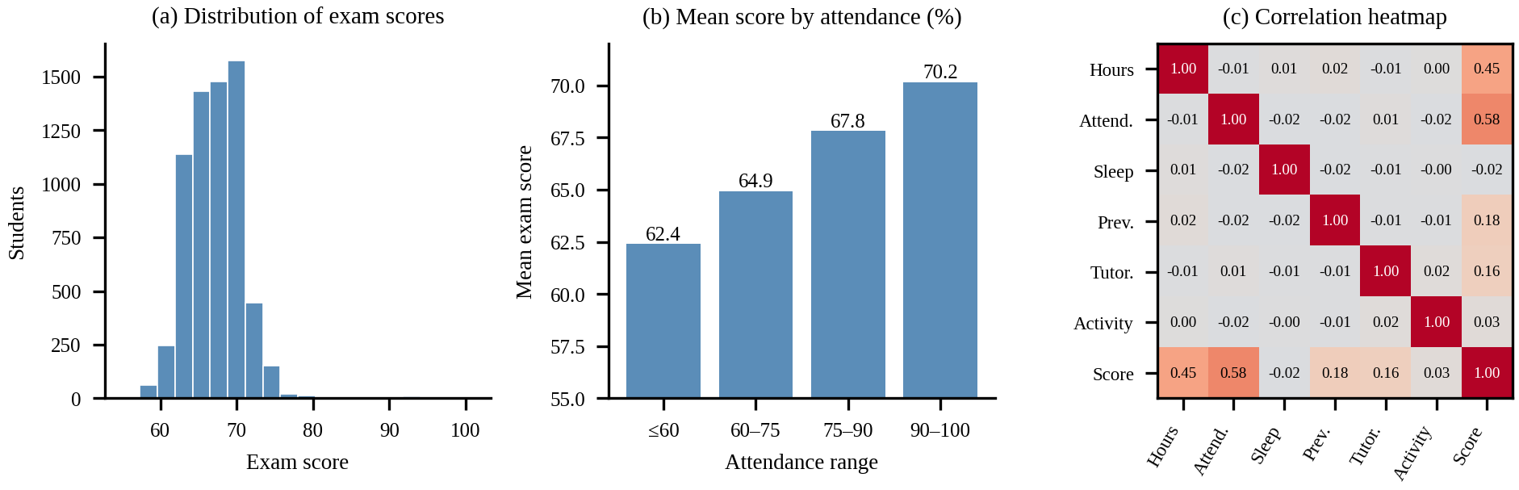
Fig. 4. Exploratory analysis: (a) distribution of exam scores, (b) mean exam score by attendance range, (c) correlation heatmap of the numeric attributes.

Attendance shows the strongest link with the score (r = 0.58), followed by hours studied (r = 0.45). Previous scores (0.18) and tutoring sessions (0.16) show weaker links, and physical activity (0.03) and sleep hours (−0.02) show almost none. The numeric inputs are practically uncorrelated with each other (|r| ≤ 0.02), so there is little redundancy between them. The mean score rises steadily with attendance: 62.4 for students at 60% or below, then 64.9, 67.8 and 70.2 for the 60–75, 75–90 and 90–100 bands.
Among the categorical factors, the mean score is almost identical for male and female students (67.24 and 67.23) and rises only slightly with family income (66.85 for low, 67.34 for medium and 67.84 for high). Past scores are only weakly related to the final score in this dataset, which differs from [1] and [3], where earlier grades were the main input. Here attendance and study hours dominate, which supports our choice to treat them as core inputs.
VIII. MODEL BUILDING AND EVALUATION METRICS
A. Linear Regression
Linear Regression models the exam score as a weighted sum of the inputs. For the encoded features x1 to xn, the predicted score is
ŷ = β0 + β1x1 + β2x2 + … + βnxn
where β0 is the intercept and β1 to βn are the learned coefficients. The coefficients minimize the residual sum of squares on the training data. The model is fast, and its coefficients can be read directly, for instance as the change in predicted score for one more hour of study.
B. Random Forest Regression
Random Forest Regression averages the predictions of T decision trees, each trained on a bootstrap sample of the training data [4]:
ŷ = (1/T) Σ (t=1 to T) ht(x)
where ht(x) is the prediction of the t-th tree. We use T = 200 trees with random_state = 42 and the default values of all other settings in scikit-learn [5]. Averaging many trees lets the model capture non-linear effects and interactions between features.
C. Evaluation Metrics
Both models are scored on the test set. MSE is the average squared error:
MSE = (1/n) Σ (yi − ŷi)²
RMSE is its square root, given in score points:
RMSE = √MSE
R² compares the model with a baseline that always predicts the mean score ȳ:
R² = 1 − [ Σ (yi − ŷi)² / Σ (yi − ȳ)² ]
An R² close to 1 means the model explains most of the variation in scores, a value near 0 means it does little better than the mean, and a negative value means it does worse. The notebook keeps the model with the higher R²; in our case that model also has the lower MSE.
IX. WEB APPLICATION
The application is called ScoreSense AI and is built with Flask. When the server starts, app.py loads best_model.pkl with joblib. The route / serves the page, /frontend/<file> serves its style and script files, and POST /predict returns a prediction.
The interface has a form with the 19 inputs, shown in Fig. 6(a). When the user presses Generate Prediction, the page checks the fields and sends them to the server as JSON. The server converts the numeric fields to numbers, builds a one-row DataFrame with the training column names, calls the model, limits the result to the range 0–100 and rounds it to two decimals. The reply is a JSON object with a success flag and the predicted score. If anything goes wrong, the reply carries an error message and the page shows it instead of a score.


Fig. 6. ScoreSense AI output: (a) the input page with the 19 student fields, (b) the prediction results page for an example student.

The results page, shown in Fig. 6(b), displays the predicted exam score out of 100 in a ring together with a likely result (Pass), a short feedback message and a summary of the details that were entered. Beside it are short AI insights (strength, opportunity, balance and an overall comment) and a prediction summary with the predicted score, the predicted result and a confidence level. Buttons let the user predict again or return to the home page. Table III shows the model's output on the first six test records.
TABLE III. SAMPLE PREDICTIONS ON TEST RECORDS
Record | Actual | Predicted | Error
1 | 65 | 64.53 | 0.47
2 | 65 | 65.27 | −0.27
3 | 71 | 71.53 | −0.53
4 | 64 | 64.28 | −0.28
5 | 66 | 66.52 | −0.52
6 | 66 | 66.61 | −0.61

X. RESULTS AND DISCUSSION
A. Model Comparison
Table IV and Fig. 5(c) compare the two models on the 1,322 test records. Linear Regression is better on all three measures. Its RMSE of 1.80 points is small next to the standard deviation of 3.89 in the scores, and its R² of 0.770 means that about 77% of the variation in exam scores is explained. Random Forest reaches an R² of 0.670 with an RMSE of 2.16 points.
TABLE IV. MODEL COMPARISON ON THE TEST SET
Model | MSE | RMSE | R²
Linear Regression | 3.2560 | 1.8044 | 0.7696
Random Forest (200 trees) | 4.6607 | 2.1589 | 0.6703

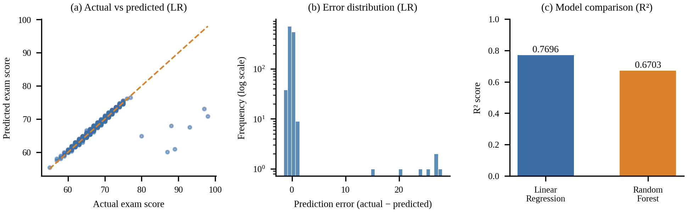
Fig. 5. Results: (a) actual versus predicted scores for Linear Regression, (b) distribution of prediction errors, (c) R² of the two models.

B. Error Analysis
Fig. 5(a) shows predictions lying close to the diagonal, and 98.6% of the test predictions are within one point of the actual score. Only seven test records have an error above three points, and they are exactly the seven test students who scored 80 or higher (actual 80–98, predicted 60–73). Those seven records produce 95% of the total squared error. Without them the MSE would be about 0.16 instead of 3.26. The model therefore works very well in the dense middle of the score range and under-predicts the rare very high scorers, as Fig. 5(b) shows, which is the pattern we expected where examples are sparse.
C. What the Model Learned
The Linear Regression coefficients are easy to read. Holding the other inputs fixed, one extra study hour adds about 0.29 points, one extra percentage point of attendance adds about 0.20 points, and each tutoring session adds about 0.51 points. High instead of low access to resources or parental involvement is worth about 2.1 and 2.0 points, and high instead of low motivation or family income about 1.0 and 1.1 points. Previous scores add only 0.05 points per mark. The Random Forest ranks attendance (0.375) and hours studied (0.241) as its two most important features, so both models agree on the main drivers (Fig. 7).

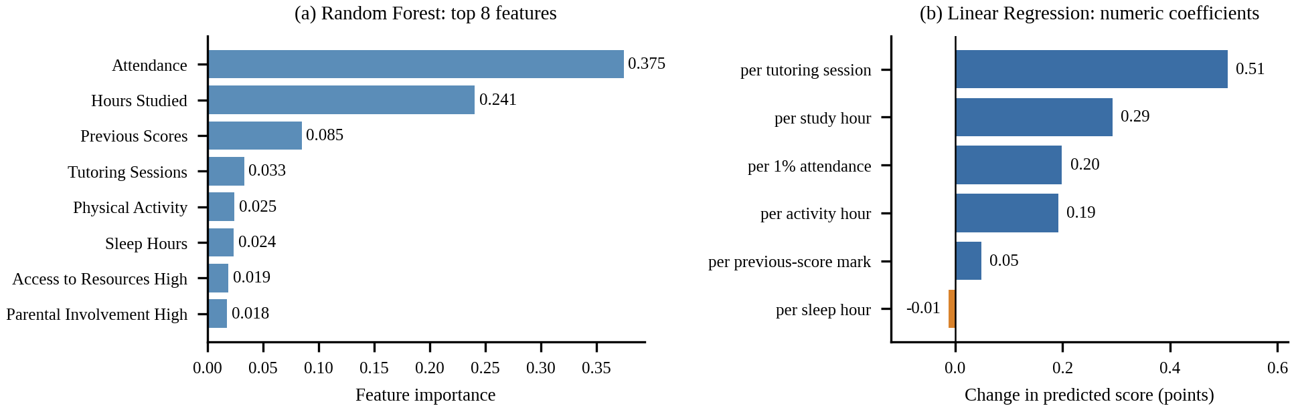
Fig. 7. What the models rely on: (a) Random Forest feature importance, (b) Linear Regression coefficients of the numeric inputs.

For a typical student (median numeric values, most common categories), the model predicts 65.0 at 70% attendance and 69.0 at 90%, and 65.6 at 15 study hours against 68.5 at 25 hours. These are associations in the data, not proof that changing a habit will change a result.
D. Comparison with the Literature
Our results fit the pattern in the reviewed studies. Linear Regression gave the best R² in [1] and matched Random Forest in [2], and here it again beats a default Random Forest, which suggests that the relationships in this dataset are close to linear. Unlike the negative R² reported for Random Forest in [2], our Random Forest stays clearly positive (0.670). Its R² is above the 0.61 of [3], although the datasets and targets differ, so the numbers should not be ranked against each other. Unlike [3], our application shows test-set metrics but not a per-prediction confidence rating, which we leave for future work.
XI. INNOVATION, CREATIVITY AND NOVELTY
A. Innovation
The project combines study behaviour, attendance, earlier scores, lifestyle, school and family factors in one pipeline, and compares a linear model with an ensemble model on the same split, instead of relying mainly on earlier grades as in [1] and [3].
B. Creativity
ScoreSense AI turns a 19-factor analysis into one score that a student can read at once, with a pass or fail result, short insights and a confidence level beside it. A user can also change one input and predict again to see how the estimate moves.
C. Novelty
The reviewed studies concentrate on evaluating models. This project goes further and delivers a working system from raw data to a deployed predictor, which students can use for self-assessment and educators can use to find students who may need support early. Table V positions the project against the three reviewed studies.

TABLE V. FACTOR COVERAGE COMPARED WITH RELATED WORK
Factor considered | Santiketa et al. [1] | Polat & Serek [2] | Parrales-Bravo et al. [3] | This system
Demographic / social attributes | Not reported | Yes | Yes | Yes
Past academic performance | Yes | Yes | Yes | Yes
Study hours and attendance as core inputs | No | Not the focus | Not the focus | Yes
Several models compared | Yes | Yes (3 models) | No (RF only) | Yes (2 models)
Error metrics reported | R², accuracy | MSE, R², MAE | MAE, RMSE, R² | MSE, RMSE, R²
Working prediction tool | Not described | Not described | Not described | Yes (Flask app)

XII. LIMITATIONS
This is a course project and it has limits. The dataset is public and its exam scores are tightly grouped between 55 and 101, so the model may not carry over to other institutions or grading schemes. Results come from a single 80:20 split. We did not use cross-validation, feature selection or hyperparameter tuning, and the Random Forest uses default settings apart from the number of trees, so a tuned forest might close the gap to Linear Regression. The comparison covers only two algorithms.
The model finds associations, not causes, and its predictions for very high scorers are poor. Self-reported inputs such as study hours can be imprecise. We saw no difference in mean score between male and female students, but we did not measure prediction error by subgroup. For these reasons the predicted score should be treated as decision support, to be read next to a teacher's own judgment, and never as a verdict on a student.
XIII. CONCLUSION AND FUTURE WORK
This paper presented a Student Exam Score Predictor built and tested on a dataset of 6,607 students and 19 attributes. After cleaning, one-hot encoding and exploratory analysis, Linear Regression and Random Forest Regression were compared on a held-out test set. Linear Regression won, with an MSE of 3.256, an RMSE of 1.804 and an R² of 0.770, against 4.661, 2.159 and 0.670 for Random Forest. Attendance and study hours turned out to be the strongest drivers of the score. The selected model is served through a Flask application that returns a predicted score from a simple form, which gives students a way to see how habits relate to results and gives educators an early signal for students at risk.
Future work includes k-fold cross-validation and hyperparameter tuning for Random Forest, trying Gradient Boosting or XGBoost, adding a confidence measure to each prediction as in [3], using explainability techniques for single predictions, checking prediction error across gender and income groups, testing the model on our own institution's data, and removing the fixed file path in app.py so the application can be deployed on a server.
ACKNOWLEDGMENT
The authors thank Dr. N. Sunanda, Professor, Department of Computer Science and Engineering, KLH Bowrampet Campus, for her guidance and support throughout this project.
REFERENCES
[1] N. Santiketa, U. Ninrutsirikun, S. Chaikhan, and N. Wattanakitrungroj, “Student academic performance prediction using machine learning with various features and scenarios,” in Proc. IEEE Conf., 2024, pp. 1–6, IEEE Xplore document no. 10770729.
[2] D. Polat and A. Serek, “Forecasting student academic performance using machine learning,” J. Emerging Technol. Comput. (JETC), vol. 2, no. 2, 2025.
[3] F. Parrales-Bravo, R. Tolozano-Benites, A. Castro-Mora, L. Vasquez-Cevallos, and E. Rodríguez-Revelo, “Integrating random forest with neutrosophic logic for predicting student academic performance and assessing prediction confidence,” Neutrosophic Sets Syst., vol. 84, 2025.
[4] L. Breiman, “Random forests,” Machine Learning, vol. 45, no. 1, pp. 5–32, 2001.
[5] F. Pedregosa et al., “Scikit-learn: Machine learning in Python,” Journal of Machine Learning Research, vol. 12, pp. 2825–2830, 2011.

