Student Exam Score Predictor
A Project Report Submitted in
the partial fulfillment of the requirements for the award of the degree of

BACHELOR OF TECHNOLOGY
In

DEPARTMENT OF COMPUTER SCIENCE AND ENGINEERING
By
G. Poojitha | : 2420030037
Yasaswi Kakunuri | : 2420030053
Sakhamuri Anjana | : 2420030499

Under the Esteemed Guidance of

Dr. N. Sunanda
Associate Professor

Department of Computer Science And Engineering

AY-2026-2027

Semester: ODD SEM




K L (Deemed to be) University
DEPARTMENT OF COMPUTER SCIENCE AND ENGINEERING

Declaration

The Project Report entitled “Student Exam Score Predictor” is a record of Bonafide work of K. Yasaswi – 2420030053, G. Poojitha – 2420030037, S.Anjana – 2420030499 submitted in partial fulfillment for the award of B. Tech in Computer Science and Engineering to the K L University. The results embodied in this report have not been copied from any other departments/University/Institute.

K. Yasaswi – 2420030053
G. Poojitha – 2420030037
S. Anjana – 2420030499

K L (Deemed to be) University
DEPARTMENT OF COMPUTER SCIENCE AND ENGINEERING

CERTIFICATE

This is certify that the mini project based report entitled “Student Exam Score Predictor” is a bonafide work done and submitted by K. Yasaswi – 2420030053, G. Poojitha – 2420030037, S. Anjana – 2420030499 in partial fulfillment of the requirements for the award of the degree of BACHELOR OF TECHNOLOGY in Department of Computer Science And Engineering, K L (Deemed to be University), during the academic year 2026-2027.

Signature of the Guide

Signature of the Course Coordinator Signature of the HOD

ACKNOWLEDGEMENT
The success in this project would not have been possible but for the timely help and guidance rendered by many people. Our wish to express my sincere thanks to all those who has assisted us in one way or the other for the completion of my project.

Our greatest appreciation to my Course Coordinator and my guide Dr. N.Sunanda, Department of Computer Science And Engineering which cannot be expressed in words for his/her tremendous support, encouragement and guidance for this project.

We express our gratitude to Mr. Venkateswa Rao Pulipati, Head of the Department for Computer Science And Engineering for providing us with adequate facilities, ways and means by which we are able to complete this project-based Lab.

We thank all the members of teaching and non-teaching staff members, and also who have assisted me directly or indirectly for successful completion of this project. Finally, I sincerely thank my parents, friends and classmates for their kind help and cooperation during my work.

K. Yasaswi – 2420030053
G. Poojitha – 2420030037
S. Anjana – 2420030499

Abstract

A student's academic performance is influenced by several factors, including how consistently they study, how regularly they attend classes, and their broader personal and demographic background. However, these factors are rarely analyzed together in a structured way that allows performance to be predicted in advance. This project aims to build a regression-based system that estimates a student's expected exam score using such academic and demographic information.
The process begins with collecting a dataset containing details like daily study hours, attendance percentage, gender, parental background, and past academic performance. This raw data is cleaned to handle missing or inconsistent values, and categorical attributes are converted into a numerical form suitable for machine learning. Exploratory data analysis is then carried out to understand how each feature relates to the final exam score, helping identify which factors have the strongest influence on performance. Once the data is prepared, regression algorithms such as Linear Regression and Random Forest Regression are applied to learn the underlying relationship between the input features and exam scores. Multiple models are trained and compared so that the most accurate and reliable one can be selected. The performance of each model is evaluated using standard metrics such as Mean Squared Error (MSE) and R-squared ( R²) score, which indicate how closely the predicted scores match the actual results.
The final system is designed to take a student's study and attendance details as input and return a predicted exam score as output. Such a tool can help students understand how their habits affect their performance and encourage them to make positive changes early on. It can also assist educators in identifying students who may be at risk of underperforming, allowing timely academic support and intervention. Overall, this project demonstrates how a simple regression model can turn everyday academic data into meaningful, actionable insights for both students and teachers.

Index

S. No. | Chapters | Topics | Page No.
 |  | Acknowledgement | 4
 |  | Abstract | 5
1 | Introduction | 1.1 Motivation  1.2 Objective  1.3 What is Educational Data Mining?  1.4 What is Regression Analysis?  1.5 Target Users | 8 - 10
2 | Software Requirement | 2.1 Problem Statement  2.2 Technologies Used  2.3 Software Used  2.4 Feasibility Study | 11 - 13
3 | Software Design | 3.1 System Architecture  3.2 Dataset Description  3.3 Data Preprocessing  3.4 Exploratory Data Analysis  3.5 Model Building  3.6 Model Evaluation Metrics | 14 - 19
4 | Implementation and User Interface | 4.1 Module Details  4.2 Detailed Description of Prediction System  4.3 Testing and Validation  4.4 Expected Results and Discussion  4.5 Ethical Considerations and Data Privacy | 20 - 25
5 | Conclusion and Future Aspects | 5.1 Conclusion  5.2 Future Aspects | 26 - 28
6 | Bibliography | References used in the project | 29
7 | Appendices | Graphs and supporting material | 30 - 35

CHAPTER 1
Introduction

  - Motivation
The main motivation of “Student Exam Score Predictor” is to give students an early estimate of their exam score before the examination. A student’s performance depends on many factors, such as daily study hours, class attendance, past academic results, and personal and family background, but these are usually looked at separately, so it is hard to see how they combine to affect the final result. Students usually learn how they performed only after the marks are announced, when it is too late to change anything, and weaknesses in their study habits or attendance go unnoticed until then. A prediction made in advance lets a student adjust their habits early and put more effort where it is needed. Seeing a predicted score also makes the effect of habits clear, because a student can see how more study hours or better attendance may raise the expected result, and this encourages them to make positive changes before it is too late. Teachers and institutions also benefit, because the attendance records and previous grades they already keep can be turned into predictions that help them identify students at risk of underperforming and offer support before the next assessment. In this way, support reaches students earlier, and it is based on data rather than on guesswork or on poor results that have already been recorded. Regression is used because it gives an actual expected score and not just a pass or fail label, which is more useful for planning revision and for deciding who needs extra attention. Together, these reasons motivated us to build a simple, data-driven tool that turns everyday academic data into meaningful and actionable insights for both students and teachers.

  - Objective

The objective of “Student Exam Score Predictor” is to build a regression-based system that estimates a student’s expected exam score from study hours, attendance, gender, parental background and past academic performance. The first step is to collect a dataset containing these details and clean it by handling missing or inconsistent values, and categorical attributes such as gender and parental background are converted into a numerical form that machine learning models can use. Exploratory data analysis is then carried out to understand how each factor relates to the final exam score and to find which factors have the strongest influence on performance. Linear Regression and Random Forest Regression are trained on the same data, so that a simple, easy-to-interpret model can be compared fairly with a more flexible ensemble model. Each model is evaluated using Mean Squared Error (MSE) and R² score, which show how closely the predicted scores match the actual results, and the more accurate and reliable model is selected as the final predictor. Finally, the system is designed to take a student’s study and attendance details as input and return a predicted exam score as output, so that students can understand how their habits affect their performance and educators can identify students who may need support. The architecture, feasibility and testing strategy are also documented clearly, so the project can be extended or reproduced by others.

  - What is Educational Data Mining ?
Educational Data Mining (EDM) and Learning Analytics are fields that apply data analysis and machine learning to data generated in educational settings. They take the data institutions already collect, such as attendance registers, assignment records and historical grades, and turn it into something predictive rather than purely descriptive. Interest in this area has grown further as institutions move more teaching and assessment online, generating richer digital trails of attendance, engagement and assignment behaviour than a purely offline classroom could.
This creates both an opportunity and a responsibility. It is an opportunity to build tools that genuinely help students and teachers, and a responsibility to build them carefully, using interpretable methods and metrics that are honest about how confident a prediction really is.

  - What is Regression Analysis ?

Regression analysis is a statistical and machine-learning technique that models the relationship between one or more input features and a continuous output value, such as a mark or a score. It learns this relationship from past data and then uses it to estimate the output for new inputs. Instead of classifying a student as “pass” or “fail”, a regression model estimates an actual expected score, which is more informative both for the student planning their revision and for a teacher deciding who needs extra attention. In this project, the input features are study hours, attendance percentage, gender, parental background and past academic performance, and the output is the exam score. Two regression algorithms are used. Linear Regression expresses the score as a weighted combination of the input features, so it is simple, fast to train and easy to interpret, and it works as a baseline. Random Forest Regression is a more flexible ensemble method that averages the predictions of many decision trees, so it can capture non-linear relationships and interactions between features, such as the combined effect of low attendance and low past performance. Comparing the two on the same data shows which approach predicts exam scores more reliably..

1.5 Target Users
The proposed system is intended for two groups of users. Students can enter their study and attendance details to obtain a predicted exam score and understand how their academic habits may influence their performance. Educators can use the predictions to identify students who may be at risk of underperforming and provide timely academic guidance and support. The system is presented as a decision-support tool and not as a verdict, so educators are expected to use the prediction alongside their own judgment.

CHAPTER 2
Software Requirement

2.1 Problem Statement
A student’s academic performance is influenced by several factors, including daily study hours, class attendance, previous academic performance, and personal and demographic characteristics. However, these factors are often considered separately, making it difficult to understand their combined impact on a student’s examination performance. In most cases, students become aware of their actual performance only after the examination, which limits the opportunity to identify weaknesses and take corrective measures beforehand.
There is therefore a need for a data-driven system that can analyze multiple student-related factors together and predict examination performance in advance. The proposed Student Exam Score Predictor addresses this problem by collecting relevant academic and demographic data, preprocessing it to handle missing or inconsistent values, and performing exploratory data analysis to identify relationships between the factors and exam scores. Linear Regression and Random Forest Regression are then used to learn patterns from historical data and estimate a student’s expected score, and the models are evaluated using Mean Squared Error (MSE) and R² score to select a reliable one.

  - Technologies used

Python: Python is the primary programming language of the project. Its mature data-science ecosystem allows data loading, cleaning, modelling and evaluation to be written in a single, readable language. Python is easy to learn, has simple syntax, and is supported by a large community and many free libraries, which makes it a common choice for machine learning projects. Because the whole pipeline, from reading the dataset to producing a predicted score, can be written in one language, the code stays consistent and is easy for all three team members to understand, test and extend.

Pandas and NumPy: Pandas handles data loading, cleaning and handling of missing values, while NumPy provides the numerical operations used in preprocessing and in computing metrics. Pandas stores the student data in tables called DataFrames, where each row is a student and each column is an attribute such as study hours or attendance. It is used to read the dataset, fill missing values with the mean, median or most frequent category, remove inconsistent entries, and convert categorical columns such as gender and parental background into numerical form using one-hot encoding. NumPy supports fast array and mathematical operations, such as standardizing features and calculating the squared errors needed for MSE and R².

Scikit-learn: Scikit-learn provides the Linear Regression and Random Forest Regression implementations along with train–test splitting, cross-validation and evaluation metrics such as MSE and R². All of these are well established and freely available [7]. Using the same library for both models makes the comparison fair, because they are trained and tested with the same functions on the same split of the data. Scikit-learn also provides tools for feature scaling and for tuning the Random Forest settings, such as the number of trees and the maximum depth, using cross-validation.

Matplotlib and Seaborn: These libraries are used for exploratory visualizations such as histograms, box plots, scatter plots and correlation heatmaps, and for residual plots during model validation. Histograms and box plots show how study hours, attendance and exam scores are distributed and where the outliers are. Scatter plots and the correlation heatmap show which attributes are most strongly related to the exam score. Residual plots show whether the prediction errors are random or whether the model is consistently over- or under-predicting for certain score ranges. Seaborn is built on Matplotlib and gives cleaner, more readable charts with less code.

  - Software Used
Jupyter Notebook / Google Colab: Development and experimentation are carried out in Jupyter Notebook or Google Colab, which allow code, visualizations and explanatory notes to sit side by side. A notebook is divided into cells, so each step of the pipeline, such as loading the data, cleaning it, plotting graphs, training the models and calculating MSE and R², can be written and run separately and the output seen straight away. This makes it easy to test a change in one step without running the whole program again, and the notes written between the cells explain what each step does. Google Colab can also be used as a free cloud notebook environment, so no specialized hardware is required and the pipeline can run on a standard laptop. Colab notebooks can be shared through a link, so all three team members can open, run and review the same work from any device with a browser.

Git and GitHub: The codebase is version-controlled using Git and hosted on GitHub, which supports collaboration among the three team members. Git records every change made to the code, so the team can go back to an earlier version if a new change causes an error, and can see who changed what and when. GitHub stores the project online, so each member can work on their own part, such as preprocessing, model building or evaluation, and then merge the work into one project without overwriting each other’s files. It also keeps a backup of the code and the notebooks, so the project is not lost if one computer fails, and the finished project can be shared easily with the faculty guide for review.
2.4 Feasibility Study
A feasibility study checks whether the project can be completed successfully with the time, tools, skills and data available. The Student Exam Score Predictor is examined here from four angles: technical, economic, operational and schedule.
Technical feasibility: Linear Regression and Random Forest Regression are well-established algorithms that are already implemented in freely available libraries such as scikit-learn, so the team does not need to write these algorithms from scratch. The preprocessing and visualization steps rely on equally mature libraries: pandas for cleaning and encoding the data, NumPy for numerical operations, and Matplotlib and Seaborn for plots. No specialized hardware such as a GPU is required, because the dataset is small and both models train in a short time on a standard laptop. If a laptop is not available, the same pipeline can run on a free cloud notebook such as Google Colab. The skills needed, which are basic Python programming, data handling and an understanding of regression, are covered in the course, and every library used has detailed documentation and a large community, so any problem faced during development can be solved quickly. For these reasons the project is technically achievable.
Economic feasibility: All the software used in this project, including Python, its libraries, Jupyter Notebook, Google Colab, Git and GitHub, is open-source or free to use, so there is no licensing cost. The dataset can be taken from publicly available educational datasets, or built from institutional records after removing identifying details such as names and roll numbers, so no data has to be bought. The project runs on the team’s existing laptops or on free cloud notebooks, so it needs no servers, paid cloud services or other infrastructure. Within its academic scope, the project therefore adds no financial cost, and the only real investment is the time and effort of the three team members.
Operational feasibility: The inputs the system needs, such as daily study hours and attendance details, are quantities that students and institutions already track, so no new data-collection process has to be introduced for the system to be used. The system takes these details as input and returns a single predicted exam score, which is easy for a student or a teacher to read and understand without any technical knowledge. For students, it shows how their habits may affect their result, and for educators, it gives an early signal about who may be at risk. The system is meant to support the judgment of educators and not to replace it, and predictions are treated as estimates and not as final verdicts, so it fits into how institutions already work. Before final use, a small group of students and the faculty guide try the interface to check that the inputs are clear and the output is easy to interpret.
Schedule feasibility: The project is divided into five sequential phases over six weeks. Data collection and preprocessing take Weeks 1–2, exploratory data analysis takes Week 3, model building of Linear Regression and Random Forest takes Week 4, model evaluation and comparison using MSE and R² takes Week 5, and final system integration and testing takes Week 6. This is a realistic timeline for the scope of the work and the team of three. Each phase has a clear task, the output of one phase feeds directly into the next, and the work can be shared among the members, for example one member on data preparation, another on model building and another on evaluation and testing. Weekly progress checkpoints with the faculty guide help keep the project on schedule and allow any delay to be noticed early.

CHAPTER 3
Software Design

3.1 System Architecture
The system follows a layered pipeline architecture, as shown in Fig No. 3.1. Raw student data is cleaned, encoded, explored and split into training and testing sets. Linear Regression and Random Forest Regression are trained on the same data and compared using MSE and R², and the better model is selected to predict a student’s exam score from their study and attendance details.
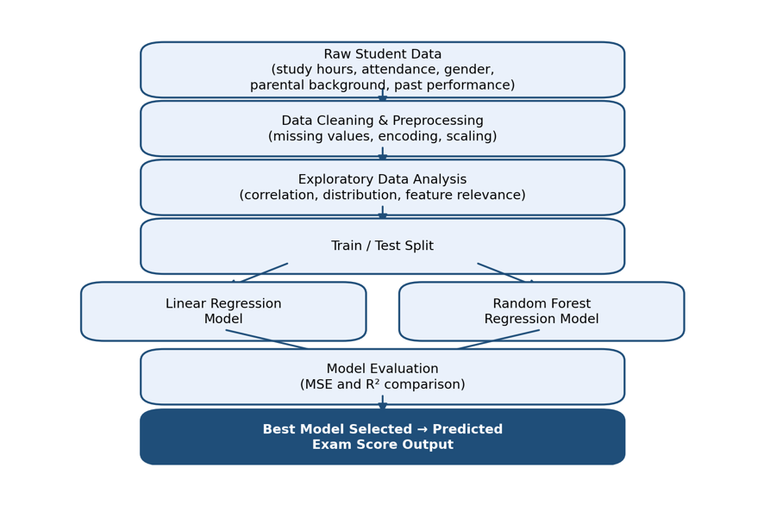
Fig No. 3.1 Overall architecture of the Student Exam Score Predictor

3.2 Dataset Description
The dataset brings together academic and demographic attributes for each student, along with the actual exam score recorded for that student. Each row of the dataset represents one student and each column represents one attribute, so the model can learn how the attributes together relate to the final score, and the data can be taken from a publicly available educational dataset or built from institutional records after anonymization, so that names and roll numbers are not included. Study Hours is a numeric attribute giving the average number of hours the student studies per day, and it shows how much effort a student puts into preparation. Since it is usually reported by the students themselves, it can be slightly imprecise, so negative or unrealistic values are corrected or removed during cleaning. Attendance is a numeric attribute giving the percentage of classes attended over the term, with valid values between 0 and 100, and it shows how regularly a student takes part in classroom learning. Study hours and attendance are both expected to show a strong relationship with the exam score. Gender and Parental Background are categorical attributes, where gender is self-reported and parental background is a broad indicator of parental education or occupation. Because they are text categories and not numbers, they are converted into numerical form using one-hot encoding before being given to the models, and they are included so that the model can account for the wider personal and family environment of the student. The predictions are also checked for fairness across these groups, so that the model does not perform worse for one gender or one parental-background category. Past Academic Performance is a numeric attribute holding the score or grade obtained in the previous examination cycle, and it shows the level the student has reached so far, which helps the model estimate where the student is likely to stand in the coming exam. Exam Score is the numeric target value that the model is trained to predict, and the models learn from it by comparing their predictions with the actual score during training and testing. Together these attributes span behavioral factors (study hours, attendance), demographic factors (gender, parental background) and historical performance, giving the model a broader picture than any single factor could provide on its own. This also allows exploratory data analysis to show which of these factors matter most for predicting the exam score.

3.3 Data Preprocessing
Raw academic data is rarely clean enough to be given directly to a model, so several preprocessing steps are applied before any model is trained. These steps make sure the data is complete, correct and in a numerical form, so that the models learn real patterns and not errors in the data.
Handling missing and inconsistent values: Missing numeric values, such as an unrecorded attendance percentage, are handled through mean or median imputation depending on how the attribute is distributed. The mean is used when the values are spread fairly evenly, and the median is used when the values are skewed or have outliers, because the median is not pulled by a few extreme values. Missing categorical values, such as an unrecorded parental background, are filled with the most frequent category (the mode), or the record is excluded where a large fraction of it is missing, since filling too many values would make the record unreliable. Inconsistent entries, such as attendance outside the valid 0–100 range or negative study hours, are corrected where the intended value is clear, for example a typing mistake, and removed otherwise. This step stops wrong values from distorting the relationships that the models learn.
Categorical encoding: Regression algorithms require numerical input, so attributes such as gender and parental background, which are stored as text, are converted using one-hot encoding. In one-hot encoding, each category becomes its own column with a value of 1 if the student belongs to that category and 0 if not. This is preferred because these categories have no natural order, and label encoding, which gives each category a number such as 0, 1 and 2, could mislead a linear model into treating them as ranked, as if one category were larger or better than another. One-hot encoding avoids this, so the model treats every category fairly. An attribute with categories that can be ranked in a meaningful order could instead use ordinal encoding.
Feature scaling: Study hours and attendance are measured on very different scales, with study hours usually a few hours per day and attendance a percentage up to 100, so standardization is applied to stop any one attribute from dominating the model only because of its larger numbers. In standardization, the mean is subtracted from each value and the result is divided by the standard deviation, so every attribute ends up with a mean of 0 and a standard deviation of 1. Linear Regression is sensitive to feature scale, so scaling helps it learn the coefficients more reliably and makes them easier to compare. Random Forest does not strictly need scaling because it works by splitting the data on thresholds and not by calculating distances, but it is trained on the same scaled features for consistency, so that both models are compared on exactly the same input.
3.4 Exploratory Data Analysis
Before any model is trained, exploratory data analysis (EDA) is used to understand the shape of the data: the distribution of exam scores, the spread of study hours and attendance, and the correlation between each feature and the final score. EDA is carried out on the cleaned dataset, and it helps the team to see what the data actually looks like before choosing and training the models. It also helps to find problems that cleaning may have missed, and to decide which attributes are worth keeping for the modelling stage. The analysis is done in three parts: univariate analysis, bivariate and correlation analysis, and feature relevance.
Univariate analysis: Histograms and box plots examine the distribution of each numeric attribute, such as study hours, attendance, past academic performance and exam score, one at a time. A histogram shows how the values are spread, for example whether most students study for two to four hours a day or whether the exam scores bunch up at the high or low end. A box plot shows the median, the spread of the middle values and any points lying far from the rest. Together they identify skew or outliers that need special handling, such as a very low attendance value or an unusually high number of study hours. They also help to decide whether the mean or the median is the better choice for filling missing values.
Bivariate and correlation analysis: Scatter plots of study hours and attendance against exam score show how the score changes as each of these attributes changes, and whether the relationship looks roughly like a straight line or more like a curve. A correlation heatmap across all numeric attributes shows the strength and direction of the relationship between every pair of attributes in one chart. These show which attributes carry the strongest predictive signal and whether any features are redundant, meaning that two features are so closely related that they give almost the same information. Attendance and study hours are expected to show the strongest correlation with exam score [4]. The charts also give an early idea of whether a simple Linear Regression model is likely to be enough or whether a more flexible model such as Random Forest will be needed.
Feature relevance: The insights from this stage directly inform the feature selection for the modelling stage that follows. Attributes with negligible correlation and no meaningful interaction with other features are candidates for exclusion, which keeps the final feature set focused and interpretable. Removing weak or repeated features also reduces noise, makes the models faster to train, and makes it easier to explain to students and teachers which factors affect the predicted score the most.

3.5 Model Building
Two regression algorithms are trained on the prepared dataset, Linear Regression and Random Forest Regression. They are chosen so that a simple, interpretable baseline can be compared against a more flexible ensemble method on the same data and the same train–test split, which makes the comparison fair.
Linear Regression: Linear Regression models the exam score as a weighted linear combination of the input features: ŷ = β0 + β1x1 + β2x2 + … + βnxn + ε, where ŷ is the predicted exam score, x1 to xn are the input features such as study hours, attendance and past academic performance, β0 is the intercept, β1 to βn are the coefficients learned for each feature, and ε is the error term. The intercept is the score the model predicts when all the features are zero, and each coefficient shows how much the predicted score changes when that feature increases by one unit while the others stay the same. The coefficients are chosen to minimize the residual sum of squares between predicted and actual scores, which means the model finds the line that is closest to the training data overall. The model is simple, fast to train and easy to interpret, since a positive coefficient on attendance can be read directly as higher attendance being associated with a higher predicted score, which makes it a useful baseline. Its limitation is that it can only capture straight-line relationships, so it may miss more complex patterns in the data.
Random Forest Regression: Random Forest Regression is an ensemble of T decision trees, each trained on a bootstrap sample of the training data, which is a random sample taken with replacement, and a random subset of features at each split. Each decision tree predicts the score by splitting the data again and again on conditions such as whether attendance is above a certain value, until it reaches a final prediction. The final prediction is the average of the individual trees’ predictions: ŷ = (1/T) Σ ht(x), where ht(x) is the prediction of the t-th tree for the input x and the sum runs over all T trees. A single decision tree can change a lot with small changes in the data, but averaging many de-correlated trees reduces this variance and lets the model capture non-linear relationships and feature interactions, such as the combined effect of low attendance and low past performance [6]. Hyperparameters such as the number of trees, maximum depth and minimum samples per leaf are tuned using cross-validation on the training set, which helps to avoid overfitting, where a model performs well on the training data but poorly on new students.
Fair comparison: Training both models on the same data and the same train–test split allows a fair, direct comparison between a simple baseline and a more flexible ensemble method, and the difference in results is not caused by different data splits or preprocessing choices. The better model is then selected using MSE and R², as explained in the next section.

3.6 Model Evaluation Metrics
After both models are trained, their performance is judged using standard regression metrics. These metrics show how closely the predicted exam scores match the actual scores, and both are computed on the held-out test set, which contains students the models have never seen during training, so that the results show how well the models are likely to work on new students.
Mean Squared Error (MSE): MSE = (1/n) Σ (yi − ŷi)² measures the average squared difference between predicted and actual scores, where n is the number of students in the test set, yi is the actual exam score of the i-th student and ŷi is the score predicted by the model. For each student the difference between the actual and predicted score is calculated and squared, and the average of these values is taken. A lower MSE indicates predictions closer to the actual scores, and an MSE of 0 would mean every prediction is exactly correct. Because errors are squared, large individual errors are penalized more heavily than small ones, so a model that makes a few very wrong predictions gets a noticeably higher MSE. Since the errors are squared, MSE is in squared units of the score, which is why its square root is sometimes also reported to bring it back to the original scale of the marks.
R-squared (R²) score: R² = 1 − [Σ (yi − ŷi)² / Σ (yi − ȳ)²] measures how much of the variance in exam scores is explained by the model, relative to a baseline that always predicts the mean score, where ȳ is the mean of the actual exam scores. The top part of the fraction is the error of the model, and the bottom part is the error of the baseline that simply predicts the average score for every student. A value closer to 1 means the model explains most of the variation in exam scores, while a value near 0 means it does little better than predicting the average. A negative value would mean the model is even worse than the baseline. R² is useful alongside MSE because it gives a sense of overall explanatory power on a fixed scale, which a single error number does not.
Model selection: MSE and R² are computed on the held-out test set for both models and compared together, and the model with the lower MSE and higher R² is chosen for the final system. A model that wins on only one metric is examined further before the final choice is made, for example by looking at residual plots and cross-validation results, so that the decision is not based on a single number.

CHAPTER 4
Implementation and User Interface

4.1 Module Details
The implementation is divided into five modules that follow the six-stage pipeline of Chapter 3. Each module takes the output of the previous one as its input and does one clear job, so the modules can be built, tested and corrected separately by different team members, and then joined into one system.
Data Collection and Preprocessing module: This module loads the dataset, handles missing and inconsistent values, encodes categorical attributes and scales numeric features. The dataset is first read into a table, where each row is one student and each column is one attribute such as study hours or attendance. Missing numeric values are filled using the mean or median, missing categories are filled with the most frequent category, and wrong entries such as negative study hours or attendance above 100 are corrected or removed. Gender and parental background are then converted into numerical form using one-hot encoding, and the numeric features are standardized so that no attribute dominates the model. The cleaned data is finally split into a training set and a test set, usually in an 80:20 ratio, and passed to the next modules.
Exploratory Data Analysis module: This module produces the distribution plots, scatter plots and correlation heatmap. Histograms and box plots show how study hours, attendance and exam scores are spread and where the outliers are, and scatter plots show how the exam score changes with study hours and attendance. The correlation heatmap shows the strength of the relationship between every pair of numeric attributes in one chart. The output of this module is not given to the models directly. It is used by the team to understand which factors matter most and to decide whether any weak or repeated features should be removed.
Model Building module: This module trains Linear Regression and Random Forest Regression on the same training data. Linear Regression learns a coefficient for each feature, and Random Forest Regression builds many decision trees and averages their predictions, with settings such as the number of trees and the maximum depth tuned using cross-validation. Because both models use exactly the same training data and preprocessing, any difference in their results comes from the algorithms and not from the data.
Model Evaluation module: This module computes MSE and R² for both models and selects the better one. Both models predict the scores of the students in the held-out test set, and these predictions are compared with the actual scores. The model with the lower MSE and higher R² is chosen as the final predictor, and if one model wins on only one metric, it is examined further using residual plots and cross-validation before the final choice is made.
Prediction module: This module accepts a student’s study and attendance details and returns a predicted exam score. The details entered by the user go through the same encoding and scaling that were used on the training data, and are then given to the selected model. The predicted score is shown as a single, easy-to-read number, so that a student can see how their habits may affect the result and a teacher can see who may be at risk.
4.2 Detailed Description of Prediction System
The user provides a student’s details, such as daily study hours and attendance percentage, as input. Other details used during training, such as gender, parental background and past academic performance, can also be entered where they are available. These values pass through the same encoding and scaling steps that were fitted on the training data. This is important because the model learned from data in that form, so new values must be converted in exactly the same way, for example by applying the same one-hot columns for gender and the same mean and standard deviation for scaling. The prepared values are then given to the selected model, which returns a predicted exam score as output. In this way, a complex multi-factor analysis is turned into a single, understandable number, and the user does not need any knowledge of machine learning to read it.
The output also gives students a concrete way to see how a change in study habits or attendance might shift their expected outcome. A student can enter their current study hours and attendance, note the predicted score, and then enter improved values, such as an extra hour of study each day or higher attendance, to see how the expected score changes. This turns the prediction into a planning tool, because the student can see which habit is worth improving before the examination and still has time to act. Predictions are most useful when paired with actionable feedback rather than a score alone [5], so the score is presented together with the habits that influenced it, and not as a bare number.
Teachers can use the same output to identify students whose predicted score is low and who may be at risk of underperforming, and can offer guidance and support before the examination. The predicted score is an estimate based on patterns in past data and not a guarantee of an outcome, so it is intended to start a conversation or encourage a change in habits and not to label a student, and educators are expected to use it alongside their own judgment.
Your text had two paragraphs, so I kept two and added a third for how teachers use the output. If you want only the two paragraphs, or the whole section in one paragraph, tell me.

4.3 Testing and Validation

Testing is carried out at four levels, and each level catches a different kind of problem. Unit testing checks the small parts of the pipeline, integration testing checks that the parts work together, model validation checks that the models are reliable, and user acceptance testing checks that the finished tool is usable. Together they make sure that the predictions given to students and teachers can be trusted.
Unit testing: Individual pipeline functions, namely the missing-value handler, the categorical encoder and the scaler, are tested in isolation on small hand-constructed examples with a known correct output, so that a bug in one step is caught early. For example, a few rows are created by hand with a missing attendance value, and the test checks that the handler fills it with the correct mean or median. In the same way, the encoder is tested to confirm that each category becomes the right one-hot column, and the scaler is tested to confirm that the scaled values have a mean of 0 and a standard deviation of 1. Testing each step on its own is important because a small error in one preprocessing step can quietly distort every later stage, and it is much easier to find the error when only one function is being checked.
Integration testing: The full pipeline is run end-to-end on a small sample of the dataset to confirm that data flows correctly through cleaning, encoding, scaling, training and evaluation without shape mismatches or silent data loss. A shape mismatch happens when one stage produces a different number of columns than the next stage expects, and silent data loss happens when rows or columns are dropped without any warning. The test therefore checks that the number of rows and columns is as expected after each stage, that no missing values remain after cleaning, and that the final evaluation produces MSE and R² values for both models. Running a small sample first also saves time, because errors are found quickly before the full dataset is used.
Model validation: Beyond the single train–test split, the models are validated using k-fold cross-validation on the training set, which reduces the chance that one lucky or unlucky split makes a model look better than it is. In k-fold cross-validation, the training data is divided into k equal parts, and the model is trained k times, each time using a different part for testing and the remaining parts for training. The average result over the k rounds gives a more stable measure of performance than a single split, and it also helps to tune the Random Forest settings and to detect overfitting. Residual plots, which show the predicted score minus the actual score plotted against the predicted score, are used to check whether errors are random or whether the model systematically over- or under-predicts for certain score ranges. Errors that are scattered randomly around zero show a healthy model, while a clear pattern shows that the model is missing something in the data.
User acceptance testing: Once the better model is selected, a small group of students and the faculty guide try the prediction interface with their own details, to confirm that the input fields are clear, the output is easy to interpret, and the tool behaves sensibly on cases outside the original dataset. The testers are asked whether they understood what to enter, whether the predicted score looked reasonable for their own situation, and whether anything was confusing. They also try unusual inputs, such as very low or very high attendance, to check that the tool gives sensible results or a clear message and does not fail. Their feedback is used to improve the interface and the way the result is presented before the project is finalized.

4.4 Expected Results and Discussion
This section describes what the project is expected to show, based on the studies reviewed in the literature survey. The system has not yet been run on the final dataset, so no actual MSE or R² values are reported here, and the expected results below are not final results. The real values will be filled in after the evaluation phase.
Studies reviewed for this project report that attendance and study hours are consistently among the strongest predictors of exam performance, so these two attributes are expected to show the strongest correlation with the exam score during exploratory data analysis. The studies also report that ensemble methods such as Random Forest tend to capture non-linear interactions better than a plain linear model, particularly when demographic and behavioral attributes are combined, for example when low attendance and low past performance together lower the score more than either does alone. At the same time, a well-specified linear model can sometimes match or outperform more complex alternatives when the relationships are close to linear and the feature set is carefully chosen [4]. This is also an advantage for Linear Regression, because it is simpler and easier to explain to students and teachers. The evaluation phase will therefore decide which pattern holds for the dataset collected here, using MSE and R² on the held-out test set rather than assuming in advance which algorithm will win. If Random Forest gives a lower MSE and a higher R², it will be selected as the final predictor, and if Linear Regression performs equally well, it may be preferred because of its simplicity.
Qualitatively, the system is expected to show lower error for students near the middle of the score distribution, where behaviour is close to the average pattern in the training data, and somewhat higher error for very high or very low performers, where fewer training examples are available. This is a common pattern in regression-based prediction, because the model learns most from the cases it sees most often. It is one reason R² is reported alongside MSE, since R² gives a sense of overall explanatory power on a fixed scale that a single error number does not. Residual plots will also be used to check whether the larger errors really do occur at the extremes of the score range, and the results will be discussed with this in mind.
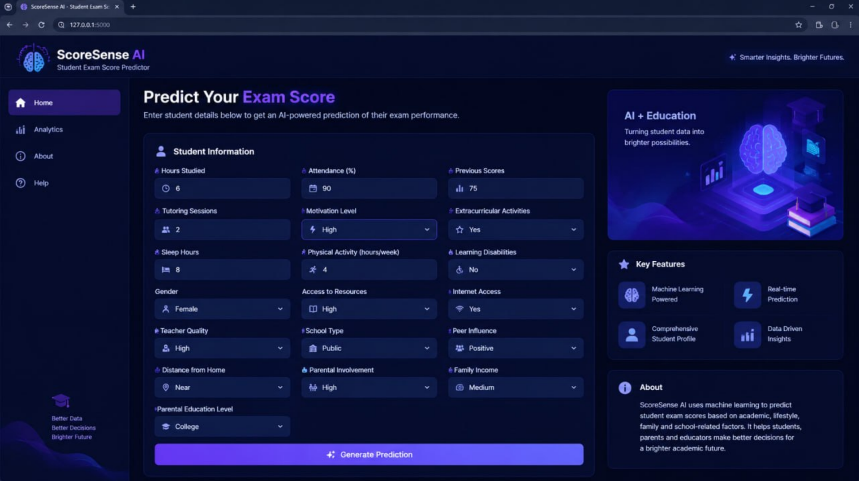

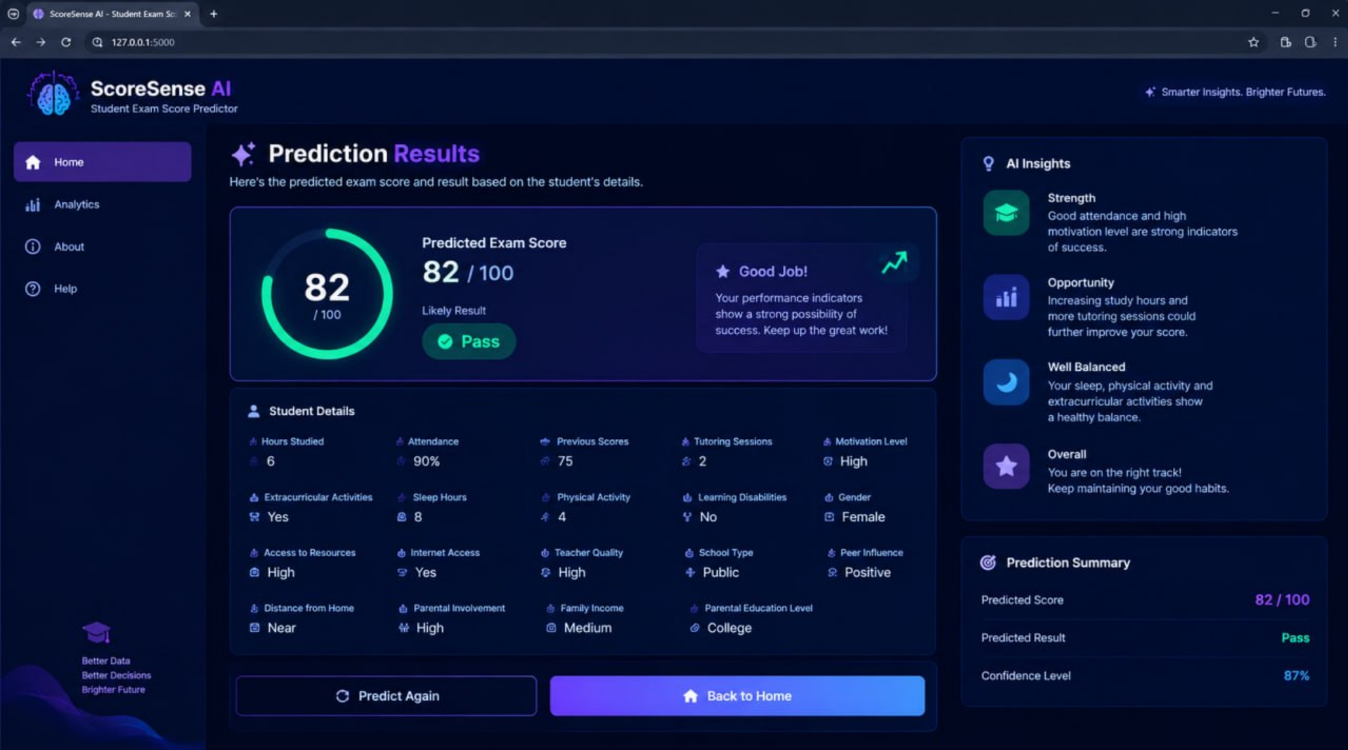

4.5 Ethical Considerations and Data Privacy
Because the system works with personal and demographic student data, privacy and fairness are part of the design. Any real student records are anonymized before use, with identifiers such as name or roll number removed or replaced, and only the minimum set of attributes needed for prediction is retained. Where institutional data is used, permission and, where applicable, student consent is obtained first.
The predictions are also checked for fairness across subgroups, for example to verify that prediction error is not systematically higher for one gender or parental-background category. The system is framed as a decision-support tool: a predicted score is an estimate based on past patterns and not a guarantee of an outcome.

CHAPTER 5

Conclusion and Future Aspects

5.1 Conclusion
This project presented the design of a Student Exam Score Predictor that uses regression-based machine learning to estimate exam scores from study habits, attendance and demographic information. The work began with the problem that students usually learn how they performed only after the examination, when it is too late to change anything. To address this, the project brings together daily study hours, attendance percentage, gender, parental background and past academic performance, which are rarely analyzed together, into a single prediction system. The data is cleaned to handle missing or inconsistent values, categorical attributes are converted into numerical form, and numeric features are scaled so that the models can learn from them reliably.
By combining data cleaning, exploratory data analysis, a documented system architecture and a comparison between Linear Regression and Random Forest Regression, the system is built to select whichever model best captures the relationship between a student’s habits and their eventual performance. Exploratory data analysis shows which factors have the strongest influence on the exam score, and both models are trained on the same data and evaluated on the same unseen test set using Mean Squared Error (MSE) and R² score, so the final choice is based on evidence and not on assumption. The final system takes a student’s study and attendance details as input and returns a predicted exam score as output, which turns a complex multi-factor analysis into a single, understandable number.
The tool is intended to benefit students, by giving them visibility into how their habits affect outcomes, and educators, by giving them an early, data-driven way to identify students who may need support. Students can use the prediction to improve their study habits and attendance while there is still time before the examination, and teachers can offer guidance before poor results are recorded. Overall, the project shows how a simple regression model can turn everyday academic data into meaningful and actionable insights for both students and teachers.
The project has some limitations. The dataset size and diversity depend on what can be collected within the project timeline, so the model may not generalize equally well beyond the group of students it was trained on. Self-reported study hours can be imprecise, since students may over- or under-estimate their own habits. The model shows association and not causation, so a strong link between attendance and score does not by itself prove that improving attendance alone will raise a given student’s score. The comparison is also limited to two algorithms, so other approaches, such as gradient boosting or neural networks, might perform differently. These limitations are stated openly so that the predictions are treated as estimates to support decisions and not as guarantees of an outcome.

5.2 Future Aspects

Future work includes extending the feature set with additional behavioral data, such as assignment submission patterns or learning-management-system engagement. At present the model relies on study hours, attendance, gender, parental background and past academic performance, but online platforms record much more, such as how regularly assignments are submitted, whether they are submitted on time, how often a student logs in, and how long they spend on course material. These details show a student’s engagement during the term and could make the prediction more accurate and allow it to be updated as the semester goes on. Further algorithms such as Gradient Boosting or XGBoost can be tried to see whether they improve on the accuracy of Random Forest. These methods build trees one after another, with each new tree correcting the errors of the previous ones, and they often perform well on tabular data like this. They would be trained on the same data and split and compared using MSE and R², so the comparison stays fair. Explainability techniques can be applied so that a prediction is broken down into the contribution of each feature for a given student. For example, the system could show that a predicted score is lower mainly because of low attendance, while study hours are helping it. This would give students clearer and more personal guidance on what to change, and it would help teachers trust and explain the prediction. Finally, the model can be packaged behind a simple web interface or dashboard so that students and educators can obtain predictions directly rather than through a script. Students could enter their details in a form and see their predicted score instantly, and teachers could view the predicted scores of a whole class and quickly find the students who may need support. The dataset can also be enlarged with students from different courses, years and institutions, so that the model generalizes better and can be checked for fairness across more groups..

CHAPTER 6
Bibliography

- S. Huang and N. Fang, “Predicting student academic performance in an engineering dynamics course: A comparison of four types of predictive mathematical models,” Computers & Education, vol. 61, pp. 133–145, 2013.

- E. Wakelam, A. Jefferies, N. Davey, and Y. Sun, “The potential for student performance prediction in small cohorts with minimal available attributes,” British Journal of Educational Technology, vol. 51, no. 2, pp. 347–370, 2020.

- M. Nachouki and M. Abou Naaj, “Predicting student performance to improve academic advising using the random forest algorithm,” International Journal of Distance Education Technologies, vol. 20, no. 1, pp. 1–17, 2022.

- F. Benkhalfallah and N. Laouar, “Predicting student exam scores: Exploring the most effective regression technique,” in Proc. IEEE Conf., 2023.

- P. Asthana, S. Mishra, N. Gupta, M. Derawi, and A. Kumar, “Prediction of student’s performance with learning coefficients using regression based machine learning models,” IEEE Access, vol. 11, pp. 72732–72742, 2023.

- L. Breiman, “Random forests,” Machine Learning, vol. 45, no. 1, pp. 5–32, 2001.

- F. Pedregosa et al., “Scikit-learn: Machine learning in Python,” Journal of Machine Learning Research, vol. 12, pp. 2825–2830, 2011.

CHAPTER 7

Appendices

GRAPHS:
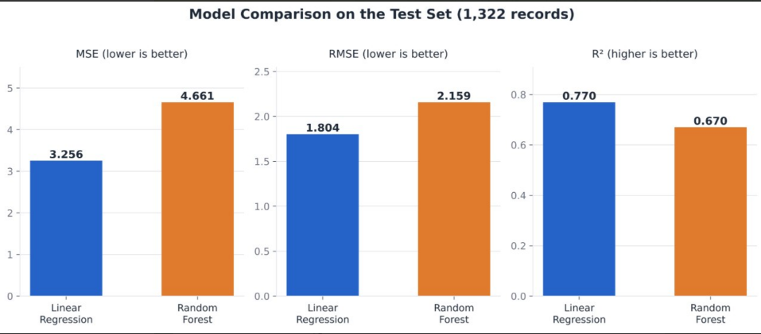

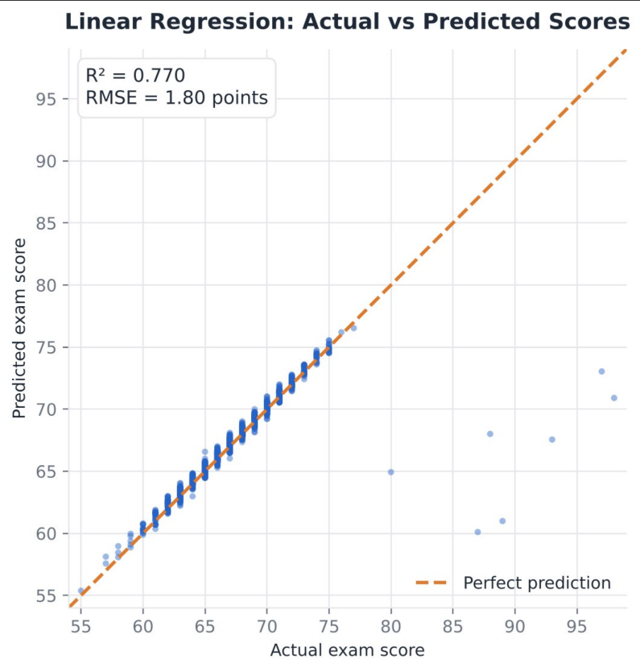

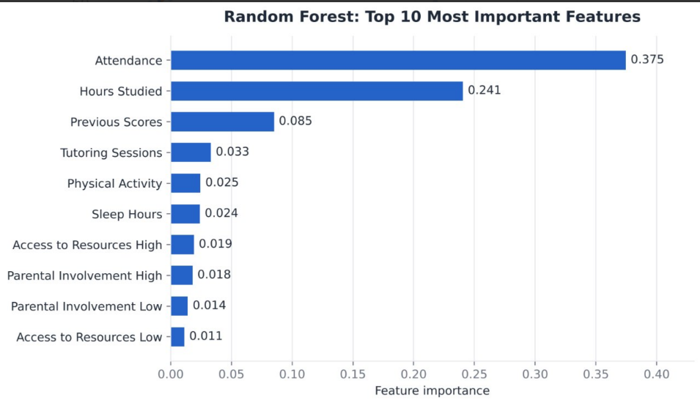

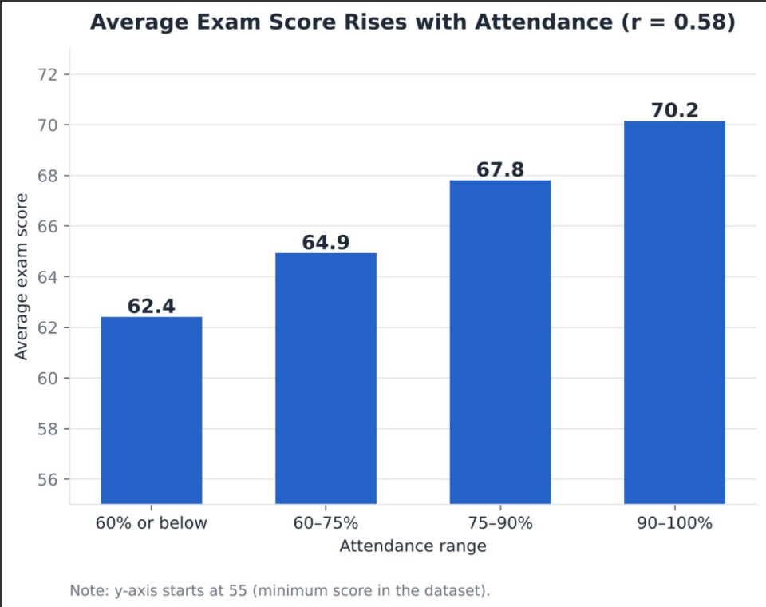
CODES:
Histogarm:
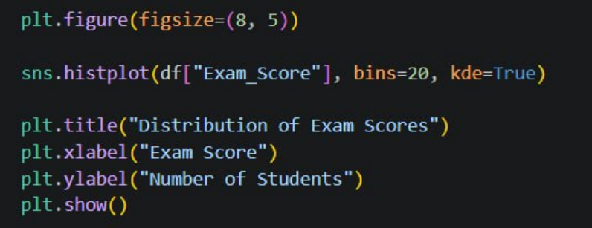
Scatter Plot Of Study Hour vs Exam Scores:
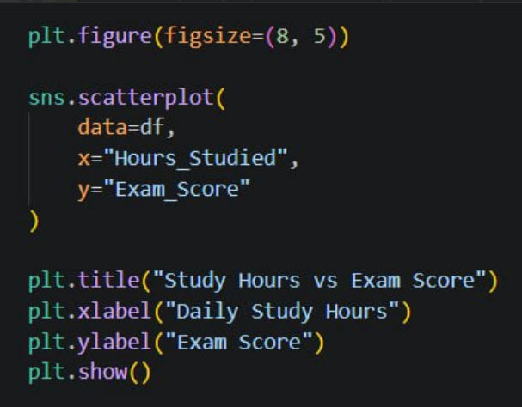

Missing Value Handling And Encoding:

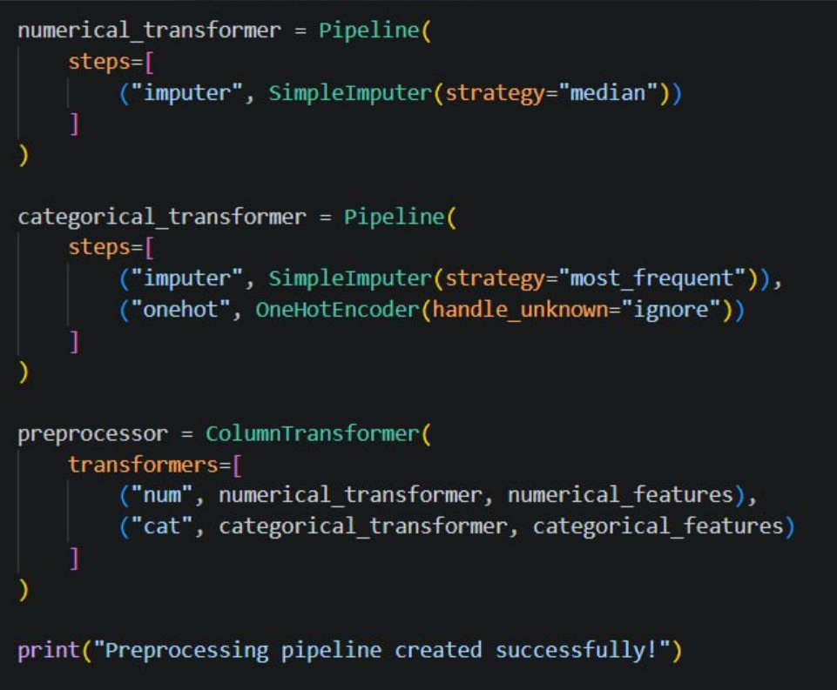

Model Comparision:


