平远灌区对接材料

（2017-1-11）

1. 报送任务排序

降水量、水位、流量、闸门开度、墒情、蓄水量、入库流量、出库流量

其它的本次都没涉及到。就不列出来了。

1. 堰闸站属性资料

（见工管之星数据库）

**ATTD（****输水洞属性表）**

|  |  |  |  |  |  |  |  |  |  |
| --- | --- | --- | --- | --- | --- | --- | --- | --- | --- |
| **序号** | **列名** | **数据类型** | **长度** | **小数位** | **标识** | **主键** | **允许空** | **默认值** | **字段说明** |
| 1 | WOhole_id | int | 4 | 0 | √ | √ |  |  | 输水洞属性表 |
| 2 | NetworkNO | char | 11 | 0 |  | √ | √ |  | 水库编码 |
| 3 | Building_Name | char | 20 | 0 |  |  | √ |  | 水工建筑物名称（实体名） |
| 4 | WOHoleName | char | 20 | 0 |  |  | √ |  | 输水洞名称 |
| 5 | FormulaType | tinyint | 1 | 0 |  |  | √ |  | 公式类型0查算表1简单公式2经验公式3蝶 |
| 6 | h0 | numeric | 5 | 2 |  |  | √ |  | 底板高程 |
| 7 | Width | numeric | 5 | 2 |  |  | √ |  | 断面宽度（）或管道直径（蝶阀）　明渠 简单 经验 孔流公式 |
| 8 | M | numeric | 5 | 3 |  |  | √ |  | 流量系数或阀门厚度 明渠 简单+经验 孔流公式 |
| 9 | a | numeric | 5 | 3 |  |  | √ |  | 闸门开度指数 （孔流->经验） |
| 10 | b | numeric | 5 | 3 |  |  | √ |  | 水头指数（明渠 孔流->经验） |
| 11 | MaxK | numeric | 5 | 3 |  |  | √ |  | 最大开度 |
| 12 | WeirConstant | decimal | 9 | 3 |  |  | √ | (0.65) | 堰流常数 |

1. 河道测流、测积、测速算法

无。

1. 闸门测流、测积、测速算法

1）矩形平板闸流量采用公式计算

2）弧形闸流量采用公式和查算表计算，二者选其一。

1. 落实河道站是否都是ADCP设备，是否需要流量曲线

均为ADCP，不需要流量曲线。

1. 落实6堰闸站的类型，工管之星相对应的表结构和算法存储过程

堰闸站的类型：有一个弧形闸，其它的为矩形平板闸

弧形闸流量计算公式：

当闸门开度小于闸前水深时，采用公式

D:\龙川江\Bitm\弧形闸门开度流量公式.bmp

否则，采用公式：

D:\龙川江\Bitm\弧形闸门自由堰流公式.bmp

Q:流量(m3/s)

u:流量系数

B：闸门宽度(m)

e:闸门开度(m)

g:重力加速度(常数：9.8m/s2)

H:闸前水深(m) 闸前水面到闸门底板的水深，

矩开平板闸流量计算公式：

当闸门开度小于闸前水深时，采用公式

D:\龙川江\Bitm\矩形平板闸门流量公式.bmp

否则，采用公式：

D:\龙川江\Bitm\弧形闸门自由堰流公式.bmp

参数说明见弧形闸流量计算公式

输水洞计算工管之星INPort表insert触发器、存储过程：dEDBD，函数：dHole_computeFlux

1. 日常巡检流程与表格
2. 日、旬、月时间期间

雨量 日 以每日早8:00为界，早8:00之前为昨日降雨，今日降雨为早8:00点到当前时间

旬 1日早8:00-11日早7:59:59(上旬) 11日早8:00-21日早7:59:59(中旬) 21日早8:00-次月1日7:59:59(下旬)

月 当月1日早8:00-前月1日早7:59:59

水位、流量则以每日0点为界

旬 1日0:00-10日23:59:59(上旬) 11日0:00-21日23:59:59(中旬) 21日早8:00-次月1日7:59:59(下旬)

月 当月1日0:00-当前月未23:59:59

水库水位雨量站：上报水位，降雨量，对应降水量表、水库水情表

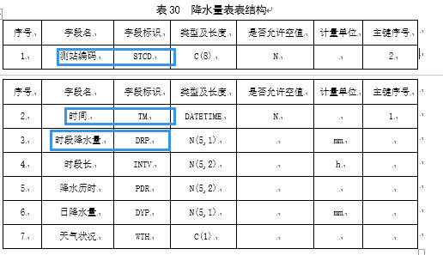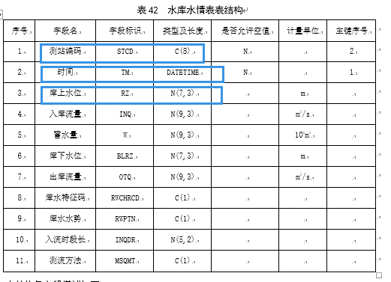

河道站：河道站有可能也会有降雨观测，有的话，也是入降水量表。

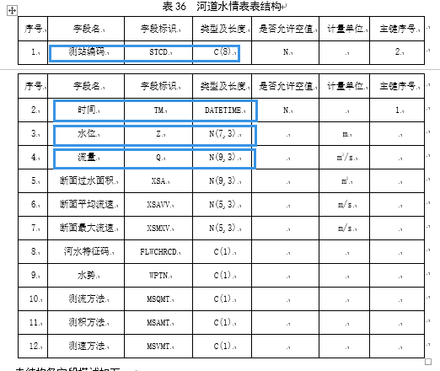

闸位站：

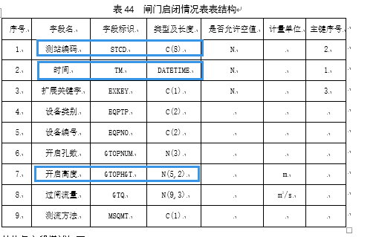

土壤墒情站：

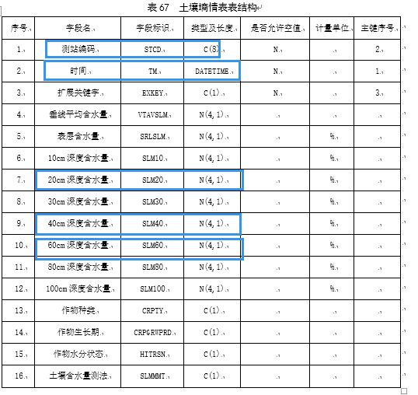

水质录入表表结构

地表水水质监测站信息表

a）用于存储地表水水质监测站的特定信息

b）表标识WQ_SWSINF_B

|  |  |  |  |  |  |  |  |
| --- | --- | --- | --- | --- | --- | --- | --- |
| 序号 | 字段名 | 字段标识 | 字段类型及长度 | 是否允许空值 | 计量单位 | 主键 | 主键序号 |
| 1 | 测站代码 | STCD | C（8） | N |  | Y | 1 |
| 2 | 测站名称 | STNM | C（30） | N |  |  |  |
| 3 | 测站类别 | STCT | C（1） | N |  |  |  |
| 4 | 水域类型 | WATP | C（1） | N |  |  |  |
| 5 | 流域名称 | BSNM | C（30） |  |  |  |  |
| 6 | 水系名称 | HNNM | C（30） |  |  |  |  |
| 7 | 河流名称 | RVNM | C（30） |  |  |  |  |
| 8 | 经度 | LGTD | N（12，9） |  | （°） |  |  |
| 9 | 纬度 | LTTD | N（11，9） |  | （°） |  |  |
| 10 | 水资源分区代码 | WRRCD | C（7） |  |  |  |  |
| 11 | 管理单位 | ADAG | C（40） |  |  |  |  |
| 12 | 监测单位 | MNAG | C（40） |  |  |  |  |
| 13 | 代表河长 | ASRL | N（5，1） |  | km |  |  |
| 14 | 代表面积 | ASAR | N（9，2） |  | km2 |  |  |
| 15 | 代表库容 | ASRC | N（10，3） |  | 万m3 |  |  |
| 16 | 距河口距离 | DSTRVM | N（6，1） |  | km |  |  |
| 17 | 水源地站标志 | WSFL | C（1） |  |  |  |  |

c）各字段描述如下：

1）测站类别：标识测站监测水体的站网分类，“1”代表地表水水质站，“2”代表地下水水质站，“3”代表大气降水水质站。

2）水域类型：测站（或水功能区）所属水域类型，“1”代表河流，“2”代表湖泊，“3”代表水库。

3）代表河长：水质评价中，该站所代表的河流长度，计量单位为km。

4）代表面积：在湖泊水质评价中，测站所代表的水体的表面积，计量单位为km2。

5）代表库容：水库正常高水位情况下测站所对应的水库蓄水量，计量单位为万m3。

6）水源地站标志：描述测站是否是水源地站，“1”代表水源地站，“2”代表非水源地站。

水质监测数据记录表 WQ_AWQMD_D

|  |  |  |  |  |  |  |  |
| --- | --- | --- | --- | --- | --- | --- | --- |
| 序号 | 字段名 | 字段标识 | 字段类型及长度 | 是否允许空值 | 计量单位 | 主键 | 主键序号 |
| 1 | 测站代码 | STCD | C（8） | N |  | Y | 1 |
| 2 | 采样时间 | SPT | DateTime | N |  | Y | 2 |
| 3 | 水温 | WT | N（3，1） |  | ℃ |  |  |
| 4 | pH值 | PH | N（4，2） |  |  |  |  |
| 5 | 五日生化需氧量 | BOD5 | N（5，1） |  | mg/L |  |  |
| 6 | 化学需氧量 | CODCR | N（7，1） |  | mg/L |  |  |
| 7 | 悬浮物 | SS | N（8，2） |  | mg/L |  |  |
| 8 | 阴离子表面活性剂 | LAS | N（6，3） |  | mg/L |  |  |
| 9 | 全盐量 | SO | N（7，2） |  | mg/L |  |  |
| 10 | 氯化物 | CL | N（7，2） |  | mg/L |  |  |
| 11 | 硫化物 | S2 | N（5，2） |  | mg/L |  |  |
| 12 | 总汞 | HG | N（9，7） |  | mg/L |  |  |
| 13 | 总镉 | CD | N（7，5） |  | mg/L |  |  |
| 14 | 总砷 | ARS | N（8，6） |  | mg/L |  |  |
| 15 | 六价铬 | CR6 | N（5，3） |  | mg/L |  |  |
| 16 | 总铅 | PB | N（7，5） |  | mg/L |  |  |
| 17 | 总铜 | CU | N（7，4） |  | mg/L |  |  |
| 18 | 总锌 | ZN | N（6，4） |  | mg/L |  |  |
| 19 | 总硒 | SE | N（7，5） |  | mg/L |  |  |
| 20 | 氟化物 | F | N（5，2） |  | mg/L |  |  |
| 21 | 氰化物 | CN | N（8，6） |  | mg/L |  |  |
| 22 | 石油类 | OIL | N（6，3） |  | mg/L |  |  |
| 23 | 挥发酚 | VLPH | N（10，6） |  | mg/L |  |  |
| 24 | 苯 | BEN | N（7，5） |  | mg/L |  |  |
| 25 | 三氯乙醛 | SLYQ | N（5，3） |  | mg/L |  |  |
| 26 | 丙烯醛 | BXQ | N（5，3） |  | mg/L |  |  |
| 27 | 硼 | B | N（4，2） |  | mg/L |  |  |
| 28 | 粪大肠菌群数 | FCG | N（10） |  | 个/L |  |  |
| 29 | 蛔虫卵数 | AO | N（10） |  | 个/L |  |  |

水质异常标准参照 灌溉水质标准 不分作物种类，按最小值取值，水质指标设计为表，各项值默认为水质标准值，可设置修改。

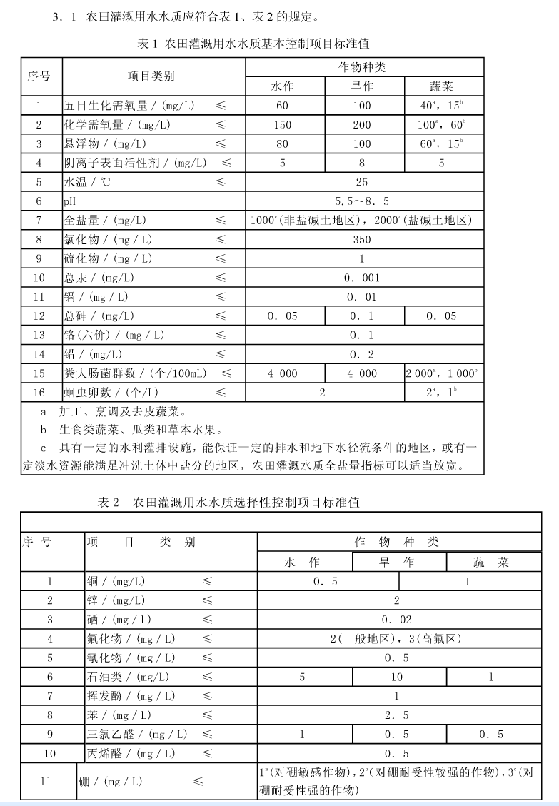

录入 查询 异常

存储过程 dEDBD

USE [Hydrology_wjm]

GO

/****** Object: StoredProcedure [dbo].[dEDBD] Script Date: 01/12/2017 09:42:43 ******/

SET ANSI_NULLS ON

GO

SET QUOTED_IDENTIFIER ON

GO

--正常记录----->N 00:00点插补-->S 忘关闸补----->F

--插入一行到EDBD_WaterOutputHole 表中

ALTER PROC [dbo].[dEDBD]

@yNetworkNo char(11),

@yBuilding_name char(20),

@ySurveyDateTime datetime,

@yWaterLevel numeric(6,2),

@ySluice_K numeric(4,2) = NULL,

@yItfValue numeric(4,2) = NULL, -- 用于自动接口

@yDiscardFlood tinyint= NULL ,

@ySurveyName char(8) = NULL,

@yCheckName char(8) = NULL,

@yMemo char(30) = NULL,

@yState int output,

@yStateD int output

--WITH ENCRYPTION

AS

DECLARE @yFlux numeric(16,3)

DECLARE @yFluxBoundary numeric(16,3)

DECLARE @sLastDT datetime,@sNextDT datetime

DECLARE @yLastWL numeric(6,2),@yLastDayWL numeric(6,2) --下一条记录水位

DECLARE @yNextWL numeric(6,2),@yNextDayWL numeric(6,2) --下一条记录水位

DECLARE @yLastK_L numeric(4,2) --上上一条记录开度

DECLARE @yLastK numeric(4,2) --上一条记录开度

DECLARE @yNextK numeric(4,2) --下一条记录开度

DECLARE @yNextSurveyName char(8),@yNextCheckName char(8),@yNextMemo char(30),@yNextDiscardFlood tinyint

DECLARE @yCountNext INTEGER,@yCountFirst INTEGER,@yCount integer,@yTheDayRecordCount integer --当天记录数

DECLARE @yRepeat integer,@ybLastIs0andSysInsert integer,@ybNextIs0andSysInsert integer

DECLARE @yFormulaType smallint,@yFlowType bit,@yh0 numeric(6,2),@yWidth numeric(6,2)

DECLARE @yM numeric(5,3),@ya numeric(5,3),@yb numeric(5,3)

DECLARE @dWeirConstant decimal(18,3)

DECLARE @sCountUpdated INT

DECLARE @yOtherFloodDT datetime --当日与本条标记相反的记录的时间

--是否存在此记录

set @yRepeat = -1

SELECT @yRepeat = count(*) FROM EDBD_WaterOutputHole WHERE NetworkNo = @yNetworkNo AND Building_name = @yBuilding_name

AND SurveyDatetime = @ySurveyDateTime AND DykeHoleFlag=3

--所有记录数

set @yCount = -1

select @yCount = count(*) from EDBD_WaterOutputHole WHERE NetworkNo = @yNetworkNo AND Building_name = @yBuilding_name AND DykeHoleFlag=3

--当天记录数@yTheDayRecordCount = 0 当天无记录

SELECT @yTheDayRecordCount = count(*) from EDBD_WaterOutputHole WHERE NetworkNo = @yNetworkNo AND Building_name = @yBuilding_name

AND SurveyDatetime >= cast(convert(char(10),@ySurveyDateTime,102)as datetime)

and SurveyDatetime < cast(convert(char(10),dateadd(day,1,@ySurveyDateTime),102)as datetime) AND DykeHoleFlag=3

--前面记录数

set @yCountFirst = -1

SELECT @yCountFirst = count(*) FROM EDBD_WaterOutputHole WHERE NetworkNo = @yNetworkNo AND Building_name = @yBuilding_name

AND SurveyDatetime < @ySurveyDateTime AND DykeHoleFlag=3

if @yCountFirst <> -1 begin

SELECT @sLastDT = max(surveydatetime) from EDBD_WaterOutputHole where NetworkNo = @yNetworkNo AND Building_name = @yBuilding_name

AND SurveyDatetime < @ySurveyDateTime AND Modified<>'F' AND DykeHoleFlag=3 --xdll add Modified<>'F'

SELECT @yLastK = Sluice_K,@yLastWL=Waterlevel from EDBD_WaterOutputHole where NetworkNo = @yNetworkNo AND Building_name = @yBuilding_name

AND Surveydatetime = @sLastDT AND DykeHoleFlag=3

select @yLastK_L=Sluice_K from EDBD_WaterOutputHole where NetworkNo = @yNetworkNo AND Building_name = @yBuilding_name

AND DykeHoleFlag=3 AND SurveyDatetime =(SELECT max(surveydatetime) from EDBD_WaterOutputHole

WHERE NetworkNo = @yNetworkNo AND Building_name = @yBuilding_name AND SurveyDatetime < @sLastDT AND DykeHoleFlag=3)

--上一条是系统插补

set @ybLastIs0andSysInsert=-1

if datepart(hour,@sLastDT) + datepart(minute,@sLastDT) = 0 begin

select @ybLastIs0andSysInsert = count(*) from EDBD_WaterOutputHole WHERE NetworkNo = @yNetworkNo AND Building_name = @yBuilding_name

AND SurveyDatetime = @sLastDT and modified = 'S' AND DykeHoleFlag=3

end

end

--后面记录数

set @yCountNext = -1

SELECT @yCountNext = count(*) FROM EDBD_WaterOutputHole WHERE NetworkNo = @yNetworkNo AND Building_name = @yBuilding_name

AND SurveyDatetime > @ySurveyDateTime AND DykeHoleFlag=3

if @yCountNext <> -1 begin

SELECT @sNextDT = min(surveydatetime) from EDBD_WaterOutputHole where NetworkNo = @yNetworkNo AND Building_name = @yBuilding_name

AND SurveyDatetime > @ySurveyDateTime AND Modified<>'F' AND DykeHoleFlag=3 --xdll add Modified<>'F'

SELECT @yNextWL = Waterlevel,@yNextK = Sluice_K,@yNextSurveyName =SurveyName,

@yNextDiscardFlood=DiscardFlood,@yNextCheckName=CheckName,@yNextMemo=Memo from EDBD_WaterOutputHole where NetworkNo = @yNetworkNo

AND Building_name = @yBuilding_name AND Surveydatetime = @sNextDT AND DykeHoleFlag=3

--下一条是系统插补

set @ybNextIs0andSysInsert=-1

if datepart(hour,@sNextDT) + datepart(minute,@sNextDT) = 0 begin

SELECT @ybNextIs0andSysInsert = count(*) from EDBD_WaterOutputHole WHERE NetworkNo = @yNetworkNo AND Building_name = @yBuilding_name

AND SurveyDatetime = @sNextDT and modified = 'S' AND DykeHoleFlag=3

end

end

if @yItfValue is not null set @ySluice_K = @yItfValue

set @yFormulaType = -1

SELECT @yFormulaType=FormulaType,@yh0=h0,@yWidth=Width,@yM=M,@ya=a,@yb=b ,@dWeirConstant=WeirConstant

FROM ATTD WHERE NetworkNo = @yNetworkNo AND Building_name=@yBuilding_name

if @yFormulaType = -1 return

set @yFlux=-1

set @yFluxBoundary=-1

--矩形平板闸和园形平板闸减掉闸槽深度 只有在新增时才减（@yRepeat<1）

if (@yFormulaType=1 or @yFormulaType=5) AND @yM is not null begin

SET @ySluice_K = @ySluice_K - @yM

end

if @ySluice_K <0 begin

SET @ySluice_K =0

end

--库中无记录或前面无记 置上一次开度为

if @yCount<1 or @yCountFirst<1 begin

Set @yLastK=0

end

if @yRepeat<1 and (@yCount<1 or @yCountFirst<1 or (@yLastK_L<>0 AND @yLastK=0 AND @yCount>2)) begin --不是修改且库中无记录或前面无记或如上上一次开度不为且上一次开度为，测插一条为的记录

INSERT INTO EDBD_WaterOutputHole(NetworkNo,Building_name,SurveyDateTime,WaterLevel,Sluice_K,Flux,FluxBoundary,DiscardFlood,SurveyName,CheckName,Memo,Modified,DykeHoleFlag)

VALUES(@yNetworkNo,@yBuilding_name,dateadd(second,-1,@ySurveyDateTime),@yWaterLevel,@yLastK,0,0,@yDiscardFlood,@ySurveyName,@yCheckName,@yMemo,'N',3)

--改变其上一条为刚插次条

set @sLastDT= dateadd(second,-1,@ySurveyDateTime)

set @yLastWL= @yWaterLevel

end

if @yRepeat > 0 begin

--1 --XDLL ADD dEDBD_MODI FOR 调用

exec dEDBD_MODI @yNetworkNo = @yNetworkNo,@yBuilding_name = @yBuilding_name,@ySurveyDateTime = @ySurveyDateTime,

@yWaterLevel=@yWaterLevel,@ySluice_K=@ySluice_K,@yDiscardFlood=@yDiscardFlood,@ySurveyName=@ySurveyName,@yCheckName=@yCheckName,@yMemo=@yMemo

--更新下一条的交界流量 @sNextDT

if @sNextDT is not null begin

exec dEDBD_MODI @yNetworkNo = @yNetworkNo,@yBuilding_name = @yBuilding_name,@ySurveyDateTime = @sNextDT,

@yWaterLevel=@yNextWL,@ySluice_K=@yNextK,@yDiscardFlood=@yNextDiscardFlood,@ySurveyName=@yNextSurveyName,

@yCheckName=@yNextCheckName,@yMemo=@yNextMemo

end

--更新当日标记相反的记录（如有当日标记相反的记录）

select @sCountUpdated=count(*) FROM EDBD_WaterOutputHole WHERE NetworkNo = @yNetworkNo AND Building_name = @yBuilding_Name

AND datediff(day,SurveyDateTime,@ySurveyDateTime) = 0 AND DiscardFlood= (@yDiscardFlood+1)%2

if @sCountUpdated >0 begin

SET @yDiscardFlood= (@yDiscardFlood+1)%2 --使标记相反

Select @yOtherFloodDT= min(surveydatetime) from EDBD_WaterOutputHole where NetworkNo = @yNetworkNo AND Building_name = @yBuilding_name

AND datediff(day,SurveyDateTime,@ySurveyDateTime) = 0 AND Modified<>'F' AND DykeHoleFlag=3 AND DiscardFlood =@yDiscardFlood

exec dEDBD_Stat @sNetworkNo=@yNetworkNo,@sBuilding_name=@yBuilding_name,@sSurveyDateTime=@yOtherFloodDT,@iDiscardFlood=@yDiscardFlood

end

end else begin --不存在测插入并按情况处理插补及日值

--2

set @yFlux = dbo.dHole_computeFlux(99,@yFormulaType,@yh0,@yWidth,@yM,99,@ya,@yb,99,@yBuilding_name,'输水洞',@yWaterLevel,@ySluice_K,@yNetworkNo,2,@dWeirConstant)

if @yCountFirst = 0 begin --后面无记录且前面无记录（第一条记录）

set @yFluxBoundary = @yFlux

end else begin

set @yFluxBoundary = dbo.dHole_computeFlux(99,@yFormulaType,@yh0,@yWidth,@yM,99,@ya,@yb,99,@yBuilding_name,'输水洞',@yWaterLevel,@yLastK,@yNetworkNo,2,@dWeirConstant)

end

INSERT INTO EDBD_WaterOutputHole(NetworkNo,Building_name,SurveyDateTime,WaterLevel,Sluice_K,Flux,FluxBoundary,DiscardFlood,SurveyName,CheckName,Memo,Modified,DykeHoleFlag)

VALUES(@yNetworkNo,@yBuilding_name,@ySurveyDateTime,@yWaterLevel,@ySluice_K,@yFlux,@yFluxBoundary,@yDiscardFlood,@ySurveyName,@yCheckName,@yMemo,'N',3)

exec dEDBD_FC01 @sDTlast =@sLastDT,@sDTthis =@ySurveyDateTime,@sDTnext =@sNextDT,@sWLlast =@yLastWL,@sWLthis =@yWaterLevel,

@sWLnext =@yNextWL,@sKlast =@yLastK,@sSluice_name =@yBuilding_name, @sH0 =@yh0,@sNetworkNo =@yNetworkNo

if @sLastDT is not null begin

exec dEDBD_Stat @sNetworkNo=@yNetworkNo,@sBuilding_name=@yBuilding_name,@sSurveyDateTime=@sLastDT,@iDiscardFlood=@yDiscardFlood

end

exec dEDBD_Stat @sNetworkNo=@yNetworkNo,@sBuilding_name=@yBuilding_name,@sSurveyDateTime=@ySurveyDateTime,@iDiscardFlood=@yDiscardFlood

if @sNextDT is not null begin

exec dEDBD_Stat @sNetworkNo=@yNetworkNo,@sBuilding_name=@yBuilding_name,@sSurveyDateTime=@sNextDT,@iDiscardFlood=@yDiscardFlood

end

--更新下一条的交界流量 @sNextDT

if @sNextDT is not null begin

exec dEDBD_MODI @yNetworkNo = @yNetworkNo,@yBuilding_name = @yBuilding_name,@ySurveyDateTime = @sNextDT,

@yWaterLevel=@yNextWL,@ySluice_K=@yNextK,@yDiscardFlood=@yNextDiscardFlood,@ySurveyName=@yNextSurveyName,

@yCheckName=@yNextCheckName,@yMemo=@yNextMemo

end

end

函数：dHole_computeFlux 溢洪道泄洪洞输水洞计算流量

USE [Hydrology_wjm]

GO

/****** Object: UserDefinedFunction [dbo].[dHole_computeFlux] Script Date: 01/12/2017 09:58:11 ******/

SET ANSI_NULLS ON

GO

SET QUOTED_IDENTIFIER ON

GO

--溢洪道泄洪洞输水洞计算流量

--由原dEDBB__computeFlux、dEDBC__computeFlux、dEDBD__computeFlux合并而来

--2007-04-16 by ll 合并 2007-05-18终结

--@dExperienceType值为0溢洪道、泄洪洞、输水洞、发电洞

--为了提高精度：power(2*9.81,0.5)改为power(2*9.81*10000,0.5)/100 power(2*9.81,1.5)/1000改为power(2*9.81*100,1.5)/1000

--power(2*9.81,2)改为power(2*9.81*100,2)/10000 power(2*9.81*100,3)/1000000

ALTER FUNCTION [dbo].[dHole_computeFlux] (

@dWierType tinyint=null,@sFormulaType tinyint,@dh0 numeric(6,2)=null,@sWidth numeric(6,2)=null,@sM numeric(4,2)=null,@sM1 numeric(4,2)=null,

@sa numeric(4,2)=null,@sb numeric(5,3)=null,@sb1 numeric(5,3)=null,

@dBuilding_name char(20),

@dSubBuilding_name char(20),

@dWaterLevel numeric(6,2),

@dSluice_K numeric(10,2),

@sNetworkNo char(11),

@dExperienceType int,

@dWeirConstant decimal(18,3)

)

RETURNS numeric(16,3)

AS

BEGIN

DECLARE @maxWL numeric(6, 2),@minWL numeric(6, 2), @FacMaxWL numeric(6, 2),@FacMinWL numeric(6, 2)

DECLARE @maxK numeric(10, 2),@minK numeric(10, 2)

DECLARE @Flux1 numeric(16,3),@Flux2 numeric(16,3),@Flux3 numeric(16,3),@Flux4 numeric(16,3)

DECLARE @e numeric (16,3)

DECLARE @yFlux numeric(16,3)

SET @yFlux = -1

IF @dWaterLevel <= @dh0 or @dSluice_K = 0 begin

SET @yFlux = 0

GOTO LabelEnd

END

IF @sFormulaType = 0 BEGIN --查算表

SELECT @yFlux=Flux FROM EDCE_NEW WHERE NetworkNo=@sNetworkNo AND Building_Name = @dBuilding_name AND StrobeNo = @dSubBuilding_name AND WaterLevel = @dWaterLevel AND Sluice_K = @dSluice_K

IF @yFlux = -1 BEGIN --没有此流量，需要插补法

SELECT @maxWL = MAX(WaterLevel) FROM EDCE_NEW WHERE NetworkNo=@sNetworkNo AND Building_Name = @dBuilding_name AND StrobeNo = @dSubBuilding_name

SELECT @minWL = MIN(WaterLevel) FROM EDCE_NEW WHERE NetworkNo=@sNetworkNo AND Building_Name = @dBuilding_name AND StrobeNo = @dSubBuilding_name

SELECT @maxK = MAX(Sluice_K) FROM EDCE_NEW WHERE NetworkNo=@sNetworkNo AND Building_Name = @dBuilding_name AND StrobeNo = @dSubBuilding_name

SELECT @minK = MIN(Sluice_K) FROM EDCE_NEW WHERE NetworkNo=@sNetworkNo AND Building_Name = @dBuilding_name AND StrobeNo = @dSubBuilding_name

IF @dWaterLevel > @maxWL OR @dWaterLevel < @minWL begin

RETURN -15

end

IF @dSluice_K > @maxK OR @dSluice_K < @minK begin

RETURN -16

end

IF @dSluice_K/(@dWaterLevel - @dh0)>@dWeirConstant BEGIN --1变量查算（堰流，用最大开度那组来算）

SET @FacMinWL = -1

SET @FacMaxWL = -1

SELECT @FacMinWL = MAX(WaterLevel) FROM EDCE_NEW WHERE NetworkNo=@sNetworkNo AND Building_Name = @dBuilding_name AND StrobeNo = @dSubBuilding_name AND Sluice_K = @maxK AND WaterLevel < @dWaterLevel

SELECT @FacMaxWL = MIN(WaterLevel) FROM EDCE_NEW WHERE NetworkNo=@sNetworkNo AND Building_Name = @dBuilding_name AND StrobeNo = @dSubBuilding_name AND Sluice_K = @maxK AND WaterLevel > @dWaterLevel

IF @FacMinWL = -1 OR @FacMaxWL = -1 Begin

RETURN(-20)

END

SELECT @Flux1 = Flux FROM EDCE_NEW WHERE NetworkNo=@sNetworkNo AND Building_Name = @dBuilding_name AND StrobeNo = @dSubBuilding_name AND Sluice_K = @maxK AND WaterLevel = @FacMinWL

SELECT @Flux2 = Flux FROM EDCE_NEW WHERE NetworkNo=@sNetworkNo AND Building_Name = @dBuilding_name AND StrobeNo = @dSubBuilding_name AND Sluice_K = @maxK AND WaterLevel = @FacMaxWL

SET @yFlux=@Flux2- (@FacMinWL - @dWaterLevel ) * (@Flux2 - @Flux1) / (@FacMaxWL - @FacMinWL)

END ELSE BEGIN --2变量查算（孔流）

IF (SELECT COUNT(WaterLevel) FROM EDCE_NEW WHERE NetworkNo=@sNetworkNo AND Building_Name = @dBuilding_name AND StrobeNo = @dSubBuilding_name AND WaterLevel = @dWaterLevel) > 0 BEGIN

--有此水位

SELECT @minK = MIN(Sluice_K) FROM EDCE_NEW WHERE NetworkNo=@sNetworkNo AND Building_Name = @dBuilding_name AND StrobeNo = @dSubBuilding_name AND WaterLevel = @dWaterLevel

SELECT @maxK = MAX(Sluice_K) FROM EDCE_NEW WHERE NetworkNo=@sNetworkNo AND Building_Name = @dBuilding_name AND StrobeNo = @dSubBuilding_name AND WaterLevel = @dWaterLevel

IF @dSluice_K > @maxK OR @dSluice_K < @minK begin

RETURN(-17)

end

SELECT @maxK = MIN(Sluice_K) FROM EDCE_NEW WHERE NetworkNo=@sNetworkNo AND Building_Name = @dBuilding_name AND StrobeNo = @dSubBuilding_name AND WaterLevel = @dWaterLevel AND Sluice_K > @dSluice_K

SELECT @minK = MAX(Sluice_K) FROM EDCE_NEW WHERE NetworkNo=@sNetworkNo AND Building_Name = @dBuilding_name AND StrobeNo = @dSubBuilding_name AND WaterLevel = @dWaterLevel AND Sluice_K < @dSluice_K

SELECT @Flux1 = Flux FROM EDCE_NEW WHERE NetworkNo=@sNetworkNo AND Building_Name = @dBuilding_name AND StrobeNo = @dSubBuilding_name AND WaterLevel = @dWaterLevel AND Sluice_K = @minK

SELECT @Flux2 = Flux FROM EDCE_NEW WHERE NetworkNo=@sNetworkNo AND Building_Name = @dBuilding_name AND StrobeNo = @dSubBuilding_name AND WaterLevel = @dWaterLevel AND Sluice_K = @maxK

SET @yFlux = (@dSluice_K - @minK) * (@Flux2 - @Flux1) / (@maxK - @minK) + @Flux1

END ELSE IF (SELECT COUNT(Sluice_K) FROM EDCE_NEW WHERE NetworkNo=@sNetworkNo AND Building_Name = @dBuilding_name AND StrobeNo = @dSubBuilding_name AND Sluice_K = @dSluice_K) > 0 BEGIN

--有此开度

SELECT @minWL = MIN(WaterLevel) FROM EDCE_NEW WHERE NetworkNo=@sNetworkNo AND Building_Name = @dBuilding_name AND StrobeNo = @dSubBuilding_name AND Sluice_K = @dSluice_K

SELECT @maxWL = MAX(WaterLevel) FROM EDCE_NEW WHERE NetworkNo=@sNetworkNo AND Building_Name = @dBuilding_name AND StrobeNo = @dSubBuilding_name AND Sluice_K = @dSluice_K

IF @dWaterLevel > @maxWL OR @dWaterLevel < @minWL begin

RETURN(-18)

end

SELECT @maxWL = MIN(WaterLevel) FROM EDCE_NEW WHERE NetworkNo=@sNetworkNo AND Building_Name = @dBuilding_name AND StrobeNo = @dSubBuilding_name AND Sluice_K = @dSluice_K AND WaterLevel > @dWaterLevel

SELECT @minWL = MAX(WaterLevel) FROM EDCE_NEW WHERE NetworkNo=@sNetworkNo AND Building_Name = @dBuilding_name AND StrobeNo = @dSubBuilding_name AND Sluice_K = @dSluice_K AND WaterLevel < @dWaterLevel

SELECT @Flux1 = Flux FROM EDCE_NEW WHERE NetworkNo=@sNetworkNo AND Building_Name = @dBuilding_name AND StrobeNo = @dSubBuilding_name AND Sluice_K = @dSluice_K AND WaterLevel = @minWL

SELECT @Flux2 = Flux FROM EDCE_NEW WHERE NetworkNo=@sNetworkNo AND Building_Name = @dBuilding_name AND StrobeNo = @dSubBuilding_name AND Sluice_K = @dSluice_K AND WaterLevel = @maxWL

SET @yFlux = (@dWaterLevel - @minWL) * (@Flux2 - @Flux1) / (@maxWL - @minWL) + @Flux1

END ELSE BEGIN

--无此水位亦无此开度，四点内插

SET @minK = -1

SET @maxK = -1

SELECT @minK = MAX(Sluice_K) FROM EDCE_NEW WHERE NetworkNo=@sNetworkNo AND Building_Name = @dBuilding_name AND StrobeNo = @dSubBuilding_name AND Sluice_K < @dSluice_K

SELECT @maxK = MIN(Sluice_K) FROM EDCE_NEW WHERE NetworkNo=@sNetworkNo AND Building_Name = @dBuilding_name AND StrobeNo = @dSubBuilding_name AND Sluice_K > @dSluice_K

IF @maxK = -1 OR @minK = -1 begin

RETURN(-19)

END

SET @FacMinWL = -1

SET @FacMaxWL = -1

SELECT @FacMinWL = MAX(WaterLevel) FROM EDCE_NEW WHERE NetworkNo=@sNetworkNo AND Building_Name = @dBuilding_name AND StrobeNo = @dSubBuilding_name AND Sluice_K = @minK AND WaterLevel < @dWaterLevel

SELECT @FacMaxWL = MIN(WaterLevel) FROM EDCE_NEW WHERE NetworkNo=@sNetworkNo AND Building_Name = @dBuilding_name AND StrobeNo = @dSubBuilding_name AND Sluice_K = @minK AND WaterLevel > @dWaterLevel

IF @FacMinWL = -1 OR @FacMaxWL = -1 Begin

RETURN(-20)

END

SELECT @Flux1 = Flux FROM EDCE_NEW WHERE NetworkNo=@sNetworkNo AND Building_Name = @dBuilding_name AND StrobeNo = @dSubBuilding_name AND Sluice_K = @minK AND WaterLevel = @FacMinWL

SELECT @Flux2 = Flux FROM EDCE_NEW WHERE NetworkNo=@sNetworkNo AND Building_Name = @dBuilding_name AND StrobeNo = @dSubBuilding_name AND Sluice_K = @minK AND WaterLevel = @FacMaxWL

--SET @Flux3 = (@dWaterLevel - @FacMinWL) * (@Flux2 - @Flux1) / (@FacMaxWL - @FacMinWL) + @Flux1

SET @Flux3 =@Flux2- (@FacMinWL - @dWaterLevel ) * (@Flux2 - @Flux1) / (@FacMaxWL - @FacMinWL)

SET @FacMinWL = -1

SET @FacMaxWL = -1

SELECT @FacMinWL = MAX(WaterLevel) FROM EDCE_NEW WHERE NetworkNo=@sNetworkNo AND Building_Name = @dBuilding_name AND StrobeNo = @dSubBuilding_name AND Sluice_K = @maxK AND WaterLevel < @dWaterLevel

SELECT @FacMaxWL = MIN(WaterLevel) FROM EDCE_NEW WHERE NetworkNo=@sNetworkNo AND Building_Name = @dBuilding_name AND StrobeNo = @dSubBuilding_name AND Sluice_K = @maxK AND WaterLevel > @dWaterLevel

IF @FacMinWL = -1 OR @FacMaxWL = -1 Begin

RETURN(-21)

END

SELECT @Flux1 = Flux FROM EDCE_NEW WHERE NetworkNo=@sNetworkNo AND Building_Name = @dBuilding_name AND StrobeNo = @dSubBuilding_name AND Sluice_K = @maxK AND WaterLevel = @FacMinWL

SELECT @Flux2 = Flux FROM EDCE_NEW WHERE NetworkNo=@sNetworkNo AND Building_Name = @dBuilding_name AND StrobeNo = @dSubBuilding_name AND Sluice_K = @maxK AND WaterLevel = @FacMaxWL

--SET @Flux4 = (@dWaterLevel - @FacMinWL) * (@Flux2 - @Flux1) / (@FacMaxWL - @FacMinWL) + @Flux1

SET @Flux4 =@Flux2- (@FacMinWL - @dWaterLevel ) * (@Flux2 - @Flux1) / (@FacMaxWL - @FacMinWL)

SET @yFlux = @Flux3+(@Flux4 - @Flux3)*(@dSluice_K-@minK) /@maxK-(@minK)

END

END

END

END ELSE IF @sFormulaType = 1 BEGIN --矩形平板闸

SET @e = @dSluice_K

Declare @hParm decimal(6,2)

Declare @kParm decimal(10,5)

Declare @uParm decimal(10,5)

Set @hParm = @dWaterLevel - @dh0

Set @kParm=@e/@hParm

IF @kParm > @dWeirConstant BEGIN --堰流公式

--SET @yFlux = 0.385 * @sWidth * power(2*9.81*10000,0.5)/100 * power(@hParm*100,1.5)/1000

SET @yFlux = 0.34 * @sWidth * power(2*9.81,0.5) * power(@hParm,1.5)

END ELSE BEGIN --孔流公式(国际使用标准)

--Set @uParm=0.20721239544768*power(@kParm*100,3)/1000000 - 0.06313098666039*power(@kParm*100,2)/10000+0.04778525396172*power(@kParm,1)+0.61071764705882

--Set @uParm=@uParm* ( -0.25757575757574*power(@kParm*100,3)/1000000+0.11856643356642*power(@kParm*100,2)/10000-0.07107409257409*power(@kParm,1)+1.00061888111888 )

--SET @yFlux = @uParm * @sWidth * @e *power(2*9.81*10000,0.5)/100 * power(@hParm*10000,0.5)/100

--中国标准

Set @uParm=0.454*power( @e/@hParm,-0.138)

SET @yFlux = @uParm * @sWidth * @e *power(2*9.81*@hParm,0.5)

END

END ELSE IF @sFormulaType= 2 and @yFlux <> 0 BEGIN --经验公式

IF @dExperienceType=0 begin --溢洪道经验公式

IF @dWierType = 1 BEGIN --宽顶堰

IF @dSluice_K / (@dWaterLevel - @dh0) > @dWeirConstant BEGIN

--使用堰流公式M b(此时a为，就是不管开度为多少，都当来处理)

SET @yFlux = @sM * @sWidth * POWER((@dWaterLevel - @dh0),@sb)

END ELSE BEGIN --M a b --使用孔流公式

SET @yFlux = @sM1 * @sWidth * POWER(@dSluice_K,@sa) * POWER((@dWaterLevel - @dh0),@sb1)

END

END ELSE IF @dWierType = 0 BEGIN --实用堰

IF @dSluice_K / (@dWaterLevel - @dh0) > @dWeirConstant BEGIN --M b

SET @yFlux = @sM * @sWidth * POWER((@dWaterLevel - @dh0),@sb)

END ELSE BEGIN --M a b

SET @yFlux = @sM1 * @sWidth * POWER(@dSluice_K,@sa) * POWER((@dWaterLevel - @dh0),@sb1)

END

END

END ELSE BEGIN --泄洪洞、输水洞经验公式--M a b

SET @yFlux = @sM * @sWidth * POWER(@dSluice_K,@sa) * POWER((@dWaterLevel - @dh0),@sb)

END

END ELSE IF @sFormulaType = 3 BEGIN --弧形闸公式

Declare @cParm decimal(10,5) --cosa

SET @e = @dSluice_K

SET @hParm = @dWaterLevel - @dh0

SET @kParm=@e/@hParm

IF @kParm>0 and @kParm<=@dWeirConstant begin

Set @cParm=(@sM-@e)/@sa

if @cParm<=0.3 begin

Set @uParm=0.60-0.176*@kParm+(0.15-0.2*@kParm) *@cParm

end else begin

if @cParm>0.3 and @cParm<=1.0 begin

Set @uParm=0.545-0.136*@kParm+0.334*(1-@kParm)*@cParm

end

end

SET @yFlux = @uParm * @sWidth * @e *power(2*9.81*10000,0.5)/100 * power(@hParm*10000,0.5)/100

END ELSE BEGIN

SET @yFlux = 0.385 * @sWidth *power(2*9.81*10000,0.5)/100 * power(@hParm*100,1.5)/1000

END

END ELSE IF @sFormulaType = 4 BEGIN --蝶阀公式 --sWidth 是管道直径--sM闸门厚度 开度为角度!!

Declare @angle INTEGER

Declare @BParm decimal(10,5)

Declare @S1 decimal(10,5)

Declare @S2 decimal(10,5)

IF @dSluice_K > 90 BEGIN

SET @dSluice_K = (180.0 - @dSluice_K)

END

Set @hParm = @dWaterLevel - @dh0

Set @BParm= @sWidth/2.0*cos(@dSluice_K*PI()/180.0)

If @BParm <= (@sM/2.0) BEGIN

Set @BParm = @sM/2.0

END

--C:(0.0117*(@dSluice_K-30)+0.05) --S1:3.14159*@sWidth*@sWidth/4.0 --S2:3.14159*@sWidth*@BParm/2

Set @S1=PI()*power(@sWidth/2.0*100,2)/10000

Set @S2=PI()*@sWidth*@BParm/2.0

IF @dSluice_K > 30 BEGIN

Set @yFlux= (0.0117*(@dSluice_K-30)+0.05)*power(2*9.81*10000, 0.5)/100* (@S1-@S2 )*power(@hParm*10000,0.5)/100

End ELSE IF @dSluice_K <= 30 BEGIN

Set @yFlux=0.002*@dSluice_K*power(2*9.81*10000, 0.5)/100 *(@S1-@S2 )*power(@hParm*10000,0.5)/100

End

END ELSE IF @sFormulaType = 5 BEGIN --圆形平板闸公式

Declare @R1 decimal(10,5)

Declare @R2 decimal(10,5)

Declare @R3 decimal(10,5)

IF @dSluice_K>@sWidth BEGIN

SET @dSluice_K=@sWidth

END

Set @hParm = @dWaterLevel - @dh0

Set @kParm=@dSluice_K/@sWidth

Set @R1=ASin(@kParm)

Set @R2=PI()/2.0-@R1

Set @R3=2*@R2

Set @yFlux=0.95*@kParm*power(2*9.81*10000,0.5)/100 * ( power(@sWidth/2.0*100,2)/10000 * (PI()-@R3+sin(@R3)) ) * power(@hParm*10000,0.5)/100

END

LabelEnd:

IF @yFlux = -1 begin

RETURN(-1)

END

RETURN (@yFlux)

END