**Implementation Progress**

**Issue# 5 & 6** namely Converting Assignment due date to local time zone & Show pre-deadline for each assignment was originally coded by Annaka. Pradeesh updated the code to address two minor issues: (1) Read the dates in csv file as Arizona time (instead of UTC). A new column titled TimeZone was added to the csv file for this purpose and suitable changes were made in the code (2) the program now determines local timezone from system time whenever it is not able to recognize the place input provided by the user.

These two issues are closed. However, the updated files are currently parked in the Issue_TimeZone branch and will be integrated with main branch in the coming days.

**Issue#12 -** Highlighting priority assignments in Yellow background is complete and the code has already been pushed to the main branch (file name ‘Assignment_Tracker.ipynb’)

**Code Analysis**

Pradeesh

I had made minor alterations to the file (few shown below) to test the pre-commit function:

Added ‘import numpy as np’ and whitespace above it. Numpy is not directly used in the program.

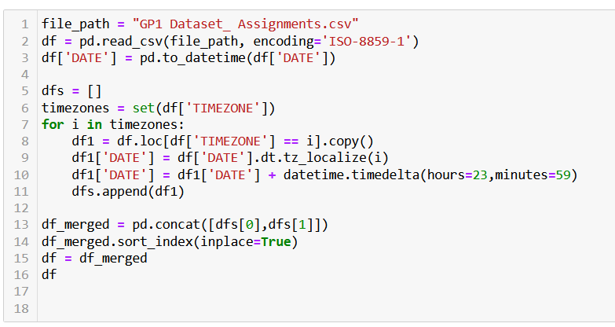

Added whitespace after df (line 16)

I ran five hooks / tests and four out of five returned Passed and one returned Skipped. However, the issue of empty whitespace was not actually resolved within the Notebook (probably because of the Jupyter Notebook file format). The issue of unused library (numpy) was also not highlighted. This may be because it requires a specific hook for the same.