**Crime Rate Prediction Using Supervised Machine Learning**

*Mohit Agrawal  
Department of Computer Science  
Lovely Professional University  
Phagwara, Punjab  
mohitagrawal250205@gmail.com*

***Abstract****Predicting crime rates is a vital area of study with implications for law enforcement resource allocation, crime prevention policies, and public safety. If produced accurately, prediction models can enable agencies to take proactive and strategic actions to address emerging crime trends, allocate policing to problem oriented areas, and implement targeted interventions. This paper reviews the literature surrounding crime rate prediction and includes both traditional statistical and machine learning approaches, as well as all data sources or methods used. We examine certain advantages and drawbacks to these two, with a consideration of the challenges of predicting social phenomena, and the ethical implications of predictive policing. We emphasize the paths forward in a continually evolving field, including considerable need for interpretable models, robust evaluation and fairness and accountability. This paper is designed to be informative to researchers, practitioners and*

*policymakers who want to understand the current state of the art in crime rate prediction and its future threats in improving public safety.*

***Keywords:*** *Predicting Crime Rates, Predictive Policing, Machine Learning, Time Series Analysis, Spatial Analysis, Crime Mapping, Data Mining, Statistical Modeling, Public Safety, Law Enforcement*

***1. Introduction:***

*Crime is a widespread societal issue that incurs a significant economic, social, and psychological cost. A proactive approach is necessary to reduce crime to the extent possible, which includes anticipating where potential criminal activity may be and deploying resources accordingly. Crime rate prediction (i.e., prediction of future crime in a particular geographic area or for a particular time, usually in the near future) has become an important technology for law enforcement agencies when considering how to better position themselves from a reactive to a preventative mode.*

*If we can accurately predict crime, there are many benefits:*

*Better Resource Allocation: Predictive models can help police departments allocate the most police presence, surveillance equipment, or other resources to the areas most likely to experience crime, which maximizes their effort and impact.*

*Proactive Crime Prevention: By forecasting emerging crime hotspots, departments can develop interventions aimed at addressing the root causes of crime, such as neighbourhood policing, street lighting upgrades, or diversion programs.*

*Improved Decision-Making: Crime rate predictions can provide useful background to guide strategic planning, policy development, and operational decision-making, at all law enforcement levels.*

*Enhanced Public Safety: Ultimately, the purpose of crime rate prediction efforts is to reduce crime and enhance the safety and well-being of citizens.*

*Nonetheless, crime prediction is a complicated task with much room for caution. There are too many factors influencing crime to offer a simple explanation, such as, socioeconomic conditions, demographic factors, physical environment, and law enforcement activities. Moreover, crime data isn't simply incomplete; it is noisy and biased by reporting behaviors in the data collection process. Crime can be complicated, and crime data can be incomplete, leading to difficult challenges in developing an accurate and reliable predictive model.*

*This paper seeks to summarize the scope of the research literature on crime rate prediction, discussing various methods, data sources, and challenging issues in the field. We will review both traditional statistical modeling approaches and advanced machine learning-based techniques, reflecting on the advantages and disadvantages of each. Moreover, we will think through various ethical issues related to predictive policing, including mechanisms for fairness, accountability, and transparency in the predictions that could affect community outcomes and law enforcement actions.*

***2. Data Sources for Crime Rate Prediction:***

*Crime rate predictions depend largely on the quality and availability of data, and there are many data sources used in crime prediction research, each having benefits and limitations.*

*Official Crime Records: The most useable data source for was often watched in the crime‐prediction research was official crime records maintained by law enforcement agencies, which included detailed information about crimes reported to local agencies (e.g., what crimes were reported; when; where; types of victims). Examples of these include:*

*Uniform Crime Reporting (UCR) Program (FBI): A nationwide crime reporting program that has contributed about reported crimes to law enforcement agencies the UCR categorizes offenses into Part I violent crimes and property crimes and a Part II category with nonviolent offenses.*

*National Incident-Based Reporting System (NIBRS) (FBI): More details of the crime reporting system than the UCR system. Not only do NIBRS crime reports give police comprehensive data about each crime incident, it also collects information about offenders; victimizations and property.*

*Local Law Enforcement Agency Records: Local police departments and sheriff's office generate their own crime reports that can add additional added detail about specific crimes beyond a national- or state-level dataset.*

*Limitations of Official Crime Records:*

*Underreporting: Crucially, most crimes are underreported to law enforcement, which will provide a clear and incomplete picture of the actual level of crime.*

*Reporting Bias: Crime reporting rates could vary depending on the citizens' trust in law enforcement and the severity of the crime, in addition to the victim's identity.*

*Data Quality Issues: The quality of a data can be a fundamental problem in that the data captured may be incomplete, inaccurate, or differently recorded in different jurisdictions.*

*Dark Figure of Crime: Unreported and undetected crimes.*

*Socio-Economic Data: Crime is frequently correlated with socio-economic data such as poverty, unemployment, income, inequality, and levels of education. Data from sources such as U.S. Census Bureau, the Bureau of Labor Statistics, and state/local government sources can be suitable for capturing these relationships.*

*Demographic Data: Certain demographic characteristics (e.g., age, race, ethnicity, population density) will influence crime rates as well. The U.S. Census Bureau has a wide variety of detailed demographic data at multiple levels of geographic area.*

*Environmental Data: Similarly, environmental factors like weather, street lighting, and public transportation options - as well as vacant buildings - can also influence the crime rate. For example, environmental data from the National Oceanic and Atmospheric Administration (NOAA) or local government agencies can be incorporated into models that predict crime.*

*Spatial Data: In general, the spatial nature of crime rarely occurs with random non-zero cases, and some places experience more crime than others. Geographic Information Systems (GIS) can be used to analyze the spatial arrangement of crime and determine crime hot - spots. Data sources include:*

*Crime Maps: Crime maps/ data visually show crime incidents plotted on a map.*

*Land Use Data: These are related data related to land - use types (e.g., residential, commercial, industrial).*

*Street Network Data: This is related to street connectivity and street data/network characteristics*

*Points of Interest (POI) Data: These are location data for businesses, schools, parks, etc.*

*Social Media Data: There are social media platforms (Twitter, Facebook) that can provide insights into public sentiment or community concerns, or anticipated criminal activity. However, concerning ethical issues about privacy and bias, the application of social media as crime prediction data becomes ethically problematic, especially if attempting to extract geo-located data.*

*Emergency Call Data (911 Calls): The frequency and characteristics of emergency call data may be predictive of criminal activity*

*Predator Data: Data on registered sex offenders can also be incorporated to determine whether the sex offender lives or works near the vulnerable population.*

*Proprietary datasets: There are also private for-profit companies and organizations that provide access to specific data points - for instance, datasets related to commercial crime such as retail theft.*

***3. Methodologies for Crime Rate Prediction:***

*There are many methodologies for predicting crime rates, from traditional statistical techniques to cutting-edge machine learning algorithms.*

***3.1 Traditional Statistical Methods:***

*Time Series Analysis: Time series simulation methodologies model the temporal nature of crime rates. Time series simulation methodologies involve some analytical assessment of the historical crime data to identify trends, seasonality, and cycles. Examples of time series methods include the following:*

*Autoregressive Integrated Moving Average (ARIMA) Models: ARIMA models are a class of statistical models that utilize past values of a time series to predict future values. ARIMA models are characterized by the following three parameters: p (the number of autoregressive terms), d (the order of differencing), and q (the number of moving average terms).*

*Exponential Smoothing Models: Exponential smoothing models are a class of time series models that use weighted averages of past values to predict future values. Different weighting schemes can be used to emphasize recent or past values.*

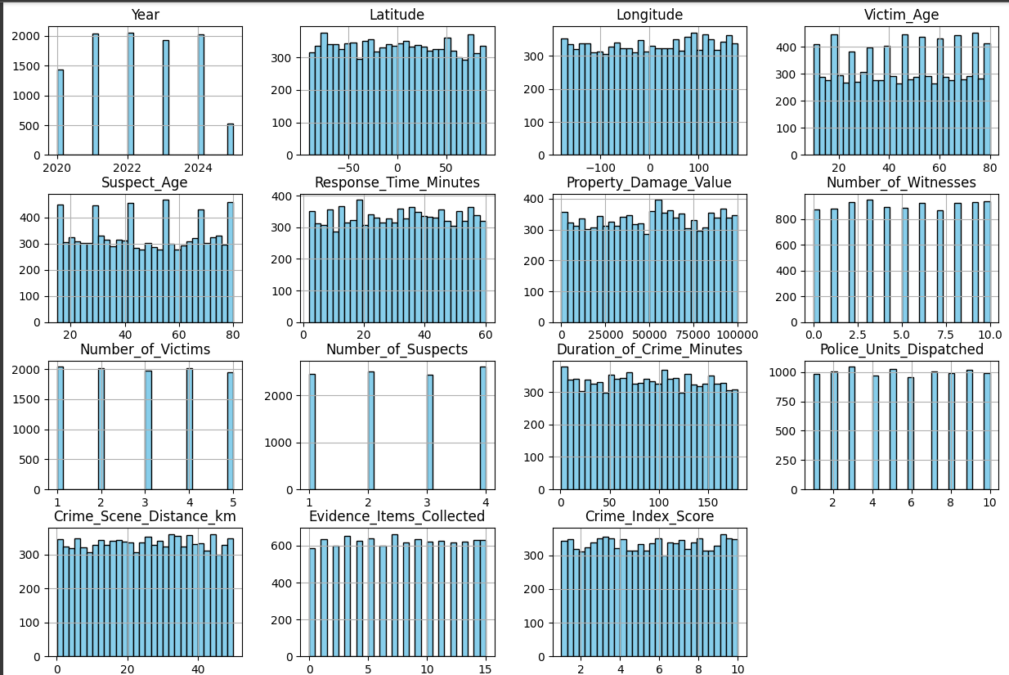

*Strengths of Time Series Analysis:*

*The analysis is relatively easy to do and understand.*

*It is useful for estimating temporal trends and seasonality.*

*It is based on a long history of statistical theory.*

*Limitations of Time Series Analysis:*

*It may be ineffective in predicting sudden changes, or those that could not be anticipated above noise in the dataset.*

*It can be susceptible to outliers and missing data.*

*It generally does not understand the underlying relationships between crime rates and other variables.*

*Regression Analysis: Regression analysis is a statistical technique used to model the relationship between crime rates and one or more predictor variables. Linear regression is a common type of regression analysis that assumes a linear relationship between the variables. Other types of regression analysis, such as logistic regression and Poisson regression, can be used to model different types of crime data.*

*Strengths of Regression Analysis:*

*Can identify factors that are associated with crime rates.*

*Relatively easy to interpret and explain.*

*Can be used to forecast future crime rates.*

*Limitations of Regression Analysis:*

*May not capture non-linear relationships between variables.*

*Can be sensitive to multicollinearity (correlation between predictor variables).*

*May not be effective for predicting rare events.*

*Spatial Statistics: Spatial statistics techniques are used to analyze the spatial patterns of crime and identify hotspots. These methods involve using spatial data to measure the clustering, dispersion, and spatial autocorrelation of crime incidents. Common spatial statistics techniques include:*

*Kernel Density Estimation (KDE): KDE is a non-parametric technique used to estimate the probability density function of a spatial point pattern. KDE can be used to identify areas with high concentrations of crime incidents.*

*Hot Spot Analysis (Getis-Ord Gi):* Getis-Ord Gi* is a statistical test used to identify statistically significant clusters of high or low crime rates.*

*Spatial Autocorrelation (Moran's I): Moran's I is a measure of the degree to which crime rates are spatially correlated.*

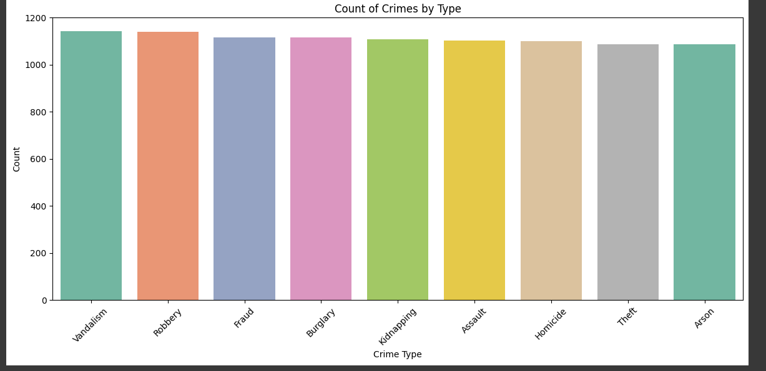

*Strengths of Spatial Statistics:*

*Can identify areas with high concentrations of crime incidents.*

*Can reveal spatial patterns and relationships that may not be apparent from traditional statistical methods.*

*Can be used to inform resource allocation and crime prevention strategies.*

*Limitations of Spatial Statistics:*

*Can be sensitive to the choice of spatial scale and bandwidth parameters.*

*May not capture temporal dynamics of crime.*

*May not account for underlying socio-economic or environmental factors.*

***3.2. Machine Learning Methods:***

*In recent years, machine learning algorithms have gained increasing popularity for crime rate prediction due to their ability to handle complex data and capture non-linear relationships.*

*Supervised Learning:*

*Classification Algorithms: Used to predict the category or class of a crime event (e.g., violent vs. property crime). Examples include:*

*Support Vector Machines (SVM): SVMs are a class of machine learning algorithms that are used for classification and regression. SVMs work by finding the optimal hyperplane that separates different classes of data.*

*Decision Trees: Decision trees are a class of machine learning algorithms that are used for classification and regression. Decision trees work by recursively partitioning the data based on the values of predictor variables.*

*Random Forests: Random forests are an ensemble learning method that combines multiple decision trees to improve accuracy and robustness. Each decision tree is trained on a random subset of the data and a random subset of the predictor variables.*

*Logistic Regression: While traditionally a statistical method, Logistic Regression is used to estimate the probability of an event occurring (e.g., the probability of a crime occurring in a given area).*

*Naive Bayes: A probabilistic classifier based on Bayes' theorem.*

*Regression Algorithms: Used to predict the continuous value of a crime rate (e.g., the number of crimes per 100,000 population). Examples include:*

*Linear Regression: As mentioned above, but often incorporated as a baseline comparison.*

*Polynomial Regression: Allows for non-linear relationships between predictors and the target variable.*

*Neural Networks (including Deep Learning): Neural networks are a class of machine learning algorithms that are inspired by the structure and function of the human brain. Neural networks consist of interconnected nodes (neurons) that process and transmit information. Deep learning is a type of neural network with multiple layers, which can learn complex patterns from data. Recurrent Neural Networks (RNNs) are particularly well-suited for time series data. Long Short-Term Memory (LSTM) networks are a type of RNN that can handle long-range dependencies in time series data.*

*K-Nearest Neighbors (KNN): KNN is a non-parametric algorithm that classifies or predicts a data point based on the majority class or average value of its k nearest neighbors.*

*Unsupervised Learning:*

*Clustering Algorithms: Used to identify clusters of crime incidents based on their spatial and temporal characteristics. Examples include:*

*K-Means Clustering: K-means clustering is an algorithm that partitions data into k clusters, where each data point belongs to the cluster with the nearest mean (centroid).*

*Hierarchical Clustering: Hierarchical clustering is an algorithm that builds a hierarchy of clusters by iteratively merging or splitting clusters.*

*DBSCAN (Density-Based Spatial Clustering of Applications with Noise): DBSCAN is a density-based clustering algorithm that identifies clusters based on the density of data points.*

*Dimensionality Reduction: Techniques like Principal Component Analysis (PCA) can reduce the number of variables while preserving the most important information.*

*Strengths of Machine Learning Methods:*

*Can handle complex data and capture non-linear relationships.*

*Can automatically learn patterns from data without requiring explicit programming.*

*Can improve prediction accuracy compared to traditional statistical methods.*

*Able to handle large datasets.*

*Limitations of Machine Learning Methods:*

*Can be difficult to interpret and explain.*

*Require large amounts of data to train effectively.*

*Can be prone to overfitting (memorizing the training data rather than generalizing to new data).*

*"Black Box" nature makes it difficult to understand how the algorithms reach their conclusions. This can raise concerns about bias and fairness.*

*Computationally expensive.*

***4. Evaluation Metrics for Crime Rate Prediction:***

*Evaluating the performance of crime rate prediction models is crucial for ensuring their accuracy and reliability. A variety of evaluation metrics are used to assess the predictive capabilities of these models.*

*Accuracy Metrics:*

*Root Mean Squared Error (RMSE): Measures the average magnitude of the errors between predicted and actual crime rates. Lower RMSE values indicate better prediction accuracy.*

*Mean Absolute Error (MAE): Measures the average absolute difference between predicted and actual crime rates. MAE is less sensitive to outliers than RMSE.*

*R-squared (Coefficient of Determination): Measures the proportion of variance in the crime rates that is explained by the model. Higher R-squared values indicate a better fit.*

*Precision and Recall:*

*Precision: Measures the proportion of predicted crime hotspots that are actually crime hotspots. High precision indicates that the model is good at avoiding false positives.*

*Recall: Measures the proportion of actual crime hotspots that are correctly identified by the model. High recall indicates that the model is good at avoiding false negatives.*

*F1-Score: The harmonic mean of precision and recall, providing a balanced measure of the model's performance.*

*Area Under the Receiver Operating Characteristic Curve (AUC-ROC): Measures the ability of the model to discriminate between crime and non-crime areas. AUC-ROC ranges from 0 to 1, with higher values indicating better performance.*

*Cumulative Gains Chart and Lift Chart: These charts are used to evaluate the effectiveness of the model in identifying high-risk areas. They compare the model's performance to a random baseline.*

*Spatio-Temporal Accuracy Metrics:*

*Prediction Accuracy Index (PAI): A metric that assesses the accuracy of predictions in both space and time.*

*Hit Rate: The percentage of actual crimes that fall within the predicted hotspots.*

*Ethical and Fairness Metrics:*

*Disparate Impact Analysis: Assessing whether the model's predictions have a disproportionate impact on certain demographic groups.*

*Calibration Metrics: Evaluating whether the model's predicted probabilities align with the observed frequencies of crime.*

***5. Challenges in Crime Rate Prediction:***

*Predicting crime rates is a complex undertaking that faces numerous challenges:*

*Data Quality and Availability: As discussed earlier, crime data is often incomplete, noisy, and subject to reporting biases. The lack of consistent data standards across different jurisdictions further complicates the task of building accurate prediction models. Furthermore, historical data patterns might not be indicative of future trends.*

*Complexity of Crime Dynamics: Crime is influenced by a multitude of factors, including socio-economic conditions, demographic characteristics, environmental factors, and the effectiveness of law enforcement strategies. Capturing these complex interactions in a prediction model is a significant challenge. The underlying factors driving crime can change over time, making it difficult to build models that generalize well to new data.*

*Spatio-Temporal Heterogeneity: Crime patterns can vary significantly across different geographic areas and time periods. A model that performs well in one area or time period may not generalize well to other areas or time periods.*

*Ethical Considerations: Predictive policing raises ethical concerns about fairness, accountability, and potential bias. If a prediction model is trained on biased data, it may perpetuate and amplify existing inequalities. The use of predictive policing technologies can also lead to over-policing of certain communities, further eroding trust between law enforcement and the public.*

*Model Interpretability: Complex machine learning models can be difficult to interpret, making it challenging to understand how the models are making their predictions. This lack of interpretability can raise concerns about transparency and accountability.*

*The "Feedback Loop" Problem: When predictions are used to guide law enforcement resource allocation, they can create a feedback loop that reinforces existing crime patterns. For example, if a model predicts high crime rates in a certain area, and police resources are directed to that area, the increased police presence may lead to more arrests, which in turn reinforces the model's prediction.*

*Dynamic Nature of Crime: Criminals adapt their behaviour in response to policing strategies, meaning that prediction models need to be constantly updated to remain accurate.*

*Privacy Concerns: Data collection and analysis for crime prediction can raise privacy concerns, particularly when using sensitive data such as social media data.*

***6. Ethical Considerations and Responsible Predictive Policing:***

*The use of crime rate prediction and predictive policing technologies raises significant ethical concerns that must be carefully addressed. It is crucial to ensure that these technologies are used in a responsible and equitable manner.*

*Bias and Fairness: Predictive policing models can perpetuate and amplify existing biases in the criminal justice system if they are trained on biased data. It is essential to carefully examine the data used to train these models and to develop strategies for mitigating bias. Algorithmic bias and fairness are of paramount concern.*

*Transparency and Accountability: The decision-making processes of predictive policing models should be transparent and accountable. Law enforcement agencies should be open about how these models are being used and should provide explanations for their predictions. This involves making the models interpretable and understandable.*

*Privacy: The collection and use of data for crime prediction should be subject to strict privacy safeguards. Data should be collected only for legitimate law enforcement purposes and should be protected from unauthorized access and disclosure.*

*Community Engagement: Law enforcement agencies should engage with communities to discuss the use of predictive policing technologies and to address community concerns.*

*Oversight and Regulation: There should be independent oversight and regulation of predictive policing technologies to ensure that they are used in a fair and responsible manner.*

*Explainable AI (XAI): Emphasizing the development of models that are not only accurate but also interpretable, allowing users to understand the reasoning behind the predictions.*

***7. Future Trends and Research Directions:***

*The field of crime rate prediction is constantly evolving, with new methodologies and data sources emerging. Future research directions include:*

*Deep Learning and Neural Networks: Further exploration of deep learning techniques, particularly recurrent neural networks (RNNs) and convolutional neural networks (CNNs), for capturing complex temporal and spatial patterns in crime data.*

*Incorporating Social Media Data: Developing ethical and privacy-preserving methods for incorporating social media data into crime prediction models.*

*Hybrid Models: Combining traditional statistical methods with machine learning algorithms to leverage the strengths of both approaches.*

*Causal Inference: Focusing on developing models that can identify causal relationships between crime rates and other factors, rather than just correlations.*

*Adversarial Machine Learning: Developing techniques to make crime prediction models more robust to adversarial attacks, where attackers attempt to manipulate the data to produce inaccurate predictions.*

*Fairness-Aware Machine Learning: Developing machine learning algorithms that are explicitly designed to mitigate bias and promote fairness in crime prediction.*

*Real-time Crime Forecasting: Developing models that can provide real-time crime forecasts based on the latest available data.*

*Integration of Diverse Data Sources: Combining data from multiple sources, such as crime records, socio-economic data, environmental data, and social media data, to create more comprehensive and accurate prediction models.*

*Development of standardized evaluation metrics: Encouraging the adoption of standardized evaluation metrics to allow for more meaningful comparisons of different crime prediction models.*

*Focus on Model Interpretability: Developing machine learning models that are not only accurate but also interpretable, allowing users to understand the reasoning behind the predictions.*

***8. Conclusion:***

*Crime rate prediction is a rapidly evolving field with the potential to significantly improve public safety. While challenges remain, the increasing availability of data and the development of more sophisticated methodologies are paving the way for more accurate and reliable predictions. However, it is crucial to address the ethical considerations surrounding predictive policing and to ensure that these technologies are used in a fair, transparent, and accountable manner. Future research should focus on developing more interpretable models, mitigating bias, and incorporating diverse data sources to create more comprehensive and effective crime prediction systems. Through responsible research and ethical implementation, crime rate prediction can continue to evolve as a valuable tool for law enforcement agencies seeking to proactively address crime and enhance community safety.*

*References:*

*(A comprehensive list of relevant academic papers, books, and reports should be included here. The references should be formatted according to a consistent citation style, such as APA or MLA. Below are some example references):*

*Brantingham, P. J., & Brantingham, P. L. (1993). Routine activity, space, and environment. Environmental criminology.*

*Chainey, S., Tompson, L., & Uhlig, S. (2008). The utility of hotspot mapping for predicting spatial patterns of crime. Security Journal, 21(1-2), 4-28.*

*Cohen, J., & Ludwig, J. (2003). Policing crime: Theory and evidence. Handbook of law and economics, 1, 989-1051.*

*Mohler, G. O., Short, M. B., Brantingham, P. J., Schoenberg, F. P., & Tita, G. E. (2011). Self-exciting point process modeling of crime. Journal of the American Statistical Association, 106(493), 100-108.*

*Perry, W. L., McInnis, B., Price, C. C., Smith, S. G., & Hollywood, J. S. (2013). Predictive policing: The role of crime forecasting in law enforcement operations. Rand Corporation.*

*Wang, X., Peng, B., Zhang, Y., & Yu, G. (2019). A review of machine learning algorithms for crime prediction. IEEE Access, 7, 107919-107933.*

*Appendix (Optional):*

*This section can include supplementary materials such as:*

*Detailed descriptions of the algorithms used*

*Code snippets*

*Additional tables and figures*

*Glossary of terms*

*This extended outline provides a comprehensive framework for a research paper on crime rate prediction. By exploring the various facets of this field, including data sources, methodologies, challenges, ethical considerations, and future trends, the paper aims to contribute to a deeper understanding of the potential and limitations of crime rate prediction for improving public safety. Remember to conduct thorough research and cite your sources appropriately. Good luck!*