

Hospital Patient Care Operations Analytics
MySQL Business Analytics Project

Project Introduction
CarePlus Hospital is a multi-specialty healthcare provider serving patients through outpatient consultations, diagnostics, follow-ups, procedures, and emergency care. The Hospital Operations team wants to use data to understand patient demand, appointment behaviour, treatment performance, doctor and room utilization, and operational problems.
You will work as Data Analysts supporting the Operations team. The task is to understand the business, interpret the ER model, build the relational database in MySQL, import the supplied CSV data, formulate analytical questions, write SQL queries, interpret results, and communicate business insights.

Sprint 1: Business Understanding and Data Understanding

1.1 Company Background
Understand hospital operations, patient appointments, medical services, treatment encounters, doctors, and room resources.

1.2 Role
Assume the role of a Data Analyst supporting Hospital Operations and Patient Services.

1.3 ER Diagram Interpretation
Study the five supplied tables before writing SQL. Identify primary keys, foreign keys, and one-to-many relationships.
Relationship flow: patients → appointments → treatments; doctors → appointments and treatments; rooms → treatments.
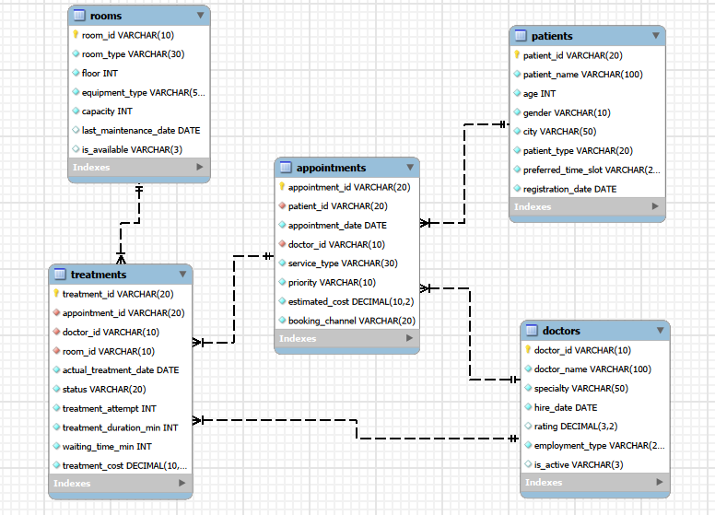

1.4 Analytical Thinking from the ER Diagram
1. Management wants to identify patients who have booked multiple appointments. Which table and columns are needed?
2. Operations wants to identify appointments that required more than one treatment attempt. Where is this information found?
3. Patient Services wants to compare General, Corporate, and Insurance patients based on appointment activity. Which tables must be connected?
4. Operations wants to compare service types based on treatment duration and waiting time. Which tables are required?
5. The team wants to identify which doctors handled treatments and examine their recorded ratings. What information is needed?
6. Operations wants to understand whether different room/equipment types are used for different service types. Which tables and columns are required?
7. Management wants to compare treatment performance across cities. What information must be connected?
8. Operations wants to investigate whether higher-priority appointments have longer waiting times or different outcomes. What information is needed?
9. Management wants to understand whether treatment outcomes differ across service types. What tables and fields should be combined?
10. The Patient Services team wants to connect each patient to their appointments and treatment outcomes. What relationships are required?

Sprint 2: Database Setup
Create the database and tables from the schema/ER design. Students should understand and implement primary keys, foreign keys, suitable data types, NOT NULL, UNIQUE/DEFAULT where appropriate, and dependency order.

Dataset Overview
Table | Rows | Columns
patients | 400 | 8
appointments | 3,000 | 8
treatments | 3,500 | 10
doctors | 80 | 7
rooms | 50 | 7
The CSV files are synthetic project data designed for learning SQL and relational business analysis. IDs are internally consistent across the supplied files.

Sprint 3: Basic Analysis / Data Exploration
1. What is the total number of patients?
2. What is the total number of appointments?
3. What is the total number of treatment records?
4. What are the different medical service types?
5. How many doctors are currently active?
6. What are the different room types?
7. What is the total estimated appointment value?
8. What is the average treatment duration?

Sprint 4: Objective-Based Analysis

4.1 Understand Patient and Appointment Demand
- Compare appointment volume across cities.
- Compare appointments across service types and priorities.
- Examine appointment volume over time.
- Compare estimated appointment value across patient types.
- Examine booking channels and their contribution to demand.
Students must formulate their own analytical questions, write multiple SQL queries, interpret the results, and record business insights.

4.2 Understand Patient Appointment Behaviour
- Compare patients by number of appointments.
- Identify patients with higher cumulative estimated appointment value.
- Compare patient activity across cities.
- Compare General, Corporate, and Insurance patients.
- Examine patient booking patterns over time.
Students must formulate their own analytical questions, write multiple SQL queries, interpret the results, and record business insights.

4.3 Evaluate Treatment Performance
- Compare treatment outcomes across cities.
- Examine treatment duration and waiting time.
- Compare Completed, Cancelled, No-Show, Rescheduled, and In Progress outcomes.
- Identify areas with higher treatment activity or poorer outcomes.
- Compare treatment performance over time.
Students must formulate their own analytical questions, write multiple SQL queries, interpret the results, and record business insights.

4.4 Understand Doctor and Room Performance
- Compare the number of treatments handled by doctors.
- Compare doctor performance across treatment outcomes.
- Examine treatment duration across doctors.
- Compare room usage across room types and equipment types.
- Evaluate treatment performance across rooms.
Students must formulate their own analytical questions, write multiple SQL queries, interpret the results, and record business insights.

4.5 Identify Treatment and Appointment Problems
- Identify appointments requiring multiple treatment attempts.
- Find common problem statuses and patterns.
- Compare waiting time for appointments with multiple attempts.
- Identify cities or service types with more cancellations, no-shows, or rescheduling.
- Investigate whether priority level is associated with waiting time or treatment outcomes.
Students must formulate their own analytical questions, write multiple SQL queries, interpret the results, and record business insights.

SQL Deliverable
- ER diagram interpretation and Sprint 1.4 logical solutions.
- MySQL database created from the project schema.
- Imported and verified CSV data.
- SQL queries for Sprint 3.
- Student-formulated analytical questions for every Sprint 4 objective.
- Supporting SQL queries for each objective.
- Findings and business insights.
- Final conclusions and practical recommendations.

Final Outcome
The project should demonstrate the complete path from a healthcare operations requirement to a data-driven answer: understand the business problem, reason from a relational data model, build the database, formulate analytical questions, write SQL, interpret results, and communicate meaningful operational insights.

