**ANALSIS OF COVID VACCINATION BY COMPARING**

**USA AND INDIA DATA**

Bhavya Yasaswini Gadu

**ABSTRACT**

Covid-19 pandemic has hit almost all the countries in the world and vaccinations are proven to be effective in reducing the severity, to minimize deaths and reduce the overall burden. The statistics of the vaccinations need to be studied more carefully for future enhancements in the vaccination drives. So, this analysis primely focuses on comparing the daily vaccinations and fully vaccinated people in two countries namely USA and INDIA.

**DATA COLLECTION**

The data set consists of around 4000 records and 15 different features containing the data like daily vaccinations, fully vaccinated people, total vaccinated people etc. of 90 countries on different dates.

**APPROACH**

* Various python libraries such as numpy, pandas and matplotlib are used for mathematical calculations, extracting data and visualizing the data.
* The USA and India data are extracted from the dataset based on the iso code.

**ANALYSIS AND VISUALIZATION**

1. **Comparison of daily vaccinations in USA and India**

Purpose

* To understand the scale of vaccinations happened in the two countries on daily basis.
* To understand when the vaccinations had started in both the countries.

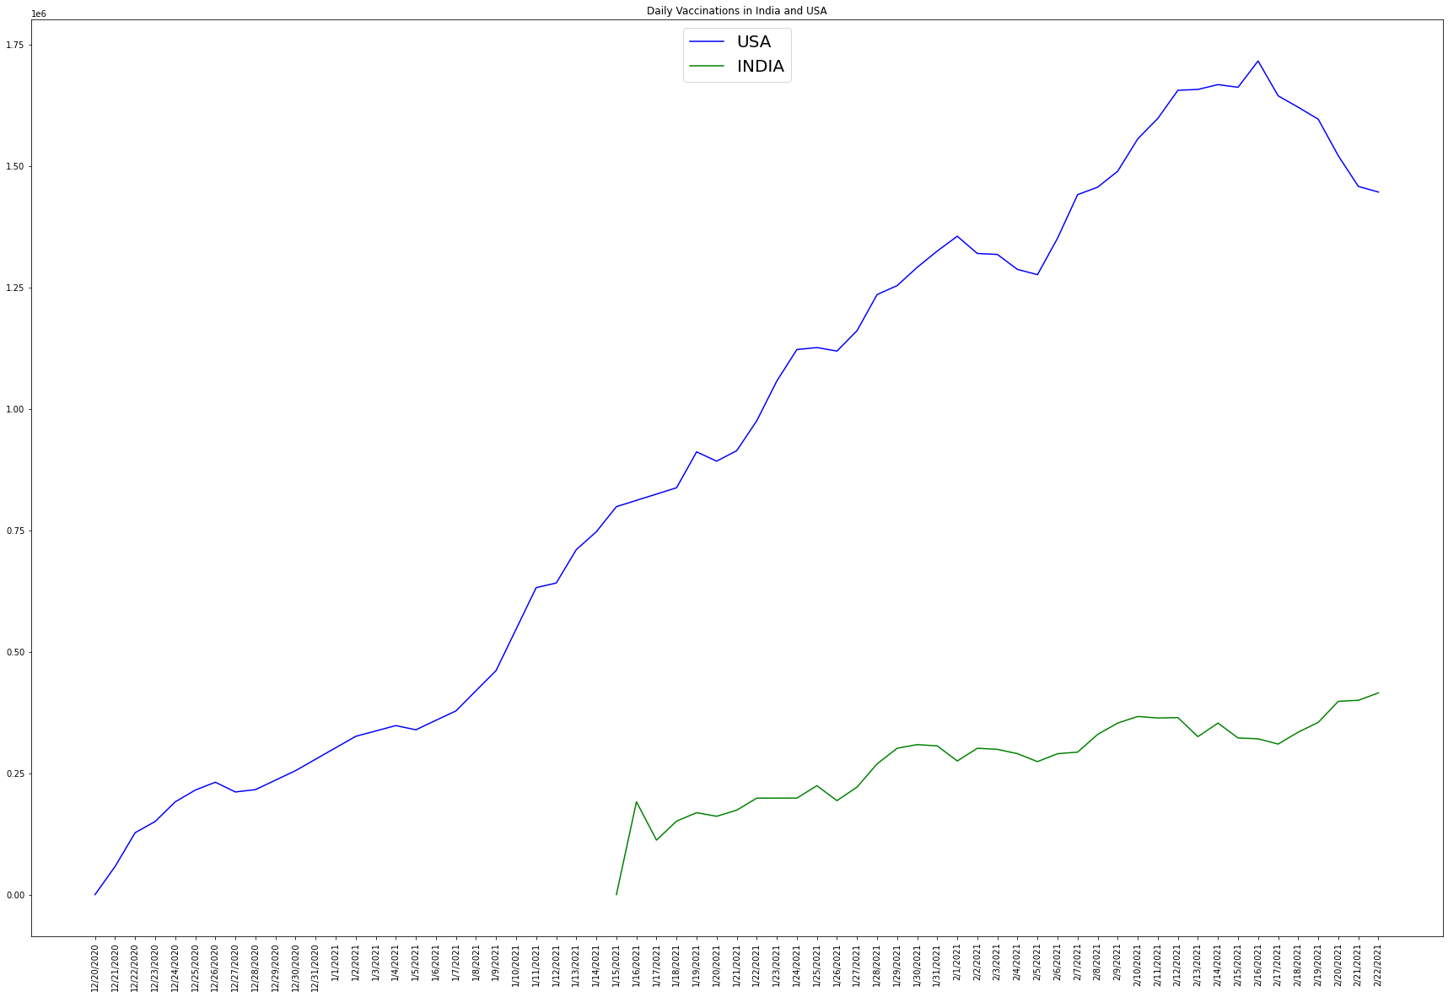

Inference

* From the above analysis it is evident that the vaccinations have started much earlier in USA than in India. Also the daily vaccinations are high in USA compared to India.

**CONCLUSION**

* Even though India’s vaccination process had started late, the daily count of vaccinations has observed to be increasing on scale.
* It has been observed that daily vaccinations in USA are on down scale from 16 of February in 2021.