AI in Software Engineering

Case 03: Food Delivery MVP
Case Study Assignment: Part 1 case tasks, Part 2 theory, Part 3 labs, Appendices
Student name | [ your full name ]
Roll number | [ your roll number ]
Class / section | [ your class and section ]
Submission date | [ date ]
File name | Case03_[ RollNumber ]_[ Name ]
Process model | Prototype
Agile method | Kanban
AI tool(s) | The case names ChatGPT. The AI assistant actually used for this work was Claude (Anthropic); see Appendix A and B.
Prototype module | Cart and order placement
GitHub repository | https://github.com/GaduginaNandini/FoodDeliveryMVP (folder case03/ holds the lab code, tests and evidence from this report)
Scenario. A start-up has 4 weeks and 3 developers to show investors ordering from 10 restaurants. Targets used everywhere: 4 weeks (20 working days), 3 developers, 10 restaurants, WIP limit 3, order in 4 taps (NFR-01), page load under 2 seconds (NFR-02), 12 Kanban cards, 5 test users, 10 stories, 10 manual test cases.

How to read this report
Every part uses the same IDs, so an answer in one place can be followed into another:
Prefix | Meaning | Defined in
FR-01 to FR-10 | Functional requirements | Table 1 (L1.1)
NFR-01 to NFR-03 | Non-functional requirements | Table 1 (L1.1)
US-01 to US-10 | User stories (same order as FR) | L2.3
TC-01 to TC-10 | Manual test cases | L4.1
AI-TC-01 to AI-TC-10 | AI-generated test cases | L1.5
DEF-01 to DEF-07 | Defects found | L4.1 and L5.3
EC-Q / EC-C | Equivalence-class tests (quantity, coupon) | Task D

Scope of the practical work
The tests, scripts and logs in this report were run on the submitted code (Django 6.1, Selenium with Chromium 153, Docker Compose with PostgreSQL, git). Where an equivalent tool or a persona was used instead (Jenkins stages run locally, pylint/radon/bandit for SonarQube), an Evidence note says so.

Part 1: Case Tasks

Task A (Module 1): Lifecycle and AI
Plan: two prototype iterations
 | Iteration 1: clickable screens | Iteration 2: working order flow
Working days | Days 1 to 8 (weeks 1 and 2) | Days 9 to 20 (weeks 3 and 4)
Goal | Investors and test users can click through list, menu, cart, checkout and history and judge the look and feel | A real user can sign in, fill a cart, place an order and see it saved, using real data
What is built | Static Django templates with hard-coded sample data, one shared stylesheet, no database logic | Models (Restaurant, FoodItem, Order, OrderItem), seed data for 10 restaurants, session cart, login-protected checkout, order history
Stories covered | US-01, US-02, US-03 (visual only), US-05 (visual only) | US-03 to US-10 with working behaviour
Exit check | 5 test users complete the “order a burger” task and answer the 10 questions below | All 10 manual test cases (TC-01 to TC-10) executed; no Critical defect open
Output | Clickable prototype and a list of changes requested by users | Working MVP demo for investors
Ten questions for 5 test users. I asked the AI assistant for questions, then removed two that led the answer (“Don’t you think the app looks modern?”) and replaced them.
- Without help, how would you start ordering a meal here? Show me.
- What did you expect to happen when you pressed “+ Add”? Did it happen?
- How did you know that the item was in your cart?
- How many taps did it take you to reach the checkout page? Did that feel fast or slow?
- Was anything on the cart page confusing (quantity buttons, totals, price)?
- Where would you expect to type a discount code?
- What would make you trust the checkout page enough to enter your address and phone number?
- Which screen felt the most polished? Which felt unfinished?
- What would stop you from using this app instead of the one you use now?
- If you could change one thing before we show this to investors, what would it be?
Method used in this report: persona walkthrough. I could not run a session with real users for this report, so I did not invent any. Instead I walked through the 10 questions as five fictional personas (not real people; the names are made up for the exercise). Each persona’s “answer” is what that kind of user would meet in the running app, based on the defects and screenshots I measured (DEF-01 to DEF-04, UX-01). This is a design technique for the early stage; it does not replace a session with real users, and the exit check for iteration 1 still requires one.
Persona (fictional) | Profile | Task given | What she meets in the app | Action
Ananya | 20, student, orders lunch on her phone, low patience | Order a burger (Q1, Q4) | Finds list and menu without help; reaches checkout in 4 taps | Keep layout (FR-01, FR-02); keep NFR-01
Priya | 27, office worker, orders for 3 colleagues | Add 3 items (Q2, Q3) | Nothing on screen changes after “+ Add”; unsure the item was added (UX-01) | Add a cart count and a short confirmation (new card)
Kavya | 35, careful with money, always uses coupons | Find a discount box (Q6) | Looks for a coupon box before checkout and finds none | Build FR-06 (US-06)
Meera | 42, first time using a delivery app, worried about typing her address | Check out (Q7) | Sees a blank total before entering address and phone (DEF-03) | Fix checkout total (DEF-03)
Divya | 24, tester-minded, tries the app as a guest and then signs in | Open the app without signing in (Q8, Q10) | Home page crashes for a visitor (DEF-01); sign-in page errors (DEF-02) | Fix DEF-01 to DEF-02 first
Reading the result. Three of the five personas hit a problem in the very first minute (Priya, Meera, Divya), so the first iteration’s exit check cannot pass until DEF-01 to DEF-03 are fixed. Both the persona method and its findings come from the code I tested, so a real-user session may find other problems (for example cart image or the look of the dark theme). The questions above are ready to use for that session.
What code is thrown away and what is kept.
Thrown away after iteration 1 | Kept for iteration 2
Hard-coded sample menus and prices inside templates | Template structure and the shared stylesheet static/css/style.css (the “polish” investors judge)
Fake totals typed into the cart page | URL design: /restaurant/<id>/, /orders/cart/, /orders/checkout/, /orders/history/
The unused orders/success.html page left from the first click-through (it is still in the repository and is no longer linked) | Data models and the seed command seed_restaurants (10 restaurants, 20 menu items)
 | Test data and, from iteration 2, all automated tests
Throw-away code is allowed in a prototype only when it is thrown away. Leftovers such as success.html are the start of technical debt (see Task E).

Task B (Module 2): Agile planning with AI (Kanban)
Board. Columns: Backlog, Design, Build, Test, Done. WIP limit 3 on Design, Build and Test. Capacity used in the simulation: 1 designer, 2 builders, 1 tester (the 3 developers share the roles). Working days Monday to Friday starting Monday 5 October 2026. Cards are pulled only when the next column has space.
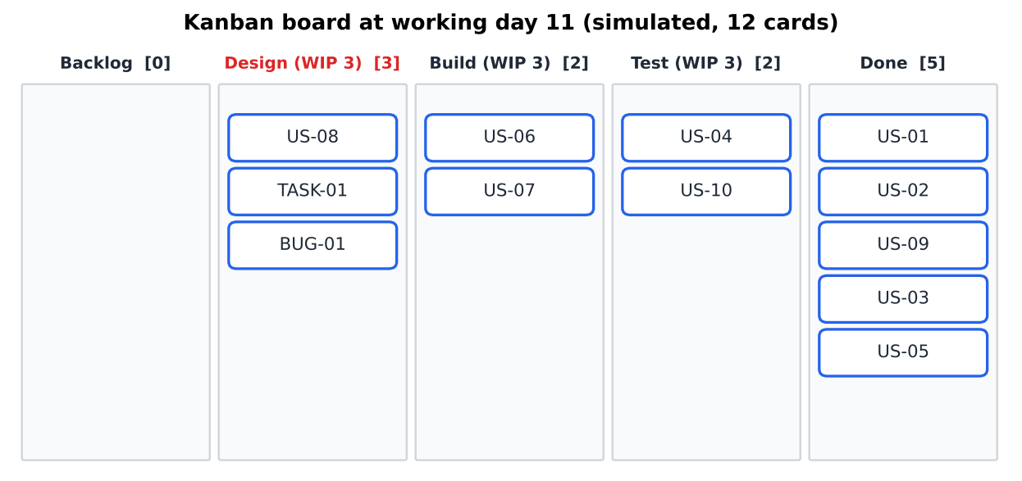
Figure 1: Kanban board on working day 11 of the simulation. Design is at its WIP limit of 3.
12 simulated cards with dates (generated by labs/kanban/kanban_sim.py; the dates are the day a card entered each column). This is a simulation: the durations are assumptions, not measurements of a real team.
ID | Card | Created | Design | Build | Test | Done | Lead (days) | Cycle (days)
US-01 | Browse 10 restaurants | 5 Oct | 5 Oct | 6 Oct | 8 Oct | 9 Oct | 4 | 4
US-02 | Restaurant menu | 5 Oct | 5 Oct | 7 Oct | 9 Oct | 12 Oct | 5 | 5
US-09 | Register / sign in | 5 Oct | 5 Oct | 8 Oct | 13 Oct | 14 Oct | 7 | 7
US-03 | Add item to cart | 5 Oct | 6 Oct | 12 Oct | 14 Oct | 16 Oct | 9 | 8
US-05 | View cart and total | 5 Oct | 7 Oct | 13 Oct | 15 Oct | 19 Oct | 10 | 8
US-04 | Change quantity (max 20) | 5 Oct | 8 Oct | 14 Oct | 19 Oct | 20 Oct | 11 | 8
US-10 | Block unavailable items | 5 Oct | 12 Oct | 15 Oct | 19 Oct | 22 Oct | 13 | 8
US-06 | Apply coupon | 5 Oct | 13 Oct | 16 Oct | 22 Oct | 23 Oct | 14 | 8
US-07 | Checkout details | 5 Oct | 14 Oct | 19 Oct | 22 Oct | 26 Oct | 15 | 8
US-08 | Place order and history | 5 Oct | 15 Oct | 21 Oct | 28 Oct | 30 Oct | 19 | 11
TASK-01 | Jenkinsfile + Docker Compose | 8 Oct | 16 Oct | 22 Oct | 27 Oct | 28 Oct | 14 | 8
BUG-01 | Checkout loses delivery details | 15 Oct | 19 Oct | 23 Oct | 29 Oct | 2 Nov | 12 | 10
Average lead time = 11.08 working days (lead time = Created to Done, sum 133 days over 12 cards). Average cycle time = 7.75 working days (Design to Done). Throughput = 3 cards per week. The last card (BUG-01, found on day 8) finishes on 2 November, one working day after the 4-week window ends on 30 October; Kanban shows this early, so the team would cut scope (for example TASK-01) or drop BUG-01’s design step.
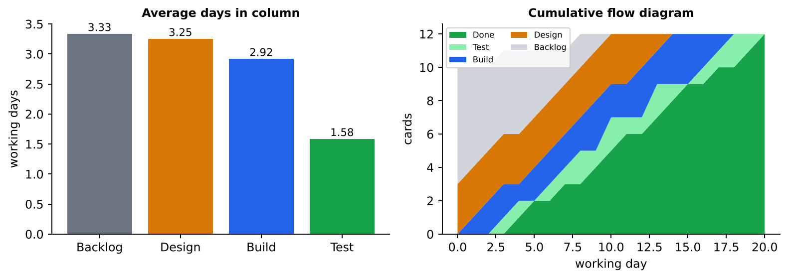
Figure 2: Average days a card spends in each column, and the cumulative flow diagram of the 12 cards.
Asking AI to guess the bottleneck from the data. I gave the dates (not my analysis) to a separate AI session and asked for the bottleneck. It answered: Design, with Build the next constraint; Test is not a constraint. It quoted Design 3.25 days against Build 2.9 and Test 1.5.
AI claim | My check against the data | Verdict
Design averages 3.25 days, Build 2.9, Test 1.5 | My calculation: 3.25, 2.92, 1.58 | Correct
Design was at its WIP limit of 3 from 8 to 12 Oct | Simulation: Design was at the limit on 12 days | Correct
Design took 4 days for “6 of the last 7 cards” | Only 4 of the last 7 cards took 4 days (US-04, US-08, TASK-01, BUG-01) | Wrong (overstated)
Build went to 4, 5, 3, 4 days for US-06, US-08, TASK-01, BUG-01 | Matches the table | Correct
Test is not a constraint | Test had max 2 cards, never at the limit | Correct
Conclusion: the AI named the right column, but one number was invented, so a guess from an AI must be checked against the data. Note that “time in Design” includes waiting for a free Build slot, so the real cause is the single designer plus the Build limit. Actions: pair on Design and Build together, and stop pulling new cards into Design while two cards wait in Build.

Task C (Module 3): Development and deployment
- Short feature branches and pull requests. main always runs; work happens in branches such as feature/coupon or bugfix/checkout-details, no longer than two days; every merge is a pull request that needs one review and a green Jenkins build (strategy diagram in T3.3, real merge conflict in L3.3).
- Add-to-cart API prompt with few-shot examples. I wrote one working example (remove_from_cart) in the project’s own style and asked for add_to_cart in the same style, with constraints (404 for missing or unavailable items, maximum 20, @require_POST, safe redirect) and a request for tests. Prompt, output and score are in L3.1 (version 4, score 4 of 5).
- Jenkins builds on every push with a failure notification step. Jenkinsfile has triggers { githubPush() }, four stages and a post { failure { mail ... } } block (listing in Appendix C; failed and passed build in L3.4).
- Docker Compose runs the app and the database. docker-compose.yml starts a Django web service and a PostgreSQL db service with a health check (L3.5).

Task D (Module 4): Testing and monitoring
Equivalence classes for the quantity field (the quantity of one item in the cart; valid range 1 to 20, MAX_QTY):
Class | Range | Representative value | Expected | Test
Valid, lower boundary | 1 | 1 | Cart line with quantity 1 | EC-Q1
Valid, typical | 2 to 19 | 5 | Quantity 5 | EC-Q2
Valid, upper boundary | 20 | 20 | Quantity 20 | EC-Q3
Invalid, above range | 21 and more | 21 | Stays at 20 (capped) | EC-Q4
Invalid, below range | 0 or negative | 0 | Line removed, never negative | EC-Q5
Equivalence classes for the coupon field (SAVE10 = 10 % off, FLAT5 = $5 off; subtotal of two cheeseburgers = $17.98):
Class | Example input | Expected total | Test
Valid percentage code | SAVE10 | $16.18 | EC-C1
Valid flat code | FLAT5 | $12.98 | EC-C2
Valid, different case or spaces | save10 | $16.18 | EC-C3
Invalid unknown code | FREEFOOD | $17.98 (no discount, error shown) | EC-C4
Invalid empty code | (empty) | $17.98 | EC-C5
Boundary: discount larger than subtotal | FLAT5 on a $1.50 cart | $0.00, never negative | EC-C6
Stored value | SAVE10 then order | Order total saved as $16.18 | EC-C7
Results: on the prototype as submitted, 6 of these 12 tests fail because the coupon and the quantity cap do not exist yet (FR-06 is not built); on the fixed copy all 12 pass (Ran 12 tests ... OK, log in L4.4).
Selenium: add 3 items, apply coupon, place order. Two versions were run in headless Chromium 153: a plain script and a Page Object version (code and comparison in L4.3). Both pass: three menu items are added (subtotal $14.48), SAVE10 gives a total of $13.03, the order is placed and saved with 3 items.
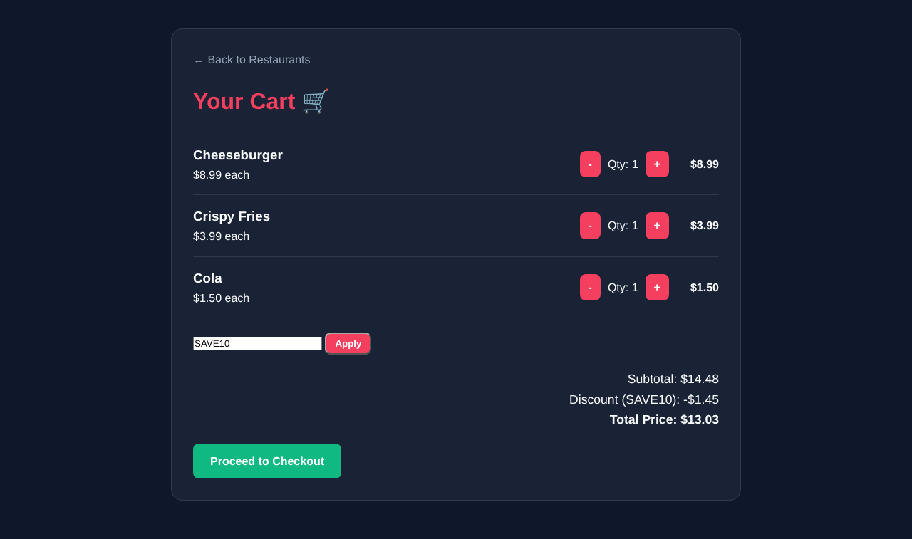
Figure 3: Selenium run, cart page after applying SAVE10 (total $13.03).
One manual exploratory session on the menu page. Charter: explore /restaurant/<id>/ on a phone-sized screen to find usability and data problems. The session was run as a script in Chromium at 375 px width on the prototype as submitted.
Check | Observation
All 10 menu pages open | Yes, status 200 for all 10 restaurants
Items per menu | 2 items per restaurant (20 in total); a real menu would look empty
Horizontal scrolling at 375 px | None
Images without alt text | 0 of 3
Feedback after pressing “+ Add” | None: no message, and the “Cart 🛒” link shows no count (UX-01)
“+ Add” is a link (GET) | /orders/cart/add/21/ changes the cart on a GET request (DEF-07)
Add the same item 4 times | Cart shows quantity 4 correctly
Keyboard Tab | Focus goes to a link; focus is usable
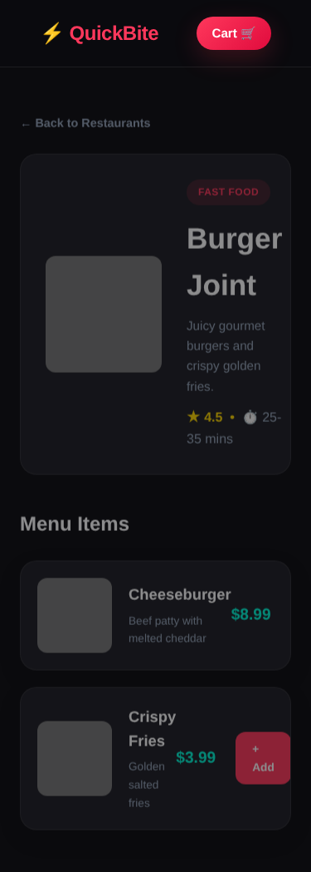
Figure 4: Menu page at 375 px width during the exploratory session.
Self-healing locators after a UI change. A Selenium test breaks when the page changes, for example when the id apply-coupon is renamed. A self-healing tool stores several attributes for each element (id, name, text, CSS path, position). When the main locator fails, it looks for the best match by the other attributes, uses it, and records the change so that a human can approve it. For Food Delivery MVP this helps when the designer renames CSS classes, because the UI changes often during the 4 weeks. The risks are that a wrong match can click the wrong button (“Apply” instead of “Checkout”) and the test still passes, and that the tool hides real UI regressions. My rule: use self-healing only for navigation steps, never for the final assertion on the total or the order record, and review every healed locator in the pull request. Stable test ids (data-testid) and the Page Object Model (L4.3) are cheaper than self-healing and are used first.

Task E (Module 5): Quality and ethics
Usability target: order in 4 taps (NFR-01). Measured with a browser script on the fixed copy (signed-in user, one item): tap 1 “+ Add”, tap 2 “Cart”, tap 3 “Proceed to Checkout”, tap 4 “Place Order”. The result is 4 taps, which meets the target; typing name, phone and address is not a tap. On the prototype as submitted, a new user cannot reach tap 1 at all: the home page returns an error for visitors who are not signed in (DEF-01) and the sign-in page returns an error (DEF-02).
Efficiency target: pages load in under 2 seconds (NFR-02). Measured with Chromium navigation timing, 10 loads per page, loadEventEnd:
Page | Average (ms) | Slowest of 10 (ms) | Target | Result
Home (restaurant list) | 123.6 | 129.3 | < 2000 | Pass
Menu | 122.8 | 131.2 | < 2000 | Pass
Cart | 121.1 | 128.4 | < 2000 | Pass
Checkout | 119.0 | 125.1 | < 2000 | Pass
Evidence note. These are local-server times. The food photos come from images.unsplash.com (30 hot-linked URLs in the seed file) and the sandbox cannot reach that site, so the photo requests were answered with a 1-pixel placeholder. On a real phone network the photos decide the load time, so the 2-second claim must be re-measured on the investor’s network, and photos should be resized and stored with the app.
SonarQube and technical debt. SonarQube was not available. Equivalent checks on the prototype (orders/views.py, 81 code lines): duplicated lines 4.9 % with a 4-line window and 8.6 % with a 3-line window; the cart-reading loop is copied in view_cart and checkout; the expression that reads a quantity (val.get('quantity', 0) if isinstance(val, dict) else int(val)) is copied 4 times; pylint score 7.56 of 10 with 36 messages (mostly trailing whitespace and an unused import); radon: checkout complexity B (9), average A (3.3); bandit: 1 low finding (hard-coded SECRET_KEY). After the refactor the duplication is 0 % and the score 8.76 (L5.2).
Ethics: AI-generated food photos and fake reviews.
Risk in Food Delivery MVP | What the code does today | My rule
AI-generated or stock food photos shown as the real dish | 30 Unsplash photos are hot-linked as the real menu photos | Label sample photos “illustrative” or use photos supplied by each restaurant; never show an AI image as the real dish. Check the photo licence before launch
Fake reviews and ratings | Restaurant.rating is a stored number (default 4.0) that the seed data filled in; no real customer produced it | Show ratings only when they come from real orders. In the demo, mark them “sample data”. Never write or buy reviews with AI
Misleading investors | A polished demo can hide DEF-04 (orders without delivery details) | Tell investors what is real and what is sample data
Personal data | Orders store name, phone and address | No real customer data in the repository or in AI prompts (L5.5)

Part 2: Theory Questions

Module 1: Software Engineering, SDLC and AI Tools

T1.1 [Basic] Phases of the SDLC and one deliverable for Food Delivery MVP
The SDLC is the ordered set of activities that takes software from an idea to a running, maintained product.
Phase | What happens | One deliverable for Food Delivery MVP
1 Planning | Decide scope, time, team, risks | 4-week plan for 3 developers and a Kanban board with 12 cards
2 Requirements analysis | Find out what users and investors need | Requirement list FR-01 to FR-10, NFR-01 to NFR-03 (Table 1)
3 Design | Decide structure and screens | Data model (Restaurant, FoodItem, Order, OrderItem), URL list, clickable screens
4 Implementation | Write the code | Django app with session cart and order placement
5 Testing | Check the code against requirements | 10 manual cases (TC-01 to TC-10) and automated tests
6 Deployment | Make it available | Dockerfile, docker-compose.yml, Jenkins build artifact
7 Maintenance | Fix and improve after release | Defect list (DEF-01 to DEF-07) and backlog for version 2
In a prototype project these phases are repeated in small loops (T1.2) instead of being run once.

T1.2 [Basic] The Prototype model
In the Prototype model the team builds a quick, incomplete version early, lets users try it, learns what is wrong or missing, and then either improves the prototype or rebuilds it properly.
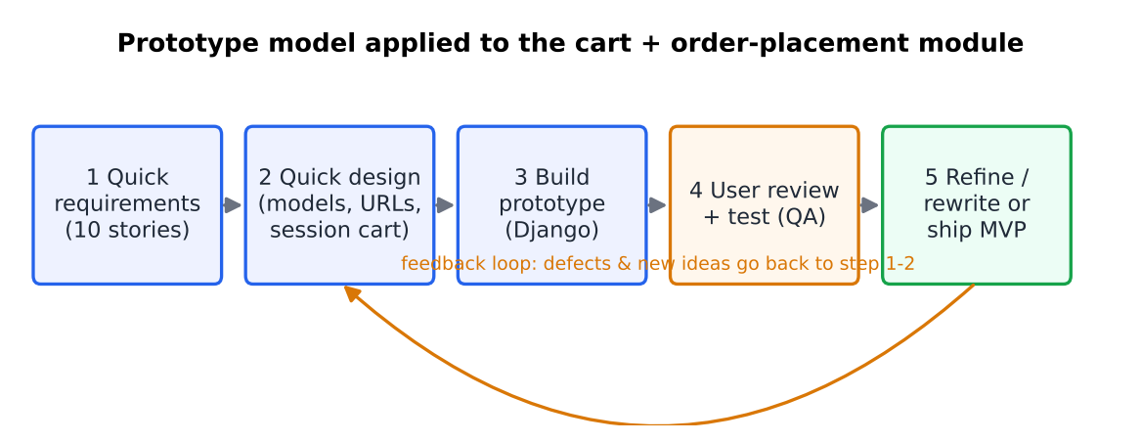
Figure 5: The Prototype model applied to the cart and order-placement module.
Two reasons it fits Food Delivery MVP. (1) Investors judge “speed of ordering and how polished it feels”, which nobody can describe in a document; they have to see and click it, so an early clickable prototype (Task A, iteration 1) answers the real question. (2) Requirements are unclear: the client notes (L1.4) do not say how payment or discounts work, and 4 weeks leaves no time for a long specification, so learning from users early is cheaper than guessing.
Two situations in which I would change the model. (1) If real payments and customer data were added, a mistake would cost money and trust, so I would move to a more controlled model such as Incremental with a formal test phase or the V-Model. (2) If the team grew from 3 developers to several teams with shared components, throw-away code would become too expensive and I would switch to Incremental or Scrum with architecture agreed up front.

T1.3 [Applied] Which phases gain most from AI, and which stay human-led
Phase | AI gain | Main risk | Decision
Requirements | Medium: turns messy notes into a list quickly | Invented requirements (in L1.4, 3 of 12 AI items were invented) | AI drafts, human decides
Design | Low to medium: suggests a data model | Looks reasonable but may ignore the team’s constraints | Human-led
Implementation | High: boilerplate such as the cart view | Insecure or wrong code (the first prompt in L3.1 gave a wrong model name and stored prices in the session) | AI writes, human reviews
Testing | High: many test cases fast; test data | Wrong tests: 4 of 12 AI tests in L4.4 asserted things nobody asked for | AI proposes, human filters
Deployment | Medium: Dockerfile and Jenkinsfile drafts | Secrets in files; wrong settings | Human reviews every file
Maintenance | Medium: explains old code | Wrong explanation | Human-led
Planning and estimation | Low: AI does not know the team | Over-confident numbers (L2.4: AI gave 8 points to order placement) | Human-led
Ethics and accountability | None | Responsibility cannot be handed to a tool | Human only
The phases that must stay human-led are requirements decisions (what the investors really want), design trade-offs, final code review and release approval.

T1.4 [Applied] GitHub Copilot, Tabnine and ChatGPT
Aspect | GitHub Copilot | Tabnine | ChatGPT
Type | Code completion in the editor (also chat) | Code completion in the editor | Chat assistant in a browser or app
Features | Completes lines and functions from the open files; chat inside the IDE | Completion; can be set to learn from the team’s own code | Explains, writes whole files, tests, documents, reviews
Context it sees | The open project files | The open project files | Only what the user pastes
Privacy | Code snippets go to the vendor’s cloud; business plans offer stricter terms | Offers private or on-premise deployment, the strongest option for private code | Everything typed in is sent to the vendor; pasting code or customer data is a risk
Integration | VS Code, JetBrains, GitHub | Many IDEs | Browser, no project integration
Best for | Daily coding | Teams with strict privacy | Planning, test ideas, explanations
Vendor privacy and plan terms change often; check each vendor’s current policy before choosing.
Recommendation for Food Delivery MVP: use ChatGPT (the tool the case names) for requirements, test ideas and explanations, and add a completion tool such as Copilot for typing the repetitive Django code. Rules for both: no real customer data, no secrets, and every output goes through review and tests, as the evidence in L1.3 and L3.1 shows that AI code can look right and still be wrong for the project.

T1.5 [Advanced] Validating AI-written requirements and AI-generated test cases
Requirements. Step 1: trace every AI requirement to a source (a line of the client’s notes or a scenario number); anything without a source is marked invented. Step 2: check that it is testable, with a number or an observable result; otherwise it is vague. Step 3: ask the client to confirm the vague and invented items. Step 4: give a requirement ID only after that. In L1.4, 12 AI items were classified this way: 5 correct, 4 vague, 3 invented.
Test cases. Step 1: derive the expected result from the requirement, not from the code, so that a test of an invented feature is visible (in L4.4, the AI wrote tests for 5 % tax, for a JSON cart and for an “out of stock” message, none of which is a requirement). Step 2: run each test against the code and against a deliberate break (a mutation: change +1 to +2 and see the test fail, as done in L3.2). Step 3: for each failing test decide: is the code wrong (defect) or the test wrong (hallucination)? Step 4: compare coverage with the requirement list to find missing tests. The accuracy rate of AI tests is then measured (L4.4: 8 of 12, 66.7 %).

Module 2: Agile Practices and AI-Driven Planning

T2.1 [Basic] Why the Agile Manifesto was created, and two values for this team
In 2001 a group of practitioners wrote the Manifesto because heavy, plan-driven processes delivered late, over budget and not what users needed. It prefers (1) individuals and interactions over processes and tools, (2) working software over comprehensive documentation, (3) customer collaboration over contract negotiation, (4) responding to change over following a plan.
- Working software over comprehensive documentation. The 3 developers do not write a long specification. At the end of every week there must be something that runs and can be shown to a test user, such as the clickable screens in week 2. This is also why the repository holds tests and a one-page README instead of a design book.
- Responding to change over following a plan. The test users’ answers (Task A) will change the plan, for example by adding the coupon box. The Kanban board lets the team swap the next card without waiting for a new plan (BUG-01 entered on day 8 in Task B).

T2.2 [Basic] Scrum, XP, Lean and Kanban compared
 | Scrum | XP | Lean | Kanban
Core idea | Fixed-length sprints with roles | Engineering practices (pair programming, TDD, small releases) | Remove waste, deliver fast | Visualise work, limit work in progress
Time box | Sprint, 1 to 4 weeks | Iteration, 1 to 2 weeks | None | None; continuous flow
Roles | Product Owner, Scrum Master, team | Coach, customer, programmers | None | None required
Change during iteration | Avoided until the next sprint | Welcomed | Welcomed | Welcomed at any time (if WIP allows)
Key measures | Velocity | Test coverage, build health | Waste, lead time | Lead time, cycle time, WIP
Best for | Stable teams with a backlog | Teams that need very high code quality | Reducing process waste | Support, fixes, small teams with a changing order of work
Why Kanban for Food Delivery MVP. The team is only 3 people, the work arrives in an unpredictable order (the investor feedback in week 3 can change priorities and bugs such as BUG-01 appear at any time), and there are only 4 weeks, so there is no room for sprint ceremonies. A WIP limit of 3 matches the team size, and lead time shows quickly whether the 4-week goal is at risk (Task B showed a finish one day late).

T2.3 [Applied] The sprint cycle and a sample sprint goal
Scrum (the sprint cycle is the standard Scrum timebox for a 2-week sprint; Food Delivery MVP itself uses Kanban, so I use this as a short iteration):
Event | Timebox (2-week sprint) | Purpose
Sprint planning | up to 4 hours | Choose the sprint goal and the backlog items
Daily scrum | 15 minutes every day | Share progress and blockers; adjust the day’s plan
Development | 2 weeks | Build and test the selected items
Sprint review | up to 2 hours | Show the working increment to stakeholders (investors)
Sprint retrospective | up to 1.5 hours | The team decides how to work better next sprint
Sample sprint goal: By the end of the sprint a signed-in user can add items from any of the 10 restaurants to a cart and place an order whose delivery details and total are saved and visible in order history (US-03, US-05, US-07, US-08).

T2.4 [Applied] How AI can forecast the delivery date from past data
The forecast uses past data: for each finished card its lead time or story points per week (velocity). A simple method is a Monte Carlo simulation: pick random past weekly throughputs many times, add them until the remaining work is done, and read the date by which 85 % of the runs finish. In this project 12 cards finished in 4 weeks at 3 cards per week (Task B), so 8 remaining cards would be forecast at about 2.7 weeks.
Assumptions: the future looks like the past (same people, same card size); cards are of similar size; the data is complete and recorded honestly; no big scope change. Risks: 3 developers and only 12 cards give very little data, so the forecast is a wide range, not a date; one illness changes everything; AI can sound certain about a number that has no evidence (in L2.4 the AI gave a total of 38 points with no team data); and a forecast that people treat as a promise causes pressure. Use the forecast as a range, update it weekly and keep the human estimate next to it.

T2.5 [Advanced] ChatGPT, Copilot and Jira AI in an Agile team
- ChatGPT writes user stories and acceptance criteria from notes, suggests estimates (L2.4), drafts retrospective summaries and test ideas.
- Copilot speeds up coding of repetitive code, can explain pull-request changes and suggests tests inside the IDE.
- Jira AI features (for example summarising issues, suggesting issue fields, searching with natural language) help keep the board tidy and find duplicate cards. Check the exact features of the Jira plan in use.
Three benefits for Food Delivery MVP: (1) faster drafting: the 10 stories and 12 cards were drafted in minutes; (2) a second opinion on estimates: the AI’s 8 points for US-08 pointed to a real risk, the missing transaction (L5.3 R1); (3) more test ideas: the AI found the empty-cart and unavailable-item cases.
Three challenges: (1) wrong or invented content, for example 3 of 12 invented requirements (L1.4) and one wrong number in the AI’s bottleneck answer (Task B); (2) privacy, because notes and code sent to a cloud tool may contain client data; (3) over-trust: a 3-person team can stop thinking critically and plan around AI numbers (L2.4).

Module 3: Development and Deployment Practices using AI Tools

T3.1 [Basic] Code completion tools versus chat tools for cart and order placement
A completion tool (Copilot, Tabnine) lives in the editor and proposes the next lines using the files that are open. When I type def add_to_cart(request, item_id): it can complete the body in the style of the remove_from_cart function that is already in the file, so it uses the project’s real names (FoodItem, view_cart). A chat tool (ChatGPT) works only on what I paste, answers in a conversation and can do larger jobs, such as writing the whole checkout view, explaining a bug or producing 10 test cases, but it does not see the project, so it may invent names. In L1.3 and L3.1 the chat answers used MenuItem, Product and a URL called cart where the project has FoodItem and view_cart. Rule of thumb: completion for small, repetitive, in-style code; chat for design questions, tests and reviews; both need review.

T3.2 [Applied] Refining a prompt that returned insecure code
The first prompt in L3.1 (“write add to cart in django”) returned a generic cart class that stored the price in the session and read the quantity from the user’s POST data; a later version redirected to an unchecked Referer. To refine: (1) state the context (Django 6, models, URL names), (2) state the cart format, (3) list security requirements in the prompt: validate the item id with get_object_or_404(..., is_available=True), cap the quantity, never take prices from the browser, change state only on POST with CSRF, redirect only to a URL on the same host, (4) include a working example in the project’s style (few-shot), (5) ask for unit tests in the same answer.
Review I would add: a checklist (input validation, authorisation, CSRF, open redirect, price from the database, transaction around order creation); bandit and pylint in the Jenkins build; a human review of every AI pull request; and tests that try bad input. In L5.3 this review found a real open redirect and an order saved without a transaction.

T3.3 [Basic] Repository, commit, branch, merge, pull request and conflict
- Repository: the folder with all project files and their full history (the GitHub repository FoodDeliveryMVP).
- Commit: a saved snapshot with a message (for example “Fix checkout total”).
- Branch: a separate line of commits, so that one feature can be developed without breaking main.
- Merge: joining the commits of one branch into another.
- Pull request (PR): a request on GitHub to merge a branch, with a place for review and automatic checks.
- Conflict: git cannot decide because two branches changed the same lines; a person must choose (shown in L3.3).
Branching strategy for 3 developers in 4 weeks: a simple flow with short-lived branches.
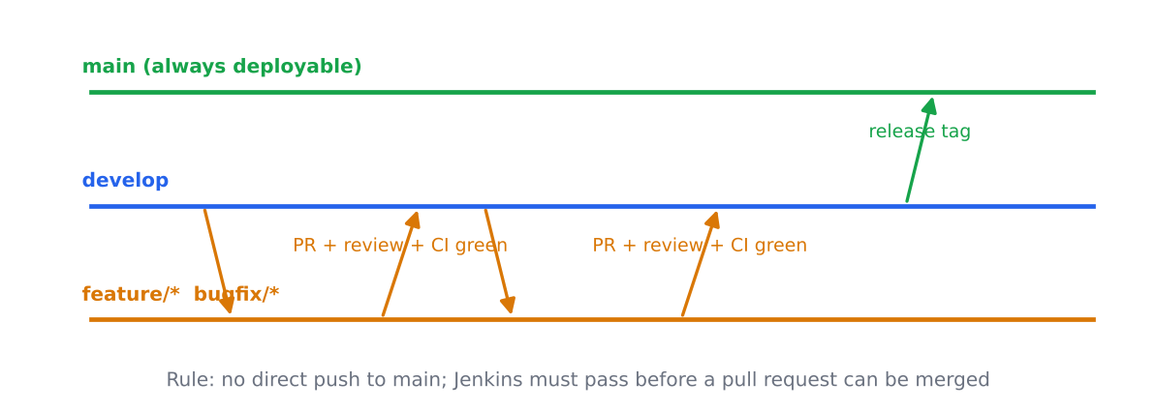
Figure 6: Branching strategy: short-lived feature branches merged by pull request when review and Jenkins are green.
main holds the demo version for investors; develop collects finished work; branches are named feature/... or bugfix/..., last at most two days, and are merged by PR. Each developer takes cards from different columns of the board so that the same file is rarely edited by two people.

T3.4 [Applied] Jenkins jobs, pipelines, the Jenkinsfile, triggers and agents
- Job: one configured task that Jenkins can run (for example “build Food Delivery MVP”).
- Pipeline: a job described as stages that run in order (Checkout, Build, Test, Package).
- Jenkinsfile: the text file in the repository that defines the pipeline, so the build is versioned with the code.
- Trigger: what starts a build; here githubPush() starts it on every push.
- Agent: the machine or container where the stages run (agent any uses any free one).
How a failed test stops a release. Each stage runs a shell command. If the Test stage command returns a non-zero exit code, Jenkins marks the stage failed, skips the later Package stage (so no release zip is produced), and runs the post { failure { ... } } block, which e-mails the team. A branch rule on GitHub that requires the Jenkins check to be green blocks the merge. L3.4 shows this: build #1 failed with 17 of 35 tests failing and no package, and build #2 passed after the fixes.
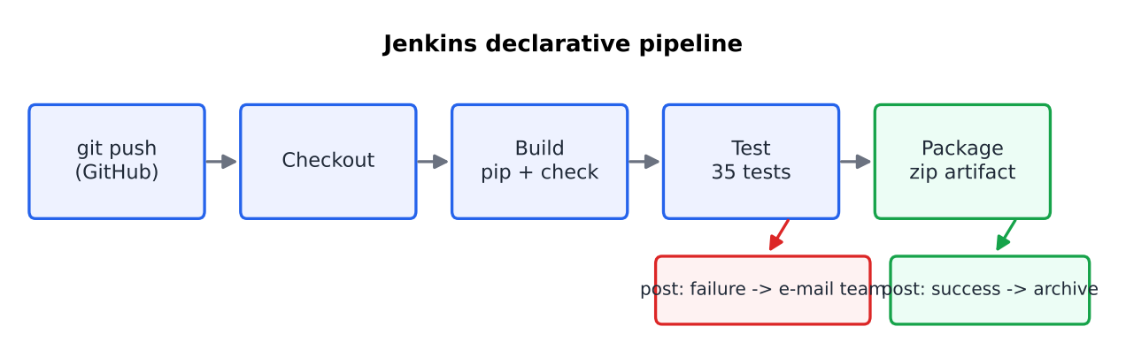
Figure 7: The pipeline used for Food Delivery MVP.

T3.5 [Advanced] Benefits and challenges of AI-assisted development and deployment (CI/CD and containers)
Benefits for Food Delivery MVP | Challenges for Food Delivery MVP
AI writes a first Dockerfile, docker-compose.yml and Jenkinsfile in minutes | AI files can contain wrong settings or secrets; the compose file in this project needed POSTGRES_PASSWORD to come from the environment, not from the file
CI finds problems on every push: 17 failing tests were visible at once in build #1 | CI only finds what the tests cover; an AI-generated suite with wrong tests gives a false green or false red (L4.4)
Containers give the same app and database for all 3 developers and the investor demo (“works on my machine” disappears) | Container and pipeline skills are new for the team; a broken compose setup can cost days in a 4-week project
AI-assisted fixes are quick (the fix for DEF-03 took a few lines) | AI code can be insecure (open redirect, state change on GET) and must be reviewed
Pipeline runs the same checks every time | Build time and server cost grow; Selenium needs a browser in the build agent

Module 4: AI-Based Testing and Monitoring

T4.1 [Basic] Software testing; manual versus automated; what to automate
Software testing is running the software with chosen inputs to compare the actual behaviour with the expected one and to find defects before users do.
 | Manual | Automated
Who or what | A person follows or explores | A script or test runner
Strength | Finds usability and “looks wrong” problems; no set-up cost | Fast, repeatable, runs on every push
Weakness | Slow, varies between people | Must be written and maintained; cannot judge looks
Automate the stable, repeated, high-risk checks: cart arithmetic (AI-TC-05), order saving (AI-TC-08 to 10), coupon classes (EC-C1 to C7), the end-to-end order with Selenium, because they run on every Jenkins build. Keep manual the exploratory session on the menu page, the “does it feel polished” check for investors, and a first look at any new screen.

T4.2 [Basic] The test pyramid for Food Delivery MVP
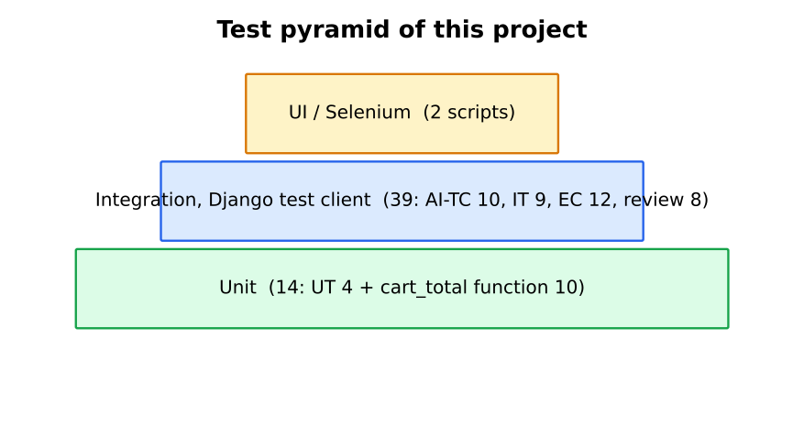
Figure 8: Test pyramid with the real counts of this project.
Level | What is tested | Who writes and runs | Count here
Unit (many, fast) | Single functions: _qty, discount rules, cart_total | Developer, on every save | 14
Integration | Views with database and session through the Django test client: add item, cart total, checkout saves an order | Developer and tester, on every push | 39
UI / end-to-end (few, slow) | The whole order in a real browser | Tester, on every push or nightly | 2 scripts (6 runs)
Manual / exploratory | Look, feel and surprises | Tester and the product owner | 10 cases and 1 session

T4.3 [Applied] Page Object Model and Selenium maintenance
The Page Object Model (POM) puts the locators and actions of each page into one class (MenuPage, CartPage, CheckoutPage), and the tests only call methods such as cart.apply_coupon('SAVE10'). If the designer changes the id of the “Apply” button, only CartPage changes. In L4.3 the plain script repeats 33 locators across 3 tests and refers to the coupon button in 3 places; the POM version holds each locator once (10 in total) and the button in 1 place, so a UI change costs 1 edit instead of 3, and the tests read like the user story.

T4.4 [Applied] AI-assisted test generation and test prioritisation before a release
AI test generation means giving the AI the requirement or the code and asking for test cases, test data and edge cases. It is fast and finds cases people forget, but it also invents tests, so each test is checked against the requirement (L4.4: 8 valid of 12, 66.7 %).
AI test prioritisation orders the tests so that the ones most likely to fail run first, using history (which tests failed recently), what code changed, and risk. For the release of Food Delivery MVP I would order the tests by risk = impact × likelihood:
Priority | Tests | Reason
1 | Order saves items, details and total (AI-TC-08 to 10, TC-10), sign-in and checkout access (TC-07) | Money and data; DEF-01, DEF-02 and DEF-04 were found here
2 | Cart arithmetic and coupon (AI-TC-05, EC-C1 to C7) | Wrong totals destroy trust
3 | Unavailable items and quantity limits (DEF-05, EC-Q) | Wrong orders
4 | Selenium end-to-end order | Catches integration breaks
5 | Look and feel checks, exploratory session | Matters for investors, rarely blocks an order

T4.5 [Advanced] Defect prediction and AI-based bug detection
Defect prediction trains a model on past project data to estimate which files or changes are most likely to contain defects, so the team tests them first. AI-based bug detection reads code and flags suspicious patterns, such as an order that is created without a transaction.
Data I would collect for Food Delivery MVP: per file and per commit: lines changed, number of authors, past defect count (DEF IDs per file), cyclomatic complexity (radon: checkout is the most complex at B 9), test coverage (93 % overall, 90 % for orders/views.py), review comments, and, from production, errors per URL. With a single commit and 7 defects there is not enough data to train a model yet, so I would start with simple rules: files with high complexity and many changes get extra review.
How the team acts on predictions: put the top-risk files (here orders/views.py and the checkout template) first in review and in the Jenkins test order; add tests before changing them; check each prediction on the next defects to see if it was right; and never use a prediction to judge a developer.

Module 5: AI-Powered QA and Ethical Development

T5.1 [Basic] Two quality attributes that matter most, and how to measure them
Attribute | Why it matters most | How I measure it | Result
Efficiency (performance) | Investors judge speed of ordering (scenario) | Page load by browser timing (NFR-02, < 2 s); taps to order (NFR-01, 4) | 119 to 124 ms locally; 4 taps (Task E)
Reliability / correctness of orders | An order with no address or $0.00 total cannot be delivered or paid | Share of orders with complete details and a correct total; test pass rate | Prototype: 2 of 2 orders in the monitored database incomplete (monitor in L4.5); fixed copy: 35 of 35 tests pass
Usability (taps to order, feedback after add) is third and also tested (Task D).

T5.2 [Applied] SonarQube and its terms in this project
SonarQube is a server that analyses source code on every push and reports quality problems; the project passes or fails a quality gate.
Term | Meaning | Example in Food Delivery MVP
Bug | Code that is wrong and will cause a failure | Ignoring full_name, phone, address and total when saving an order (DEF-04)
Vulnerability | A weakness an attacker could use | Redirecting to an unchecked Referer (open redirect, DEF-07)
Security hotspot | Code that needs a human security check | Hard-coded SECRET_KEY and DEBUG = True in settings.py (bandit B105)
Code smell | Maintainability problem | The quantity expression copied 4 times; unused import get_object_or_404; trailing whitespace
Duplication | Copy-pasted code | The cart-reading loop in view_cart and checkout (4.9 % duplicated lines)
Coverage | Share of lines executed by tests | 93 % overall; 90 % for orders/views.py
Quality gate | Pass/fail rule on new code | Example: no new bugs, coverage of new code at least 80 %, duplication under 3 %

T5.3 [Applied] AI code review, human review and static analysis
 | Static analysis (pylint, bandit, SonarQube) | AI review | Human review
Finds | Known patterns: unused imports, hard-coded key, complexity | Logic, design and security ideas in plain language | Business meaning, whether it is the right thing to build
Misses | Logic errors such as DEF-04 (valid code that ignores a form field) | Can be wrong (2 of the AI’s 8 review suggestions were false alarms in L5.3) | Gets tired; slower
Consistency | Same every time | Varies by prompt | Varies by person
Cost | Cheap, automatic | Cheap, fast | Most expensive
Combination: static analysis runs automatically in Jenkins (rule-based findings, no argument); the AI reviews each pull request and every suggestion is tested before it is accepted (L5.3); a human reviewer makes the final decision and checks the business meaning. Evidence: the tests I wrote for the AI’s review suggestions confirmed 5 as real defects, showed 2 to be false alarms, and left 2 as style opinions.

T5.4 [Advanced] Accountability for harm caused by AI-generated code
- Developer: the developer who accepts, merges and ships the code is accountable for it. “The AI wrote it” is not a defence, because the developer chose to use it without enough review. In L5.3 the AI-generated checkout had no transaction; a developer who merged it unreviewed would own the orphan orders.
- Company (the start-up): responsible for setting the policy (L5.5), training, review rules and for what is shown to investors and customers; it carries the legal responsibility toward customers and for data protection.
- Tool vendor: responsible for how it builds and describes its tool, security of its service and the terms it offers; but vendor terms normally say that the user must check the output, so liability mostly stays with the user and the company. The exact terms differ by vendor and contract and should be read; I am not giving legal advice.
A harm in Food Delivery MVP could be orders delivered with no address (DEF-04), or a customer’s phone number leaked through a debug page (DEBUG = True shows variables). The chain is: the developer should have tested and reviewed, the company should have required it, and the vendor is a supplier whose output is an input to be checked.

T5.5 [Advanced] Benefits and challenges of AI in SQA, and why AI help must be acknowledged
Benefits (with evidence from this report) | Challenges (with evidence)
Many test cases quickly: 10 AI test cases found 2 real defects (L1.5) | Hallucinated tests: 4 of 12 raw AI tests were wrong (L4.4)
Review suggestions that found a real open redirect and missing transaction (L5.3) | 2 of 8 review suggestions were false positives (L5.3 R7, R8)
The AI function passed 10 of 10 edge-case tests, my hand-written one 7 of 10 (L5.4) | AI explanation of data can contain a wrong number (Task B)
Fast refactoring with no change in behaviour (L3.2) | Privacy and bias: data pasted into tools; AI trained on code with bad habits
Why AI assistance must be acknowledged: (1) honesty: the reader should know who did the work and judge the work correctly; (2) accountability: it shows who checked the output and how (Appendix A); (3) integrity and law: AI output can contain code under a licence or text that is not the student’s own, and universities and employers require disclosure; (4) reproducibility: others can repeat and audit the work. Hiding AI use makes a failure look like the student’s hidden incompetence or dishonesty, and removes the reader’s chance to check the AI-written parts more carefully.

Part 3: Lab Questions
All code, tests and logs are in the repository folder case03/. The “prototype as submitted” is the code in FoodDeliveryMVP.zip; the “fixed copy” is the same code with the corrections listed in L4.1 and L5.3 plus the coupon feature (FR-06).

Module 1 Labs: SDLC, Process Models and AI Tools

L1.1 [Basic] SDLC phases of Food Delivery MVP with one output per phase
Figure 9: SDLC phases with the Prototype loop, one output per phase.
Phase | Output for Food Delivery MVP | Where it is in this report
Planning | 4-week plan, Kanban board, 12 cards | Task B
Requirements | Table 1 below | Table 1
Design | Models, URLs, screens | T1.1, Task A
Implementation | Cart and order-placement code | repository
Testing | TC-01 to TC-10, AI-TC-01 to 10, EC tests | L4.1, L1.5, Task D
Deployment | Jenkinsfile, Dockerfile, compose | L3.4, L3.5
Maintenance | DEF-01 to DEF-07 and v2 backlog | L4.1
Table 1: Requirements used in every part
ID | Requirement | Story
FR-01 | The user can see the list of 10 restaurants | US-01
FR-02 | The user can open a restaurant and see its menu with prices | US-02
FR-03 | The user can add a menu item to the cart with one tap | US-03
FR-04 | The user can increase or decrease the quantity of an item (1 to 20) | US-04
FR-05 | The cart shows line subtotals and a total | US-05
FR-06 | The user can apply a coupon code (SAVE10 = 10 %, FLAT5 = $5) | US-06
FR-07 | A signed-in user enters name, phone and delivery address at checkout | US-07
FR-08 | Placing the order saves items, prices, delivery details and total, and clears the cart | US-08
FR-09 | The user can see their past orders | US-08
FR-10 | A visitor can register and sign in; unavailable or unknown items cannot be ordered | US-09, US-10
NFR-01 | A user can place an order in 4 taps
NFR-02 | Pages load in under 2 seconds
NFR-03 | What the user typed at checkout must be what is stored (data integrity)

L1.2 [Applied] First milestone under Waterfall and under Incremental
Milestone: a user can order from one restaurant.
 | Waterfall | Incremental
Plan | Complete requirements, then design, then code, then test, in order | Deliver 3 increments: (1) browse and menu, (2) cart, (3) checkout and order
Effort | Big up-front effort in requirements and design (about 5 days of 20) before any code | Effort spread over the 4 weeks; each increment includes its own tests
Time to first working screen | Week 3 | End of week 1
Risk | High: wrong requirements are found only at the end (e.g. the missing coupon box or the blank total) | Lower: each increment is tried by users
Feedback | Only after testing at the end | After every increment (3 times)
Cost of change | High | Low to medium
Fit with the scenario | Poor: investors judge look and speed and need an early demo | Good, and the Prototype model (T1.2) is a form of it

L1.3 [Applied] The same prompt in two AI tools
Prompt (identical): Write a Django 6 view add_to_cart(request, item_id) … stores the cart in request.session[‘cart’] as {str(item_id): quantity}, then a checkout(request) that creates an Order (user, full_name, phone_number, address, total_amount) and OrderItem rows from the cart, clears the cart and redirects to ‘order_history’. Models: restaurants.FoodItem, orders.Order, orders.OrderItem.
Evidence note. Only one vendor’s assistant was available to me, so the two “tools” are two models of the same vendor: Tool A = Claude Haiku 5.5, Tool B = Claude Sonnet 5.5. If the module requires two different vendors (for example ChatGPT and Copilot), repeat this prompt there and replace the columns; the method of comparison is the same.
Criterion | Tool A (Haiku) | Tool B (Sonnet)
add_to_cart | @require_POST, 404 if unavailable, quantity read from user input (up to 99) | @require_POST, 404 if unavailable, always +1
Redirect after add | redirect("cart") (URL name does not exist in the project; it is view_cart) | redirect(request.POST.get('next') or 'order_history'): unchecked user-supplied target (open redirect)
checkout | @require_POST on the whole view, so the checkout form page cannot be shown | Handles GET (shows the form) and POST
Prices and total | From the database; Decimal sum | From the database; Decimal sum
Transaction | transaction.atomic(), bulk_create | transaction.atomic(), bulk_create
Unavailable items at checkout | Rejects the order with a message | Silently drops them
Explanation | 3 lines, mentions the assumed URL name | 3 lines, mentions the assumed template
Works in the project as is? | No (URL name, GET-based “+ Add” links in templates, form page) | Closer, but needs a safe redirect and CSRF forms
Privacy | Prompt contained no personal data. Both are from the same vendor, so the same terms apply | Same
Method: static review of both outputs against the project’s URL names, models and templates; the outputs were not executed. Result: Tool B was more correct for the checkout flow (it serves the form); Tool A was safer for the cart redirect but allowed a client-chosen quantity and broke the form page. Neither output was usable without edits, which is the point of L3.1.

L1.4 [Applied] Eight messy client notes and the AI extraction
Notes (8 lines):
- “we need the app to be super fast, investors hate waiting”
- “people pick food from 10 restaurants, maybe more later”
- “cart should remember stuff even if they refresh”
- “has to have discount codes like SAVE10, marketing wants it”
- “payment? card and UPI I think, ask Raj”
- “must look premium, like Uber Eats but better”
- “nobody should be able to order sold-out dishes”
- “orders need a delivery address, name, phone obviously”
AI output (12 requirements) and my classification:
# | AI requirement | From note | Class | Corrected requirement / action
R1 | Pages shall load in under 2 seconds | 1 | Vague (the number 2 s was added by the AI; it comes from the scenario) | NFR-02, confirmed by scenario
R2 | The system shall list 10 restaurants | 2 | Correct | FR-01
R3 | The system shall be scalable to more restaurants | 2 | Vague (“maybe more later”; no number) | Keep 10 for MVP; ask for the next target
R4 | The cart shall persist across page refreshes | 3 | Correct | FR-03 / FR-05 (session cart)
R5 | The user can apply the coupon code SAVE10 | 4 | Correct | FR-06
R6 | SAVE10 gives 10 % off | 4 | Vague (percentage not in the note) | Confirm with marketing; FLAT5 added later
R7 | The system shall support card and UPI payments through a gateway | 5 | Invented (the note is a question, “ask Raj”) | Out of scope for MVP until confirmed
R8 | The UI shall be premium and polished | 6 | Vague (not measurable) | Replace by a test-user question (Task A, Q8)
R9 | The system shall integrate with Uber Eats | 6 | Invented (the note only names a style reference) | Delete
R10 | Unavailable (sold-out) items cannot be ordered | 7 | Correct | FR-10
R11 | Checkout shall collect delivery address, name and phone | 8 | Correct | FR-07
R12 | The system shall provide live order tracking with a map | none | Invented | Delete
Counts: 5 correct (R2, R4, R5, R10, R11), 4 vague (R1, R3, R6, R8), 3 invented (R7, R9, R12). Accuracy of the AI list = 5 / 12 = 41.7 % used as written; 9 / 12 = 75 % after confirming the vague ones. The corrected list is Table 1 (FR-01 to FR-10, NFR-01 to NFR-03).

L1.5 [Advanced] Ten AI test cases run against the code
The AI generated 10 test cases for cart and order placement from the requirements; they were written as Django tests (labs_tests/test_ai10.py) and run on the prototype as submitted.
ID | Test | Result | Why it failed
AI-TC-01 | Add item creates cart line with quantity 1 | Pass
AI-TC-02 | Add same item twice gives quantity 2 | Pass
AI-TC-03 | “-” reduces quantity | Pass
AI-TC-04 | “-” on the last unit removes the line | Pass
AI-TC-05 | Cart total = sum of price x quantity ($21.97 for 2 burgers + 1 fries) | Pass
AI-TC-06 | Anonymous checkout redirects to login | Pass | (the redirect works, but the login page itself fails: DEF-02)
AI-TC-07 | Empty-cart checkout redirects to the cart | Pass
AI-TC-08 | Valid order creates items and clears the cart | Pass
AI-TC-09 | Order stores name, phone and address | Fail | checkout() never reads full_name, phone_number, address from request.POST (DEF-04)
AI-TC-10 | Order stores the total amount | Fail | total_amount is never set, so it stays at the default 0.00 (DEF-04)
prototype as submitted: Ran 10 tests ... FAILED (failures=2)
fixed copy: Ran 10 tests ... OK
8 passed, 2 failed. Both failures are real defects in the code, not wrong tests, because they come straight from FR-08 and NFR-03. The same defect is visible in the project’s own database: the one order already stored in db.sqlite3 has an empty name, empty address and total $0.00.
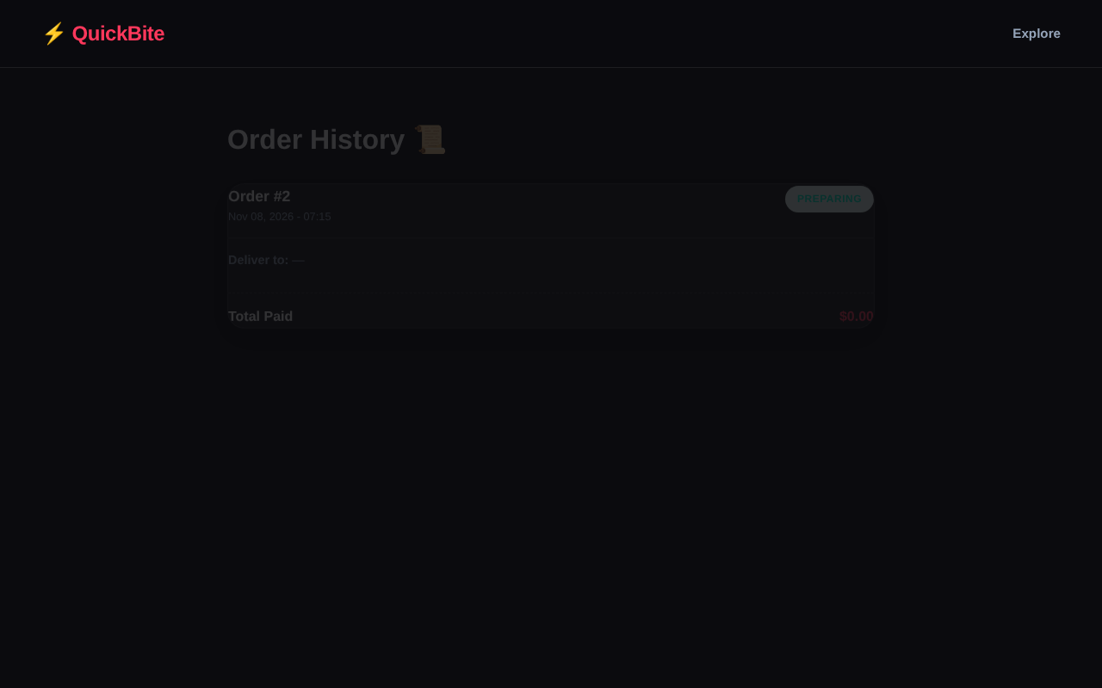
Figure 10: DEF-04 on the prototype as submitted. A real order was placed with name, phone and address filled in. Order history shows “Deliver to: -” and “Total Paid $0.00”. (Food photos are placeholders, see Task E.)

Module 2 Labs: Agile, Scrum and AI-Driven Planning

L2.1 [Basic] Six practices classified under Agile Manifesto values
# | Practice in Food Delivery MVP | Manifesto value or principle
1 | Show the clickable prototype to 5 users after week 2 | Customer collaboration over contract negotiation
2 | Keep one README and tests instead of a long specification | Working software over comprehensive documentation
3 | Pull BUG-01 into the board the day it is found | Responding to change over following a plan
4 | Daily 15-minute stand-up at the board | Individuals and interactions over processes and tools
5 | Pair on checkout code (2 of 3 developers) | Principle: attention to technical excellence and good design
6 | Release a demo every Friday | Principle: deliver working software frequently

L2.2 [Basic] Sprint goal and Definition of Done for the first iteration
Goal (first iteration, days 1 to 8): Five test users can click through list, menu, cart, checkout and history for 10 restaurants and tell us what to change.
Definition of Done: the screens are merged to main by pull request; Jenkins is green; the page loads in under 2 seconds; no Critical defect is open for the screens; every card has been tried by someone other than its author.
Three acceptance checks:
- Given the home page, when a signed-in user opens it, then 10 restaurants are listed (FR-01).
- Given a restaurant, when the user opens its menu, then each item shows a name and a price (FR-02).
- Given the menu page, when the user presses “+ Add” then “Cart”, then the cart page opens in 2 taps and shows the item (FR-03, NFR-01).

L2.3 [Applied] Backlog prioritised by MoSCoW and by value versus effort
Value 1 to 5 (investor impact). Effort = points from my estimate (L2.4). Value/effort = value divided by effort.
Table A: MoSCoW
Story | Requirement | MoSCoW | Reason
US-01 | Browse 10 restaurants | Must | The demo starts here
US-02 | Restaurant menu | Must | Nothing to order without it
US-03 | Add item to cart | Must | Core of the module
US-05 | View cart and total | Must | Needed to order
US-07 | Checkout details | Must | Needed to deliver
US-08 | Place order and history | Must | The goal of the product
US-09 | Register and sign in | Must | Checkout needs a user
US-04 | Change quantity | Should | People expect it, but there is a workaround (add again)
US-10 | Block unavailable items | Should | Avoids wrong orders
US-06 | Coupon | Could | Marketing wants it; not required for the first demo
(not in scope) | Real payment, live tracking | Won’t (this time) | No time in 4 weeks
Table B: value versus effort
Story | Value (1 to 5) | Effort (points) | Value / effort | Rank
US-01 | 4 | 1 | 4.00 | 1
US-03 | 5 | 2 | 2.50 | 2
US-02 | 4 | 2 | 2.00 | 3 (tie)
US-05 | 4 | 2 | 2.00 | 3 (tie)
US-10 | 3 | 2 | 1.50 | 5
US-07 | 4 | 3 | 1.33 | 6
US-04 | 3 | 3 | 1.00 | 7 (tie)
US-06 | 3 | 3 | 1.00 | 7 (tie)
US-08 | 5 | 5 | 1.00 | 7 (tie)
US-09 | 4 | 5 | 0.80 | 10
Why the two tables differ. MoSCoW asks “can the product work without it?” and puts US-09 and US-08 in Must, although their value/effort is the lowest (they are expensive). Value versus effort asks “what gives the most benefit per effort?” and ranks cheap, visible stories first (US-01, US-03). I combine them: take Musts in value/effort order, so the order of work is US-01, US-03, US-02, US-05, US-07, US-09, US-08, then Should and Could.

L2.4 [Applied] Estimates: planning poker and AI
- “Human” column: my own solo estimates, based on the code that exists. A team round of planning poker was not held for this report, so these are one person’s cards, not a team consensus.
- AI column: a separate AI session received only the 10 story texts, the team size and the tech stack (not my numbers) and answered in Fibonacci points.
Story | Human (points) | AI (points) | Difference (AI minus human) | Absolute
US-01 Browse restaurants | 1 | 2 | +1 | 1
US-02 Menu | 2 | 3 | +1 | 1
US-03 Add to cart | 2 | 5 | +3 | 3
US-04 Change quantity | 3 | 3 | 0 | 0
US-05 View cart and total | 2 | 3 | +1 | 1
US-06 Coupon | 3 | 5 | +2 | 2
US-07 Checkout details | 3 | 3 | 0 | 0
US-08 Place order | 5 | 8 | +3 | 3
US-09 Register and sign in | 5 | 3 | -2 | 2
US-10 Block unavailable items | 2 | 3 | +1 | 1
Total | 28 | 38 | +10 | 14
Reasons for the biggest gaps.
- US-03 (+3) and US-08 (+3). The AI treats a session cart as a new “structure” (5) and order placement as the riskiest story (8: transaction, price snapshot, total recalculation). I know that the session cart is 14 lines in this project, so I gave 2; the AI over-estimated the cart. But for US-08 the AI was right about the risk: the prototype’s order code lost the delivery details and total (DEF-04) and had no transaction (L5.3 R1). My 5 was too low for the risk, even if not for the typing effort. Lesson: effort and risk are different things; the AI mixed them in the cart and was right in the order.
- US-09 (-2). The AI assumed Django’s built-in authentication makes sign-in 3 points. In the prototype the login template path pointed to a file that does not exist and no register page was wired, so the home page and the sign-in page crash (DEF-01, DEF-02): my 5 reflects that wiring and templates still need work.
- US-06 (+2). The AI included rounding and floor-at-zero cases; they are real (EC-C6), and I would raise my 3 to 5.

L2.5 [Advanced] Three benefits and three challenges of AI in the Agile work
# | Benefit | Evidence in this report | Challenge | Evidence in this report
1 | Fast drafting of stories, questions and test cases | 10 AI test cases found 2 real defects (L1.5) | Invented content | 3 of 12 AI requirements invented (L1.4); 4 of 12 AI tests wrong (L4.4)
2 | A second opinion on estimates and risk | AI gave 8 to US-08; defects were later found there (L2.4, L5.3) | Over-estimation and false certainty | AI gave 5 points to a 14-line cart (L2.4); one wrong number in the bottleneck analysis (Task B)
3 | Quick analysis of board data | AI named Design as the bottleneck and the main numbers were right (Task B) | Needs human checking; time cost of checking | 2 of 8 review suggestions were false (L5.3); every suggestion needed a test

Module 3 Labs: Prompting, Git, Jenkins and Docker

L3.1 [Basic] Four versions of a prompt for add-to-cart, scored 1 to 5
Each version was sent to a fresh AI session (Claude Haiku 5.5), so earlier answers could not influence later ones. Scoring rubric: score = 1 + points for each of the following, worth 1 if fully met, 0.5 if partly met, 0 if not: (a) fits the project (model FoodItem, cart format {str(id): int}, works with the existing links), (b) behaves as required (404 for unknown or unavailable item, maximum 20), (c) secure (state change only on POST, redirect checked), (d) tests supplied and runnable.
Ver. | Prompt (shortened) | What came back | a | b | c | d | Score
1 | “write add to cart in django” | A generic Cart class for a Product model with CART_SESSION_ID in settings, price stored in the session, a quantity from user input, a template form. Not usable in the project | 0 | 0 | 0 | 0 | 1
2 | “Write a Django view add_to_cart(request, item_id) for a food delivery website. The cart must be stored in the session.” | One view on a MenuItem model, 404 if unavailable, @require_POST, quantity from user input (no upper limit), unchecked Referer redirect | 0 | 1 | 0.5 | 0 | 2.5
3 | Version 2 plus: Django 6; FoodItem(name, price, is_available); cart {str(id): int}; 404 if missing or unavailable; maximum 20; redirect back or to restaurant_list; session.modified; “return only the code” | 20-line view: get_object_or_404, min(qty + 1, 20), redirect only if url_has_allowed_host_and_scheme passes. Still changes the cart on GET, and crashes on a legacy {'quantity': n} value | 1 | 1 | 0.5 | 0 | 3.5
4 | Few-shot: my remove_from_cart as the style example; same constraints; @require_POST; safe redirect; “then write 3 unit tests” | View in the project style with @require_POST, cap 20, safe redirect, plus 3 tests | 0.5* | 1 | 1 | 0.5** | 4
* POST-only breaks the existing “+ Add” links, so the templates need small forms with {% csrf_token %}. ** The AI’s own tests failed on the first run with IntegrityError: NOT NULL constraint failed: restaurants_fooditem.restaurant_id because the fixture did not create a restaurant, although the AI wrote “adjust the fields to match the model”. I give half a point for the tests because the code is right and the fix to the test is one line. The half point in (a) is because the POST-only view needs a small template change.
Version 4 prompt (few-shot) and output (code only)
# prompt example given to the AI (the project's own style)
def remove_from_cart(request, item_id):
cart = request.session.get('cart', {})
key = str(item_id)
if key in cart:
if cart[key] > 1:
cart[key] -= 1
else:
del cart[key]
request.session['cart'] = cart
request.session.modified = True
return redirect('view_cart')
# AI output for add_to_cart
@require_POST
def add_to_cart(request, item_id):
item = get_object_or_404(FoodItem, pk=item_id, is_available=True)
cart = request.session.get('cart', {})
key = str(item_id)
cart[key] = min(cart.get(key, 0) + 1, MAX_QTY)
request.session['cart'] = cart
request.session.modified = True
referer = request.META.get('HTTP_REFERER', '')
if referer and url_has_allowed_host_and_scheme(
referer, allowed_hosts={request.get_host()},
require_https=request.is_secure()):
return redirect(referer)
return redirect('restaurant_list')
I also ran the version-3 and version-4 code inside a copy of the project against my 7 behaviour tests: version 3 passed 5 of 7 (it failed on the legacy dict value, and on “unknown id is stored”, which is actually the better behaviour); version 4 failed all 7 because it is POST-only and my tests use GET links, which is correct for security but needs the template change. Finding: each better prompt gave a better answer (scores 1, 2.5, 3.5, 4); the biggest jump came from naming the real model and the cart format (version 2 to 3), and the security quality came from stating security rules explicitly and giving an example in the project’s style (version 4).

L3.2 [Applied] AI refactors one function; tests prove the behaviour is unchanged
Function: add_to_cart. The quantity-reading expression appeared 4 times in views.py; the AI was asked to remove the nested if and the repeated expression, without changing behaviour.
# BEFORE (14 lines) # AFTER (12 lines)
def add_to_cart(request, item_id): def _quantity(value):
cart = request.session.get('cart', {}) """Cart values may be a dict (old format) or an int."""
str_item_id = str(item_id) return value.get('quantity', 0) if isinstance(value, dict) else int(value)
current_qty = 0 def add_to_cart(request, item_id):
if str_item_id in cart: cart = request.session.get('cart', {})
val = cart[str_item_id] key = str(item_id)
current_qty = (val.get('quantity', 0) cart[key] = _quantity(cart.get(key, 0)) + 1
if isinstance(val, dict) else int(val)) request.session['cart'] = cart
request.session.modified = True
cart[str_item_id] = current_qty + 1 return redirect(request.META.get('HTTP_REFERER',
request.session['cart'] = cart 'restaurant_list'))
request.session.modified = True
return redirect(request.META.get('HTTP_REFERER',
'restaurant_list'))
Tests. Seven characterization tests were written before the refactor (test_refactor_add_to_cart.py): new item starts at 1; repeated adds increment; a legacy {'quantity': 4} value is upgraded to 5; other items are untouched; redirect goes back to the referer; redirect goes to the list when there is no referer; an unknown id keeps today’s behaviour (it is stored; this is the defect DEF-05 and is kept on purpose so that the refactor changes nothing).
BEFORE refactor : Ran 7 tests ... OK
AFTER refactor : Ran 7 tests ... OK
MUTATION CHECK : change "+ 1" to "+ 2" in the refactored code -> Ran 7 tests ... FAILED (failures=5)
The mutation check shows that the 7 tests would have caught a behaviour change, so “7 passed” is meaningful evidence.

L3.3 [Basic] A merge conflict in cart and order placement
Two branches changed the same line of cart.html, the checkout button label, in a copy of the repository.
$ git checkout -b feature/cart-checkout-label # developer 1
df305ef Cart: friendlier checkout button label
$ git checkout main && git checkout -b feature/coupon-ui # developer 2
f655287 Cart: hint about coupon on checkout button
$ git checkout main && git merge feature/cart-checkout-label
1 file changed, 1 insertion(+), 1 deletion(-)
$ git merge feature/coupon-ui
Auto-merging orders/templates/orders/cart.html
CONFLICT (content): Merge conflict in orders/templates/orders/cart.html
Automatic merge failed; fix conflicts and then commit the result.
$ git status --short
UU orders/templates/orders/cart.html
Conflict markers in the file:
<<<<<<< HEAD
<a href="{% url 'checkout' %}" class="checkout-btn">Checkout securely →</a>
=======
<a href="{% url 'checkout' %}" class="checkout-btn">Pay now (apply coupon first)</a>
>>>>>>> feature/coupon-ui
What the AI suggested: keep one label, because a button cannot have two, and do not lose the coupon hint: move the hint into a tooltip (title) attribute. My resolution: I accepted this because it keeps both intents (a friendlier label and a coupon reminder) and it does not make the button text longer on a phone.
<a href="{% url 'checkout' %}" class="checkout-btn" title="Apply your coupon first">Checkout securely →</a>
$ git add orders/templates/orders/cart.html && git commit -m "Merge feature/coupon-ui: resolve checkout button conflict"
* bf2110c Merge feature/coupon-ui: resolve checkout button conflict
|\
| * f655287 Cart: hint about coupon on checkout button
* | df305ef Cart: friendlier checkout button label
|/
* 4fd4813 Initial cart page (from prototype)

L3.4 [Applied] Jenkinsfile with checkout, build, test and package; one failed and one successful build
The Jenkinsfile (full listing in Appendix C) has the four stages, triggers { githubPush() } and a post { failure { mail ... } } block. The Test stage runs 35 tests.
Figure 11: The CI/CD pipeline of the project.
Evidence note. No Jenkins server was available. The logs below come from labs/run_stages.sh, which runs the same shell commands as each stage on the real code and prints them in Jenkins style. The e-mail step is simulated because the sandbox has no mail server. No Jenkins screenshots are included because no server was run.
Build #1: the prototype as submitted (FAILED).
Started by GitHub push (emulated) - Build #1
[Pipeline] { (Checkout) } > git checkout main
[Pipeline] { (Build) } + pip install -r requirements.txt requirements resolved
+ python manage.py check System check identified no issues
+ python manage.py makemigrations --check --dry-run No changes detected
[Pipeline] { (Test) } + python manage.py test labs_tests.test_ai10 ...
ERROR: test_IT_07_home_page_loads_for_anonymous_visitor
ERROR: test_IT_08_login_page_loads
FAIL: test_AI_TC_09_order_stores_delivery_details
FAIL: test_AI_TC_10_order_stores_total_amount
FAIL: test_IT_02_full_order_flow_and_history
FAIL: test_IT_04_checkout_page_shows_total
FAIL: test_IT_05_cannot_add_unavailable_item
FAIL: test_IT_06_cannot_add_nonexistent_item
FAIL: test_IT_09_empty_delivery_details_rejected
(and 8 more: coupon tests EC-C1/C2/C3/C6/C7, EC-Q4, UT-01, UT-04: features not built yet)
Ran 35 tests in 10.273s FAILED (failures=13, errors=4)
ERROR: script returned exit code 1
Stage 'Package' skipped due to earlier failure(s)
[Pipeline] mail -> to: team@example.com | subject: FAILED: FoodDeliveryMVP #1 (simulated)
Finished: FAILURE
Fix. Of the 17 failures, 9 are real defects (DEF-01 to DEF-06) and 8 test features that were not built (coupon FR-06, quantity cap, helper functions). The fix: register and login wiring (DEF-01, DEF-02), checkout total variable (DEF-03), save delivery details and total (DEF-04), reject unavailable or unknown items (DEF-05), server-side validation (DEF-06), plus the coupon feature and the quantity cap.
Build #2: the fixed copy (SUCCESS).
Started by GitHub push (emulated) - Build #2
[Pipeline] { (Test) } + python manage.py test labs_tests.test_ai10 labs_tests.test_cart_order labs_tests.test_equivalence
Ran 35 tests in 10.298s OK
[Pipeline] { (Package) } + zip -qr foodmvp-2.zip config orders restaurants static manage.py requirements.txt Dockerfile docker-compose.yml
archiveArtifacts: foodmvp-2.zip (52 KB)
Build, tests and package passed - artifact archived.
Finished: SUCCESS

L3.5 [Advanced] Cart and order placement with a database in Docker Compose
docker-compose.yml (listing in Appendix C) starts two services: db (PostgreSQL 16 with a volume and a health check) and web (the Django app, which waits until db is healthy, then runs migrate, seed_restaurants and the server). The settings read POSTGRES_HOST, POSTGRES_USER and POSTGRES_PASSWORD from the environment, so no password is stored in the repository; the compose file refuses to start if POSTGRES_PASSWORD is not set.
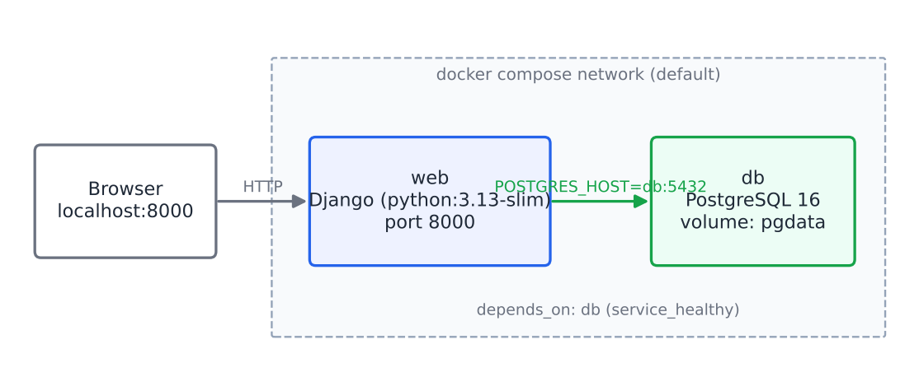
Figure 12: How the two containers communicate.
Check | Result
POSTGRES_PASSWORD=x docker compose config | Valid: both services and the pgdata volume are listed
docker compose config without the password | Stops with “required variable POSTGRES_PASSWORD is missing a value” (the intended safety check)
Django settings with POSTGRES_HOST=db | Uses django.db.backends.postgresql, host db
python manage.py check | No issues
Real run (Docker Engine 29.9.2, docker compose up, PostgreSQL 16). I started the project’s own Dockerfile and docker-compose.yml unchanged. The sandbox cannot reach Docker Hub, so I could not pull the official python:3.13-slim and postgres:16-alpine images. I built substitute base images with the same tags from Ubuntu 24.04 packages (Python 3.12.3 and PostgreSQL 16.2) and ran the compose file on top of them. An extra override file (not part of the project) only gave the image build access to the package proxy. So this proves that the Dockerfile builds, that the two containers start in the right order, and that the app and the database work together. It does not test the official images, and the app ran on Python 3.12, not 3.13.
$ docker compose ps
NAME IMAGE STATUS PORTS
fixed-db-1 postgres:16-alpine Up About a minute (healthy) 5432/tcp
fixed-web-1 fixed-web Up About a minute 0.0.0.0:8000->8000/tcp
db-1 | database system is ready to accept connections
web-1 | Applying orders.0001_initial... OK (and 20 more migrations)
web-1 | Successfully seeded 10 restaurants
web-1 | System check identified no issues (0 silenced).
web-1 | Starting WSGI development server at http://0.0.0.0:8000/
web-1 | "POST /orders/register/ 302", "GET /orders/cart/add/1/ 302" (x2), "POST /orders/checkout/ 302"
$ docker compose exec db psql -U foodmvp -c "select id, full_name, phone_number, total_amount, status from orders_order;"
id | full_name | phone_number | total_amount | status
----+-------------+-----------------+--------------+-----------
1 | Docker Demo | +91 90000 00000 | 17.98 | Preparing
I drove the browser (Chromium) through register, two “+ Add” clicks, the cart, checkout and history. The order is stored in PostgreSQL with the name, phone and total (the prototype stored none of them, DEF-04), and the 10 seed restaurants are in the db container. The db service has a health check, and web waits for it (depends_on: condition: service_healthy), so the migration did not start before the database was ready. The phone number and name are test data. The database password was generated for the run and is not stored in the repository. Figures 12a to 12c show the run.
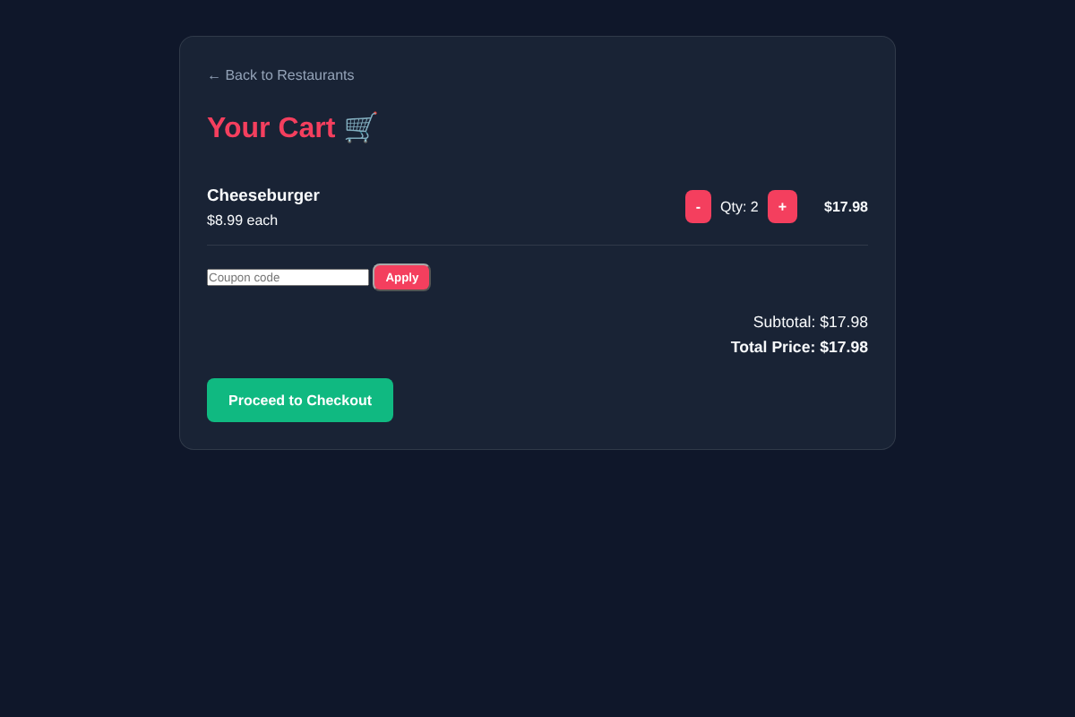
Figure 12a: The cart inside the container.
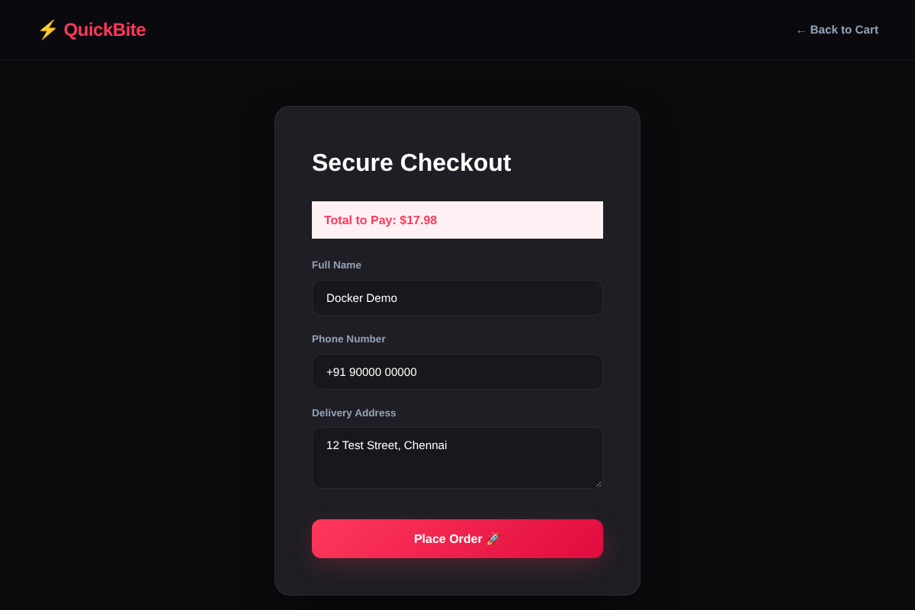
Figure 12b: Checkout with delivery details.
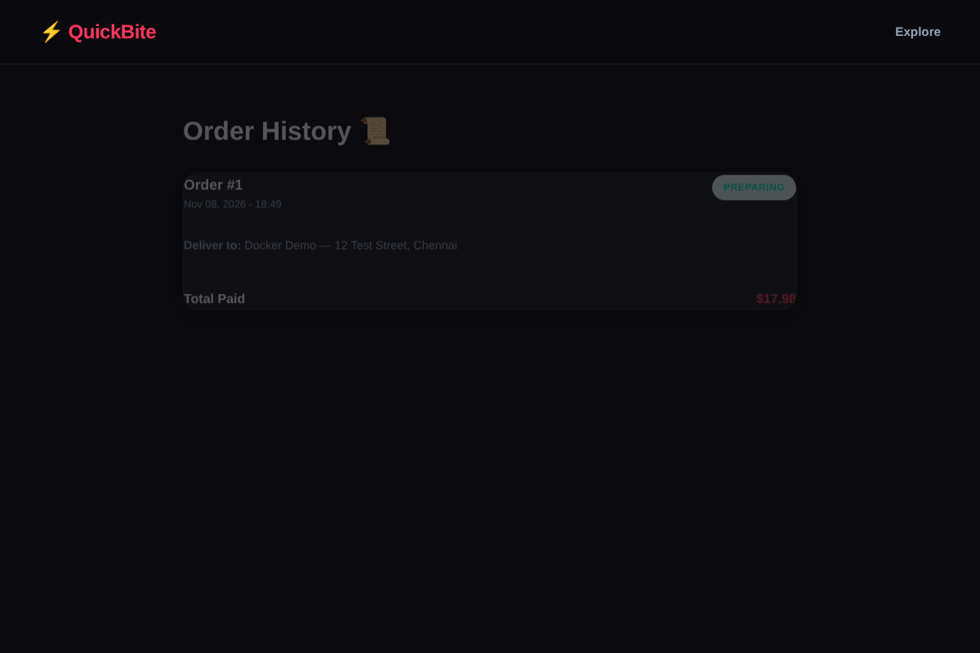
Figure 12c: Order history read back from PostgreSQL ($17.98).

Module 4 Labs: Testing, Selenium and Monitoring

L4.1 [Basic] Ten manual test cases, executed, and two defects
Executed on the prototype as submitted (steps done in a browser session driven by a script for repeatability; results match the automated tests). Test data: restaurant “Burger Joint”, items Cheeseburger $8.99 and Crispy Fries $3.99; user alice.
ID | Requirement | Steps | Expected | Actual | Result
TC-01 | FR-03 | Open the menu; press “+ Add” on Cheeseburger | Cart has Cheeseburger x 1 | Cart has Cheeseburger x 1 | Pass
TC-02 | FR-04 | Press “+ Add” on the same item twice | Quantity 2 | Quantity 2 | Pass
TC-03 | FR-04 | In the cart, press “-” at quantity 2 | Quantity 1 | Quantity 1 | Pass
TC-04 | FR-04 | Press “-” at quantity 1 | Line removed | Line removed | Pass
TC-05 | FR-05 | Add 2 burgers and 1 fries; open the cart | Total $21.97 | Total $21.97 | Pass
TC-06 | FR-05 | Open the cart with nothing in it | “Cart is empty” message | Message shown | Pass
TC-07 | FR-10 | As a visitor, open checkout | Redirected to a working sign-in page | Redirect happens, then the sign-in page returns an error 500 | Fail (DEF-02)
TC-08 | FR-07 | Signed in, empty cart, open checkout | Redirected to the cart | Redirected to the cart | Pass
TC-09 | FR-07 | Signed in, 1 burger in the cart, open checkout | “Total to Pay: $8.99” | “Total to Pay: $” (blank) | Fail (DEF-03)
TC-10 | FR-08, NFR-03 | Fill name, phone, address; press “Place Order” | Order saved with those values and total $8.99 | Order saved with empty name/phone/address and total $0.00; history shows “Deliver to: -” | Fail (DEF-04)
Result: 7 passed, 3 failed. Defects found while testing (all are reported with steps, expected result, actual result and severity):
ID | Title | Steps to reproduce | Expected | Actual | Severity
DEF-04 | Order loses delivery details and total | 1 Sign in. 2 Add an item. 3 Checkout: enter “Alice Rao”, “+91 98765 43210”, “12 MG Road, Pune”. 4 Place Order. 5 Open order history | Order shows the name, address and total | Deliver to: -, Total Paid $0.00. Cause: checkout() does not read the form fields or compute total_amount | Critical (a real order cannot be delivered or paid)
DEF-03 | Checkout total is blank | 1 Add an item. 2 Open /orders/checkout/ | “Total to Pay: $8.99” | “Total to Pay: $”. Cause: the view passes total_price but the template prints total | Major
Further defects from the same session and the automated runs:
ID | Title | Severity | Evidence
DEF-01 | Home page returns error 500 for a visitor who is not signed in (NoReverseMatch: 'register'; the link exists in the template but no register URL exists) | Critical | Figure 13, IT-07
DEF-02 | /accounts/login/ returns error 500 (TemplateDoesNotExist: restaurants/login.html; the file is in orders/templates/orders/) | Critical | Figure 14, IT-08
DEF-05 | Unavailable or non-existent items can be added to the cart (/orders/cart/add/99999/ stores id 99999) | Medium | IT-05, IT-06
DEF-06 | Delivery fields are validated only by the browser (required); the server accepts an empty order | Medium | IT-09
DEF-07 | Cart changes happen on GET links, and the redirect after adding trusts the Referer header (open redirect) | Medium | R3a, R3b in L5.3
UX-01 | No feedback after “+ Add”; the cart link shows no item count | Low | Task D session
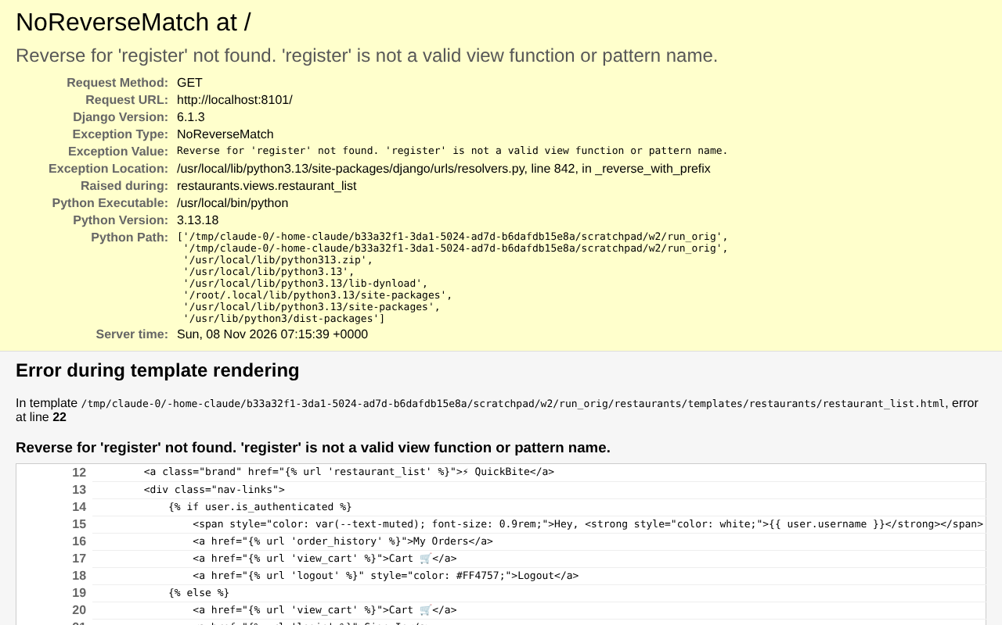
Figure 13: DEF-01. The home page for a visitor who is not signed in.
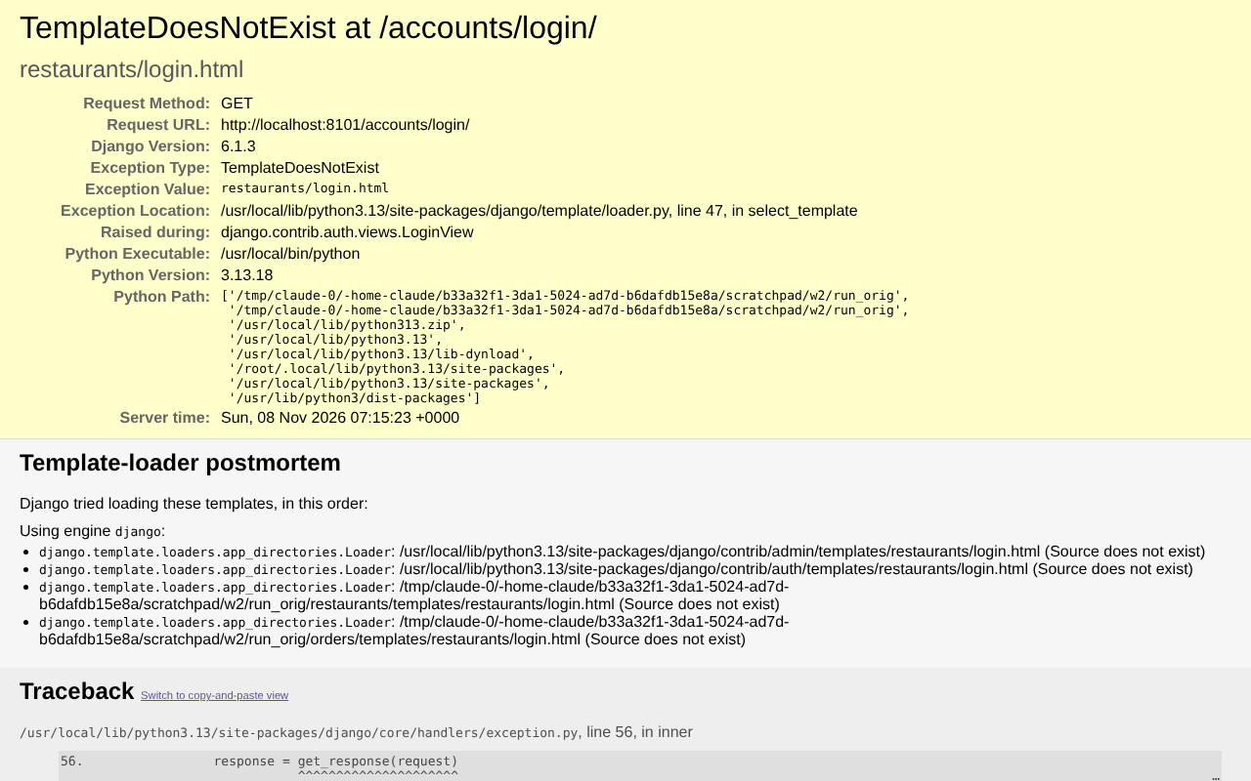
Figure 14: DEF-02. The sign-in page. The error page is the Django debug page because DEBUG is True.
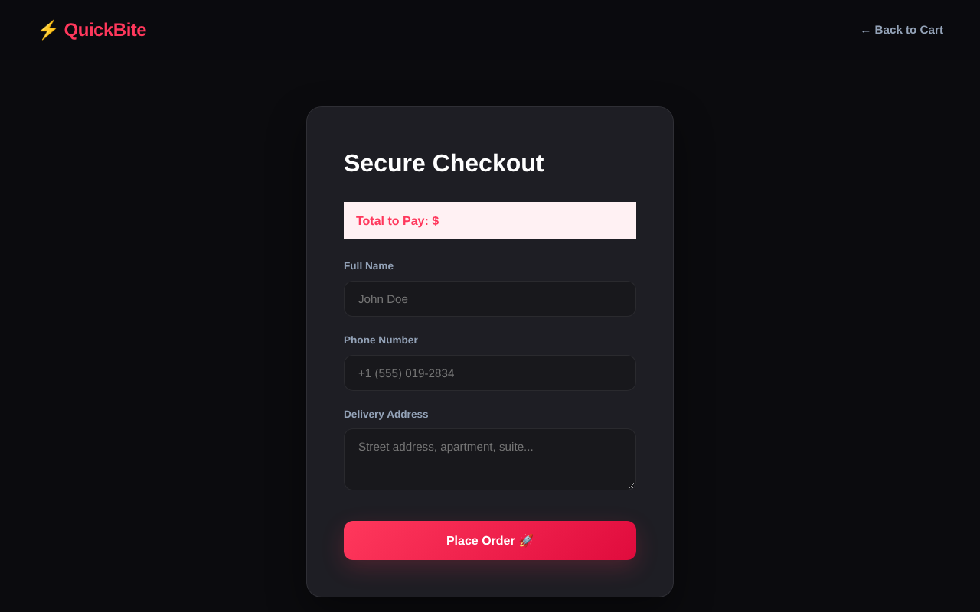
Figure 15: DEF-03. The checkout page shows “Total to Pay: $” with no number.

L4.2 [Basic] Five acceptance scenarios (Given-When-Then) and their execution
ID | Scenario | Prototype as submitted | Fixed copy
AS-1 | Given a signed-in customer with 3 items in the cart, when she applies SAVE10 and places the order, then the order total is $13.03 and the cart is empty | Fail (no coupon box) | Pass (Selenium S1)
AS-2 | Given a signed-in customer at checkout, when she leaves the address empty and submits, then no order is created and an error is shown | Fail (an empty order is created, DEF-06) | Pass (IT-09)
AS-3 | Given a visitor who is not signed in, when she opens the checkout, then she is taken to a working sign-in page | Fail (error 500, DEF-02) | Pass (AI-TC-06 + IT-08)
AS-4 | Given a sold-out item, when a customer tries to add it, then it is not added | Fail (it is added, DEF-05) | Pass (IT-05)
AS-5 | Given a placed order, when the customer opens order history, then it shows her name, address and total | Fail (blank details, DEF-04) | Pass (IT-02)
Evidence note. The five scenarios were executed by automated tests (the Result column above), not by a classmate acting as the client. No classmate sign-off is claimed. In a real project the product owner would run AS-1 to AS-5 on the fixed copy and mark each Accepted or Rejected before release.

L4.3 [Applied] The Selenium script converted to the Page Object Model
Both versions run in headless Chromium 153 with 3 scenarios each (S1 SAVE10 total $13.03, S2 FLAT5 total $9.48, S3 invalid code total $14.48); both pass (Ran 3 tests ... OK).
Version 1: plain script (one test shown).
def test_S1_save10(self):
d = self.driver
self.login_by_cookie()
for i in range(3):
d.get(f'{self.live_server_url}/restaurant/{self.rest.id}/')
d.find_elements(By.CSS_SELECTOR, 'a.btn-card')[i].click()
d.get(f'{self.live_server_url}/orders/cart/')
d.find_element(By.ID, 'coupon').send_keys('SAVE10')
d.find_element(By.ID, 'apply-coupon').click()
WebDriverWait(d, 5).until(EC.presence_of_element_located((By.ID, 'subtotal')))
self.assertEqual(d.find_element(By.ID, 'total').text, '13.03')
d.find_element(By.ID, 'checkout-link').click()
d.find_element(By.NAME, 'full_name').send_keys('Alice Rao')
d.find_element(By.NAME, 'phone_number').send_keys('+91 98765 43210')
d.find_element(By.NAME, 'address').send_keys('12 MG Road, Pune')
d.find_element(By.CSS_SELECTOR, 'button.btn-submit').click()
self.assertIn('/orders/history/', d.current_url)
Version 2: Page Object Model (page classes in Appendix C).
def test_S1_save10(self):
self.login_by_cookie()
MenuPage(self.driver, self.live_server_url).add_first_n_items(self.rest.id, 3)
cart = CartPage(self.driver, self.live_server_url).open().apply_coupon('SAVE10')
self.assertEqual(cart.total(), '13.03')
cart.proceed_to_checkout().place_order('Alice Rao', '+91 98765 43210', '12 MG Road, Pune')
self.assertIn('/orders/history/', self.driver.current_url)
Maintenance comparison (measured)
Measure | Plain script (3 tests) | POM (3 tests + pages.py)
Non-blank lines of code | 74 | 29 + 39 = 68
Locators written inline | 33 | 10 (all in pages.py)
Places that mention the “Apply” button | 3 | 1
Places that mention the “Checkout” link | 3 | 1
Test readability | Technical steps | Reads like the story
Note. If the designer renames #apply-coupon, the plain script needs 3 edits (one per test) and the POM needs 1. With one test the effort is the same, so POM pays off from the second test. The cost of POM is an extra file and an extra layer to learn; for a 4-week prototype I would start with POM once there is more than one scenario.

L4.4 [Applied] AI-generated tests: keep, remove, add
The AI produced 12 raw tests for the cart and order module (test_ai_raw_L44.py). Validity was judged against the requirements, not against what the code happens to do.
ID | Raw AI test | Valid? | Reason | Run on submitted code
A01 | Add returns a redirect | Valid | FR-03 | Pass
A02 | Quantity increments | Valid | FR-04 | Pass
A03 | “-” never goes negative | Valid | FR-04 | Pass
A04 | Cart total correct ($10.49) | Valid | FR-05 | Pass
A05 | Anonymous checkout is blocked | Valid | FR-10 | Pass
A06 | Order saves items and clears cart | Valid | FR-08 | Pass
A07 | Order saves the delivery address | Valid | FR-07, NFR-03 | Fail (DEF-04)
A08 | Order history lists orders | Valid | FR-09 | Pass
A09 | Add-to-cart must be POST-only (405 on GET) | Wrong | Not a requirement of the MVP (it is a security improvement, DEF-07, not a defect of the stated requirement) | Fail
A10 | Cart adds 5 % tax | Wrong | No tax in the scenario or the notes | Fail
A11 | “out of stock” message on a sold-out item | Wrong | The model has is_available only; no stock or message requirement | Error
A12 | Cart endpoint returns JSON | Wrong | The app renders HTML pages | Fail
Accuracy = 8 valid / 12 generated = 66.7 %. Of the 4 wrong tests, A09 is the one I turned into a real backlog item (DEF-07); the other 3 were removed.
Missing tests added by me (the AI did not think of them): empty cart (TC-06), unavailable item cannot be added (IT-05), unknown id (IT-06), empty delivery details (IT-09), checkout shows the total (IT-04), history shows only the user’s own orders (IT-03), quantity cap 20 (EC-Q4), coupon classes (EC-C1 to C7), and a corrupt or negative quantity (R2). Final set: the 8 valid AI tests were kept (they are covered by test_ai10 and test_cart_order), the 4 wrong ones were removed, and the missing ones were added; the final suite is the 35 tests of the Jenkins build (test_ai10 10, test_cart_order 13, test_equivalence 12). Final run on the fixed copy: Ran 35 tests ... OK; on the submitted code: 17 fail (13 failures, 4 errors).

L4.5 [Advanced] Monitoring dashboard with 6 metrics, thresholds and alert actions
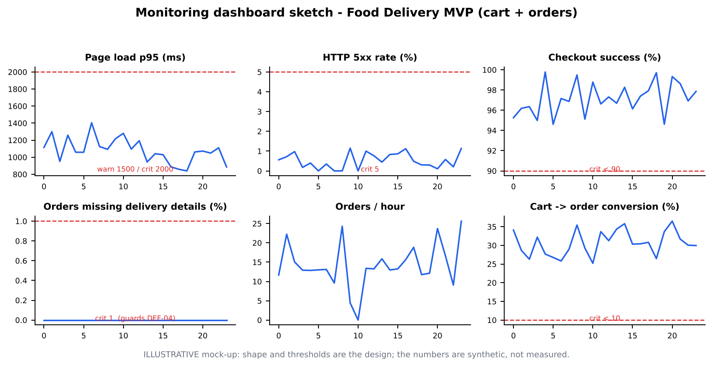
Figure 16: Dashboard sketch. The numbers in the sketch are synthetic; the six panels and the thresholds are the design.
# | Metric | How collected | Warn | Critical | Alert action
1 | Page load, 95th percentile (ms) | Probe of menu and cart pages every minute | 1500 | 2000 (NFR-02) | Check image sizes and database queries; roll back the last release if it started after a deploy
2 | HTTP 5xx error rate (%) | Probe and server log | 1 | 5 | Page the developer on duty; open a defect (this would have caught DEF-01 and DEF-02 at once)
3 | Checkout success rate (%) | Server log: completed orders divided by started checkouts | below 95 | below 90 | Stop the current release; check Jenkins and the last merge
4 | Orders missing details or total (%) | Database query on Order | 0.1 | 1 | Block new deploys; fix immediately (guards DEF-04, NFR-03)
5 | Orders per hour | Database count | falls 50 % below the same hour last week | 0 orders for 1 hour at peak | Check that the site is reachable; tell the product owner
6 | Cart-to-order conversion (%) | Needs analytics events | below 20 | below 10 | Product review: look at the checkout page and the coupon step
labs/monitoring/monitor.py implements metrics 1, 2, 4 (and the zero-total check) against the real app. Real output, run against a copy of the project database, which already holds one order placed through the app, plus one order placed by the script:
PROTOTYPE AS SUBMITTED FIXED COPY
page_load_p95_ms 3.1 OK page_load_p95_ms 3.8 OK
http_5xx_rate_pct 0.0 OK http_5xx_rate_pct 0.0 OK
orders_missing_details_pct 100 CRIT orders_missing_details_pct 50 CRIT
orders_zero_total_pct 100 CRIT orders_zero_total_pct 50 CRIT
The monitor catches the data defect (DEF-04) that the speed and error metrics cannot see. On the fixed copy 50 % is still critical, correctly, because the old order from before the fix remains in the database; it needs a data repair. Metrics 3, 5 and 6 need request logs or analytics that the prototype does not have.

Module 5 Labs: SQA, SonarQube and Ethical AI

L5.1 [Basic] Review with a checklist and the defects found
Evidence note. The sheet asks for a classmate’s code or requirement list. No classmate’s work was available, so the checklist was applied to this project’s own cart and order module and its requirement list (Table 1). No classmate review is claimed.
# | Checklist question | Met? | Finding
1 | Does every requirement have an ID and a test? | No | Before this report there was no test at all (orders/tests.py is empty)
2 | Does every form field that the user types get stored? | No | full_name, phone_number, address ignored (DEF-04)
3 | Are totals computed and shown correctly? | No | Blank total at checkout (DEF-03); total_amount never set (DEF-04)
4 | Do all pages open for every kind of user? | No | Home page for visitors (DEF-01); sign-in page (DEF-02)
5 | Is user input validated on the server? | No | Empty delivery details accepted (DEF-06); unknown and sold-out items accepted (DEF-05)
6 | Do state-changing actions use POST and CSRF? | No | Cart changes by GET link; unchecked Referer redirect (DEF-07)
7 | Are secrets kept out of the code? | No | SECRET_KEY is in settings.py
8 | Is debug mode off and are allowed hosts set for release? | No | DEBUG = True, ALLOWED_HOSTS = []
9 | Is duplicated code removed? | Partly | Quantity expression copied 4 times
10 | Are unused files and imports removed? | No | Unused success.html; unused import get_object_or_404 in orders/views.py
11 | Is the data model consistent with the migrations? | Yes | makemigrations --check reports no changes
12 | Are names clear and consistent with the requirements? | Yes | view_cart, order_history, FoodItem are clear
13 | Does the user get feedback after an action? | No | No message or cart count after “+ Add” (UX-01)
14 | Is personal data handled carefully? | Partly | Order stores phone and address (needed); no real data in the repository; the database file db.sqlite3 is committed
Result: of 14 questions, 10 were not met, 2 were partly met and 2 were met; 8 distinct defects and issues are reported (DEF-01 to DEF-07, UX-01) plus 3 hygiene findings (items 7, 8, 10).

L5.2 [Applied] Three code-quality findings in detail (rule, risk, fix)
Evidence note. SonarQube was not available, so these findings come from bandit, pylint and Django’s check --deploy, which report the same kind of issues. In SonarQube they would appear as one vulnerability or hotspot, one code smell and one duplication issue.
 | Finding 1: hard-coded secret | Finding 2: duplicated quantity logic | Finding 3: debug mode and open hosts
Tool and rule | bandit B105 (hardcoded_password_string), Low severity, config/settings.py:23 | Duplication check: the expression val.get('quantity', 0) if isinstance(val, dict) else int(val) appears 4 times in orders/views.py; duplication 4.9 % (4-line window) | Django check --deploy: security.W018 (DEBUG is True) and security.W020 (ALLOWED_HOSTS is empty)
Risk | Anyone who can read the repository knows the key that signs sessions and cookies; they could forge a session | A fix in one copy and not the others gives different cart behaviour in different pages (the corrupt-value crash in L5.3 R2 would have to be fixed 4 times) | With debug on, an error page shows source code, settings and variables to the visitor, as Figure 14 shows for DEF-02
Fix | Read the key from the environment: SECRET_KEY = os.environ['DJANGO_SECRET_KEY']; create a new key and never commit it | One helper _qty(); all 4 copies call it (done in the fixed copy; duplication 0 %, pylint 7.56 to 8.76) | DEBUG = os.environ.get('DEBUG') == '1'; ALLOWED_HOSTS from the environment (done for hosts in the fixed copy); set both in the Docker Compose file

L5.3 [Applied] AI code review of a pull request; every suggestion tested before acceptance
The pull request is the change from the prototype to the fixed copy (orders/views.py, 222 lines of diff: checkout saves details and total, coupon, helper functions, register view). The AI (a separate session that saw only the diff) returned 8 suggestions; suggestion 3 has two parts, so the table has 9 rows (R1 to R8, with R3a and R3b). For each I wrote a test that asserts the desired behaviour (test_ai_review_checks.py) and ran it on the code before the review.
ID | AI suggestion | Test result before change | Verdict | Decision
R1 | Create the order and its items inside transaction.atomic() | Fail: when the 2nd item fails, an orphan Order stays (1 order instead of 0) | Real (High) | Accepted: with transaction.atomic() added
R2 | A corrupt or negative quantity in the session must not crash or reduce the total | Fail: 'abc' raised ValueError; quantity -3 gave total $-26.97 | Real (High) | Accepted: _qty clamps to 0..20 and skips bad lines
R3a | Cart actions must not change state on GET; use @require_POST and CSRF forms | Fail: GET returns 302 and changes the cart | Real (High) | Deferred: the “+ Add” and “-” buttons are links; needs template forms (BUG-03)
R3b | Do not redirect to an unvalidated Referer | Fail: redirect went to https://evil.example/phish | Real (High) | Accepted: url_has_allowed_host_and_scheme added
R4 | A coupon can make the total $0.00 and be reused without limit; decide the rules | Fail: a $0.00 order is accepted | Real (Medium), but a business decision | Deferred to the product owner (BUG-04)
R5 | Keep the user’s input when the form shows an error; use a Django Form | not tested (style) | Reasonable (Medium) | Deferred (UX improvement)
R6 | Use django.contrib.messages instead of a session key for the coupon error | not tested (style) | Low value (the reviewer itself admitted no bug) | Rejected for this release
R7 | register may raise ValueError because login() has no backend | Pass: with one authentication backend (our configuration) registration works | False positive | Rejected
R8 | order_history has an N+1 query problem | Pass: exactly 3 queries for 3 orders (the template does not read the items) | False positive (also claimed that migrations were missing; the fields were already in migration 0001) | Rejected
Result of the 9 rows: 5 were confirmed real by a failing test (R1, R2, R3a, R3b, R4), 2 were style points that no test can prove (R5, R6), and 2 were false positives (R7, R8). Decisions: 3 accepted and fixed (R1, R2, R3b), 3 deferred (R3a, R4, R5), 3 rejected (R6 low value, R7 and R8 wrong). After the accepted changes:
before: Ran 8 tests ... FAILED (failures=5, errors=1)
after : Ran 8 tests ... OK (expected failures=2) # R3a and R4 are kept as documented, known failing tests
and the 35-test Jenkins suite still passes

L5.4 [Applied] One function written by hand and one by AI: 10 tests and static analysis
Function: cart_total(cart, prices): the sum of price x quantity for the lines in a cart. Manual version: the cart-total loop as it was written in the prototype’s view_cart, lifted into a function (the project’s own code). AI version: written from a prompt that described the cart format, legacy values and the limit 20. Both were run against the same 10 tests (labs/l54/test_total.py).
Measure | Manual version | AI version
Tests passed (of 10) | 7 | 10
Failing tests | 08 corrupt quantity 'abc' (crashes with ValueError); 09 negative quantity (total -$17.98); 10 quantity capped at 20 ($75.00 instead of $30.00) | none
Statements / branch coverage by the 10 tests | 12 / 100 % | 10 / 100 %
Cyclomatic complexity (radon) | cart_total A (4) | cart_total A (3), _quantity A (3)
Maintainability index (radon) | A (66.83) | A (66.69)
Security issues (bandit) | none | none
pylint score | 7.50 / 10 (unused import Decimal, no docstring, long line) | 8.00 / 10 (2 long lines)
Returns exact Decimal | No: starts from the integer 0, so an empty cart returns 0 not Decimal('0.00') | Yes
Evidence note. SonarQube was not available; the table shows its kind of measures (complexity, maintainability, security, duplication) from radon, bandit, pylint and coverage.
Reading the result. The AI version handled all the edge cases, but only because the prompt listed them; the manual version is exactly what the prototype did and it contains the defect R2 found in L5.3. The 10 tests, not the author, decided the comparison. Static analysis scores were close (7.50 versus 8.00), so they would not have caught the three functional gaps.

L5.5 [Advanced] AI disclosure statement, AI usage policy and licence check
The disclosure statement is in Appendix B. The usage log is in Appendix A.
One-page AI usage policy for the Food Delivery MVP team
# | Rule
1 | Allowed: drafting stories and test ideas, explaining code, generating boilerplate (Dockerfile, Jenkinsfile), refactoring, reviewing pull requests.
2 | Not allowed: pasting secrets, passwords, customer names, phones or addresses, or the production database into any AI tool. Use fake data (the seed restaurants and alice).
3 | Review: every AI-written line is read by a human before merge. Code needs a test; a security-relevant change needs a second person.
4 | Verification: AI facts and numbers are checked against the data or the documentation. An unverified AI statement does not go into a report or a pull request.
5 | Record: each use is written in the AI usage log (tool, prompt, how verified, decision). The pull request says which parts were AI-assisted.
6 | Accountability: the developer who merges the code owns it. “The AI wrote it” is not an excuse.
7 | Ethics: no fake reviews or ratings, no AI image presented as the real dish; sample data is labelled as sample data (Task E).
8 | Licences: check the licence of any library and any snippet that is not our own; no code copied from an unknown source.
9 | Bias and fairness: do not use AI to rank customers or restaurants in a way that hides the rule from them; examine suggestions that treat users differently by area, name or language.
10 | Review of this policy: at every retrospective, and after any incident.
Licence check of libraries and an AI snippet used (read from the installed package metadata):
Item | Licence | Use in the project | Can we use it?
Django 6.1.3 | BSD-3-Clause | The web framework (shipped) | Yes; keep the copyright notice
Selenium 4.52 | Apache-2.0 | UI tests (not shipped) | Yes
psycopg 3 (binary) | LGPL-3.0 | PostgreSQL driver in Docker | Yes as an unmodified library; do not modify it without publishing the changes
pylint 4.1 | GPL-2.0-or-later | Analysis tool (run on the code, not shipped) | Yes as a tool; its licence does not apply to the code it checks
bandit, coverage, radon | Apache-2.0, Apache-2.0, MIT | Analysis tools (not shipped) | Yes
AI snippet: add_to_cart (version 4, L3.1) | No separate licence; it uses only the public Django API | Part of the project code | Used as the project’s own code after review. The AI vendor’s terms (which say who owns the output) must be read by the team; I did not search for similar public code
Note: the repository has no LICENSE file; before publishing, the team should choose one (for example MIT) and add it.

Appendices

Appendix A: AI Usage Log
“Claude” = Claude Sonnet 5.5, the main assistant that worked on this report. “Separate session” = a fresh Claude session given only the text shown, so that it could not see my other work. The case names ChatGPT; ChatGPT was not used (see Appendix B).
Step | Tool | Prompt used (summary) | How I verified it | Decision
1 | Claude | Read the assignment sheet (6 pages) and the project zip; list every task, question and lab | Re-read the sheet pages a second time before writing each part | Accepted
2 | Claude | Inspect the code and run the app; find defects | Ran the app, the Django test client and a browser; screenshots (Figures 10, 13, 14, 15) | Accepted: DEF-01 to DEF-07
3 | Claude | Write 10 test cases for cart and order placement (AI-TC-01 to 10) | Ran them against the code; the 2 failures were traced to the lines of code | Accepted
4 | Claude | Write the fixed copy: save details and total, coupon, quantity cap, register and login wiring | 35 tests and 3 Selenium scenarios pass; migrations check clean | Accepted
5 | Claude | Write 12 raw tests for L4.4 and classify them | Judged each against the requirement list; ran them | Kept 8, removed 4
6 | Claude, separate session (Haiku) | L1.3 prompt, Tool A | Static comparison with project names, URLs and templates | Used for comparison only
7 | Claude, separate session (Sonnet) | L1.3 prompt, Tool B | Same | Used for comparison only
8 | Claude, separate session (Haiku) x 4 | L3.1 prompt versions 1 to 4 (one fresh session each) | Rubric scoring; version 3 and 4 code run inside a copy of the project with my tests | Version 4 chosen as best
9 | Claude, separate session (Sonnet) | L2.4: estimate the 10 stories (no access to my numbers) | Compared with my estimates; checked the biggest gaps against the code | Used as a second opinion
10 | Claude, separate session (Sonnet) | Task B: guess the bottleneck from the card dates | Re-computed every number from the data: 4 correct, 1 wrong | Used with the correction
11 | Claude, separate session (Sonnet) | L5.3: review the pull-request diff (8 suggestions) | Wrote a test for each suggestion and ran it before and after | Accepted 3, deferred 3, rejected 3
12 | Claude | L3.2: refactor add_to_cart | 7 behaviour tests before and after; a deliberate mutation was caught | Accepted
13 | Claude | L1.4: extract requirements from 8 messy notes; classify | Traced every item to a note | 5 correct, 4 vague, 3 invented
14 | Claude | Task A: 10 interview questions; summary table format | Removed 2 leading questions. The answer table is an illustration to be replaced with real user answers | Questions accepted; answers to be replaced
15 | Claude | L5.4: write the AI version of cart_total | 10 tests, coverage, radon, bandit, pylint | Accepted
16 | Claude | Write Jenkinsfile, Dockerfile, docker-compose.yml, requirements.txt | docker compose config validates; stage commands run locally; docker compose up run with PostgreSQL (L3.5), order saved and read back | Accepted; official images not tested
17 | Claude | Kanban simulation, dashboard and diagrams (code) | Re-computed lead time by hand (133 / 12 = 11.08); looked at every image | Accepted
18 | Claude | Draft the text of the report from the evidence | Every number was checked against the saved logs; statements that were not run are marked “Evidence note” | Accepted; to be read and owned by the student

Appendix B: AI Disclosure Statement
I used Claude (Anthropic) as an AI assistant (the case sheet names ChatGPT; I did not use ChatGPT). I used it to read the assignment and my project, to find defects, to write and run tests, to write a corrected copy of the cart and order module, to write the Jenkins, Docker and monitoring files, to draft the report text, and, in separate sessions, to estimate stories, review a pull request, guess a bottleneck and compare outputs. Each use is listed in Appendix A.
I verified the output by running the code and tests (35 Django tests, 3 Selenium scenarios in headless Chromium, a Docker Compose run with PostgreSQL, behaviour tests before and after a refactor), by checking each number in the report against the saved logs, by testing every AI review suggestion before accepting it, and by marking in the report the parts that were not run (SonarQube, Jenkins, official Docker images, real users, classmate sign-off, team poker).
I did not share confidential or personal data with any AI tool. The project uses sample restaurants and a test user only.
I have read this work, I have run the tests myself, and I can explain every answer in an interview.
Signature: ______________________ Date: ______________

Appendix C: Code Listings

C.1 Jenkinsfile
pipeline {
agent any
triggers { githubPush() } // build on every push
options { timestamps() }
stages {
stage('Checkout') { steps { checkout scm } }
stage('Build') {
steps {
sh 'python3 -m venv .venv'
sh '. .venv/bin/activate && pip install -r requirements.txt'
sh '. .venv/bin/activate && python manage.py check && python manage.py makemigrations --check --dry-run'
}
}
stage('Test') {
steps {
sh '. .venv/bin/activate && python manage.py test labs_tests.test_ai10 labs_tests.test_cart_order labs_tests.test_equivalence labs_tests.test_ai_review_checks_post -v 2'
}
}
stage('Package') {
steps {
sh 'zip -qr foodmvp-${BUILD_NUMBER}.zip config orders restaurants static manage.py requirements.txt Dockerfile docker-compose.yml'
archiveArtifacts artifacts: 'foodmvp-*.zip', fingerprint: true
}
}
}
post {
failure {
mail to: 'team@example.com',
subject: "FAILED: ${env.JOB_NAME} #${env.BUILD_NUMBER}",
body: "Build failed at ${env.BUILD_URL}console - the release was NOT packaged."
}
success { echo 'Build, tests and package passed - artifact archived.' }
}
}

C.2 Dockerfile
FROM python:3.13-slim
ENV PYTHONDONTWRITEBYTECODE=1 PYTHONUNBUFFERED=1
WORKDIR /app
COPY requirements.txt .
RUN pip install --no-cache-dir -r requirements.txt
COPY . .
EXPOSE 8000
CMD ["python", "manage.py", "runserver", "0.0.0.0:8000"]

C.3 docker-compose.yml
services:
db:
image: postgres:16-alpine
environment:
POSTGRES_DB: foodmvp
POSTGRES_USER: foodmvp
POSTGRES_PASSWORD: ${POSTGRES_PASSWORD:?set POSTGRES_PASSWORD in your shell or .env (not committed)}
volumes:
- pgdata:/var/lib/postgresql/data
healthcheck:
test: ["CMD-SHELL", "pg_isready -U foodmvp -d foodmvp"]
interval: 3s
timeout: 3s
retries: 15
web:
build: .
depends_on:
db:
condition: service_healthy
environment:
POSTGRES_HOST: db
POSTGRES_DB: foodmvp
POSTGRES_USER: foodmvp
POSTGRES_PASSWORD: ${POSTGRES_PASSWORD}
ALLOWED_HOSTS: localhost,127.0.0.1
ports:
- "8000:8000"
command: >
sh -c "python manage.py migrate --noinput &&
python manage.py seed_restaurants &&
python manage.py runserver 0.0.0.0:8000"
volumes:
pgdata:

C.4 Page objects for the Selenium tests (pages.py)
"""Page Object Model: one class per page; locators live here and nowhere else."""
from selenium.webdriver.common.by import By
from selenium.webdriver.support.ui import WebDriverWait
from selenium.webdriver.support import expected_conditions as EC
class BasePage:
def __init__(self, driver, base_url):
self.driver, self.base = driver, base_url
class MenuPage(BasePage):
ADD_BUTTONS = (By.CSS_SELECTOR, 'a.btn-card')
def open(self, restaurant_id):
self.driver.get(f'{self.base}/restaurant/{restaurant_id}/')
return self
def add_first_n_items(self, restaurant_id, n):
for i in range(n):
self.open(restaurant_id)
self.driver.find_elements(*self.ADD_BUTTONS)[i].click()
return self
class CartPage(BasePage):
COUPON = (By.ID, 'coupon'); APPLY = (By.ID, 'apply-coupon')
TOTAL = (By.ID, 'total'); CHECKOUT = (By.ID, 'checkout-link')
def open(self):
self.driver.get(f'{self.base}/orders/cart/'); return self
def apply_coupon(self, code):
self.driver.find_element(*self.COUPON).send_keys(code)
self.driver.find_element(*self.APPLY).click()
WebDriverWait(self.driver, 5).until(EC.presence_of_element_located((By.ID, 'subtotal'))) # page reloaded
return self
def total(self):
return self.driver.find_element(*self.TOTAL).text
def proceed_to_checkout(self):
self.driver.find_element(*self.CHECKOUT).click(); return CheckoutPage(self.driver, self.base)
class CheckoutPage(BasePage):
NAME = (By.NAME, 'full_name'); PHONE = (By.NAME, 'phone_number')
ADDRESS = (By.NAME, 'address'); SUBMIT = (By.CSS_SELECTOR, 'button.btn-submit')
def place_order(self, name, phone, address):
self.driver.find_element(*self.NAME).send_keys(name)
self.driver.find_element(*self.PHONE).send_keys(phone)
self.driver.find_element(*self.ADDRESS).send_keys(address)
self.driver.find_element(*self.SUBMIT).click()

C.5 Fixed checkout and cart helpers (orders/views.py, excerpt)
MAX_QTY = 20 # equivalence class: valid quantity per item is 1..20
COUPONS = {
'SAVE10': ('percent', Decimal('10')), # 10 % off
'FLAT5': ('flat', Decimal('5.00')), # $5 off
}
def _qty(val):
"""Cart values may be a dict (old format) or an int (current format).
Corrupt values count as 0; valid ones are clamped to 0..MAX_QTY (AI review R2)."""
try:
raw = val.get('quantity', 0) if isinstance(val, dict) else val
return max(0, min(int(raw), MAX_QTY))
except (TypeError, ValueError):
return 0
def _cart_lines(cart):
"""Return (lines, subtotal, clean_cart) for the session cart; skips bad ids."""
lines, subtotal, clean = [], Decimal('0.00'), {}
for item_id, val in cart.items():
try:
food = FoodItem.objects.get(pk=int(item_id), is_available=True)
except (FoodItem.DoesNotExist, ValueError):
continue
qty = _qty(val)
if qty < 1:
continue
line_total = food.price * qty
subtotal += line_total
lines.append({'food': food, 'quantity': qty, 'subtotal': line_total})
clean[item_id] = qty
return lines, subtotal, clean
def discount_for(code, subtotal):
"""Discount amount for a coupon code (never more than the subtotal)."""
rule = COUPONS.get((code or '').strip().upper())
if not rule:
return Decimal('0.00')
kind, value = rule
amount = subtotal * value / 100 if kind == 'percent' else value
return min(amount.quantize(Decimal('0.01')), subtotal)
@login_required
def checkout(request):
lines, subtotal, clean = _cart_lines(request.session.get('cart', {}))
if not clean:
request.session['cart'] = {}
return redirect('view_cart')
discount = discount_for(request.session.get('coupon'), subtotal)
total = subtotal - discount
if request.method == 'POST':
name = request.POST.get('full_name', '').strip()
phone = request.POST.get('phone_number', '').strip()
address = request.POST.get('address', '').strip()
if not (name and phone and address):
return render(request, 'orders/checkout.html',
{'total': total, 'total_price': total,
'error': 'All delivery fields are required'}, status=400)
with transaction.atomic(): # AI review R1: all-or-nothing
order = Order.objects.create(user=request.user, full_name=name,
phone_number=phone, address=address,
total_amount=total)
for line in lines:
OrderItem.objects.create(order=order, food_item=line['food'],
quantity=line['quantity'], price=line['food'].price)
request.session['cart'] = {}
request.session.pop('coupon', None)
return redirect('order_history')
return render(request, 'orders/checkout.html', {'total': total, 'total_price': total})

Appendix D: Repository Map and How to Reproduce
Path (in case03/) | Contents
original/ | The prototype exactly as submitted (zip contents)
fixed/ | Corrected copy with coupon feature, review fixes, Jenkinsfile, Dockerfile, docker-compose.yml, requirements.txt (the database file is not included; run migrate and seed_restaurants)
fixed/labs_tests/ | All tests: test_ai10, test_cart_order, test_equivalence, test_ai_raw_L44, test_ai_review_checks(_post), test_refactor_add_to_cart, Selenium linear and POM, pages.py
labs/l54/ | Manual and AI cart_total and their 10 tests
labs/kanban/ | Kanban simulation, card CSV and summary
labs/monitoring/monitor.py | Monitoring probe (L4.5)
labs/run_stages.sh, labs/dupcheck.py, labs/diagrams.py, labs/shots_perf.py, labs/explore.py | Pipeline emulation, duplicate detector, figures, screenshots and timing, exploratory session
evidence/ | Test logs, screenshots, timing and monitor output used in this report
cd fixed
python manage.py migrate && python manage.py seed_restaurants
python manage.py test labs_tests.test_ai10 labs_tests.test_cart_order labs_tests.test_equivalence # 35 tests
CHROMEDRIVER=<path> python manage.py test labs_tests.test_selenium_pom # Selenium (needs Chrome)
python labs/kanban/kanban_sim.py # Kanban table

