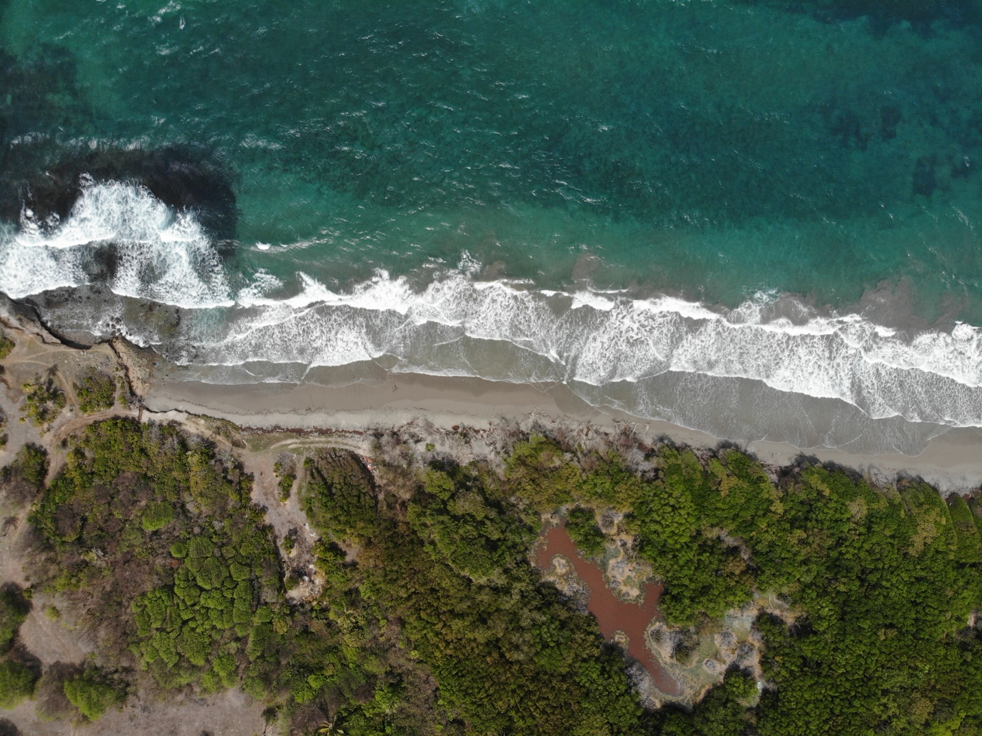SPECIES SORTING IN COASTAL WETLANDS – A HOLISTIC LOOK AT THE BIODIVERSITY WITHIN GRENADA’S MANGROVES

Zoya Buckmire1,2, Courtney Robichaud2, Casey Remmer2, Wayne Smart2, Brittney St. Clair3, Marissa Cornwall3, Patricia Rosa3, Nigel Gibbs2,3, Steve Nimrod3, Jody Daniel3

1 Grenada Fund for Conservation, St. George, Grenada, West Indies

2 Gaea Conservation Network, Grand Anse, St. George, Grenada, West Indies

3 St. George’s University, True Blue, St. George, Grenada, West Indies

* **Corresponding Author**: [jodyndaniel@gmail.com](mailto:jodyndaniel@gmail.com)

*Abstract*:

This study investigates bird community composition in Grenada's mangrove ecosystems, examining potential species sorting processes and relationships with plant communities. We assessed cross-taxon congruence between bird and plant communities, evaluated avian community differences between fringing and basin mangroves, and analyzed the predictive power of plant characteristics and site type on bird diversity. Our results revealed significant cross-taxon congruence only between bird communities and tree height. We found no significant differences in avian community composition between fringing and basin mangroves, and limited predictive power of plant characteristics or site type on bird diversity metrics. Preliminary data on invasive mammals and stable isotope analysis suggest additional factors influencing bird communities that may support species sorting mechanisms not captured by current physiographic categories. This study provides the first published records of bird communities in these understudied Grenadian mangrove sites, establishing valuable baseline data for Caribbean ornithology. Our findings highlight the complexity of factors influencing avian communities in mangrove ecosystems and emphasize the importance of comprehensive mangrove protection strategies for bird conservation in the Caribbean.

*Keywords*: Avian ecology; Mangrove conservation; Species sorting; Community composition; Cross-taxon congruence; Caribbean ornithology; Wetland birds

# 

# Introduction

By virtue of their abundant microhabitats, mangals (mangrove ecosystems) can support a wide range of wetland-dependent species such as waders, waterfowl, shorebirds, and more (Weller 1999; Hogarth 2015). These microhabitats are often due to differences in physiography - fringe, basin or riverine. Fringe mangroves, which are largely dominated by tidal regimes (Ewel et al., 1998) and have higher Nitrogen availability and cycling, also exhibit enhanced structural development (i.e., larger trees with wider canopies) when compared to basin mangroves (Rivera-Monroy et al., 1995; Reis et al., 2017). Basin mangroves, which are often fed by occasional storm/high tides, are more interior (Ewel et al., 1998) and their lower structural development may suggest that they are favored by birds of different functional traits from fringe mangroves. Tidal regimes are, therefore, the dominant abiotic filter structuring mangrove communities and assuming birds’ dispersal abilities among patches are equivalent, mangals may serve as a useful ecosystem to interrogate a species sorting model (see Leiobold et al 2004 for community assembly models).

Understanding the role of mangrove physiography in bird community structure would be valuable in our advocacy for protecting these neotropical wetlands. The vegetation, substrate, shallow water, and deep-water microhabitats all attract different types of waterbirds, with, for instance, waders preying on surface invertebrates like crabs, shorebirds probing for invertebrates in the substrate, and kingfishers feeding on fish in shallow waters (Weller 1999; Hogarth 2015). Many waterbirds also roost and nest in mangals (Weller 1999; Acosta et al. 2011; Hogarth 2015), often in large, mixed species colonies. Assuming mangroves vary on a gradient of tidal influence, we may come to observe that whichever avian family comes to dominate a wetland will be according to their functional groups and needs (Acosta et al. 2011; Hogarth 2015). Thus, each mangrove patch would support a unique assemblage of birds, making it important to protect the integrity of all wetlands in a geographic area. If we see, however, that there is little difference in the composition of birds that use various mangrove patches, it may suggest that the value of protecting a wetland complex is to …

In the Grenada, as with other Caribbean islands, mangroves more often serve as stopover sites for birds en route to South American overwintering sites (McNair 2008), with migratory species especially depending on mangroves as they are attracted to the shallow water habitat and abundant food in these ecosystems (Hogarth 2015; Azimah & Tarmiji 2018); . The patches of stopover habitat provided by the Caribbean islands are critical for these migratory birds (McNair 2008; Merken et al. 2015), and Grenadian mangals serve an important role on the southern end of this stopover network.In the multi-island state of Grenada, there are ~298 ha of mangrove forest across almost 40 sites (Moore et al. 2015). Most of these are basin mangrove habitat, which is characterized by the diverse microhabitats described above, and Moore et al. considered this type of mangal to be “some of the most valuable and diverse foraging habitat for birds” (2015:158). Official records of the bird community in mangals in Grenada are lacking, but citizen-science data has identified >80 species, and indeed the (top 10) most diverse local hotspots on eBird are mangrove wetlands or sites that contain some mangrove vegetation (eBird 2020). Of the 153 avian species officially documented in Grenada, over 40% (63 species) are migratory (Gerbracht and Levesque 2019). Migratory birds are particularly sensitive to habitat changes, detecting them from distances as much as 500 m away (Azimah & Tarmiji 2018), so small changes in the extent or quality of available mangroves can have significant impacts on stopover habitat use. The ripple effects of stopover habitat loss include lower migration or reproduction success and higher mortality (Merken et al. 2015). Unfortunately, mangrove habitats in Grenada are under threat from several natural and anthropogenic forces (FAO 2007; Moore et al. 2015; Buckmire et al., 2022).

Hurricanes are one such threat, often resulting in significant degradation or destruction of habitat with slow and asynchronous/nonlinear recovery (McNair 2008; Moore et al. 2015). Grenada’s southerly location precludes it from regular/frequent storms like the rest of the Caribbean, but it has experienced 3 major hurricanes in the last 7 decades (Hurricane Janet in 1955, Hurricanes Ivan and Emily in 2004 and 2005 respectively); the effects of these storms on mangroves throughout the country are well-documented (e.g., Moore 2004, Layman et al. 2006). Furthermore, deforestation, especially for tourism development, is rampant, and the FAO (2007) recognized this as the primary cause of mangrove loss in the region over the preceding decades. On the island of Grenada, three mangals (totaling ~ 59 ha) are currently undergoing disturbance related to resort developments, and the impacts on the bird community are still being determined (Buckmire in review). Climate change is also expected to increasingly threaten mangrove ecosystems, through a myriad of processes including sea level rise, surface and atmospheric temperature increases, saltwater intrusion, acidification, changes in coastal topography, habitat conversion, and increased storm intensity and frequency (Merken et al. 2015; Moore et al. 2015; Jennerjahn et al. 2017).

To combat these losses and safeguard waterbird habitat, mangrove restoration is recommended (Lewis 2009) and has been attempted at several sites in Grenada, primarily by the Grenada Fund for Conservation Inc. and YWF-Kido Foundation. However, in the absence of information on the relationship between mangrove physiography and bird community structure, we may restore/recreate wetlands that do not improve the integrity of national-level wetland complexes. Assuming that fringing mangroves support more diverse bird habitat, it may be valuable to focus efforts (when there is little capacity) on protecting and restoring these habitats. If, however, there is no real difference in the functional traits and bird composition by basin versus fringing mangroves, it would suggest that even with little capacity, we should equally restore and protect both basin and fringing mangroves.

Here, under a, a multi-year project funded by Environment and Climate Change Canada, we attempt to improve the mangrove restoration success rates using a data-driven approach. We sought to determine whether there was support for species sorting in mangroves in Grenada, using data on bird and plant communities. We assumed that if there was support for species sorting, where plant communities determine which birds occupy a wetland, we would observe; 1) strong cross-taxon relationships between birds and plants; 2) differences in community composition by whether the site was fringing versus basin; 3) differences in which species/functional traits are associated with basin versus fringing mangroves. We also sought to understand whether plant or site-type were predictive of bird diversity. We hypothesize that if species sorting explains which taxa occupy sites, it provides support for efforts to protect all mangroves, regardless of their physiography. Thus, this study aimed to quantify the avian community within mangals in Grenada, and identify any correlations, if present, between mangrove community structure and avian community composition. This paper also provides the first published records of the bird community at these understudied but critical mangrove sites.

# Methods

We collected this data in February–June 2020, at four mangals on the island of Grenada (12°06' N, 61°41' W). These sites were identified from previous mapping done by Moore et al. (2015) and preliminary surveys in June 2019, and were selected based on their diversity in size, shape, species composition, and anthropogenic disturbance. The four sites are the Mt. Hartman (12°00'27" N, 61°45'0" W), Westerhall (12°01'01" N, 61°42'09" W), Conference (12°09'26" N, 61°36'33" W), and Levera (12°13'19" N, 61°36'44" W) wetlands (**Figure 1**).

Mt. Hartman and Westerhall are both located on the southeastern coast of Grenada. Mt. Hartman is a 12-ha wetland (Moore et al. 2015) with a pair of large, rectangular mudflats interspersed with mangrove trees; field surveys for this study were only conducted in the slightly larger west pond. The site is bordered on its landward edge by a National Park and dove sanctuary; however, the land adjacent to the park, including the wetlands, was recently leased for development of a resort village and the fringes of the mangal have already sustained damage. The area was unfortunately also used as a dumping site for construction debris, resulting in significant pollution. Westerhall is a narrow 14.0-ha mangal (Moore et al. 2015) bordered on its inland edge by a sugarcane plantation and some industrial buildings. The surrounding communities (to the north, east, and west) are densely populated and there may be effluent pollution from a nearby rum factory.

Conference and Levera are located on the northeastern coast of the island. Conference is 27 ha (Moore et al. 2015) and has two ponds within the system. The surrounding land is agricultural and the nearest community (to the west) is sparsely distributed; however, a rum factory was recently built just inland of the mangal, and the effects of any effluent from the factory remain to be seen. Levera is the largest of the four sites (and largest in Grenada) at 46 ha (Moore et al. 2015), with a large central pond of ~9 ha. There are developments/settlements to the south and east of the mangal, and while the mangal is technically protected as a Ramsar site (est. 2012; Ramsar Sites Information Services n.d.), parts of the forest have recently been leased for development of a resort village. All surveys at Mt. Hartman and Levera were conducted before the start of the resort developments at those sites.

## Field Surveys

We established several transects at each site, spaced 200 m apart on the shoreline. Each site had a different number of transects due to its unique shape and size; Mt. Hartman and Conference both had 2 transects, Westerhall had 4 transects, and Levera had 7 transects. Along each transect, we established 3 equidistant plots for our mangrove sampling, with one plot at either end (seaward and landward) and one in the middle of the transect; this was done to ensure each zone of the mangal was sampled equally. The distance between plots varied among sites and transects, from approximately 35 m at the shortest transect to 290 m at the longest. Levera was unique in that all the transects were oriented to its central pond and thus radiated out from the pond rather than running perpendicular to the shoreline like at the other sites.

At each plot, we first made note of the species present and counted all established/viable seedings (<1 m tall) and estimated the percentage cover by species. We divided mature trees into 5 size classes by circumference (at breast height): 0–3.18 cm, 3.19–7.96 cm, 7.97–31.82 cm, 31.83–63.65 cm, and >63.65 cm. After counting all the trees of each species in each size class, we then selected a representative tree from each class and took additional height and canopy width measurements. Several water quality parameters were measured where standing water was present, including depth, salinity, temperature, and dissolved oxygen (DO); the latter were measured using a TOA-DKK WQC-24 multiparameter water quality meter. Lastly, we recorded the depth of the redox potential discontinuity layer, as a proxy for oxygen content in the soil. These methods were adapted for local conditions from Cintrón-Molero & Schaeffer-Novelli (1984), Hortsman et al. (2014), and World Bank (2019).

We also surveyed birds at the 1st (seaward) and 3rd (landward) plots at each site. Bird counts were done between sunrise and 1100, once monthly per site. After a 5–10-min acclimation period at each plot, we used 8-min single-observer point counts with a radius of 25 m, recording all birds seen or heard. Surveys were conducted between February–May and each site was visited twice/thrice; additional surveys were planned but could not be completed due to Covid-19 restrictions in place at the time.

## Data Analysis

Assuming that whether a mangrove is classified as fringe or basin constrains which birds choose to forage or nest, we sought to understand whether there was evidence of species sorting among Grenada's mangroves. We posited that if mangrove type limited which species could occupy a site, we would observe strong agreement in plant and bird community composition. We also sought to evaluate which plant structural characteristics were predictive of bird diversity and whether community structure differed by site type, conducting all analyses in R version 4.2.2 (R Core Team, 2022).

We used both Procrustes Analysis and Mantel tests to assess whether bird and plant composition covary. These complementary approaches were chosen to provide a robust assessment of community congruence: Procrustes analysis considers the specific spatial configuration of community data points, while Mantel tests examine the correlation between distance matrices. Different data transformations were applied to optimize each test's performance and to ensure the assumptions of each test were met. Due to the limited sample size when sites were categorized by type (basin or fringe), we focused our analyses on overall community composition rather than conducting separate analyses for basin and fringe sites. We examined the congruence between bird communities and individual plant metrics (tree height, basal area, and canopy width) using the same approach.

For the Procrustes analysis, we first performed Hellinger transformations on both the bird and plant community matrices using the decostand function from the vegan package (version 2.6-4; Oksanen et al., 2023) in R. This transformation is particularly useful for abundance data as it gives low weights to variables with low counts and many zeros. We then used the protest function to perform the Procrustes test. For the Mantel test, we applied Wisconsin double standardization to both matrices using the wisconsin function, which standardizes species to maximum abundance and sites by total abundance. This was followed by the calculation of dissimilarity matrices using the vegdist function. We then performed the Mantel test using the mantel function with Spearman's rank correlation, which is less sensitive to non-linear relationships than Pearson's correlation.

We used Permutational Multivariate Analysis of Variance (PERMANOVA) to assess whether community composition differed by site type for both birds and plants. For birds, we analyzed both abundance data and trait data. For plants, we examined tree height, basal area, and canopy width separately. First, we prepared the data matrices, applying appropriate transformations: Wisconsin double standardization for bird abundance data, and maximum standardization for plant metrics and bird trait data. We then calculated distance matrices using Bray-Curtis dissimilarity. PERMANOVA was performed to test for homogeneity of multivariate dispersions, followed by an ANOVA to assess the significance of differences between site types. We also conducted post-hoc pairwise comparisons using Tukey's Honest Significant Difference test to identify specific differences between site types. To account for potential effects of data transformation on the results, we ran additional analyses using Hellinger transformation for the plant metrics. This approach allowed us to compare the consistency of our findings across different data transformations.

Finally, we used a series of ANCOVA models to assess whether plant abundance and site type were predictive of bird diversity. These models examined the effects of site type and species basal area on bird species abundance, species richness, Shannon-Weiner index, functional dispersion, functional richness, functional evenness, and functional divergence. We used the dbFD function from the FD package (version 1.0-12; Laliberté et al., 2014) in R to calculate various functional diversity metrics for the bird communities, including functional dispersion, functional richness, functional evenness, and functional divergence. These functional metrics were based on a matrix of species abundances and binary traits.

# Results

From our preliminary results, we found that red and white mangroves were structurally the most important species overall, with IVIs of 124 and 123 respectively. Black mangroves were least important overall, except at Mt. Hartman where black and white mangroves were equally important and red mangroves were the minority.

We counted over 600 individual birds of 34 species across all 4 sites. Levera was the most diverse site, with 25 species, followed by Westerhall (20), Mt. Hartman (19) and Conference (16). The most commonly seen species were landbirds like Bananaquits, Scaly-naped Pigeons (‘ramier’), and Tropical Mockingbirds, but we also found high numbers of Laughing Gulls, Common Gallinules (‘moorhen’), and Black-bellied Whistling Ducks. The endemic subspecies of House Wren was found at all sites, and the endemic Grenada Flycatcher was common as well. Thus, the mangrove ecosystems in Grenada are very diverse and support both waterbirds and landbirds, including endemic species and subspecies.

To assess whether bird and plant composition covary, we conducted Procrustes analysis and Mantel tests on the overall dataset, combining both site types. Both the Procrustes analysis and Mantel test showed significant congruence between bird community composition and tree height (m^2 = 0.838, p = 0.035; r = 0.296, p = 0.012). While for the Procrustes analysis, congruence between bird communities and basal area (m2 = 0.797, p = 0.161) or canopy width (m2 = 0.795, p = 0.301) were not significant, they were for the Mantel test (basal area - r = 0.200, p = 0.063; canopy width: r = 0.161, p = 0.081).

We conducted Permutational Multivariate Analysis of Variance (PERMANOVA) to assess whether community composition differed by site type (basin vs. fringe) for both birds and plants. The PERMANOVA for bird abundance data showed no significant difference in community composition between basin and fringe sites (F(1) = 0.230, p = 0.635). Similarly, when analyzing bird functional traits, we found no significant difference between site types (F(1) = 0.338, p = 0.566). For plant characteristics, we analyzed basal area, canopy width, and tree height separately: 1) basal area: no significant difference was found between basin and fringe sites (F(1) = 2.29, p = 0.137); 2) canopy width: the analysis showed no significant difference between site types (F(1) = 1.33, p = 0.255); and 3) tree height: there was a marginally significant difference in tree height between basin and fringe sites (F(1) = 3.64, p = 0.0631).

We conducted a series of ANCOVA models to examine the effects of mangrove species composition and basal area on various bird community metrics. Our ANCOVA models did not reveal any significant effects of mangrove species composition or basal area on bird community metrics, including species richness, abundance, Shannon-Wiener diversity, functional dispersion, and functional divergence. Log-transformed species richness and abundance were not significantly affected by mangrove type (F(2,39) = 0.093, p = 0.911 for richness; F(2,39) = 0.012, p = 0.988 for abundance) or basal area (F(1,39) = 0.025, p = 0.875 for richness; F(1,39) = 0.055, p = 0.816 for abundance). The interaction between mangrove type and basal area was also non-significant for both metrics (F(2,39) = 0.086, p = 0.918 for richness; F(2,39) = 0.006, p = 0.994 for abundance). The Shannon-Wiener diversity index showed no significant relationship with mangrove type (F(2,39) = 0.151, p = 0.860), basal area (F(1,39) = 0.143, p = 0.708), or their interaction (F(2,39) = 0.259, p = 0.773). Functional dispersion was not significantly affected by mangrove type (F(2,39) = 0.454, p = 0.638) or its interaction with basal area (F(2,39) = 1.114, p = 0.338). While basal area showed a marginally stronger effect on functional dispersion, it was not statistically significant (F(1,39) = 2.148, p = 0.151). Similarly, functional divergence showed no significant relationships with mangrove type (F(2,39) = 0.499, p = 0.611), basal area (F(1,39) = 1.278, p = 0.265), or their interaction (F(2,39) = 1.057, p = 0.357).

# Discussion

In this study, we examined species sorting processes in Grenada's mangrove ecosystems, focusing on the relationships between bird and plant communities. We investigated whether plant communities influence bird occupancy in mangroves, a key aspect of species sorting theory. Our research assessed cross-taxon congruence between bird and plant communities, evaluated differences in community composition between fringing and basin mangroves, and examined associations of bird species and functional traits with these mangrove types. We also analyzed the predictive power of plant characteristics and site type on bird diversity. This investigation aims to provide evidence-based support for mangrove conservation strategies, emphasizing the potential importance of protecting all mangroves regardless of their physiography. Additionally, our study contributes the first published records of bird communities in these understudied mangrove sites in Grenada, establishing valuable baseline data for future research and conservation efforts.

Our results showed limited evidence for species sorting in Grenada's mangroves, with only tree height demonstrating significant cross-taxon congruence with bird communities.

The lack of significant differences in community composition between fringing and basin mangroves suggests that these physiographic categories may not be strong determinants of bird community structure in our study sites, or we lacked sufficient power to detect these relationships due to sample size.

Despite the absence of clear species sorting patterns, our findings highlight the importance of tree height as a potential driver of bird community composition in mangrove ecosystems.

Our study sites harbor complex ecological interactions beyond bird-plant relationships, as evidenced by unpublished data on invasive mammal occurrence (Appendix1) and fish community composition (Appendix 2) in fringing mangroves, which may influence avian community structure through predation pressure and prey availability, respectively.

Preliminary stable isotope data indicate that plant species may be utilizing different water sources within the mangrove ecosystem, potentially supporting species sorting mechanisms that are not captured by our current physiographic categories (Appendix 3).

The absence of strong predictive relationships between plant characteristics or site type and bird diversity metrics underscores the complexity of factors influencing avian communities in mangrove ecosystems.

Our study provides valuable baseline data on bird communities in Grenada's mangroves, highlighting the need for further research to untangle the multiple factors influencing community assembly in these important ecosystems.

# References

Acosta M, Mugica L, Rodríguez A, Jiménez A. 2011. A General Overview of Waterbird Communities in Cuba. Journal of Caribbean Ornithology 24:10–19.

Azimah AR, Tarmiji M. 2018. Habitat requirements of migratory birds in the Matang Mangrove Forest Reserve, Perak. Journal of Tropical Forest Science 30:304–311.

Cintrón-Molero G, Schaeffer-Novelli Y. 1984. Methods for studying mangrove structure. Pages 91–113 in S. C. Snedaker and J. G. Snedaker, editors. The Mangrove Ecosystem: research methods. Unesco, Bungay, United Kingdom.

FAO. 2007. The world’s mangroves 1980-2005. FAO Forestry Paper 153:89.

Hogarth PJ. 2015. The Mangrove Community: Terrestrial Components. Pages 80–106 The Biology of Mangroves and Seagrasses, 3rd edition. Oxford University Press.

Ewel, K., Twilley, R., & Ong, J. I. N. (1998). Different kinds of mangrove forests provide different goods and services. Global Ecology & Biogeography Letters, 7(1), 83-94.

Jennerjahn TC, Gilman E, Krauss KW, Lacerda LD, Nordhaus I, Wolanski E. 2017. Mangrove ecosystems under climate change. Page Mangrove Ecosystems: A Global Biogeographic Perspective: Structure, Function, and Services.

Laliberté, E., Legendre, P., & Shipley, B. (2014). FD: measuring functional diversity from multiple traits, and other tools for functional ecology. R package version 1.0-12.

Lewis RR. 2009. Methods and Criteria for Successful Mangrove Forest Restoration. Pages 787–800 COASTAL WETLANDS: An Integrated Ecosystem ApproachFirst edit. Elsevier. Available from http://dx.doi.org/10.1016/B978-0-444-53103-2.00028-4.

McNair DB. 2008. Bird Abundance and Species Richness in Mangrove Forest At Sugar Bay, St. Croix, Us Virgin Islands: Long-Term Comparison Before and After Hurricane Hugo. Journal of Caribbean Ornithology 21:17.

Merken R, Deboelpaep E, Teunen J, Saura S, Koedam N. 2015. Wetland suitability and connectivity for trans-saharan migratory waterbirds. PLoS ONE 10:1–20.

Moore GE, Gilmer BF, Schill SR. 2015. Distribution of Mangrove Habitats of Grenada and the Grenadines. Journal of Coastal Research 31:155.

Oksanen, J., Simpson, G. L., Blanchet, F. G., Kindt, R., Legendre, P., Minchin, P. R., ... & Wagner, H. (2023). vegan: Community Ecology Package. R package version 2.6-4. <https://CRAN.R-project.org/package=vegan>

Reis, C. R. G., Nardoto, G. B., Rochelle, A. L. C., Vieira, S. A., & Oliveira, R. S. (2017). Nitrogen dynamics in subtropical fringe and basin mangrove forests inferred from stable isotopes. Oecologia, 183, 841-848.

Rivera-Monroy VH, Day JH, Twilley RR, Vera-Herrera F, CoronadoMolina C (1995) Flux of nitrogen and sediment in a fringe mangrove forest in Terminos Lagoon. Mex Estuar Coast Shelf Sci 40:139–160. doi:10.1016/S0272-7714(05)80002-2

R Core Team (2022). R: A language and environment for statistical computing. R Foundation for Statistical Computing, Vienna, Austria. URL <https://www.R-project.org/>.

Weller MW. 1999. Major groups of birds that use wetlands. Pages 23–48 Wetland Birds: habitat resources and conservation implications. Cambridge University Press, Cambridge.

World Bank. 2019. Mangroves Monitoring and Evaluation Manual for Jamaica (2019).

**Figure 1**: Mangrove site locations in the island of Grenada, grouped as either fringe (Mt Hartman and Westerhall) or Basin (Conference and Levera).

**Figure 2**: Mantel and Procustes Analyses results, showing the strength of the relationship between birds and plants using basal area, canopy width and tree height as a proxy for plant community composition for red (), black () and white mangroves (). 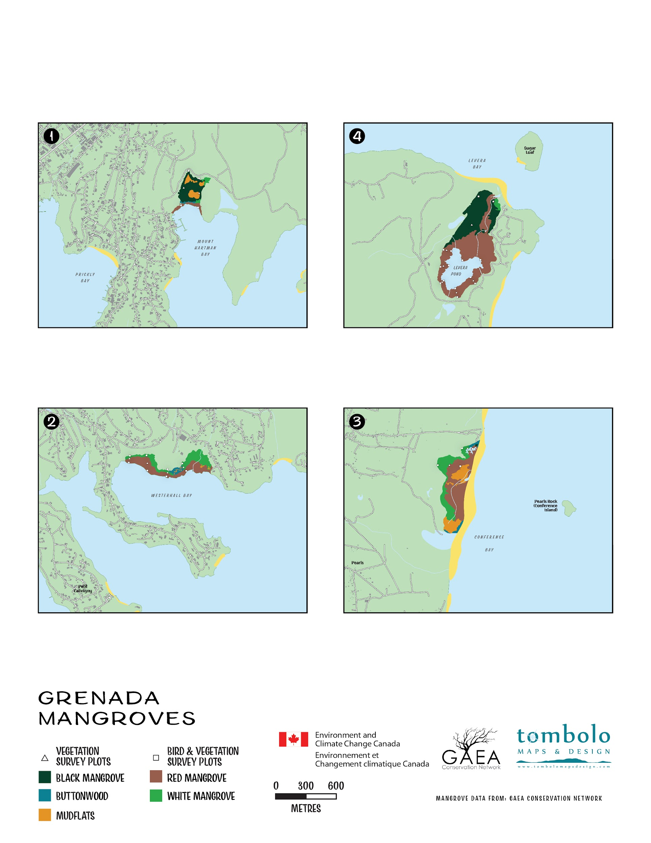

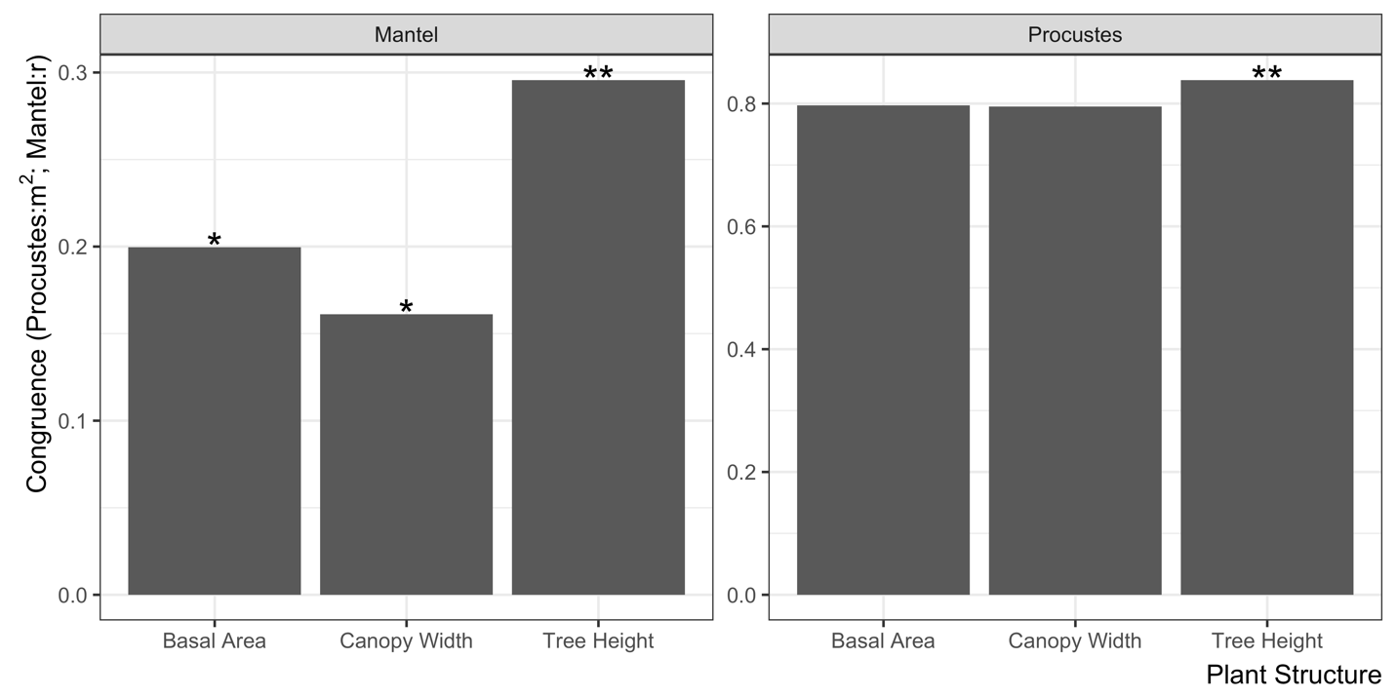

**Appendix 1**: Number of camera detections of mammals at Mt. Hartman, Conference, and Levera using trail cameras left out for one week during the same period. Brown rat occupancy and detection probabilities were significant overall (22% and 17%, respectively, p<0.005p < 0.005p<0.005), but these probabilities did not differ significantly between sites. For dogs and cats, the limited number of detections resulted in unstable estimates for occupancy and detection, making it difficult to compare across sites. Occupancy and detection estimates were derived using single-season occupancy models implemented in the unmarked package in R. The underlying data are available on FigShare (DOI: 10.6084/m9.figshare.25442140).

**Appendix 2**: Abundance of juvenile fish, by functional guild, observed from catch and relase study in Mt Hartman and Westerhall. The underlying data are available on FigShare (DOI: 10.6084/m9.figshare.25442140).

**Appendix 3**: Stable isotopes result for X and Y from samples collected at all four sites. The water samples were sourced from either the sea, streams or surface accumulation. The underlying data are available on FigShare (DOI: 10.6084/m9.figshare.25442140).