VELLORE INSTITUTE OF TECHNOLOGY
School of Computer Science Engineering and Information Systems
BACSE203 P Computer Network Lab
FIRST REVIEW
Project Title: Closed-Loop Network Intrusion Detection: Translating Explainable AI (SHAP) into Automated Firewall Rule Synthesis
Submitted by:
# | Name | Reg. Number
1 | Abburu Gayatri Sree | 25BDE0045
2 | Shashwat Jaiswal | 25BDE0060
3 | Swathya Mohit Tulsian | 25BYB0104
4 | KH Manishkanda | 25BDE0063

Under the Guidance of: Dr. Priya M, Associate Professor
Date of Submission: 06/10/2026

1. Title & Abstract
Title: Closed-Loop Network Intrusion Detection: Translating Explainable AI (SHAP) into Automated Firewall Rule Synthesis.
Abstract
Signature-based security tools cannot recognise novel, zero-day attacks, while accurate machine learning alternatives often behave as opaque “black boxes”. Explainable AI (XAI) reduces that opacity, but current XAI-based network intrusion detection systems (NIDS) remain purely observational: they produce force plots and beeswarm graphs that network engineers must interpret by hand and then re-write as firewall syntax while an active attack is underway. This project treats explainability not as the end goal but as an intermediate engine. It benchmarks a GPU-accelerated XGBoost classifier against a Random Forest baseline on NSL-KDD, applies SHAP (TreeExplainer) to isolate the header attributes that drive each anomaly verdict, and passes those attributions to a novel, deterministic rule-translation engine. The engine extracts SHAP’s top marginal contributors (for example, a src_bytes threshold or an anomalous TCP flag) and formats them as deployable Snort and iptables rules. A Scapy-based .pcap pipeline and a Streamlit dashboard complete the loop by letting an administrator upload a capture, inspect the verdicts and explanations, and copy the generated rule in one click. Phase 1 groundwork has already validated high-precision detection (97%), which is the property that keeps automatically generated blocking rules from disrupting benign traffic.

2. Problem Statement
Defending a modern network involves three linked problems, each of which leaves the next one unsolved:
- Signature systems (detection gap). Tools such as Snort match traffic against known rules, so unknown or mutated payloads produce no alert until a signature is written and deployed.
- Standard machine learning (explanation gap). Classifiers detect anomalies far better than static rules, but most return only a label such as “attack”. The opaque prediction prevents an administrator from quickly verifying the incident or knowing how to mitigate it.
- Current explainable AI (the passive XAI bottleneck, and the research gap). Existing XAI tools produce visual plots (force plots, beeswarm graphs) designed for post-incident human review. During an active breach, human reaction time is too slow to translate those graphs into firewall syntax. There is no automated bridge between algorithmic interpretability and network prevention.
Problem to solve: build an anomaly-based NIDS that is accurate on unseen attack traffic, justifies every alert in terms of packet and flow attributes an administrator already understands, and converts that justification directly into a deployable firewall rule.

3. Objectives
- Benchmark core classifiers: train and compare a Scikit-Learn Random Forest and a GPU-accelerated XGBoost model (tree_method='hist') across the 41 flow attributes of the NSL-KDD benchmark, using accuracy, precision, recall, F1-score, confusion matrices and training/inference time.
- Feature attribution via cooperative game theory: deploy SHAP (TreeExplainer) to compute exact Shapley values for individual flagged connections, isolating the malicious header characteristics.
- Automated mitigation rule synthesis (novel core): design a deterministic Python translation engine that converts primary SHAP anomaly thresholds into deployable Snort rule signatures and iptables commands.
- Operational verification dashboard: build an interactive Streamlit dashboard paired with a Scapy .pcap parser to ingest offline packet captures, display classification metrics, render attribution graphs, and output the auto-generated firewall rules.

4. Literature Review & Base Paper
Traditional tabular NIDS research (for example the survey by Shaukat et al. [5]) established that machine learning detects attacks better than static rules. This review therefore concentrates on recent work (2025–2026) on explainable and actionable intrusion detection and positions the project against it.

Reference / Year | Focus & Methodology | Key Findings & Strengths | Limitations & Identified Research Gap
[1] ExAI5G (arXiv, April 2026) | Base Paper: Logic-based XAI framework for 5G networks using a Transformer-based IDS, Integrated Gradients, surrogate decision trees, and LLM-generated explanations. | Achieved 99.9% accuracy with a 16-rule set at 99.7% fidelity. Successfully proved that deep learning detection performance and operational transparency (inspectable rules) can coexist. | Relies on a surrogate model and an LLM layer, which introduces latency and hallucination risks into security-critical paths. The explanation layer is non-deterministic and computationally heavy.
[2] Khan et al. (Industry 5.0 Review) | Systematic review of 135 studies evaluating XAI-based intrusion detection frameworks and trust in Industry 5.0 environments. | Concluded that the opacity of black-box models is the primary barrier to high-stakes adoption. Established the necessity of "dual-output" systems (delivering both classification and feature-level rationale). | Focuses on passive XAI-NIDS approaches where explanations (SHAP/LIME) are generated strictly as visual plots for human review, offering no automated mitigation.
[3] Sensors Study (2026) | Explainable anomaly detection for IoT sensor networks utilizing a deep autoencoder and feedforward classifier paired with SHAP and LIME. | Demonstrated that attributing each anomaly to specific network features is the definitive route to trustworthy detection in edge networks. | Output is purely observational. Fails to close the loop by translating the explained tree-model alerts into actionable prevention measures.
[5] Shaukat et al. (NIDS Survey) | Comprehensive survey evaluating traditional tabular Network Intrusion Detection Systems (NIDS) and classical machine learning methodologies. | Established the foundational premise that machine learning algorithms significantly outperform static, signature-based rules (e.g., Snort) in detecting complex attacks. | Classical ML approaches (like Random Forest) are computationally large and offer little to no built-in explanation for individual alerts.
Proposed System | Deterministic Closed-Loop ML NIDS integrating XGBoost, SHAP (TreeExplainer), and a Scapy .pcap ingestion pipeline via a Streamlit dashboard. | Generates the anomaly alert, visual SHAP explanation, and a ready-to-deploy Snort/iptables firewall rule in a single, sub-millisecond pass. Eliminates LLM latency and hallucination risks. | Auto-generated rules are constrained to network header-derivable features.

Research gap. Existing work either detects well but cannot explain, explains only as plots for human review, or derives rules through heavy surrogate and LLM pipelines. None closes the loop from an explained tree-model alert to a ready-to-deploy Snort/iptables rule that is reproducible and cheap enough for the edge. This project fills that gap, and connects it to real packet captures through a .pcap-to-dashboard pipeline.

Capability | Signature NIDS | Passive XAI-NIDS | Proposed system
Detects unseen (zero-day) attacks | No | Yes | Yes
Explains each alert | Rule name only | Yes (plots) | Yes (SHAP, per alert)
Generates a firewall rule automatically | No (written by hand) | No | Yes (Snort / iptables)
Accepts raw .pcap input | Yes | Rarely | Yes (Scapy)
Interactive analyst view | Console / logs | Rarely | Streamlit dashboard with rule export

4.1 References
- ExAI5G: A Logic-Based Explainable AI Framework for Intrusion Detection in 5G Networks. arXiv:2604.18052, April 2026.
- N. Khan et al., “Explainable AI-Based Intrusion Detection Systems for Industry 5.0 and Adversarial XAI: A Systematic Review,” Information, vol. 16, no. 12, art. 1036, 2025.
- “Explainable Intrusion and Anomaly Detection for IoT Sensor Networks Using Hybrid Feature Selection and Deep Autoencoder Learning,” Sensors, vol. 26, no. 14, art. 4540, July 2026, doi: 10.3390/s26144540.
- NSL-KDD dataset: https://www.kaggle.com/datasets/hassan06/nslkdd
- K. Shaukat, S. Luo, V. Varadharajan, I. A. Hameed and M. Xu, “A Survey on Machine Learning Techniques for Cyber Security in the Last Decade,” IEEE Access, vol. 8, pp. 222310–222354, 2020, doi: 10.1109/ACCESS.2020.3041951 (https://ieeexplore.ieee.org/document/9277523).

5. Proposed Methodology & Architecture
The system has two paths that share one trained model (Fig. 1). The offline path prepares NSL-KDD and benchmarks the two classifiers. The inference path turns a Wireshark capture into flow features, predicts, explains, and then synthesises a firewall rule. The key change from a standard XAI-NIDS is the dedicated Rule Synthesis Engine placed between the SHAP Explainer and the Streamlit interface. The step-by-step flow is shown in Fig. 2.
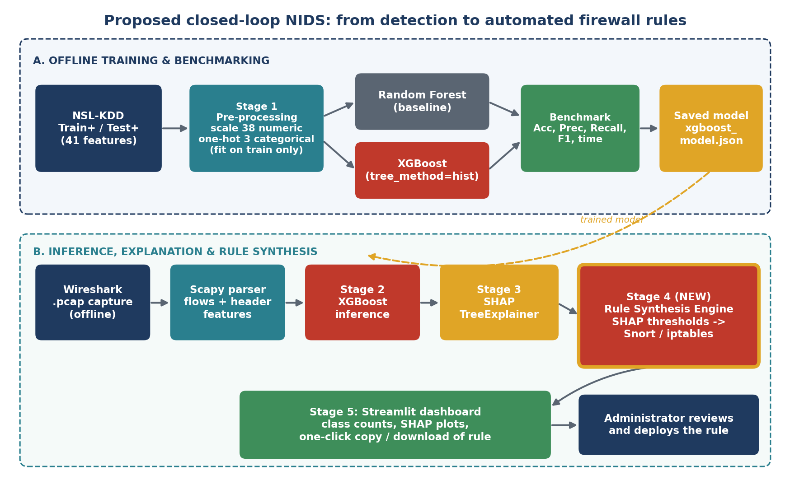
Figure 1: Block diagram of the proposed closed-loop NIDS.

5.1 Five-stage architecture
- Data preprocessing. Standard scaling of the 38 continuous features; one-hot encoding of the categorical fields (protocol_type, service, flag). Both transforms are fitted strictly on training data to prevent statistical leakage. NSL-KDD (KDDTrain+ with 125,973 records, KDDTest+ with 22,544 records) is first checked for duplicates and nulls.
- Inference engine. High-throughput inference with the trained XGBoost classifier (tree_method='hist' on the NVIDIA RTX 3050) on incoming flows. A Random Forest trained on the same split serves as the benchmark baseline and is evaluated on KDDTest+, whose attack mix differs from training, which tests generalisation to unseen attack variants.
- Attribution layer. SHAP TreeExplainer calculates local feature contributions for any flow classified as Anomaly (1). Global summary plots show which features drive detection overall; per-alert plots show why one flow was flagged.
- Rule synthesis engine (new). A Python parser extracts the features whose attribution exceeds a threshold (for example src_bytes > 5200 together with flag == S0) and maps them through a fixed dictionary of feature-to-rule-field translations into Snort syntax, for example:
alert tcp any any -> any any (msg:"Auto-Mitigated Anomaly";
dsize:>5200; flags:S; sid:1000001;)

The same attributions are also formatted as an iptables command (for example, iptables -A INPUT -p tcp --syn -m length --length 5200:65535 -j DROP). Both outputs are illustrative of the format; the exact thresholds come from the SHAP analysis of each flagged flow.
- Interface and delivery. The Streamlit dashboard displays live classification counts, SHAP plots, and a one-click copy/download button for the generated prevention rule. A Scapy script reads the offline .pcap upload, groups packets into flows (source/destination IP, ports, protocol) and computes the flow statistics (duration, src_bytes, dst_bytes, flags, connection counts) that feed stage 2.

5.2 Feasibility note: feature alignment
NSL-KDD contains 41 features. Basic features (duration, protocol, service, flag, src_bytes, dst_bytes) and time-window traffic features (for example count, srv_count, serror_rate) can be computed from packet headers and flow grouping. Content features (for example num_failed_logins, root_shell) need payload or host-log inspection and cannot be derived reliably from a header-level .pcap. The Phase 1 benchmark uses all 41 features. For the deployed pipeline, the project adds a feature-alignment step: the model used on uploaded captures is trained on the subset of NSL-KDD features the Scapy parser can reproduce, and both models are compared again on that subset. This matters doubly for rule synthesis, because a firewall rule can only reference attributes that exist in a packet or flow header (bytes, flags, ports, protocol). Flow-level quantities such as src_bytes also map only approximately onto per-packet rule fields such as dsize, so generated rules are shown to the administrator for confirmation rather than pushed to a firewall automatically.
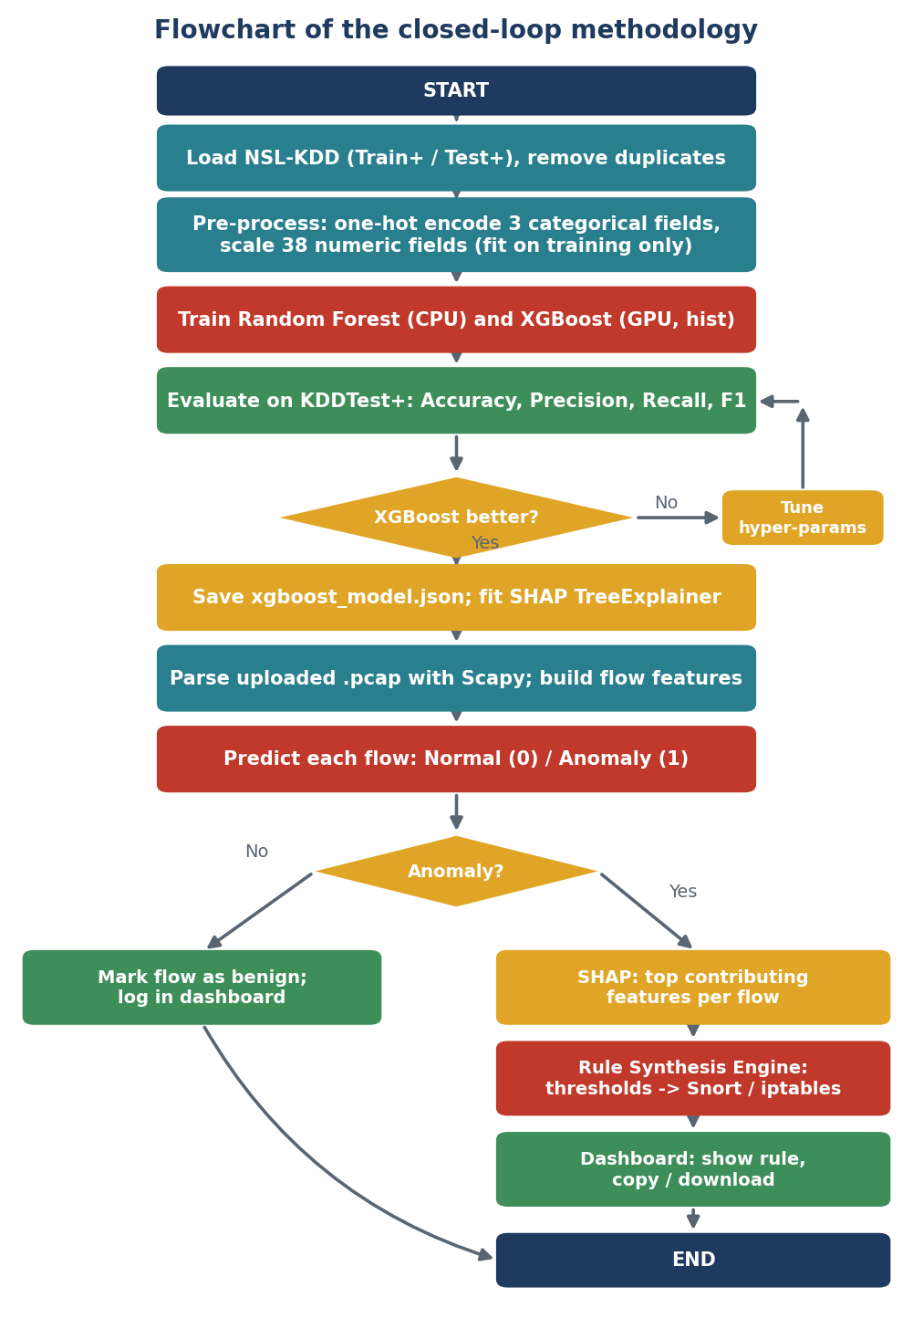
Figure 2: Flowchart of the proposed methodology.

6. Current Progress & Performance (Phase 1 – 70%)
Phase 1, covering pre-processing and the Random Forest and XGBoost benchmark on NSL-KDD, is complete and accounts for about 70% of the project. The test metrics below are unchanged from the earlier review; what changes is how they support the automated-defence goal.
Metric | Result | Why it matters for the closed loop
Accuracy | XGBoost 80.42% vs Random Forest 76.48% | XGBoost outperforms the baseline on KDDTest+, so it is the model carried into SHAP and rule synthesis.
Recall | 68% on KDDTest+ | KDDTest+ deliberately contains attack variants absent from the training set. 68% recall shows the model generalises to unseen, zero-day-like traffic rather than memorising known patterns.
Precision | 97% | The primary strength. In an automated rule generator, false positives are costly because blocking legitimate traffic is a self-inflicted denial of service.
False positives | 307 of 9,711 normal connections (about 3.2%) | Few enough benign flows are misflagged that generated rules rarely target legitimate traffic; the dashboard still shows each rule for review before use.

The 97% precision figure is what makes the project’s central claim credible: SHAP-driven rules are built only from flows the model flags, so a classifier that rarely flags benign traffic is the precondition for rules that rarely block it.

7. Tools & Environment
Category | Tool | Purpose
Hardware | NVIDIA GeForce RTX 3050 GPU | GPU-accelerated XGBoost training (tree_method='hist') and fast inference
Language | Python 3 | Entire pipeline, including the rule synthesis engine
ML libraries | Scikit-learn, XGBoost | Pre-processing, Random Forest, XGBoost, metrics
Explainability | SHAP | Per-feature attribution (TreeExplainer) on the saved xgboost_model.json
Packet handling | Scapy | Parse .pcap files, build flow features
Capture / analysis | Wireshark | Generate and verify .pcap test captures
Rule output | Snort rule syntax, iptables | Target formats for the synthesised prevention rules
Interface | Streamlit | Interactive dashboard with one-click rule copy/download
Dataset | NSL-KDD | Training and benchmark data

8. Work Plan & Phase Breakdown (Remaining 30%)
The remaining work, leading to the Final Review (Oct, 2nd week 2026), is split into four steps over seven days (Fig. 3). Phase 1 is complete.
Phase | Tasks | Window | Output
Phase 1 (done) | Pre-process NSL-KDD; train and benchmark Random Forest and XGBoost | Complete | Saved model, baseline metrics
Explainability layer | Initialise SHAP TreeExplainer on the saved xgboost_model.json artifact; generate static summary plots and local force plots | Days 1–2 | Global and local explanations
PCAP ingestion & translation logic | Build the Scapy packet dissector converting raw .pcap files into model features; code the dictionary-based Snort rule synthesis script | Days 3–4 | Parser and rule synthesis scripts
Dashboard integration | Assemble the Streamlit UI: .pcap upload, risk score gauges, interactive SHAP visualisers and rule generation display | Days 5–6 | Working dashboard
Evaluation packaging | Capture screenshots of an end-to-end zero-day detection and automated rule export; compile all benchmark graphs for the final review | Day 7 | Final review material
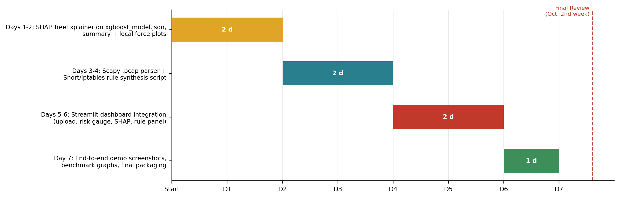
Figure 3: Gantt chart of the work plan for the remaining 30%.

