T-Stick Performance Setup for FM Synthesis

Requirements
Hardware
- T-Stick Sopranino, 5th Generation
- Laptop
- Router (optional but recommended for a dedicated network)
Software
- Supercollider 3.13.0 or higher: https://supercollider.github.io/
- SC3 plugins (ensure installation before starting) TBC
Files
- TStick-FM-Gen5.scd: SuperCollider patch.

Preparatory steps

- Follow the connection guide to update T-Stick to connect to the same WiFi network as your laptop. You will need to IP address of your computer on the network you’re connected to.
  - Either create a Wireless access point (hotspot) or use a dedicated router (it is not recommended to rely on a public WiFi network)
- The patch requires a basic knowledge of Supercollider. In file TStick-FM-Gen5.scd:
  - Select output device. If you’re using an external soundcard select the corresponding ASIO driver (On Windows, WASAPI is recommended)
  - If the chosen device is not found, SC will boot using system’s default device
  - The list of drivers / device available can be found by running the following line of code:

- Assign the name of T-Stick to global variable ~tStick and value of the port to which the T-Stick will send data to global variable ~recvPort
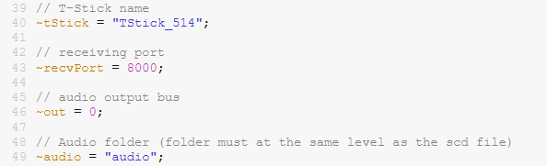
It is recommended to perform these steps in advance before a performance, although they can be performed at step 4 of the concert performance setup….
Performance Setup
- Initialize Hardware
- If using a router, power it on and allow time for initialization.
- Connect your soundcard to the laptop (if applicable).
- Prepare Laptop (not necessary during a rehearsal…)
- Set the laptop’s power and sleep settings to "Never" to avoid losing WiFi connection.
- Connect the laptop to the local network (hotspot or router).
- Power On T-Stick
- Turn on the T-Stick (button double-click) and ensure it connects to the network.
- Start SuperCollider
- Launch SuperCollider, open TStick-FM-Gen5.scd and choose the appropriate audio driver, port and T-Stick name.
- Evaluate main code.
- Tune FSR (Force-Sensitive Resistors) and Shake Inputs
- Calibrate the sensitivity settings in the patch based on your performance needs.
- Start and navigate calibration by single-clicking button.

These are the steps reconmmended for concert setup

Volume may be adapted with the volume GUI if lack of other volume control

