EVGAM – Non -Stationary test

Auld paper:

I found the formulae used in the Auld et al, 2023 ‘s paper. They are using the Markov random field smoothing.

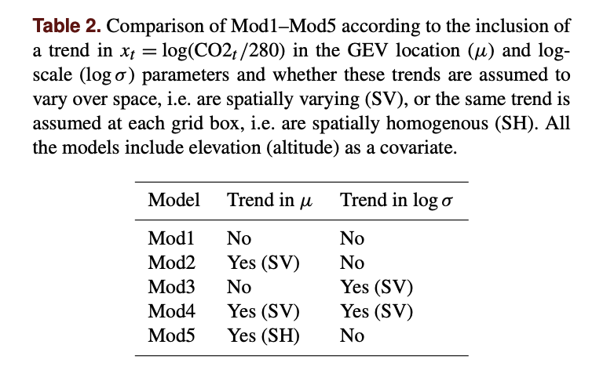

The formulas for their different tests.

mod1_formulas <- list(MaxTemp ~ s(cell,bs="mrf",k=989, xt=list(nb=nb)) +

elevation,

~ s(cell,bs="mrf", k=494, xt=list(nb=nb)),

~ s(cell,bs="mrf", k=395, xt=list(nb=nb)))

mod2_formulas <- list(MaxTemp ~ s(cell,bs="mrf", k=989, xt=list(nb=nb)) +

s(cell,bs="mrf", k=494, xt=list(nb=nb), by=CO2) +

elevation,

~ s(cell,bs="mrf", k=494, xt=list(nb=nb)),

~ s(cell,bs="mrf", k=395, xt=list(nb=nb)))



mod3_formulas <- list(MaxTemp ~ s(cell,bs="mrf",k=989, xt=list(nb=nb)) +

elevation,

~ s(cell,bs="mrf",k=494, xt=list(nb=nb)) +

s(cell,bs="mrf",k=494, xt=list(nb=nb), by=CO2),

~ s(cell,bs="mrf",k=395, xt=list(nb=nb)))

mod4_formulas <- list(MaxTemp ~ s(cell,bs="mrf",k=989, xt=list(nb=nb)) +

s(cell,bs="mrf",k=494, xt=list(nb=nb), by=CO2) +

elevation,

~ s(cell,bs="mrf",k=494, xt=list(nb=nb)) +

s(cell,bs="mrf",k=494, xt=list(nb=nb), by=CO2),

~ s(cell,bs="mrf",k=395, xt=list(nb=nb)))

mod5_formulas <- list(MaxTemp ~ s(cell,bs="mrf",k=989, xt=list(nb=nb)) +

elevation + CO2,

~ s(cell,bs="mrf", k=494, xt=list(nb=nb)),

~ s(cell,bs="mrf", k=395, xt=list(nb=nb)))

Here is a table of the different tests I did.

Test 6 is not yet implemented and I won’t use the same k. If I understand correctly, they are using cell as a lon,lat smoothing with nb the neighbors of those cell.

|  |  |  |  |  |
| --- | --- | --- | --- | --- |
|  | Time period | location | scale | shape |
| Test 0 | 1980 - 2008 | s(glost,k=5) +  s(air, bs = "cr") +  s(lon, lat) | s(lon, lat) | s(lon, lat) |
| Test 1 | 1980 - 2008 | s(glost,k=5) +  s(air, bs = "cr") +  s(lon, lat) | s(air, bs = "cr")+ s(lon, lat) | s(air, bs = "cr")+ s(lon, lat) |
| Test 2 | 1950 - 2008 | s(glost,k=5) +  s(air, bs = "cr") +  s(lon, lat) | s(lon, lat) | s(lon, lat) |
| Test 3 | 1980 - 2008 | s(glost,k=5) +  s(air) +  s(lon, lat) | s(air)+  s(lon, lat) | s(air)+  s(lon, lat) |
| Test 4 | 1980 - 2008 | s(glost,k=5) +  s(air, bs = "cr") +  s(lon, lat) | s(glost,k=5) + s(lon, lat) | s(lon, lat) |
| Test 6 | 1980-2008 | s(cell,bs="mrf",k=989, xt=list(nb=nb)) +  s(cell,bs="mrf",k=494, xt=list(nb=nb), by=glost) +  elevation | s(cell,bs="mrf",k=494, xt=list(nb=nb)) +  s(cell,bs="mrf",k=494, xt=list(nb=nb), by=CO2), | s(cell,bs="mrf",k=395, xt=list(nb=nb)) |

glost : Annual Global Land and Ocean Temperature Anomalies from NOAA_GLOST_anomaly.csv

air= DJF mean Temperature at each grid point computed from ERA5 tas file.

**TEST 0**

1980 - 2008

%R fmla_gev_glost <- list(AFI ~ s(glost,k=5) + s(air, bs = "cr") + s(lon, lat),

~ s(lon, lat) ,

~ s(lon, lat))

%R fmla_gev <- list(AFI ~ s(air, bs = "cr") + s(lon, lat),

~ s(lon, lat) ,

~ s(lon, lat))

**fmla_gev**

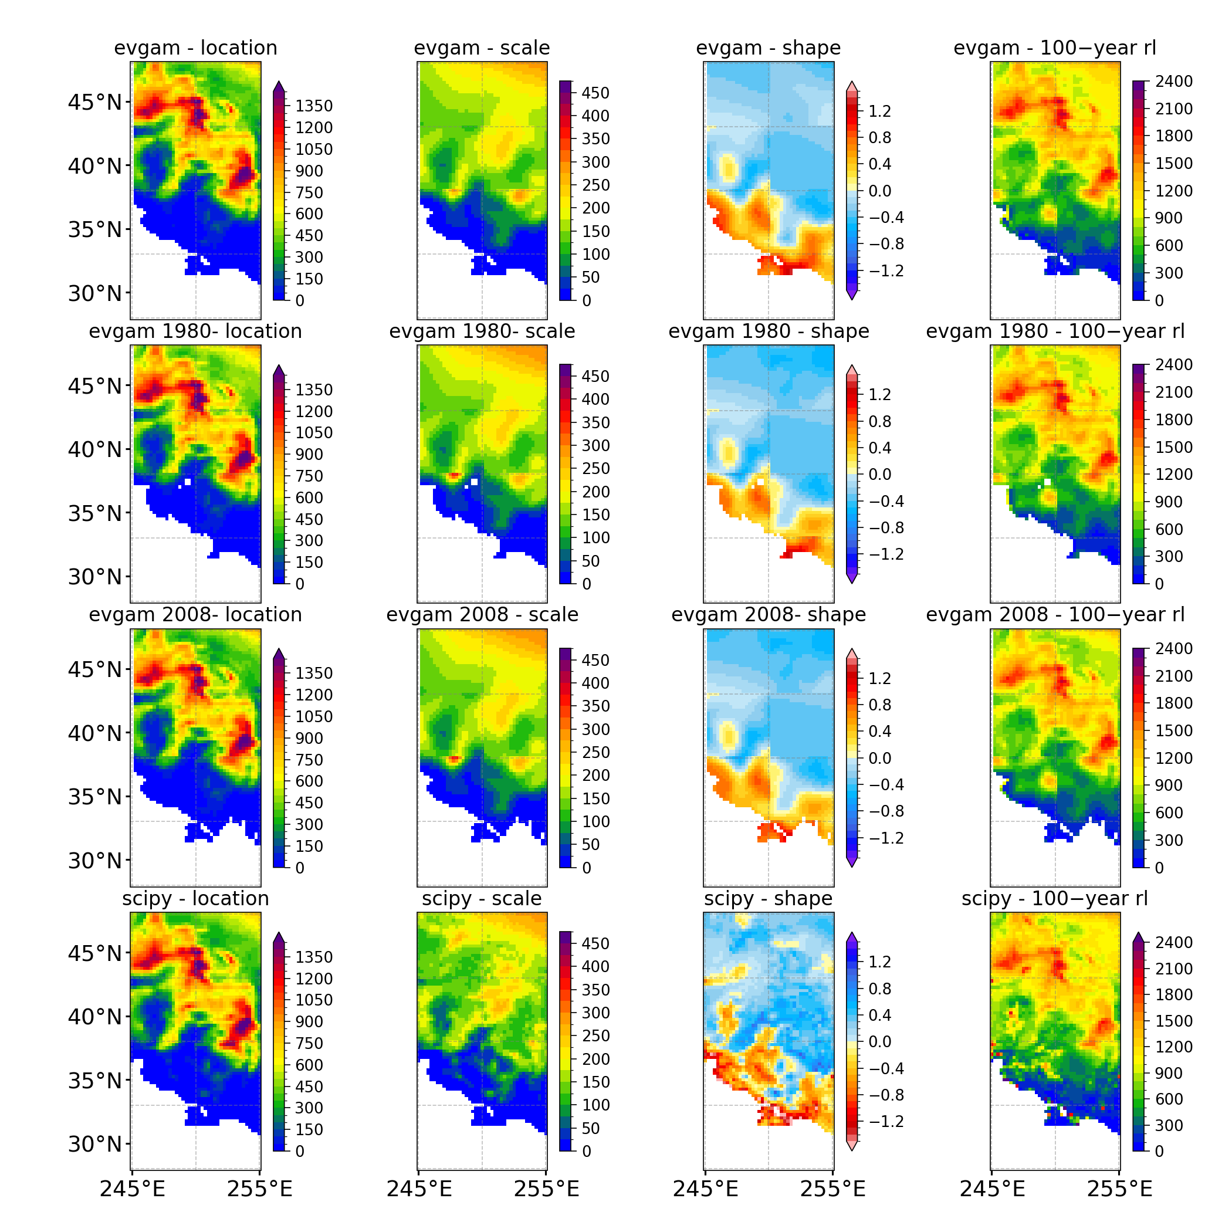

**fmla_gev_glost**

**2008**

**fmla_gev_glost**

**1980**

**1980**

**TEST 1**

1980 - 2008

%R fmla_gev_glost <- list(AFI ~ s(glost,k=7) + s(air, bs = "cr") + s(lon, lat),

~ s(air, bs = "cr")+ s(lon, lat),

~ s(air, bs = "cr")+ s(lon, lat))

%R fmla_gev <- list(AFI ~ s(air, bs = "cr") + s(lon, lat),

~ s(air, bs = "cr") + s(lon, lat),

~ s(air, bs = "cr")+ s(lon, lat))

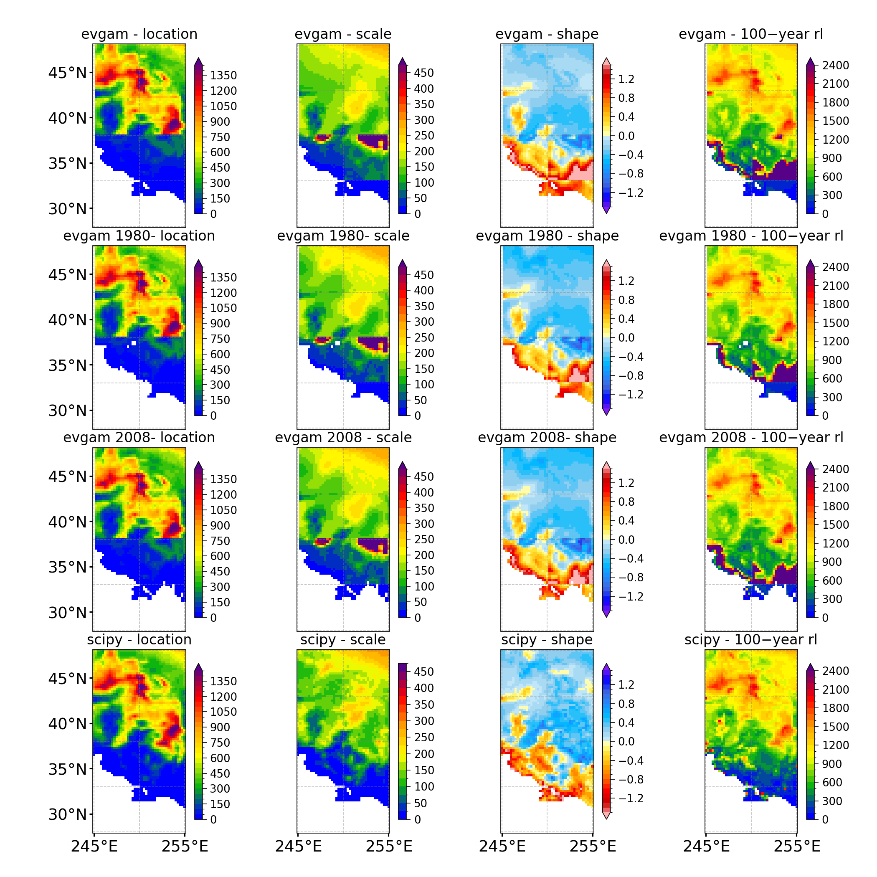

**fmla_gev_glost**

**2008**

**fmla_gev**

**fmla_gev_glost**

**1980**

**1980**

**TEST 2**

1950 - 2008

And formulae as Test0

%R fmla_gev_glost <- list(AFI ~ s(glost,k=5) + s(air, bs = "cr") + s(lon, lat),

~ s(lon, lat) ,

~ s(lon, lat))

%R fmla_gev <- list(AFI ~ s(air, bs = "cr") + s(lon, lat),

~ s(lon, lat) ,

~ s(lon, lat))

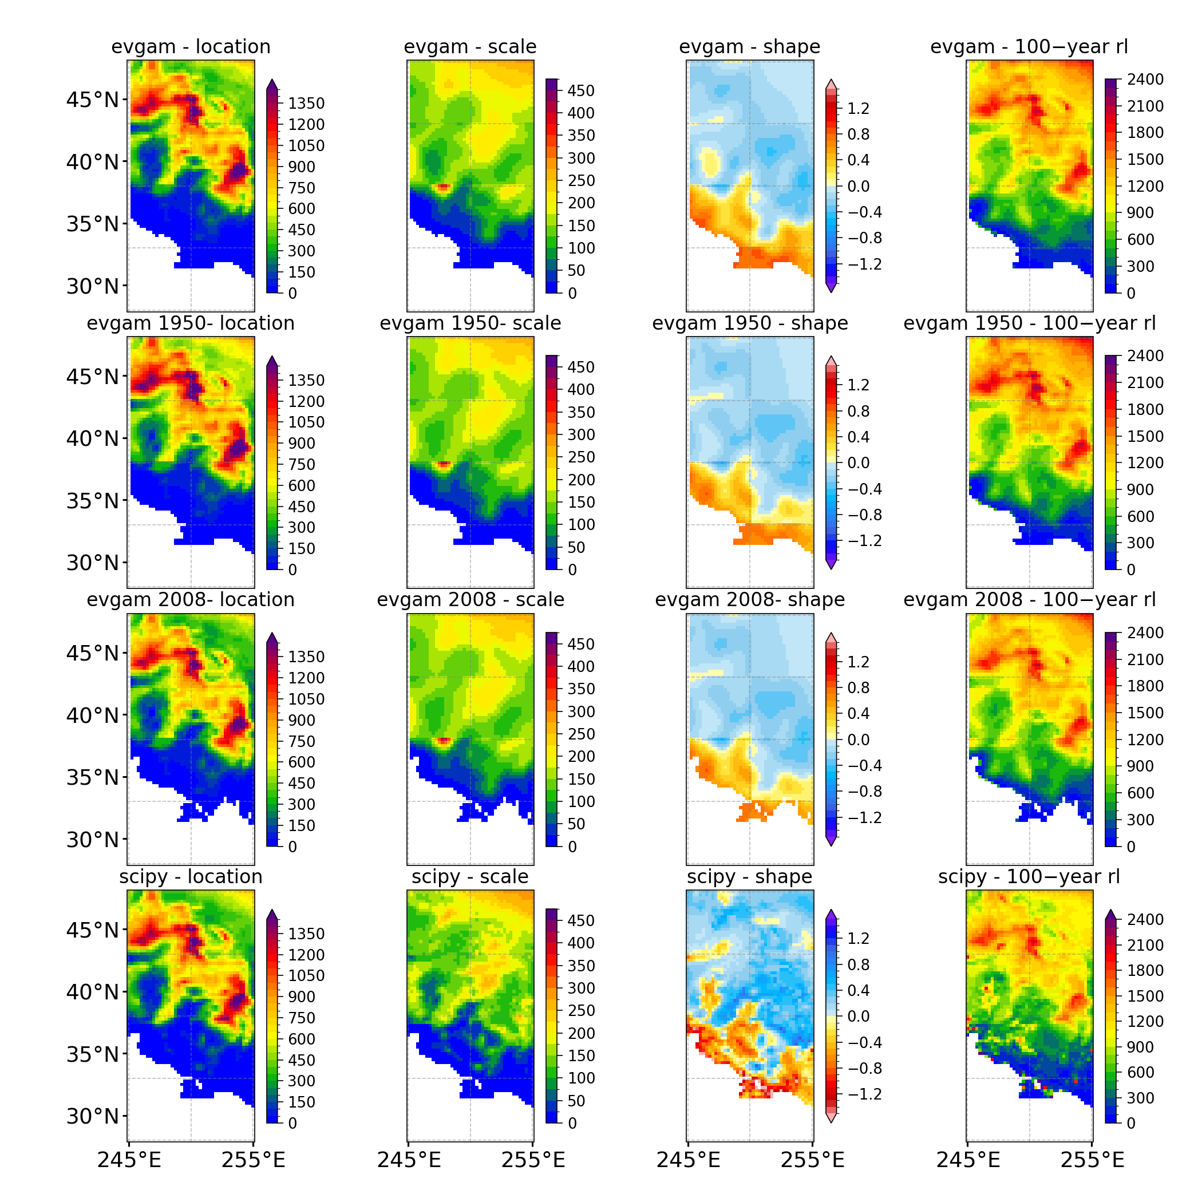

**fmla_gev_glost**

**2008**

**fmla_gev_glost**

**1950**

**fmla_gev**

**1950-2008**

**TEST 3**

1980 - 2008

%R fmla_gev_glost <- list(AFI ~ s(glost,k=7) + s(air) + s(lon, lat),

~ s(air)+ s(lon, lat),

~ s(air)+ s(lon, lat))

%R fmla_gev <- list(AFI ~ s(air) + s(lon, lat),

~ s(air) + s(lon, lat),

~ s(air)+ s(lon, lat))

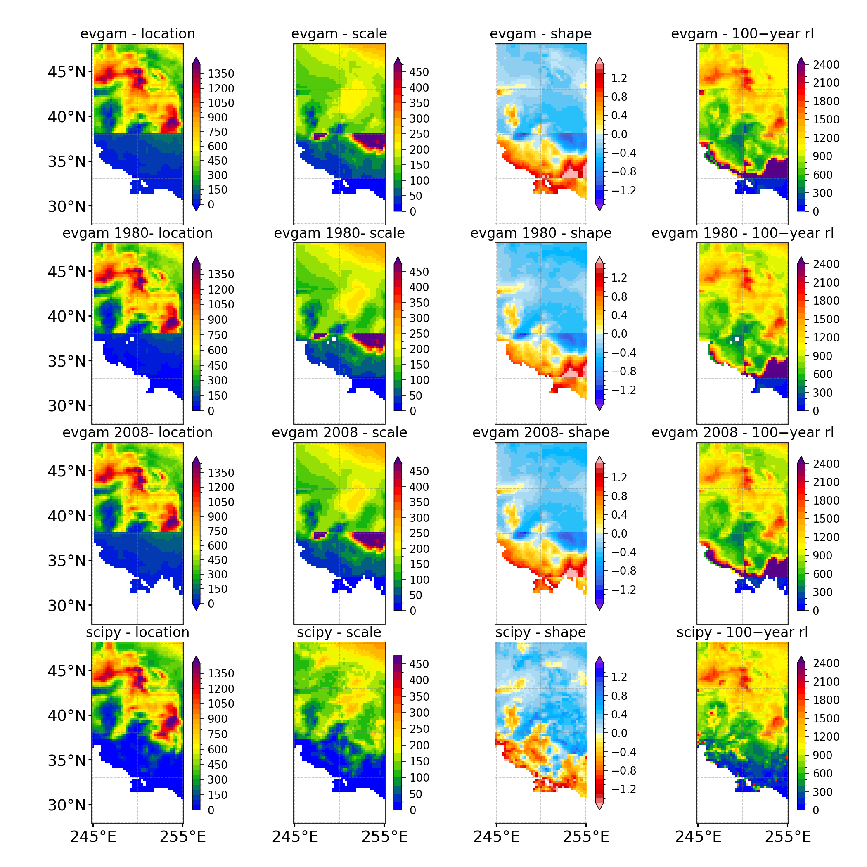

**fmla_gev_glost**

**1980**

**1980**

**fmla_gev_glost**

**2008**

**fmla_gev**

**TEST 4**

1980 - 2008

%R fmla_gev_glost <- list(AFI ~ s(glost,k=5) + s(air, bs = "cr") + s(lon, lat),

~ s(glost,k=5) + s(lon, lat) ,

~ s(lon, lat))

%R fmla_gev <- list(AFI ~ + s(air, bs = "cr") + s(lon, lat),

~ s(lon, lat) ,

~ s(lon, lat))

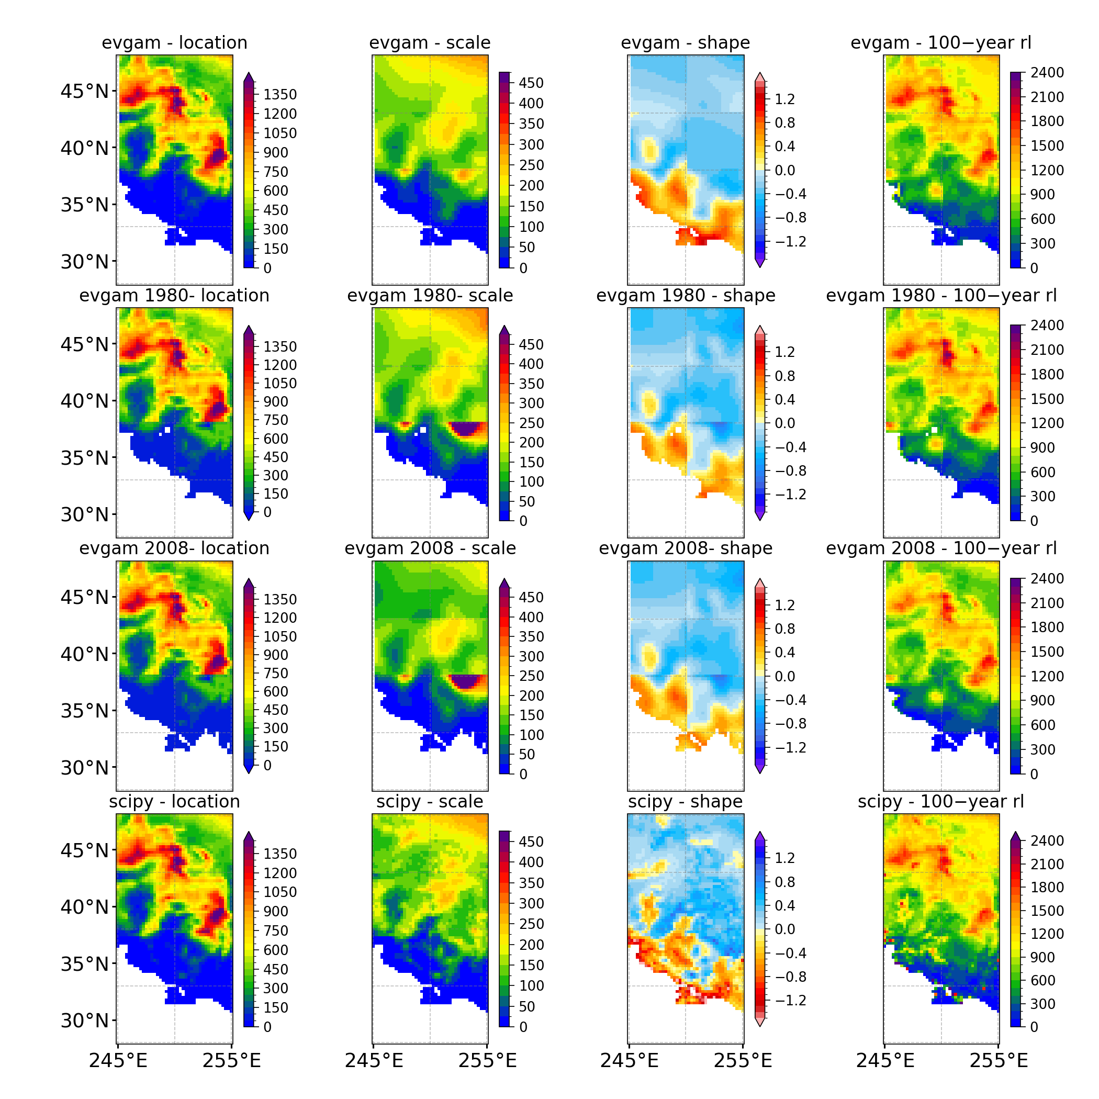

**fmla_gev_glost**

**2008**

**fmla_gev_glost**

**1980**

**1980**

**fmla_gev**

**EXTRA PLOTS**

From scipy CONUS domain parameters

