**How to install WSL2 on Windows**

This document explains in detail how to install wsl2 and certain libraries.

1. **Run the WSL2_installer executable:**

Double-click on:



A terminal opens automatically. Follow the instructions in red: 

These instructions are detailed in the next steps.

1. **Give administration rights to the installer:**



When you press Enter, Windows will ask you if you want to give administrator rights and let the executable modify your computer. Click on Yes. If you are not logged in as an administrator user, you will need to enter the username and password of an administrator user.

1. **Wait:**

After giving the admin right a second windows will open. Wait until the second windows it’s close.



If your computer was not setup for wsl in the past you will have the indication of the step 4 and 5 that will appear, if not pass to the step 6.

1. **Restart your computer:**

The installer will ask you to restart your computer in order to apply the changes to your system. Remember to save all your open files before writing "Yes"!



1. **Relaunch WSL2_installer:**



After restarting the computer, restart the installer and follow steps 1 to 3, then go on to step 6.

If you've already installed wsl on your computer, and just need to install the libraries, you won't see the following instructions, so please proceed to step 9.

1. **Installing Ubuntu.**

Read the red line and press enter to install Ubuntu.

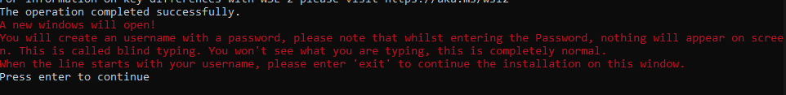

Please note that the progress bar may take some time to appear, so don't touch your computer and wait.

1. **Create your new username and password for wsl2.**

When Ubuntu is installed, a new window will open. In this window, you will create a new user for wsl2. To do this, you'll enter a username and password. Please note that when you type your password, you won't be able to see what you're typing. This is called blind typing and is completely normal.A screen shot of a computer

1. **Exit the second window:**

When the line starts with your username (usually green), enter "exit" to leave this window.

1. **Install the libraries:**

Enter the password of the user you created when installing WSL2.

Note that the third line may take a while to appear, so wait until it does. You won't be able to see what you're typing - this is called blind typing. This is perfectly normal.A black background with white text

1. **End:**

Wait for these two lines to appear:



Congratulation you installed WSL2 and the require libraries!