R Code – 2022 NASA International Space Apps Challenge

> nasa <- read.csv("Dropbox/data_science/projects/nasa_space_apps_2022/data/WWW-AIR_1664426457975/FIREXAQ-AMS_DC8_20190722_R2_df.csv", head = TRUE)

> nasa_data <- nasa %>% select(-OA_prec_PM1_AMS, -OA_DL_PM1_AMS, -Sulfate_prec_PM1_AMS, -Sulfate_DL_PM1_AMS, -Nitrate_prec_PM1_AMS, -Nitrate_DL_PM1_AMS, -Ammonium_prec_PM1_AMS, -Ammonium_DL_PM1_AMS, -NR_Chloride_prec_PM1_AMS, -NR_Chloride_DL_PM1_AMS, -Potassium_prec_PM1_AMS, -Potassium_DL_PM1_AMS, -MSA_prec_PM1_AMS, -MSA_DL_PM1_AMS, -ClO4_prec_PM1_AMS, -ClO4_DL_PM1_AMS, -Iodine_prec_PM1_AMS, -Iodine_DL_PM1_AMS, -Bromine_prec_PM1_AMS, -Bromine_DL_PM1_AMS, -Seasalt_prec_PM1_AMS, -Seasalt_DL_PM1_AMS, -SDDataFlag_AMS, -CloudFlag_AMS, -Flowrate_AMS, -StdtoVol_AMS, -InletRH_AMS)

> PM1_AMS <- c("OA_PM1_AMS", "Sulfate_PM1_AMS", "Nitrate_PM1_AMS", "Ammonium_PM1_AMS", "NR_Chloride_PM1_AMS", "Potassium_PM1_AMS", "MSA_PM1_AMS", "ClO4_PM1_AMS", "Iodine_PM1_AMS", "Bromine_PM1_AMS", "Seasalt_PM1_AMS", "AmmBalance_PM1_AMS", "OtoC_Ratio_PM1_AMS", "HtoC_Ratio_PM1_AMS", "OAtoOC_PM1_AMS", "OSc_PM1_AMS", "OrgNitrFraction_PM1_AMS", "f43_PM1_AMS", "f44_PM1_AMS", "f57_PM1_AMS", "f60_PM1_AMS", "f82_PM1_AMS", "f91_PM1_AMS", "fC2H3O_PM1_AMS", "fCO2_PM1_AMS", "fC4H9_PM1_AMS", "fC2H4O2_PM1_AMS", "fC5H6O_PM1_AMS", "fC7H7_PM1_AMS")

//> nasa_data <- nasa_data %>% filter(ALT_AMS != -9999 & Density_PM1_AMS != -8888 & OADensity_PM1_AMS != -8888)

# maybe use this instead of the above command to filter across all columns

# This may have worked, but I forgot the negative signs and ended up trying something else

//> nasa_data <- nasa_data %>% filter(across(everything(), ~ . != 9999)) %>% filter(across(everything(), ~ . != 8888))

# Ended up trying this and it worked also:

> nasa_data %>% summarise(across(where(is.numeric), ~ min(.x)))

Time_Start Time_Stop Time_Mid LAT_AMS LON_AMS ALT_AMS OA_PM1_AMS Sulfate_PM1_AMS Nitrate_PM1_AMS Ammonium_PM1_AMS NR_Chloride_PM1_AMS Potassium_PM1_AMS

1 66009.87 66010.87 66010.37 -9999 -9999 279.2 0.9745 -0.088 -0.0789 -0.0093 -0.093 -12.6691

MSA_PM1_AMS ClO4_PM1_AMS Iodine_PM1_AMS Bromine_PM1_AMS Seasalt_PM1_AMS AmmBalance_PM1_AMS Density_PM1_AMS OADensity_PM1_AMS OtoC_Ratio_PM1_AMS

1 -8888 -8888 -8888 -8888 -8888 -8888 1.114 1.019 -8888

HtoC_Ratio_PM1_AMS OAtoOC_PM1_AMS OSc_PM1_AMS OrgNitrFraction_PM1_AMS f43_PM1_AMS f44_PM1_AMS f57_PM1_AMS f60_PM1_AMS f82_PM1_AMS f91_PM1_AMS

1 -8888 -8888 -8888 -9999 -8888 -8888 -8888 -8888 -8888 -8888

fC2H3O_PM1_AMS fCO2_PM1_AMS fC4H9_PM1_AMS fC2H4O2_PM1_AMS fC5H6O_PM1_AMS fC7H7_PM1_AMS

1 -8888 -8888 -8888 -8888 -8888 -8888

> nasa_data <- nasa_data %>% filter(across(where(is.numeric), ~ .x != -8888))

Warning message:

Using `across()` in `filter()` is deprecated, use `if_any()` or `if_all()`.

> nasa_data %>% summarise(across(where(is.numeric), ~ min(.x)))

Time_Start Time_Stop Time_Mid LAT_AMS LON_AMS ALT_AMS OA_PM1_AMS Sulfate_PM1_AMS Nitrate_PM1_AMS Ammonium_PM1_AMS NR_Chloride_PM1_AMS Potassium_PM1_AMS

1 66059.42 66060.42 66059.92 -9999 -9999 279.2 1.4755 0.1343 -0.0789 0.0589 -0.093 -12.6691

MSA_PM1_AMS ClO4_PM1_AMS Iodine_PM1_AMS Bromine_PM1_AMS Seasalt_PM1_AMS AmmBalance_PM1_AMS Density_PM1_AMS OADensity_PM1_AMS OtoC_Ratio_PM1_AMS

1 -0.2794 -0.1554 -0.0789 -0.0908 -1.1968 0.148 1.217 1.078 0.329

HtoC_Ratio_PM1_AMS OAtoOC_PM1_AMS OSc_PM1_AMS OrgNitrFraction_PM1_AMS f43_PM1_AMS f44_PM1_AMS f57_PM1_AMS f60_PM1_AMS f82_PM1_AMS f91_PM1_AMS

1 1.134 1.641 -1.221 -9999 0.001 0.0189 -0.0287 -0.0176 -0.0094 -0.0162

fC2H3O_PM1_AMS fCO2_PM1_AMS fC4H9_PM1_AMS fC2H4O2_PM1_AMS fC5H6O_PM1_AMS fC7H7_PM1_AMS

1 -0.0014 0.0127 -0.0373 -0.0057 -0.0054 -0.0094

> nasa_data <- nasa_data %>% filter(across(where(is.numeric), ~ .x != -9999))

Warning message:

Using `across()` in `filter()` is deprecated, use `if_any()` or `if_all()`.

s> nasa_data %>% summarise(across(where(is.numeric), ~ min(.x)))

Time_Start Time_Stop Time_Mid LAT_AMS LON_AMS ALT_AMS OA_PM1_AMS Sulfate_PM1_AMS Nitrate_PM1_AMS Ammonium_PM1_AMS NR_Chloride_PM1_AMS Potassium_PM1_AMS

1 66229.25 66230.25 66229.75 33.5997 -121.5409 279.2 1.4755 0.1343 -0.0789 0.0658 -0.093 -12.6691

MSA_PM1_AMS ClO4_PM1_AMS Iodine_PM1_AMS Bromine_PM1_AMS Seasalt_PM1_AMS AmmBalance_PM1_AMS Density_PM1_AMS OADensity_PM1_AMS OtoC_Ratio_PM1_AMS

1 -0.2794 -0.1554 -0.0485 -0.0908 -1.1968 0.148 1.217 1.078 0.329

HtoC_Ratio_PM1_AMS OAtoOC_PM1_AMS OSc_PM1_AMS OrgNitrFraction_PM1_AMS f43_PM1_AMS f44_PM1_AMS f57_PM1_AMS f60_PM1_AMS f82_PM1_AMS f91_PM1_AMS

1 1.134 1.641 -1.221 0 0.001 0.0189 -0.0287 -0.0176 -0.0094 -0.0162

fC2H3O_PM1_AMS fCO2_PM1_AMS fC4H9_PM1_AMS fC2H4O2_PM1_AMS fC5H6O_PM1_AMS fC7H7_PM1_AMS

1 0.0077 0.0127 -0.0373 -0.0057 -0.0054 -0.0039

> nasa_data_gather <- nasa_data %>% keep(is.numeric) %>% gather(key = "component", value = "measurement", -c(Time_Start, Time_Stop, Time_Mid, ALT_AMS, LAT_AMS, LON_AMS, Density_PM1_AMS, OADensity_PM1_AMS)) %>% filter(measurement != -8888 & measurement != -9999)

> nasa_data_gather %>% ggplot(aes(x = ALT_AMS, y = measurement, color = OADensity_PM1_AMS)) + facet_wrap(~ component, scales = "free") + geom_point(size = 0.1) + theme_bw() + theme(strip.text.x = element_text(size = 5), axis.text = element_text(size = 5), panel.grid = element_blank()) + labs(title = "FIREX-AQ: Aersols by Altitude (data:WWW-AIR_1664426457975/FIREXAQ-AMS_DC8_20190722_R2)", y = "", x = "Altitude (meters)", color = "Organic Aerosol\nDensity (g/m3)")

> nasa_data_per_OAden <- nasa_data %>% mutate(across(all_of(PM1_AMS), ~ . / OADensity_PM1_AMS, .names = "{col}_per_OAden"))

> nasa_data_per_OAden_gather <- nasa_data_per_OAden %>% keep(is.numeric) %>% gather(key = "component", value = "measurement", -c(Time_Start, Time_Stop, Time_Mid, ALT_AMS, LAT_AMS, LON_AMS, Density_PM1_AMS, OADensity_PM1_AMS)) %>% filter(measurement != -8888 & measurement != -9999)

> nasa_data <- nasa_data %>% filter(ALT_AMS != -9999 & Density_PM1_AMS != -8888 & OADensity_PM1_AMS != -8888)

> nasa_data_gather <- nasa_data %>% keep(is.numeric) %>% gather(key = "component", value = "measurement", -c(Time_Start, Time_Stop, Time_Mid, ALT_AMS, LAT_AMS, LON_AMS, Density_PM1_AMS, OADensity_PM1_AMS)) %>% filter(measurement != -8888 & measurement != -9999)

//> nasa_data_gather <- nasa_data %>% keep(is.numeric) %>% gather(key = "component", value = "measurement", -c(Time_Start, Time_Stop, Time_Mid, ALT_AMS, LAT_AMS, LON_AMS, Density_PM1_AMS, OADensity_PM1_AMS)) %>% filter(measurement != -8888 & measurement != -9999 & ALT_AMS != -9999 & Density_PM1_AMS != -8888 & OADensity_PM1_AMS != -8888)

> nasa_data_gather %>% ggplot(aes(x = ALT_AMS, y = measurement, color = OADensity_PM1_AMS)) + facet_wrap(~ component, scales = "free") + geom_point(size = 0.1) + theme_bw() + theme(strip.text.x = element_text(size = 5), axis.text = element_text(size = 5), panel.grid = element_blank()) + labs(title = "FIREX-AQ: Aersols by Altitude (data:WWW-AIR_1664426457975/FIREXAQ-AMS_DC8_20190722_R2)", y = "", x = "Altitude (meters)", color = "Organic Aerosol\nDensity (g/m3)")

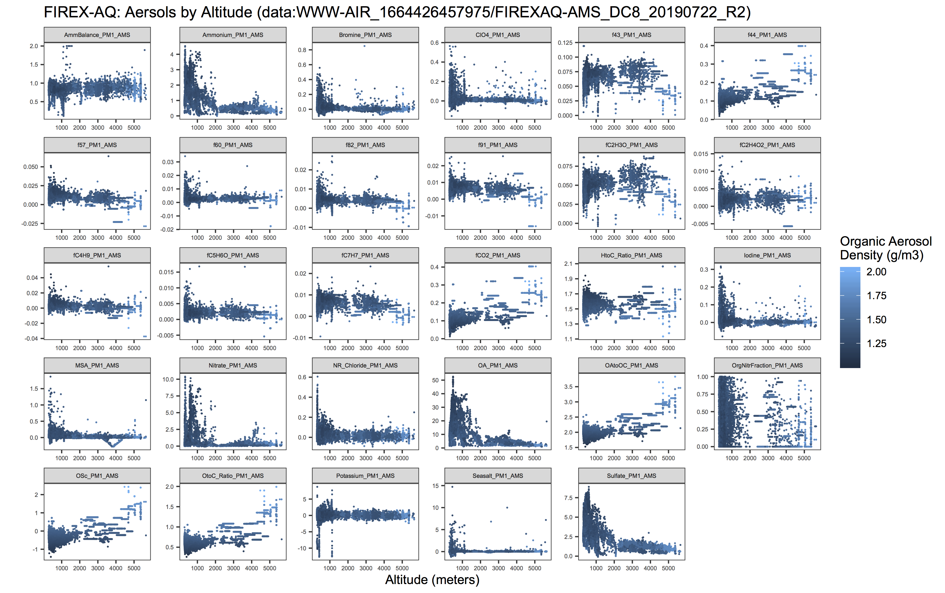

> PM1_AMS_df <- data.frame(unique(nasa_data_gather$component))

> colnames(PM1_AMS_df) <- c("components")

> PM1_AMS_df

components

1 OA_PM1_AMS

2 Sulfate_PM1_AMS

3 Nitrate_PM1_AMS

4 Ammonium_PM1_AMS

5 NR_Chloride_PM1_AMS

6 Potassium_PM1_AMS

7 MSA_PM1_AMS

8 ClO4_PM1_AMS

9 Iodine_PM1_AMS

10 Bromine_PM1_AMS

11 Seasalt_PM1_AMS

12 AmmBalance_PM1_AMS

13 OtoC_Ratio_PM1_AMS

14 HtoC_Ratio_PM1_AMS

15 OAtoOC_PM1_AMS

16 OSc_PM1_AMS

17 OrgNitrFraction_PM1_AMS

18 f43_PM1_AMS

19 f44_PM1_AMS

20 f57_PM1_AMS

21 f60_PM1_AMS

22 f82_PM1_AMS

23 f91_PM1_AMS

24 fC2H3O_PM1_AMS

25 fCO2_PM1_AMS

26 fC4H9_PM1_AMS

27 fC2H4O2_PM1_AMS

28 fC5H6O_PM1_AMS

29 fC7H7_PM1_AMS

> nasa_data_per_OADen <- nasa_data %>% mutate(across(PM1_AMS_df, .names = "{col}_per_OADen"/OADensity_PM1_AMS))

# Repeat the below code for several missions each that targeted wildfires & agri fires

> nasa <- read.csv("Dropbox/data_science/projects/nasa_space_apps_2022/data/WWW-AIR_1664426457975/FIREXAQ-AMS_DC8_20190722_R2_df.csv", head = TRUE)

> nasa_data <- nasa %>% select(-OA_prec_PM1_AMS, -OA_DL_PM1_AMS, -Sulfate_prec_PM1_AMS, -Sulfate_DL_PM1_AMS, -Nitrate_prec_sPM1_AMS, -Nitrate_DL_PM1_AMS, -Ammonium_prec_PM1_AMS, -Ammonium_DL_PM1_AMS, -NR_Chloride_prec_PM1_AMS, -NR_Chloride_DL_PM1_AMS, -Potassium_prec_PM1_AMS, -Potassium_DL_PM1_AMS, -MSA_prec_PM1_AMS, -MSA_DL_PM1_AMS, -ClO4_prec_PM1_AMS, -ClO4_DL_PM1_AMS, -Iodine_prec_PM1_AMS, -Iodine_DL_PM1_AMS, -Bromine_prec_PM1_AMS, -Bromine_DL_PM1_AMS, -Seasalt_prec_PM1_AMS, -Seasalt_DL_PM1_AMS, -SDDataFlag_AMS, -CloudFlag_AMS, -Flowrate_AMS, -StdtoVol_AMS, -InletRH_AMS)

> PM1_AMS <- c("OA_PM1_AMS", "Sulfate_PM1_AMS", "Nitrate_PM1_AMS", "Ammonium_PM1_AMS", "NR_Chloride_PM1_AMS", "Potassium_PM1_AMS", "MSA_PM1_AMS", "ClO4_PM1_AMS", "Iodine_PM1_AMS", "Bromine_PM1_AMS", "Seasalt_PM1_AMS", "AmmBalance_PM1_AMS", "OtoC_Ratio_PM1_AMS", "HtoC_Ratio_PM1_AMS", "OAtoOC_PM1_AMS", "OSc_PM1_AMS", "OrgNitrFraction_PM1_AMS", "f43_PM1_AMS", "f44_PM1_AMS", "f57_PM1_AMS", "f60_PM1_AMS", "f82_PM1_AMS", "f91_PM1_AMS", "fC2H3O_PM1_AMS", "fCO2_PM1_AMS", "fC4H9_PM1_AMS", "fC2H4O2_PM1_AMS", "fC5H6O_PM1_AMS", "fC7H7_PM1_AMS")

> nasa_data <- nasa_data %>% filter(across(where(is.numeric), ~ .x != -9999)) %>% filter(across(where(is.numeric), ~ .x != -8888))

> nasa_data_gather <- nasa_data %>% keep(is.numeric) %>% gather(key = "component", value = "measurement", -c(Time_Start, Time_Stop, Time_Mid, ALT_AMS, LAT_AMS, LON_AMS, Density_PM1_AMS, OADensity_PM1_AMS))

> nasa_data_per_OAden <- nasa_data %>% mutate(across(all_of(PM1_AMS), ~ . / OADensity_PM1_AMS, .names = "{col}_per_OAden"))

> nasa_data_per_OAden_gather <- nasa_data_per_OAden %>% keep(is.numeric) %>% gather(key = "component", value = "measurement", -c(Time_Start, Time_Stop, Time_Mid, ALT_AMS, LAT_AMS, LON_AMS, Density_PM1_AMS, OADensity_PM1_AMS))

> nasa_data_per_OAden_gather %>% filter(str_detect(component, 'per_OAden')) %>% ggplot(aes(x = ALT_AMS, y = measurement, color = OADensity_PM1_AMS)) + facet_wrap(~ component, scales = "free") + geom_point(size = 0.1) + theme_bw() + theme(strip.text.x = element_text(size = 5), axis.text = element_text(size = 5), panel.grid = element_blank()) + labs(title = "FIREX-AQ: Aersols by Altitude (data:WWW-AIR_1664426457975/FIREXAQ-AMS_DC8_20190722_R2)", y = "Units per Organic Aerosol Density (relative measure)", x = "Altitude (meters)", color = "Organic Aerosol\nDensity (g/m3)")

# Wrote an R script that takes care of almost all the above commands (except first and last)

> nasa <- read.csv("Dropbox/data_science/projects/nasa_space_apps_2022/data/WWW-AIR_1664426457975/FIREXAQ-AMS_DC8_20190722_R2_df.csv", head = TRUE)

> source(file="/Users/gaellemuller-greven/Dropbox/data_science/projects/nasa_space_apps_2022/nasa.R")

> nasa_data_per_OAden_gather %>% filter(str_detect(component, 'per_OAden')) %>% ggplot(aes(x = ALT_AMS, y = measurement, color = OADensity_PM1_AMS)) + facet_wrap(~ component, scales = "free") + geom_point(size = 0.1) + theme_bw() + theme(strip.text.x = element_text(size = 5), axis.text = element_text(size = 5), panel.grid = element_blank()) + labs(title = "FIREX-AQ: Aersols by Altitude (data:WWW-AIR_1664426457975/FIREXAQ-AMS_DC8_20190722_R2)", y = "Units per Organic Aerosol Density (relative measure)", x = "Altitude (meters)", color = "Organic Aerosol\nDensity (g/m3)")

# R Script (located at Dropbox/data_science/projects/nasa_space_apps_2022/nasa.R)

filenames = c("FIREXAQ-AMS_DC8_20190722_R2", "FIREXAQ-AMS_DC8_20190724_R2", "FIREXAQ-AMS_DC8_20190725_R2", "FIREXAQ-AMS_DC8_20190729_R3", "FIREXAQ-AMS_DC8_20190730_R2", "FIREXAQ-AMS_DC8_20190802_R3", "FIREXAQ-AMS_DC8_20190803_R2")

filename = ""

plot_airborne_data <- function(filename){

filename = filename

filename_csv = paste(filename, "_df.csv", sep = "")

filename_title = paste(filename, ")", sep = "")

nasa <- read.csv(paste("/Users/gaellemuller-greven/Dropbox/data_science/projects/nasa_space_apps_2022/data/WWW-AIR_1664426457975/", filename_csv, sep = ""), head = TRUE)

nasa_data <- nasa %>% select(-OA_prec_PM1_AMS, -OA_DL_PM1_AMS, -Sulfate_prec_PM1_AMS, -Sulfate_DL_PM1_AMS, -Nitrate_prec_PM1_AMS, -Nitrate_DL_PM1_AMS, -Ammonium_prec_PM1_AMS, -Ammonium_DL_PM1_AMS, -NR_Chloride_prec_PM1_AMS, -NR_Chloride_DL_PM1_AMS, -Potassium_prec_PM1_AMS, -Potassium_DL_PM1_AMS, -MSA_prec_PM1_AMS, -MSA_DL_PM1_AMS, -ClO4_prec_PM1_AMS, -ClO4_DL_PM1_AMS, -Iodine_prec_PM1_AMS, -Iodine_DL_PM1_AMS, -Bromine_prec_PM1_AMS, -Bromine_DL_PM1_AMS, -Seasalt_prec_PM1_AMS, -Seasalt_DL_PM1_AMS, -SDDataFlag_AMS, -CloudFlag_AMS, -Flowrate_AMS, -StdtoVol_AMS, -InletRH_AMS)

PM1_AMS <- c("OA_PM1_AMS", "Sulfate_PM1_AMS", "Nitrate_PM1_AMS", "Ammonium_PM1_AMS", "NR_Chloride_PM1_AMS", "Potassium_PM1_AMS", "MSA_PM1_AMS", "ClO4_PM1_AMS", "Iodine_PM1_AMS", "Bromine_PM1_AMS", "Seasalt_PM1_AMS", "AmmBalance_PM1_AMS", "OtoC_Ratio_PM1_AMS", "HtoC_Ratio_PM1_AMS", "OAtoOC_PM1_AMS", "OSc_PM1_AMS", "OrgNitrFraction_PM1_AMS", "f43_PM1_AMS", "f44_PM1_AMS", "f57_PM1_AMS", "f60_PM1_AMS", "f82_PM1_AMS", "f91_PM1_AMS", "fC2H3O_PM1_AMS", "fCO2_PM1_AMS", "fC4H9_PM1_AMS", "fC2H4O2_PM1_AMS", "fC5H6O_PM1_AMS", "fC7H7_PM1_AMS")

nasa_data <- nasa_data %>% filter(across(where(is.numeric), ~ .x != -9999)) %>% filter(across(where(is.numeric), ~ .x != -8888))

nasa_data_gather <- nasa_data %>% keep(is.numeric) %>% gather(key = "component", value = "measurement", -c(Time_Start, Time_Stop, Time_Mid, ALT_AMS, LAT_AMS, LON_AMS, Density_PM1_AMS, OADensity_PM1_AMS))

nasa_data_per_OAden <- nasa_data %>% mutate(across(all_of(PM1_AMS), ~ . / OADensity_PM1_AMS, .names = "{col}_per_OAden"))

nasa_data_per_OAden_gather <- nasa_data_per_OAden %>% keep(is.numeric) %>% gather(key = "component", value = "measurement", -c(Time_Start, Time_Stop, Time_Mid, ALT_AMS, LAT_AMS, LON_AMS, Density_PM1_AMS, OADensity_PM1_AMS))

nasa_data_per_OAden_gather %>% filter(str_detect(component, 'per_OAden')) %>% ggplot(aes(x = ALT_AMS, y = measurement, color = OADensity_PM1_AMS)) + facet_wrap(~ component, scales = "free") + geom_point(size = 0.1) + theme_bw() + theme(strip.text.x = element_text(size = 5), axis.text = element_text(size = 5), panel.grid = element_blank()) + labs(title = paste("FIREX-AQ: Aersols by Altitude (data:WWW-AIR_1664426457975/",filename_title), y = "Units per Organic Aerosol Density (relative measure)", x = "Altitude (meters)", color = "Organic Aerosol\nDensity (g/m3)")

ggsave(paste(filename,".png", sep = ""), device = "png", dpi = "retina", width = 3000, height = 2000, units = "px", path = "/Users/gaellemuller-greven/Dropbox/data_science/projects/nasa_space_apps_2022/plots/WWW-AIR_1664426457975")

}

for(filename in filenames){

plot_airborne_data(filename)

}

- - - - - -

# called from the console like so:

> source(file="/Users/gaellemuller-greven/Dropbox/data_science/projects/nasa_space_apps_2022/nasa.R")

# WORKS BEAUTIFULLY…. ABOUT TO CRY HAPPY TEARS

# Plotting Flight Tracks

> df %>% filter(LAT_AMS != -9999 & LON_AMS != -9999 & LAT_AMS > 30 & LON_AMS < -80) %>% ggplot(aes(x = LON_AMS, y = LAT_AMS, color = mission)) + geom_point(size = 0.1, alpha = 0.5) + scale_color_discrete(guide = "none") + theme_classic() + labs(title = "FIREX-AQ: DC8 Flight Tracks", y = "Latitude (degrees)", x = "Longitude (degrees)", color = "")

> df %>% filter(LAT_AMS != -9999 & LON_AMS != -9999 & LAT_AMS > 30 & LON_AMS < -80 & Sulfate_PM1_AMS != -8888) %>% ggplot(aes(x = LON_AMS, y = LAT_AMS, color = Sulfate_PM1_AMS)) + geom_point(size = 0.1, alpha = 0.5) + scale_color_viridis_c(option = "plasma", trans = "log") + theme_classic() + labs(title = "FIREX-AQ: DC8 Flight Tracks", y = "Latitude (degrees)", x = "Longitude (degrees)", color = "Sulfate PM1 (log)")

> df %>% filter(LAT_AMS != -9999 & LON_AMS != -9999 & LAT_AMS > 30 & LON_AMS < -80 & Ammonium_PM1_AMS != -8888) %>% ggplot(aes(x = LON_AMS, y = LAT_AMS, color = Ammonium_PM1_AMS)) + geom_point(size = 0.1, alpha = 0.5) + scale_color_viridis_c(option = "plasma", trans = "log") + theme_classic() + labs(title = "FIREX-AQ: DC8 Flight Tracks", y = "Latitude (degrees)", x = "Longitude (degrees)", color = "Ammonium PM1 (log)")

> df %>% filter(LAT_AMS != -9999 & LON_AMS != -9999 & LAT_AMS > 30 & LON_AMS < -80 & Nitrate_PM1_AMS != -8888) %>% ggplot(aes(x = LON_AMS, y = LAT_AMS, color = Nitrate_PM1_AMS)) + geom_point(size = 0.1, alpha = 0.5) + scale_color_viridis_c(option = "plasma", trans = "log") + theme_classic() + labs(title = "FIREX-AQ: DC8 Flight Tracks", y = "Latitude (degrees)", x = "Longitude (degrees)", color = "Nitrate PM1 (log)")

> df %>% filter(LAT_AMS != -9999 & LON_AMS != -9999 & LAT_AMS > 30 & LON_AMS < -80 & Density_PM1_AMS != -8888) %>% ggplot(aes(x = LON_AMS, y = LAT_AMS, color = Density_PM1_AMS)) + geom_point(size = 0.1, alpha = 0.5) + scale_color_viridis_c(option = "plasma", trans = "log") + theme_classic() + labs(title = "FIREX-AQ: DC8 Flight Tracks", y = "Latitude (degrees)", x = "Longitude (degrees)", color = "Density PM1 (log)")

# plot on map with sf

# basic map with no datapoints with coord limits for lower 48

> ggplot(data = world) + geom_sf(alpha = 0.2) + coord_sf(xlim = c(-123, -69), ylim = c(26, 49))

# below code WORKS but need to filter out -8888 and -9999 NA flags

> ggplot(data = world) + geom_sf(lwd = 0.2, color = rgb(156, 156, 156, maxColorValue = 255), alpha = 0.6) + coord_sf(xlim = c(-123, -69), ylim = c(26, 49)) + geom_point(data = df, aes(x = LON_AMS, y = LAT_AMS, color = Seasalt_PM1_AMS), size = 0.1, alpha = 0.5) + scale_color_viridis_c(option = "plasma") + labs(title = "FIREX-AQ: DC8 Flight Tracks", y = "Latitude (degrees)", x = "Longitude (degrees)", color = "Seasalt PM1 (log)")

missions <- c("FIREXAQ-AMS_DC8_20190722_R2", "FIREXAQ-AMS_DC8_20190724_R2", "FIREXAQ-AMS_DC8_20190725_R2", "FIREXAQ-AMS_DC8_20190729_R3", "FIREXAQ-AMS_DC8_20190730_R2", "FIREXAQ-AMS_DC8_20190802_R3", "FIREXAQ-AMS_DC8_20190803_R2", "FIREXAQ-AMS_DC8_20190806_R3", "FIREXAQ-AMS_DC8_20190807_R3", "FIREXAQ-AMS_DC8_20190808_R2", "FIREXAQ-AMS_DC8_20190812_R2", "FIREXAQ-AMS_DC8_20190813_R2", "FIREXAQ-AMS_DC8_20190815_R2", "FIREXAQ-AMS_DC8_20190816_R3", "FIREXAQ-AMS_DC8_20190819_R2", "FIREXAQ-AMS_DC8_20190821_R3", "FIREXAQ-AMS_DC8_20190823_R3", "FIREXAQ-AMS_DC8_20190826_R3", "FIREXAQ-AMS_DC8_20190829_R3", "FIREXAQ-AMS_DC8_20190830_R3", "FIREXAQ-AMS_DC8_20190831_R3", "FIREXAQ-AMS_DC8_20190903_R3", "FIREXAQ-AMS_DC8_20190905_R2")

> missions_wildfire <- c("FIREXAQ-AMS_DC8_20190722_R2", "FIREXAQ-AMS_DC8_20190724_R2", "FIREXAQ-AMS_DC8_20190725_R2", "FIREXAQ-AMS_DC8_20190729_R3", "FIREXAQ-AMS_DC8_20190730_R2", "FIREXAQ-AMS_DC8_20190802_R3", "FIREXAQ-AMS_DC8_20190803_R2", "FIREXAQ-AMS_DC8_20190806_R3", "FIREXAQ-AMS_DC8_20190807_R3", "FIREXAQ-AMS_DC8_20190808_R2", "FIREXAQ-AMS_DC8_20190812_R2", "FIREXAQ-AMS_DC8_20190813_R2", "FIREXAQ-AMS_DC8_20190815_R2", "FIREXAQ-AMS_DC8_20190816_R3")

> missions_agriburns <- c("FIREXAQ-AMS_DC8_20190819_R2", "FIREXAQ-AMS_DC8_20190821_R3", "FIREXAQ-AMS_DC8_20190823_R3", "FIREXAQ-AMS_DC8_20190826_R3", "FIREXAQ-AMS_DC8_20190829_R3", "FIREXAQ-AMS_DC8_20190830_R3", "FIREXAQ-AMS_DC8_20190831_R3", "FIREXAQ-AMS_DC8_20190903_R3", "FIREXAQ-AMS_DC8_20190905_R2")

> nasa_data <- nasa_data %>% mutate(mission_type = as.factor(ifelse(mission %in% missions_wildfire, "wildfire", ifelse(mission %in% missions_agriburns, "agriburn", ""))))

# map of flight missions with legend

> ggplot(data = world) + geom_sf(lwd = 0.2, color = rgb(156, 156, 156, maxColorValue = 255), alpha = 0.6) + coord_sf(xlim = c(-123, -69), ylim = c(26, 49)) + geom_point(data = nasa_data_per_OAden, aes(x = LON_AMS, y = LAT_AMS, color = mission), size = 0.1, alpha = 0.5) + labs(title = "FIREX-AQ: DC8 Flight Tracks", y = "Latitude (degrees)", x = "Longitude (degrees)", color = "Flight Mission") + theme(legend.position="bottom", legend.text=element_text(size=6)) + guides(color = guide_legend(override.aes = list(size = 5)))

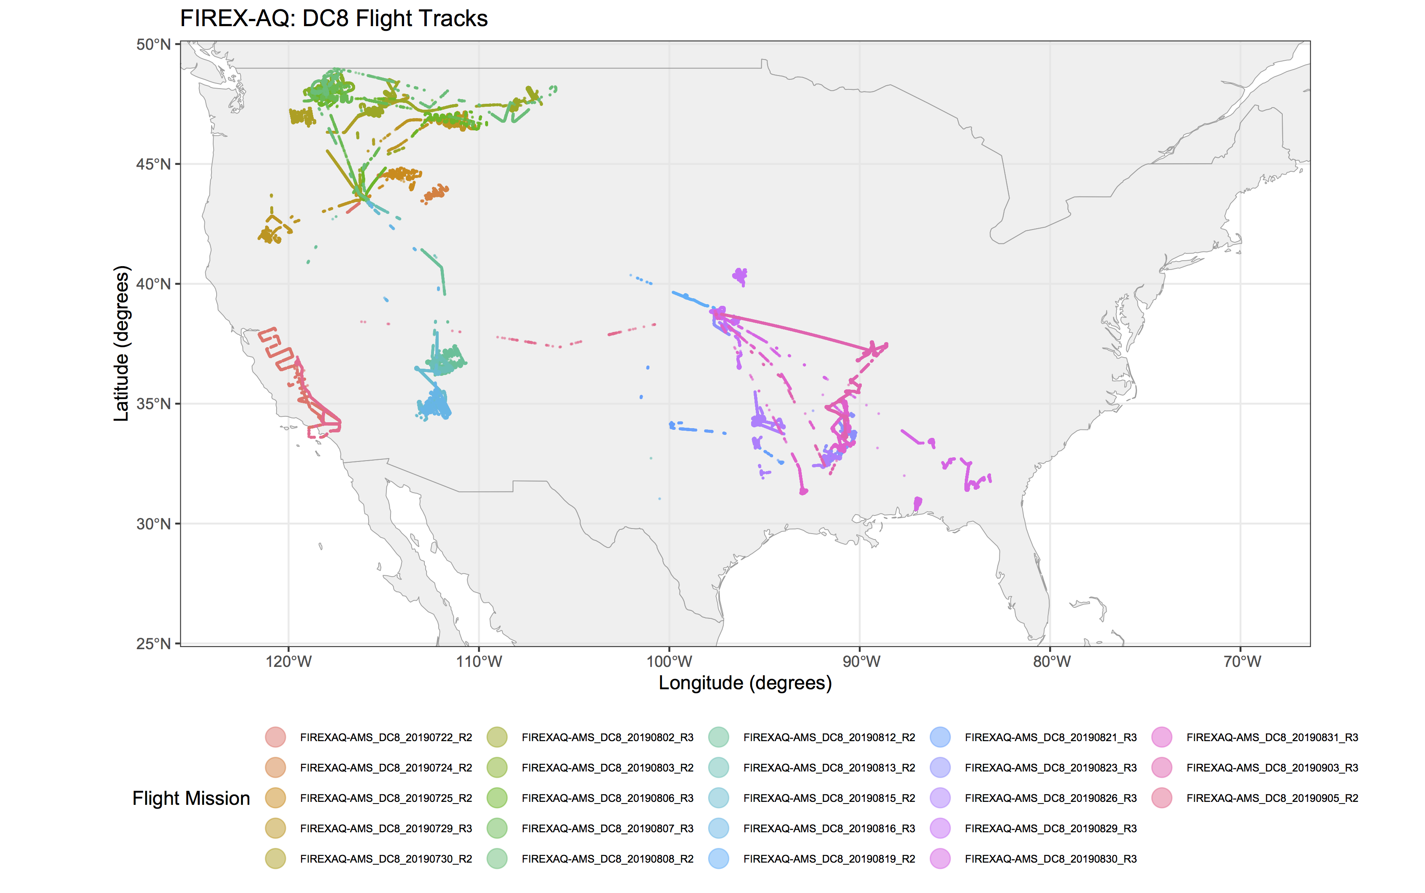

> nasa_data_mission_summary <- nasa_data %>% group_by(mission) %>% summarize(mean_LAT = mean(LAT_AMS), mean_LON = mean(LON_AMS))

> as.data.frame(nasa_data_mission_summary)

mission mean_LAT mean_LON

1 FIREXAQ-AMS_DC8_20190722_R2 36.28655 -119.37623

2 FIREXAQ-AMS_DC8_20190724_R2 43.79656 -112.60827

3 FIREXAQ-AMS_DC8_20190725_R2 44.46708 -114.01934

4 FIREXAQ-AMS_DC8_20190729_R3 44.20016 -116.73073

5 FIREXAQ-AMS_DC8_20190730_R2 46.44514 -117.92307

6 FIREXAQ-AMS_DC8_20190802_R3 47.36740 -114.04139

7 FIREXAQ-AMS_DC8_20190803_R2 47.97129 -117.97825

8 FIREXAQ-AMS_DC8_20190806_R3 46.81102 -114.46495

9 FIREXAQ-AMS_DC8_20190807_R3 47.25013 -116.80051

10 FIREXAQ-AMS_DC8_20190808_R2 47.40813 -115.14226

11 FIREXAQ-AMS_DC8_20190812_R2 37.06341 -111.96700

12 FIREXAQ-AMS_DC8_20190813_R2 37.31930 -112.43061

13 FIREXAQ-AMS_DC8_20190815_R2 35.93673 -112.59932

14 FIREXAQ-AMS_DC8_20190816_R3 35.21878 -112.33157

15 FIREXAQ-AMS_DC8_20190819_R2 39.31130 -98.75152

16 FIREXAQ-AMS_DC8_20190821_R3 33.24950 -94.32014

17 FIREXAQ-AMS_DC8_20190823_R3 33.52473 -91.05090

18 FIREXAQ-AMS_DC8_20190826_R3 33.66570 -93.82184

19 FIREXAQ-AMS_DC8_20190829_R3 39.12000 -96.54619

20 FIREXAQ-AMS_DC8_20190830_R3 31.91907 -85.76911

21 FIREXAQ-AMS_DC8_20190831_R3 33.69196 -91.22169

22 FIREXAQ-AMS_DC8_20190903_R3 35.81522 -90.87053

23 FIREXAQ-AMS_DC8_20190905_R2 34.98109 -117.82508

> missions_wildfire <- c("FIREXAQ-AMS_DC8_20190722_R2", "FIREXAQ-AMS_DC8_20190724_R2", "FIREXAQ-AMS_DC8_20190725_R2", "FIREXAQ-AMS_DC8_20190729_R3", "FIREXAQ-AMS_DC8_20190730_R2", "FIREXAQ-AMS_DC8_20190802_R3", "FIREXAQ-AMS_DC8_20190803_R2", "FIREXAQ-AMS_DC8_20190806_R3", "FIREXAQ-AMS_DC8_20190807_R3", "FIREXAQ-AMS_DC8_20190808_R2", "FIREXAQ-AMS_DC8_20190812_R2", "FIREXAQ-AMS_DC8_20190813_R2", "FIREXAQ-AMS_DC8_20190815_R2", "FIREXAQ-AMS_DC8_20190816_R3", "FIREXAQ-AMS_DC8_20190905_R2")

> missions_agriburns <- c("FIREXAQ-AMS_DC8_20190819_R2", "FIREXAQ-AMS_DC8_20190821_R3", "FIREXAQ-AMS_DC8_20190823_R3", "FIREXAQ-AMS_DC8_20190826_R3", "FIREXAQ-AMS_DC8_20190829_R3", "FIREXAQ-AMS_DC8_20190830_R3", "FIREXAQ-AMS_DC8_20190831_R3", "FIREXAQ-AMS_DC8_20190903_R3")

> nasa_data <- nasa_data %>% mutate(mission_type = as.factor(ifelse(mission %in% missions_wildfire, "wildfire", ifelse(mission %in% missions_agriburns, "agriburn", ""))))

> nasa_data_per_OAden <- nasa_data %>% mutate(across(all_of(PM1_AMS), ~ . / OADensity_PM1_AMS, .names = "{col}_per_OAden"))

> nasa_data_per_OAden_gather <- nasa_data_per_OAden %>% gather(key = "component", value = "measurement", -c(Time_Start, Time_Stop, Time_Mid, ALT_AMS, LAT_AMS, LON_AMS, mission, mission_type, Density_PM1_AMS, OADensity_PM1_AMS))

> str(nasa_data_per_OAden_gather)

'data.frame': 20534300 obs. of 12 variables:

$ Time_Start : num 66229 66232 66233 66234 66235 ...

$ Time_Stop : num 66230 66233 66234 66235 66236 ...

$ Time_Mid : num 66230 66233 66234 66235 66236 ...

$ LAT_AMS : num 34.6 34.6 34.6 34.6 34.6 ...

$ LON_AMS : num -118 -118 -118 -118 -118 ...

$ ALT_AMS : num 2999 3035 3046 3060 3071 ...

$ Density_PM1_AMS : num 1.66 1.65 1.65 1.65 1.63 ...

$ OADensity_PM1_AMS: num 1.57 1.57 1.57 1.57 1.57 ...

$ mission : Factor w/ 23 levels "FIREXAQ-AMS_DC8_20190722_R2",..: 1 1 1 1 1 1 1 1 1 1 ...

$ mission_type : Factor w/ 2 levels "agriburn","wildfire": 2 2 2 2 2 2 2 2 2 2 ...

$ component : chr "OA_PM1_AMS" "OA_PM1_AMS" "OA_PM1_AMS" "OA_PM1_AMS" ...

$ measurement : num 2.09 2.65 2.68 2.36 3.33 ...

> ggplot(data = world) + geom_sf(lwd = 0.2, color = rgb(156, 156, 156, maxColorValue = 255), alpha = 0.6) + coord_sf(xlim = c(-123, -69), ylim = c(26, 49)) + geom_point(data = nasa_data_per_OAden, aes(x = LON_AMS, y = LAT_AMS, color = mission_type), size = 0.1, alpha = 0.5) + scale_color_manual(values = c("agriburn" = "orange3", "wildfire" = "orangered3"), labels = c("Agri Burn", "Wildfire")) + labs(title = "FIREX-AQ: DC8 Flight Tracks", y = "Latitude (degrees)", x = "Longitude (degrees)", color = "Mission Type") + theme(legend.position="bottom", legend.text=element_text(size=12)) + guides(color = guide_legend(override.aes = list(size = 5)))

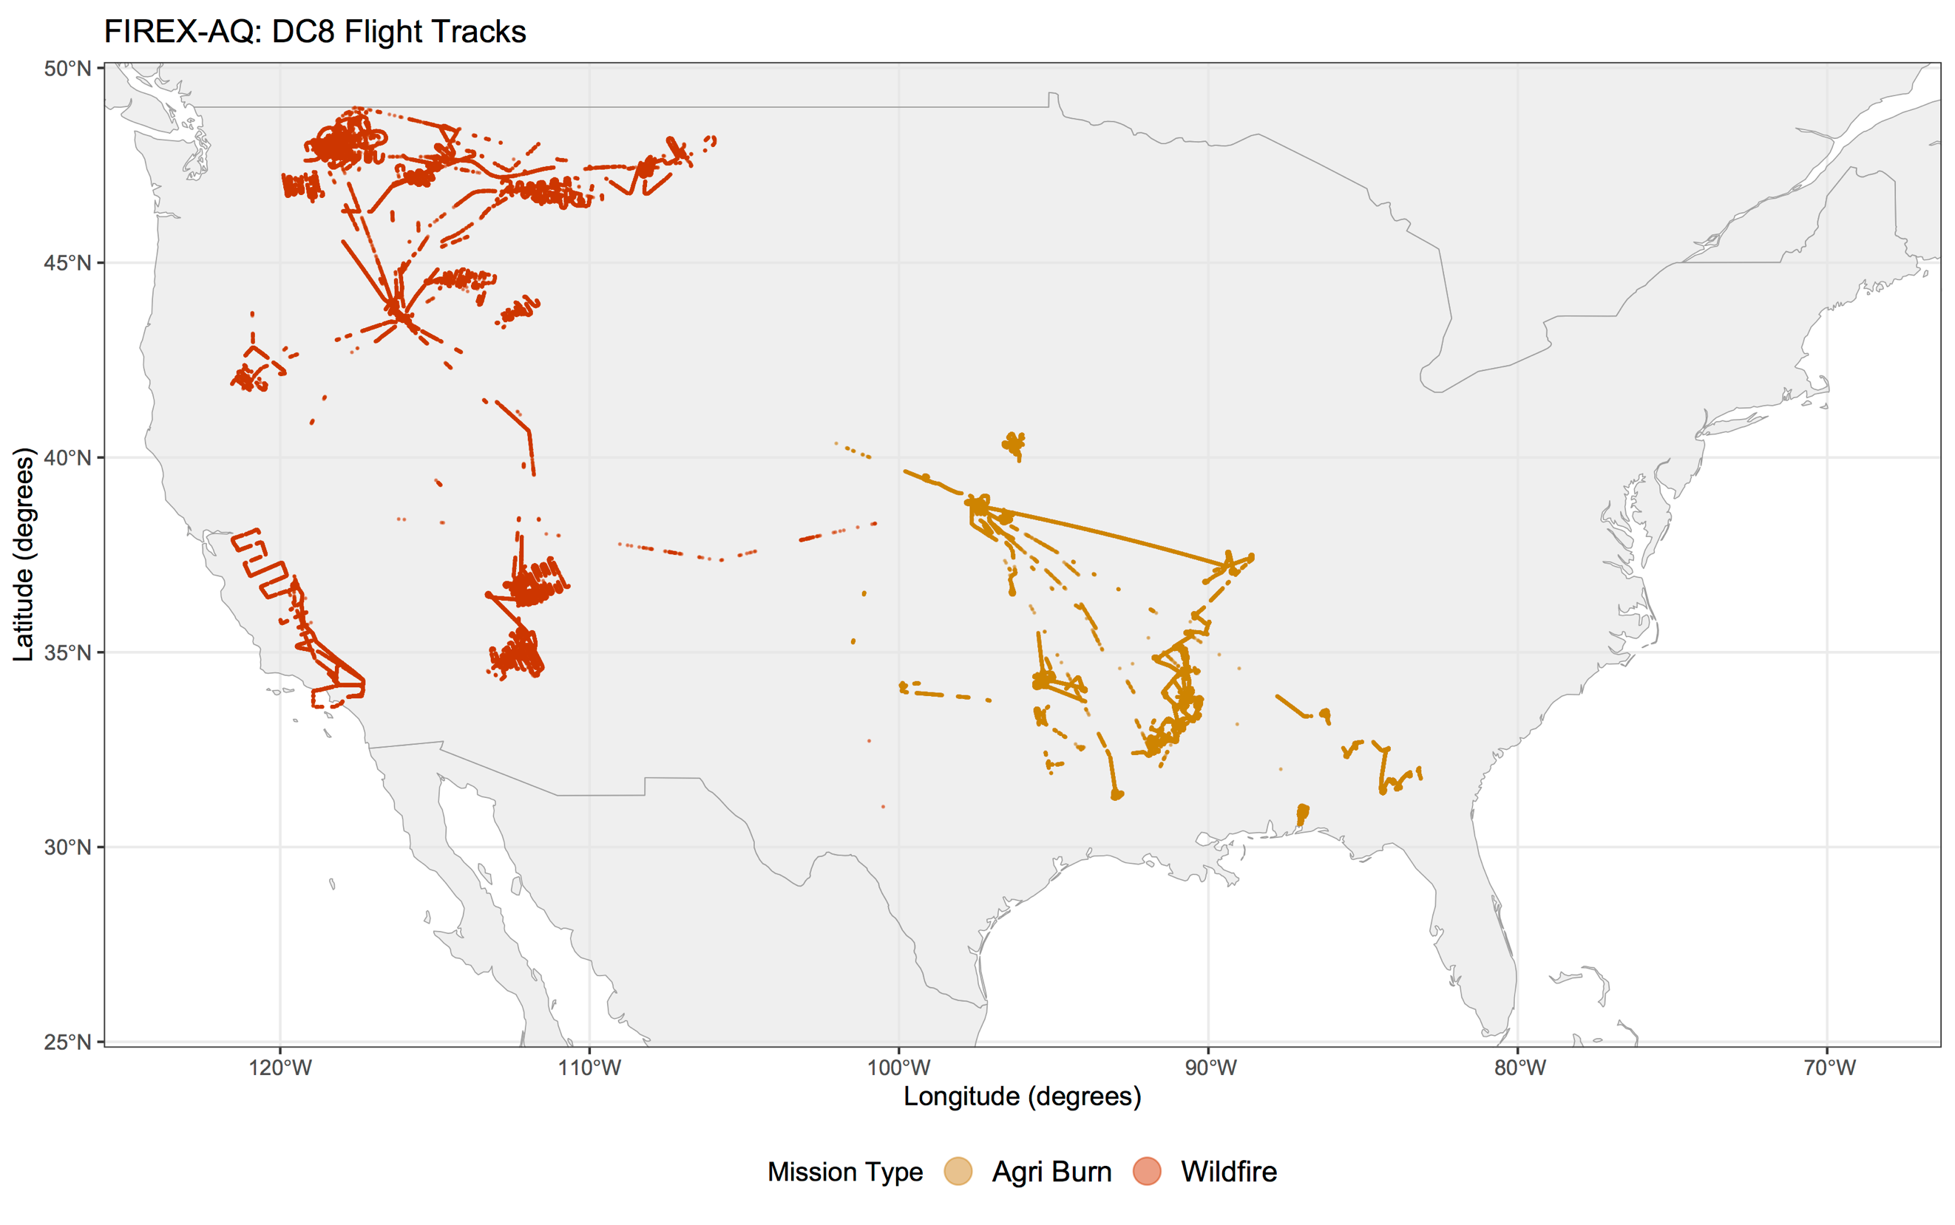

# STATS

> PM1_AMS_per_OAden <- c("OA_PM1_AMS_per_OAden", "Sulfate_PM1_AMS_per_OAden", "Nitrate_PM1_AMS_per_OAden", "Ammonium_PM1_AMS_per_OAden", "NR_Chloride_PM1_AMS_per_OAden", "Potassium_PM1_AMS_per_OAden", "MSA_PM1_AMS_per_OAden", "ClO4_PM1_AMS_per_OAden", "Iodine_PM1_AMS_per_OAden", "Bromine_PM1_AMS_per_OAden", "Seasalt_PM1_AMS_per_OAden", "AmmBalance_PM1_AMS_per_OAden", "OtoC_Ratio_PM1_AMS_per_OAden", "HtoC_Ratio_PM1_AMS_per_OAden", "OAtoOC_PM1_AMS_per_OAden", "OSc_PM1_AMS_per_OAden", "OrgNitrFraction_PM1_AMS_per_OAden", "f43_PM1_AMS_per_OAden", "f44_PM1_AMS_per_OAden", "f57_PM1_AMS_per_OAden", "f60_PM1_AMS_per_OAden", "f82_PM1_AMS_per_OAden", "f91_PM1_AMS_per_OAden", "fC2H3O_PM1_AMS_per_OAden", "fCO2_PM1_AMS_per_OAden", "fC4H9_PM1_AMS_per_OAden", "fC2H4O2_PM1_AMS_per_OAden", "fC5H6O_PM1_AMS_per_OAden", "fC7H7_PM1_AMS_per_OAden")

> nasa_data_per_OAden_lm <- nasa_data_per_OAden %>% select(c(mission_type, ALT_AMS, Density_PM1_AMS, OADensity_PM1_AMS), all_of(PM1_AMS_per_OAden))

> logit <- glm(mission_type ~ ., data=nasa_data_per_OAden_lm, family="binomial")

> summary(logit)

Call:

glm(formula = mission_type ~ ., family = "binomial", data = nasa_data_per_OAden_lm)

Deviance Residuals:

Min 1Q Median 3Q Max

-6.1271 -0.2270 -0.0677 0.2057 8.4904

Coefficients:

Estimate Std. Error z value Pr(>|z|)

(Intercept) 5.766e+01 1.476e+00 39.056 < 2e-16 ***

ALT_AMS 1.593e-03 9.226e-06 172.692 < 2e-16 ***

Density_PM1_AMS 8.171e+00 5.016e-01 16.288 < 2e-16 ***

OADensity_PM1_AMS -3.809e+01 9.896e-01 -38.486 < 2e-16 ***

OA_PM1_AMS_per_OAden 1.220e-01 4.358e-03 28.007 < 2e-16 ***

Sulfate_PM1_AMS_per_OAden -4.829e-01 5.101e-02 -9.468 < 2e-16 ***

Nitrate_PM1_AMS_per_OAden 9.787e-01 5.896e-02 16.600 < 2e-16 ***

Ammonium_PM1_AMS_per_OAden -1.091e+00 1.454e-01 -7.503 6.21e-14 ***

NR_Chloride_PM1_AMS_per_OAden -6.190e+00 1.925e-01 -32.150 < 2e-16 ***

Potassium_PM1_AMS_per_OAden -2.188e-01 1.500e-02 -14.585 < 2e-16 ***

MSA_PM1_AMS_per_OAden 2.800e-01 1.235e-01 2.268 0.023337 *

ClO4_PM1_AMS_per_OAden -4.514e+00 2.632e-01 -17.149 < 2e-16 ***

Iodine_PM1_AMS_per_OAden 5.446e+00 5.705e-01 9.545 < 2e-16 ***

Bromine_PM1_AMS_per_OAden 9.748e-01 3.530e-01 2.761 0.005757 **

Seasalt_PM1_AMS_per_OAden -3.027e-02 6.958e-02 -0.435 0.663566

AmmBalance_PM1_AMS_per_OAden 7.419e-02 7.406e-02 1.002 0.316453

OtoC_Ratio_PM1_AMS_per_OAden -1.580e+02 1.050e+01 -15.056 < 2e-16 ***

HtoC_Ratio_PM1_AMS_per_OAden 5.750e+01 5.267e+00 10.918 < 2e-16 ***

OAtoOC_PM1_AMS_per_OAden 2.868e+00 8.097e-01 3.543 0.000396 ***

OSc_PM1_AMS_per_OAden 7.027e+01 5.248e+00 13.390 < 2e-16 ***

OrgNitrFraction_PM1_AMS_per_OAden 2.815e-01 5.116e-02 5.503 3.73e-08 ***

f43_PM1_AMS_per_OAden -8.195e+00 1.735e+00 -4.722 2.33e-06 ***

f44_PM1_AMS_per_OAden 4.564e+00 3.160e+00 1.444 0.148649

f57_PM1_AMS_per_OAden -3.349e+01 4.125e+00 -8.119 4.71e-16 ***

f60_PM1_AMS_per_OAden -1.874e+02 7.320e+00 -25.596 < 2e-16 ***

f82_PM1_AMS_per_OAden 1.081e+02 8.695e+00 12.428 < 2e-16 ***

f91_PM1_AMS_per_OAden 1.043e+02 8.312e+00 12.547 < 2e-16 ***

fC2H3O_PM1_AMS_per_OAden -6.160e+01 1.896e+00 -32.493 < 2e-16 ***

fCO2_PM1_AMS_per_OAden 3.987e+01 3.175e+00 12.558 < 2e-16 ***

fC4H9_PM1_AMS_per_OAden 1.014e+02 4.968e+00 20.403 < 2e-16 ***

fC2H4O2_PM1_AMS_per_OAden 7.495e+01 7.641e+00 9.809 < 2e-16 ***

fC5H6O_PM1_AMS_per_OAden -1.916e+02 1.162e+01 -16.489 < 2e-16 ***

fC7H7_PM1_AMS_per_OAden 1.471e+02 7.415e+00 19.837 < 2e-16 ***

---

Signif. codes: 0 ‘***’ 0.001 ‘**’ 0.01 ‘*’ 0.05 ‘.’ 0.1 ‘ ’ 1

(Dispersion parameter for binomial family taken to be 1)

Null deviance: 324901 on 241579 degrees of freedom

Residual deviance: 90981 on 241547 degrees of freedom

AIC: 91047

Number of Fisher Scoring iterations: 9