PRODUCT DESIGN REVIEW | 26 AUGUST 2026

Homeplate Product UI
Design Feedback
From functional web app to a finished, trustworthy and desirable consumer product.
Core conclusion
The current build proves the product can work, but it does not yet communicate the experience Homeplate is selling. The next design cycle should focus on visual hierarchy, content quality, brand identity, richer listing cards, the booking flow, and polished system states - not on adopting a large UI framework by default.
What “finished” should feel like
- Warm and human - the product should feel like hospitality, not administration.
- Trustworthy - approved hosts, privacy boundaries and booking information should feel deliberate and safe.
- Effortless - users should understand what is available, when, where and how many seats remain in seconds.
- Distinctive - Homeplate should have its own visual identity rather than imitate Airbnb or look like a default web template.
Prepared as design feedback on the current search experience and the proposed UI direction.

1. Current-state assessment
The interface is structurally sound, readable and already organized around a reusable design system. However, the rendered experience still reads as an early product prototype.
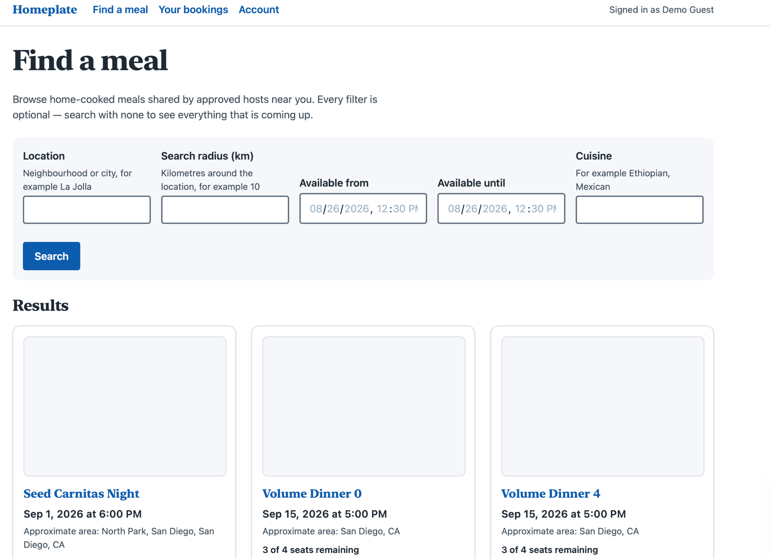
Current search page render
What already works  Clear navigation, legible controls, consistent spacing system, accessible color discipline, reusable cards and predictable page structure. | What makes it feel unfinished  Large form-like search area, weak content hierarchy, empty image placeholders, limited brand expression, sparse metadata treatment and prototype-style account/navigation copy.

Primary design issue  The screen communicates data but not desire. A consumer marketplace must make the user want the experience, not simply understand the record. | Framework conclusion  A new UI framework may accelerate component authoring, but it will not solve the content, hierarchy, brand and interaction problems visible in this screen.

2. Design position
Homeplate should not be designed as “Airbnb for meals.” It should borrow proven marketplace and booking patterns while expressing a different emotional proposition: a seat at someone’s table, at a specific time, with limited availability.
Treat listings as events, not products | Date, host, neighborhood, cuisine and remaining seats should be the dominant metadata. Scarcity and time are core to the experience.

Use the existing system harder | The current tokenized CSS architecture can support a polished visual system. Improve hierarchy, spacing, surfaces, cards and states before replacing the foundation.

Content is part of the interface | Photography, host identity, descriptions and meaningful demo data are not optional decoration. They materially determine whether the marketplace feels credible.

Accessibility is a design constraint, not a visual limitation | Keep measured contrast and token discipline. Build a warm brand by choosing compliant shades and using accent color intentionally, rather than weakening accessibility gates.

Where a dependency can make sense
Use a well-audited single-purpose library when a component is genuinely complex and accessibility-sensitive - for example a date picker, combobox, advanced menu or virtualized list. Keep that dependency scoped to the problem instead of making it the new visual architecture for the entire product.
Important correction to the current reasoning
“No webfont CDN” does not mean “no custom typeface.” If licensing allows it, a font can be self-hosted with the application and loaded without a third-party request. The same principle applies to icons: a small self-hosted icon set or inline SVG components can provide polish without introducing a heavy framework.

3. Search experience redesign
The search page should move from “form + records” to “discovery + event cards.” The results should dominate the viewport, while filters support discovery without consuming the page.

A. Compress the filter experience
Replace the tall five-field panel with a compact horizontal search bar on desktop. Use clear controls for location, date/time window, cuisine and radius/guests as appropriate. Allow natural wrapping on narrow screens. The first row of listings should appear much higher in the viewport.

B. Make cards visually dominant
Use a responsive card grid with a fixed image aspect ratio. Reduce hard borders, increase whitespace, clarify title/metadata hierarchy, make the whole card clickable and provide subtle hover/focus feedback.

C. Rewrite metadata for scanning
Replace sentences such as “Approximate area: North Park, San Diego, San Diego, CA” with concise display strings such as “North Park, San Diego.” Preserve richer data in the model, not in the visual sentence.

D. Treat seats as status
“1 seat left,” “3 of 4 seats,” and “Sold out” should be visual states with controlled emphasis. This is a core product signal, not secondary prose.

E. Remove prototype language
Replace “Signed in as Demo Guest” with a real account pattern such as avatar/initials, bookings and account menu. Keep test identity in development tooling rather than the finished navigation.

Recommended card information order
Order | Element | Purpose
1 | Image | Create desire and communicate atmosphere.
2 | Meal title | Immediate recognition of the experience.
3 | Neighborhood + cuisine | Fast context without exposing exact location.
4 | Date, time + seats | Reinforce the scheduled event and make availability immediately visible.

4. Content and brand system
The agent is correct that photography is the highest-impact missing ingredient. However, the right response is not to accept empty cards as the final visual language. The demo content and the product model should be upgraded alongside the interface.

Photography strategy
- Build 15-20 high-quality demo listings rather than relying on more than a thousand thin seed records.
- Support multiple image types: meal, table setting, host, cooking process and social atmosphere.
- Define image guidance so listings feel coherent: aspect ratio, minimum resolution, crop behavior and fallback treatment.
- Use a branded fallback illustration or intentional neutral treatment when an image is unavailable - not a large empty gray rectangle.

Brand direction
The current blue palette and heavy serif treatment feel closer to an institutional or editorial website than a social dining marketplace. Homeplate should feel warmer and more human while remaining trustworthy.
Area | Recommendation | Design intent
Color | Warm accent + restrained neutrals | Hospitality and appetite without compromising contrast.
Typography | Sans-serif for product UI; optional display face for large marketing headlines | Modern scanning with a small amount of editorial personality.
Icons | Consistent minimal icon set | Make date, location, seats and account actions feel finished and easier to scan.
Surfaces | Softer borders, controlled radius and subtle elevation | Reduce the “form/table” feeling and introduce depth without visual noise.

5. Listing detail and booking experience
The listing detail page is where Homeplate must convert curiosity into trust and commitment. It deserves more design attention than the search page alone.

Two-column desktop layout
Primary content on the left; a sticky reservation panel on the right with date, time, remaining seats and the primary booking action.

Host trust block
Host photo, name, verification status, hosting history and reviews when available. This directly addresses the interpersonal trust inherent in dining at someone’s home.

Experience narrative
A short, well-edited description of the meal and the atmosphere. Avoid generic database fields presented as labels. Add only model fields that improve the experience, such as host avatar, image gallery, dietary tags, verification, languages, duration and reviews when meaningful.

Menu and dietary information
Present the menu as a scannable section with tags for relevant dietary information.

Privacy-conscious location
Show neighborhood-level information before booking and clearly explain that the exact address is shared after reservation. Turn the privacy constraint into a trust signal.

Clear reservation state
Handle available, nearly full, sold out, booking in progress, success and failure states explicitly.

Interaction polish
- 150-250 ms hover/focus/press transitions where they improve feedback.
- Skeleton loading for card grids and detail content.
- Clear button loading states during reservation.
- Purposeful empty states with recovery actions such as “Clear filters.”
- Error states with retry behavior rather than raw technical messages.
- Success confirmation that summarizes the booking and next steps.

6. Prioritized roadmap
The sequence below prioritizes the largest improvement in perceived product quality with the least architectural disruption.
Pri. | Workstream | Effort | Expected effect
P0 | Create 15-20 polished demo listings with strong imagery | Low-Med | Largest immediate improvement to perceived marketplace quality.
P0 | Compress filters and redesign result cards | Med | Moves the page from administrative form to consumer discovery.
P0 | Define brand tokens: accent, typography, radius, elevation, icon style | Med | Creates a consistent visual identity without changing architecture.
P1 | Redesign listing detail with sticky reservation panel | Med | Improves trust, comprehension and booking conversion.
P1 | Add minimal icon system and polished navigation/account treatment | Low | Strong increase in perceived completeness.
P1 | Design loading, empty, error, sold-out and success states | Med | Removes prototype behavior and improves resilience.
P2 | Add micro-interactions and image loading polish | Low-Med | Adds refinement once core hierarchy is correct.

Definition of “finished enough” for the next milestone
- First viewport shows real listings rather than mostly filters.
- At least 90% of demo listings have intentional imagery or a designed fallback.
- Cards clearly prioritize image, title, location/cuisine, date and seat status.
- Core states are designed: loading, empty, error, sold out, booking and success.
- Accessibility contract remains green and no framework is added solely for visual polish.
Final recommendation
Do not spend the next cycle debating Tailwind versus MUI versus custom CSS. Make Homeplate feel like Homeplate: warm photography, compact discovery, event-first cards, trustworthy booking flows, deliberate brand tokens and polished states. Revisit dependencies only for genuinely complex interactions.

