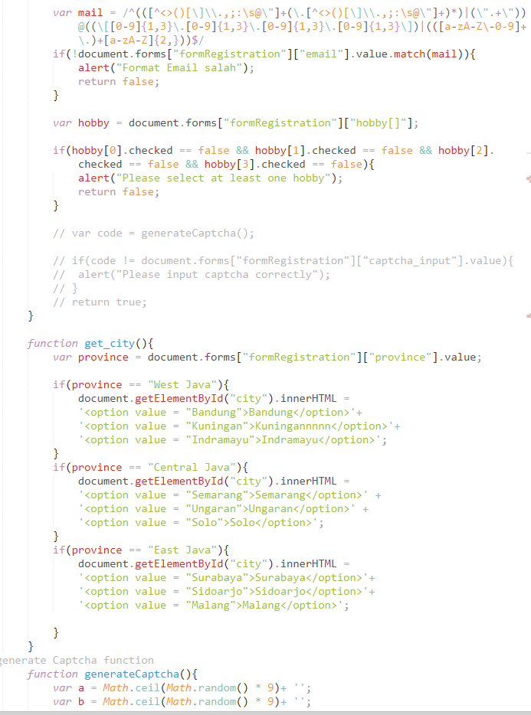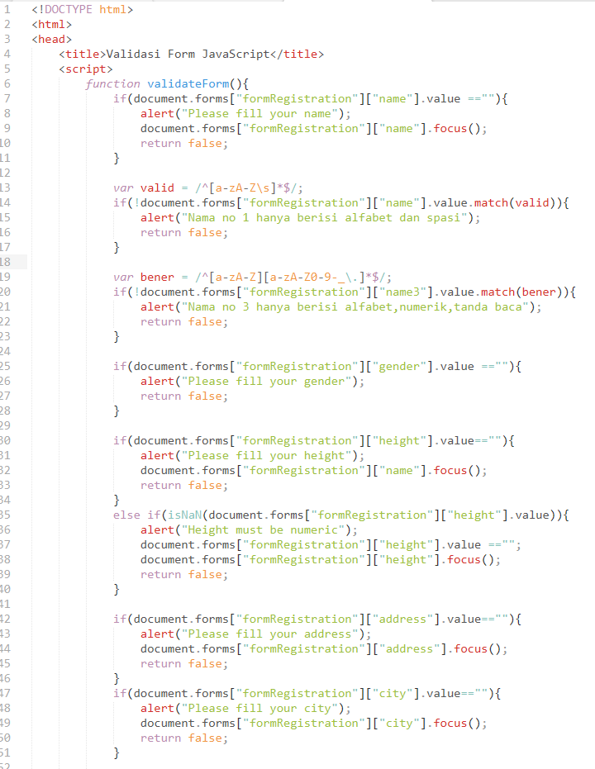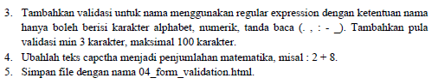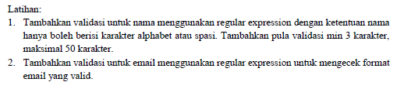

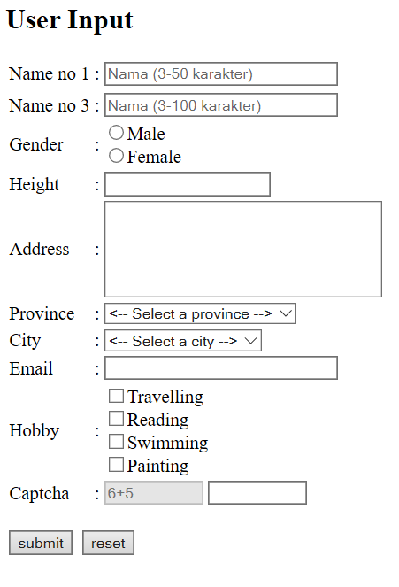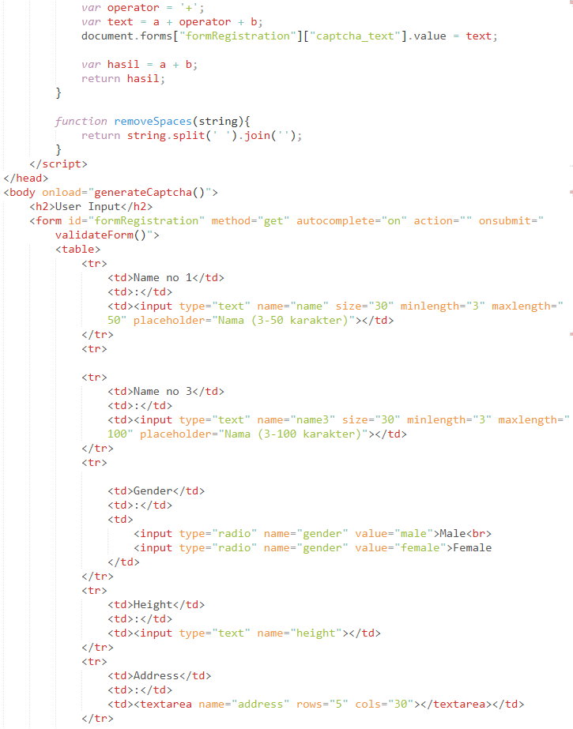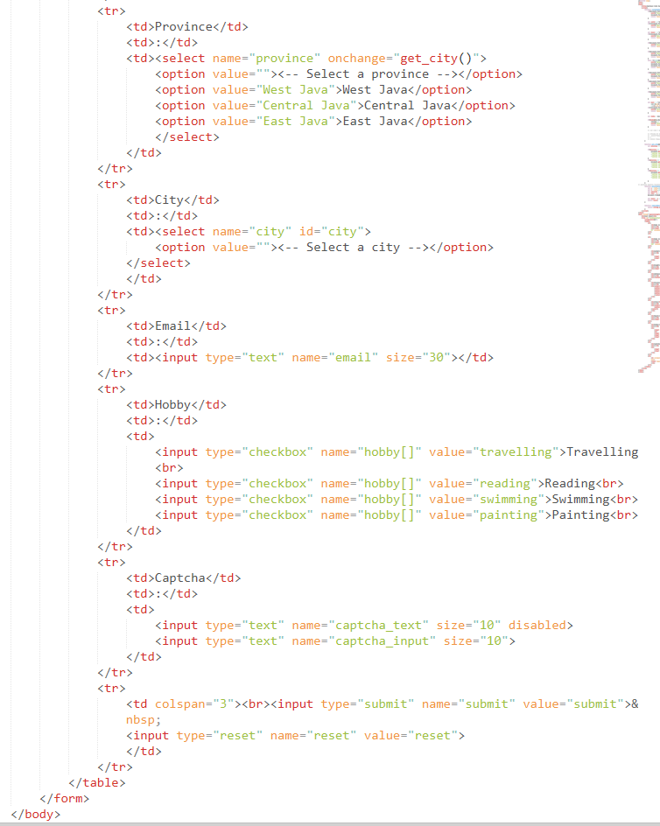

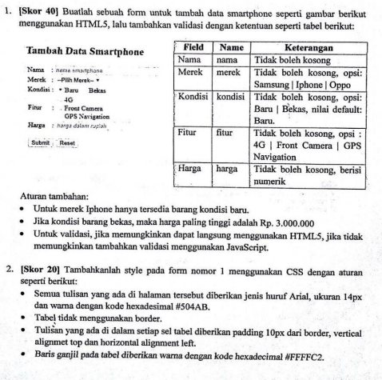

|  |
| --- |
| <!DOCTYPE html>  <html>  <head>  <title></title>  <style>  body{  font-family: arial;  }  #formtambah td{  padding: 10px;  vertical-align: top;  text-align: left;  }  #formtambah tr:nth-of-type(odd){  background-color: #ffffc2;  }  </style>  <script>  function validasiForm(){  if(document.forms["formtambah"]["merk"].value=="")  {  alert("merk tidak boleh kosong");  document.forms["formtambah"]["merk"].focus();  return false;  }  if(document.forms["formtambah"]["radio"].value=="")  {  alert("tolong isi kondisinya:)");  document.forms["formtambah"]["radio"].focus();  return false;}  if(document.forms["formtambah"]["merk"].value=="iphone" && document.forms["formtambah"]["radio"].value=="bekas"){  alert("iphone hanya ada kondisi baru");  return false;    }  var fitur = document.forms["formtambah"]["fitur[]"];    if(fitur[0].checked == false && fitur[1].checked == false && fitur[2].checked == false){  alert("Please select at least one fitur");  return false;  }  var valid = /^[0-9]+$/;  if(!document.forms["formtambah"]["harga"].value.match(valid)){  alert("hanya boleh angka doang harganya");  return false;  }  if (document.forms["formtambah"]["harga"].value >3000000 && document.forms["formtambah"]["radio"].value=="bekas"){  alert("maksimal 3 juta untuk yang bekas");  return false;  }    }  </script>  </head>  <body>  <h1>Tambah Data Smartphone</h1>  <form id="formtambah" method="get" action="" autocomplete="on" onsubmit="validasiForm()">  <table>  <tr>  <td>Nama</td>  <td>:</td>  <td><input type="text" name="name" placeholder="nama smartphone" required /></td>  </tr>  <tr>  <td>Merk</td>  <td>:</td>  <td><select name="merk">  <option value="">--Pilih Merk--</option>  <option value="samsung">Samsung</option>  <option value="iphone">Iphone</option>  <option value="opppo">Oppo</option>  </select>  </td>  </tr>  <tr>  <td>Kondisi</td>  <td>:</td>  <td><input type="radio" name="radio" value="baru" checked>Baru  <input type="radio" name="radio" value="bekas">Bekas</td>  </tr>  <tr>  <td>Fitur</td>  <td>:</td>  <td>  <input type="checkbox" name="fitur[]" value="4g">4G <br>  <input type="checkbox" name="fitur[]" value="frontcamera">Front Camera <br>  <input type="checkbox" name="fitur[]" value="gps">GPS Navigation <br>  </td>  </tr>  <tr>  <td>Harga</td>  <td>:</td>  <td><input type="text" name="harga" placeholder="harga dalam rupiah" />  </td>  </tr>  <td colspan="3"> <br>  <input type="submit" name="submit" value="submit">  <input type="reset" name="reset" value="reset">    </td>  </table>  </form>  </body>  </html> |

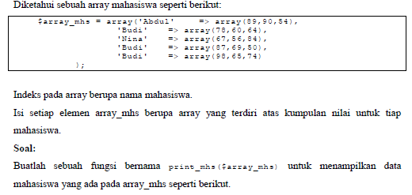

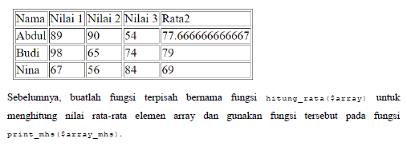

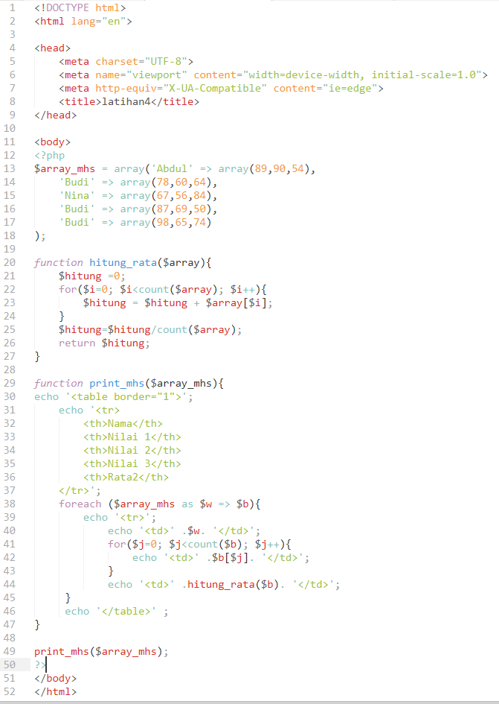

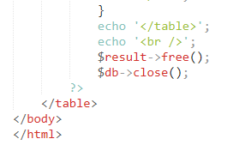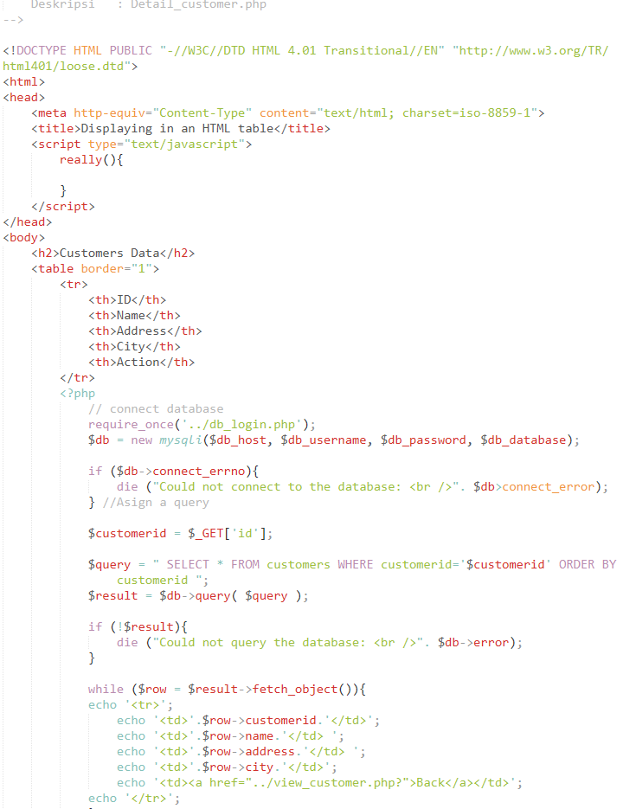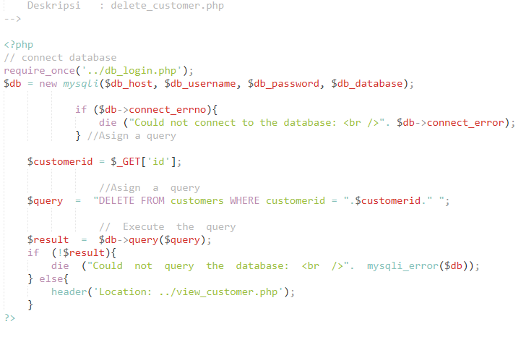

|  |
| --- |
| <?php  //Nama : Ilman Nabil Shiddiq  //NIM : 24060117140065  //File : edit_customer.php  //Deskripsi : menampilkan form edit data customer dan mengupdate data ke database  $error_city = "";  $error_name = "";  $error_address = "";  $id = $_GET['id']; // connect database  require_once('../db_login.php');  $db = new mysqli($db_host, $db_username, $db_password, $db_database);  if ($db->connect_errno){  die ("Could not connect to the database: <br />". $db>connect_error);  }  if (!isset($_POST["submit"])){  $query = " SELECT * FROM customers WHERE customerid=".$id." "; // Execute the query  $result = $db->query( $query );  if (!$result){  die ("Could not query the database: <br />". $db->error);  }else{  while ($row = $result->fetch_object()){  $name = $row->name;  $address = $row->address;  $city = $row->city;  }  }  }else{  $name = test_input($_POST['name']);  if ($name == ''){  $error_name = "Name is required";  $valid_name = FALSE;  }elseif (!preg_match("/^[a-zA-Z ]*$/",$name))  {  $error_name = "Only letters and white space allowed";  $valid_name = FALSE;  }else{  $valid_name = TRUE;  }  $address = test_input($_POST['address']);  if ($address == ''){  $error_address = "Address is required";  $valid_address = FALSE;  }else{  $valid_address = TRUE;  }  $city = $_POST['city'];  if ($city == '' || $city == 'none'){  $error_city = "City is required";  $valid_city = FALSE;  }else{  $valid_city = TRUE;  } //update data into database  if ($valid_name && $valid_address && $valid_city){ //escape inputs data  $name = $db->real_escape_string($name);  $address = $db->real_escape_string($address);  $city = $db->real_escape_string($city); //Asign a query  $query = " UPDATE customers SET name='".$name."', address='".$address."', city='".$city."' WHERE customerid=".$id." "; // Execute the query  $result = $db->query( $query );  if (!$result){  die ("Could not query the database: <br />". $db->error);  }else{  echo 'Data has been updated.<br /><br />';  echo '<a href="../view_customer.php">Back to customers data</a>';  $db->close();  exit;  }  }  }  function test_input($data) {  $data = trim($data);  $data = stripslashes($data);  $data = htmlspecialchars($data);  return $data;  }  ?>  <!DOCTYPE HTML>  <html>  <head>  <style>  .error {color: #FF0000;}  </style>  <style>  .error {color: #FF0000;}  </style>  </head>  <body>  <h2>User Input</h2>  <form method="POST" autocomplete="on" action="<?php echo htmlspecialchars($_SERVER["PHP_SELF"]).'?id='.$id;?>">  <table>  <tr>  <td valign="top">Name</td>  <td valign="top">:</td>  <td valign="top"><input type="text" name="name" size="30" maxlength="50" placeholder="Name (max 50 characters)" autofocus value="<?php echo $name;?>"></td>  <td valign="top"><span class="error">* <?php echo $error_name;?></span></td>  </tr>  <tr>  <td valign="top">Address</td>  <td valign="top">:</td>  <td valign="top"><textarea name="address" rows="5" cols="30" placeholder="Address (max 100 characters)"><?php echo $address;?></textarea></td>  <td valign="top"><span class="error">* <?php echo $error_address;?></span></td>  </tr>  <tr>  <td valign="top">City</td>  <td valign="top">:</td>  <td valign="top"><select name="city" required>  <option value="none" <?php if (!isset($city)) echo 'selected="true"';?>>--Select a city--</option>  <option value="Airport West" <?php if (isset($city) && $city=="Airport West") echo 'selected="true"';?>>Airport West</option>  <option value="Box Hill" <?php if (isset($city) && $city=="Box Hill") echo 'selected="true"'; ?>>Box Hill</option>  <option value="Yarraville" <?php if (isset($city) && $city=="Yarraville") echo 'selected="true"'; ?>>Yarraville</option>  </select>  </td>  <td valign="top"><span class="error">* <?php echo $error_city;?></span></td>  </tr>  <tr>  <td valign="top" colspan="3"><br><input type="submit" name="submit" value="Submit">  </tr>  </table>  </form>  </body>  </html>  <?php  $db->close();  ?> |