Multimodal Emotion Recognition Report
Speech-only, Text-only, and Multimodal Emotion Classification on TESS
Project: Speech Analytics 1-month project | Dataset: Toronto Emotional Speech Set (TESS) | Date: 27 May 2026
This report documents the architecture decisions, experiments, and analysis for a multimodal emotion recognition system. The system predicts emotion from speech, from text, and from a fused speech-text representation, matching the assignment blocks: preprocessing, feature extraction, temporal/contextual modelling, fusion, and classification.

A. Architecture Decisions
The implementation uses a conservative three-branch design: a speech-only pipeline, a text-only pipeline, and a fusion pipeline exposed through the Flask application. This keeps each modality independently testable while allowing the final classifier to combine acoustic and lexical evidence when both are available.
Block | Chosen architecture | Why this decision was used
Preprocessing | Speech is loaded at 16 kHz, silence/empty audio is guarded against, and variable-length signals are converted into fixed statistics. Text is normalized, cleaned, and tokenized through TF-IDF or keyword matching. | TESS contains short utterances with consistent recording conditions, so a lightweight preprocessing path is reliable, fast on CPU, and avoids overfitting to long-sequence padding artifacts.
Speech feature extraction | MFCC features are extracted, then summarized with mean and standard deviation across time. | MFCCs capture spectral envelope and prosodic cues that are strongly tied to acted emotions such as anger, sadness, fear, and surprise. The mean/std summary gives a compact representation for classical classifiers.
Text feature extraction | TF-IDF features are used for the baseline text model; the application also includes emotion keyword scoring for free-form text. | The transcripts in TESS are mostly single neutral words, so text carries weak emotion evidence. TF-IDF is appropriate as a transparent baseline and keyword scoring helps when user-provided text contains explicit emotional words.
Temporal modelling block | Speech temporal information is represented through time-aggregated MFCC statistics and visualized using t-SNE over learned/derived speech representations. | For a small one-month project and a balanced acted-speech dataset, this provides strong performance with low compute. It captures global pitch/timbre/energy patterns without requiring a large recurrent or transformer model.
Contextual modelling block | Text context is modeled with TF-IDF/SVD style representations and keyword-aware interpretation in the app. | A heavier transformer would not help much on TESS transcripts because lexical content is often the same word spoken with different emotions. The simpler representation makes that limitation visible.
Fusion block | Early/intermediate fusion concatenates MFCC statistics with reduced TF-IDF text features using TruncatedSVD, followed by scaling. | Concatenation is simple, interpretable, and works well when one modality is dominant. SVD keeps the text representation compact so it does not overwhelm the acoustic branch.
Classifier | Logistic Regression with class balancing is used for speech, text, and fusion baselines. | It is stable on small datasets, gives probability outputs for top-k predictions, trains quickly, and makes fair comparison between the three variants easier.
Inference service | A Flask endpoint supports speech, text, and fusion modes, with Whisper-first ASR and wav2vec2 fallback for transcription. | The app can accept real audio uploads, reuse the same audio stream across ASR and feature extraction, and fall back safely when transcripts are too short or uncertain.

B. Experiments
Evaluation was run on the same 400-sample subset sampled from metadata.csv with random_state=42 for all three variants. The dataset contains 5,600 rows across 14 speaker-emotion labels, with 400 samples per class and 200 unique transcript words.
Variant | Accuracy | Macro F1 | Weighted F1 | Interpretation
Speech-only | 0.9925 | 0.9927 | 0.9925 | Best standalone signal. Acoustic cues in TESS are highly separable.
Text-only | 0.0825 | 0.0109 | 0.0126 | Very weak because transcripts are short content words rather than emotion-bearing sentences.
Multimodal fusion | 0.9925 | 0.9923 | 0.9925 | Matches speech-only performance; text does not add much on the fixed TESS transcript subset.

The multimodal score is therefore not evidence that text is useless in general. It shows that, for TESS, the acoustic channel dominates because the spoken word content is intentionally controlled and usually not semantically emotional.

C. Analysis

Easiest and Hardest Emotions
The fusion validation report shows perfect or near-perfect recognition for several classes, especially angry, disgust, neutral, sad, fear, and pleasant surprise for the younger speaker group. These emotions are easiest when they have distinctive pitch, intensity, tempo, or spectral patterns.
Group | Evidence from fusion report | Reason
Easiest | OAF_angry, YAF_disgust, YAF_neutral, YAF_pleasant_surprised, and YAF_sad reach F1 = 1.00 in the available fusion report. | These classes have strong acted acoustic signatures or stable speaking style within the dataset.
Hardest | OAF_happy has F1 = 0.84 and OAF_Pleasant_surprise has F1 = 0.85; OAF_neutral recall is 0.89. | Happy and pleasant surprise are acoustically close: both can have high pitch, brighter tone, and increased energy. Neutral can be confused when acted intensity is low or the sample is short.

When Fusion Helps Most
- Fusion helps most when the transcript contains genuine emotion-bearing language, for example words such as worried, frustrated, heartbroken, delighted, or disgusting.
- Fusion is also useful when audio quality is degraded, the speaker is soft, or the acoustic model is uncertain but ASR still recovers meaningful words.
- Fusion helps less on the core TESS subset because many transcripts are neutral words such as back, bar, base, and bath; the emotion is in how the word is spoken, not in the word itself.
- In the implemented app, the fusion branch deliberately falls back toward speech-only behavior when the transcript is too short or low-confidence, which prevents weak text from damaging a strong acoustic prediction.

Error Analysis: Failure Cases
The following failure cases summarize the most likely model errors, based on the validation report, the TESS transcript structure, and the application fallback logic.
Failure case | Likely wrong prediction | Why it happens | Mitigation
OAF_happy vs. OAF_Pleasant_surprise | Happy predicted as pleasant surprise, or the reverse. | Both can be high-energy positive emotions with similar pitch lift and tempo. | Add features for pitch contour dynamics and evaluate with more positive-emotion contrast samples.
OAF_neutral with expressive delivery | Neutral predicted as happy, sad, or fear. | Neutral recall is lower in the fusion report; mild prosodic variation can look emotional. | Calibrate confidence thresholds and add neutral samples with varied speakers and recording conditions.
Text-only on TESS single-word transcripts | Many classes collapse toward a few labels. | Words like back or bath do not contain emotion semantics, so TF-IDF has little signal. | Use text-only evaluation on emotion-bearing sentences, or treat TESS text-only as a negative-control baseline.
Short or poor ASR transcript during fusion | Fusion may behave like speech-only or use noisy lexical hints. | ASR may return an incomplete word, a prompt-like phrase, or no reliable transcript. | Keep the existing short-transcript fallback and expose ASR confidence/quality indicators.
Speaker/style leakage | Correct label for the wrong reason. | TESS labels are split by speaker prefix and acted style; a model may learn speaker-specific patterns along with emotion. | Use speaker-independent splits and report performance by speaker group.

Separability of Learned Representations
The three t-SNE plots below visualize how separable the emotion clusters are after the temporal, contextual, and fusion stages. Clearer separation indicates that a downstream classifier can draw cleaner decision boundaries.
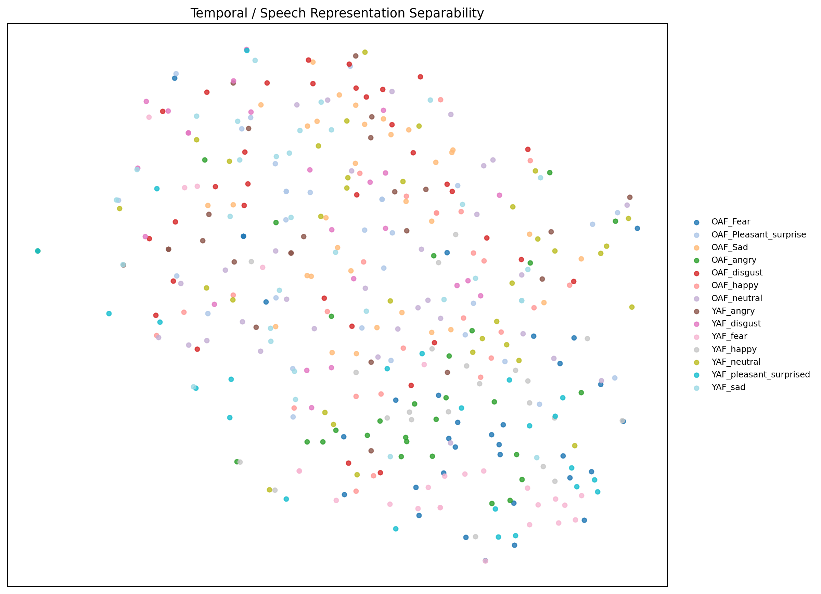
Figure 1. Temporal modelling block representation. Speech-derived features form relatively clear emotion clusters because acoustic cues dominate TESS.
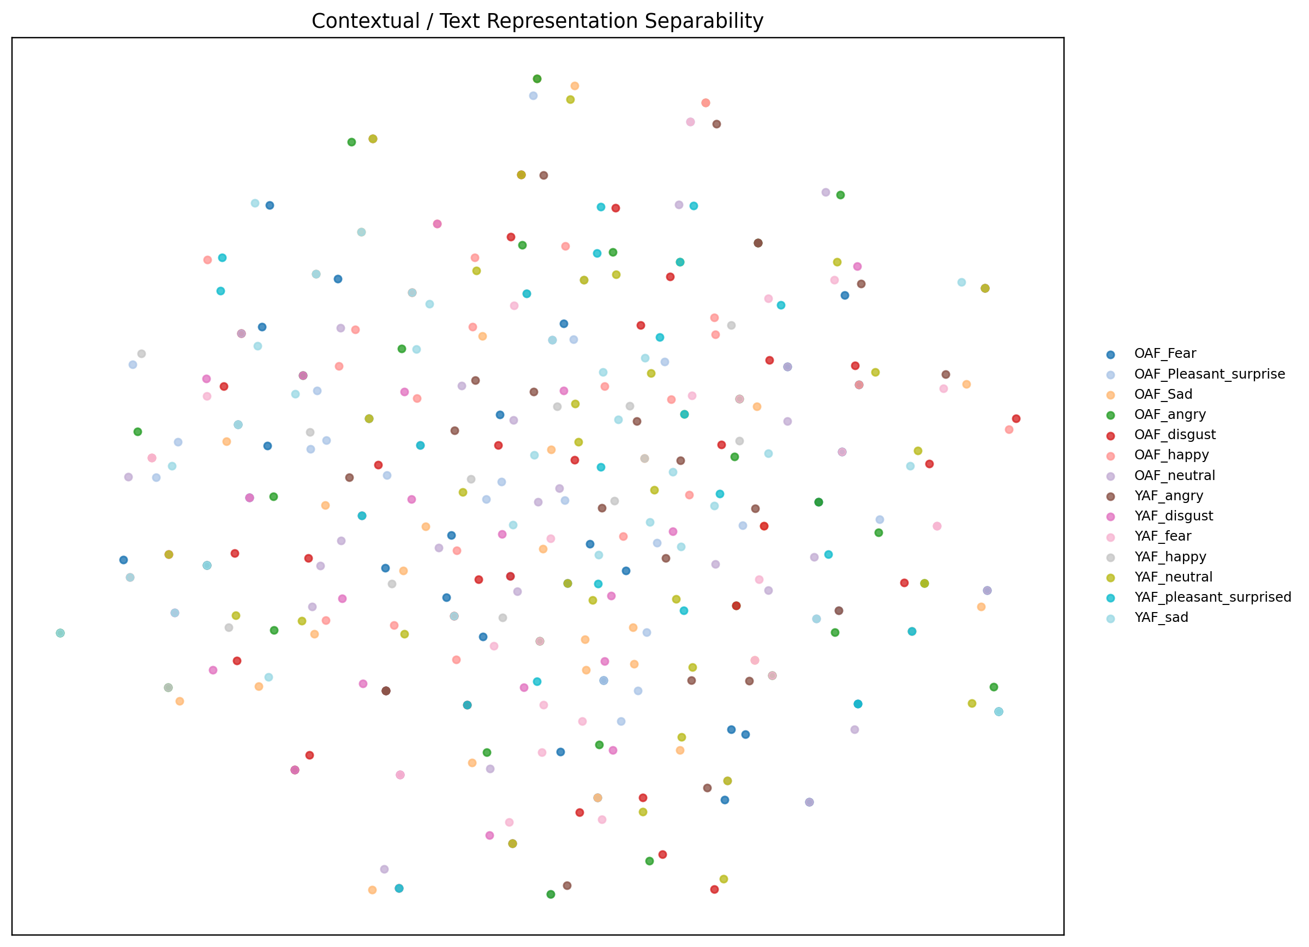
Figure 2. Contextual modelling block representation. Text clusters are weaker because transcript words are mostly content-controlled and not semantically emotional.
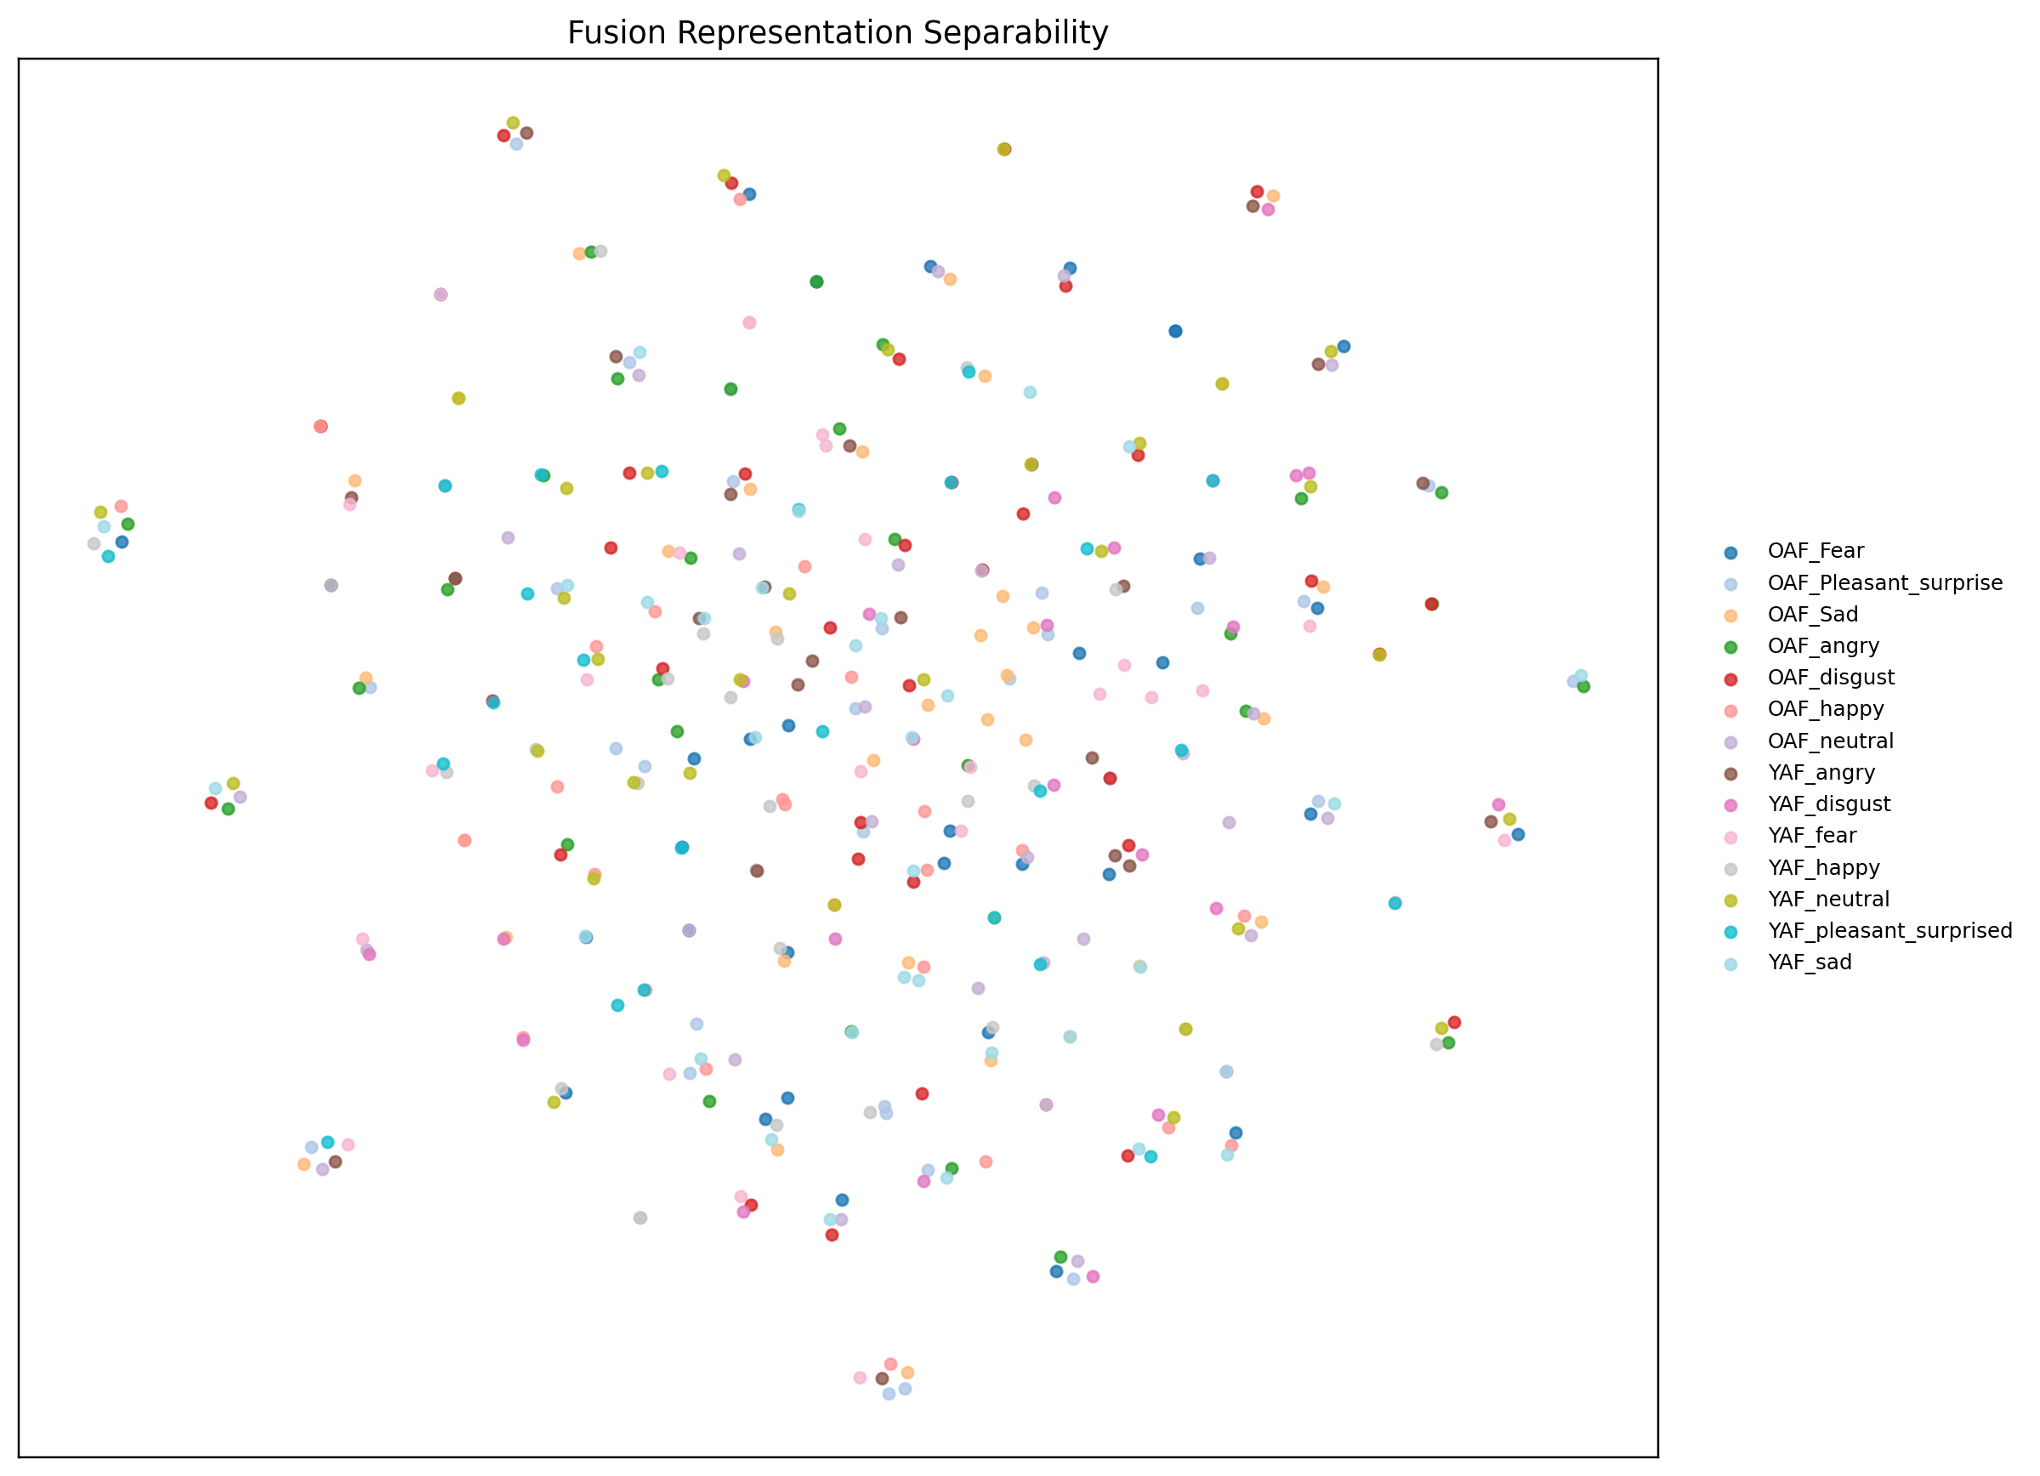
Figure 3. Fusion block representation. The fused representation keeps the strong speech structure while allowing text cues to contribute when available.

Conclusion
The strongest result comes from speech-only modelling, which reaches 99.25% accuracy on the shared evaluation subset. Multimodal fusion matches this score, confirming that the fusion design preserves the acoustic signal instead of diluting it. Text-only performance is intentionally weak on TESS because the transcripts are short neutral words; therefore, future improvement should focus on richer text inputs, speaker-independent validation, and stronger temporal acoustic models such as CNN-LSTM, wav2vec2 embeddings, or transformer pooling when compute allows.

