**How to use the code**

* Compile the code using the following command  
  make –f make1.mk
* Then we can user the addgroup command.
* Use –n indicate the Group Name .
* Use –i to indicate the Group ID.
* Use –p to indicate the Group Password .
* User –m to indicate the group members .
* Group members have to be separated using “,”.

**OUTPUTS:**

1>If there is some Error in the details provided by the User it will pop up the syntax of the addgroup command as shown:



2>If all the syntax given by the user is proper then the output will be as followed

A new group would have successfully created

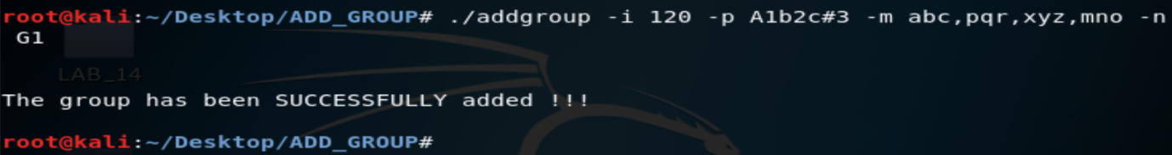

3>All the details other than the password of the group will be stored in the group.txt file which is in the same folder

The data is stored in the format:

<Group Name>:x:<to indicate password>:<Group ID>:<Group Members separated with “:”>

As shown below



4>The Encrypted password and all the other information is stored in another file called gshadow.txt

The data is stored in the similar format as that of the group.txt

I have user a simple ROT13 cypher for the encryption of the password

