Quantum-Enhanced Intelligent Transportation System for Real-Time Urban Traffic Optimization
A project report submitted in partial fulfillment of the requirements
for the award of the degree of B.tech in CSE

By
Gagandeep Singh (2023UCD2152)
Naman Singhal (2023UCD3078)
Piyush (2023UCA1941)
Group number - 101

Under the supervision of
Dr. Rashmi Chaudhry
Computer Science and Engineering (CSE)
Netaji Subhas University of Technology



Department of Computer Science and Engineering Netaji Subhas
University of Technology (NSUT) New Delhi, India - 110078
September 2026

Supervisor Sign :

Table of Contents
1. Introduction 1
2. Motivation 1
3. Literature Survey 2
3.1 Base paper: Q-ITS 2
3.2 Reviews of quantum computing in transportation 2
3.3 Related quantum-based vehicle network systems 2
3.4 Research gap 3
4. Problem Statement 3
5. Objectives and Methodology 3
5.1 Objectives 3
5.2 How the system works 3
5.3 Traffic simulation and phone data 4
5.4 The quantum decision-maker 4
5.5 How the circuit learns 4
5.6 Secure communication layer (kept as in the paper) 4
5.7 Methods compared and test procedure 5
5.8 Work completed and results 5
6. Simulation Platform and Requirements 6
6.1 Software 6
6.2 Hardware 6
6.3 Simulation settings and dataset 7
6.4 Reproducibility 7
6.5 Requirements for the next phase 7
7. Conclusion 7
References 8

1. Introduction
Traffic jams waste time and fuel in every large city. An Intelligent Transportation System (ITS) collects live traffic data and uses it to control traffic signals and to guide vehicles. Two new technologies can make an ITS better. First, smartphones and in-car devices already travel with most vehicles, so they can report position and speed without installing new roadside sensors. Second, quantum technology offers new tools: small quantum circuits can be trained to make decisions, and quantum communication can protect the messages sent between vehicles and the road network.
The base paper of this project, Ahmad et al. [1], combines both ideas in a system called Q-ITS. At every intersection, a small quantum circuit reads traffic data reported by phones and decides two things: how to spread vehicles over the next roads (routing), and how to share green time between the north–south and east–west directions (signal timing). The circuit keeps learning while traffic runs. Intersections share information over links protected by quantum key distribution. The paper reports large gains over classical systems, including 42.1 % less average delay, 42.1 % lower decision latency and 37.4 % less communication overhead.
The authors did not release their code or data. The first phase of this project was therefore to build Q-ITS from scratch, following the paper closely, and to check whether its results hold when compared fairly with other methods. This report describes that work. Table 1 explains the main terms used.
Table 1. Key terms used in this report
Term | Meaning in simple words
Delay | Extra travel time of a vehicle compared with driving on an empty road.
Green split | The share of green time given to the north–south direction in each signal cycle.
Qubit, quantum circuit | A qubit is the quantum version of a bit. A circuit is a sequence of operations on qubits, ending with a measurement.
VQC | Variational quantum circuit: a circuit with adjustable angles that is trained, like a small neural network.
Shots | How many times the circuit is run and measured to estimate its output (8192 per decision here).
SPSA | The training method: it tries two slightly different settings and moves in the better direction.
QKD (BB84) | Quantum key distribution: a way to share secret keys; an eavesdropper creates errors and is detected.
DQN | Deep Q-Network: a standard classical reinforcement-learning method, used here as a baseline.
Seed | A number that fixes the random traffic, so every method is tested on exactly the same traffic.

2. Motivation
- Traffic changes all the time. Fixed signal plans cannot follow demand that changes minute by minute. A controller that reacts to live data can reduce delay.
- Phones are a cheap source of traffic data. Even if only 60 % of vehicles report, every approach of every intersection gets estimates of queue length, speed and inflow.
- Quantum methods are promising but not yet proven. Recent surveys find that quantum approaches to transport are still mostly proof-of-concept studies on small networks, and that they are rarely compared with strong classical methods using proper statistics [3], [4]. Large claimed gains therefore need to be checked independently.
- A method must be understood before it can be improved. Rebuilding Q-ITS shows which parts really help, which claims hold, and where the method is weak. This decides where the project's own contribution should go. As agreed for this project, the security layer is kept exactly as in the paper, and all improvements will be on the traffic side.

3. Literature Survey
The survey covers the base paper, three recent review papers on quantum computing in transportation, and two recent systems that combine quantum ideas with vehicle networks.

3.1 Base paper: Q-ITS
Ahmad et al. [1] propose Q-ITS, published in IEEE Transactions on Consumer Electronics (2026). Each intersection uses a 4-qubit variational circuit, trained with SPSA, to set routing probabilities and a green split from phone-reported traffic data. Communication between intersections uses entangled links, BB84 key distribution and a one-time pad, with trust scores and consensus between neighbours. The method is tested in simulation on a synthetic grid with Poisson traffic. It is compared with a DQN and a rule-based controller, and the paper reports lower delay, latency, communication overhead and energy use. No code was released.

3.2 Reviews of quantum computing in transportation
Niu et al. [2] (Transportation Letters, 2026) review quantum computing for transport science under three approaches: gate-based quantum computing, quantum annealing and quantum machine learning. Many of the reviewed studies write transport problems as QUBO problems (optimisation over binary variables), for example vehicle routing, railway rescheduling, traffic flow optimisation and traffic signal control. The authors conclude that current hardware is limited by the small number of qubits, high error rates and noise. Real problems with continuous variables need many qubits after binary encoding, so hybrid quantum–classical methods are needed to move beyond proof-of-concept studies.
Somvanshi et al. [3] (IEEE Transactions on Intelligent Transportation Systems, 2026) survey quantum computing across ITS, traffic management, vehicle routing, logistics and autonomous vehicles. For signal control they describe quantum annealing (QUBO) methods and quantum-inspired search methods such as quantum particle swarm optimisation. These methods beat fixed-cycle control, especially under unbalanced traffic. The authors state that near-term gains come from hybrid methods rather than from a pure quantum advantage. They also note that most studies use toy networks and are not benchmarked systematically against advanced classical methods, and they call for fair and reproducible evaluations.
Guerrero-Domínguez et al. [4] (IEEE Transactions on Intelligent Transportation Systems, 2026) systematically review 40 studies that use quantum computing for predictive transport modelling, such as traffic and demand forecasting. Forecasting studies typically report modest error reductions of 5–30 % over classical baselines. However, many studies give no variance or significance analysis, no standard benchmark exists, and quantum machine learning has not yet shown clear superiority over classical methods. They argue that real-world outperformance is unlikely before large, error-corrected quantum computers are available. Until then, application studies should be treated as proof-of-concept and judged with principled benchmarking.

3.3 Related quantum-based vehicle network systems
Awan et al. [5] (IEEE Transactions on Consumer Electronics, 2026) propose QIVNOM, which jointly optimises vehicle communication (V2V/V2I) and urban traffic control. It is quantum-inspired: candidate routing–signal plans are treated like probability ‘superpositions’, but everything runs on classical edge–cloud hardware without a quantum processor. In SUMO and OMNeT++/Veins simulations calibrated with the real METR-LA traffic dataset on a 5 × 5 km map, it reaches 57.3 ms mean end-to-end latency (about 20 % below the best baseline) and 96.7 % packet delivery.
Ramya et al. [6] (ICTMIM conference, 2026) present a ‘quantum-safe’ Internet-of-Vehicles framework. It combines machine-learning congestion prediction with an architecture designed to be compatible with post-quantum cryptography. No specific post-quantum algorithm is implemented. Using 15,200 records from 92 vehicles over 30 days, the congestion classifier (low, moderate, high) reaches 94.6 % accuracy. Processing at the edge cuts latency from 305 ms to 87 ms, and an ESP32 hardware prototype gives nearby-vehicle alerts.

3.4 Research gap
The literature shows three gaps. First, in the studies covered by these reviews, quantum signal control is done mainly with quantum annealing or quantum-inspired search, not with trained quantum circuits deciding the signal phase [2], [3]. Second, quantum transport results are rarely tested against strong classical methods with proper statistics [3], [4]. Third, the claims of Q-ITS [1] have not been checked independently. Phase 1 of this project addresses the third gap and follows the advice of [3] and [4] on fair testing. Phase 2 will address the first gap.

Table 2. Summary of the literature
Paper | Type | Main point | Relevance to this project
Ahmad et al. [1] | Method (base paper) | VQC + SPSA for routing and green split; QKD-secured links; large reported gains | The method reproduced in Phase 1
Niu et al. [2] | Review | Gate-based, annealing and QML methods; QUBO widely used; hardware still limited | Background; signal control so far mainly as QUBO
Somvanshi et al. [3] | Survey | Annealing and quantum-inspired methods beat fixed-cycle signals; toy networks, weak benchmarking | Need for fair comparison with strong baselines
Guerrero-Domínguez et al. [4] | Systematic review (40 studies) | QML not yet clearly better than classical; statistics often missing | Need for many seeds, CIs and significance tests
Awan et al. [5] | Method (quantum-inspired) | Joint V2X + traffic control on classical hardware; real-data-calibrated SUMO | Related system; shows value of realistic simulation
Ramya et al. [6] | Method (IoV + ML) | Congestion prediction with a post-quantum-ready design; real vehicle data | Related system; security side only at design level

4. Problem Statement
A city road network is modelled as a grid of signalised intersections. Vehicles enter at random times (a Poisson process) with random start and end points. About 60 % of vehicles carry a phone that reports noisy position and speed. At each intersection, a controller that sees only this local phone data must choose (a) routing probabilities for the outgoing roads and (b) the green split of the signal, so that the average vehicle delay in the network is as low as possible. Intersections may talk only to their neighbours, over quantum-secured links.
Q-ITS [1] is proposed as a solution, but it has no public code, leaves several details undefined and reports results that cannot be checked. This phase answers three questions:
- Can Q-ITS be built from the paper alone, with every missing detail decided and written down?
- Do its claimed results hold when it is compared fairly with classical methods on exactly the same traffic?
- Where is it weak on the traffic side? This decides the new contribution in Phase 2.

5. Objectives and Methodology

5.1 Objectives
- Build a traffic simulator and a phone-data model that match the paper's setup.
- Build the Q-ITS decision layer: data encoding, the 4-qubit circuit, the cost function and SPSA training, with a realistic noise model.
- Build the secure communication layer exactly as described in the paper.
- Build classical methods for comparison and the paper's ablation variants, and test all of them on the same 30 random seeds.
- Compare every paper claim with our result and record every assumption.

5.2 How the system works
Fig. 1 shows the system. It works in a loop: (1) traffic is generated and simulated; (2) phones report what they see; (3) each intersection turns the reports into 16 numbers; (4) these numbers are loaded into the quantum circuit; (5) the circuit's measured output gives the routing and green-split decisions, which are applied to the traffic; (6) the circuit is updated by SPSA, using information shared by neighbours over the secure links.
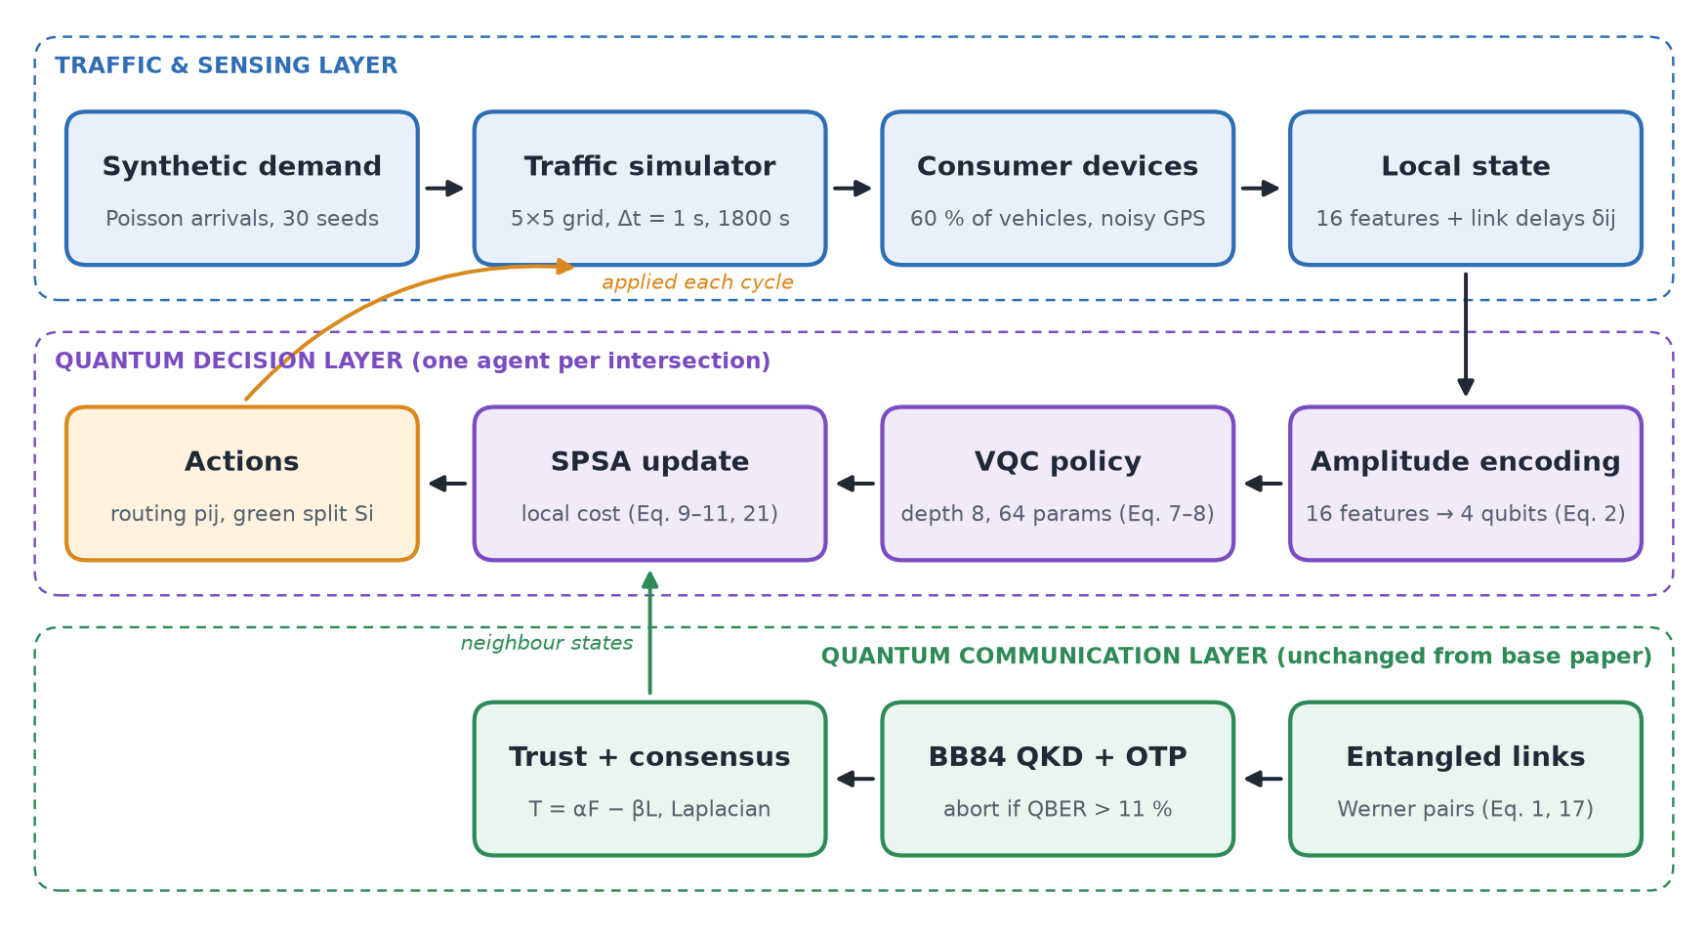
Fig. 1. Architecture of the implemented Q-ITS system: three layers working in a closed loop.

5.3 Traffic simulation and phone data
The road network is a 5 × 5 grid of intersections, 100 m apart, with two lanes in each direction. Vehicles drive at the speed limit, wait in a queue at a red light, and leave at 0.5 vehicles per second per lane on green. If the next road is full (26 vehicles), no more vehicles can enter it. Each signal cycle is 60 s with 3 s all-red between phases. Traffic is tested at three levels: low, medium and high, equal to 30 %, 60 % and 90 % of the network's measured capacity (6.5 vehicles/s). Phones on 60 % of vehicles report position and speed with small random errors. From these reports, each intersection estimates, for each of its four approaches, the number of vehicles, their speed, the queue length and the arrival rate (16 numbers), plus the expected delay on each outgoing road.

5.4 The quantum decision-maker
The 16 numbers are loaded into 4 qubits (2⁴ = 16 amplitudes; ‘amplitude encoding’). The circuit then applies 8 layers of rotations and entangling gates, with 64 adjustable angles in total. The circuit is measured 8192 times. From the measured results, two qubits give the routing probabilities for the four directions, and one qubit gives the green split. To be realistic, the circuit is simulated with the noise of today's quantum hardware (errors in every gate and loss of quantum state over time), using the values given in the paper.

5.5 How the circuit learns
Each intersection gives its current decision a cost. The cost adds up (a) the expected delay of the roads it sends vehicles to, (b) a small penalty for uneven routing, (c) a signal term that is low when the green split matches the demand in each direction, and (d) a small penalty for disagreeing with neighbours (the consensus term). SPSA lowers this cost. It changes all 64 angles slightly in a random direction, measures the cost for a step forward and a step back, and moves the angles towards the better side. The paper's step size (0.01) was too small to learn through the measurement noise, so 0.1 was used; with it, training settles within about 150–300 steps.

5.6 Secure communication layer
Neighbouring intersections share entangled links whose quality (fidelity) starts at 0.95 and slowly decays. When the link quality becomes too low, the link is refreshed; broken links are bypassed through another intersection. Secret keys are created with BB84 and messages are encrypted with a one-time pad; if the key error rate exceeds 11 %, an eavesdropper is assumed and the key is discarded. Each intersection trusts its neighbours according to link quality and loss, and neighbours gradually agree on shared values (consensus).

5.7 Methods compared and test procedure
Q-ITS was compared with four classical controllers:
- Fixed-time: equal green time, never changes.
- Rule-based: gives more green time to the busier direction using simple thresholds.
- DQN (phase): a trained neural network that picks which direction gets green every 5 s.
- DQN-split: the same network, but allowed only the same action as Q-ITS: one green split per 60 s cycle.
The paper's ablation variants were also run. NoQOpt replaces the quantum circuit with a classical model trained the same way, NoQKD uses ordinary channels, and NoCons removes the consensus term. Every method was tested on the same 30 random seeds at each traffic level, for 30 minutes of simulated time. Results are reported as averages with 95 % confidence intervals, and differences are checked with paired t-tests.

5.8 Work completed and results
All planned work is complete: simulator and demand calibration, phone-data model, quantum circuit and noise model, communication layer, the full Q-ITS controller, DQN and other baselines, ablations and energy analysis, and the write-up. The code passes 48 automated tests. Table 3 gives the main result.
Table 3. Average vehicle delay in seconds (mean of 30 seeds; 95 % confidence interval below ±0.2 s)
Method | Low (30 %) | Medium (60 %) | High (90 %)
Fixed-time | 26.17 | 27.87 | 30.98
Rule-based | 25.74 | 27.43 | 31.09
DQN-split (same action as Q-ITS) | 26.18 | 28.81 | 32.47
DQN (phase every 5 s) | 12.89 | 15.22 | 19.59
Q-ITS (our implementation) | 24.05 | 24.95 | 26.97

Main findings.
- Q-ITS beats rule-based control and DQN-split. Delay is 6.6 / 9.0 / 13.2 % lower than rule-based and 8.1 / 13.4 / 16.9 % lower than DQN-split at low / medium / high traffic. Every difference is statistically significant (p < 10⁻¹⁸).
- The gain comes mainly from routing. In a 5-seed check, Q-ITS with routing only kept most of the gain, while Q-ITS with signal control only was no better than rule-based.
- A DQN that picks the phase every 5 s is clearly better than Q-ITS. Q-ITS delay is 38–87 % higher. Changing the green split only once per 60 s cycle is the likely reason.
- Q-ITS decisions are slower. Each decision takes about 99.8 ms (mostly the 8192 circuit runs), compared with 35 ms for the DQN.
- A classical model did better than the quantum circuit. In the ablation, NoQOpt reduced delay by 22.5 % against rule-based, compared with 9.6 % for full Q-ITS, and needed only 1.5 ms per decision. Removing QKD or consensus changed the result by only 0.1 percentage points.
- The communication layer works as described. Packet delivery was 99.0 % (paper: 98.2 %) and mean link fidelity 0.918 (paper: above 0.90).

Table 4 compares the paper's main claims with our results. Some differences can be seen in the paper's own numbers. At 90 % traffic it reports 57 s delay for Q-ITS and 73 s for rule-based; these values give a 21.9 %
reduction, not the 42 % stated. Its energy values (2.30 kWh against 1.40 kWh) give a 39 % saving, while the text states 16.7 % and the summary table states 36.9 %. The paper also does not define the DQN's actions, how delay is measured, or how latency and energy are calculated.

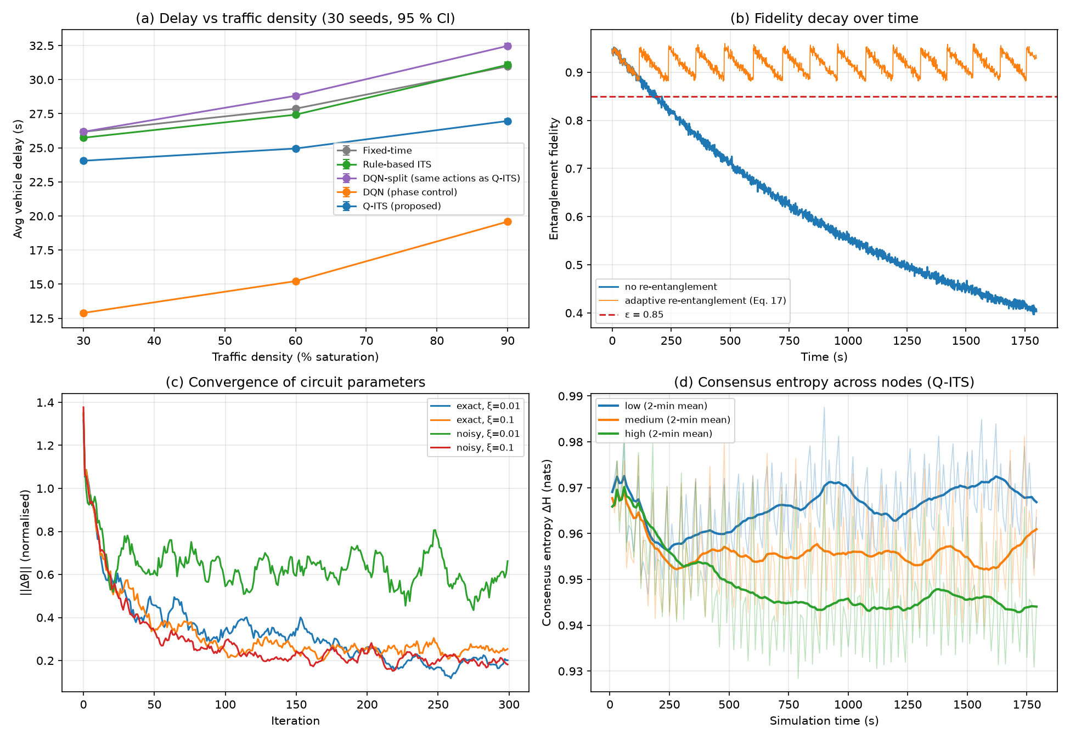
Fig. 2. Our reproduction of the paper's Fig. 1: (a) delay against traffic level, (b) link fidelity with and without refreshing, (c) training of the circuit angles, (d) agreement between intersections (consensus entropy).
Table 4. Main claims of the paper compared with this work
Claim | Paper | This work | Status
Packet delivery ratio | 98.2 % | 99.0 % | Reproduced
Mean entanglement fidelity | > 0.90 | 0.918 | Reproduced
Average delay reduction | 42.1 % | 9.8 % vs rule-based; worse than DQN | Partly
Entropic stability gain | 61.3 % | 15.9 % | Partly
Communication overhead | −37.4 % | −82 % consensus; +11.5× with QKD | Partly

6. Simulation Platform and Requirements

6.1 Software
Everything is written in Python. Qiskit is used to build and check the quantum circuits, and PyTorch to train the DQN baseline. Table 5 lists the versions used.
Table 5. Software used
Component | Version | Used for
Python | 3.12.6 | Main programming language
NumPy / SciPy | 2.5.3 / 1.18.1 | Traffic simulator and quantum-state simulation
Qiskit / Qiskit Aer | 2.5.2 / 0.17.2 | Building circuits and checking the noise model
PyTorch (CPU) | 2.14.0 | DQN baselines
pandas / Matplotlib | 3.0.6 / 3.11.2 | Result tables and figures
PyYAML / pytest | 6.0.3 / 9.1.1 | Settings files and 48 automated tests

6.2 Hardware
All experiments ran on a laptop with an Intel Core i5-1240P processor (12 cores, 16 threads) and 16 GB RAM, running Windows 11. No GPU or real quantum computer is needed: the quantum circuits and their noise are simulated. Six runs are executed in parallel, the most that fit in memory.

6.3 Simulation settings and dataset
Table 6 lists the main settings. As in the base paper, the traffic data is synthetic. For each traffic level and seed, random vehicle arrivals and trips are generated once and saved, and every method uses the same saved traffic, so all comparisons are fair.
Table 6. Main simulation settings
Setting | Value | Setting | Value
Network | 5 × 5 grid, 100 m roads | Qubits / layers / angles | 4 / 8 / 64
Lanes, discharge rate | 2 per direction, 0.5 veh/s/lane | Shots per decision | 8192
Cycle, all-red time | 60 s, 3 s | SPSA step sizes | 0.05, 0.1
Traffic (low/med/high) | 1.95 / 3.90 / 5.85 veh/s | Initial link fidelity | 0.95
Run length, time step | 1800 s, 1 s | QKD abort threshold | 11 % errors
Seeds per level | 30 (42–71) | Consensus weight | 0.01
Phones (penetration) | 60 % of vehicles | DQN training | 500 episodes × 600 s

6.4 Reproducibility
The code is split into clear parts (traffic, quantum, communication, controllers, metrics, energy), and all settings are in one file. The finished Phase 1 code is saved under a version-control tag (base-paper-v1) so it can always be shown unchanged. One command rebuilds every figure and table from the saved results.

6.5 Requirements for the next phase
- Harder and more realistic traffic: rush-hour peaks, unbalanced (one-direction) flows, and traffic based on real data, as done in [5].
- Optionally, the SUMO simulator with a real city map for a more realistic test. This needs more computing time but no special hardware.

7. Conclusion
Phase 1 is complete. The Q-ITS system of the base paper has been built from scratch: the traffic simulator, phone-based sensing, the 4-qubit quantum circuit trained with SPSA under realistic noise, and the full secure communication layer. All methods were tested on the same traffic over 30 seeds and three traffic levels, with confidence intervals and significance tests, as recommended by recent reviews [3], [4].
The results support the paper's main direction: Q-ITS clearly reduces delay compared with rule-based control and with a DQN limited to the same actions, and the communication layer reaches the reported delivery ratio and link quality. The results do not support the size of the paper's headline gains. A DQN that controls the signal phase does better than Q-ITS, and a classical model of the same size does better than the quantum circuit. Some of the paper's percentages cannot be obtained even from its own reported values.
Phase 2 will improve only the traffic side and keep the security layer unchanged:
- Main idea: phase-level, pressure-aware quantum signal control. A quantum circuit that chooses the signal phase every few seconds, using queue ‘pressure’ information. This targets the biggest weakness found above and the first gap in Section 3.4.
- A faster and fairer quantum model. Fewer shots to cut the 100 ms decision time, and a better circuit design. It will always be compared with a classical model of the same size.
- Congestion-aware routing (if time permits). Adding the delay that a routing decision itself causes to the cost.
The new methods will be tested with exactly the same procedure as Phase 1, plus harder traffic scenarios, so every improvement can be measured against the reproduced base paper.

References
[1] T. Ahmad, A. A. H. Elnour, M. U. Hadi, K. Fang, and T. R. Gadekallu, "Quantum-enhanced ITS leveraging consumer devices for real-time urban traffic optimization in smart cities," IEEE Trans. Consum. Electron., vol. 72, no. 1, pp. 2540–2548, Feb. 2026, doi: 10.1109/TCE.2026.3650949.
[2] C. Niu, E. Irannezhad, C. R. Myers, and V. Dixit, "Quantum computing in transport science: A review," Transportation Letters, published online Mar. 2026, doi: 10.1080/19427867.2026.2640414.
[3] S. Somvanshi, S. Das, M. M. Islam, S. B. B. Polock, G. Chhetri, and D. Anderson, "Quantum computing in transportation engineering: A survey," IEEE Trans. Intell. Transp. Syst., vol. 27, no. 7, pp. 7332–7349, Jul. 2026, doi: 10.1109/TITS.2026.3662626.
[4] D. Guerrero-Domínguez, C. Lima Azevedo, S. Karlsson, and O. A. Nielsen, "Quantum computing for predictive transport modeling: A systematic literature review and future research needs," IEEE Trans. Intell. Transp. Syst., vol. 27, no. 8, pp. 8982–8998, Aug. 2026, doi: 10.1109/TITS.2026.3676854.
[5] K. A. Awan, S. Khan, E. A. Aldakheel, S. Al-Kuwari, and A. Farouk, "Quantum inspired vehicular network optimization for intelligent decision making in smart cities," IEEE Trans. Consum. Electron., early access, 2026, doi: 10.1109/TCE.2026.3677115.
[6] R. Ramya, S. Subhikshaa, and M. Shanmugam, "Quantum safe vehicle networks using ML and IoT for traffic congestion prediction," in Proc. 6th Int. Conf. Trends in Material Science and Inventive Materials (ICTMIM), 2026, pp. 1487–1493, doi: 10.1109/ICTMIM68190.2026.11506658.

