TestRail
TestRail is a web-based test case management tool for QA teams to organize, track, and manage software testing efforts, centralizing test cases, plans, and results for better collaboration and reporting, with features for test execution, progress tracking, automation coverage
Basic Test Management workflow in TestRail
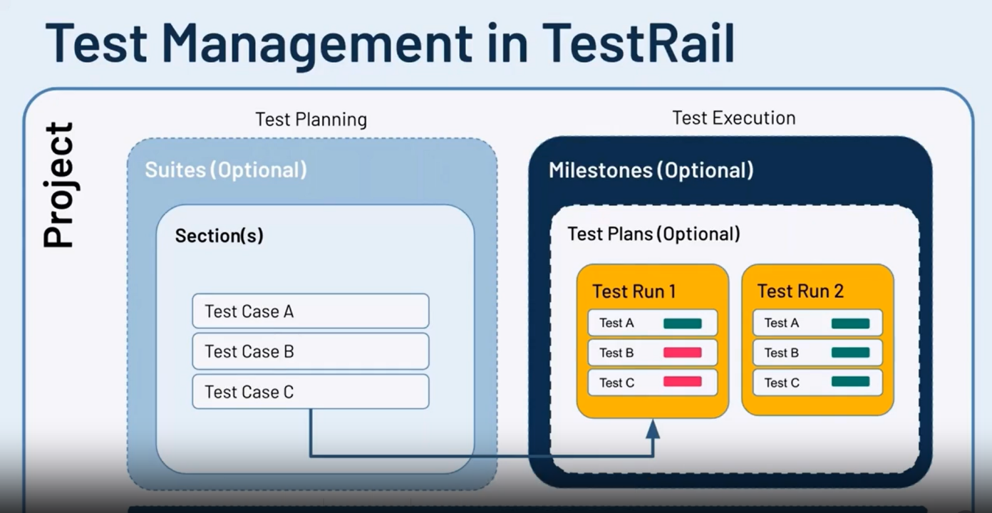

Key Terms
- Test Case
- Section and sub-Sections
- Test Suite
- Tests
- Test Run
- Test Plan
- Milestone
- References
- Defects
Test Cases
Test cases are the basic building blocks in TestRail. They are contained inside projects and can be reused in multiple test runs over time.
A test case consists of:
● A summary of what you need to test
● A description of how to run your test, including prerequisites, steps, and expected results
● Additional information to help you prioritize, group, and track your test
case like priority, type, and linked requirements
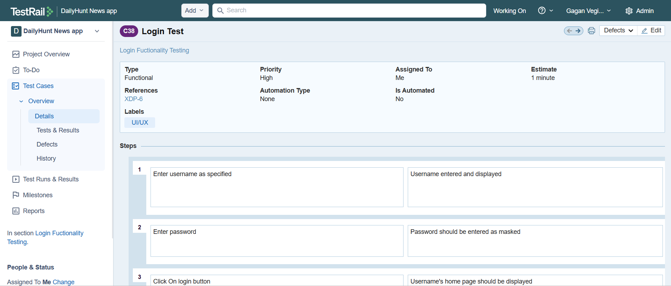
Sections and Sub Sections
Sections and subsections are like folders, allowing you to organize test cases in a hierarchical tree structure. How you group your sections depends on the size of your project. If you have a lot of test cases for a project module, it is recommended to break down your sections further and create subsections for specific project modules, areas of functionality, or processes within your application.
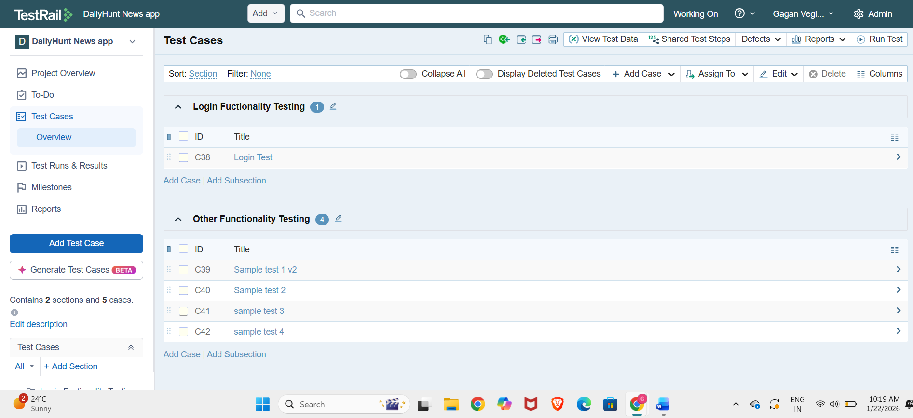

Test Suite
In TestRail, you will only find test suites when opting for the multiple test suites project
type to manage your test cases. Test suites give you an additional layer of
separation between groups of test cases. Each suite is independent and not related to
other test suites within your project. You can use sections and subsections to
further organize test cases within test suites, like in a single repository-type project.
Tests
When a test case is selected to be part of a test run, TestRail creates a test with a unique ID for
that specific test run. That test can then be assigned to a team member, who will add the test results and set a status after all the testing steps described in the test case are completed. Test cases and tests mean different things in TestRail. Test case is a description of the procedure to test any functionality. This procedure is executed in a particular test.
This is the crucial step where we verify the test in a step-by-step process, Here we indicate the status of each step and leave remarks, add references or even defects(bugs if any arises) about that particular step.
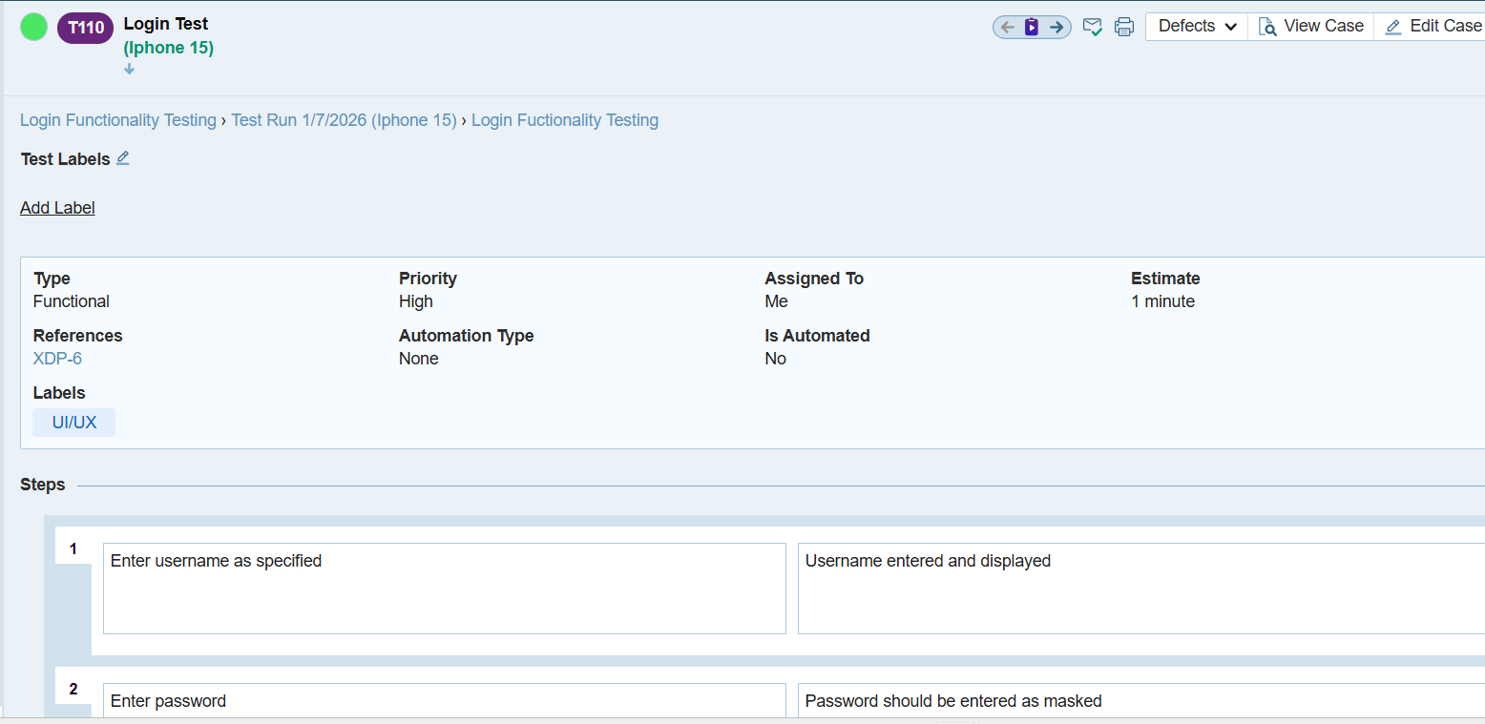
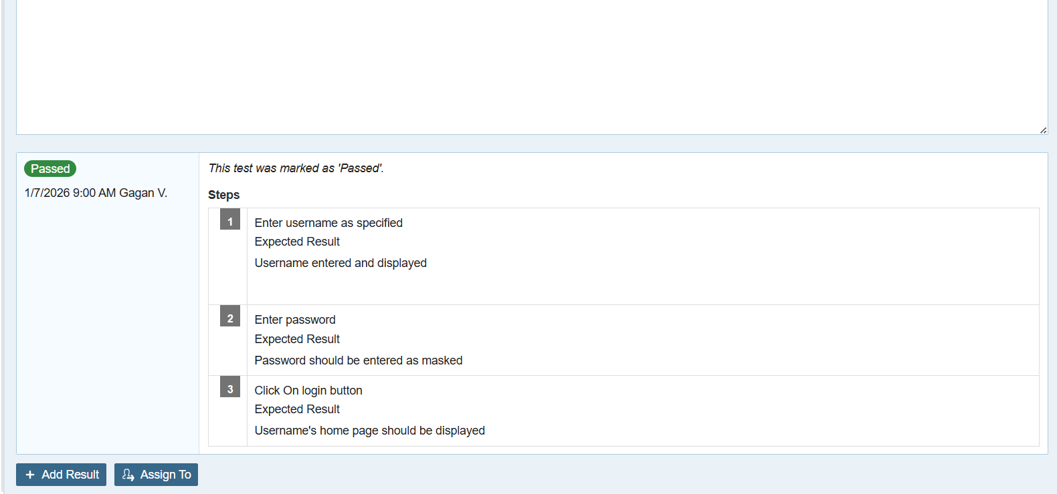
Test Run
A test run consists of individual tests for each test case that you add, and it represents what
you actually plan to test as part of a specific test cycle, sprint, or milestone. When you create a test run, you can choose to include all cases of a test suite, section, or subsection, select a specific set of test cases, or set a dynamic filter. Whereas test cases, sections, subsections, and suites document how to test your application, a test run is an actual set of tests you are conducting.
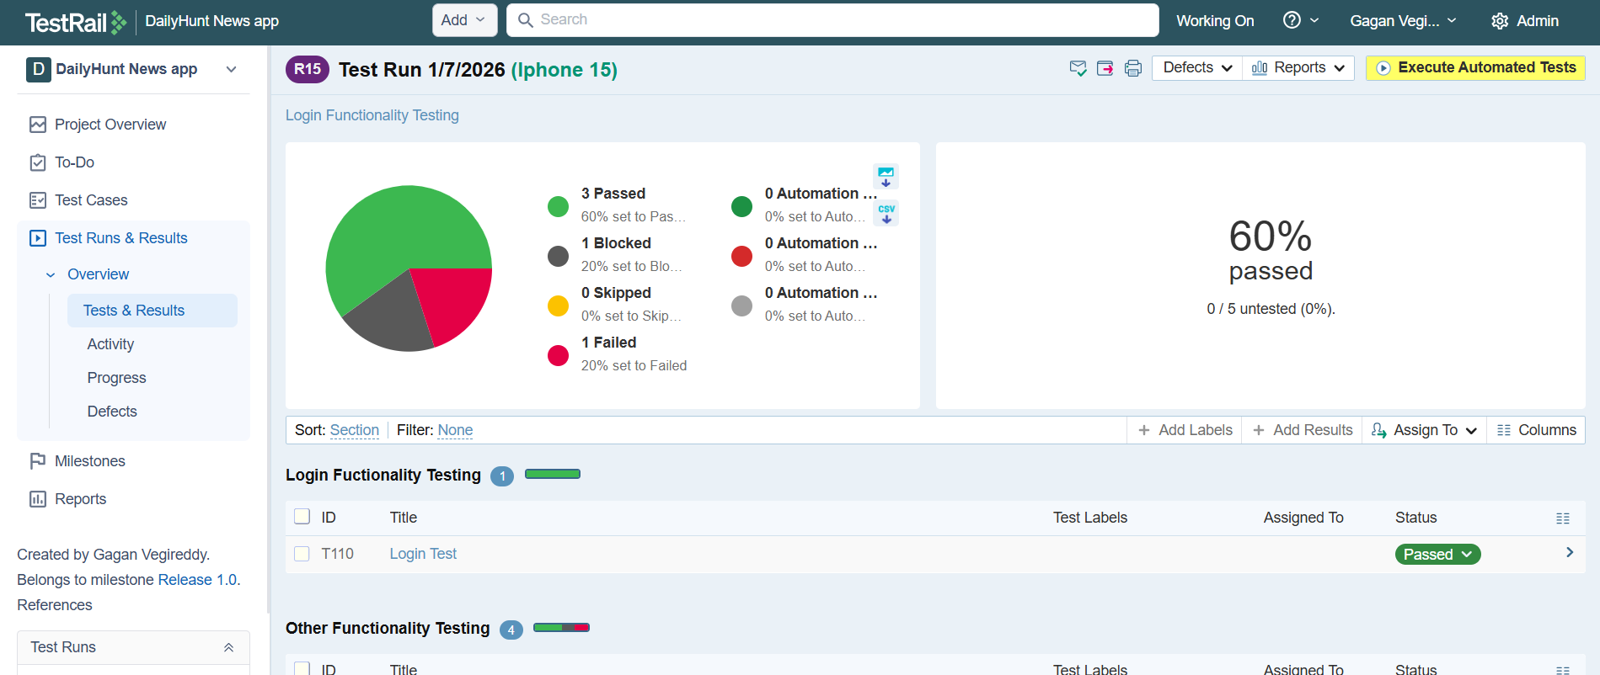

Test Plan
When you need to manage multiple test runs for a single release or milestone, a test plan
come in handy. Test plans allow you to create multiple test runs at once and group them for easier tracking. You can generate test runs for various configurations automatically.
A configuration can be anything you need to test your projects against, such as different
OS.
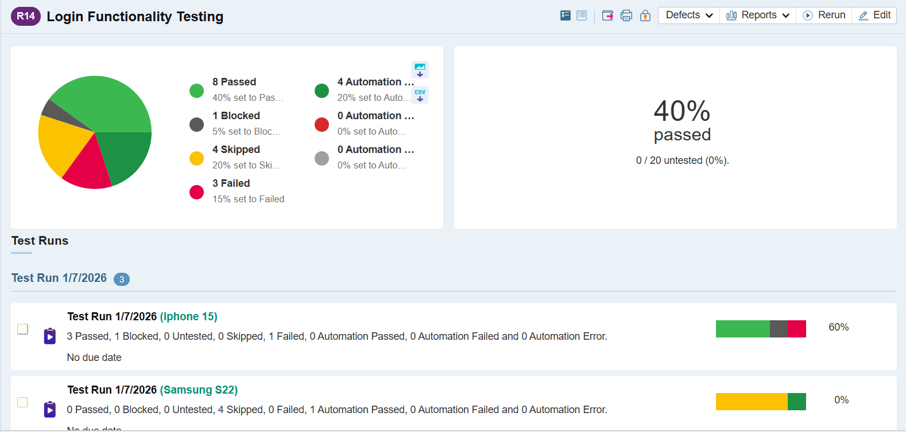

Milestone
A milestone can represent any project milestone you deem to be important, such as a planned software release, phase of a project, development sprint. You can define a start and end date, add a description and attachments, and mark once a milestone has been completed. Once you have added your milestones to TestRail, you can link test plans or test runs to specific milestones so that you can easily track all of their test activities and results in a single dashboard. A milestone can be release of a new version of your system. Completion of a specific set of tests (i.e.: security)
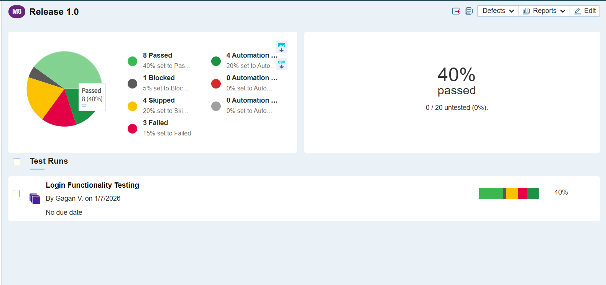

Project Overview
This show high level overview of the project like how test cases summary, activities that are happening, everything about milestones, test runs and test cases that are present in that particular project
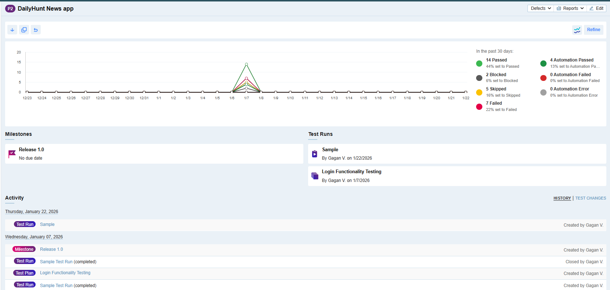

Reports
Reporting in TestRail is a powerful feature designed to provide visibility into your testing progress, quality metrics, and team workload. It ranges from high-level project summaries to granular traceability reports. These reports are organized into categories such as Summary, Results, Defects, and Users, enabling you to track everything from high-level project milestones to individual tester productivity. To generate one, you simply select a template, define the scope by choosing specific test runs or sections, and decide whether to run the report immediately or schedule it for automated delivery via email. A standout feature is the Traceability and Coverage reporting, which links test results to external requirements (like Jira issues) to ensure full testing transparency.
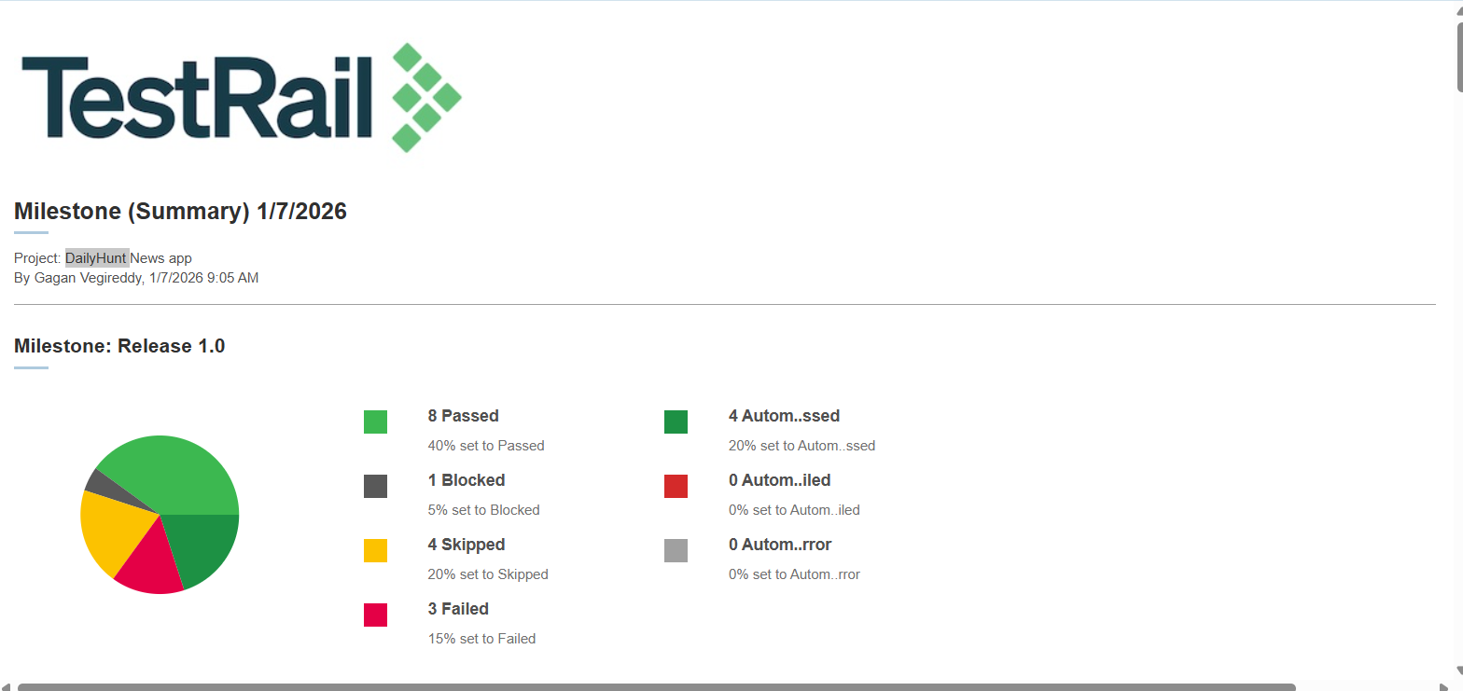

Note : we can download report of a particular test case, test, test plan, test run or milestone in the overview page of the respective section where we can find a download button.

