JIRA

Creating a rule to assign a bug to developer when priority is set to highest
-Created Developer Group
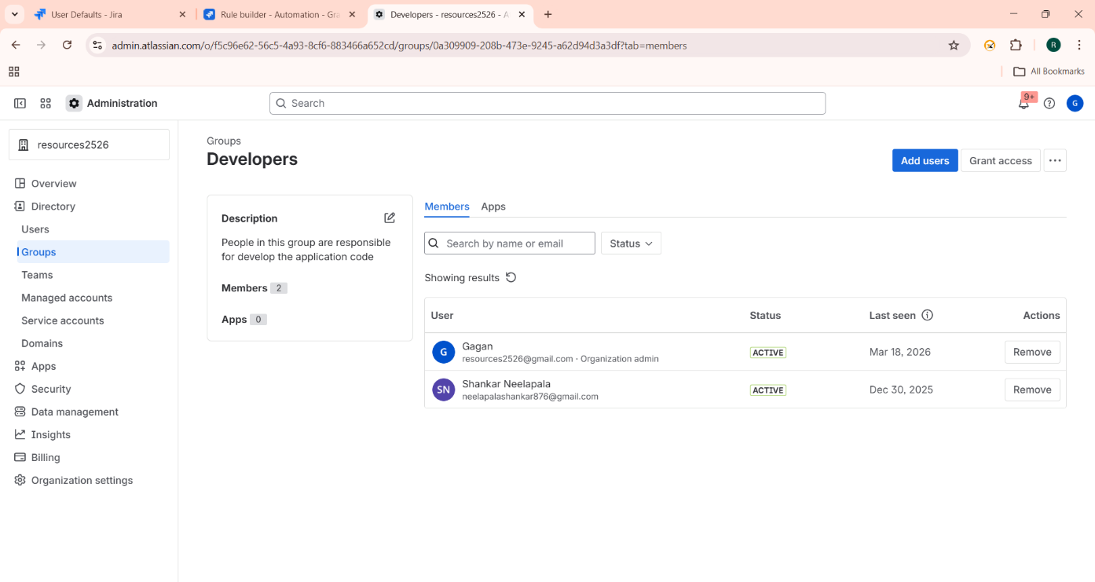

-Created the required rule
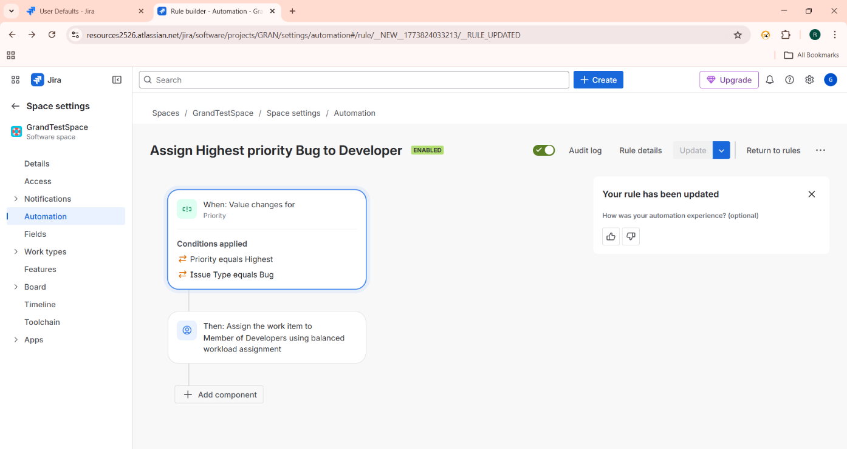

-Normal Bug with medium priority
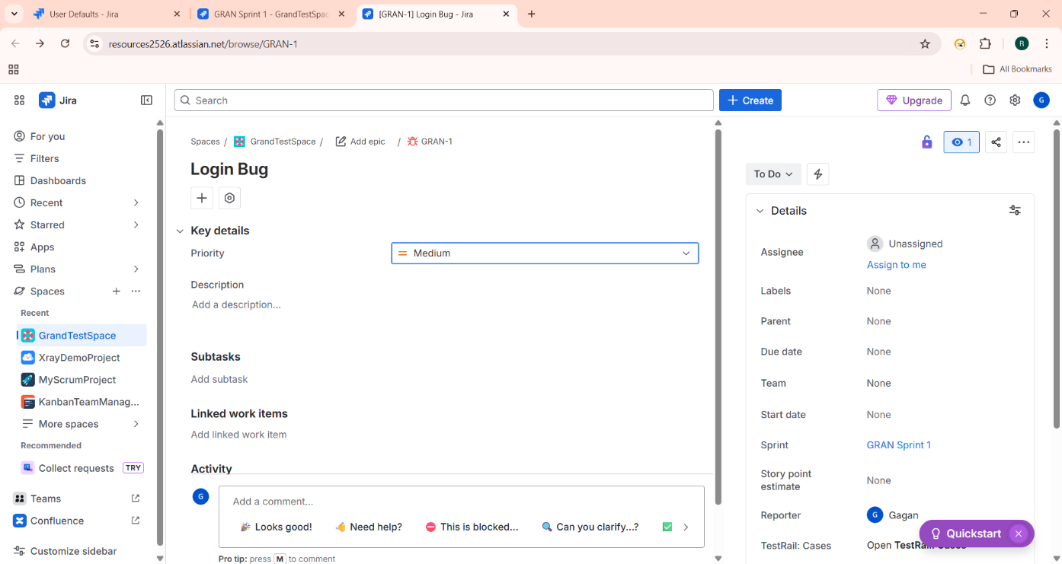

-When priority is set to highest it assigns the bug to members of developer team
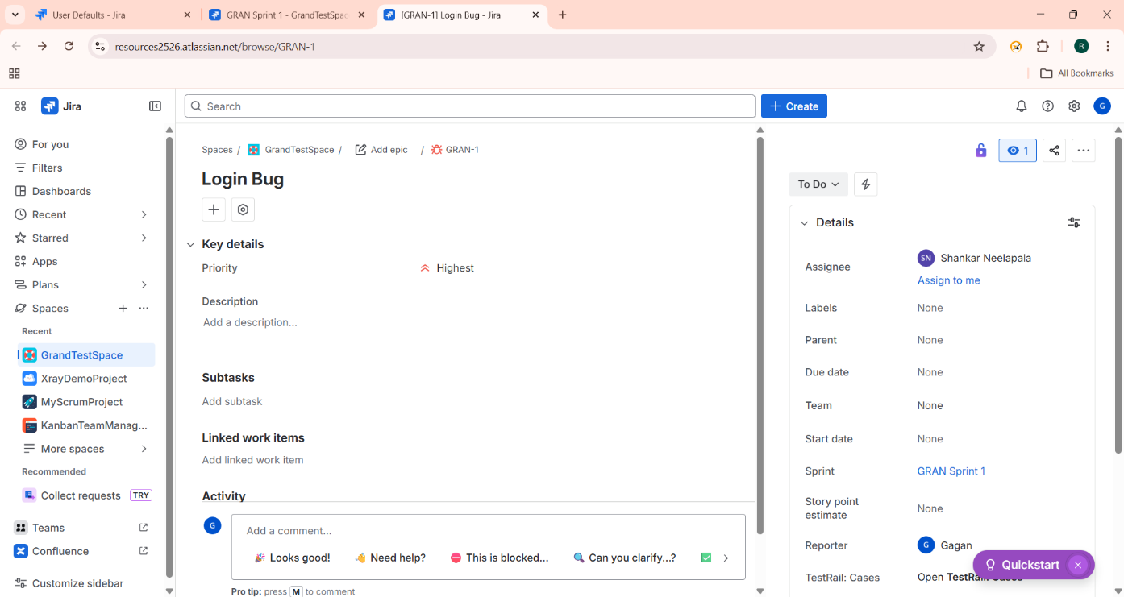

Query to find all unresolved bugs in a specific project assign to a specific user
