X-Ray
Xray is a Jira add-on for test management. Xray supports organizations with :
- Test Management
- Test Monitoring
- Test Coverage
- Test Execution
- Test Reporting

Issues Types
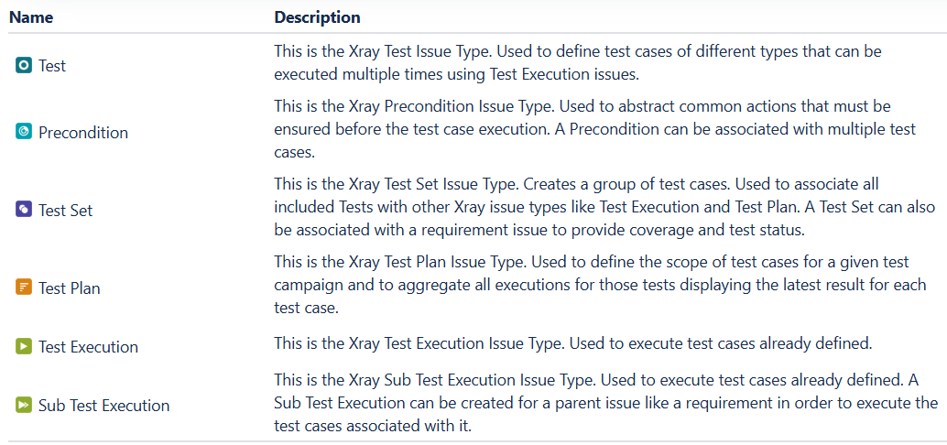

Test
Test is a core artifact for documenting individual test cases, containing steps, data, and expected outcomes, linked to requirements and managed like other Jira issues.
Here's what it contains:
- Test Details: A custom interface for defining the test.
- Test Type: Specifies if it's Manual, Generic, or Cucumber (BDD).
- Prerequisites: Conditions that must be met before execution, often linked to Pre-Condition issues.
- Test Data: Data used during test execution, with formatting options.
- Test Steps: Step-by-step instructions, with rich formatting, attachments (screenshots), and the ability to call other tests or import steps.
- Expected Results: What should happen after each step.
- Attachments: Screenshots or supporting files for steps.
- Traceability: Links to requirements (user stories) and defects.
- Execution Data: Links to Test Sets, Test Plans, and Test Runs (executions).
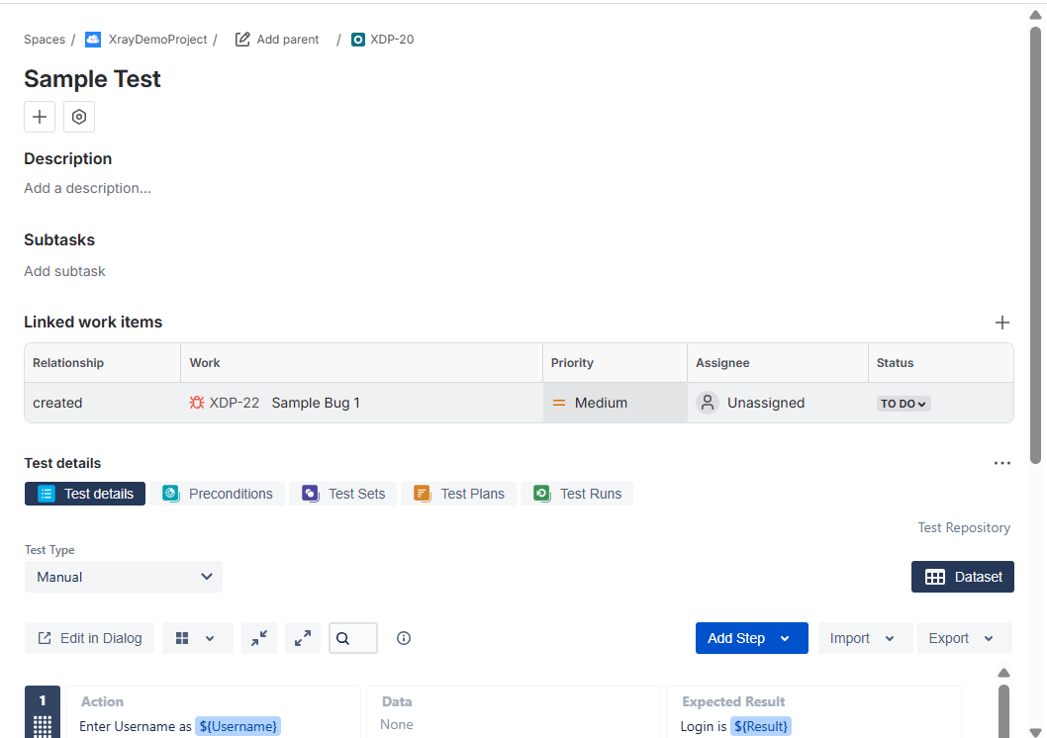

Precondition
Precondition defines the necessary setup or "step zero" that must be met before a test case can run, acting as a reusable prerequisite like logging in or restoring a database, managed as independent Jira issues that link to multiple tests for consistent setup and execution
Key aspects
- Types: Can be Manual, Generic, or Cucumber (using Given/When/Then scenarios).
- Reusability: Define common setup steps once, then link them to any test needing that state.
- Isolation: Promotes test independence, so failures pinpoint the exact broken step (precondition or test step).
- Management: Can be created before or after tests, reordered within a test, and tracked.
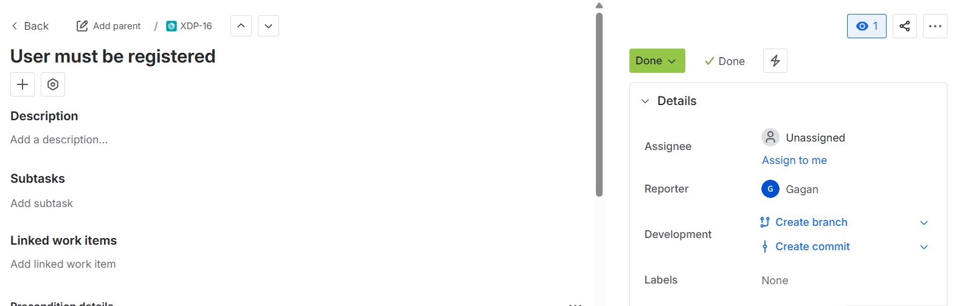

Test Set
Test Set is a Jira issue type that acts as a flexible, flat list for grouping related Test Cases, allowing you to organize them by feature, release, or testing type (like regression) for easier management and execution, even allowing a single test to belong to multiple sets for different scenarios like planning or execution.
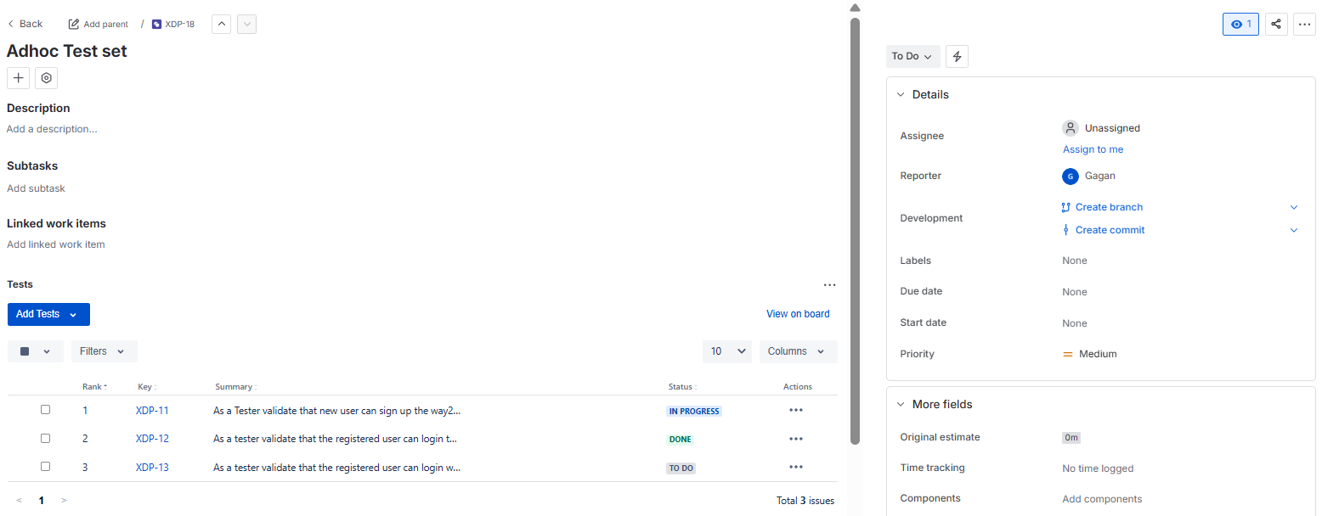

Test Plan
- Test Plan is a key Jira issue type used for organizing, planning, and tracking a specific set of tests for a release, sprint, or testing activity, providing a high-level view of progress and allowing creation of Test Executions.
- It acts as a container, grouping existing tests (manual/automated) or test sets, enabling hierarchical organization via folders, and showing the latest status of tests across multiple execution cycles, making it central for release testing management.
Functions:
- Centralized Management: Groups tests for a specific purpose (e.g., a release) into a single Jira issue.
- Hierarchical Organization: Uses folders (Test Plan Board) to structure tests for better visibility and management, like a file system.
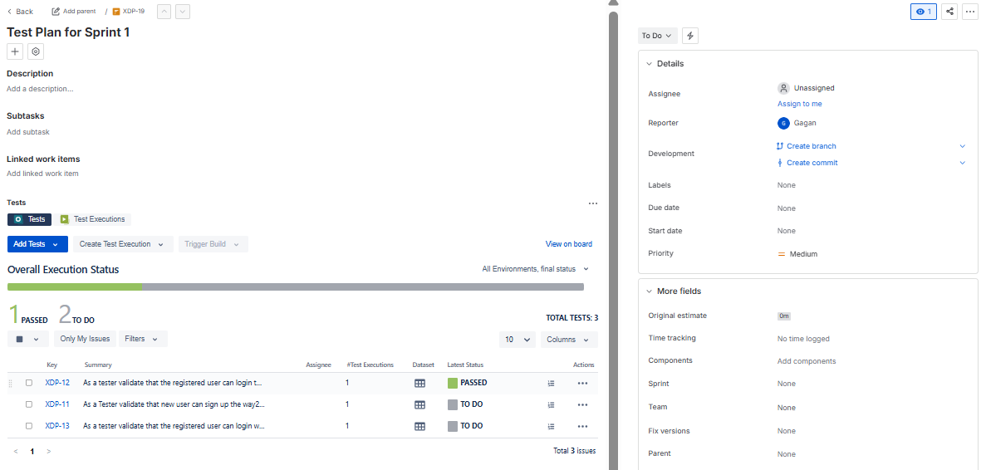

Test Execution
- Test Execution is a specific Jira issue type that groups a collection of Tests (Test Cases) to be run in a particular context, acting as a container for tracking progress (Passed, Failed, etc.) and environments, generating Test Runs (instances of a Test) as tests are performed, providing a dashboard for test cycles.
- It allows assigning testers, setting dates, and offers a specialized interface for managing test cycles, distinct from standard Jira issues like Stories or Bugs, making it a core part of Xray's test management capabilities.
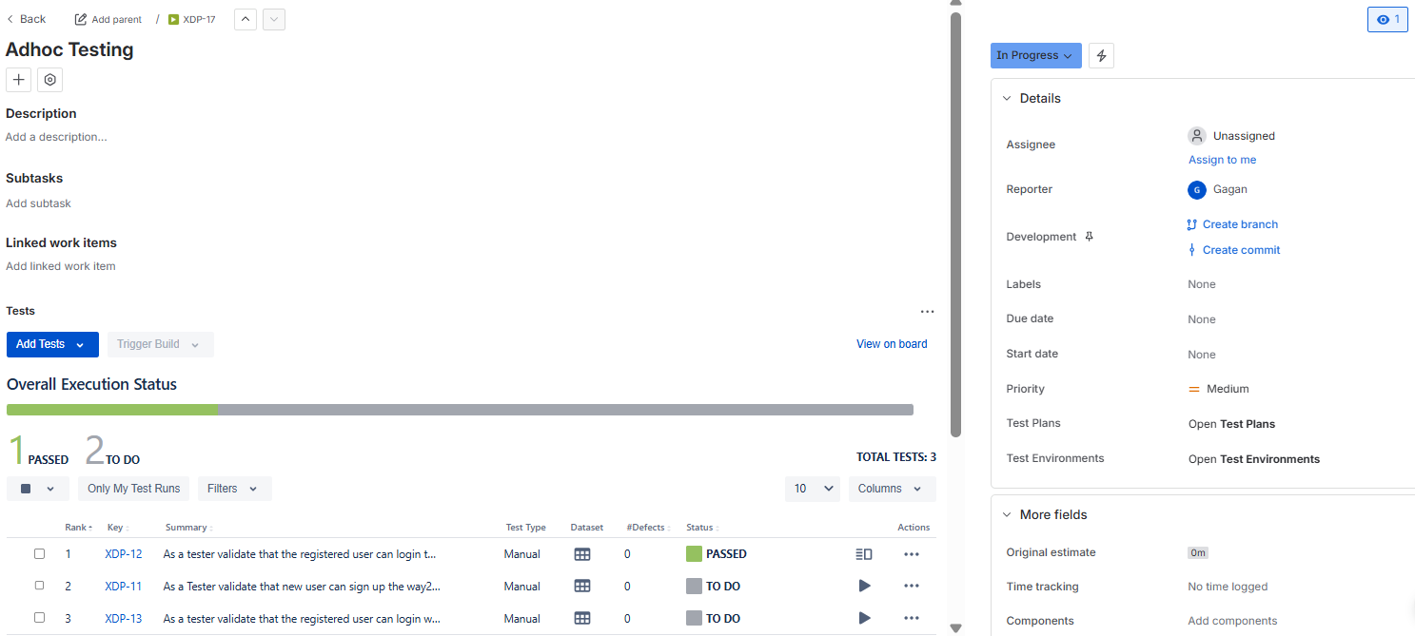

- Test Run window is the place where give record the findings ,progress and defects if any
- It is where we can records elements like time taken to executed, when it is executed
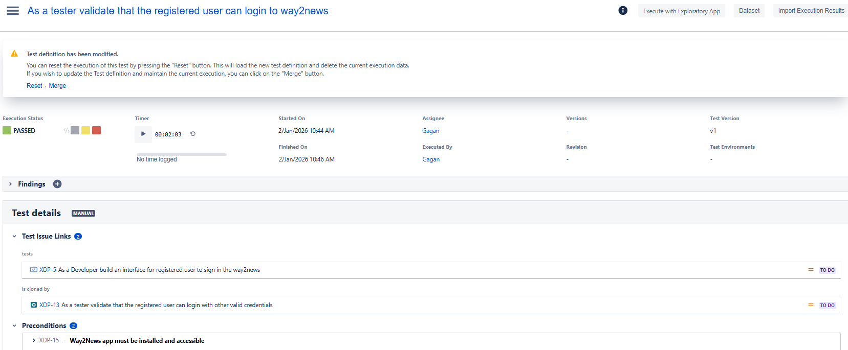
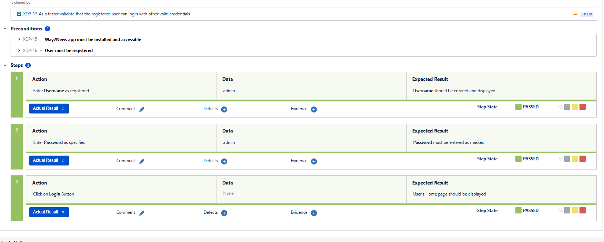
DashBoards and Reporting
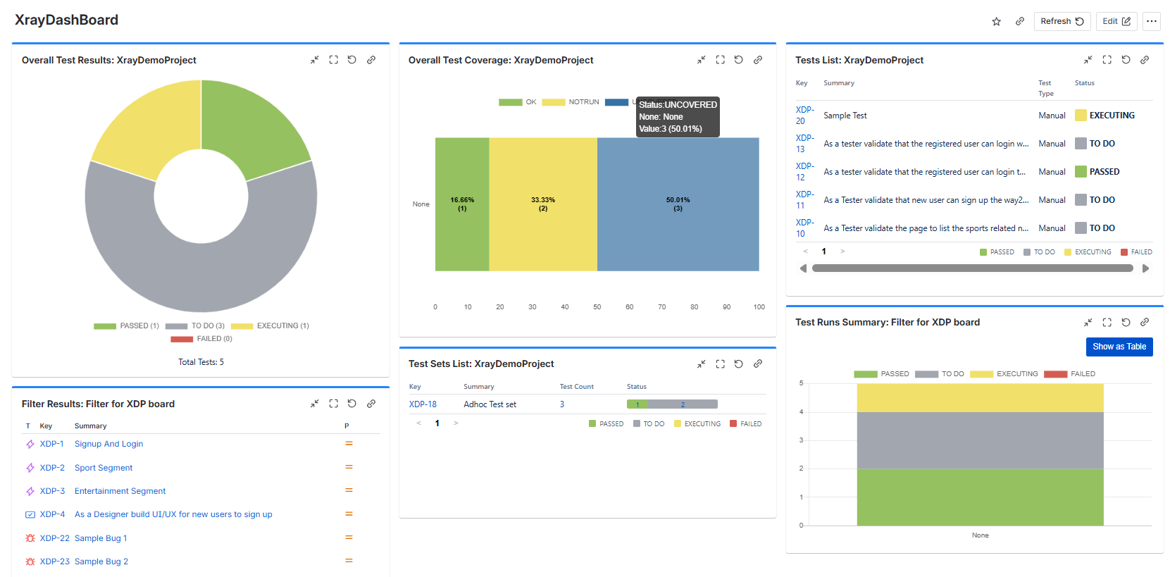

Key Xray Dashboard Gadgets
You can add these specific gadgets to any Jira dashboard to visualize your testing data:
- Overall Test Results: Provides a high-level summary of all test runs (Pass, Fail, Todo) within a specific scope, such as a project or filter.
- Overall Requirement Coverage: Visualizes the testing status of your requirements (Epics, Stories, Tasks), helping you identify which features are "covered" or "at risk".
- Test Runs Summary: Displays historical trends and execution details for individual tests, useful for identifying regressions.
- Test Executions List: A detailed list of test executions showing current status, owners, and environments.
- Test Plan Metrics: (Enterprise only) Offers a consolidated view of test status, defects found, and test types specifically for a given Test Plan.
Reporting & Traceability
Beyond dashboards, Xray includes built-in reports that can be linked to your dashboard for deeper analysis:
- Requirement Traceability Report: A critical tool for compliance and audits that shows the end-to-end link from requirements to tests, executions, and bugs.
- Historical Reports: Track how testing progress has evolved over time by version or environment.
- Document Generator: Allows you to export these dashboard views and reports into Word, PDF, or Excel for stakeholders outside of Jira.

Document Generator
Xray's Document Generator creates customizable reports (PDF, DOCX, XLSX) from Jira data, acting as deliverables, progress reports, or summaries for test plans, test runs, and requirements. It uses templates from a store or custom uploads, allowing users to include details like test steps, attachments, defects, and more, and can be accessed from issues, boards, or the test repository to export single or multiple items.
Features & Functionality
- Template-Based: Relies on pre-installed or uploaded templates (Word, Excel) with placeholders for dynamic data.
- Customizable Content: Includes issue details, test steps, evidence, defects, and more, depending on the template.
- Multiple Export Formats: Generates reports in PDF, Word (.docx), and Excel (.xlsx).
- Versatile Access: Available for single issues (via ellipsis menu), Test Repository, Test Plans, and Agile Boards (sprints/backlog).
- Targeted Data: Can pull data from Xray issues, requirements, and defects.
