**Analysis and key Insights of WeRateDogs Twitter archive**

1. **Tweets posted by WeRateDogs decreased over time**

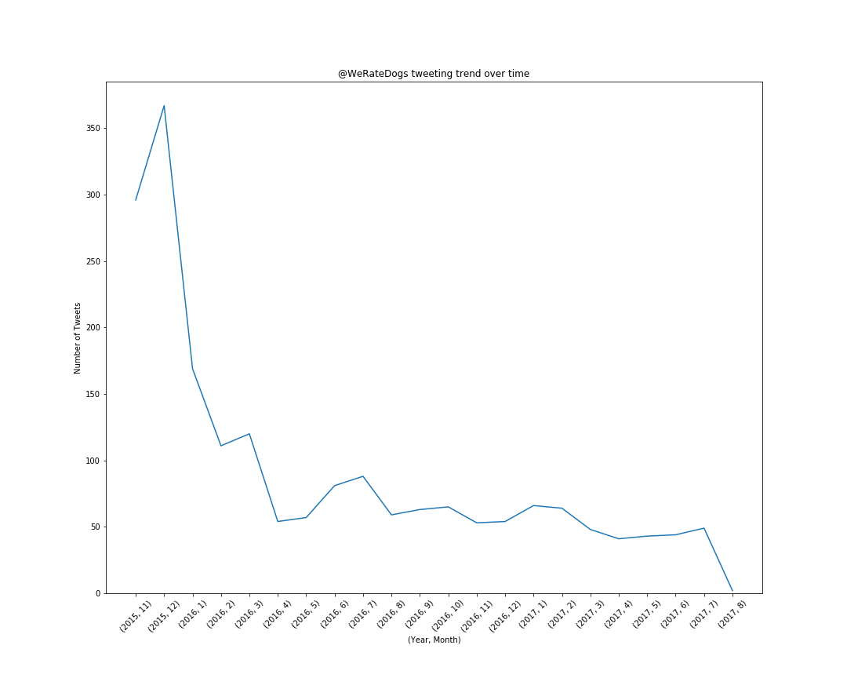

WeRateDogs, a Twitter account started in 2015, tweeted a lot in its starting year. Admins posted around 300 tweets in the November 2015, which increased to around 350 tweets in exactly the next month i.e December 2015. However, its tweeting activity reduced drastically in the subsequent months with average of between 50 and 100 in year 2016.

1. **Rating of 12/10 is most popular amongs dogs, after that score of 10/10 is the most frequent rating.**

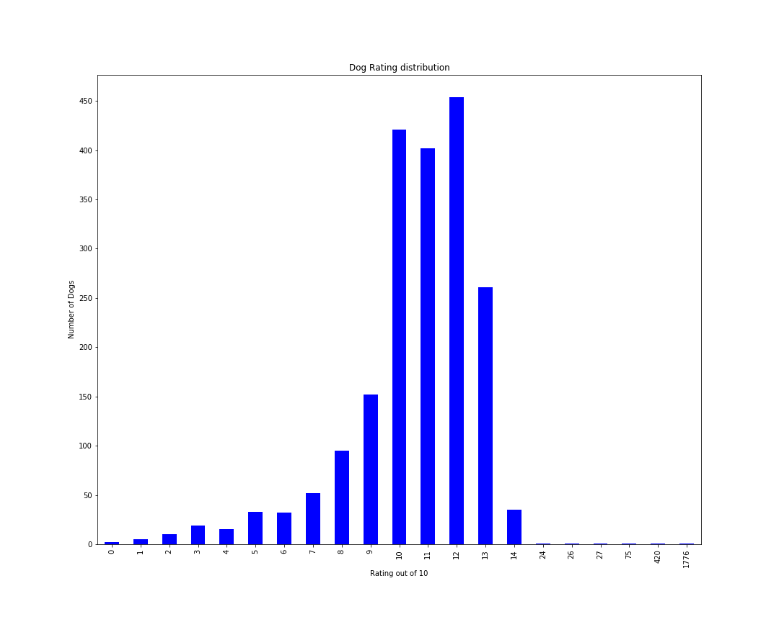

Most of the dogs are rated 12/10 (i.e. 455 out of 1994 dogs). Excluding the 6 rating outliers (24,26,27,75,420 and 1776), the highest rating received by any dog is 14/10. Moreover, rating of 14/10 is received by only 2% (i.e. 37) dogs got this rating.

1. **Popularity of twitter handle @WeRatedogs increased over time**

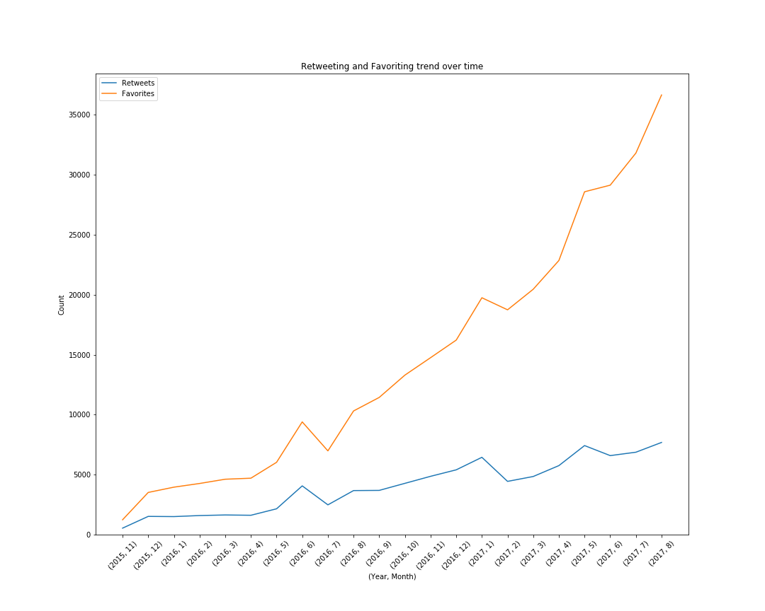

The above plot clearly shows an increasing trend of retweeting and favoriting tweets posted by ‘WeRateDogs' since November, 2015. However, the favoriting trend shows a much higher increase with time as compared to the retweeting trend.

It shows that the popularity of WeRateDogs increases significantly with time.

|  |  |  |
| --- | --- | --- |
| **Scenario** | **Avg Retweet Count** | **Avg Favourite Count** |
| **Complete Data** | 2767 | 8896 |
| **Dog rating greater than 10** | 3846 | 12797 |
| **Based on Dog Stages** | | |
| **Doggo** | 6745 | 18503 |
| **Floofer** | 4777 | 13701 |
| **Poppo** | 2364 | 7198 |
| **Pupper** | 7027 | 22724 |

From the above table, it is evident that tweets of dogs that were rated above 10 by WeRateDogs, were retweeted and favorited more by almost 40%.

Another interesting point is the huge increase in retweeting and favoriting of tweets having a mention of the "dog stage" (i.e. Doggo, Floofer or Puppo), while the ‘Pupper’, usually younger, is probably less popular as compared to its older ones.

1. **Charlie is the most common dog name**

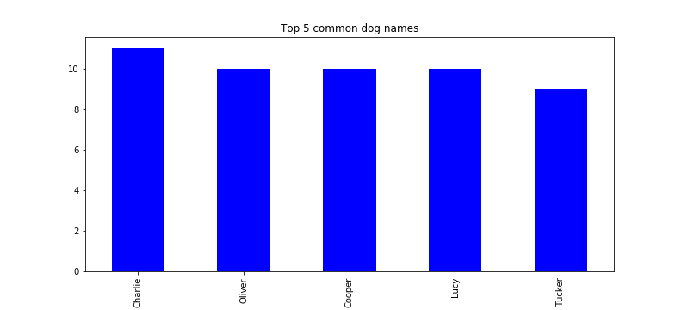

It seems Charlie is most common name among all dogs being rated by @WeRateDogs. While name ‘Lucy’, ‘Oliver’ and ‘Cooper’ being the second most popular with 10 dogs.

1. **‘Iphone’ is favourite among @WeRateDogs admins for tweeting**

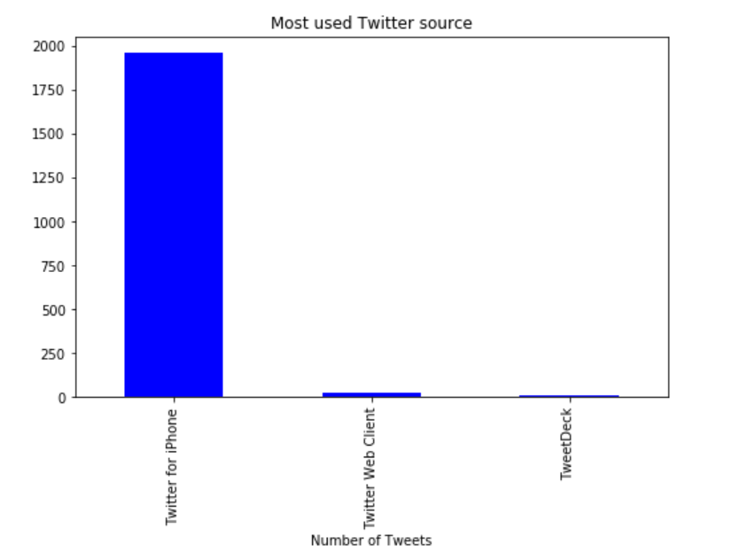

It clearly shows that 98% of tweets by @WeRateDogs are being posted by ‘IPhone’.