Index

S.no. | Content | Sign
1. | Chapter 1: Introduction to Python  1.1Automated File Organizer  1.2 Contact Book with SQLite  1.3 A Simple Blockchain Implementation  1.4 Multi - Threaded Port Scanner  1.5 Text-Based RPG Battle Engine
2. | Chapter 2: SDLC – Waterfall Model and Agile Model
3. | Chapter 3: Project Analysis and Design  3.1 Title of Project  3.2 Software Used  3.3 Analysis  3.4 Program Design
4. | References

CHAPTER 1: INTRODUCTION TO PYTHON
Python is a dynamically typed, platform independent and interpreted high level programming languge which is also fully object oriented.
Here are some examples of problems solved using Python:
1. Automated File Organizer
This script monitors a specific directory and organizes files into subfolders based on their file extensions (e.g., moves .jpg to "Images", .pdf to "Documents"). It uses the os and shutil libraries.
- Concepts: File I/O, Dictionary mapping, Error handling, Path manipulation.
Program:
import os
import shutil
# --- CONFIGURATION ---
# Change this path to the folder you want to organize
SOURCE_DIR = r"C:\Users\Public\Downloads"
# Mapping file extensions to folder names
EXTENSION_MAP = {
'Images': ['.jpg', '.jpeg', '.png', '.gif', '.bmp', '.svg'],
'Documents': ['.pdf', '.docx', '.txt', '.xlsx', '.pptx', '.csv'],
'Archives': ['.zip', '.rar', '.7z', '.tar', '.gz'],
'Audio': ['.mp3', '.wav', '.flac', '.m4a'],
'Video': ['.mp4', '.mkv', '.flv', '.avi', '.mov'],
'Executables': ['.exe', '.msi', '.bat', '.sh'],
'Code': ['.py', '.js', '.html', '.css', '.java', '.cpp']
}
def create_folders():
"""Creates the destination folders if they don't exist."""
for folder_name in EXTENSION_MAP.keys():
folder_path = os.path.join(SOURCE_DIR, folder_name)
if not os.path.exists(folder_path):
try:
os.makedirs(folder_path)
print(f"[+] Created folder: {folder_name}")
except OSError as e:
print(f"[-] Error creating {folder_name}: {e}")
# Create a miscellaneous folder for unknown types
other_path = os.path.join(SOURCE_DIR, "Others")
if not os.path.exists(other_path):
os.makedirs(other_path)
def get_destination_folder(filename):
"""Determines the folder name based on the file extension."""
_, ext = os.path.splitext(filename)
ext = ext.lower()
for folder, extensions in EXTENSION_MAP.items():
if ext in extensions:
return folder
return "Others"
def organize_files():
"""Main logic to move files."""
if not os.path.exists(SOURCE_DIR):
print(f"[-] The directory '{SOURCE_DIR}' does not exist.")
return
print(f"[*] Organizing files in: {SOURCE_DIR}")
create_folders()
files_moved = 0
errors = 0
# List all files in the directory
for filename in os.listdir(SOURCE_DIR):
source_path = os.path.join(SOURCE_DIR, filename)
# Skip directories, strictly move files
if os.path.isdir(source_path):
continue # Skip this script if it's inside the folder
if filename == os.path.basename(__file__):
continue
dest_folder = get_destination_folder(filename)
dest_path = os.path.join(SOURCE_DIR, dest_folder, filename)
try:
# Handle duplicate filenames by appending a counter
if os.path.exists(dest_path):
base, ext = os.path.splitext(filename)
counter = 1
while os.path.exists(os.path.join(SOURCE_DIR, dest_folder, f"{base}_{counter}{ext}")):
counter += 1
dest_path = os.path.join(SOURCE_DIR, dest_folder, f"{base}_{counter}{ext}")
shutil.move(source_path, dest_path)
print(f" -> Moved: {filename} to {dest_folder}")
files_moved += 1
except Exception as e:
print(f" [!] Failed to move {filename}: {e}")
errors += 1
print("\n" + "="*30)
print(f"Summary: {files_moved} files moved. {errors} errors.")
print("="*30)
if __name__ == "__main__":
organize_files()

OUTPUT:

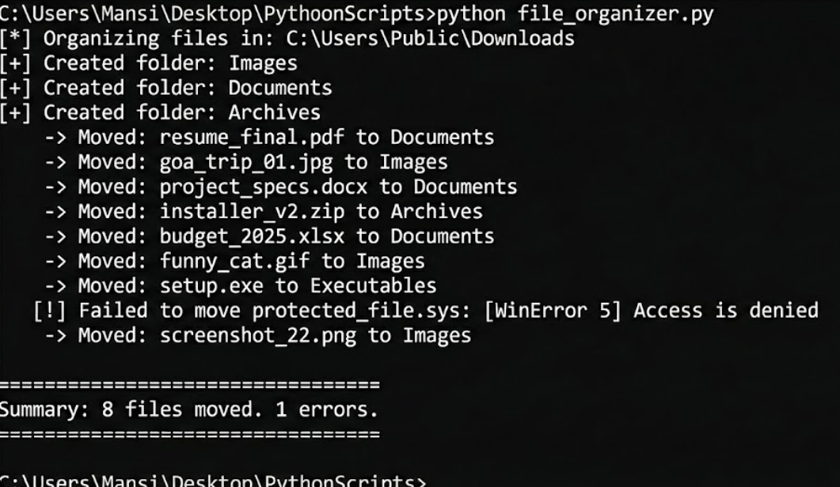

2. Contact Book with SQLite
This program creates a persistent database to store contacts. It uses SQL commands directly within Python to Create, Read, Update, and Delete (CRUD) data.
- Concepts: sqlite3 integration, SQL queries, Input validation, formatted console output.
PROGRAM:
import sqlite3
import sys
# Database setup
DB_NAME = "contacts.db"
def connect_db():
"""Connects to the SQLite database and creates the table if missing."""
conn = sqlite3.connect(DB_NAME)
cursor = conn.cursor()
cursor.execute('''
CREATE TABLE IF NOT EXISTS contacts (
id INTEGER PRIMARY KEY AUTOINCREMENT,
name TEXT NOT NULL,
phone TEXT NOT NULL UNIQUE,
email TEXT
)
''')
conn.commit()
return conn
def add_contact(conn):
name = input("Enter Name: ").strip()
phone = input("Enter Phone: ").strip()
email = input("Enter Email (optional): ").strip()
if not name or not phone:
print("[-] Name and Phone are required!")
return
try:
cursor = conn.cursor()
cursor.execute("INSERT INTO contacts (name, phone, email) VALUES (?, ?, ?)",
(name, phone, email))
conn.commit()
print("[+] Contact added successfully.")
except sqlite3.IntegrityError:
print("[-] Error: A contact with this phone number already exists.")
def view_contacts(conn):
cursor = conn.cursor()
cursor.execute("SELECT * FROM contacts")
rows = cursor.fetchall()
if not rows:
print("[*] No contacts found.")
return
print("\n" + "="*50)
print(f"{'ID':<5} {'Name':<20} {'Phone':<15} {'Email'}")
print("-" * 50)
for row in rows:
print(f"{row[0]:<5} {row[1]:<20} {row[2]:<15} {row[3]}")
print("="*50 + "\n")
def search_contact(conn):
query = input("Enter Name or Phone to search: ").strip()
cursor = conn.cursor()
cursor.execute("SELECT * FROM contacts WHERE name LIKE ? OR phone LIKE ?",
(f'%{query}%', f'%{query}%'))
rows = cursor.fetchall()
if rows:
print(f"[*] Found {len(rows)} matches:")
for row in rows:
print(f" -> {row[1]} | {row[2]} | {row[3]}")
else:
print("[-] No matches found.")
def delete_contact(conn):
try:
contact_id = int(input("Enter the ID of the contact to delete: "))
except ValueError:
print("[-] Invalid ID.")
return
cursor = conn.cursor()
cursor.execute("DELETE FROM contacts WHERE id = ?", (contact_id,))
if cursor.rowcount > 0:
conn.commit()
print("[+] Contact deleted.")
else:
print("[-] Contact ID not found.")
def main():
conn = connect_db()
while True:
print("\n--- CONTACT MANAGER ---")
print("1. Add Contact")
print("2. View All Contacts")
print("3. Search Contact")
print("4. Delete Contact")
print("5. Exit")
choice = input("Choose an option: ")
if choice == '1':
add_contact(conn)
elif choice == '2':
view_contacts(conn)
elif choice == '3':
search_contact(conn)
elif choice == '4':
delete_contact(conn)
elif choice == '5':
print("Goodbye!")
conn.close()
sys.exit()
else:
print("[-] Invalid choice.")
if __name__ == "__main__":
main()

OUTPUT:
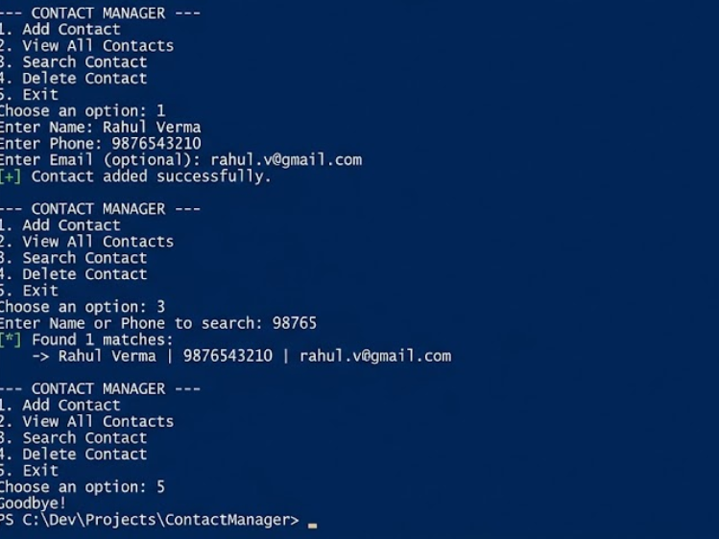

3. A Simple Blockchain Implementation
This program simulates the core logic of a cryptocurrency blockchain, including the "Proof of Work" (mining) algorithm that keeps networks like Bitcoin secure.
- Concepts: Hashing (SHA-256), JSON serialization, Class structure, Linked Lists logic, Difficulty algorithms.
PROGRAM:
import hashlib
import json
import time
class Block:
def __init__(self, index, transactions, timestamp, previous_hash, nonce=0):
self.index = index
self.transactions = transactions
self.timestamp = timestamp
self.previous_hash = previous_hash
self.nonce = nonce
self.hash = self.compute_hash()
def compute_hash(self):
"""Returns the hash of the block contents."""
block_string = json.dumps(self.__dict__, sort_keys=True)
return hashlib.sha256(block_string.encode()).hexdigest()
class Blockchain:
def __init__(self):
self.unconfirmed_transactions = []
self.chain = []
self.difficulty = 2 # Hardness of mining (number of leading zeros)
self.create_genesis_block()
def create_genesis_block(self):
"""Generate the first block in the blockchain."""
genesis_block = Block(0, [], time.time(), "0")
genesis_block.hash = genesis_block.compute_hash()
self.chain.append(genesis_block)
@property
def last_block(self):
return self.chain[-1]
def add_new_transaction(self, transaction):
self.unconfirmed_transactions.append(transaction)
def proof_of_work(self, block):
"""
Function that tries different values of nonce to get a hash
that satisfies our difficulty criteria.
"""
block.nonce = 0
computed_hash = block.compute_hash()
while not computed_hash.startswith('0' * self.difficulty):
block.nonce += 1
computed_hash = block.compute_hash()
return computed_hash
def add_block(self, block, proof):
"""
A function that adds the block to the chain after verification.
"""
previous_hash = self.last_block.hash
if previous_hash != block.previous_hash:
return False
if not self.is_valid_proof(block, proof):
return False
block.hash = proof
self.chain.append(block)
return True
def is_valid_proof(self, block, block_hash):
return (block_hash.startswith('0' * self.difficulty) and
block_hash == block.compute_hash())
def mine(self):
"""
This function serves as an interface to add the pending
transactions to the blockchain by adding them to the block
and figuring out the Proof of Work.
"""
if not self.unconfirmed_transactions:
return False
last_block = self.last_block
new_block = Block(index=last_block.index + 1,
transactions=self.unconfirmed_transactions,
timestamp=time.time(),
previous_hash=last_block.hash)
print(f"[*] Mining block #{new_block.index}...")
proof = self.proof_of_work(new_block)
self.add_block(new_block, proof)
self.unconfirmed_transactions = [] # Reset pending transactions
return new_block.index
# --- Main Execution ---
if __name__ == "__main__":
my_blockchain = Blockchain()
print("--- Simulating Blockchain Transaction ---")
# 1. Add transactions
my_blockchain.add_new_transaction({"sender": "Alice", "receiver": "Bob", "amount": 50})
my_blockchain.add_new_transaction({"sender": "Bob", "receiver": "Charlie", "amount": 25})
# 2. Mine the block
mined_index = my_blockchain.mine()
print(f"[+] Block #{mined_index} has been mined and added to chain!")
# 3. Add more transactions
my_blockchain.add_new_transaction({"sender": "Charlie", "receiver": "Dave", "amount": 10})
mined_index = my_blockchain.mine()
print(f"[+] Block #{mined_index} has been mined and added to chain!")
# 4. Print the full chain
print("\n--- Full Blockchain Data ---")
for block in my_blockchain.chain:
print(f"Index: {block.index}")
print(f"Hash: {block.hash}")
print(f"Prev_Hash: {block.previous_hash}")
print(f"Transactions: {block.transactions}")
print("-" * 30)

OUTPUT:

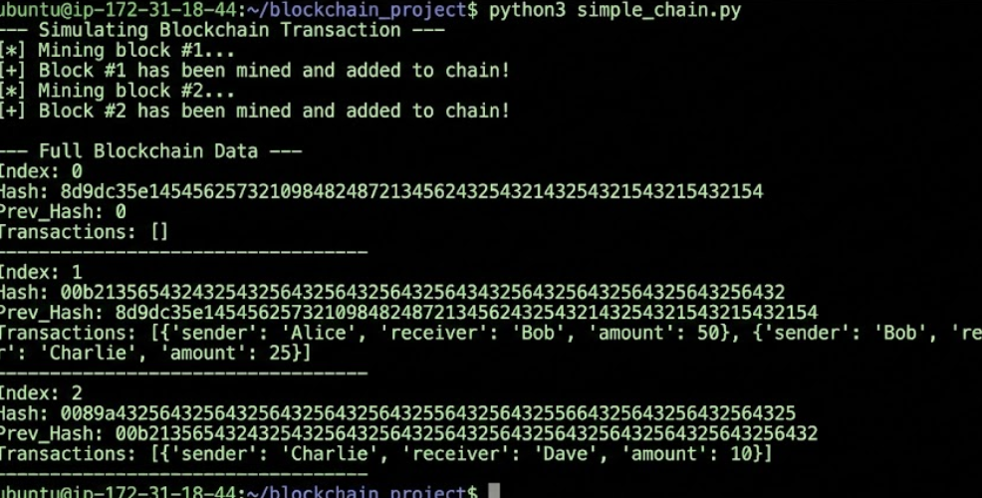

4. Multi-Threaded Port Scanner
This tool scans a target IP address for open ports. It uses threading to scan multiple ports simultaneously, making it significantly faster than a linear scanner.
- Concepts: socket programming, Multi-threading, Queue management, Daemon threads.
PROGRAM:
import socket
import threading
from queue import Queue
import time
# --- CONFIGURATION ---
TARGET = "scanme.nmap.org" # Replace with the IP/Host you own/have permission to scan
START_PORT = 1
END_PORT = 1000 # Scanning first 1000 ports
THREAD_COUNT = 50 # Number of concurrent threads
# Thread-safe queue
queue = Queue()
open_ports = []
def port_scan(port):
"""
Tries to connect to a specific port.
Returns True if connection is successful, False otherwise.
"""
try:
s = socket.socket(socket.AF_INET, socket.SOCK_STREAM)
s.settimeout(1) # Timeout prevents hanging on closed ports
result = s.connect_ex((TARGET, port))
if result == 0:
return True
s.close()
except:
pass
return False
def worker():
"""
The worker thread function.
Pulls a port from the queue and scans it.
"""
while not queue.empty():
port = queue.get()
if port_scan(port):
print(f" [+] Port {port} is OPEN")
open_ports.append(port)
queue.task_done()
def main():
print(f"[*] Starting scan on host: {TARGET}")
print(f"[*] Scanning ports {START_PORT}-{END_PORT} with {THREAD_COUNT} threads...")
start_time = time.time()
# 1. Fill the queue
for port in range(START_PORT, END_PORT + 1):
queue.put(port)
# 2. Create and start threads
thread_list = []
for _ in range(THREAD_COUNT):
thread = threading.Thread(target=worker)
thread_list.append(thread)
for thread in thread_list:
thread.start()
# 3. Wait for all threads to finish
for thread in thread_list:
thread.join()
end_time = time.time()
print("\n" + "="*40)
print(f"Scan completed in {end_time - start_time:.2f} seconds")
print(f"Open Ports: {sorted(open_ports)}")
print("="*40)
if __name__ == "__main__":
try:
# Resolve hostname to IP to ensure we have a valid target
ip = socket.gethostbyname(TARGET)
print(f"[*] Resolved {TARGET} to {ip}")
main()
except socket.gaierror:
print("[-] Could not resolve hostname.")
except KeyboardInterrupt:
print("\n[!] Exiting...")

OUTPUT:

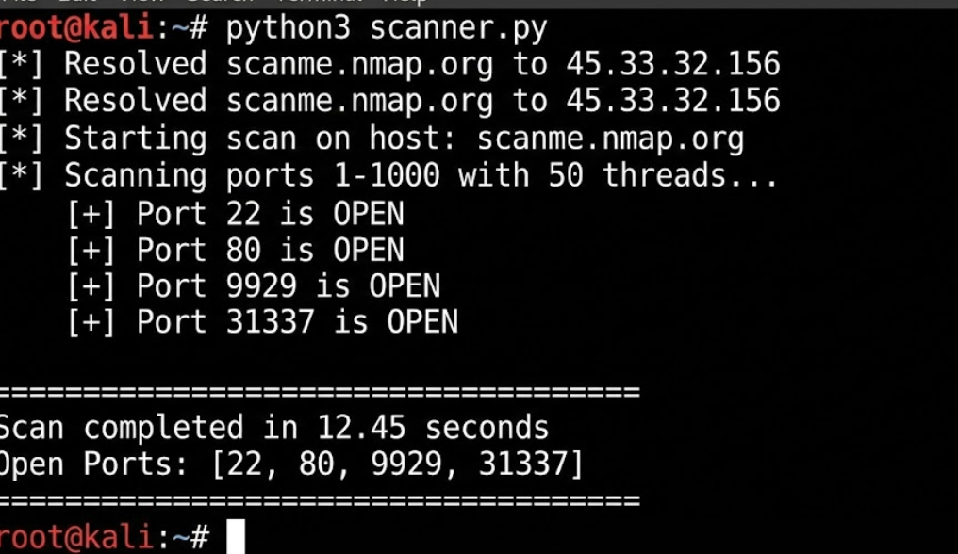

5. Text-Based RPG Battle Engine
A "Dungeons & Dragons" style battle simulator. This demonstrates robust Object-Oriented Programming (OOP) design. It includes classes for Entities, Players, and Enemies, with methods for attacking, healing, and using special abilities.
- Concepts: OOP (Inheritance, Polymorphism), Randomization, Game Loop state management.
PROGRAM:
import random
import time
class Entity:
"""Base class for any character in the game."""
def __init__(self, name, hp, max_hp, strength):
self.name = name
self.hp = hp
self.max_hp = max_hp
self.strength = strength
def is_alive(self):
return self.hp > 0
def take_damage(self, dmg):
self.hp -= dmg
if self.hp < 0: self.hp = 0
print(f"{self.name} takes {dmg} damage! (HP: {self.hp}/{self.max_hp})")
def attack(self, target):
# Damage varies slightly (±20% of strength)
dmg = int(self.strength * random.uniform(0.8, 1.2))
print(f"{self.name} attacks {target.name}...")
target.take_damage(dmg)
class Player(Entity):
def __init__(self, name):
super().__init__(name, hp=100, max_hp=100, strength=15)
self.potions = 3
self.mana = 50
def heal(self):
if self.potions > 0:
amount = 30
self.hp += amount
if self.hp > self.max_hp: self.hp = self.max_hp
self.potions -= 1
print(f"[+] {self.name} used a potion. HP restored to {self.hp}. Potions left: {self.potions}")
else:
print("[-] No potions left!")
def cast_spell(self, target):
cost = 20
if self.mana >= cost:
self.mana -= cost
dmg = self.strength * 2
print(f"*** {self.name} casts FIREBALL! ***")
target.take_damage(dmg)
print(f"Mana remaining: {self.mana}")
else:
print("[-] Not enough mana!")
class Enemy(Entity):
def __init__(self, name, difficulty_level):
hp = 50 * difficulty_level
strength = 10 * difficulty_level
super().__init__(name, hp, hp, strength)
def game_loop():
print("Welcome to the Python RPG Arena!")
name = input("Enter your hero's name: ")
player = Player(name)
# Generate random enemy
enemy_names = ["Goblin", "Orc", "Dark Knight", "Dragon"]
enemy_name = random.choice(enemy_names)
difficulty = random.randint(1, 3) # 1=Easy, 3=Hard
enemy = Enemy(f"{enemy_name} (Lvl {difficulty})", difficulty)
print(f"\nA wild {enemy.name} appeared!")
print(f"Stats -> HP: {enemy.hp}, Strength: {enemy.strength}")
while player.is_alive() and enemy.is_alive():
print("\n" + "-"*30)
print(f"{player.name}: {player.hp}/{player.max_hp} HP | {player.mana} Mana | {player.potions} Potions")
print(f"{enemy.name}: {enemy.hp}/{enemy.max_hp} HP")
print("-" * 30)
print("1. Attack")
print("2. Heal")
print("3. Cast Spell (20 Mana)")
choice = input("Your move: ")
# Player Turn
if choice == '1':
player.attack(enemy)
elif choice == '2':
player.heal()
elif choice == '3':
player.cast_spell(enemy)
else:
print("Hesitation caused you to miss a turn!")
if not enemy.is_alive():
print(f"\n*** VICTORY! You defeated {enemy.name}! ***")
break
time.sleep(1) # Suspense
# Enemy Turn
print(f"\n{enemy.name}'s turn!")
enemy.attack(player)
if not player.is_alive():
print("\n*** DEFEAT! You have fallen in battle. ***")
break
if __name__ == "__main__":
game_loop()

OUTPUT:
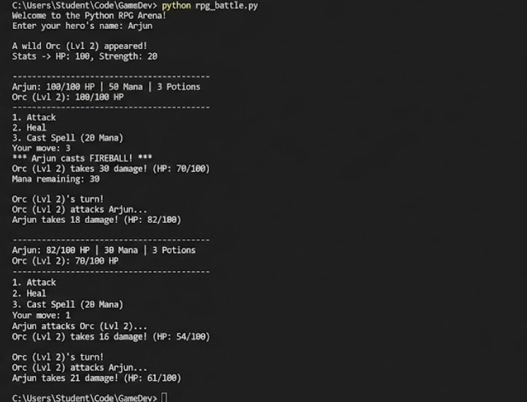

CHAPTER 2: SDLC
2.1 Waterfall Model for FinSmart AI
The Waterfall Model is a linear, sequential project management approach where each phase must be completely finished before the next one begins. It flows downwards like a waterfall.
Phase 1: Requirement Analysis & Feasibility
Goal: Define exactly what the "Advisor" can and cannot do.
- Key Activities:
  - Define User Stories: "As a student, I want to scan a receipt so I don't have to type numbers."
  - AI Scope Definition: Decide strictly what the AI will answer. (e.g., "It will answer budget questions, but it will refuse to recommend specific stocks for legal safety").
  - Data Sources: Decide if you are using Plaid API (real bank data) or manual CSV uploads (safer for student projects).
- Deliverable: Software Requirement Specification (SRS) Document.
Phase 2: System Design
Goal: Blueprint the architecture before writing a single line of code.
- Key Activities:
  - Database Design: Create the Entity Relationship (ER) Diagram. (Users ↔ Transactions ↔ Budgets).
  - API Design: Define your FastAPI endpoints (e.g., POST /api/chat, GET /api/expenses).
  - AI Design: Design the "System Prompt." Decide if you need RAG (Vector Database) or just a simple Context window.
  - UI/UX: Create Figma wireframes for the Dashboard and Chat Interface.
- Deliverable: System Design Document (SDD) & ER Diagrams.
Phase 3: Implementation (Coding)
Goal: Build the software pieces based on the design.
- Key Activities:
  - Unit 1: Backend Development: Set up Python/FastAPI, connect to PostgreSQL, and build the CRUD (Create, Read, Update, Delete) logic.
  - Unit 2: AI Integration: Set up the connection to Gemini/OpenAI API and write the logic to inject user data into the prompt.
  - Unit 3: Frontend Development: Build the React/Next.js interface, charts, and chat window.
- Deliverable: Functional Source Code.
Phase 4: Testing
Goal: Verify the software works and the AI isn't "hallucinating" wildly.
- Key Activities:
  - Unit Testing: Test individual functions (e.g., does the calculate_total_expense() function return the correct number?).
  - Integration Testing: Ensure the Frontend correctly receives data from the Backend.
  - AI Evaluation: "Red Teaming" the AI. Ask it tricky questions to ensure it doesn't break character or give dangerous advice.
  - Performance Testing: Ensure the dashboard loads quickly even with 1,000 transactions.
- Deliverable: Test Reports & Bug Log.
Phase 5: Deployment
Goal: Make the project live on the web.
- Key Activities:
  - Database: Deploy PostgreSQL on a cloud provider (e.g., Neon or Supabase).
  - Backend: Dockerize the FastAPI app and deploy (e.g., Render or Railway).
  - Frontend: Deploy Next.js to Vercel.
  - Environment Variables: Securely store API Keys (OpenAI/Gemini keys) in the cloud dashboard.
- Deliverable: Live URL (e.g., finsmart-ai.vercel.app).
Phase 6: Maintenance
Goal: Fix issues found during the final presentation.
- Key Activities:
  - Fixing UI glitches discovered during the demo.
  - Refining the AI prompt if it answers too slowly.
  - Writing the final "Project Report" or Thesis for your university.
- Deliverable: Final Project Report & User Manual.

2.2 Agile model for FinSmartAI
The Agile Model is an iterative and incremental software development approach where the website is developed in small cycles called sprints, allowing continuous feedback and improvement.

Sprint Breakdown (The Schedule)
Sprint 0: Setup & Foundation (Weeks 1-2)
- Goal: Get the "Hello World" version running.
- Tasks:
  - Initialize GitHub Repository.
  - Set up the Database (PostgreSQL) and connect it to the Backend (FastAPI).
  - Create a basic Frontend (Next.js) landing page.
  - Deliverable: A web page that connects to the server (even if it just says "System Online").
Sprint 1: The Core MVP (Weeks 3-4)
- Goal: Allow users to input financial data.
- Tasks:
  - Backend: Create APIs to POST (add) and GET (view) transactions.
  - Frontend: Build forms for adding Income/Expenses.
  - Database: Verify data is saving correctly.
  - Deliverable: A working "Digital Ledger" where data persists.
Sprint 2: AI "Brain" Integration (Weeks 5-6)
- Goal: Connect the AI and make it talk.
- Tasks:
  - Get API Keys for Gemini or OpenAI.
  - Build the "Chat Interface" UI (Text box + Send button).
  - Write the basic backend function to send user text to the LLM and get a response.
  - Deliverable: A chatbot that can answer general questions (e.g., "What is a stock?") but doesn't know your data yet.
Sprint 3: Context & Personalization (Weeks 7-8)
- Goal: Make the AI "smart" about your money.
- Tasks:
  - Prompt Engineering: Modify the backend to fetch the user's SQL data and inject it into the System Prompt.
  - Logic: Teach the AI to warn about overspending.
  - Deliverable: You can ask, "How much did I spend on food?" and it answers correctly based on Sprint 1 data.
Sprint 4: Visualization & Polish (Weeks 9-10)
- Goal: Make it look like a final-year project.
- Tasks:
  - Integrate Recharts to show spending graphs.
  - Implement "Dark Mode" or better CSS styling.
  - Fix bugs found in previous sprints.
  - Deliverable: A beautiful, fully functional dashboard.
Sprint 5: Advanced Features (Optional/Buffer)
- Goal: The "Wow" factor.
- Tasks:
  - Add RAG (Upload PDF Bank Statements).
  - Add Export to CSV features.
  - Prepare final presentation slides.

CHAPTER 3: PROJECT ANALYSIS AND DESIGN
3.1 FinSmart AI
FinSmart AI is an intelligent personal financial advisor designed to help users track expenses, analyze spending habits, and receive personalized financial guidance. Built using a modern full-stack architecture (Next.js, FastAPI, PostgreSQL), the system integrates Large Language Models (LLMs) to function as a conversational advisor. Unlike traditional finance apps that only display charts, FinSmart AI allows users to interact naturally—asking questions like "Can I afford a vacation?"—while the AI analyzes their real-time transaction data to provide actionable, context-aware answers. The project aims to democratize financial literacy by combining intuitive data visualization with the reasoning capabilities of Generative AI.

3.2 Software Used
Here is the comprehensive list of all technologies used in the FinSmart AI project:
1. Frontend (User Interface)
- Next.js (React): The main web framework used for building a fast, interactive, and responsive dashboard.
- HTML5: Provides the structural backbone of all web pages.
- CSS3 & Tailwind CSS: Used for styling, layout, and ensuring the app looks good on mobile devices.
- TypeScript / JavaScript: Handles the client-side logic and interactivity.
- Recharts: A library for rendering data visualizations like pie charts and line graphs.
2. Backend (Server Logic)
- Python: The primary programming language for server-side operations and AI integration.
- FastAPI: A high-speed web framework to create the API endpoints that connect the frontend to the database and AI.
- LangChain: A framework used to orchestrate the flow between the user's data and the AI model.
3. Database (Storage)
- PostgreSQL: A powerful relational database used to store user profiles, transaction logs, and budgets securely.
- SQL: The query language used to interact with the database.
4. AI & Intelligence
- Gemini API (or OpenAI API): The Large Language Model (LLM) that powers the "Advisor," enabling it to understand and generate natural language responses.
5. Tools & DevOps
- Git & GitHub: For version control and code collaboration.
- VS Code: The primary code editor (IDE).
- Postman: Used for testing API endpoints during development.
- Docker: Used to containerize the application for consistent performance across different environments.
- Vercel / Render: Cloud platforms used for deploying the frontend and backend respectively.

3.3 Project Analysis

3.3.1 Purpose and Motivation
Purpose The primary purpose of this project is to bridge the gap between static financial data and actionable advice. While traditional apps merely record transactions, FinSmart AI aims to function as an intelligent companion that helps users understand what their data means. Technically, the project serves to demonstrate the practical application of Generative AI and Full Stack Development in solving real-world fintech problems, providing a seamless interface where users can converse with their financial records.
Motivation The motivation behind this project stems from the observation that financial literacy is often low among students and young professionals. Many individuals struggle to interpret complex bank statements or visualize their spending habits, leading to poor financial health. Driven by the recent advancements in Large Language Models (LLMs), the goal was to build a system that makes financial planning less intimidating and more interactive. The project is designed to replace tedious manual spreadsheets with an empathetic, automated advisor that is available 24/7.
3.3.2 Objective
The main objectives of the FinSmart AI project are:
- To Develop a Robust Web Application: To build a secure and scalable full-stack platform using Next.js, FastAPI, and PostgreSQL for managing user financial data.
- To Integrate Artificial Intelligence: To implement a conversational AI agent using LLMs (Gemini/OpenAI) that can analyze transaction history and provide personalized financial advice in natural language.
- To Visualize Financial Data: To create an intuitive dashboard with dynamic charts and graphs, enabling users to identify spending trends and anomalies at a glance.
- To Enhance Financial Literacy: To provide a user-friendly tool that simplifies complex financial concepts, helping users make informed decisions through interactive dialogue.
3.3.3 Functional Requirements
1. User Authentication & Management
- Registration/Login: The system shall allow users to create an account using an email and password.
- Authentication: The system shall use secure authentication (e.g., JWT Tokens) to ensure users can only access their own financial data.
- Profile Management: The system shall allow users to update their profile details or reset their password.
2. Transaction Management (Core Features)
- Add Transaction: The system shall allow users to manually input income and expenses with details such as Amount, Category (Food, Rent, Salary), Date, and Description.
- View History: The system shall provide a list view of all past transactions, filterable by month or category.
- Edit/Delete: The system shall allow users to modify or remove incorrect transaction entries.
3. AI Advisory System
- Chat Interface: The system shall provide a conversational interface where users can type natural language queries (e.g., "How much did I save this month?").
- Contextual Analysis: The system shall dynamically fetch the user's transaction data and feed it to the AI model to generate accurate, data-backed responses.
- Advice Generation: The system shall be capable of identifying spending patterns and suggesting budget improvements (e.g., "You spent 20% more on dining out than last month").
4. Data Visualization & Dashboard
- Graphical Representation: The system shall generate visual charts (Pie Charts for category breakdown, Bar Graphs for monthly trends) based on the user's data.
- Summary Cards: The dashboard shall display immediate "at-a-glance" totals for Total Income, Total Expense, and Current Balance.
5. Data Export (Optional/Advanced)
- Export Reports: The system shall allow users to download their monthly financial summary as a CSV or PDF file.
3.3.4 Challenges
Building an AI-driven financial application presents several technical and ethical hurdles:
- AI Hallucinations (Accuracy): Large Language Models (LLMs) are excellent at language but can struggle with precise arithmetic. Ensuring the AI does not "invent" numbers or miscalculate totals is a major technical challenge that requires robust prompt engineering and backend verification.
- Data Privacy & Security: Handling financial data requires high security. Ensuring that user data is encrypted and that the AI API does not retain sensitive user information for training is a critical privacy concern.
- Context Window Limits: LLMs have a limit on how much text they can process at once. Feeding an entire year’s worth of transaction history into the AI for analysis without exceeding token limits requires efficient data summarization techniques.
- Latency: Real-time AI responses can be slow depending on the API load. Minimizing the delay between a user asking a question and receiving an answer is essential for a good user experience.
3.3.5 Applications
This system has practical utility across various domains:
- Personal Finance Management for Students: Ideally suited for students and young professionals who need to manage limited budgets and track monthly allowances or stipends.
- Freelancer Expense Tracking: Useful for freelancers who have irregular income streams and need an automated way to categorize business vs. personal expenses.
- Financial Literacy Tool: Acts as an educational tool for individuals with low financial literacy, explaining complex concepts (like "debt-to-income ratio") in simple terms based on their own data.
- Small Business Cash Flow: Can be adapted for small shop owners to track daily cash flow and ask questions like "Which day had the lowest sales this month?"
3.3.6 Limitations
To ensure the project scope remains realistic, the system has the following boundaries:
- No Real Money Transfer: The system is an informational advisor only. It cannot execute real bank transfers or payments; it only tracks data recorded by the user.
- Not Professional Financial Advice: The AI provides guidance based on patterns, but it is not a certified financial planner. It cannot be held legally liable for investment losses or tax filing errors.
- Dependency on Internet: As the AI relies on external APIs (Gemini/OpenAI), the "Advisor" feature will not function without an active internet connection.
- Manual Entry (MVP): In the initial version, the system relies on the user to input data or upload files; it does not automatically sync with bank accounts in real-time due to banking API restrictions (PSD2/Open Banking access).

3.3.7 PROGRAM DESIGN

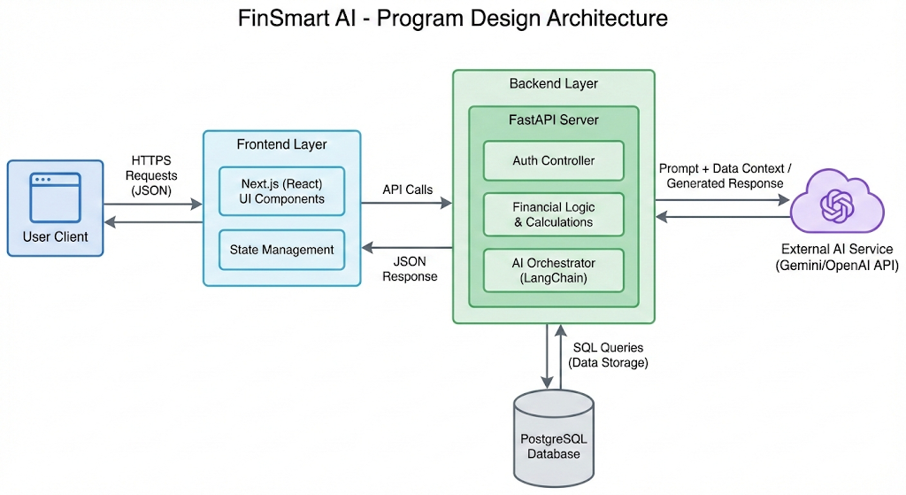

REFERENCES
https://developer.mozilla.org/ (Used for HTML/CSS/JavaScript standards)
https://www.w3schools.com/ (Used for SQL query reference)
https://www.geeksforgeeks.org/ (Used for Python algorithm reference)
https://www.promptingguide.ai/ "How Retrieval Augmented Generation (RAG) Works" (Concept for AI):
https://nextjs.org/docs (Next.js Documentation)
https://fastapi.tiangolo.com/ (FastAPI Documentation)
https://www.postgresql.org/docs/ (PostgreSQL Documentation)
https://react.dev/ (React (Frontend) Documentation)
https://ai.google.dev/docs (Google Gemini API (AI) Docs)
https://python.langchain.com/docs/get_started/introduction (LangChain (AI Integration) Docs)

