VISVESVARAYA TECHNOLOGICAL UNIVERSITY


“JnanaSangama”, Belgaum -590014, Karnataka.

LAB REPORT
On
ANALYSIS AND DESIGN OF ALGORITHMS (23CS4PCADA)

Submitted by
Gagan Gowda H P(1BM25CS443)

in partial fulfillment for the award of the degree of BACHELOR OF ENGINEERING in COMPUTER SCIENCE AND ENGINEERING



B.M.S. COLLEGE OF ENGINEERING (Autonomous Institution under VTU) BENGALURU-560019 February to June 2026
CERTIFICATE
B. M. S. College of Engineering,
Bull Temple Road, Bangalore 560019
(Affiliated To Visvesvaraya Technological University, Belgaum)

Department of Computer Science and Engineering



This is to certify that the Lab work entitled “ANALYSIS AND DESIGN OF ALGORITHMS” carried out by Gagan Gowda H P (1BM25CS443), who is bonafide student of B. M. S. College of Engineering. It is in partial fulfillment for the award of Bachelor of Engineering in Computer Science and Engineering of the Visvesvaraya Technological University, Belgaum during the year 2025-26. The Lab report has been approved as it satisfies the academic requirements in respect of Analysis and Design of Algorithms Lab - (23CS4PCADA) work prescribed for the said degree.

Dr H S Guruprasad Dr. Kavitha Sooda
Professor Professor and Head
Department of CSE Department of CSE
BMSCE, Bengaluru BMSCE, Bengaluru

Index Sheet
Sl.  No. | Experiment Title | Page No.
1 | Write program to obtain the Topological ordering of vertices in a given  digraph. | 4
2 | Implement Johnson Trotter algorithm to generate permutations. | 7
3 | Sort a given set of N integer elements using Merge Sort technique and  compute its time taken. Run the program for different values of N and record the time taken to sort. | 9
4 | Sort a given set of N integer elements using Quick Sort technique and compute  its time taken. | 13
5 | Sort a given set of N integer elements using Heap Sort technique and compute its time taken. | 15
6 | Implement 0/1 Knapsack problem using dynamic programming. (5 Marks) | 18
7 | Implement All Pair Shortest paths problem using Floyd’s algorithm. | 20
8 | - Find Minimum Cost Spanning Tree of a given undirected graph using Prim’s algorithm.  - Find Minimum Cost Spanning Tree of a given undirected graph using  Kruskal’s algorithm. | 22
9 | Implement Fractional Knapsack using Greedy technique. | 26
10 | From a given vertex in a weighted connected graph, find shortest paths to other vertices using Dijkstra’s algorithm. | 28
11 | Implement “N-Queens Problem” using Backtracking. | 30
12 | Leetcode problems | 33

Course outcomes:
CO1 | Analyze time complexity of algorithms using asymptotic notations.
CO2 | Apply various algorithm design techniques for the given problem.
CO3 | Evaluate the appropriate algorithm/design technique for solving a given problem.
CO4 | Conduct practical experiments by applying appropriate algorithm design technique to solve problems.

Lab program 1: Write program to obtain the Topological ordering of vertices in a given digraph.

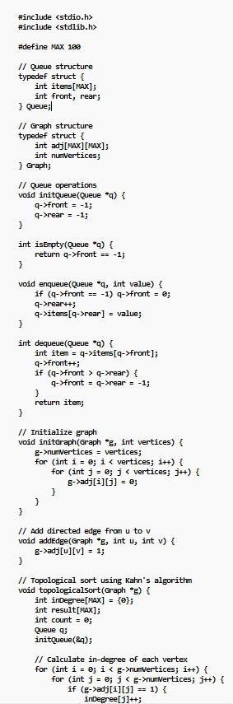

QUeue q;
initQ.Jeue{BQ!)_;
II calcu'la;te, in-<degree,of ,each vertex
fir ,(in:t .i = e; .i < g->m.llflertices; i+1-) {
-for {irrt j = 0_; j < g->m.111,rertices_; jtt) { if (g->adj[ilul == 1) {
iro�gree{j}tt;

// Enqueue vertices "ll'ith in-d�e
fir (in± .i = e_; i < g->m.11wertices_; i++) { i-f 1(�'[i]. == e) {
,enqueue:(iq,, i) _;

}

/J Process vertices r,;nile {!.isEC¢y{iqi)) {
int u = dequeue{liq,); result{oaun±++] = u_;

// .Reduce in� oF neighbors
-for {int v •= 0_; v < g->m.111,,1ertices_; vtt) { if (g->adj[u][v] == 1) {
� vl-- _;
if (irllegree[v] == e) {
,enq,ueue:(iq, v);

}

}

lJ Check if topol,ogi.cal sort is possible
if {coon± != g->ntm!ertiGes) {
pcirrtf(.En,or: Graph has a cyde! Topologicail. sort not possible. \nn_;

ll Print result pcintf{,opologicail. OlrdEr: -) _;
fuc:- {in± .i = e_; i < caunt_; itt) {
prirrl:-f{"'Xd ••• l'eSUlt:[iJ);
}
pcintfC\n-);

JI l'la:in functioo int min() {
Graph g_;
int vertices., edges, u,, v;

pcintf{-Errter mnber of vertices: "') _; s can,f{"'Xd-, &vertices)_;

ini�{&g, vertices);

prin±-FCEnter m.11ber ,of eqges: -) _; scan-F,("'Xd,., &eclges);
pcintf{-Errter edges {u v) �e= eclge is -fl'IEI u fo v:\n-);
-For (in± i = e_; i < eclges_; .itt) {
.scanf'{"%d %cl-, &u, &v);
addEdge{,11,g1, 1, v)_;

t,opologicalsort:{8,g)_;

r.etum e_;

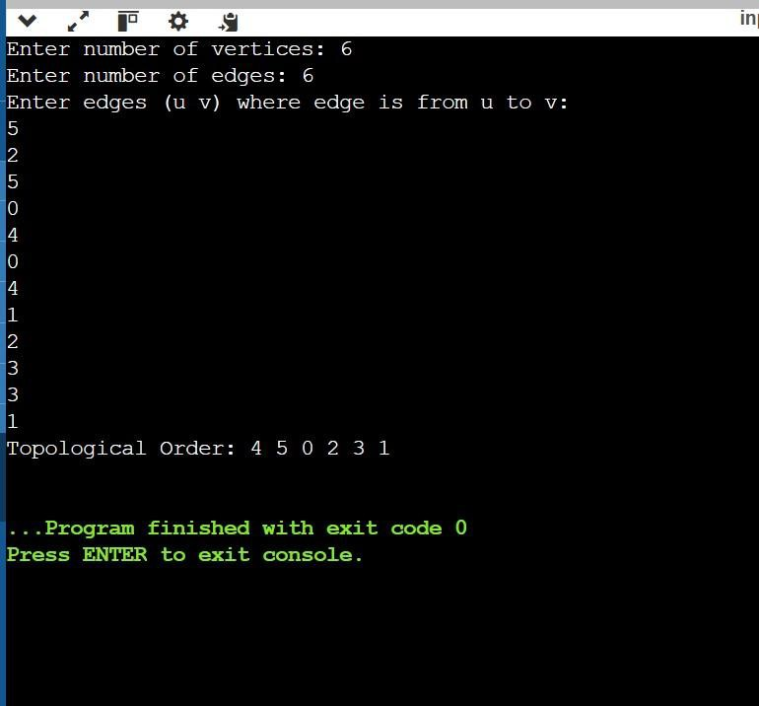

Lab program 2: Implement Johnson Trotter algorithm to generate permutations.
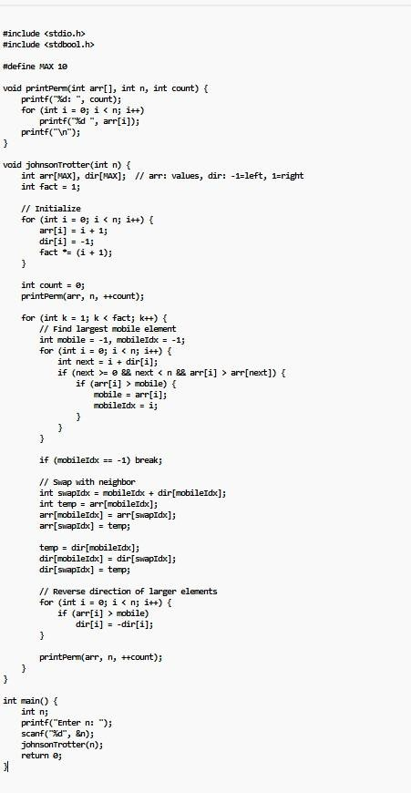

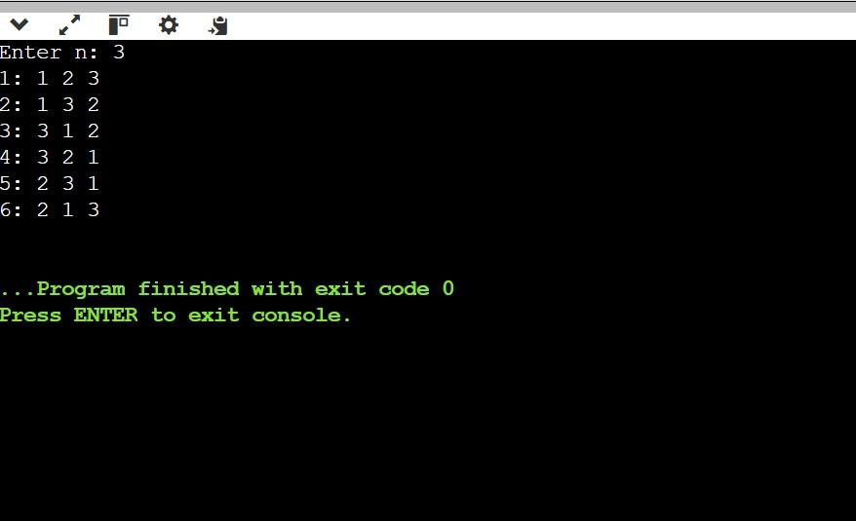

Lab program 3: Sort a given set of N integer elements using Merge Sort technique and compute its time taken. Run the program for different values of N and record the time taken to sort.
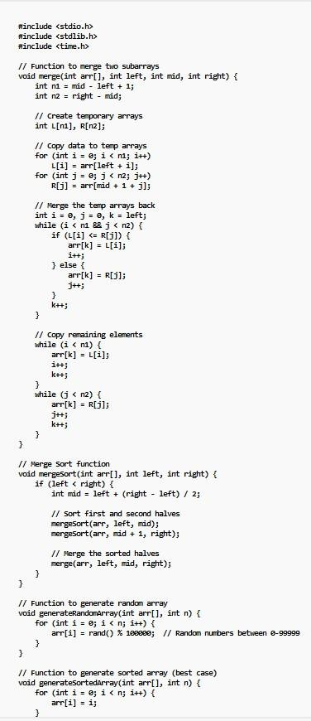

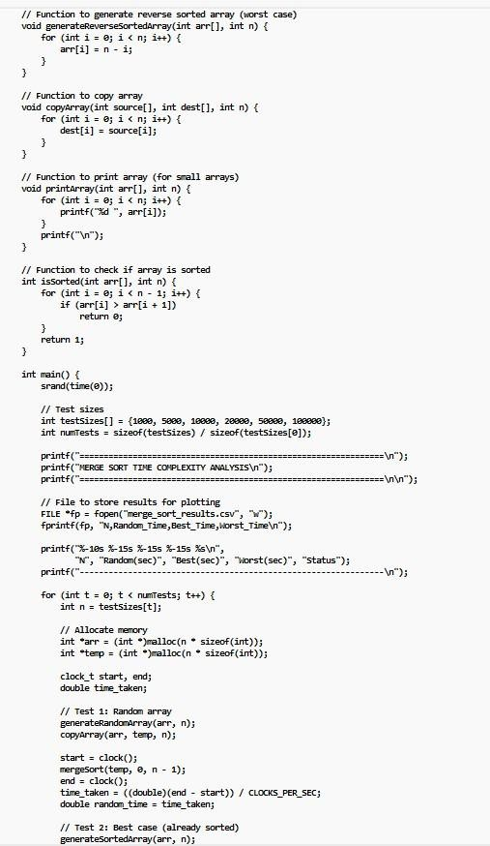



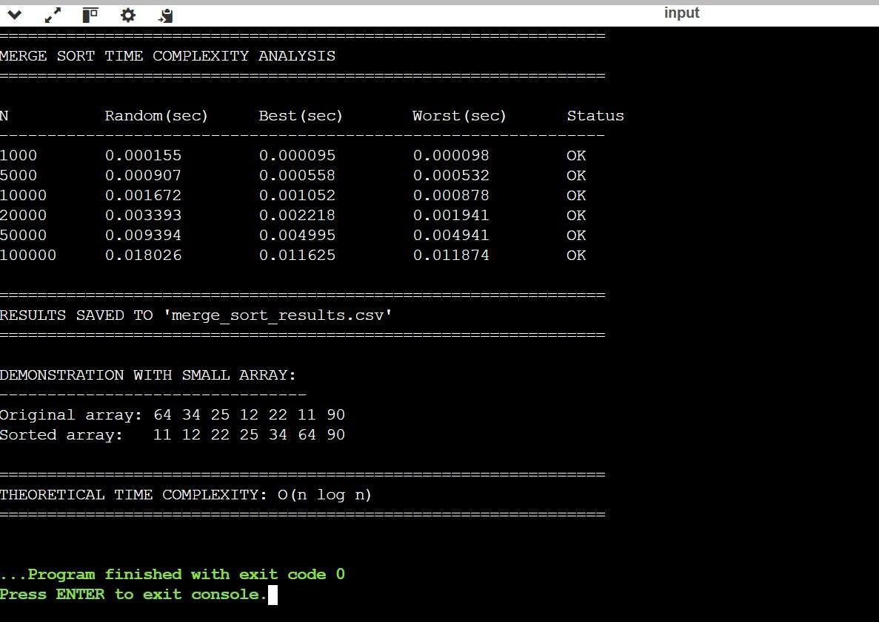
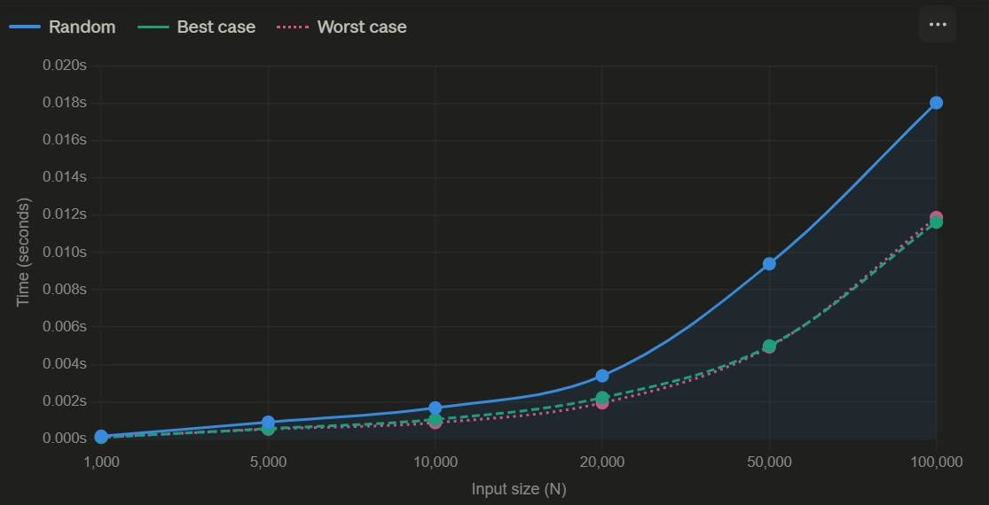

Lab program 4: Sort a given set of N integer elements using Quick Sort technique and compute its time taken.
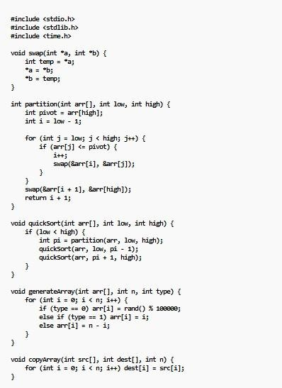
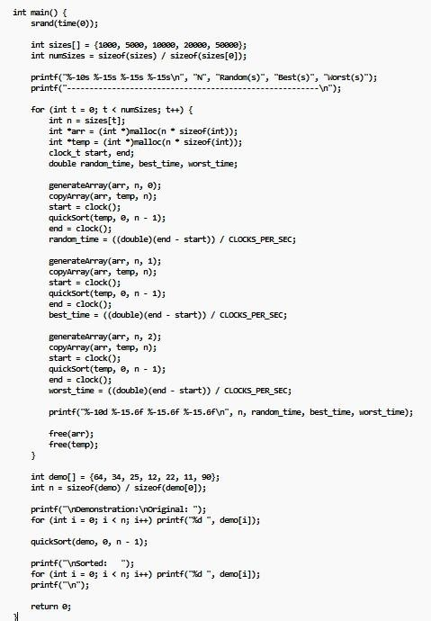

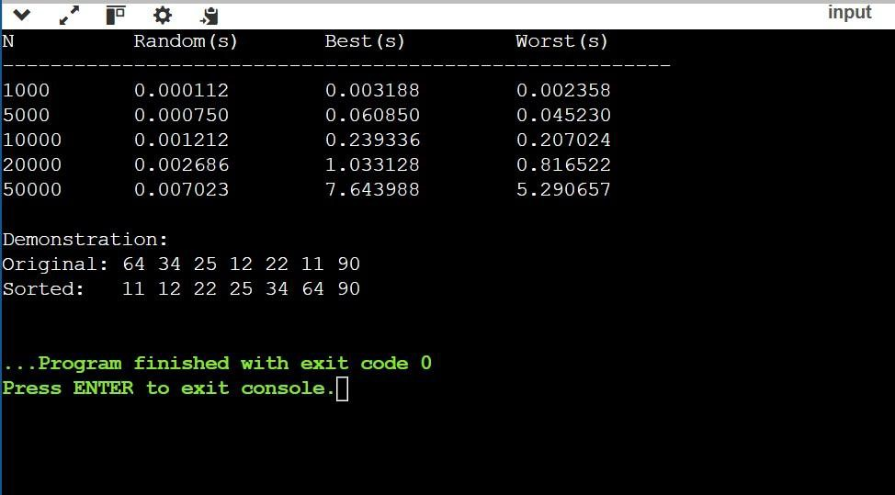

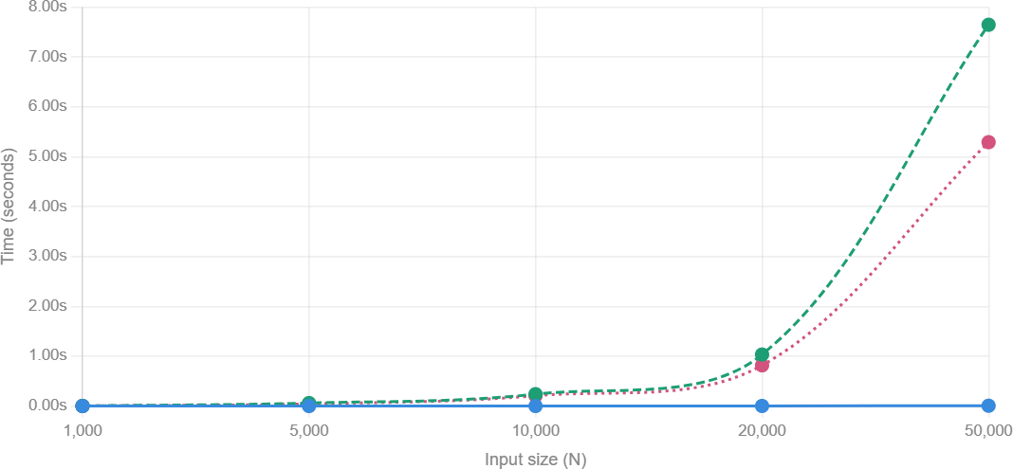

Lab program 5: Sort a given set of N integer elements using Heap Sort technique and compute its time taken.
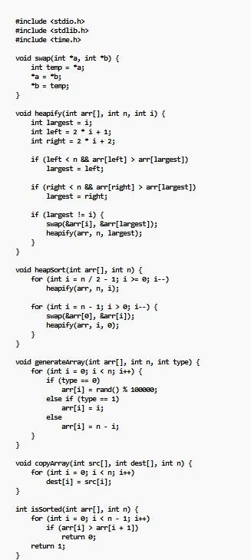

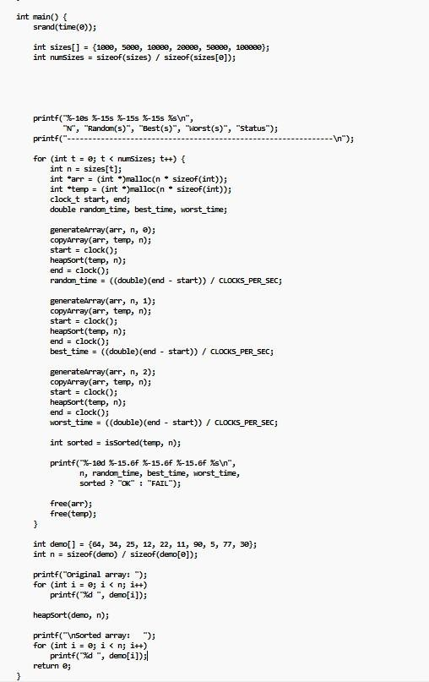

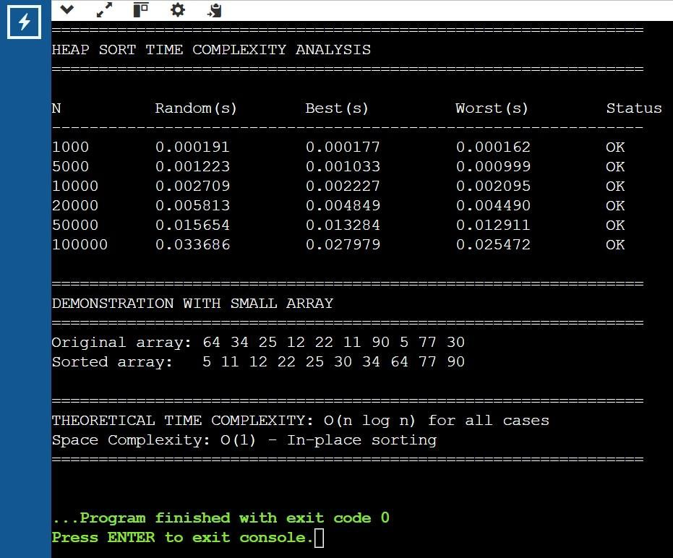
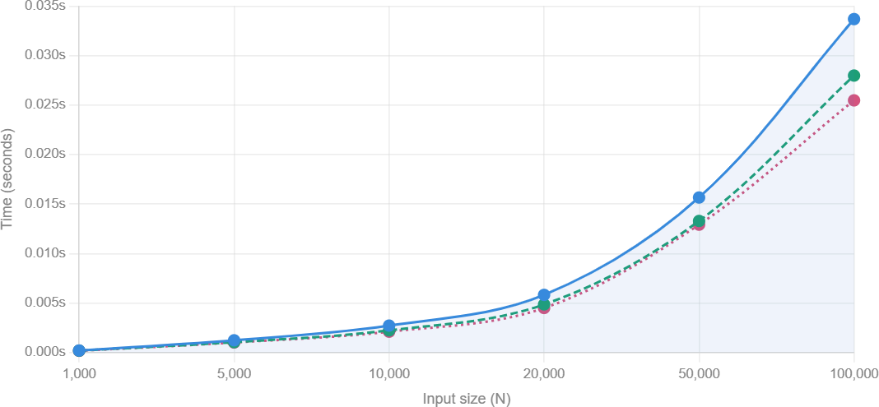

Lab program 6: Implement 0/1 Knapsack problem using dynamic programming. (5 Marks)
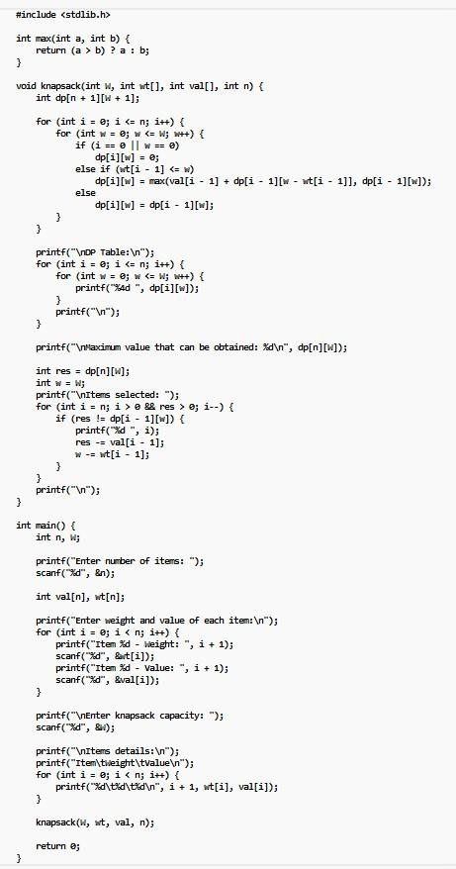

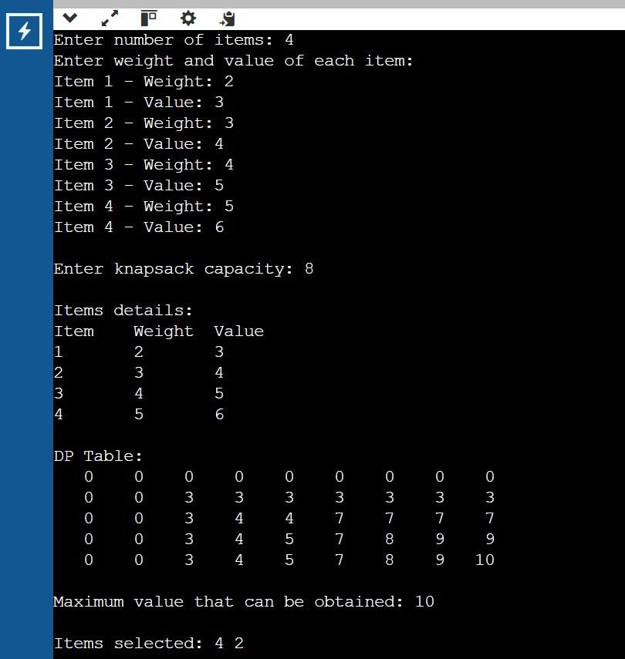

Lab pogram 7: Implement All Pair Shortest paths problem using Floyd’s algorithm
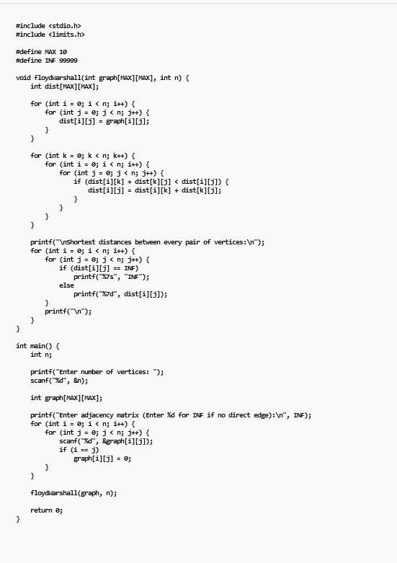

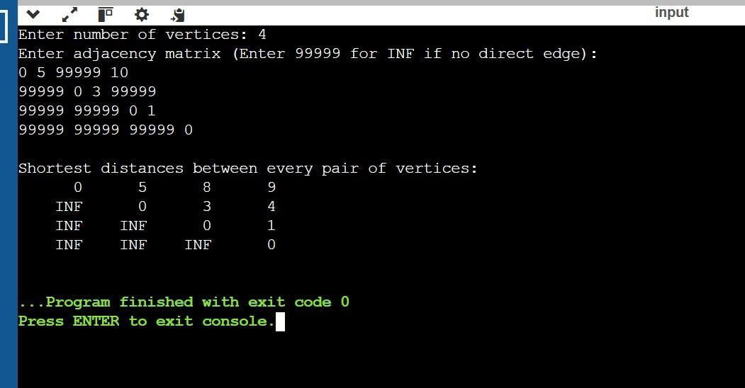

- Lab program 8: Find Minimum Cost Spanning Tree of a given undirected graph using Prim’s algorithm.
- Find Minimum Cost Spanning Tree of a given undirected graph using Kruskal’s algorithm.

a)
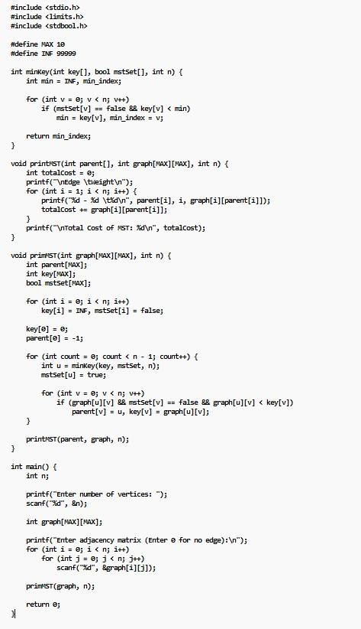

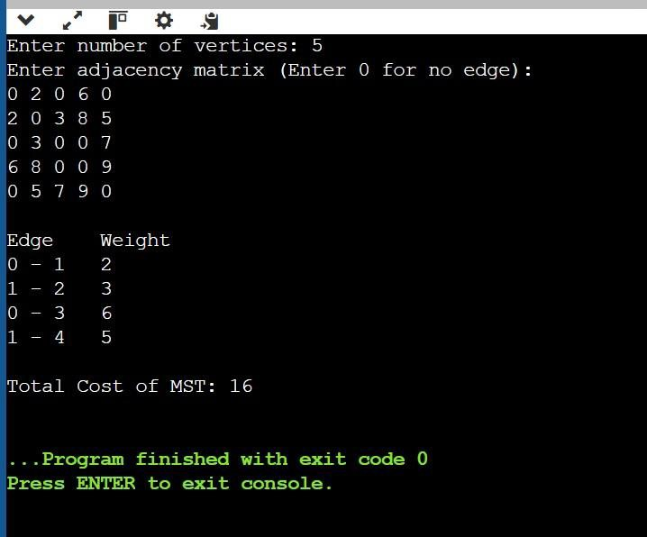

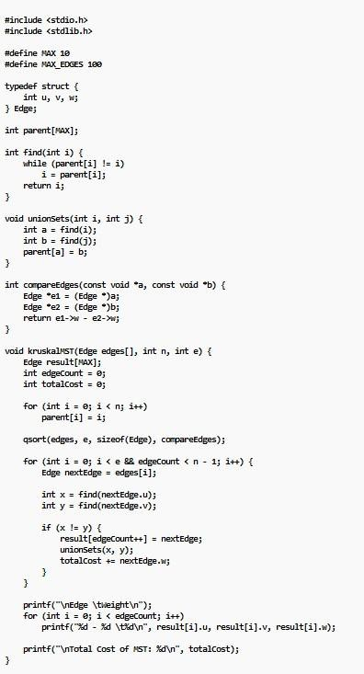
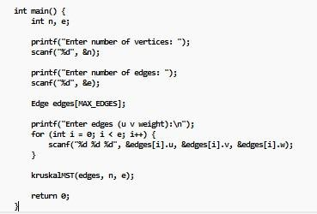

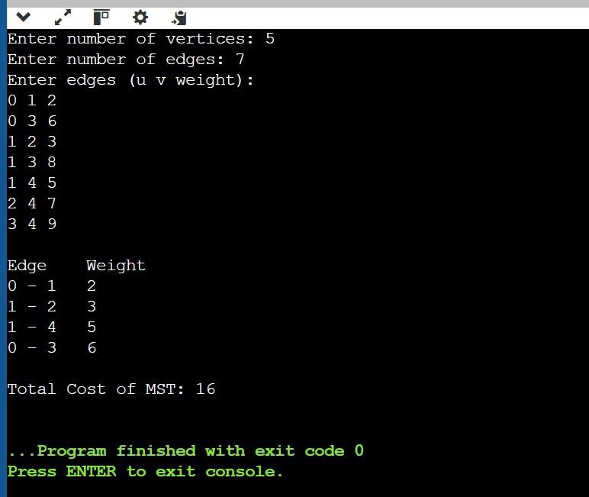

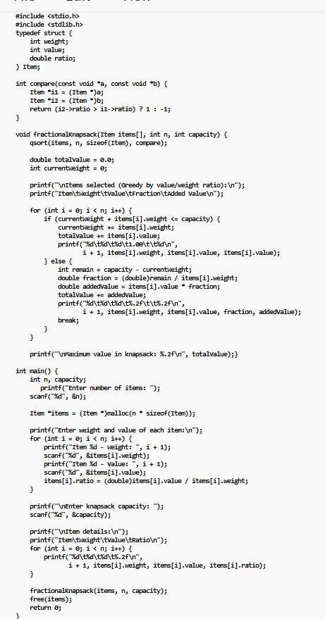
Lab program 9: Implement Fractional Knapsack using Greedy technique.

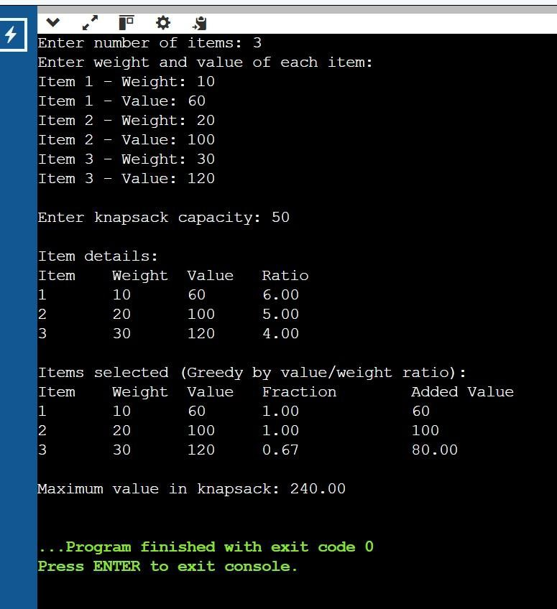

Lab program 10: From a given vertex in a weighted connected graph, find shortest paths to other vertices using Dijkstra’s algorithm.
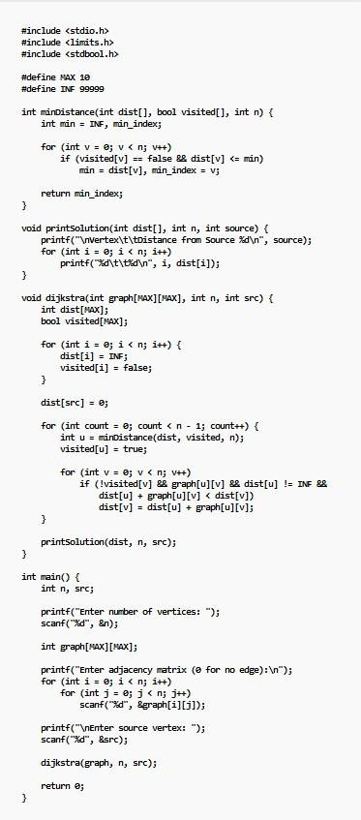

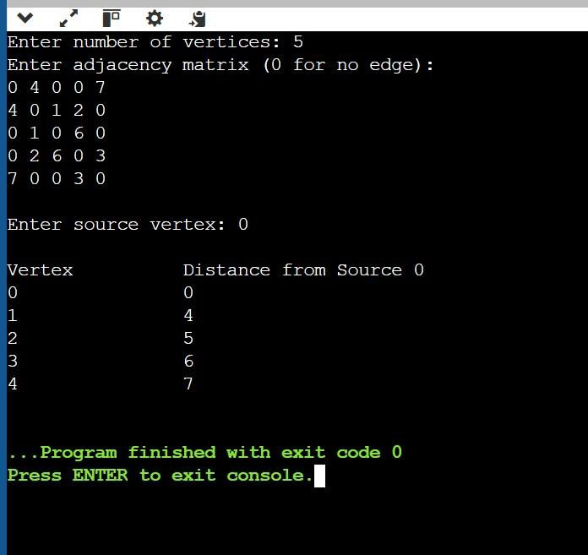
Lab program 11: Implement “N-Queens Problem” using Backtracking.

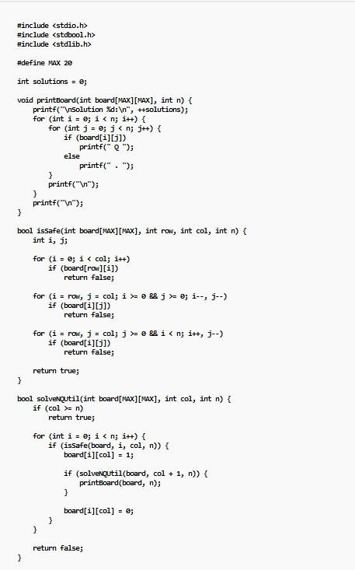

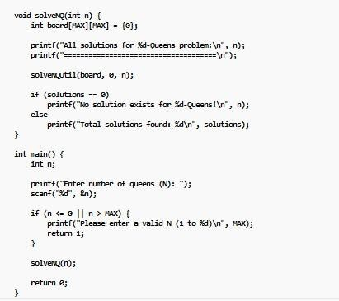
/

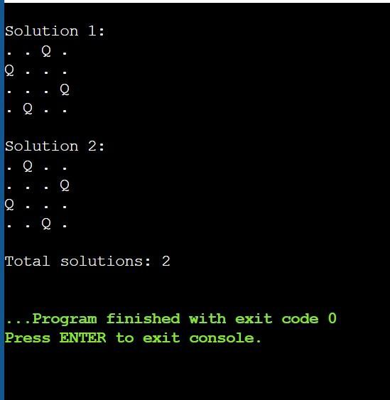

Leetcode problem 1: Sort colors
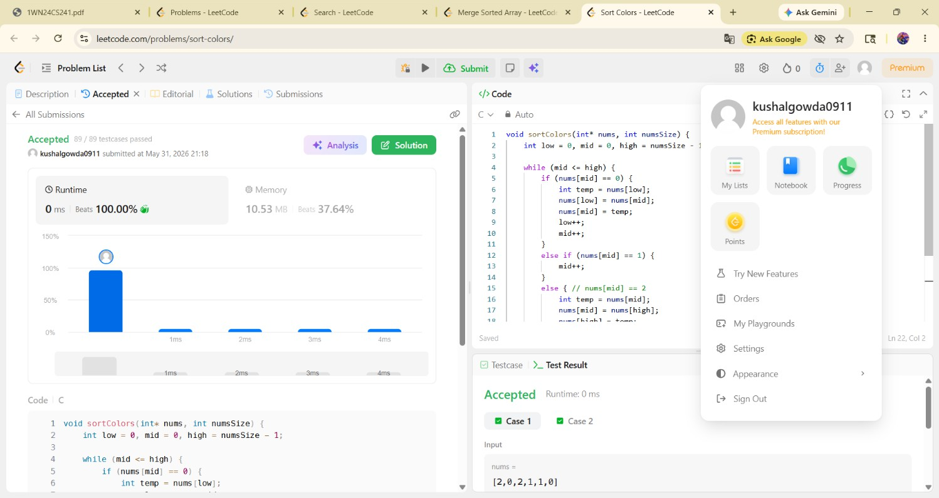

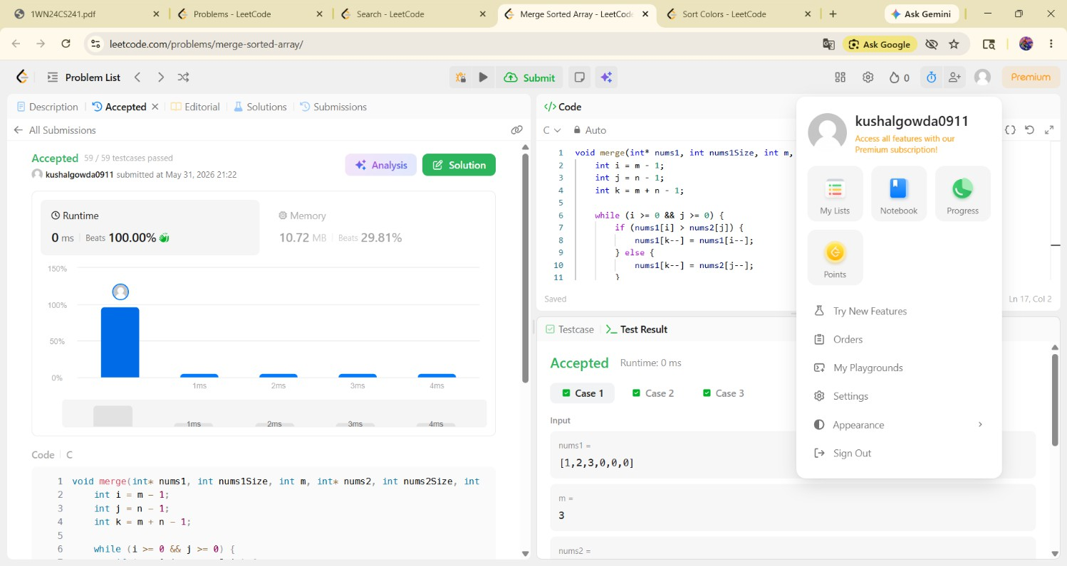
Leetcode problem 2:Merge sorted array

Leetcode problem 3:
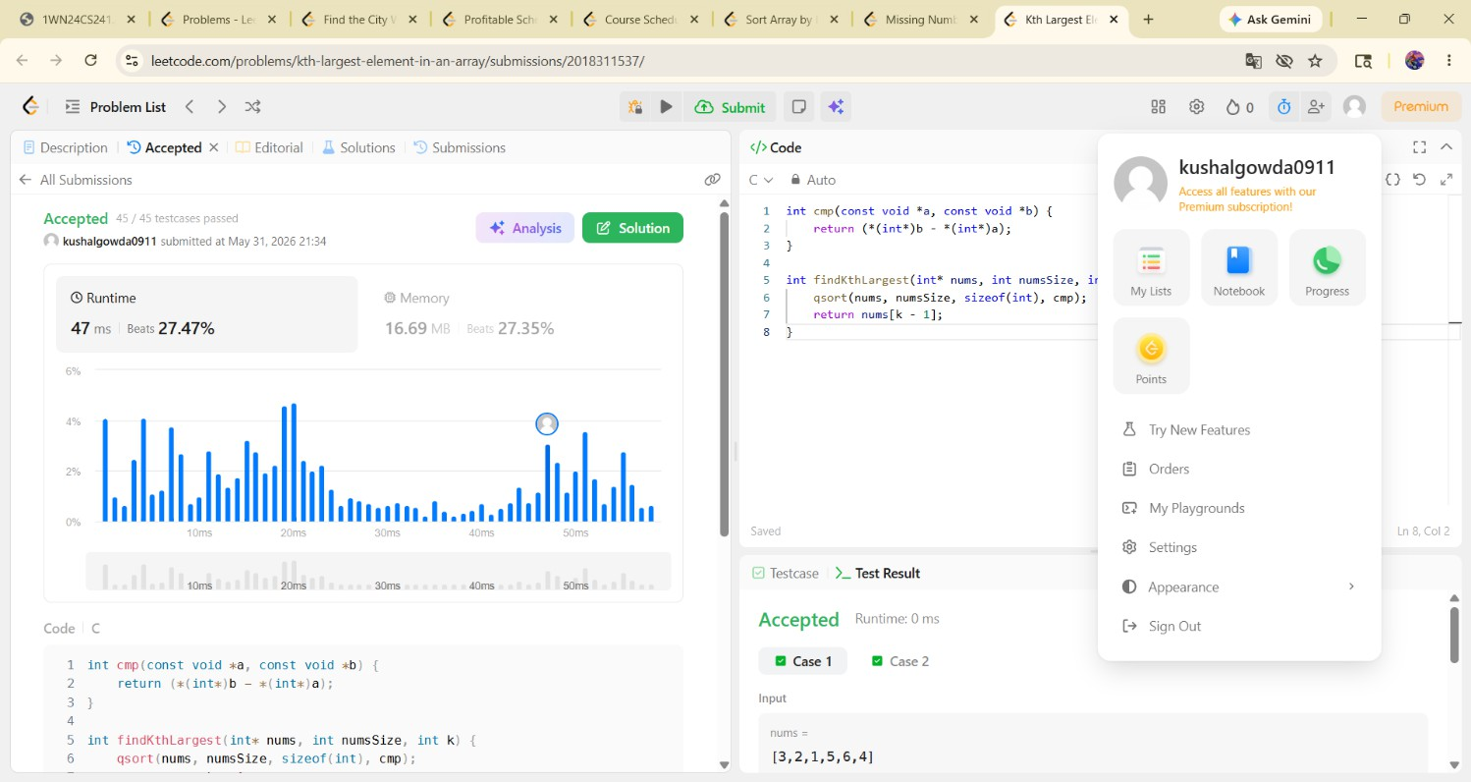

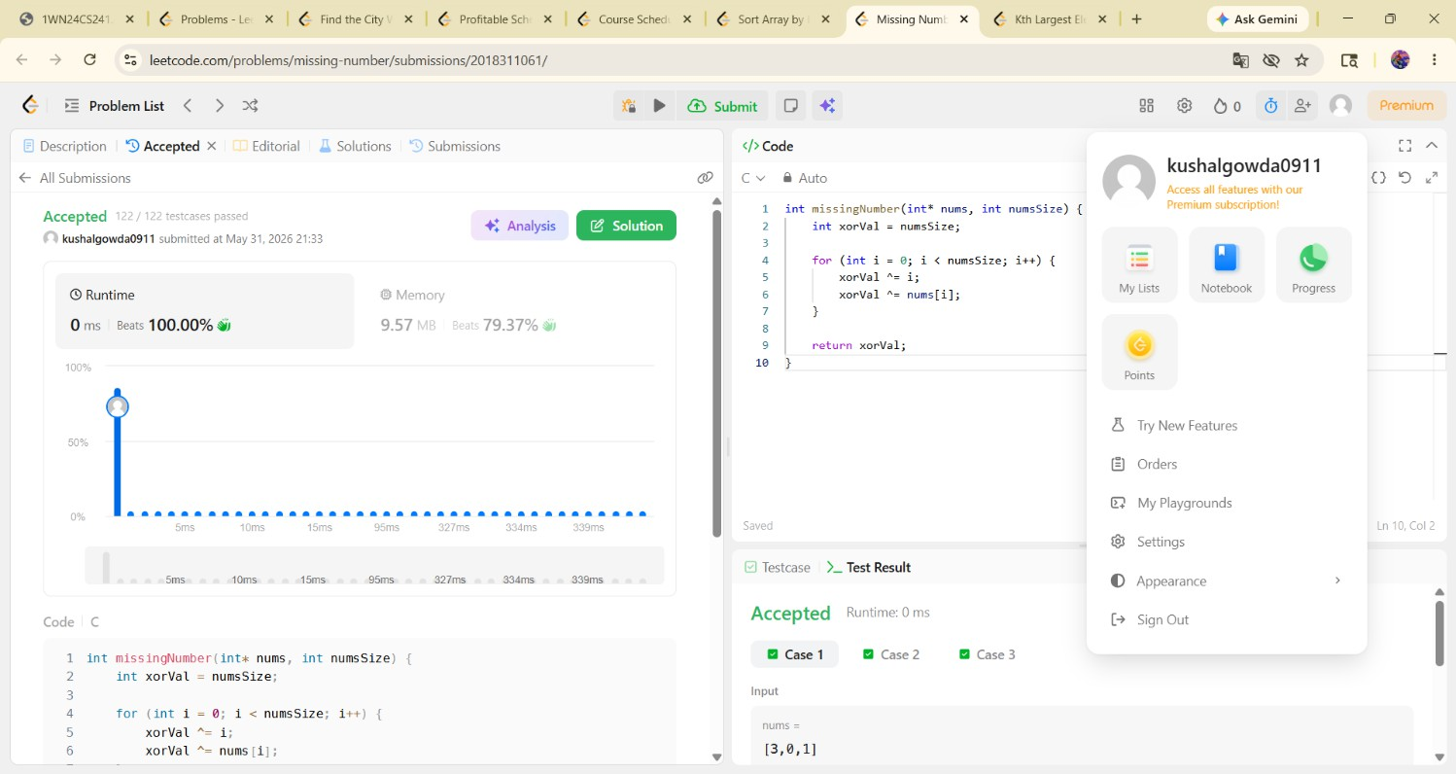
Leetcode problem 4:Missing number

Leetcode problem 5:Sort array by increasing frequency
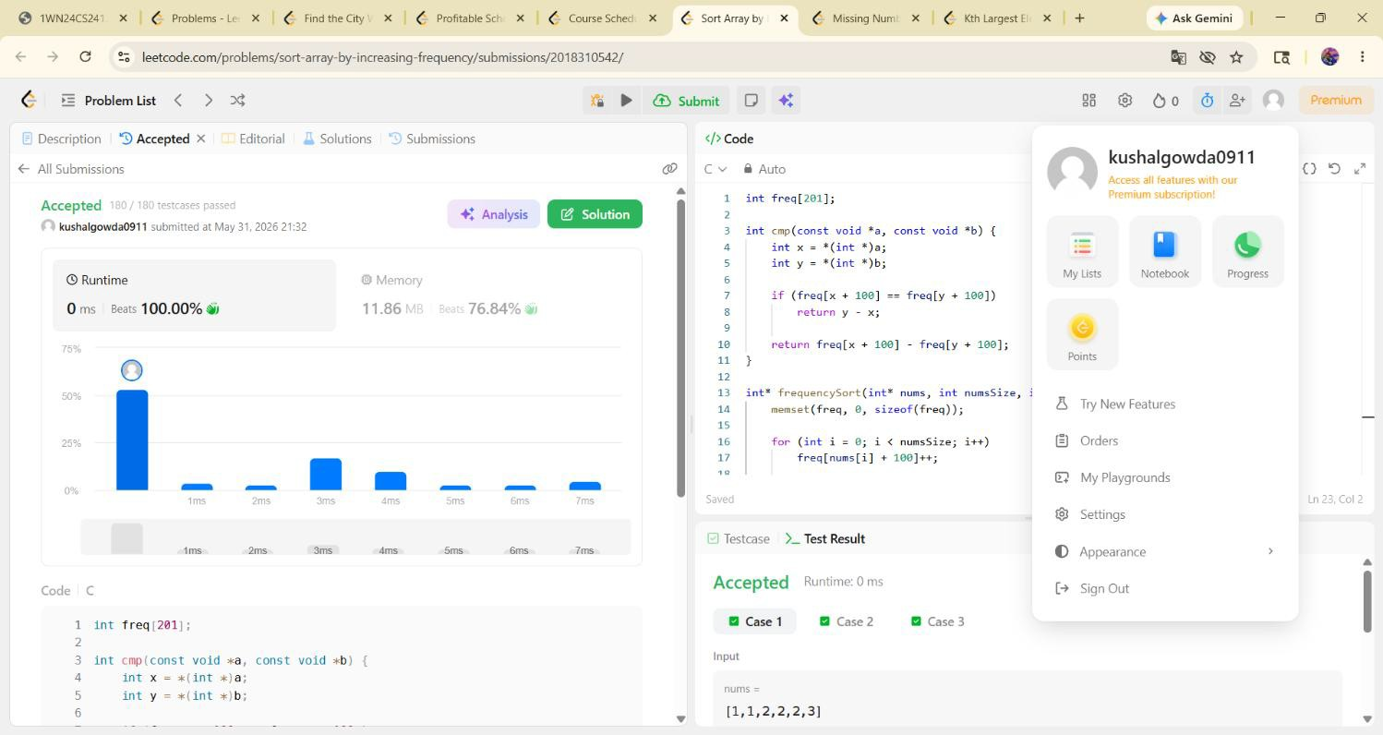

Leetcode problem 6: Course schedule

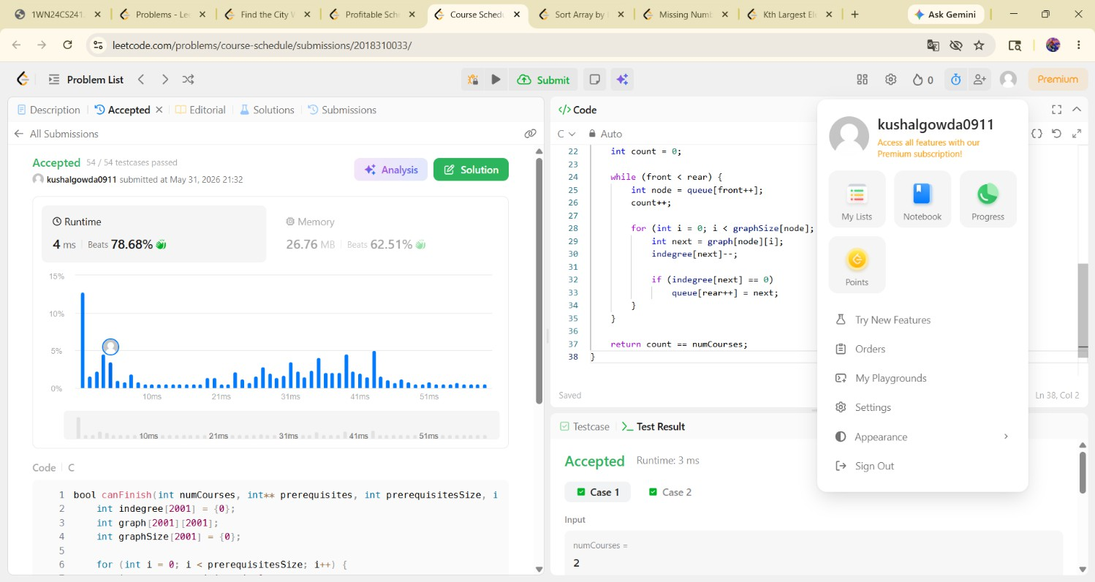

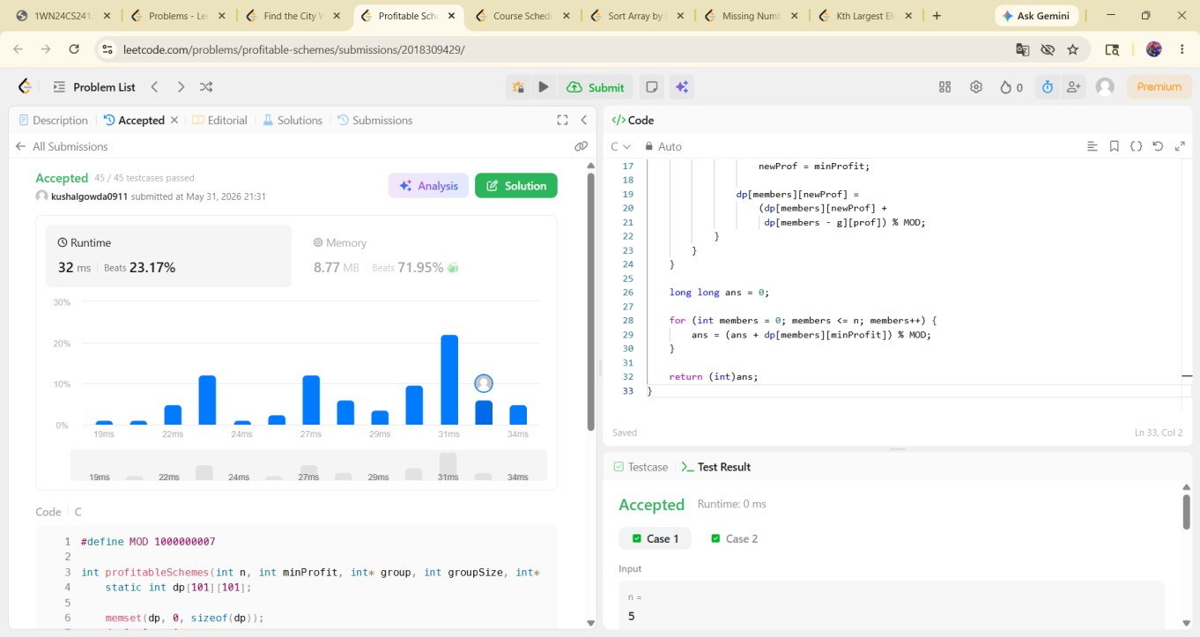
Leetcode problem 7:profitable schemes

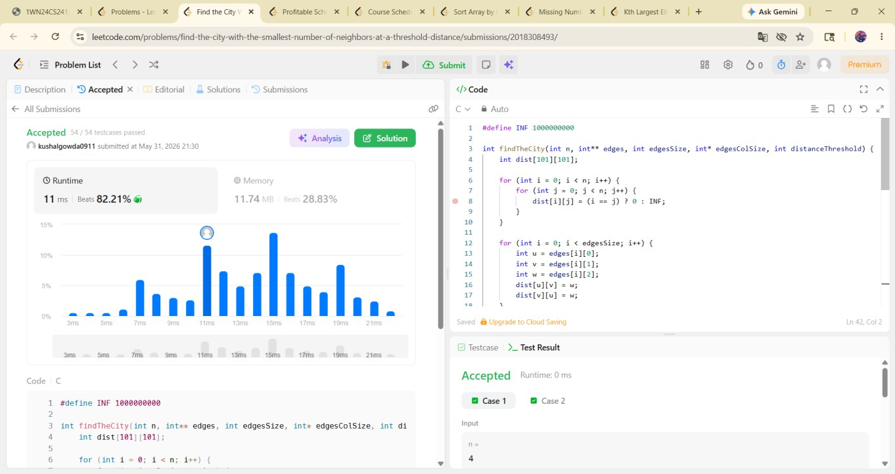
Leetcode 8:

