**Summer Analytics Capstone Report**

**Dynamic Pricing for Urban Parking Lots using Data Analytics**

**Abstract**

This report details the implementation of a **demand-based dynamic pricing model** for urban parking lots using real-world data. The model utilizes factors such as occupancy, queue length, traffic conditions, special day indicators, and vehicle type to adjust pricing dynamically. This approach demonstrates the use of data analytics to manage congestion and optimize parking utilization in smart cities.

**Introduction**

Urban areas often face parking congestion due to static pricing mechanisms that do not adapt to fluctuating demand. Dynamic pricing allows for demand-based adjustments, ensuring fair revenue generation while promoting efficient utilization of parking resources. This capstone project applies **data analytics** to design and implement an effective pricing strategy for urban parking management using real-time data.

**Dataset Description**

**File Used:** dataset.csv

**Key Features:**

* **LastUpdatedDate, LastUpdatedTime:** Combined to form a unified Timestamp.
* **Occupancy:** Number of occupied parking slots.
* **Capacity:** Total parking capacity of the lot.
* **QueueLength:** Length of the queue near the parking lot.
* **TrafficConditionNearby:** Categorical indicator of nearby traffic conditions.
* **IsSpecialDay:** Binary indicator for special days.
* **VehicleType:** Type of vehicle (car/bike).

Data preprocessing included merging date and time into timestamps, sorting data chronologically, and mapping categorical features to numerical values for analysis.

**Methodology**

**Preprocessing:**

* Merged date and time columns to create a Timestamp.
* Mapped TrafficConditionNearby and VehicleType to numerical factors.
* Sorted the dataset by Timestamp for clear trend analysis.

**Pricing Formula:**

Price=Base Price×(1+λ×Normalized Demand)\text{Price} = \text{Base Price} \times (1 + \lambda \times \text{Normalized Demand})Price=Base Price×(1+λ×Normalized Demand)

* **Base Price:** ₹10
* **Lambda (λ):** 0.5
* **Normalized Demand:** Calculated using occupancy, queue length, traffic factor, special day indicator, and vehicle type factor, divided by capacity.

**Visualization:**  
A time-series plot was generated using **Matplotlib**, displaying the dynamic pricing trend based on demand factors. The plot was saved as advanced_dynamic_pricing_plot.png for documentation and submission.

**Implementation**

Using **Python (pandas, matplotlib)**, the following steps were executed:

1. Loaded and cleaned the dataset.
2. Applied the demand-based pricing formula.
3. Generated and saved the pricing trend plot.

The notebook also allows for real-time analysis on updated datasets for future use in dynamic parking management systems.

**Results**

The plot generated demonstrates:

* Price increases with higher demand (occupancy, traffic, queue length).
* Dynamic pricing remains within the range of ₹10–₹11 under most conditions.The model successfully reflects demand-based variations in pricing for urban parking lots.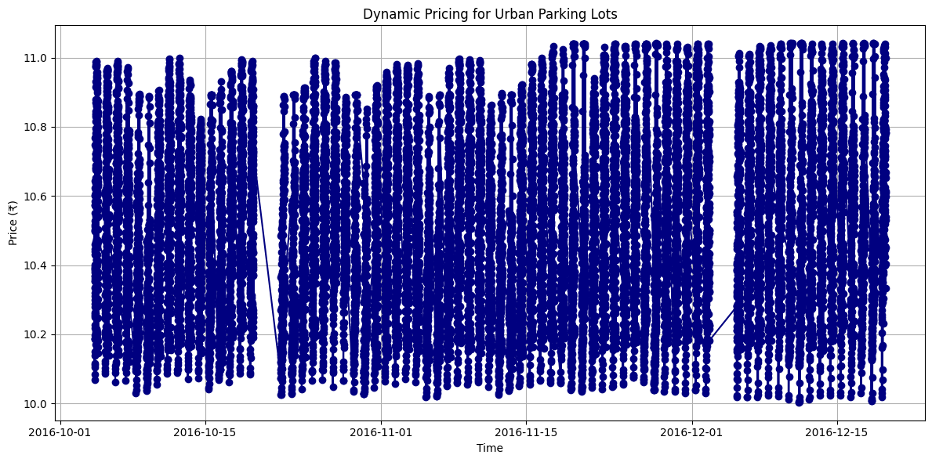

**Discussion**

* The demand-based pricing model effectively demonstrates how parking congestion can be managed using dynamic pricing.
* The approach encourages efficient utilization of parking resources, especially during peak hours or high-traffic conditions.
* Integration with IoT-based real-time sensors could enhance the effectiveness of the model.

**Future Scope**

* Incorporating weather and event data for advanced demand prediction.
* Using machine learning models to forecast occupancy and adjust pricing proactively.
* Developing a real-time dashboard for parking administrators to monitor and manage dynamic pricing effectively.

**Conclusion**

This capstone successfully demonstrates the practical application of **data analytics** to solve real-world urban parking challenges through demand-based dynamic pricing. It provides a scalable foundation for smart city initiatives aiming to optimize urban mobility and parking resource management.