Program for Translation:
#include <stdio.h>
#include <graphics.h>
#include <stdlib.h>
void main() {
int gd = DETECT, gm;
int x1, x2, x3, y1, y2, y3;
int nx1, nx2, nx3, ny1, ny2, ny3;
int xt, yt;
printf("\t Program for Basic Translation of a Triangle\n");
printf("\n\t Enter the Points of Triangle (x1, y1, x2, y2, x3, y3): ");
scanf("%d%d%d%d%d%d", &x1, &y1, &x2, &y2, &x3, &y3);

printf("\n Enter the translation factors (xt, yt): ");
scanf("%d%d", &xt, &yt);

initgraph(&gd, &gm, "");

line(x1, y1, x2, y2);
line(x2, y2, x3, y3);
line(x3, y3, x1, y1);
nx1 = x1 + xt;
nx2 = x2 + xt;
nx3 = x3 + xt;
ny1 = y1 + yt;
ny2 = y2 + yt;
ny3 = y3 + yt;

line(nx1, ny1, nx2, ny2);
line(nx2, ny2, nx3, ny3);
line(nx3, ny3, nx1, ny1);
delay(5000);
closegraph();
}

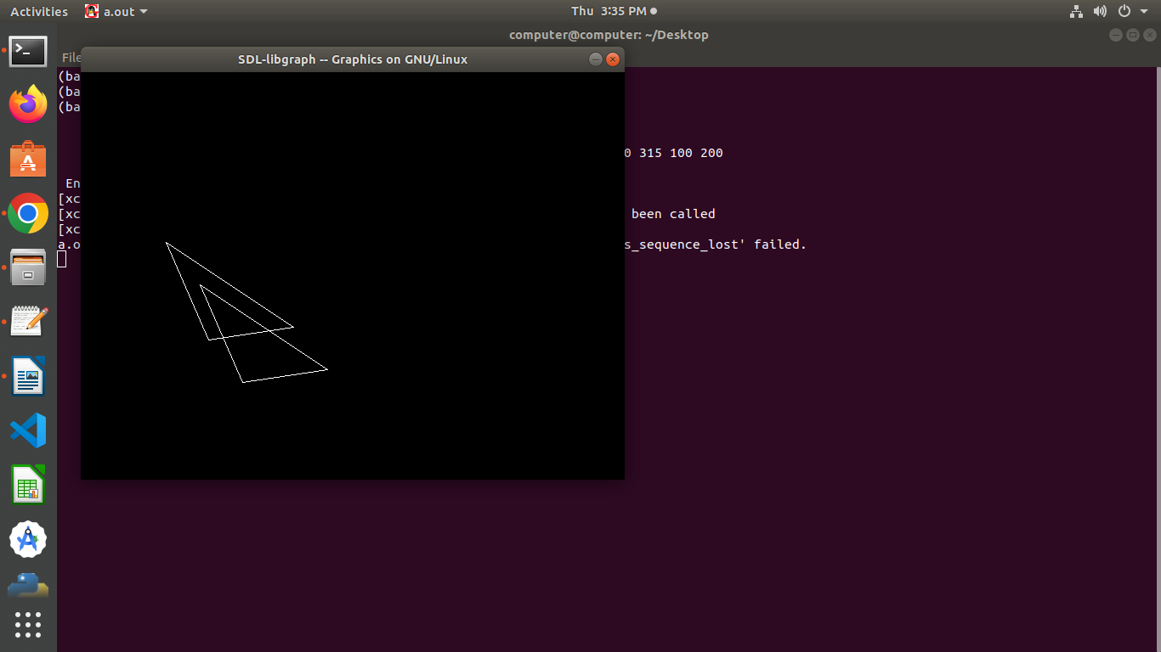
Output:

