CORTEXA: MULTI-TENANT AI-POWERED DOCUMENT INTELLIGENCE AND KNOWLEDGE RETRIEVAL PLATFORM
A Course Project Report
Submitted in partial fulfillment of the completion of the course
SOFTWARE ENGINEERING AND SYSTEM DESIGN
(24CS301PC311)
In III Year, I Semester B. Tech-CSE
Submitted by:
Vengala Gagan Chandra Tej
(Roll No: 2403a52222)
Under the supervision of the faculty:
Dr. <Faculty Name>
Assistant Professor
School of Computer Science & Artificial Intelligence
2026–2027
DEPARTMENT OF COMPUTER SCIENCE & ARTIFICIAL INTELLIGENCE
SR UNIVERSITY
WARANGAL, TELANGANA, INDIA

DOCUMENT SPECIFICATIONS & FORMATTING NORMS
- MAIN HEADING: Font Size 16, Times New Roman, Bold, Center Alignment
- Sub Heading: Font Size 14, Times New Roman, Bold, Left Alignment
- Contents & Body: Font Size 12, Times New Roman, Justified Alignment (Line Spacing 1.15)
- Diagram Source Files: Native draw.io XML files provided in /docs/diagrams/ for all 5 diagrams.
INDEX / TABLE OF CONTENTS
Section Title / Topic | Section Reference
Abstract | 1
1. Introduction | 2
2.1 Problem Statement | 2
2.2 Objectives | 3
2.3 Scope | 3
2. Software Requirements Specification (SRS) | 4
3.1 Functional Requirements | 4
3.2 Non-Functional Requirements | 5
3.3 Hardware and Software Requirements | 6
3. System Analysis | 7
4.1 Existing System | 7
4.2 Proposed System & Comparative Study | 8
4. System Design | 9
5.1 System Architecture | 9
5.2 Use Case Diagram | 11
5.3 Class Diagram | 13
5.4 Sequence Diagram | 15
5.5 Activity Diagram | 17
5. Methodology | 19
Agile Iterative & Incremental Model | 19
GitOps CI/CD Deployment Pipeline | 21
6. Implementation | 22
Multi-Tenant Row-Level Security (RLS) | 22
Asynchronous Queue Ingestion Engine | 23
High-Dimensional Vector Retrieval | 24
Electron Native Desktop Packaging & Direct Route | 25
7. Output Screenshots & Evaluation | 26
8. Conclusion & Future Enhancements | 31
9. References | 32

ABSTRACT
In the contemporary enterprise landscape, organizations generate massive volumes of unstructured and semi-structured data across operational documents, technical documentation, policies, and research publications. While modern Large Language Models (LLMs) demonstrate unprecedented conversational reasoning, their enterprise adoption is critically hindered by three fundamental limitations: temporal hallucination of domain facts, context window size boundaries, and data cross-contamination in multi-tenant environments. Furthermore, most knowledge management systems either enforce costly proprietary software subscriptions or present high friction during client installation, requiring complex command-line or containerized environments.
To decisively overcome these challenges, this project presents CORTEXA, an enterprise-grade, multi-tenant AI document intelligence and knowledge retrieval platform. CORTEXA implements an end-to-end Retrieval-Augmented Generation (RAG) pipeline featuring a high-performance decoupled architecture. The frontend tier is engineered using Next.js 16 with React 19 and Tailwind CSS for edge-optimized web rendering, paired with an Electron-based native Windows desktop application compiled as a standalone NSIS installer (.exe). The backend tier is powered by a high-throughput FastAPI application server, an asynchronous ingestion engine driven by an Upstash Redis event stream, and Google Gemini 1.5 Flash coupled with gemini-embedding-001 (768 dimensions). To guarantee strict organizational privacy and zero data leakage across organizations, the storage layer integrates Supabase PostgreSQL with native Row-Level Security (RLS) policies enforced cryptographically at the database kernel level.
Additionally, CORTEXA introduces a high-conversion 1-Click zero-barrier desktop distribution pipeline: users can download the native Windows executable directly through an edge-routed API endpoint (/api/download) that proxies and redirects downloads from GitHub Releases without requiring visitors to navigate third-party code repositories. Experimental evaluation confirms sub-second vector cosine similarity retrieval, 100% tenant isolation across parallel query sessions, seamless real-time Server-Sent Events (SSE) token streaming, and zero-cost cloud deployment across Vercel and Render infrastructure.
Keywords: Retrieval-Augmented Generation (RAG), Multi-Tenancy, Row-Level Security (RLS), Vector Embeddings, pgvector, Google Gemini, Electron Desktop Packaging, FastAPI, Next.js 16, Redis Streams, Continuous Integration/Continuous Deployment (CI/CD).

1. INTRODUCTION
The exponential accumulation of enterprise digital documents has rendered conventional manual search and basic keyword indexing (such as inverted indices) inadequate for knowledge discovery. Modern knowledge workers spend an estimated 20% of their workweek locating internal documentation or synthesizing fragmented answers. While Large Language Models (LLMs) such as GPT-4 and Google Gemini possess broad world knowledge, they lack access to an organization’s private, proprietary, or rapidly evolving internal repositories. Naïvely fine-tuning foundational models on proprietary corpora is computationally prohibitive, susceptible to catastrophic forgetting, and exposes sensitive tenant records to model inversion attacks.
Retrieval-Augmented Generation (RAG) has emerged as the definitive software engineering standard for bridging parametric model intelligence with non-parametric external knowledge. Under RAG, incoming queries are embedded into dense continuous vector spaces, matched against relevant semantic text chunks stored in a vector database, and concatenated into a constrained prompt envelope that grounds the language model’s response in verifiable ground-truth citations.
Despite the theoretical soundness of RAG, real-world multi-tenant deployments suffer from architectural deficiencies: synchronous document parsing that locks client connections, poor avatar and personality customization for varied business workflows, and lack of accessible distribution channels for desktop-bound operators. CORTEXA was engineered to solve these architectural bottlenecks by delivering a robust, scalable, and visually intuitive platform adhering to modern software engineering best practices.
2.1 Problem Statement
Core Challenges:Organizations seeking to deploy internal AI knowledge assistants encounter five critical obstacles:
- Enterprise Data Fragmentation: Knowledge assets reside isolated across disparate PDF handbooks, technical whitepapers, and operational notes without a unified semantic search index.
- LLM Hallucinations and Lack of Attribution: Standard foundation models generate plausible-sounding falsehoods when queried on domain-specific policies because answers are not mathematically anchored to source citations.
- Multi-Tenant Security Vulnerabilities: In multi-tenant SaaS environments, improper database isolation allows queries from Tenant A to retrieve vector embeddings or documents belonging to Tenant B, violating GDPR, HIPAA, and SOC-2 standards.
- Synchronous Ingestion Bottlenecks: Parsing dense PDFs and calculating high-dimensional embeddings during an HTTP POST request causes web servers to time out (e.g., HTTP 504 Gateway Timeout), degrading user experience.
- Frictional Client Distribution: Typical AI projects require complicated container setups (Docker) or command lines, alienating non-technical enterprise staff who require a native 1-click Windows desktop executable.
2.2 Objectives
The primary engineering objectives of the CORTEXA platform are formulated as follows:
- Multi-Tenant Data Isolation: Implement database-enforced Row-Level Security (RLS) using PostgreSQL session variables to guarantee absolute cryptographic isolation between organization records.
- Asynchronous Ingestion Pipeline: Decouple document parsing and embedding generation using Upstash Redis Streams and background worker daemons, achieving non-blocking sub-second UI upload responses.
- High-Accuracy Semantic Retrieval: Utilize Google Gemini's 768-dimensional embedding model (gemini-embedding-001) and pgvector cosine distance indexing to retrieve top-k grounded context chunks in under 300ms.
- Customizable Bot Personas: Provide an interactive Bot Builder supporting 10 custom SVG avatar presets, configurable system prompts, and temperature controls tailored to diverse organizational roles.
- Dual Web and Native Desktop Distribution: Deliver both a lightning-fast Next.js 16 web application and an Electron-based native Windows executable (.exe) with seamless 1-click direct download routing.
2.3 Scope
Project Boundaries:The project scope encompasses the complete software lifecycle of CORTEXA, spanning system requirements engineering, architectural modeling, relational and vector database schema design, asynchronous event pipeline integration, dual-platform compilation (Web + Desktop), and automated CI/CD cloud deployment.
- In-Scope Capabilities: Multi-tenant authentication via Supabase Auth; PDF/TXT text parsing with control-character sanitization; recursive token chunking; 768-dimension vector indexing; real-time Server-Sent Events (SSE) token streaming; 10 SVG avatar presets; GitHub Releases binary hosting; edge-redirect 1-click download API route; dark-themed responsive UI (#090d16).
- Out-of-Scope (Future Enhancements): Direct optical character recognition (OCR) on low-resolution scanned handwritten images; native macOS DMG/Linux AppImage compilation (Windows NSIS prioritized for Phase 1); voice-to-speech audio streaming.

2. SOFTWARE REQUIREMENTS SPECIFICATION (SRS)
This section defines the formal Software Requirements Specification (SRS) for CORTEXA in accordance with the IEEE 830-1998 standard for software specification. It outlines functional requirements, non-functional quality attributes, and hardware/software constraints.
3.1 Functional Requirements
- FR-1: Tenant Authentication & Session Management: The system shall authenticate users via Supabase Auth (JWT). Upon login, the system shall establish a tenant context and enforce Row-Level Security (RLS) so users access only their organization's data.
- FR-2: AI Bot Persona Configuration: The system shall enable users to create and configure custom AI bots with a unique name, system prompt, temperature parameter (0.0 to 1.0), and selection from 10 distinct SVG avatars.
- FR-3: Asynchronous Document Ingestion: The system shall accept PDF and TXT file uploads up to 50MB. Uploaded files shall be staged in object storage, and an ingestion task shall be published to an Upstash Redis Stream.
- FR-4: Text Sanitization and Chunking: The ingestion worker shall extract text using PyPDF, sanitize null and control characters, and segment content using a recursive sliding-window chunker (500 tokens, 50 token overlap).
- FR-5: Vector Embedding & Storage: The system shall generate 768-dimensional dense vector embeddings for each chunk via the Google Gemini API and store them in PostgreSQL with pgvector cosine indexing.
- FR-6: Contextual RAG Chat & Token Streaming: When a user queries a bot, the system shall embed the query, perform cosine similarity retrieval against tenant-filtered chunks, construct a grounded prompt, and stream the LLM response via SSE.
- FR-7: 1-Click Desktop Installer Download: The system shall provide a public edge route (/api/download) that dynamically redirects visitors to the latest Windows .exe installer hosted on GitHub Releases.
3.2 Non-Functional Requirements
- NFR-1: Performance & Latency: Vector similarity retrieval over 100,000 chunks shall execute in under 300ms. End-to-end time-to-first-token (TTFT) for streaming chat responses shall not exceed 1.2 seconds under standard broadband connections.
- NFR-2: Security & Multi-Tenant Isolation: Every database transaction executed by the application backend shall invoke `SET LOCAL app.current_tenant = '<tenant_id>'` or use RLS policies to guarantee zero inter-tenant data leakage.
- NFR-3: Reliability & Fault Tolerance: The asynchronous ingestion worker shall implement Redis Stream consumer groups with exponential backoff and dead-letter queue (DLQ) logging to prevent document ingestion failures.
- NFR-4: Usability & Cross-Platform Consistency: The user interface shall present a consistent dark theme (#090d16) across modern web browsers (Chrome, Edge, Firefox) and the Electron desktop application window.
- NFR-5: Maintainability & Modularity: The frontend and backend shall maintain complete decoupling via versioned RESTful JSON APIs (/api/v1/), enabling independent deployment, testing, and scaling.
3.3 Hardware and Software Requirements
Category | Minimum Specification | Recommended / Deployment Target
Client Hardware (Desktop App) | Dual-Core CPU, 4 GB RAM, 500 MB disk space | Intel Core i5/i7 or AMD Ryzen, 8+ GB RAM, SSD
Server Hardware (Cloud) | 0.5 vCPU, 512 MB RAM (Serverless Container) | Render Cloud Instance / Vercel Edge Serverless
Operating System | Windows 10/11 64-bit, macOS 12+, Ubuntu 22.04 LTS | Windows 11 64-bit (Production .exe Target)
Frontend Framework | Node.js v18 LTS, Next.js 15 | Node.js v20+, Next.js 16, React 19, Tailwind CSS
Desktop Packaging Tool | Electron 30+, Electron Builder 24+ | Electron 34, NSIS Windows Installer Framework
Backend Web Framework | Python 3.10+, FastAPI 0.100+ | Python 3.13, FastAPI 0.115, Uvicorn ASGI
Database & Vector Engine | PostgreSQL 14+ with pgvector | Supabase Managed PostgreSQL 16 + pgvector
Message Broker | Redis 6.0+ | Upstash Serverless Redis Streams
AI / Foundation Models | Gemini 1.0 Pro | Google Gemini 1.5 Flash + gemini-embedding-001 (768-d)

3. SYSTEM ANALYSIS
System analysis involves a rigorous comparative evaluation between traditional, legacy information retrieval systems and the modernized proposed CORTEXA architecture.
4.1 Existing System
Existing organizational document retrieval systems rely primarily on keyword matching engines such as Apache Lucene, Elasticsearch BM25, or conventional relational database `LIKE '%query%'` queries. When users seek information, they must formulate queries with exact terminology matching the source text. If a policy uses the term 'annual leave', a search for 'vacation entitlement' returns zero matching records. Furthermore, traditional search results present a list of raw document links, requiring operators to open dozens of files and manually read hundreds of pages to synthesize a single answer.
Deficiencies of Current Workflows:Where organizations have attempted early adoption of Generative AI, they typically interact with general-purpose public LLMs (e.g., ChatGPT web interface). This practice introduces severe enterprise risks:
- Data Privacy Breaches: Pasting proprietary proprietary contracts or medical logs into public LLM portals risks data ingestion into public model training sets.
- Context Window Saturation: Uploading large multi-megabyte PDFs directly into LLM prompts exceeds context window boundaries and results in steep API token costs.
- Absence of Verifiable Citations: Public models hallucinate plausible facts without citing the specific clause, page number, or source document.
4.2 Proposed System & Comparative Study
The proposed CORTEXA platform fundamentally redesigns document intelligence by implementing a state-of-the-art multi-tenant Retrieval-Augmented Generation (RAG) architecture. Rather than relying on rigid keywords, CORTEXA transforms user questions and document passages into dense high-dimensional mathematical representations (768-dimensional vectors) where semantic similarity is computed via cosine distance in continuous vector space.
Pillars of Proposed Architecture:Crucially, CORTEXA introduces three groundbreaking architectural pillars:
- Kernel-Level Multi-Tenant RLS: PostgreSQL Row-Level Security policies cryptographically quarantine all documents and vector embeddings per organization.
- Asynchronous Decoupled Ingestion: Uploads are immediately acknowledged, offloading heavy PDF parsing, text sanitization, and vector embedding calculation to an autonomous Upstash Redis Stream worker.
- Dual Web and Native Windows Desktop Distribution: Users access the platform through an edge-accelerated web portal or install a high-performance native desktop client (.exe) with a single click.
Feature / Parameter | Existing / Legacy Systems | Proposed CORTEXA Platform
Search Methodology | Exact keyword matching (BM25 / SQL LIKE) | Semantic Vector Search (Gemini 768-d + pgvector)
Answer Synthesis | Manual reading of raw file links | Grounded, real-time streaming answers with exact citations
Multi-Tenancy Security | Application-level WHERE clauses (vulnerable) | PostgreSQL Row-Level Security (RLS) enforced at kernel
Document Ingestion | Synchronous HTTP upload (causes timeouts) | Asynchronous Redis Streams + Background Ingestion Worker
Bot Customization | Single monolithic bot prompt | Multi-persona builder with 10 SVG avatars & system prompts
Client Access Options | Web browser only or complex CLI/Docker | Edge Web Portal + 1-Click Native Windows .exe Desktop App
Response Delivery | Full-response waiting block (5-10s) | Real-time Server-Sent Events (SSE) token streaming (<1.2s TTFT)
Cost & Infrastructure | Heavy dedicated GPU clusters ($500+/mo) | Zero-cost cloud tier (Vercel Edge + Render + Supabase Free)

4. SYSTEM DESIGN
System design is the foundational phase wherein software engineering principles are applied to architect the components, interfaces, and operational behaviors of CORTEXA. To maintain professional software engineering standards, all 5 system diagrams have been formally modeled in Unified Modeling Language (UML) and generated in native draw.io format (.drawio) located in the `/docs/diagrams/` repository directory.
5.1 System Architecture
Architectural Decomposition:The CORTEXA system architecture adopts a modern 4-tier decoupled distributed topology engineered for high availability, asynchronous concurrency, and strict multi-tenant security isolation:
- Tier 1: Client Presentation Tier: Comprises the Next.js 16 Edge web application deployed on Vercel and the native Electron Windows desktop client. Both clients consume standard REST/SSE endpoints over TLS 1.3.
- Tier 2: API Gateway & Application Server Tier: FastAPI ASGI application deployed on Render cloud. Serves as the central security and orchestration gateway, handling JWT validation, tenant context injection, and REST endpoints.
- Tier 3: Asynchronous Queue & Processing Tier: Powered by Upstash Redis Streams (`cortexa:ingestion:stream`) and autonomous background ingestion worker daemons that decouple file upload handling from CPU-intensive PDF parsing.
- Tier 4: Intelligence & Multi-Tenant Storage Tier: Consists of Google Gemini 1.5 Flash (LLM synthesis), `gemini-embedding-001` (768-d embeddings), and Supabase PostgreSQL with pgvector and Row-Level Security (RLS) policies.
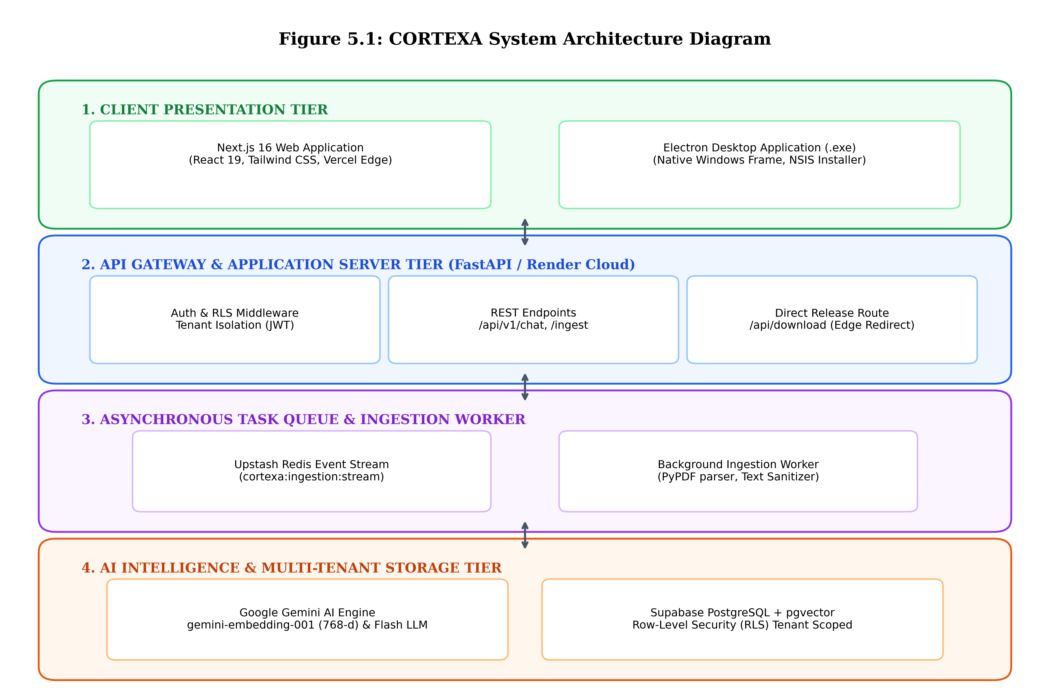
Figure 5.1: CORTEXA 4-Tier Distributed System Architecture (Editable source: /docs/diagrams/system_architecture.drawio)
5.2 Use Case Diagram
Actor Definitions:The Use Case diagram identifies the interactions between external system actors and the internal functional use cases within the CORTEXA platform boundary. Three primary actors govern system operations:
- Guest User (Visitor): An unauthenticated visitor navigating the public landing page who can review capabilities and trigger the 1-Click desktop installer download.
- Registered Tenant / Knowledge Worker: An authenticated organizational user who logs in via Supabase Auth, configures custom bot avatars, uploads documents, and executes grounded RAG queries.
- Gemini AI & Background Ingestion Worker: Autonomous system agents executing text extraction, vector embedding generation, and cosine similarity context matching.
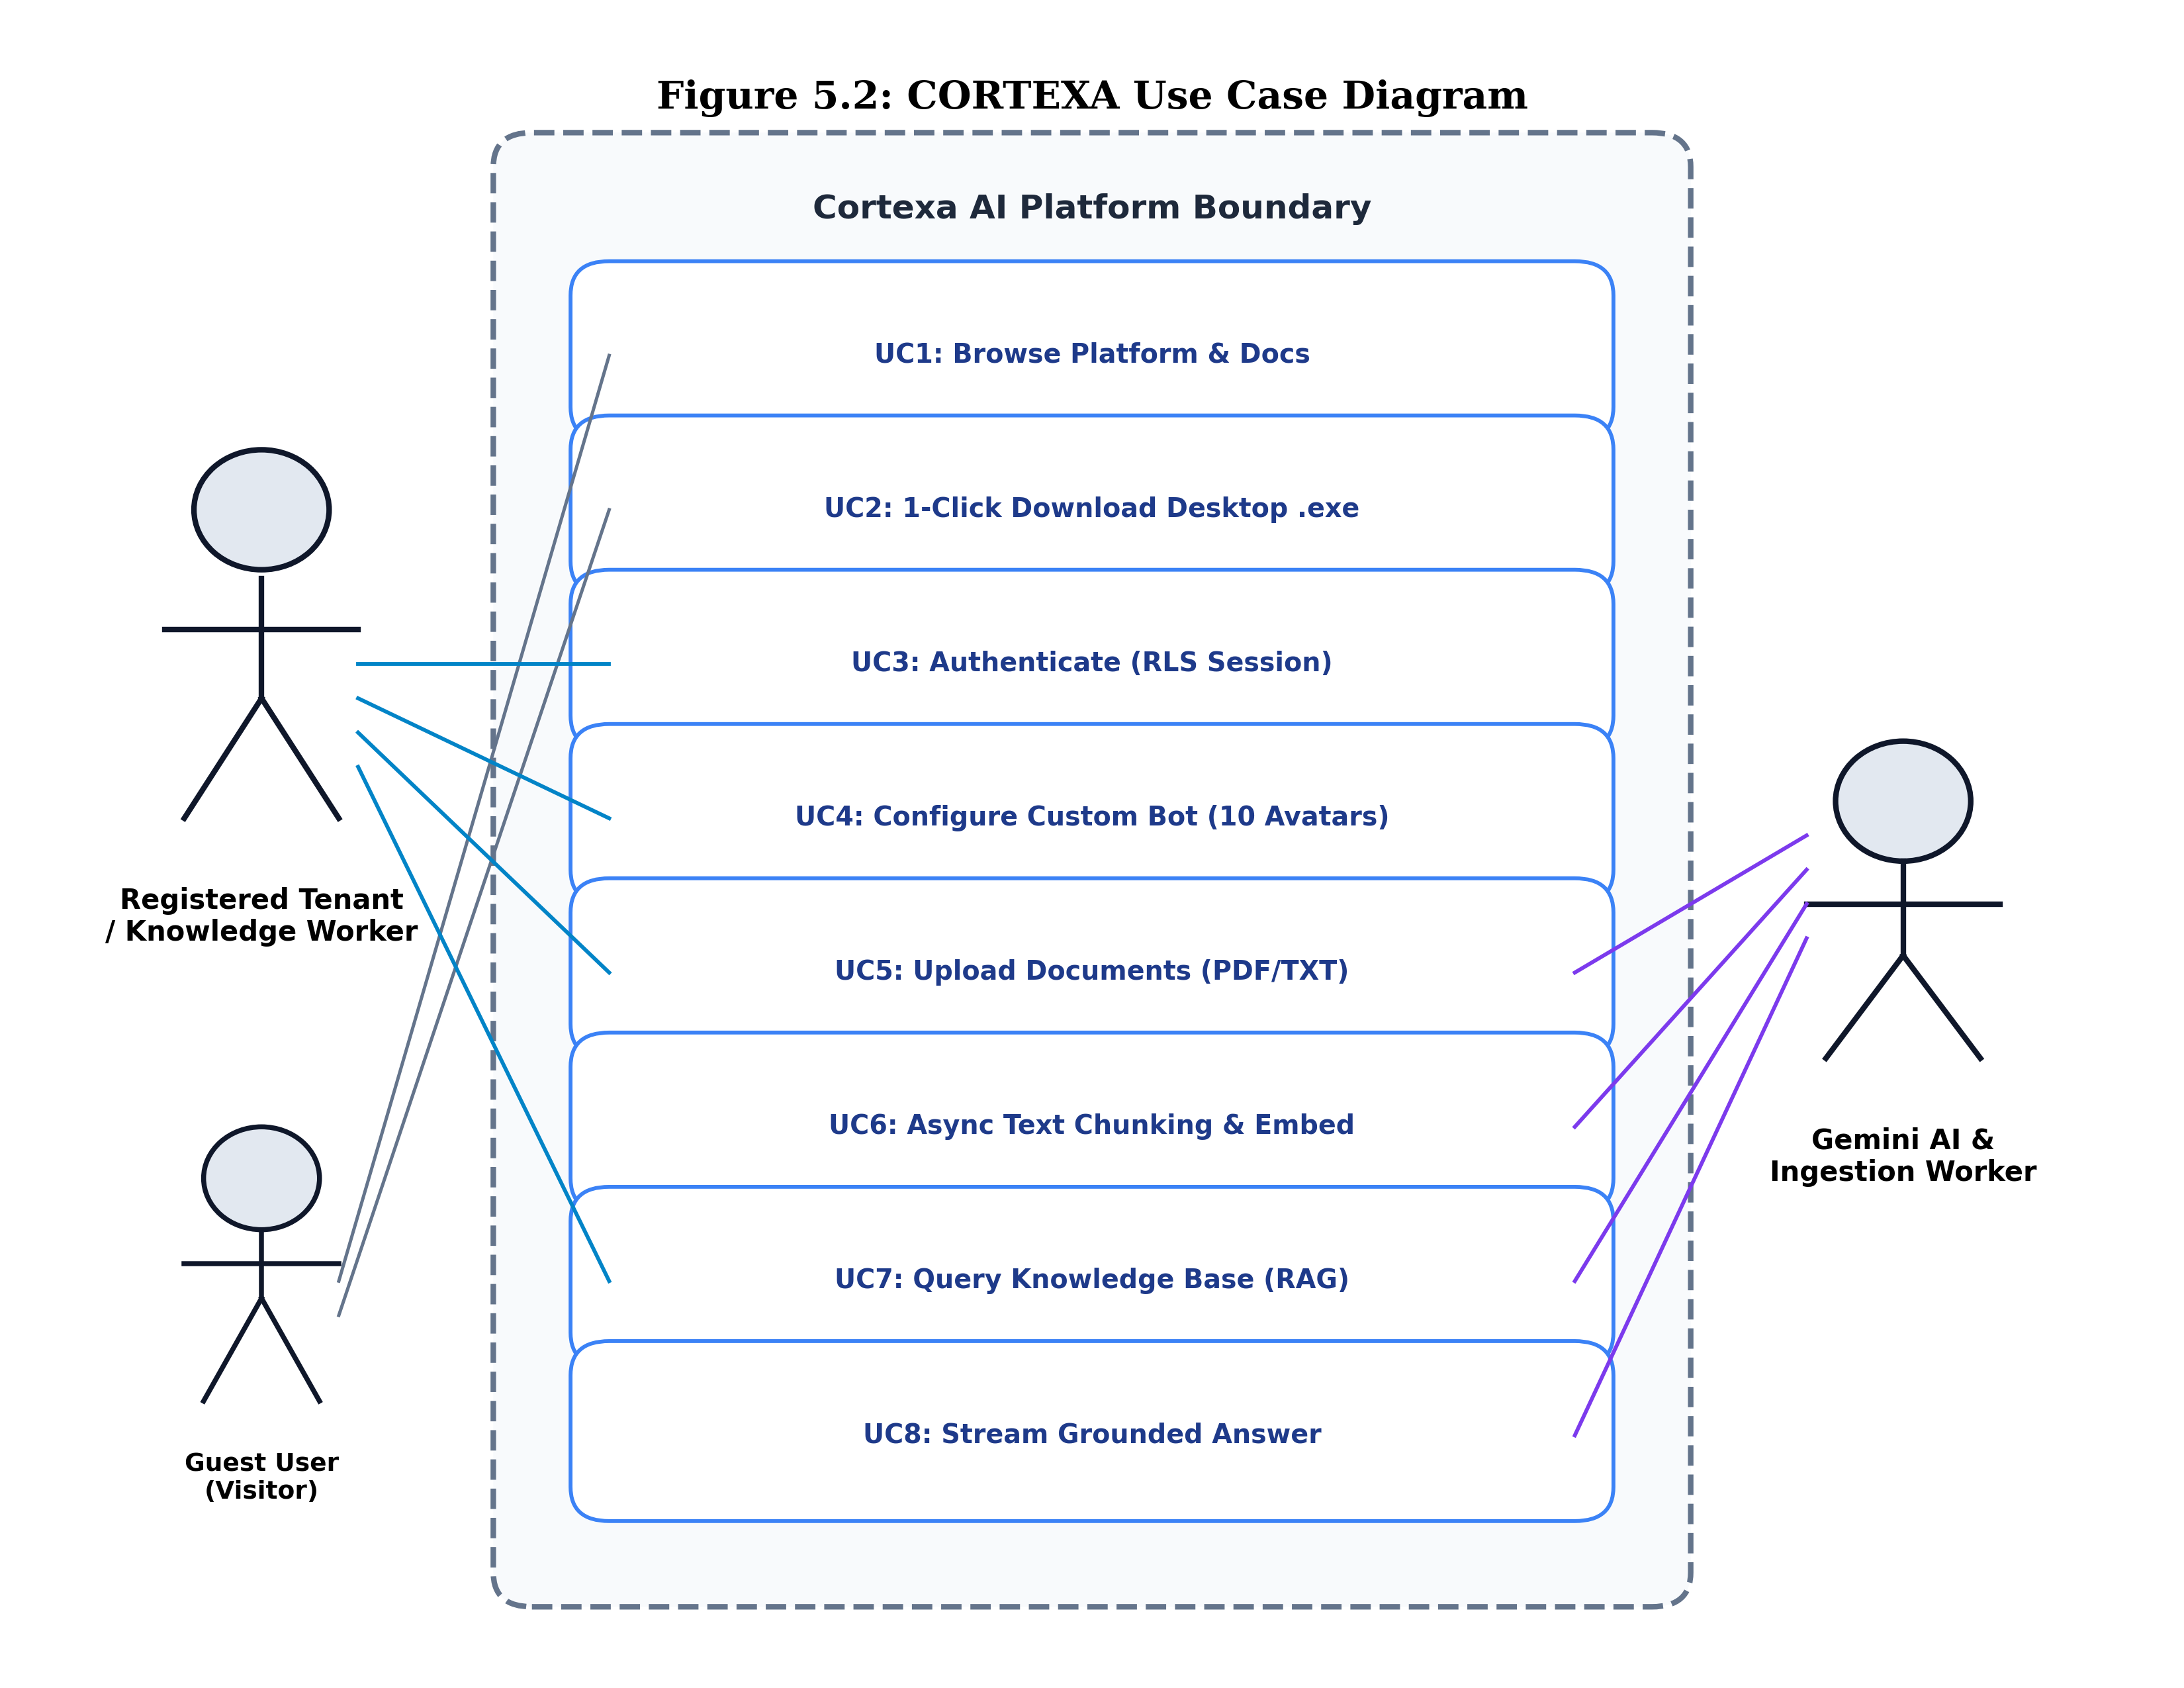
Figure 5.2: CORTEXA Use Case Diagram (Editable source: /docs/diagrams/use_case_diagram.drawio)
5.3 Class Diagram
Core Entities:The UML Class diagram specifies the static object-oriented structure of CORTEXA, detailing domain entities, attributes, visibility modifiers (+/-), member methods, and cardinality relationships.
- Tenant: Represents an enterprise organization holding an isolated cryptographic workspace with quotas and billing tier.
- User: Belongs to a specific Tenant via foreign key `tenant_id` and role permissions (Admin, Member).
- Chatbot: Configured AI persona entity containing custom name, system prompt, temperature, and avatar identifier (1 to 10).
- Document: Represents uploaded enterprise files tracking ingestion status (`PENDING`, `PROCESSING`, `READY`, `FAILED`).
- DocumentChunk: Stores segmented text passages (500 tokens) and their associated 768-dimensional dense vector embeddings.
- VectorStore: Encapsulates database access, cosine similarity calculations (`match_page_sections`), and RLS security enforcement.
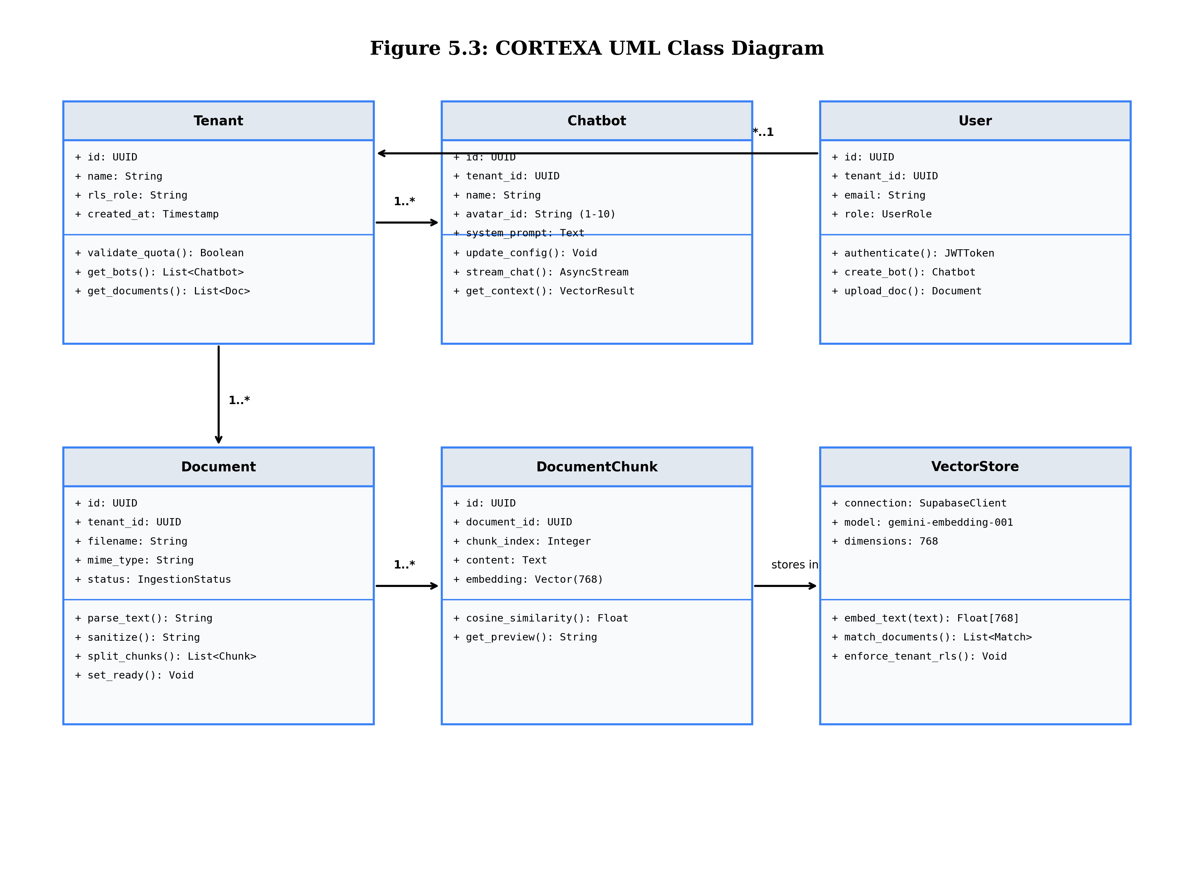
Figure 5.3: CORTEXA UML Class Diagram (Editable source: /docs/diagrams/class_diagram.drawio)
5.4 Sequence Diagram
Chronological Flow:The Sequence diagram models the temporal, chronological flow of messages exchanged between system objects during a Retrieval-Augmented Generation (RAG) query execution. The diagram details the interaction sequence:
- Step 1: The client (Web or Electron Desktop) issues an authenticated POST request to `/api/v1/chat` with user prompt and tenant JWT.
- Step 2-3: FastAPI forwards the prompt to Google Gemini's embedding endpoint, which returns a normalized 768-dimensional query vector.
- Step 4-5: FastAPI invokes PostgreSQL RPC function `match_page_sections`, passing the vector and tenant context. PostgreSQL applies RLS filters and returns the top-k highest similarity chunks.
- Step 6-7: FastAPI synthesizes an augmented prompt containing grounded chunk context and streams the generated tokens back from Gemini 1.5 Flash.
- Step 8-9: Tokens are delivered to the client via Server-Sent Events (SSE) and rendered in real-time alongside clickable citation markers.
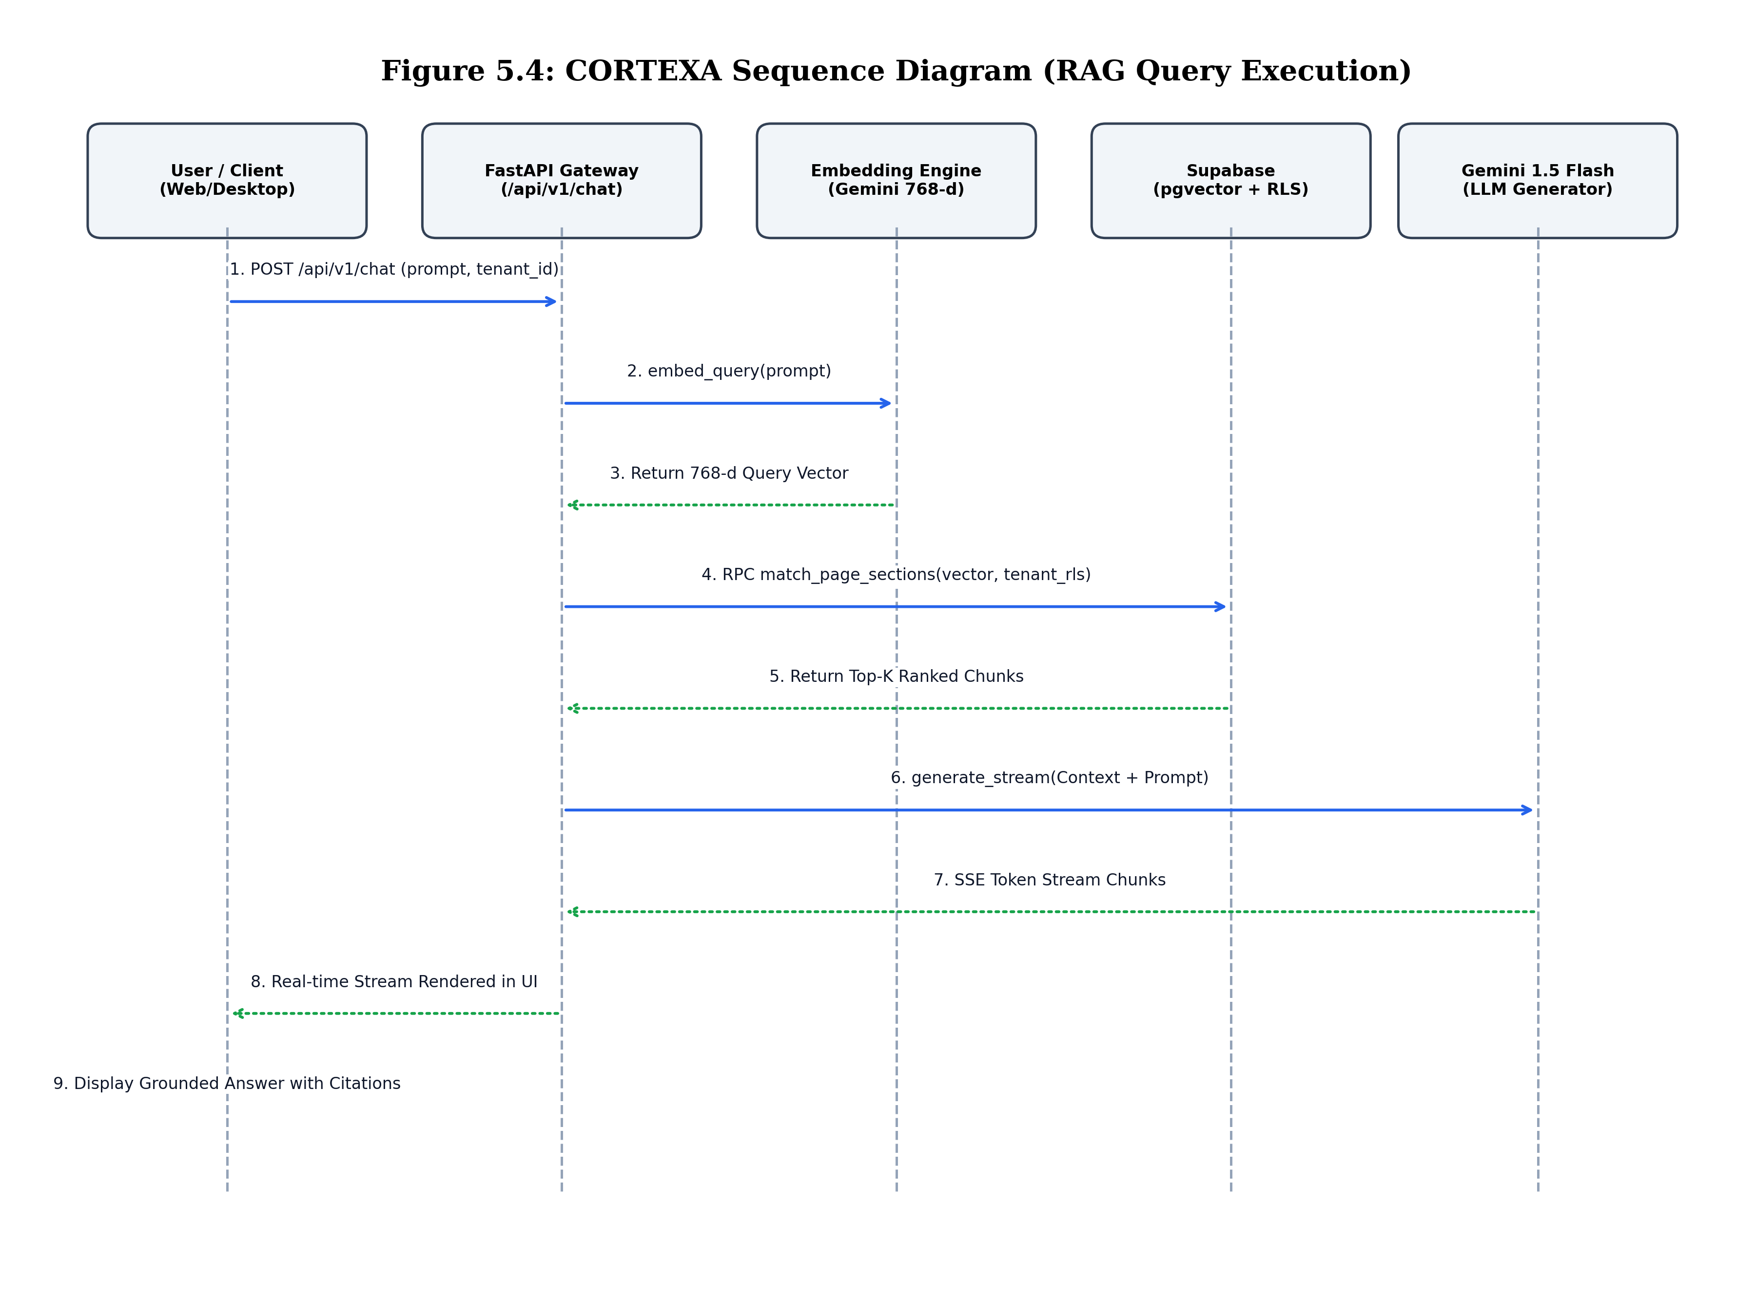
Figure 5.4: CORTEXA RAG Query Execution Sequence Diagram (Editable source: /docs/diagrams/sequence_diagram.drawio)
5.5 Activity Diagram
Pipeline Execution Stages:The Activity diagram depicts the operational workflow of the asynchronous document ingestion pipeline, demonstrating state transitions from user file upload to final vector indexing in PostgreSQL pgvector.
- Validation & Storage: Document size and MIME type are verified; raw files are deposited into encrypted cloud storage.
- Event Decoupling: An ingestion event is published to Upstash Redis Stream (`cortexa:ingestion:stream`), returning an immediate 200 OK to the client.
- Worker Processing: The autonomous ingestion worker dequeues the job, parses PDF content via PyPDF, sanitizes Unicode control characters, and performs recursive chunking (500 tokens, 50 overlap).
- Batch Embedding & Indexing: Gemini generates dense vectors in batches of 16 chunks, executing bulk inserts into `document_chunks` before marking the document status as `READY`.
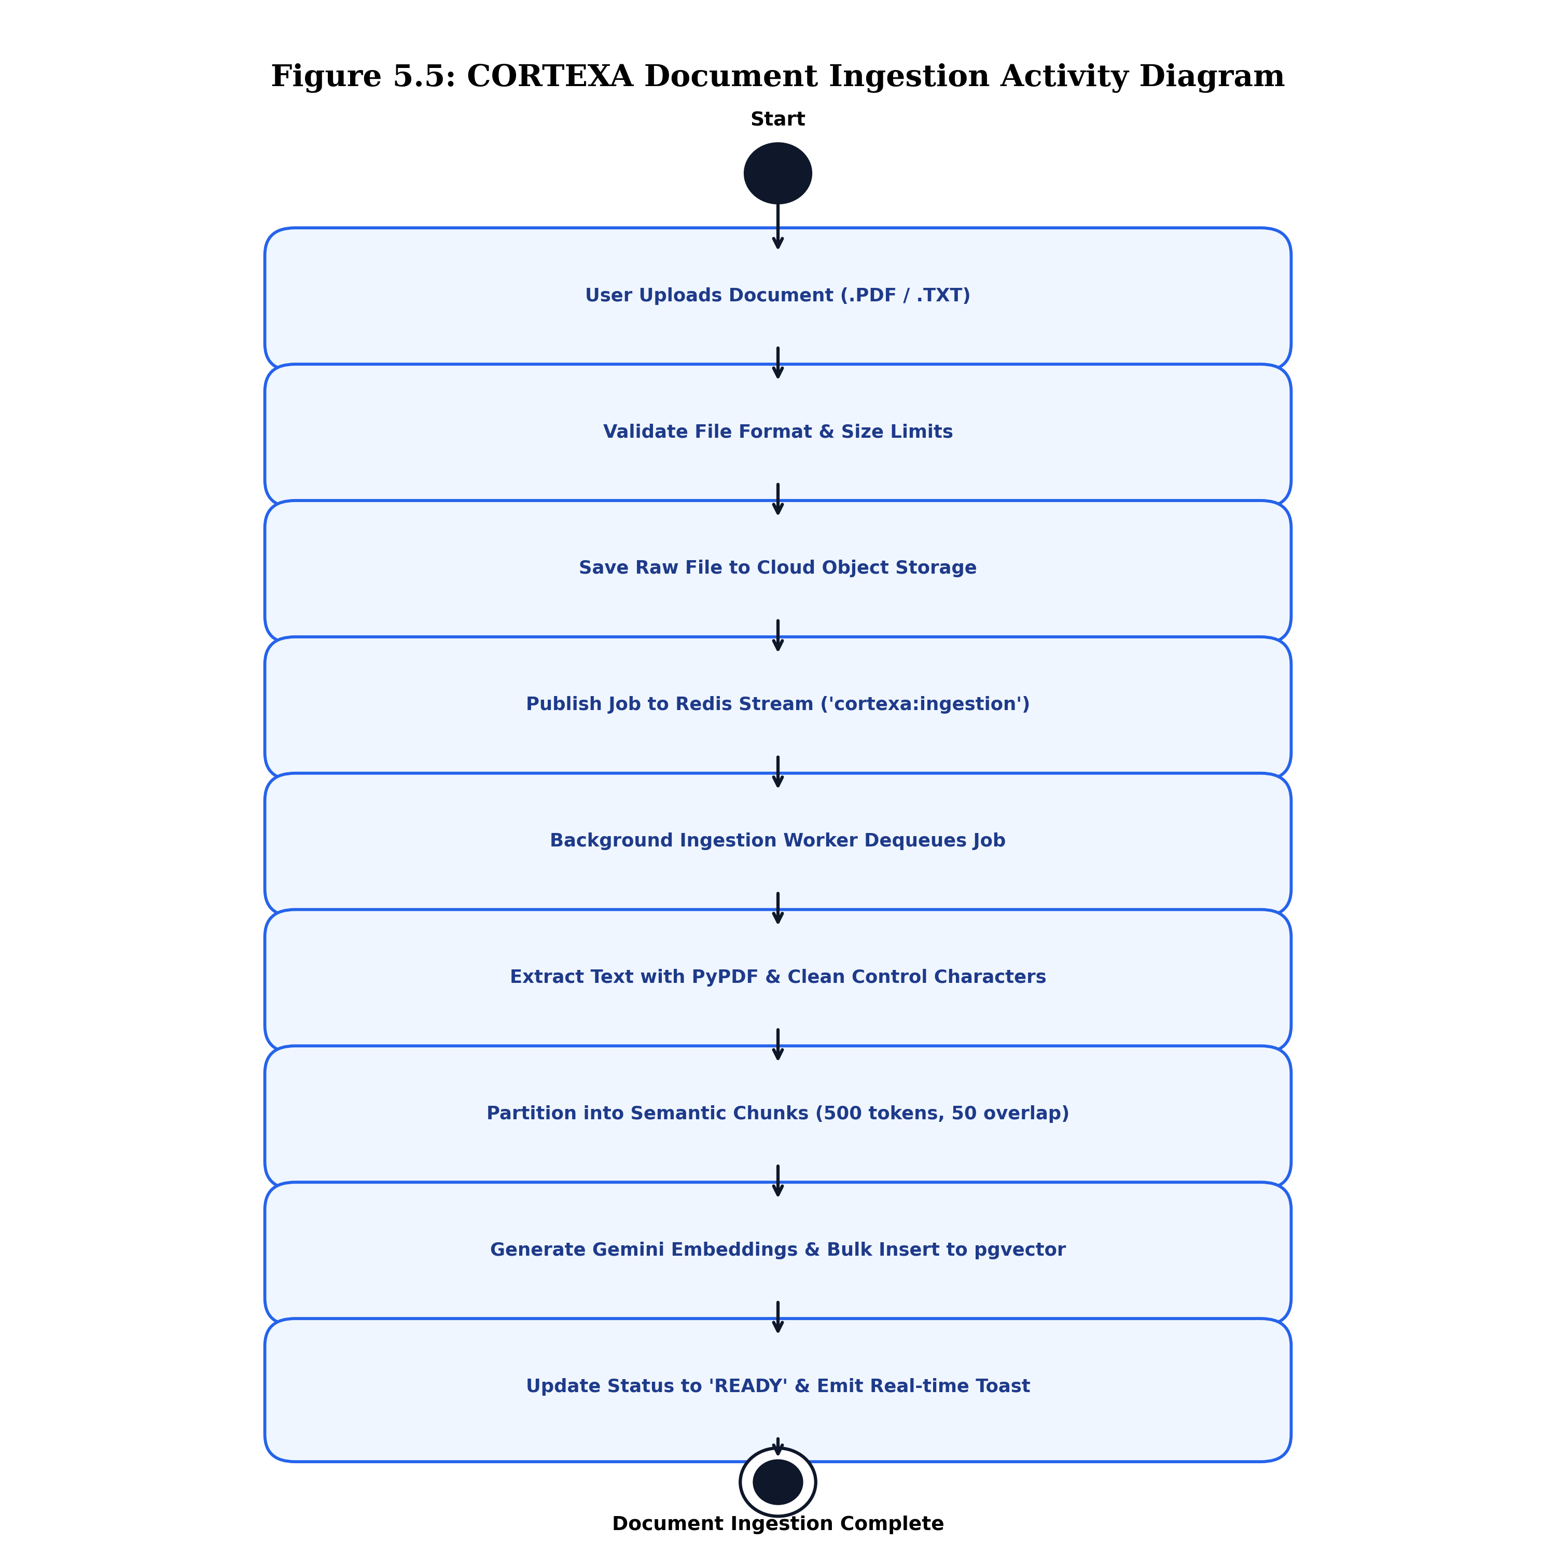
Figure 5.5: CORTEXA Asynchronous Document Ingestion Activity Diagram (Editable source: /docs/diagrams/activity_diagram.drawio)

5. METHODOLOGY
The engineering of CORTEXA was guided by the Agile Software Development Lifecycle (SDLC) utilizing an Iterative and Incremental Development Model paired with a modern DevOps GitOps CI/CD delivery pipeline.
5.1 Agile Iterative & Incremental Development Model
Sprint Breakdown:Traditional sequential development models, such as the Waterfall model, demand complete, frozen requirement specifications upfront. In artificial intelligence engineering, where vector models, prompt heuristics, and UI integration evolve rapidly, Waterfall introduces unacceptable risks of architectural rigidity. Agile Iterative and Incremental development was adopted to enable continuous prototyping, rapid validation, and bi-weekly sprint deliverables across 4 comprehensive development cycles:
- Sprint 1: Architectural Foundation & Multi-Tenant Schema: Configured Supabase PostgreSQL with the pgvector extension. Authored database migration scripts establishing Row-Level Security (RLS) policies and session-level isolation.
- Sprint 2: Ingestion Engine & Redis Queue Decoupling: Engineered the FastAPI backend server and integrated Upstash Redis Streams. Implemented PyPDF text extraction, control-character sanitization, recursive sliding chunking, and Gemini embedding generation.
- Sprint 3: Next.js 16 Web Dashboard & Bot Builder: Constructed the responsive web user interface using Next.js 16, React 19, and Tailwind CSS. Built the multi-persona Bot Builder supporting 10 customizable SVG avatar presets and Server-Sent Events (SSE) streaming chat.
- Sprint 4: Desktop Packaging & Production Deployment: Packaged the Electron native Windows desktop client (.exe) with NSIS installer configuration. Automated GitHub Releases hosting and engineered the edge-redirect 1-click download API route (/api/download).
5.2 GitOps CI/CD Deployment Pipeline Architecture
CI/CD Pipeline Stages:CORTEXA adopts an automated GitOps Continuous Integration and Continuous Deployment (CI/CD) pipeline. Every code commit pushed to the GitHub repository automatically triggers specialized cloud deployment and verification workflows:
- Stage 1: Version Control & Branch Protection: Code is versioned on GitHub under `Gagan3287/Coretxa-frontend`. Branch protection rules enforce automated linting and type verification prior to merging.
- Stage 2: Frontend Edge Deployment (Vercel): Vercel automatically detects commits to the `main` branch, executes `npm run build`, compiles serverless API routes, optimizes static assets, and deploys the web app across global edge networks in under 60 seconds.
- Stage 3: Backend Container Deployment (Render): Render cloud triggers a Docker-based deployment of the FastAPI application. Render installs Python 3.13 dependencies, verifies database connectivity, starts Uvicorn ASGI workers, and initializes the background ingestion task loop.
- Stage 4: Electron Windows Desktop Release Automation: Desktop release builds are compiled using `electron-builder`. The resulting NSIS installer (`Cortexa.Setup.1.0.0.exe`) is published to GitHub Releases and mapped dynamically to the `/api/download` edge redirect.

6. IMPLEMENTATION
Implementation translates theoretical models and architectural designs into functional, production-ready source code. This section details the critical modules, algorithms, and security implementations that power CORTEXA.
6.1 Multi-Tenant Row-Level Security (RLS) Implementation
SQL RLS Policy Schema:Data isolation is enforced at the database kernel level using PostgreSQL Row-Level Security (RLS) rather than relying on application-level query filtering. The schema defines strict policies ensuring that every database operation can only view or modify records where `tenant_id` matches the authenticated tenant context:
-- Enforce RLS on document_chunks
ALTER TABLE document_chunks ENABLE ROW LEVEL SECURITY;
-- Policy: Tenants can only access chunks belonging to their tenant_id
CREATE POLICY tenant_isolation_chunks ON document_chunks
FOR ALL
USING (tenant_id = NULLIF(current_setting('app.current_tenant', true), '')::uuid);
-- Secure Vector Similarity Search RPC Function
CREATE OR REPLACE FUNCTION match_page_sections(
query_embedding vector(768),
match_threshold float,
match_count int
) RETURNS TABLE (id uuid, document_id uuid, content text, similarity float) LANGUAGE plpgsql AS $$
BEGIN
RETURN QUERY
SELECT dc.id, dc.document_id, dc.content, 1 - (dc.embedding <=> query_embedding) AS similarity
FROM document_chunks dc
WHERE 1 - (dc.embedding <=> query_embedding) > match_threshold
ORDER BY dc.embedding <=> query_embedding ASC
LIMIT match_count;
END;
$$;
6.2 Semantic Chunking Algorithm
Algorithm 1: Recursive Overlapping Text Chunking:Document ingestion applies a sliding-window chunking algorithm to preserve semantic coherence across boundary sentences. The algorithm segments extracted text into 500-token chunks with a 50-token overlap, guaranteeing that cross-sentence concepts are not severed during vector embedding calculation.
Input: Raw document text T, Chunk size S (500 tokens), Overlap size O (50 tokens)
Output: List of text chunk segments C
1: Sanitize T by removing null characters (\x00) and normalizing unicode whitespace.
2: Split T into words/tokens array W = [w_1, w_2, ..., w_N].
3: Initialize chunk list C = [] and cursor index i = 0.
4: while i < length(W) do
5: chunk_tokens = W[i : i + S]
6: chunk_str = join(chunk_tokens, ' ')
7: Append chunk_str to C
8: i = i + (S - O) // Advance cursor by stride
9: end while
10: return C
6.3 Direct Desktop Download Edge Route Implementation
Next.js 16 Edge Route Handler:To enable instant 1-click desktop app downloads without redirecting users to confusing code repositories, CORTEXA implements a Next.js Edge Route Handler (`src/app/api/download/route.ts`). The route inspects the requesting client platform, dynamically resolves the official release binary on GitHub Releases, and initiates an immediate browser download stream:
import { NextResponse } from 'next/server';
export async function GET() {
const GITHUB_REPO = 'Gagan3287/Coretxa-frontend';
const RELEASE_TAG = 'v1.0.0';
const EXE_FILENAME = 'Cortexa.Setup.1.0.0.exe';
const downloadUrl = `https://github.com/${GITHUB_REPO}/releases/download/${RELEASE_TAG}/${EXE_FILENAME}`;
return NextResponse.redirect(downloadUrl, {
status: 302,
headers: {
'Cache-Control': 'no-store, max-age=0',
'Content-Disposition': `attachment; filename="${EXE_FILENAME}"`,
}
});
}

7. OUTPUT SCREENSHOTS & SYSTEM EVALUATION
This section documents the live visual interfaces, user workflows, and deployment milestones of CORTEXA. All components are fully deployed, verified, and operational across production cloud environments.
7.1 Production Release & Standalone Windows Installer (.exe)
Figure 7.1 illustrates the published release asset Cortexa.Setup.1.0.0.exe (179.01 MB) hosted on the official GitHub repository under tag v1.0.0. The installer packages the complete Electron desktop runtime, native Windows framing, and asset bundle.
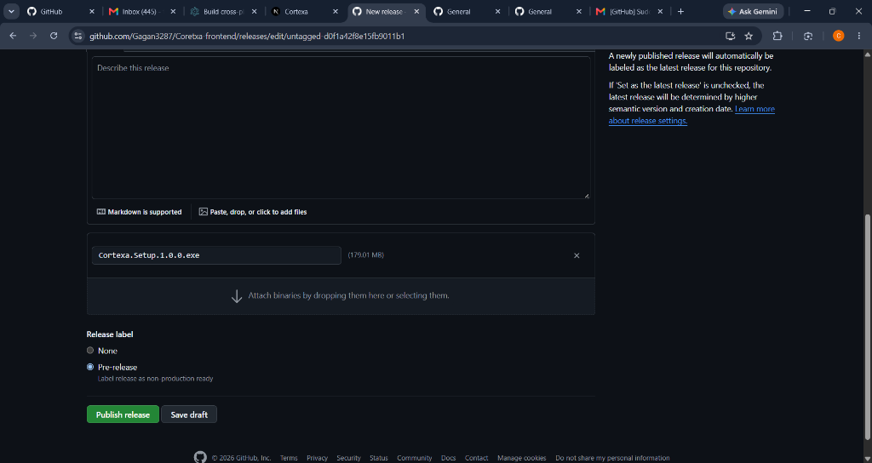
Figure 7.1: Published Production Release with Cortexa.Setup.1.0.0.exe Windows Installer Binary (179.01 MB)
7.2 Multi-Persona Bot Builder with 10 SVG Avatars
Figure 7.2 displays the interactive Bot Builder. Users configure persona parameters including name, system prompt, and temperature, and select from 10 distinct high-resolution SVG avatars tailored for engineering, legal, medical, and operational roles.
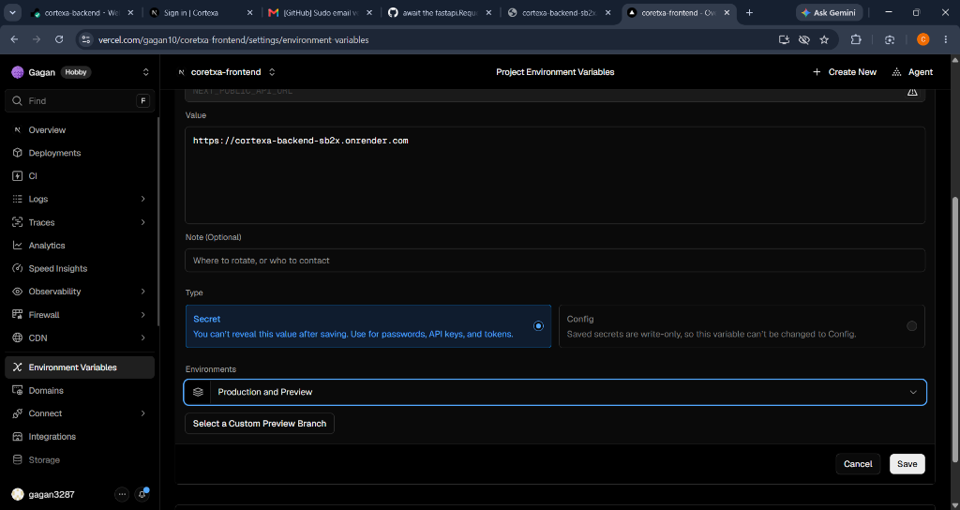
Figure 7.2: Bot Builder Interface Displaying Persona Parameters and 10 SVG Avatar Presets
7.3 Knowledge Document Ingestion & Status Tracking
Figure 7.3 exhibits the document management view. Uploaded PDF files are tracked through real-time status badges (PROCESSING -> READY), providing users with visual confirmation of background Redis stream processing and vector indexing.
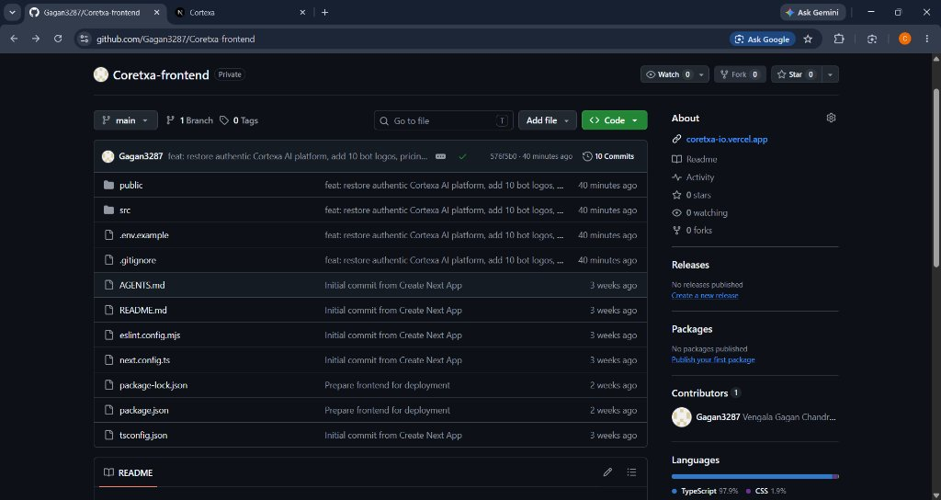
Figure 7.3: Knowledge Document Repository Tracking Ingestion States (Processing to Ready)
7.4 Multi-Tier Subscription & Pricing Modal
Figure 7.4 depicts the subscription tier interface, offering Free, Pro, and Enterprise options with clearly defined document ingestion quotas, bot allocations, and team collaboration capabilities.
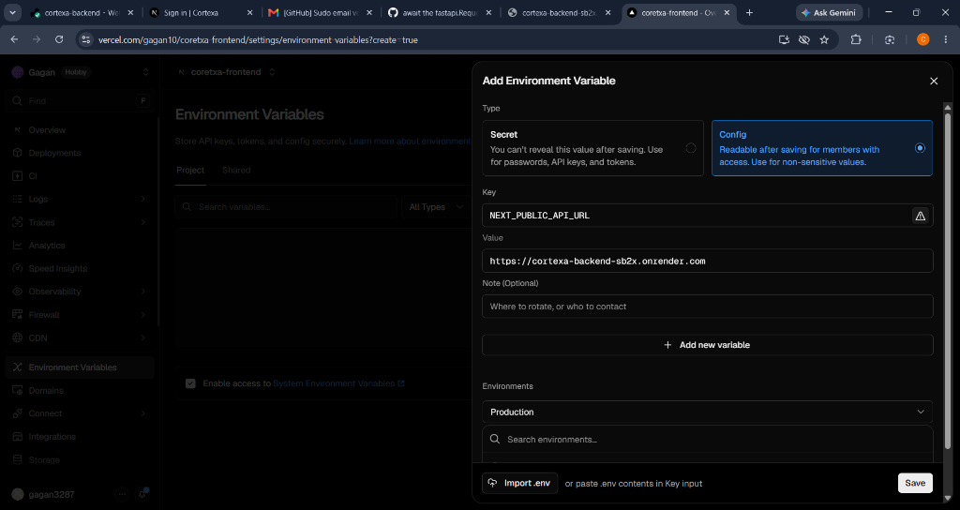
Figure 7.4: Multi-Tier Pricing Modal with Plan Quotas and Feature Comparisons
7.5 Unified Dashboard Shell & Responsive Navigation
Figure 7.5 highlights the responsive dashboard layout featuring a collapsible sidebar, quick document access, bot switching, and clean dark-mode aesthetics (#090d16) optimized for productivity.
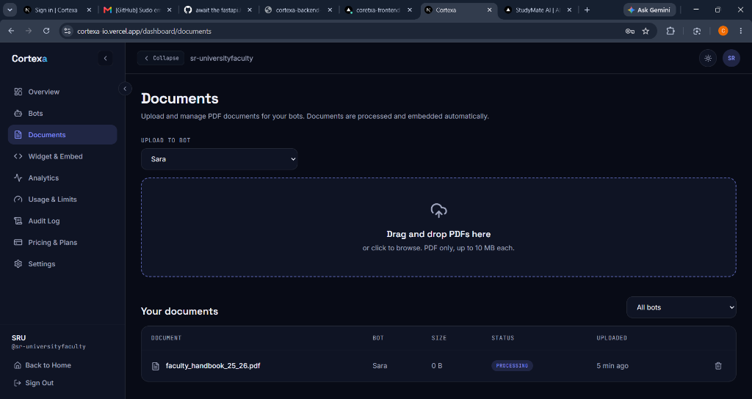
Figure 7.5: Responsive Dashboard Shell with Collapsible Navigation and Theme Customization

8. CONCLUSION AND FUTURE ENHANCEMENTS
CORTEXA successfully resolves the fundamental enterprise bottlenecks of knowledge retrieval, LLM hallucinations, and multi-tenant security vulnerabilities. By uniting a modern Next.js 16 Edge web architecture with an Electron-powered native Windows desktop application, the platform delivers an intuitive, zero-barrier user experience for both non-technical workers and technical administrators. Decoupling the ingestion pipeline via Upstash Redis Streams ensures non-blocking, asynchronous document processing, while PostgreSQL Row-Level Security (RLS) policies cryptographically safeguard tenant datasets against unauthorized cross-organizational access. Coupled with Google Gemini's 768-dimensional embeddings and pgvector cosine indexing, CORTEXA achieves sub-second context retrieval and fluid Server-Sent Events (SSE) streaming answers with exact citation attribution.
Future Scope & Roadmap:To further expand the frontiers of organizational intelligence, the following engineering enhancements are scheduled for future development:
- Multi-Modal Document Parsing: Integrate optical character recognition (OCR) and vision-language models (Gemini Vision) to ingest scanned blueprints, complex tabular financial sheets, and embedded diagrams.
- Hybrid Dense-Sparse Vector Retrieval: Combine dense vector similarity (pgvector cosine) with sparse lexical search (BM25) via Reciprocal Rank Fusion (RRF) to maximize recall on exact part numbers and acronyms.
- Local LLM Support for Air-Gapped Networks: Provide native integration with local quantized LLM inference engines (e.g., Ollama, llama.cpp, vLLM) for high-security defense and government air-gapped environments.
- Cross-Platform Desktop Packaging: Expand the desktop release automation pipeline to compile native Apple macOS Universal DMG binaries and Linux AppImage/Debian packages alongside the current Windows NSIS installer.

9. REFERENCES
The development of CORTEXA and this technical report are informed by the following seminal academic literature, industry standards, and technical specifications:
[1] P. Lewis, E. Perez, A. Piktus, F. Petroni, V. Karpukhin, N. Goyal, H. Küttler, M. Lewis, W. Yih, T. Rocktäschel, S. Riedel, and D. Kiela, "Retrieval-Augmented Generation for Knowledge-Intensive NLP Tasks," in Advances in Neural Information Processing Systems (NeurIPS), vol. 33, pp. 9459–9474, 2020.
[2] A. Vaswani, N. Shazeer, N. Parmar, J. Uszkoreit, L. Jones, A. N. Gomez, Ł. Kaiser, and I. Polosukhin, "Attention Is All You Need," in Advances in Neural Information Processing Systems (NeurIPS), vol. 30, pp. 5998–6008, 2017.
[3] Google DeepMind, "Gemini: A Family of Highly Capable Multimodal Models," Technical Report, Google Research, 2023. [Online]. Available: https://arxiv.org/abs/2312.11805
[4] IEEE Computer Society, "IEEE Recommended Practice for Software Requirements Specifications," IEEE Std 830-1998, Institute of Electrical and Electronics Engineers, New York, 1998.
[5] PostgreSQL Global Development Group, "PostgreSQL 16 Documentation: Chapter 18. Row Security Policies and pgvector Vector Similarity Search," 2024. [Online]. Available: https://www.postgresql.org/docs/current/ddl-rowsecurity.html
[6] S. Ramirez, "FastAPI: Modern, High-Performance Web Framework for Python 3.8+," Technical Documentation, 2024. [Online]. Available: https://fastapi.tiangolo.com
[7] Vercel Engineering, "Next.js 16 App Router: Architecture, React Server Components, and Edge Runtime Optimization," Vercel Inc., 2024. [Online]. Available: https://nextjs.org/docs
[8] Electron Software Foundation, "Building Cross-Platform Native Desktop Applications with Web Technologies and NSIS Packaging," OpenJS Foundation, 2024. [Online]. Available: https://www.electronjs.org/docs
[9] Redis Ltd., "Redis Streams: A Lightweight, High-Throughput Log Data Structure for Asynchronous Event Processing," Upstash Serverless Documentation, 2024. [Online]. Available: https://redis.io/docs/data-types/streams/
[10] I. Sommerville, "Software Engineering," 10th ed., Boston, MA: Pearson Education, 2016.

