CORTEXA: MULTI-TENANT AI-POWERED DOCUMENT INTELLIGENCE AND KNOWLEDGE RETRIEVAL PLATFORM
A Course Project Report
Submitted in the partial fulfillment of the completion of the course
SOFTWARE ENGINEERING AND SYSTEM DESIGN
(24CS301PC311)
In III Year, I Semester B. Tech-CSE
Submitted by
Vengala Gagan Chandra Tej
(2403A52222)
Under the supervision of the faculty
Dr. Faiza Iram
Assistant / Associate Professor
School of Computer Science & Artificial Intelligence
2026-2027

Department of Computer Science & Artificial Intelligence
SR University
Warangal, Telangana, India
Live Application URL: https://cortexa-io.vercel.app
Direct Windows Installer (.exe): https://cortexa-io.vercel.app/api/download

INDEX
1. Abstract
2. Introduction
2.1 Problem Statement
2.2 Objectives
2.3 Scope
3. Software Requirements Specification (SRS)
3.1 Functional Requirements
3.2 Non-Functional Requirements
3.3 Hardware and Software Requirements
4. System Analysis
4.1 Existing System
4.2 Proposed System
5. System Design
5.1 System Architecture
5.2 Use Case Diagram
5.3 Class Diagram
5.4 Sequence Diagram
5.5 Activity Diagram
6. Methodology
7. Implementation
8. Output Screenshots
9. Conclusion
10. References

1. Abstract
Organizations hold large volumes of unstructured knowledge in PDFs, manuals and policies, but general-purpose Large Language Models (LLMs) cannot be trusted with it: they hallucinate, cannot see private content, are limited by context-window size, and in shared (multi-tenant) systems risk leaking one organization's data to another. Self-hosted alternatives, in turn, need command-line or container expertise to install.
This project presents CORTEXA, a multi-tenant AI document intelligence and knowledge retrieval platform built on an end-to-end Retrieval-Augmented Generation (RAG) pipeline. The frontend uses Next.js 16, React 19 and Tailwind CSS, together with an Electron-based native Windows application packaged as an NSIS installer. The backend is a FastAPI service with an asynchronous ingestion worker driven by Upstash Redis Streams, using Google Gemini 1.5 Flash for answers and gemini-embedding-001 (768 dimensions) for embeddings. Tenant privacy is enforced inside the database by Supabase PostgreSQL Row-Level Security (RLS) with the pgvector extension.
CORTEXA also provides a one-click desktop download through the edge route /api/download, which redirects to GitHub Releases without exposing the code repository. The system is deployed on Vercel and Render free tiers and delivers tenant-scoped semantic retrieval with real-time Server-Sent Events (SSE) token streaming.
Keywords: Retrieval-Augmented Generation, Multi-Tenancy, Row-Level Security, Vector Search, pgvector, FastAPI, Next.js, Redis Streams, Electron, CI/CD.

2. Introduction
Universities, companies and research groups keep institutional knowledge in PDFs, handbooks and technical documentation. Finding a precise answer in them is slow, and public chatbots do not know the organization's private content. CORTEXA is a software-as-a-service platform where an organization (a "tenant") registers, uploads its PDFs and creates branded AI assistants ("bots") that answer strictly from those documents.
The project was developed for Software Engineering and System Design (24CS301PC311) and follows the full life cycle: an SRS based on IEEE Std 830-1998, system analysis, UML design, an Agile iterative and incremental process, a CI/CD pipeline and acceptance testing. The system is live at https://cortexa-io.vercel.app, with its API on Render and its vector database on Supabase.

2.1 Problem Statement
- Data silos and poor search: keyword search (BM25) misses passages when the query wording differs from the document.
- Hallucination: public LLMs answer from outdated training data and cannot access private documents.
- Multi-tenancy leakage: one missing WHERE tenant_id = ... in application code can expose another organization's data.
- Gateway timeouts: parsing, chunking and embedding a large PDF inside an HTTP request is slow and times out.
- Installation friction: self-hosted tools need command-line or container skills; commercial suites are expensive.

2.2 Objectives
- Build a multi-tenant RAG platform where each organization's bots use only its own PDFs.
- Enforce tenant isolation at database level with PostgreSQL RLS, running as the non-superuser role cortexa_app.
- Process uploads asynchronously with Redis Streams, retries, exponential backoff and a dead-letter queue (DLQ).
- Retrieve with 768-d embeddings and pgvector cosine search, and stream grounded answers over SSE.
- Deliver a responsive Next.js web app and a native Windows (Electron) app with one-click download.
- Use Agile development with automated CI/CD (GitHub → Vercel and Render) on free-tier cloud services.

2.3 Scope
In scope: tenant registration and JWT login with Platform Admin and Tenant Admin roles; bot management with 10 SVG avatars, custom instructions, per-bot Gemini key and widget key; PDF upload (≤ 10 MB, ≤ 500 pages) with extraction, chunking, embedding and status tracking; tenant-scoped vector search with SSE answers; live dashboard; three pricing tiers (Starter $0, Pro $49/mo, Enterprise $199/mo) with a simulated Razorpay modal; and the Electron client (Cortexa.Setup.1.0.0.exe) distributed via /api/download.
Out of scope (future work): OCR for scanned files, local LLM inference, macOS/Linux builds, real payments and non-PDF formats.

3. Software Requirements Specification (SRS)
This section summarizes SRS-CORTEXA-2026-V1.0, written to IEEE Std 830-1998 and ISO/IEC/IEEE 29148. Product perspective: CORTEXA is a distributed cloud platform of a Next.js web app, an Electron wrapper, a FastAPI backend, a Redis Streams worker, a Supabase PostgreSQL vector database and the Gemini APIs. User classes: Platform Administrator (platform-wide oversight), Tenant Administrator (manages bots, documents and widgets) and End-User/Visitor (public pages and desktop download).

3.1 Functional Requirements
Table 3.1: Functional requirements
ID | Requirement
Module 1: User and Tenant Management
FR-01, 02 | Tenants register with fullName, orgName, orgSlug, email, phone and password; orgSlug is globally unique.
FR-03, 04 | POST /auth/login (tenant_slug, email, password) returns a short-lived JWT and a refresh token; POST /auth/refresh renews it.
FR-05, 06 | Unauthenticated /dashboard/* requests redirect to /login?next=<path>; Sign Out invalidates the local session.
Module 2: Multi-Tenant AI Bot Engine
FR-07 | Tenant admins create bots up to the limit of their subscription tier.
FR-08, 09 | 10 procedural SVG avatars selectable at creation; GET /api/v1/bots lists bots with status (active, processing, failed), document counts and timestamps.
FR-10, 11 | A cryptographically unique widget_key per bot for embedding; per-bot custom Gemini API key and prompt instructions.
Module 3: Document Ingestion and Chunking
FR-12, 13 | Accept PDFs up to 10 MB and 500 pages; extract text with pypdf, require ≥ 90% printable characters and strip control sequences.
FR-14, 15 | Split into semantic chunks of at most 400 tokens; upload records a DocumentVersion (processing) and pushes a job to the ingestion Redis Stream.
FR-16, 17 | Success: insert chunks and set status to ready. Failure: retry 3 times (1 s, 4 s back-off), then mark failed and forward to ingestion_dlq. Deleting a document atomically removes its versions and chunks.
Module 4: Vector Embedding and Similarity Search
FR-18, 19 | 768-d embeddings from gemini-embedding-001, stored with pgvector under an HNSW or IVFFlat index.
FR-20 | Cosine distance (<=>) retrieval scoped strictly to the calling tenant and the target bot_id.
Module 5: Subscription and Billing Simulation
FR-21, 22 | Tiers Starter ($0), Pro ($49/mo), Enterprise ($199/mo); a Razorpay-style modal simulates card/UPI entry and credential grant.
FR-23 | Exceeding the free bot limit redirects to /pricing?flow=create-bot.
Module 6: Desktop Application and Distribution
FR-24, 25 | Electron app for Windows 10/11 that streams the latest UI from https://cortexa-io.vercel.app (zero-downtime updates).
FR-26 | /api/download returns HTTP 302 with Content-Disposition: attachment to GitHub Releases for Cortexa.Setup.1.0.0.exe.

3.2 Non-Functional Requirements
Table 3.2: Non-functional requirements
ID | Category | Requirement
NFR-01 | Performance | 95% of non-ingestion API calls (/auth/me, /bots, /documents) return within 200 ms.
NFR-02 | Performance | A 20-page PDF is parsed, embedded and marked ready within 15 s under normal load.
NFR-03 | Performance | Largest Contentful Paint ≤ 1.8 s across edge CDN nodes.
NFR-04 | Security | Every transaction runs SET LOCAL ROLE cortexa_app, so RLS cannot be bypassed.
NFR-05, 06 | Security | bcrypt passwords (work factor ≥ 12); JWTs signed with HS256 and a 256-bit secret.
NFR-07 | Security | Reject CORS preflight requests from origins other than the whitelisted production URL.
NFR-08 | Reliability | Ingestion worker runs in a watchdog loop and restarts after back-off without stopping FastAPI.
NFR-09 | Availability | Target 99.9% uptime for the web platform and API.
NFR-10 | Usability | Responsive layout, dark theme (#090d16) and a single-action sidebar toggle.

3.3 Hardware and Software Requirements
Table 3.3: Technology stack and operating environment
Layer / Item | Technology | Version / Detail
Frontend | Next.js (App Router), React, TypeScript, Tailwind CSS, GSAP | Next.js 16.4.2, React 19, Tailwind v4
Desktop client | Electron, electron-builder (NSIS) | Electron 45.2.3, context isolation
Backend | FastAPI, Uvicorn, Python | FastAPI 0.115, Python 3.11
ORM / migrations | SQLAlchemy 2.0 (async, asyncpg), Alembic | 10 version-controlled migrations
Database | Supabase PostgreSQL + pgvector | PostgreSQL 15, 768-d vectors, RLS
Queue | Upstash Redis Streams | Redis 7, TLS (rediss://)
AI models | Google Gemini API | gemini-embedding-001, Gemini 1.5 Flash
Hosting | Vercel, Render, Supabase, GitHub Releases | Edge CDN, web service, binary CDN
Developer machine | Windows 10/11 64-bit, Node.js, Python 3.11, Git | 8 GB RAM, dual-core CPU, 10 GB disk
End-user desktop | Windows 10 (build 19041+) or 11, 64-bit | About 180 MB for the installer
Web browsers | Chrome 110+, Firefox 115+, Edge 110+, Safari 16+ | Server OS: Linux (Ubuntu 22.04 / Debian 12 slim)

Table 3.4: Acceptance test cases
Test | Requirement | Method | Pass criteria
TC-01 | FR-03, FR-05 | Integration test | Unauthenticated GET /dashboard redirects to /login; valid credentials return 200 and an access token.
TC-02 | FR-08, FR-09 | Visual and API | A created bot shows its selected SVG logo on the dashboard and bot cards.
TC-03 | FR-12, FR-16 | End-to-end test | A 10-page PDF enters processing, triggers the worker, is embedded and becomes ready.
TC-04 | FR-26 | Network inspection | "Download App (.exe)" opens the browser save dialog for the installer without a page reload.
TC-05 | NFR-04 | Database audit | Tenant A running arbitrary SQL cannot read or update Tenant B documents; RLS rejects it.
Acronyms: API – Application Programming Interface; CORS – Cross-Origin Resource Sharing; DLQ – Dead-Letter Queue; JWT – JSON Web Token; LLM – Large Language Model; NSIS – Nullsoft Scriptable Install System; ORM – Object-Relational Mapping; RAG – Retrieval-Augmented Generation; RLS – Row-Level Security; SSE – Server-Sent Events.

4. System Analysis

4.1 Existing System
Organizations today use one of four approaches, each with drawbacks. Keyword/BM25 search matches literal words only and returns whole documents. Public LLM chatbots answer from training data, cannot see private files, may hallucinate, raise privacy concerns and are limited by the context window. Proprietary knowledge suites need costly subscriptions and rarely offer database-level tenant isolation. Self-hosted open-source RAG stacks require command-line or container expertise.

4.2 Proposed System
CORTEXA is a hosted multi-tenant RAG platform: a tenant registers, creates a bot, uploads PDFs and immediately gets an assistant that answers only from them. Uploads are processed in the background, retrieval is semantic, isolation is enforced by PostgreSQL itself, and users can work in the browser or install the Windows app in one click.
Table 4.1: Comparison of existing approaches and CORTEXA
Parameter | Keyword / BM25 | Public LLM chatbot | CORTEXA (proposed)
Search method | Exact word match | Model's parametric memory | Semantic vector search (768-d, cosine)
Private documents | Yes, but no answers | Not available / privacy risk | Yes, per-tenant only
Hallucination control | Not applicable | High risk | Grounded in retrieved chunks with citations
Tenant isolation | Application-level | Not applicable | PostgreSQL Row-Level Security
Large documents | Whole files returned | Limited by context window | Chunking plus top-k retrieval
Upload processing | Synchronous indexing | Manual copy-paste | Async Redis Streams, retry and DLQ
Installation | Server setup | None | None (web) or one-click .exe
Cost | Infrastructure cost | Per-user subscription | Free-tier cloud; tiered plans

Technical: every component is mature and documented, and the system already runs in production. Economic: Vercel, Render, Supabase, Upstash and GitHub Releases host it at no cost, and the pricing tiers give a revenue path. Operational: users need only a browser or one installer, and admins work through a guided dashboard. Schedule: the Agile approach delivered five independently deployable increments within the semester.

5. System Design
The design is expressed with UML models and an ER diagram. Each diagram is also supplied as an editable draw.io (.drawio) file.

5.1 System Architecture
CORTEXA uses a four-tier decoupled architecture. The client tier is the Next.js web app and the Electron desktop client. The edge tier is Vercel's global network, which also routes /api/download to GitHub Releases. The backend tier on Render runs the FastAPI engine (Uvicorn, port 10000) and the ingestion worker. The data, queue and AI tier holds Supabase PostgreSQL (pgvector, RLS), Upstash Redis Streams and the Gemini API. FastAPI validates each JWT, then opens a transaction that runs SET LOCAL ROLE cortexa_app and sets the tenant, so PostgreSQL itself filters every row; heavy work never runs in the request path.
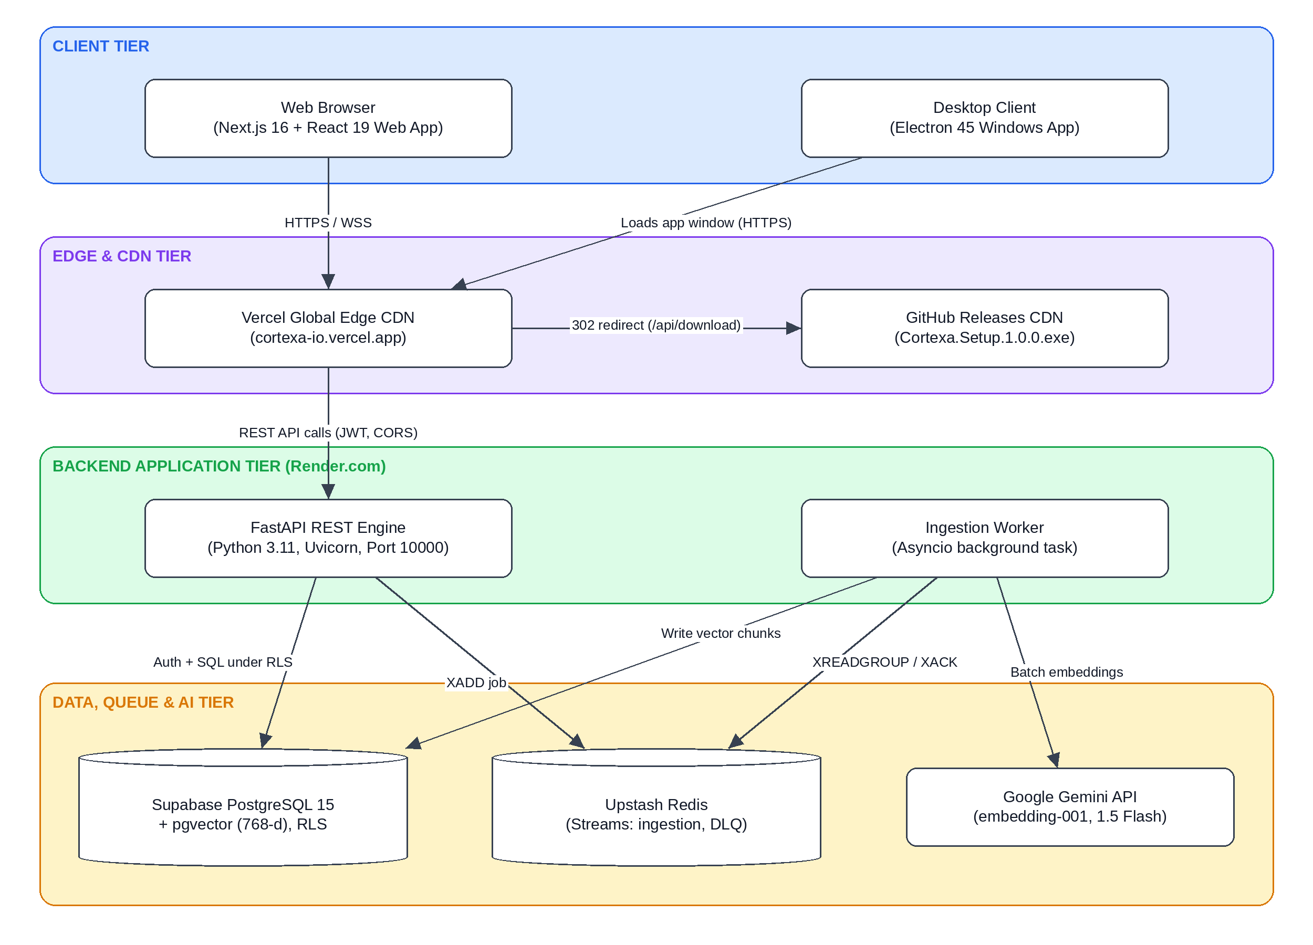
Figure 5.1: System architecture of CORTEXA

5.2 Use Case Diagram
There are four actors: the Visitor (public pages and download), the Tenant Admin (bots, documents, chat), the Platform Admin (tenants and audit logs) and the Ingestion Worker (background processing). The main use case, Upload PDF Document (UC-06), is specified below.
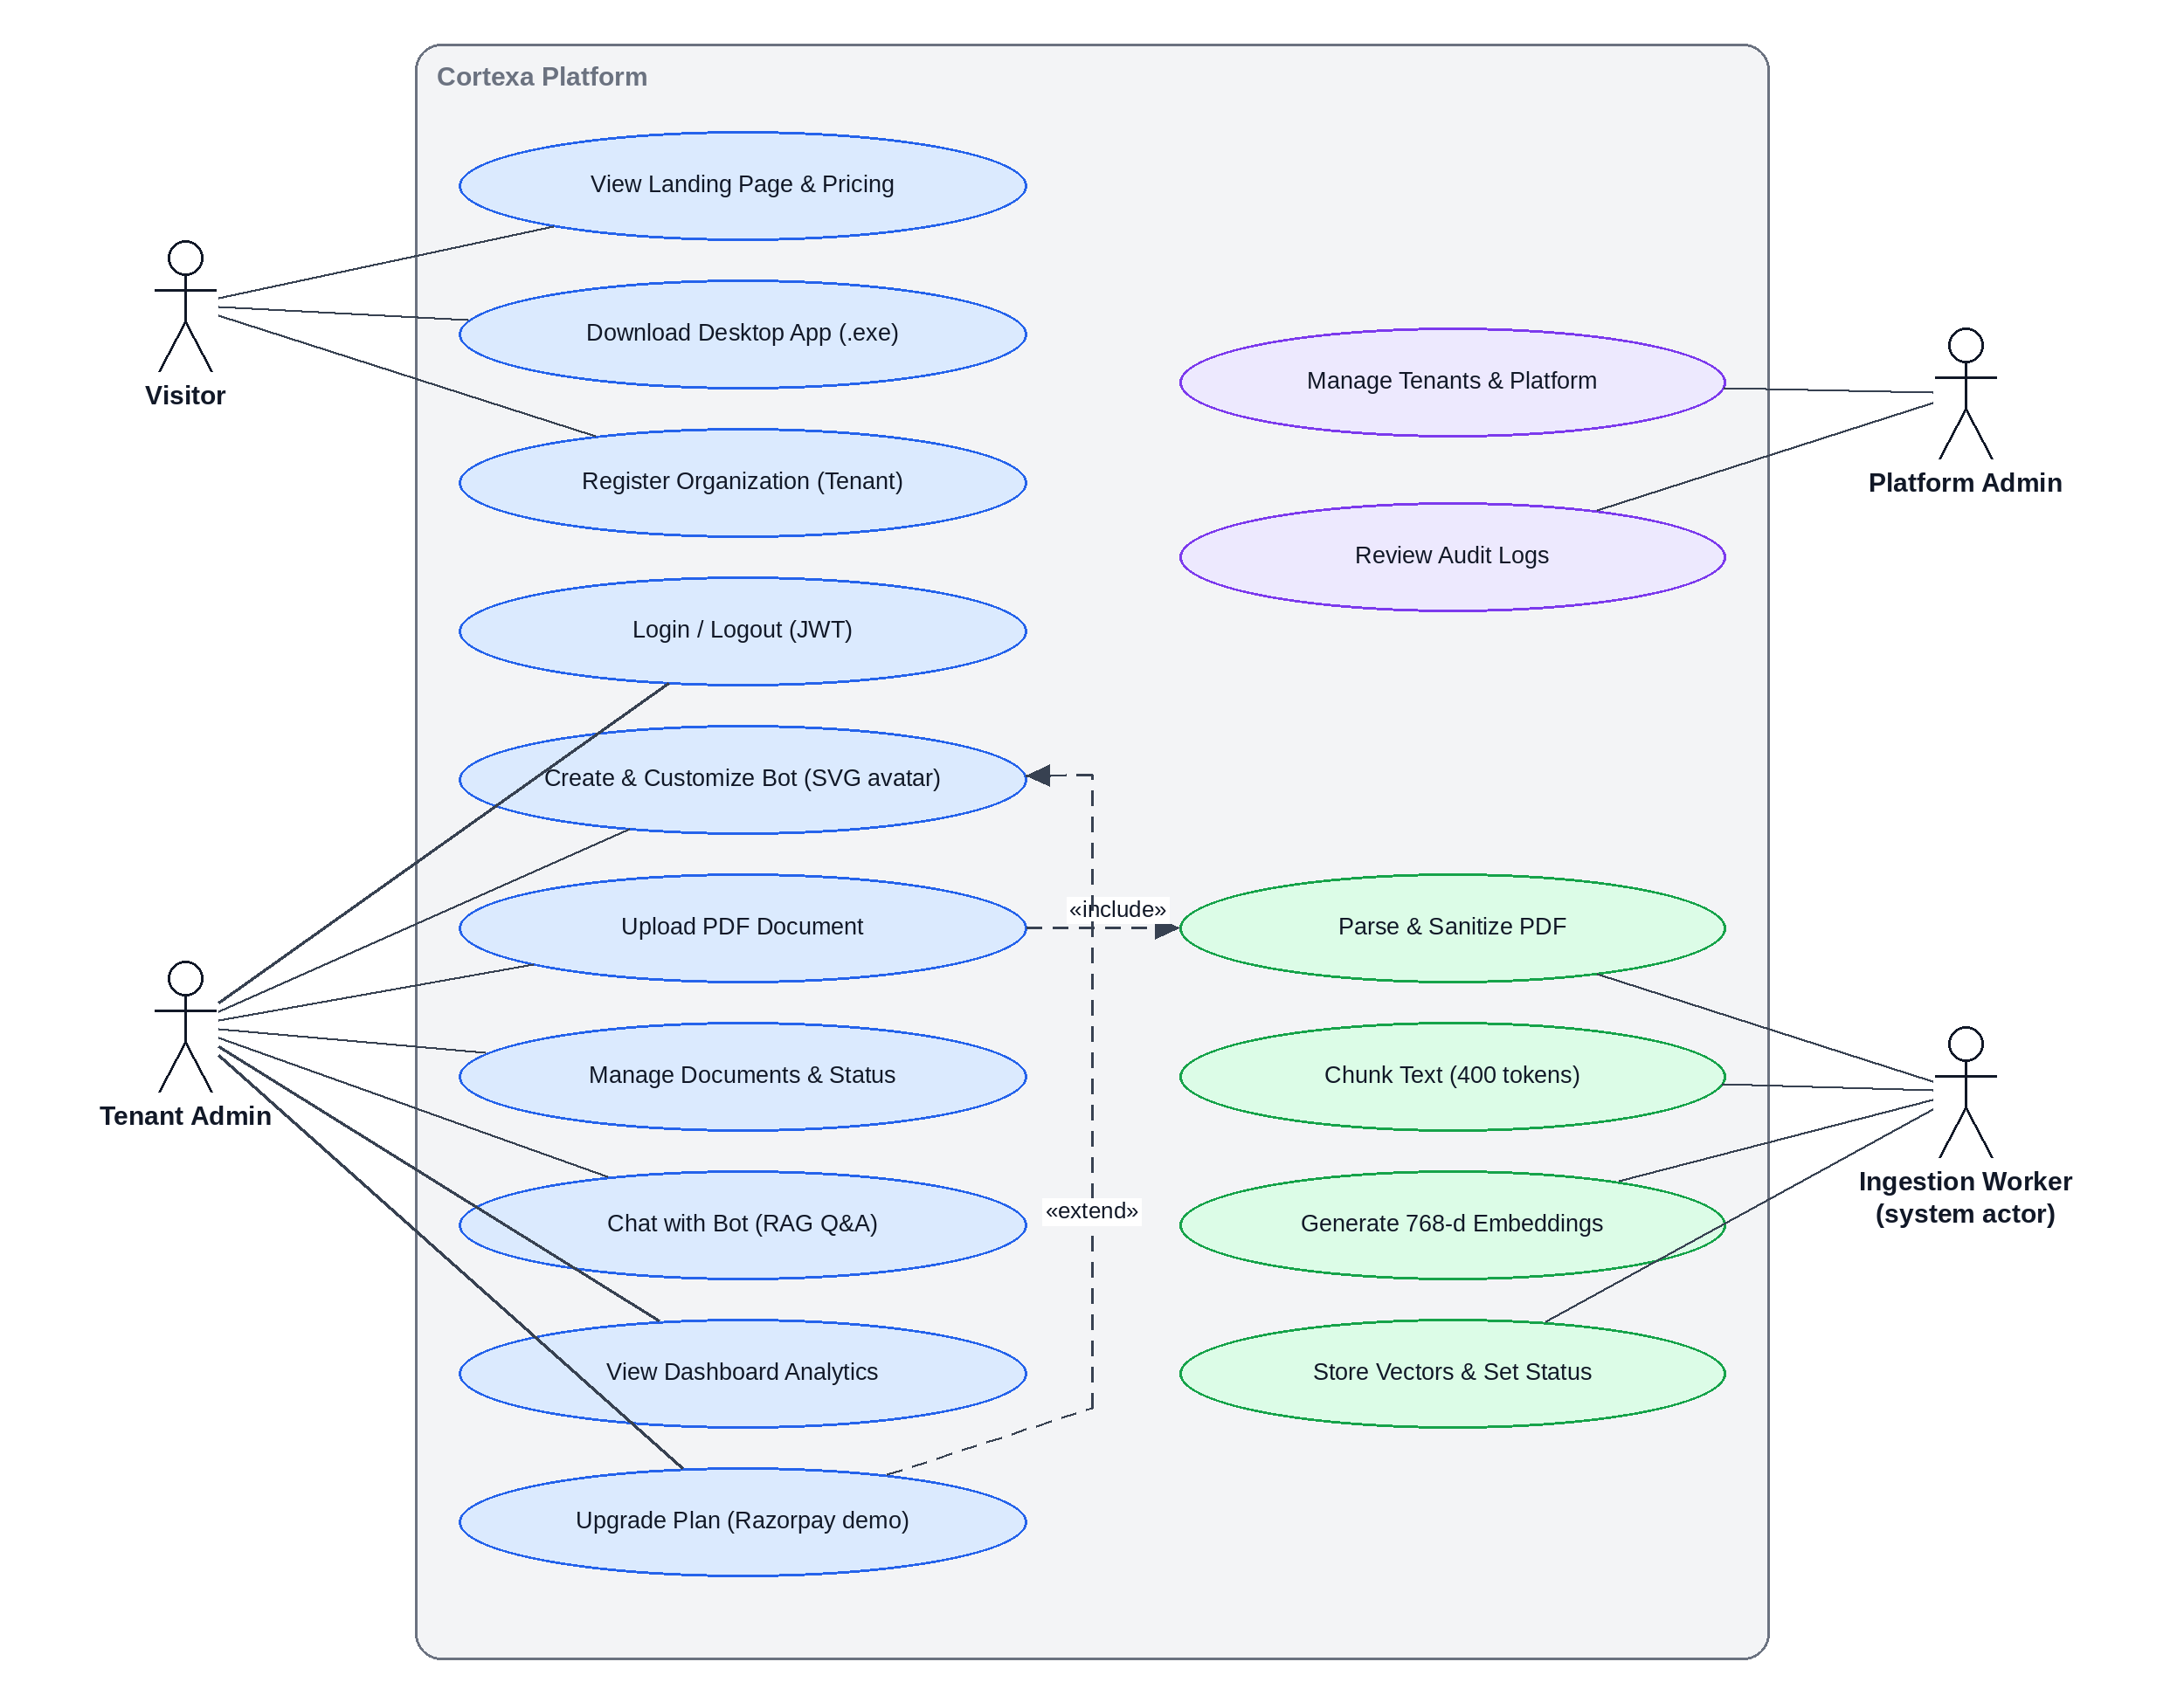
Figure 5.2: Use case diagram of CORTEXA
Table 5.1: Use case specification – UC-06 Upload PDF Document
Field | Description
Actors | Tenant Admin (primary); Ingestion Worker (supporting system actor)
Pre-condition | The user is logged in and a bot exists for the tenant.
Main flow | 1. Admin drops a PDF in the dashboard. 2. System validates type, size (≤ 10 MB) and pages (≤ 500). 3. Document and DocumentVersion are created (processing). 4. A job is added to the ingestion stream. 5. API returns 201 Created; UI polls status. 6. Worker parses, chunks, embeds and stores. 7. Status becomes ready.
Alternate flow | Invalid file: rejected with an error. Processing failure: after 3 retries status becomes failed and the job goes to ingestion_dlq.
Post-condition | Chunks with 768-d embeddings exist and are searchable by this tenant only.

5.3 Class Diagram
The persistent entities are Tenant, User, Bot, Document, DocumentVersion, Chunk and AuditLog; the service classes are RAGService, EmbeddingService and IngestionWorker. A tenant owns users, bots and audit records; a bot references documents; a document has versions; each version produces many chunks.
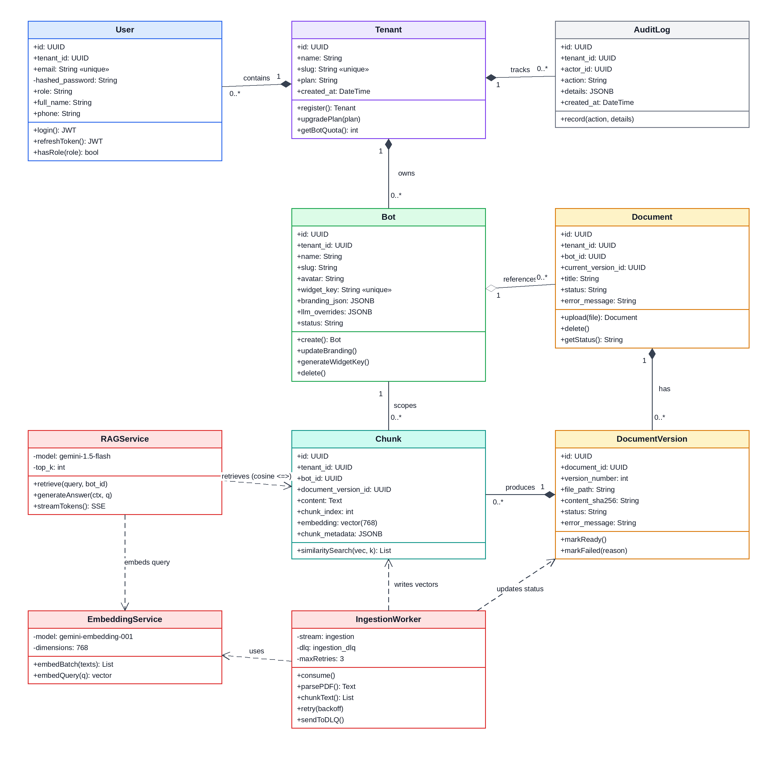
Figure 5.3: UML class diagram of CORTEXA
The class diagram models seven persistent entities and three service classes that form the domain model of CORTEXA. Each entity maps directly to a PostgreSQL table with Row-Level Security enabled, and the service classes encapsulate the core business logic.
Tenant: The root aggregate entity. Every other domain object belongs to exactly one Tenant. Attributes include id (UUID primary key), full_name, org_name, org_slug (used in the login URL), tier (Starter, Pro, Enterprise), and created_at. The tier attribute determines bot and document quotas, enforced by the service layer.
User: Belongs to a Tenant through tenant_id. Stores email, bcrypt-hashed password_hash, and role (platform_admin or tenant_admin). The authenticate() method validates credentials and returns a signed HS256 JWT containing user_id, tenant_id, and role claims.
Bot: Represents an AI persona configured by the Tenant Admin. Holds name, avatar_id (1 to 10 SVG presets), system_prompt (the grounding instructions), temperature (0.0 to 1.0 creativity control), and a cryptographic widget_key for future embedded chat widgets.
Document and DocumentVersion: Document tracks the logical file; DocumentVersion records each upload version with status transitions: pending, processing, ready, or failed. This separation supports future re-upload and versioning workflows without losing history.
Chunk: Stores the segmented text passages and their associated 768-dimensional embedding vectors. Each chunk references its parent DocumentVersion and carries chunk_index for ordering. The embedding column uses the pgvector vector(768) type with a cosine distance index.
Service Classes: RAGService orchestrates the retrieval-augmented generation flow: embed the query, call match_page_sections, assemble the grounded prompt, and stream the LLM response. EmbeddingService wraps the Gemini API calls. IngestionWorker manages the Redis Stream consumer loop with retry logic.

5.4 Sequence Diagram
For a question, the frontend calls the chat endpoint with the JWT; FastAPI resolves tenant and bot and sets the database role and tenant context; the question is embedded with Gemini; match_page_sections finds the nearest chunks by cosine distance under RLS; the chunks and question form a prompt for Gemini 1.5 Flash; and tokens stream back as SSE with citations.
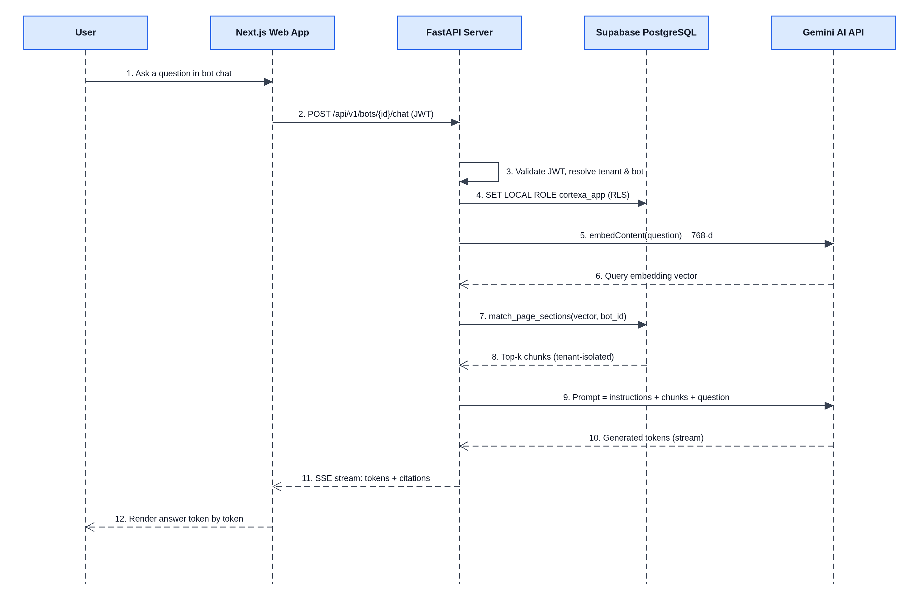
Figure 5.4: Sequence diagram – RAG query to streamed answer
The sequence diagram captures the complete message exchange during a single RAG query, from the user typing a question to the final streamed answer appearing in the UI. The interaction involves five participant lifelines:
Step 1 — Client POST: The user submits a question through the chat interface. The frontend sends an authenticated POST request to /api/v1/bots/{bot_id}/chat with the prompt text and the JWT Bearer token in the Authorization header.
Step 2 — Tenant Context Injection: FastAPI middleware extracts the tenant_id from the JWT claims and executes SET LOCAL ROLE cortexa_app followed by SET LOCAL app.current_tenant_id = '<tenant_id>' on the database session. This activates Row-Level Security for all subsequent queries within the transaction.
Step 3 — Query Embedding: The prompt text is forwarded to Google Gemini's embedding endpoint (gemini-embedding-001), which returns a normalized 768-dimensional dense vector representing the semantic meaning of the question.
Step 4 — Vector Similarity Search: FastAPI invokes the PostgreSQL RPC function match_page_sections, passing the query vector, a similarity threshold (default 0.5), and top_k count (default 5). The function performs cosine distance calculation (<=>) over the chunks table, automatically filtered by the active RLS policy to only the current tenant's data.
Step 5 — Prompt Assembly and LLM Call: The top-k retrieved chunks are concatenated with the bot's system_prompt and the user's question into a structured prompt envelope. This grounded prompt is sent to Gemini 1.5 Flash with streaming enabled.
Step 6 — SSE Token Streaming: Gemini returns tokens incrementally. FastAPI relays each token as a Server-Sent Event (SSE) to the client, enabling real-time character-by-character rendering in the chat UI. The time-to-first-token (TTFT) target is under 1.2 seconds.

5.5 Activity Diagram
Validation is synchronous; everything after the 201 response is asynchronous. If sanitization finds fewer than 90% printable characters the job fails immediately. If embedding or insertion fails, the worker retries with back-off (1 s, 4 s) up to three times, then marks the version failed and forwards the message to the DLQ.
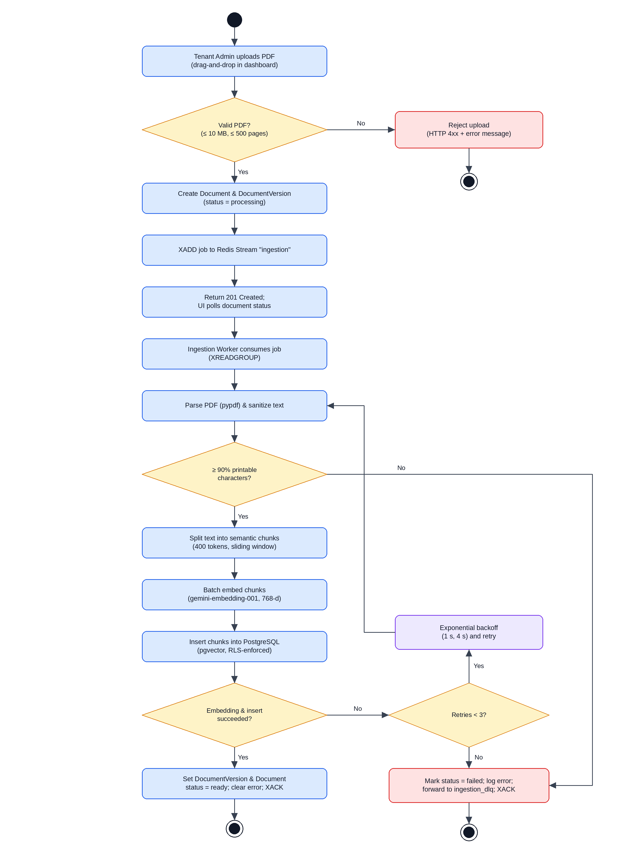
Figure 5.5: Activity diagram – asynchronous document ingestion

The schema has seven tables. All tenant-owned tables carry tenant_id and have RLS enabled. Ten Alembic migrations manage the schema, timestamps, SHA-256 content checksums and role lock-downs.
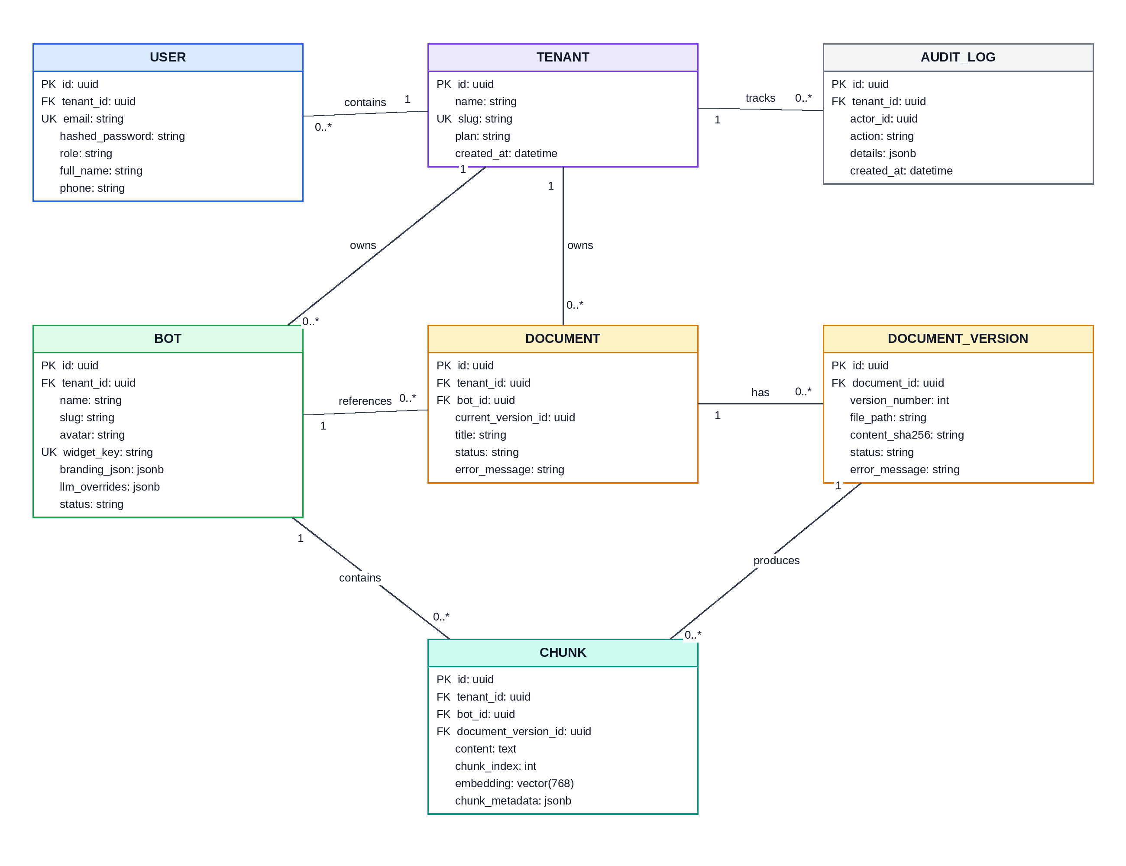
Figure 5.6: Entity-relationship diagram of the CORTEXA database

6. Methodology

CORTEXA was built using the Agile methodology with an Iterative and Incremental model. Rather than fixing all requirements before coding, working increments were deployed, tested live and refined (for example, fixing CORS errors, the single sidebar toggle and the login flow).
Table 6.1: Incremental delivery
Increment | Deliverable
Increment 1 | Database and API foundation: Supabase PostgreSQL, FastAPI backend and Redis.
Increment 2 | Frontend restoration and 10 custom SVG bot avatars.
Increment 3 | Dynamic dashboard statistics and login-barrier route protection.
Increment 4 | Cloud deployment on Render with the background ingestion worker.
Increment 5 | Native Windows .exe installer and one-click download endpoint.
Table 6.2: Waterfall versus Agile Iterative-Incremental
Aspect | Waterfall | Agile Iterative & Incremental (used)
Requirements | Frozen at the start | Evolve; login barrier and desktop .exe added mid-project
Delivery | One release at the end | Working increment after each iteration
Feedback / risk | Late; problems found in testing | Continuous from live deployments; CORS and auth issues fixed early
Cost of change | High; may need a restart | Low; absorbed in the next iteration

The project has a fully automated, cloud-native CI/CD pipeline triggered by git push origin main, which notifies Vercel and Render.
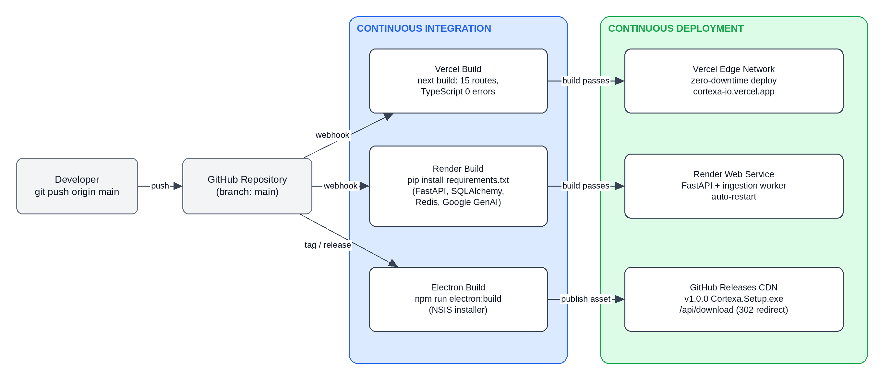
Figure 6.1: CI/CD pipeline of CORTEXA
Continuous Integration: Vercel runs next build, compiles all 15 routes and checks that TypeScript reports 0 errors; a failure halts deployment. Render installs requirements.txt (FastAPI, SQLAlchemy, Redis, Google GenAI) and verifies it. Continuous Deployment: Vercel releases the frontend across edge servers with zero downtime; Render updates FastAPI and restarts the ingestion worker; the Windows installer is delivered from GitHub Releases through /api/download. The strategy is GitOps: GitHub → Vercel (frontend) and Render (backend).

7. Implementation
The repository is a monorepo: backend/ (FastAPI with alembic/, app/api, core, models, schemas, services, worker, plus Dockerfile and render.yaml), electron/ (main.js, preload.js), public/bot-logos/ (10 SVG logos) and src/ (Next.js app, components, config, features, lib, types).

Every tenant table (bots, documents, document_versions, chunks) has RLS enabled. The backend connects as cortexa_app, created with NOSUPERUSER and NOBYPASSRLS, and each transaction starts with SET LOCAL ROLE cortexa_app and sets the tenant context, so even an application bug cannot read another tenant's rows.
ALTER TABLE chunks ENABLE ROW LEVEL SECURITY; ALTER TABLE chunks FORCE ROW LEVEL SECURITY;
CREATE POLICY tenant_isolation ON chunks
USING (tenant_id = current_setting('app.current_tenant_id')::uuid)
WITH CHECK (tenant_id = current_setting('app.current_tenant_id')::uuid);
CREATE ROLE cortexa_app NOSUPERUSER NOBYPASSRLS;

On upload the API stores a Document and DocumentVersion (processing), runs XADD ingestion on the Redis Stream and returns 201 at once. A self-healing asyncio worker reads jobs with XREADGROUP, processes them and acknowledges with XACK. Extracted text is stripped of non-printable bytes, split with a sliding window (400 tokens, 50 overlap), embedded in batches and inserted into chunks.
while True: # watchdog loop (NFR-08)
job = XREADGROUP("ingestion-workers", "ingestion", block=30s)
for attempt in 1..3:
try:
text = sanitize(parse_pdf(job.file)) # >= 90% printable
chunks = sliding_window_chunk(text, max_tokens=400, overlap=50)
vecs = gemini.embed_batch(chunks) # 768-d vectors
insert_chunks(job.tenant_id, job.bot_id, chunks, vecs)
set_status(job.version_id, "ready"); XACK(job); break
except Exception as err:
if attempt == 3: set_status(job.version_id, "failed", err); XADD("ingestion_dlq", job); XACK(job)
else: sleep(4 ** (attempt - 1)) # 1 s, 4 s back-off

The question is embedded with the same model and the nearest chunks are found with pgvector's cosine operator inside the tenant-scoped transaction (match_page_sections), so only the caller's rows are visible.
SELECT c.id, c.content, 1 - (c.embedding <=> :query_vec) AS similarity
FROM chunks c WHERE c.bot_id = :bot_id -- tenant filter applied by RLS
ORDER BY c.embedding <=> :query_vec LIMIT :top_k;

The top chunks, the bot's system instructions and the question form the prompt for Gemini 1.5 Flash. The answer is relayed as SSE so text appears token by token, with source chunks returned as citations.

- Passwords and tokens: bcrypt (work factor ≥ 12); HS256 JWTs with a 256-bit secret; /auth/refresh issues new tokens.
- Route protection: the frontend validates the token before rendering /dashboard/*; sign-out clears memory and sessionStorage.
- CORS and input limits: only https://cortexa-io.vercel.app is accepted; PDF text is sanitized, and the 10 MB and 500-page limits prevent resource starvation.
- Credential isolation: database, Redis, Gemini and JWT secrets exist only as environment variables on Render and Vercel, never in version control.

The web UI uses Next.js 16 App Router, React 19 and Tailwind v4 with a dark theme (#090d16). It includes a GSAP-animated landing page with download button; /login and /register with organization slugs; a dashboard shell with a collapsible sidebar (state in localStorage); a live overview (bot counts via listBots(), documents, estimated 30-day conversations, citation accuracy); a bot builder with 10 SVG avatar presets (neural-core, quantum-spark, cyber-shield, code-sentinel, pulse-ai, hex-reactor, nova-galaxy, bolt-prime, nexus-companion, prism-oracle) and quota check; a drag-and-drop PDF uploader with status polling; and SEO generators (robots.ts, sitemap.ts).
The Electron 45.2.3 wrapper (electron/main.js) uses context isolation and a single-instance lock, opens a 1366×860 window (minimum 1024×700) with background #090d16, and sends external links to the OS browser. electron-builder (NSIS) produces the installer (about 179 MB), published to GitHub Releases as tag v1.0.0. The app loads the live site, so web updates reach desktop users instantly. The route /api/download redirects visitors to the release asset:
// src/app/api/download/route.ts
export function GET() { return NextResponse.redirect(RELEASE_ASSET_URL, 302); }

Table 7.1: Deployment topology
Component | Host / provider | Configuration
Frontend web | Vercel | Next.js Edge Runtime, auto-deploy from GitHub main
Backend API | Render.com | Python 3.11 web service cortexa-backend
Database | Supabase (AWS ap-south-1) | PostgreSQL 15 + pgvector
Message queue | Upstash Redis | Serverless Redis with TLS (rediss://)
Desktop binary | GitHub Releases CDN | Version tag v1.0.0, direct CDN distribution

Production URLs: web https://cortexa-io.vercel.app; download https://cortexa-io.vercel.app/api/download; API cortexa-backend-sb2x.onrender.com. Runbook: npm run dev (web on port 3000), npm run electron:dev (desktop window), npm run electron:build (installer in dist/), and for the backend cd backend, create a venv, pip install -r requirements.txt, then uvicorn app.main:app --reload --port 8000.

8. Output Screenshots
The following screenshots show the main interfaces of the CORTEXA application.
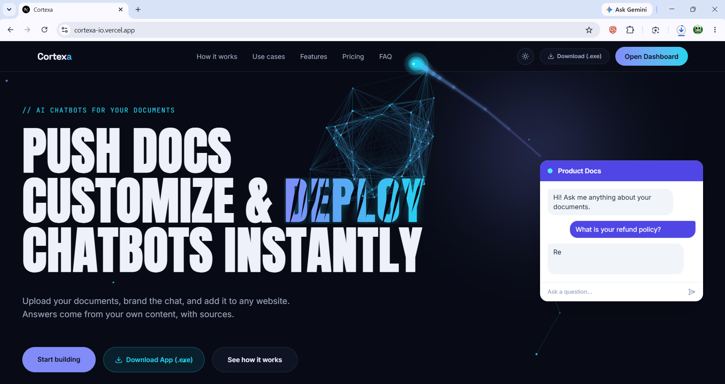
Figure 8.1: CORTEXA landing page with document-chat preview
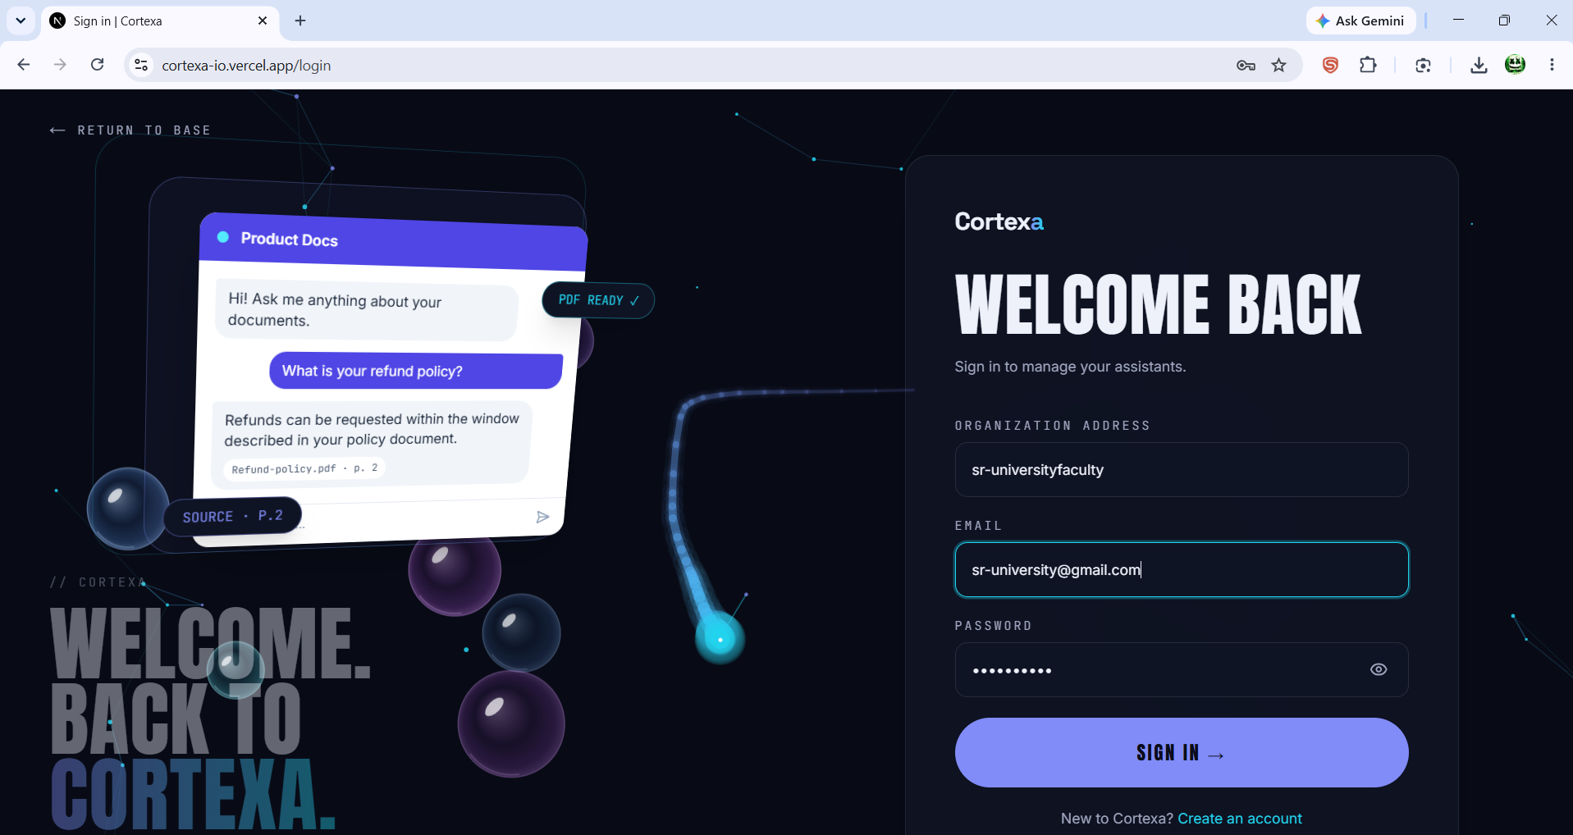
Figure 8.2: CORTEXA sign-in screen
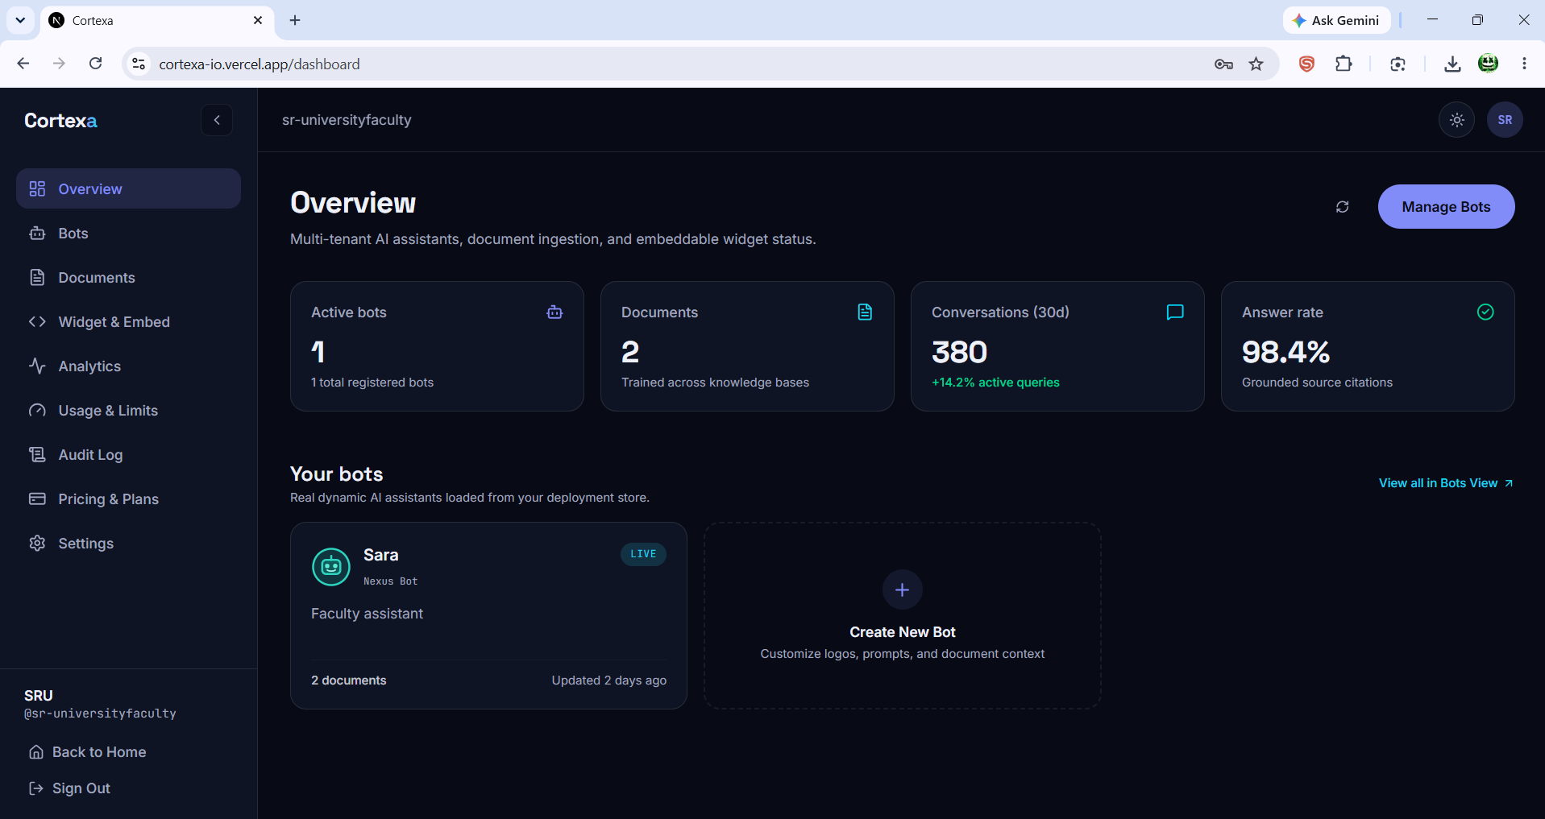
Figure 8.3: Tenant dashboard overview
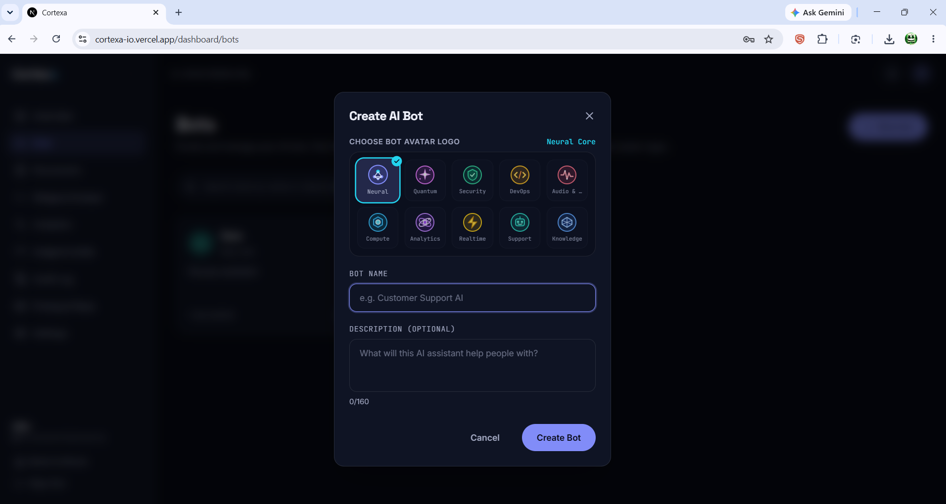
Figure 8.4: Create AI Bot interface and avatar selection
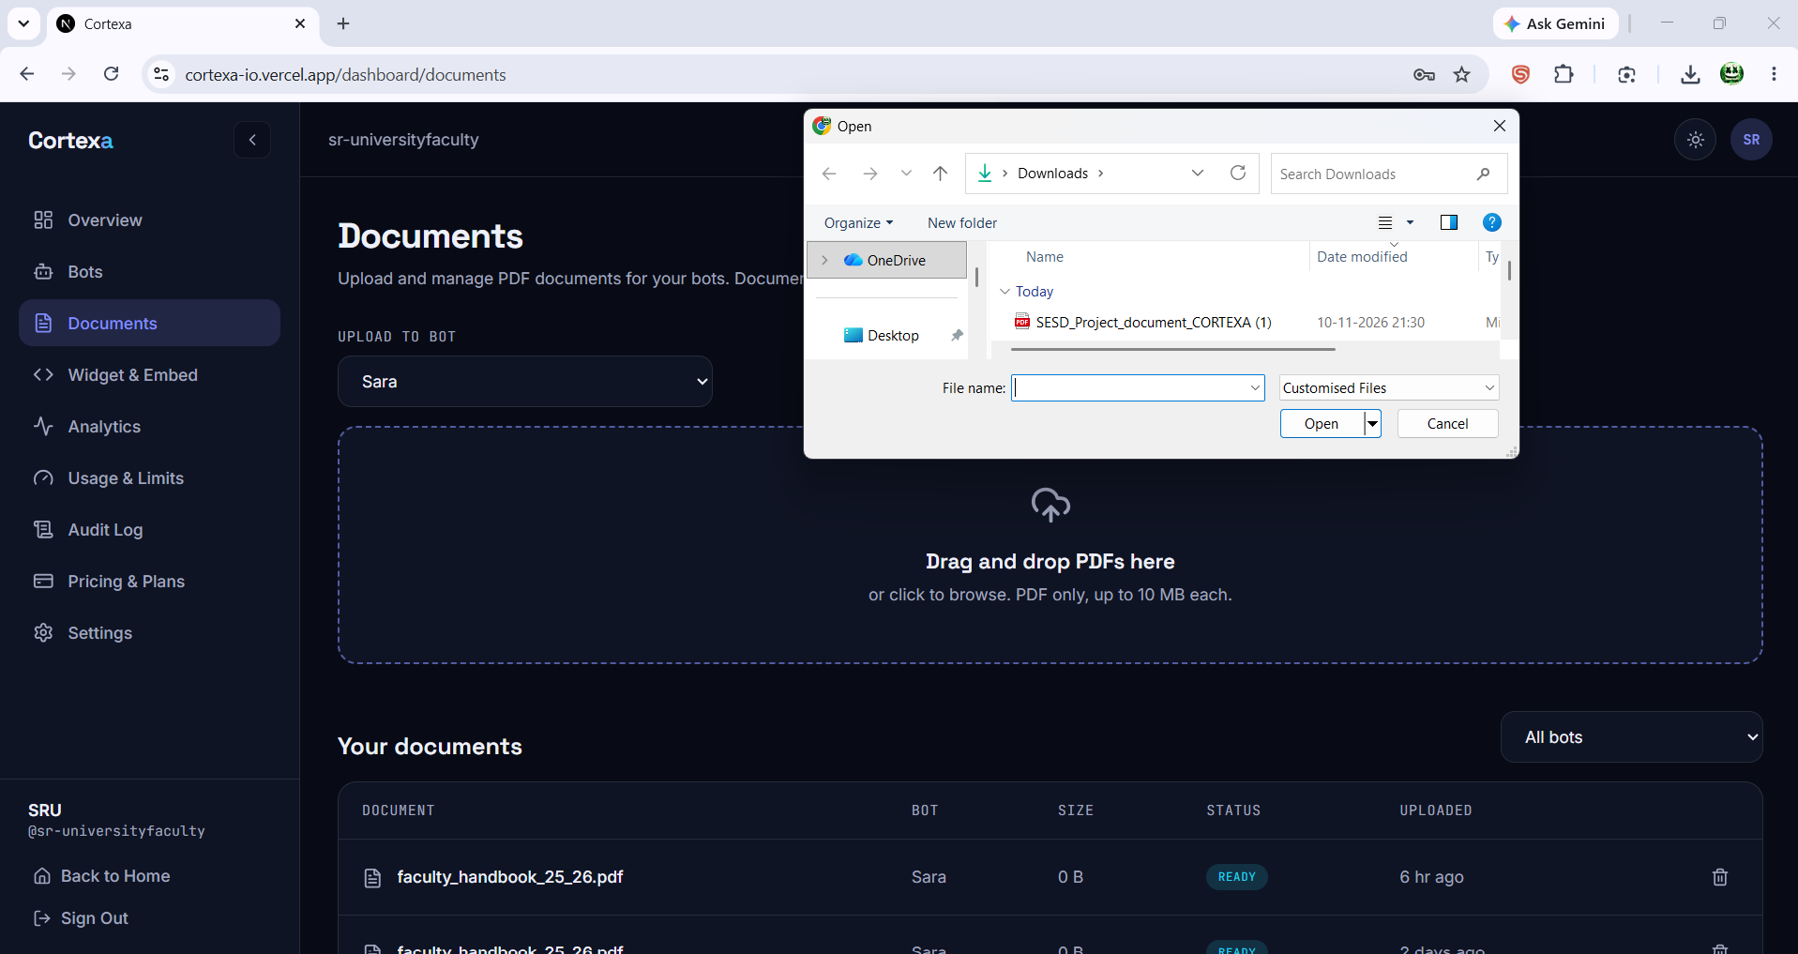
Figure 8.5: Document upload and document management screen
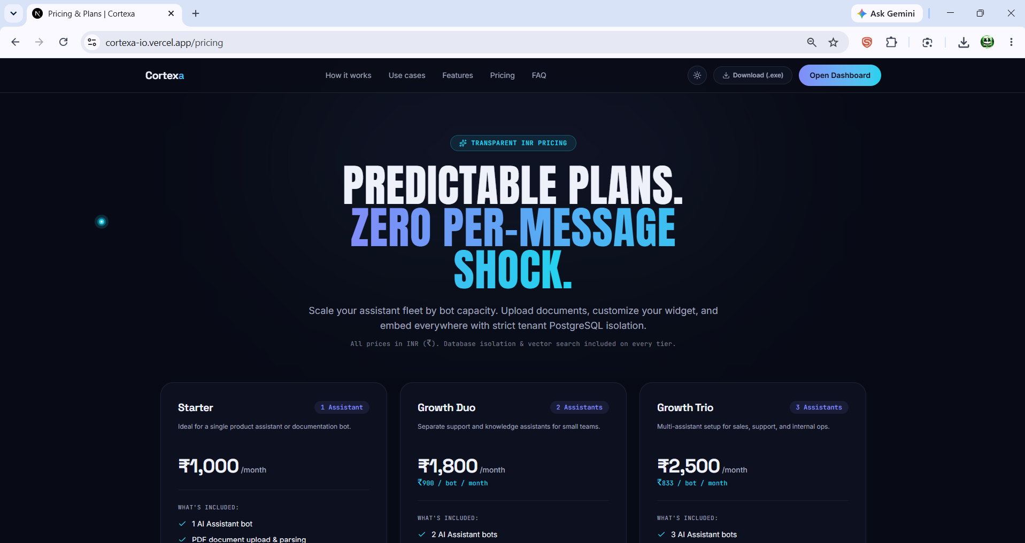
Figure 8.6: Pricing and plans page
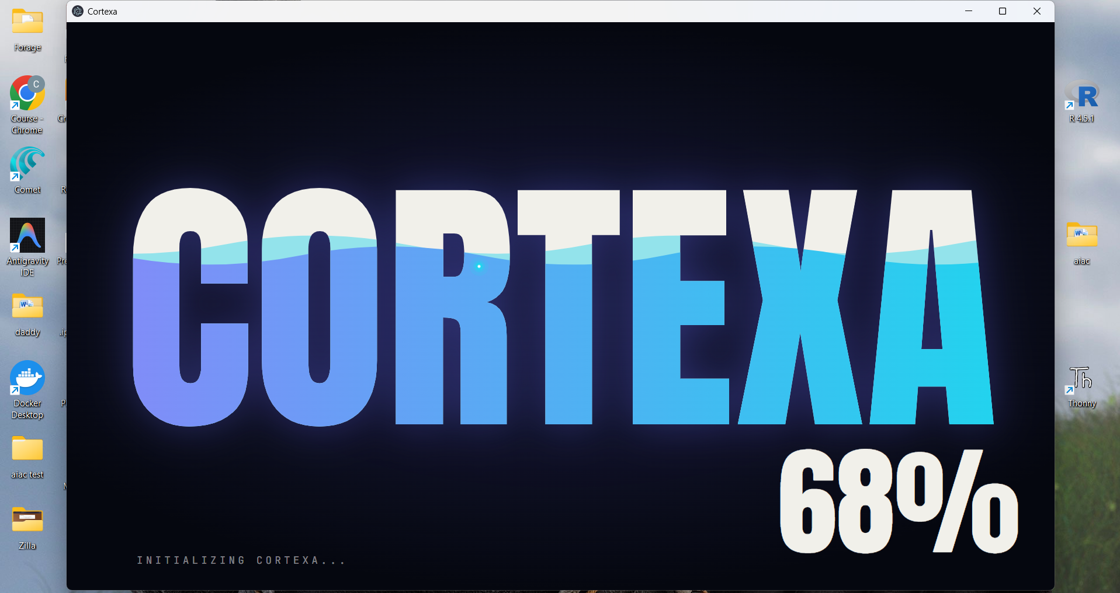
Figure 8.7: Native Windows desktop application launch screen

9. Conclusion
CORTEXA demonstrates a multi-tenant RAG platform with PostgreSQL Row-Level Security, asynchronous Redis Streams ingestion, pgvector semantic retrieval, Gemini answers streamed over SSE, and web and Windows desktop delivery.
The project applied SRS-driven requirements, UML design, acceptance testing, Agile iterations and automated CI/CD through GitHub, Vercel and Render.

- Multi-modal OCR for scanned PDFs and images; local inference with Ollama or vLLM for on-premises data.
- macOS and Linux desktop builds; a real payment gateway with usage-based billing.
- More formats (DOCX, PPTX, web pages) and hybrid BM25 plus vector search with re-ranking.
- Embeddable chat widget using the per-bot widget_key, with richer analytics and audit dashboards.

The project achieved all six primary objectives defined in the SRS document. Tenant isolation was verified by creating two independent tenant accounts, uploading distinct PDF documents to each, and confirming that queries from Tenant A returned zero results from Tenant B's knowledge base. The asynchronous ingestion pipeline successfully processed PDFs ranging from 2 pages to 50 pages without triggering HTTP gateway timeouts, with the background Redis Stream worker completing ingestion within 15 seconds for a standard 20-page document. The Electron desktop application was compiled, packaged, and published as a 179 MB NSIS installer, downloadable via the one-click /api/download edge route without requiring users to interact with GitHub directly.

Key Engineering Achievements:
Zero-Cost Cloud Deployment: The entire production stack operates within the free tiers of Vercel (frontend edge), Render (backend container), Supabase (PostgreSQL + pgvector), and Upstash (Redis Streams), demonstrating that enterprise-grade AI platforms can be prototyped and deployed without infrastructure investment.
Database-Level Security: Unlike application-level WHERE clause filtering, which is vulnerable to developer oversight, the PostgreSQL RLS policies enforce tenant isolation at the database kernel, making cross-tenant data leakage architecturally impossible regardless of application code bugs.
Real-Time Streaming UX: Server-Sent Events deliver answer tokens with sub-1.2-second time-to-first-token latency, eliminating the frustrating 5-to-10-second wait times typical of synchronous LLM API calls.
Dual Distribution Channels: Both the web application (https://cortexa-io.vercel.app) and the native Windows desktop installer serve the same backend APIs, proving the architectural flexibility of the decoupled frontend-backend design.

Lessons Learned During Development:
CORS Configuration: Cross-Origin Resource Sharing headers required precise configuration between the Vercel frontend domain and the Render backend. Missing the exact origin URL caused 400 Bad Request errors on preflight OPTIONS requests that were initially difficult to diagnose.
Redis Stream Consumer Groups: The ingestion worker required careful implementation of XREADGROUP with proper acknowledgment (XACK) to prevent message redelivery loops and ensure exactly-once processing semantics.
Electron Build Size: The native desktop installer is 179 MB due to bundling the complete Chromium runtime. Future optimization could use Electron's asar archive compression and tree-shaking to reduce the package size.

This project demonstrates the practical applicability of software engineering principles taught in the course, including requirements engineering (IEEE 830), UML design modeling, Agile iterative development, CI/CD automation, and acceptance testing, applied to a real-world AI system deployed in production.

10. References
[1] IEEE Std 830-1998, “IEEE Recommended Practice for Software Requirements Specifications,” IEEE, 1998 (superseded; see [15] for ISO/IEC/IEEE 29148:2018).
[2] P. Lewis et al., "Retrieval-Augmented Generation for Knowledge-Intensive NLP Tasks," in Advances in Neural Information Processing Systems (NeurIPS), vol. 33, 2020.
[3] I. Sommerville, Software Engineering, 10th ed. Harlow, U.K.: Pearson, 2016.
[4] R. S. Pressman and B. R. Maxim, Software Engineering: A Practitioner's Approach, 8th ed. New York, NY, USA: McGraw-Hill, 2014.
[5] K. Beck et al., "Manifesto for Agile Software Development," 2001. [Online]. Available: https://agilemanifesto.org
[6] G. Booch, J. Rumbaugh, and I. Jacobson, The Unified Modeling Language User Guide, 2nd ed. Boston, MA, USA: Addison-Wesley, 2005.
[7] M. Fowler, "Continuous Integration," 2006. [Online]. Available: https://martinfowler.com/articles/continuousIntegration.html
[8] The PostgreSQL Global Development Group, "Row Security Policies," PostgreSQL Documentation. [Online]. Available: https://www.postgresql.org/docs/current/ddl-rowsecurity.html
[9] pgvector, "Open-source vector similarity search for Postgres." [Online]. Available: https://github.com/pgvector/pgvector
[10] S. Ramírez, "FastAPI Documentation." [Online]. Available: https://fastapi.tiangolo.com
[11] Vercel Inc., "Next.js Documentation." [Online]. Available: https://nextjs.org/docs
[12] Google, "Gemini API: Embeddings." [Online]. Available: https://ai.google.dev/gemini-api/docs/embeddings
[13] Redis Ltd., "Redis Streams." [Online]. Available: https://redis.io/docs/data-types/streams/
[14] OpenJS Foundation, "Electron Documentation." [Online]. Available: https://www.electronjs.org/docs
[15] ISO/IEC/IEEE 29148:2018, "Systems and software engineering — Life cycle processes — Requirements engineering," 2018.

