CIFAR-10 ML System Optimization
Performance Evaluation of DataLoader Workers and Batch Size
Project Report
Student / Group: ______________________________
Course: ML System Optimization
Date: 28 October 2026

Abstract
This project measures the effect of DataLoader worker count and batch size on a compact CNN trained on CIFAR-10. Experiment A compares 0, 2, and 4 workers; Experiment B compares batch sizes 64, 128, and 256 with four workers. Each setting used three trial seeds (42, 43, 44) and 15 epochs. Compared with two workers, four workers reduced mean steady-state epoch training time by 38.44% and increased throughput by 62.89%. Compared with batch size 64, batch size 256 reduced mean epoch time by 10.77% and increased throughput by 11.23%, while batch size 64 had the highest mean best-validation accuracy. Only one physical GPU was used; this is single-GPU tuning, not multi-GPU distributed scaling.

1. Problem Statement and Objectives
The goal is to empirically compare system settings affecting CNN training time, throughput, and validation performance.
- Record a baseline training run.
- Compare DataLoader worker counts with other major settings held constant.
- Compare batch sizes using four DataLoader workers.
- Report mean and sample standard deviation across three seeds.
- Explain performance–accuracy trade-offs and limitations.

2. Hardware and Software Environment
Component | Recorded environment
Operating system | Windows 10
Python | 3.11.9
PyTorch / Torchvision | 2.5.1+cu121 / 0.20.1+cu121
GPU | NVIDIA RTX 4050 Laptop GPU, 6 GB
CUDA | Available; one physical GPU

Before submission, rerun src/check_environment.py and confirm these values against its current output.

3. Dataset and Data Pipeline
The project uses CIFAR-10, a dataset of 60,000 colour images of size 32×32 across 10 classes. The recorded split uses 45,000 training images, 5,000 validation images, and the official 10,000-image test set. The train/validation split seed is 42; trial loader seeds are 42, 43, and 44. Confirm the transforms and split in src/dataset.py before submission.

4. Model and Training Configuration
SmallCNN uses convolutional blocks with channel sizes 3→32, 32→64, and 64→128, with batch normalization, ReLU, and max pooling in each block. The classifier uses flattening, a 256-unit fully connected layer, ReLU, dropout 0.3, and a 10-class output layer.
Setting | Value
Loss | CrossEntropyLoss
Optimizer | Adam
Learning rate / weight decay | 0.001 / 0.0001
Epochs per trial | 15
Trial seeds | 42, 43, 44
Experiment A batch size | 128
Experiment B workers | 4

5. Experimental Methodology

5.1 Baseline
The baseline used batch size 128, two DataLoader workers, seed 42, and 15 epochs. Recorded best validation accuracy was 80.46%, test accuracy 78.99%, test loss 0.5994, total training time 74.12 s, mean epoch training time 4.94 s, test evaluation time 6.18 s, and test throughput 1,619.17 images/s. This baseline is reported separately because its timing summary includes startup effects and is not directly comparable to repeated experiments' steady-state epoch timings.

5.2 Experiment A — Worker count
Worker counts 0, 2, and 4 were tested at batch size 128. Each configuration used three seeds and 15 epochs. Steady-state timing excludes the first epoch.

5.3 Experiment B — Batch size
Batch sizes 64, 128, and 256 were tested with four DataLoader workers, three seeds, and 15 epochs per trial.

6. Results

6.1 Experiment A — DataLoader workers
Workers | Train time (s/epoch) | Response (s/epoch) | Throughput (images/s) | Best validation accuracy
0 | 12.884 ± 1.943 | 13.623 ± 2.091 | 3,556 ± 502 | 79.793% ± 0.329%
2 | 4.312 ± 0.222 | 4.600 ± 0.231 | 10,474 ± 498 | 79.947% ± 0.662%
4 | 2.654 ± 0.152 | 2.837 ± 0.165 | 17,061 ± 942 | 79.640% ± 0.374%

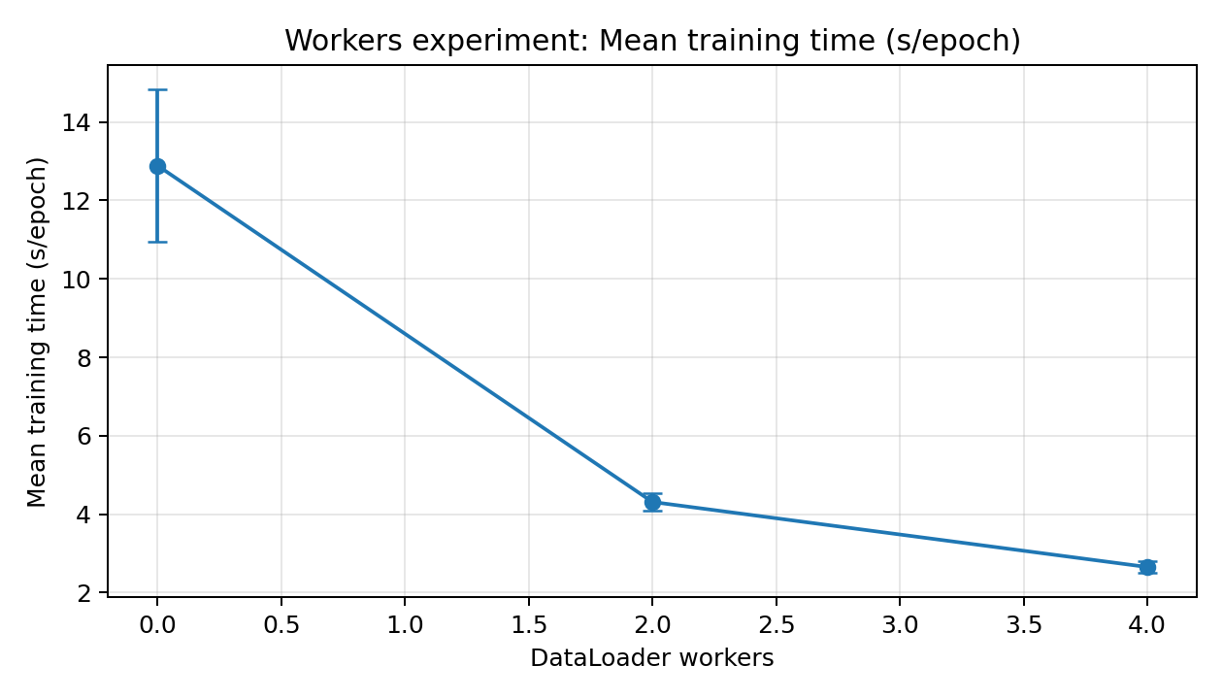
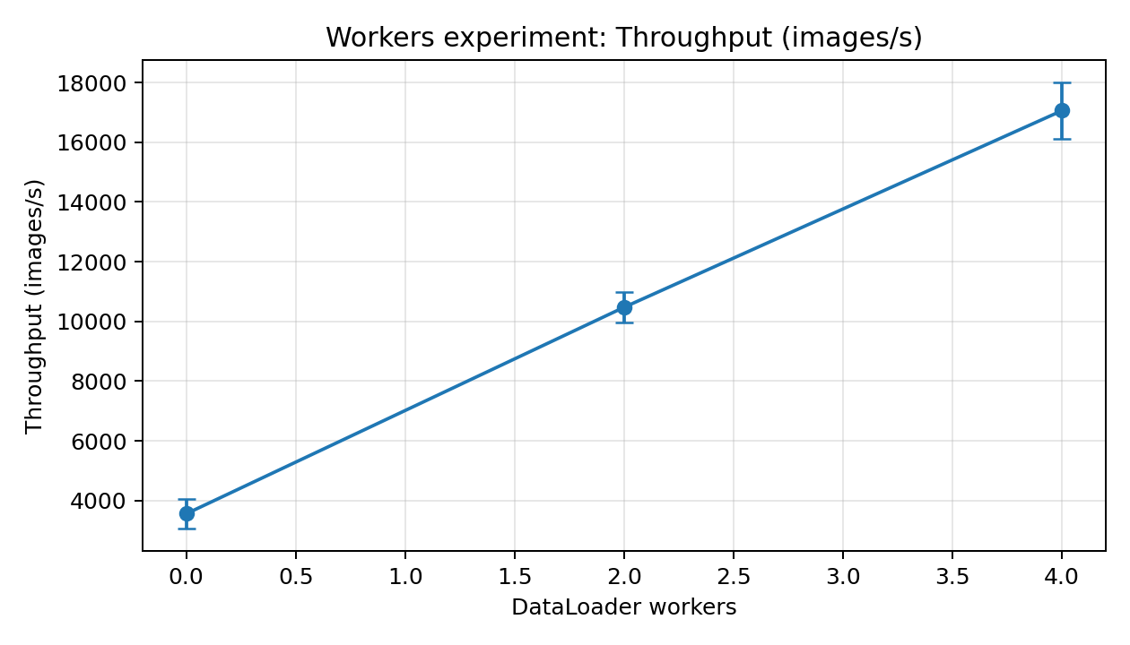
Four workers produced the shortest mean steady-state epoch time and highest measured throughput. Comparing two versus four workers: 4.3118 / 2.6544 = 1.624× measured time ratio, 38.44% time reduction, and 62.89% throughput increase. Two workers had the highest mean best-validation accuracy in this experiment.

6.2 Experiment B — Batch size
Batch | Train time (s/epoch) | Response (s/epoch) | Throughput (images/s) | Best validation accuracy
64 | 2.797 ± 0.245 | 2.973 ± 0.268 | 16,262 ± 1,325 | 80.467% ± 0.665%
128 | 2.512 ± 0.199 | 2.683 ± 0.216 | 18,010 ± 1,382 | 79.640% ± 0.374%
256 | 2.496 ± 0.144 | 2.669 ± 0.153 | 18,088 ± 1,032 | 79.393% ± 1.115%

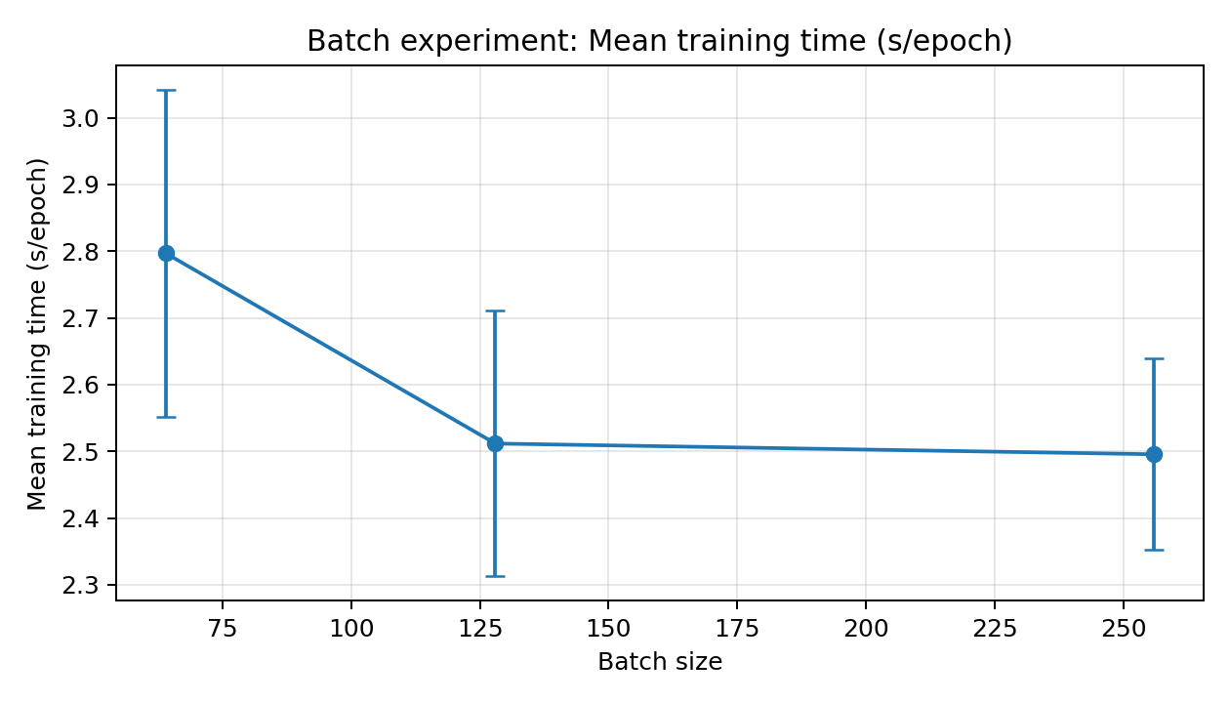
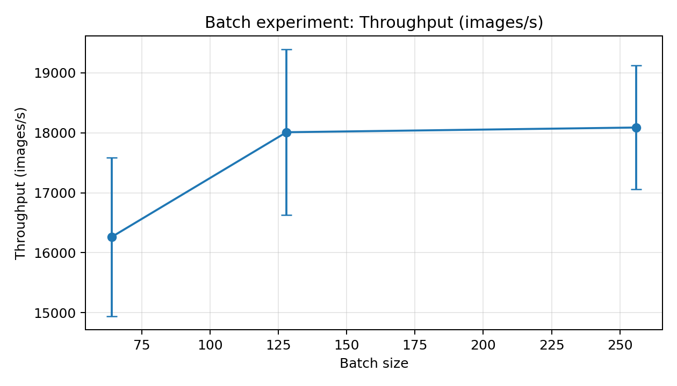
Batch size 256 achieved the shortest mean steady-state epoch time and highest throughput. Comparing batch sizes 64 versus 256: 2.7967 / 2.4956 = 1.121× measured time ratio, 10.77% time reduction, and 11.23% throughput increase. Batch size 64 had the highest mean best-validation accuracy, approximately 1.073 percentage points above batch size 256.

7. Performance Metrics
Measured time ratio = baseline time / optimized time.
Time reduction (%) = ((baseline time − optimized time) / baseline time) × 100.
Throughput change (%) = ((optimized throughput − baseline throughput) / baseline throughput) × 100.
Experiment A (2 → 4 workers): 1.624× time ratio, 38.44% reduction, 62.89% throughput increase. Experiment B (batch 64 → 256): 1.121× time ratio, 10.77% reduction, 11.23% throughput increase.
These ratios compare measured epoch times in controlled single-GPU experiments. They are not multi-GPU speedup. Distributed parallel efficiency E = S/N, multi-GPU communication time, and all-reduce cost were not measured.

8. Discussion
- Increasing workers from zero to four reduced steady-state epoch time substantially in this setup.
- The fastest worker setting did not have the highest validation accuracy.
- Increasing batch size improved throughput, but the timing difference between 128 and 256 was small.
- Batch size 64 favoured validation accuracy; batch size 256 favoured throughput.
- Three seeds give a basic variability estimate but are insufficient to claim statistical significance.

9. Limitations
- Only one physical GPU was used; no multi-GPU distributed training was performed.
- Inter-GPU communication, network transfer cost, all-reduce time, and distributed parallel efficiency were not measured.
- Results depend on this hardware, model, software, and data pipeline.
- Three trials per setting provide limited statistical power.
- Warm-up, background activity, caching, and Windows worker-process overhead may affect timing.
- Baseline and repeated-run timing summaries differ; comparisons should use matched steady-state measurements.

10. Conclusion
DataLoader worker count and batch size affect training performance for the CIFAR-10 CNN. Four workers gave the highest throughput in Experiment A and reduced mean epoch time by 38.44% relative to two workers. Batch size 256 gave the highest throughput in Experiment B and reduced mean epoch time by 10.77% relative to batch size 64. Batch size 64 nevertheless achieved the highest mean best-validation accuracy. The preferred configuration depends on whether throughput or validation accuracy is the priority. These results describe single-GPU tuning, not multi-GPU distributed scaling.

11. Reproducibility and Project Files
- src/check_environment.py — environment capture.
- src/dataset.py — DataLoader construction.
- src/model.py — SmallCNN model.
- src/train.py — baseline run.
- src/experiment_workers_repeated.py — repeated worker experiment.
- src/experiment_batch_size.py — repeated batch-size experiment.
- src/analyze_performance.py — measured ratios and throughput changes.
- results/experiment_A_repeated/ and results/experiment_B_batch_size/ — logs, checkpoints, aggregates.
- results/plots/ — generated plots.

12. References
1. Krizhevsky, A. (2009). Learning Multiple Layers of Features from Tiny Images. CIFAR-10: https://www.cs.toronto.edu/~kriz/cifar.html
2. PyTorch documentation, data loading: https://pytorch.org/docs/stable/data.html
3. PyTorch documentation, CUDA semantics: https://pytorch.org/docs/stable/notes/cuda.html

Appendix — Submission checklist
- Verify the assignment rubric and required report template.
- Rerun src/check_environment.py and confirm the environment.
- Confirm split and transforms in src/dataset.py.
- Include required logs, checkpoints, aggregate CSVs, and plots.
- Add student name, ID, group number, and instructor details if required.
- Do not claim multi-GPU speedup, communication cost, or parallel efficiency as measured.

