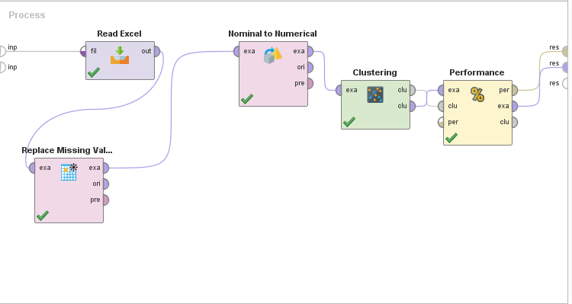

|  |  |
| --- | --- |
|  | Cluster Distance Performance |

he Cluster Distance Performance operator takes this centroid cluster model and clustered set as input and evaluates the performance of the model based on the cluster centroids. Two performance measures are supported: Average within cluster distance and Davies-Bouldin index. These performance measures are explained in the parameters.

K=3

**PerformanceVector**

PerformanceVector:

Avg. within centroid distance: 1935726448497994.500

Avg. within centroid distance_cluster_0: 2492228297597510.000

Avg. within centroid distance_cluster_1: 10973714215652.848

Avg. within centroid distance_cluster_2: 2448563714512001.000

Davies Bouldin: 0.452

K=4

# PerformanceVector

PerformanceVector:

Avg. within centroid distance: 866592634002730.100

Avg. within centroid distance_cluster_0: 12027660291353.370

Avg. within centroid distance_cluster_1: 10973714215652.848

Avg. within centroid distance_cluster_2: 2448563714512001.000

Avg. within centroid distance_cluster_3: 11472000289006.355

Davies Bouldin: 0.271

K=5

PerformanceVector:

Avg. within centroid distance: 11671973665769.566

Avg. within centroid distance_cluster_0: 12027660291353.370

Avg. within centroid distance_cluster_1: 10973714215652.848

Avg. within centroid distance_cluster_2: 11601956365112.863

Avg. within centroid distance_cluster_3: 11472000289006.355

Avg. within centroid distance_cluster_4: 12459258278464.734

Davies Bouldin: 0.060

K=6

# PerformanceVector

PerformanceVector:

Avg. within centroid distance: 9540469608764.492

Avg. within centroid distance_cluster_0: 2722364521187.006

Avg. within centroid distance_cluster_1: 10973714215652.848

Avg. within centroid distance_cluster_2: 11601956365112.863

Avg. within centroid distance_cluster_3: 11472000289006.355

Avg. within centroid distance_cluster_4: 12459258278464.734

Avg. within centroid distance_cluster_5: 2928148705609.381

Davies Bouldin: 0.199

K=7

Davies Bouldin: +0.315

K=8

PerformanceVector:

Avg. within centroid distance: 6069447141862.127

Avg. within centroid distance_cluster_0: 3125599609270.358

Avg. within centroid distance_cluster_1: 12459258278464.734

Avg. within centroid distance_cluster_2: 2921794632546.107

Avg. within centroid distance_cluster_3: 2928148705609.381

Avg. within centroid distance_cluster_4: 11601956365112.863

Avg. within centroid distance_cluster_5: 2948230875186.970

Avg. within centroid distance_cluster_6: 2722364521187.006

Avg. within centroid distance_cluster_7: 2612779365459.963

Davies Bouldin: 0.396

|  |  |  |  |  |  |  |
| --- | --- | --- | --- | --- | --- | --- |
| **k** | 3 | 4 | **5** | 6 | 7 | 8 |
| **Davies Bouldin:** | 0.452 | 0.271 | 0.06 | 0.199 | 0.315 | 0.396 |

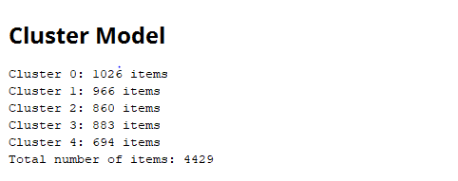

c