**PROJECT REPORT**

(Project Term January- May 2024)

## (WEATHER FORECASTING)

Submitted by

### GAGANPREET GADDEY Registration Number : 12208006

**Course Code : INT222**

### Course Title : Advance Web Development

Submitted To

### BRIJESH PANDEY Sir

**School of Computer Science and Engineering**



**DECLARATION**

We hereby declare that the project work entitled Weather Forecasting is an authentic record of our own work carried out as requirements of Capstone Project for the award of Bachlor Technology degree in Computer Science from Lovely Professional University, Phagwara, under the guidance of (Brijesh Pandey Sir), during January to May 2023. All the information furnished in this project report is based on my own intensive work and is genuine.

Project Group Number: 07

Name of Student: Gaganpreet Gaddey

Registration Number: 12208006

Gaganpreet Gaddey

(Signature of Student) Date: 14/04/24

**CERTIFICATE**

This is to certify that the declaration statement made by the student is correct to the best of my knowledge and belief. He /She have completed this Project under my guidance and supervision. The present work is the result of his/her original investigation, effort and study. No part of the work has ever been submitted for any other degree at any University. The Project is fit for the submission and partial fulfillment of the conditions for the award of B.Tech degree in Computer Science from Lovely Professional University, Phagwara.

### Brijesh Pandey Sir

### Assistant Professor

**School of Computer Science and Engineering,**

Lovely Professional University, Phagwara, Punjab.

Date : 14/04/24

## TABLE OF CONTENTS

Inner first page (i)

PAC form… (ii)

Declaration… (iii)

Certificate… (iv)

Acknowledgement… (v)

Table of Contents… (vi)

### Introduction

1. **Profile of the Problem**

### Rationale/Scope of the study (Problem Statement)

1. **Existing System**

### Introduction

* 1. **Existing Software**

### DFD for Present System

* 1. **What’s New in the System to be Developed**

### Problem Analysis

* 1. **Product Definition**

### Feasibility Analysis

1. **Software Requirement Analysis**

### Introduction

* 1. **General Description**

### Specific Requirements

1. **Design**

### System Design

* 1. **Design Notations**

### Detailed Design

* 1. **Flowcharts**

### Pseudo Code

1. **Testing**

### Functional Testing

* 1. **Non-Functional Testing**

### Implementation

* 1. **Implementation of the Project**

### Conversion Plan

* 1. **Post-Implementation and Software Maintenance**

### Project Legacy

* 1. **Current Status of the Project**

### Remaining Areas of Concern

* 1. **Technical and Managerial Lessons Learned**

### User Manual

* 1. **A Complete Document (Help Guide) of the Software Developed**

### GitHub Link (Source Code)

* 1. **Source Code Output (or) System Snapshot**

1. **Bibliography**

# Introduction: a

In an era where weather plays a crucial role in our daily lives, from planning outdoor activities to making informed travel decisions, the need for a reliable and intuitive weather application has never been greater. Our introduction serves as a beacon, illuminating the path toward a comprehensive solution that meets the diverse needs of modern users.

Weather applications have become indispensable tools for individuals, businesses, and organizations worldwide. However, the landscape of existing solutions is marked by a variety of shortcomings, ranging from inaccuracies in forecasting to cumbersome user interfaces.

Recognizing these challenges, our team has embarked on a mission to develop a cutting-edge weather application that not only addresses these issues but also sets a new standard for excellence in weather forecasting and presentation.

At its core, our weather application aims to empower users with timely, accurate, and easy-to- understand weather information tailored to their specific needs and preferences. Whether it's a detailed hourly forecast for outdoor enthusiasts, severe weather alerts for safety-conscious individuals, or long-term climate trends for businesses and policymakers, our application endeavors to deliver comprehensive weather insights with precision and clarity.

# Profile of the Problem:

The app is designed for fitness enthusiasts and individuals looking to track their exercise routines.In this section, you'll detail the problem the weather application aims to address. This could include factors like the need for accurate and accessible weather information, the inconvenience of existing weather applications, and the potential benefits of a new and improved solution. The scope of the study should outline the boundaries of the project, including the geographical area covered, the features included, and any limitations.

# Existing System:

**a. Introduction**: This section provides an overview of the current state of weather applications, including their strengths, weaknesses, and limitations. It should analyze existing software solutions in terms of their features, user experience, data accuracy, and availability. Additionally, you'll outline the current system's data flow using a Data Flow Diagram (DFD) and discuss what improvements the new system will bring.

**b. Existing Software**: There are various existing software and applications available for weather forecasting and providing weather information. Some of the most popular ones include:

|  |  |  |  |  |  |  |
| --- | --- | --- | --- | --- | --- | --- |
|  | | | | | | |
|  | ✓ | **AccuWeather** | | | : AccuWeather provides real-time weather data and forecasts. Their software | |
| is available on various platforms such as iOS, Android, and the web. | | | | | |
|  | | | | | | |
|  | ✓ | **The Weather Channel**: | | | | The Weather Channel offers comprehensive weather updates, |
| including live radar, severe weather alerts, and forecasts for the upcoming days. | | | | | |
|  | | | | | | |
|  | ✓ | **Weather Underground** | | | | : Weather Underground provides hyper-local weather forecasts and |
| real-time weather data. The app is known for its detailed information and reliable forecasts. | | | | | |
|  | | | | | | |
|  | ✓ | **WeatherBug** | | : WeatherBug offers weather forecasts, severe weather alerts, and live radar | | |
| maps. It's available on various platforms and provides a wide range of weather-related information. | | | | | |
|  | | | | | | |
|  | ✓ | **Dark Sky** | : Dark Sky (now owned by Apple) is known for its minute-by-minute weather | | | |
| forecasts and real-time data. It provides hyper-localized weather information. | | | | | |
|  | | | | | | |

.

### c. DFD for Present System:

A Data Flow Diagram (DFD) is a graphical representation of the flow of data in a system. It shows how data is input, processed, stored, and output in a system. In the context of a weather application, a DFD can help visualize the data flow between various components and entities involved in providing weather forecasts and related services.

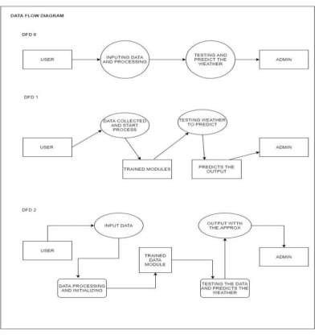

### d. What’s New in the System to be Developed:

When developing a new weather application, there are several innovative features and improvements that can be incorporated to enhance user experience and provide more valuable and personalized weather information. Here are some potential features that could be added to a new weather application:

* Hyper-Local Forecasts: Offer highly localized weather forecasts based on the user's specific location, using data from multiple sources such as local weather stations and sensors.
* Real-Time Alerts: Provide real-time alerts for severe weather events such as thunderstorms, tornadoes, hurricanes, and flash floods. Alerts can be customized based on user preferences.
* Weather Maps and Visualizations: Include interactive maps and visualizations showing real- time weather patterns, radar data, and satellite imagery.
* AI-Powered Forecasting: Utilize machine learning algorithms to analyze historical and current weather data to improve forecasting accuracy and provide more precise predictions.
* Personalized Weather Insights: Offer personalized insights based on the user's daily activities and preferences, such as commute time, outdoor exercise, or gardening.

# Problem Analysis :

### Product Definition

A modern weather application that offers users hyper-local, real-time weather forecasts and alerts tailored to their specific location and preferences. The app provides personalized insights and recommendations for daily activities, including commute, outdoor exercise, and travel plans. It features interactive maps, radar data, and satellite imagery for an immersive visual experience. Advanced AI-powered forecasting improves accuracy and provides precise predictions. The app also integrates health and air quality information, offering comprehensive insights into local conditions. Voice assistant compatibility and social sharing capabilities enhance user convenience, making it a go-to tool for staying informed about the weather.

### Feasibility Analysis

* + **Technical Feasibility**:
* Infrastructure: Leverage existing cloud-based infrastructure for data storage, processing, and delivery, which is widely available and cost-effective.
* Data Sources: Access to reliable weather data providers such as NOAA, AccuWeather, or OpenWeatherMap ensures high-quality weather information.

### Economic Feasibility:

* Development Costs: Initial development costs may include licensing data, employing skilled developers, and investing in infrastructure.
* Revenue Opportunities: Potential revenue sources include in-app ads, premium subscriptions, partnerships, and data licensing.

### Operational Feasibility:

* Scalability: Cloud-based infrastructure allows for easy scaling as user demand increases.
* Maintenance: Regular updates and maintenance ensure the app remains up-to-date with the latest weather data and features.

# Software Requirement Analysis :

### Introduction:

A software requirement analysis is a critical process in the development of a weather application. It involves understanding the needs and expectations of the users, identifying the features and functionalities the application should offer, and establishing the technical requirements to achieve the desired outcomes. This analysis lays the foundation for a successful weather application by defining clear objectives and guiding the development process.

In the context of a weather application, the requirement analysis focuses on delivering precise and timely weather information tailored to users' specific locations and preferences. The application should offer real-time forecasts, severe weather alerts, and advanced visualizations to help users make informed decisions in their daily lives.

### General Description:

A modern weather application that provides users with real-time, hyper-local weather forecasts and alerts. The app features a user-friendly interface with interactive maps, radar data, and satellite imagery for a comprehensive visual experience. It offers personalized weather insights tailored to users' daily activities and preferences, such as commute times, outdoor exercises, and travel plans.

Advanced AI-powered forecasting improves accuracy, delivering precise predictions and timely updates on severe weather events. Users can access detailed health-related information, including air quality, pollen levels, and UV index. Integration with voice assistants allows for convenient, hands-free weather updates, while social sharing features enable users to share weather insights with friends and family.

### Specific Requirements:

Functional Requirements:

Real-Time Weather Data: Provide users with real-time updates on temperature, precipitation, wind speed, and other weather parameters.

Hyper-Local Forecasts: Offer localized weather forecasts tailored to the user's specific location, updated frequently.

Severe Weather Alerts: Send timely alerts and notifications for severe weather events such as thunderstorms, tornadoes, hurricanes, and floods.

**Database Management**: The NoSQL database for the Weather Forecasting website will be MongoDB; access and manipulation will be facilitated by Node.js and the MongoDB native driver; daily backups will be used for data recovery.

The database will be routinely reported to the stakeholders using Node.js reporting tools,

periodically tweaked using MongoDB performance tuning techniques, and continuously monitored using MongoDB monitoring tools.

The website's front end will be developed with HTML, CSS, and JavaScript. AJAX will be used to interact with the Node.js program and dynamically update the web pages.

**Responsive Design**: The app should be responsive and work across various devices (desktop, tablet, mobile) to provide a consistent user experience.

**Performance Optimization**: The app should optimize data retrieval and rendering to provide a smooth user experience, even with large amounts of weather data.

**User Interface**: The user interface should be intuitive, easy to navigate, and visually appealing. It should include:

|  |  |  |  |  |
| --- | --- | --- | --- | --- |
| ✓ | The user interface of the Weather Forecasting website will be designed to be intuitive | | |  |
| and user-friendly. |  | | |
| * It will feature a clean and modern design to enhance user experience. * The interface will be responsive, ensuring a seamless experience across various devices. * Users will be able to easily navigate through the website to access weather forecasts, alerts, maps, and historical data. * Interactive elements will be incorporated to engage users and provide a dynamic experience. * Accessibility features will be implemented to cater to users with disabilities. | | | | |
| ✓ | Multiple language support will be provided to accommodate a diverse user base. | |  | |

# Design

### System Design

**Overview**: The system design of the MERN Stack weather Tracker app consists of a three-tier architecture:

**Client Side (Frontend):** Developed using React, the frontend presents the user interface and interacts with the backend via API calls.

**Server Side (Backend):** Implemented using Node.js and Express, the backend handles API requests from the frontend and manages business logic.

**Database:** MongoDB serves as the data store, holding information on weathers and user data. Interaction: The client-side application communicates with the server side through RESTful API endpoints. The server side interacts with the database to read and write data as needed.

### Design Notations :

**UML**

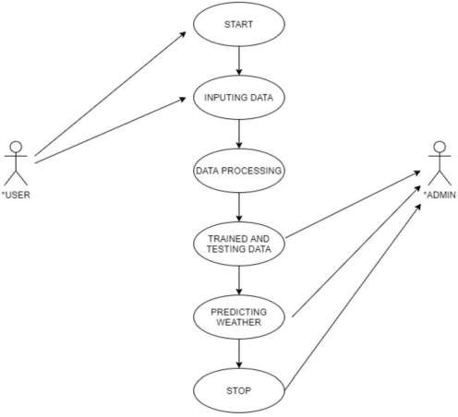

### ER DIAGRAM

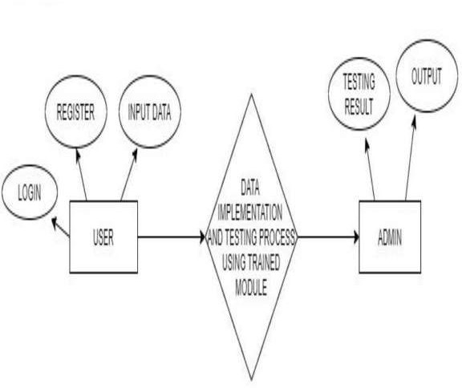

1. **Detailed Design :**

### Client-Side (Frontend) Components:

JavaScript. The following components will be included:

The client-side of the Weather Forecasting website will be developed using HTML, CSS, and

|  |  |  |  |
| --- | --- | --- | --- |
| ✓ | **Header**: The header will contain the website logo, navigation menu, and user account | |  |
| information. |  | |
| * **Search Bar**: The search bar will allow users to search for weather forecasts by location. * **Weather Forecasts**: The weather forecasts section will display the forecast for the next 5 days, including temperature, precipitation, wind speed, and humidity. * **Weather Alerts**: The weather alerts section will display any severe weather warnings or advisories for the user's location. | | | |

|  |  |  |  |
| --- | --- | --- | --- |
| * **Weather Maps**: The weather maps section will display interactive maps of weather conditions, such as radar, satellite, and temperature. * **Historical Data**: The historical data section will allow users to view weather data for previous dates. | | | |
| ✓ | **Footer**: The footer will contain links to legal information, such as terms of use and privacy | |  |
| policy. |  | |

The following technologies will be used:

|  |  |  |  |
| --- | --- | --- | --- |
| ✓ | **HTML**: The structure of the web pages will be defined using HTML5. |  | |
| * **CSS**: The style and layout of the web pages will be defined using CSS3. * **JavaScript**: The behavior of the web pages will be defined using JavaScript. * **Bootstrap**: The Bootstrap framework will be used to create a responsive and mobile- friendly design. * **JQuery**: The JQuery library will be used to simplify HTML document traversing, event handling, and animation. * **Web Fonts**: Web fonts will be used to enhance the typography and visual appeal of the web pages. * **Color Scheme**: A color scheme that aligns with the brand identity will be used to ensure consistency and recognition. * **Accessibility**: Accessibility features, such as high contrast mode and keyboard navigation, will be implemented to cater to users with disabilities. | | | |
| ✓ | **Localization**: The user interface will be localized to support multiple languages. | |  |

**State Management:**

* React State and Context: React's use State and use Context hooks manage state within components and share data across components.
* Global State: A global state (using React Context) keeps track of user and weather data to avoid unnecessary API calls.

### API Calls:

weather data. Some top APIs include:

The client-side of the Weather Forecasting website will utilize various Weather APIs to access

|  |  |  |  |
| --- | --- | --- | --- |
| ✓ | **Visual Crossing API**: Provides historical weather records and forecasts. | |  |
| * **Tomorrow.io API**: Offers advanced weather forecasting and alerts. | | | |
| ✓ | **Weather Company API**: Provides real-time weather data access. |  | |

To integrate these APIs:

|  |  |  |  |
| --- | --- | --- | --- |
| 1. | Obtain an API key from the provider. |  | |
| 1. Follow API documentation for requests and responses. 2. Make requests with the API key to access weather data. | | | |
| 4. | Parse and display the weather information on the website for users. | |  |

* 1. **Server-Side (Backend)**

### API Endpoints:

|  |  |  |  |
| --- | --- | --- | --- |
| ✓ | **GET /forecast**: Retrieve weather forecasts for a given location. | |  |
| * **GET /alerts**: Retrieve weather alerts for a given location. * **GET /maps**: Retrieve weather maps for a given location. * **GET /history**: Retrieve historical weather data for a given location. * **POST /login**: Authenticate a user and create a session. | | | |
| ✓ | **POST /logout**: Terminate a user session. |  | |

**Middleware:**

* Authentication: Middleware to handle user authentication and authorization.
* Validation: Middleware for validating incoming data, ensuring that it meets the required criteria.

### Data Models:

The Weather Forecasting website's data model includes:

|  |  |  |  |  |  |  |  |  |  |
| --- | --- | --- | --- | --- | --- | --- | --- | --- | --- |
| ✓ | **User**, | **Location**, | **Forecast**, | **Alert**, and | | **History** | entities. |  | |
| * **User** can have multiple **Locations**. * **Location** can have multiple **Forecasts**, **Alerts**, and **History** records. | | | | | | | | | |
| ✓ | The data model supports efficient storage and retrieval of weather data and user | | | | | | | |  |
| authentication and authorization. | | | |  | | | | |

* 1. **Database**

### Schema Design:

The schema design for the Weather Forecasting website includes:

|  |  |  |  |  |  |  |  |
| --- | --- | --- | --- | --- | --- | --- | --- |
| ✓ | **User**, | **Location**, | **Forecast**, | **Alert**, and | **History** | schemas. |  |
| * Optimized for efficient data storage and retrieval. * Supports data validation and integrity. * Normalized for scalability and performance. * Supports indexing for fast data retrieval. | | | | | | | |
| ✓ | Flexible and extensible for future growth and evolution. | | | | | |  |

**Indexing:**

* Optimize database queries by creating indexes on commonly searched fields such as weather name or user email.

### Other Components

**Error Handling:**

* Frontend: Handle errors gracefully and provide feedback to users when operations fail.
* Backend: Implement proper error handling in API endpoints to return meaningful error responses.

### Security:

* Implement security measures such as input validation, rate limiting, and HTTPS to protect user data and prevent attacks.

### Flowchart :

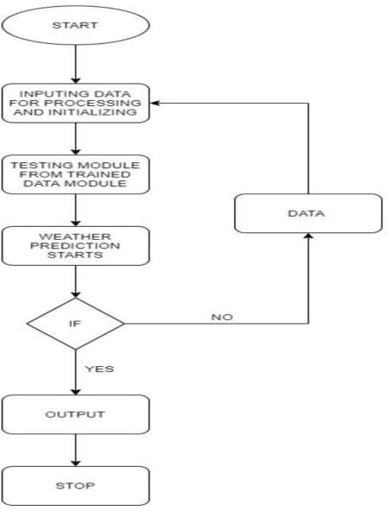

1. **Pseudo Code :**

|  |  |  |
| --- | --- | --- |
| ➢ | **Get Weather Forecast for a Specific Location:** |  |

function getWeatherForecast(location) { response = callWeatherAPI(location) forecast = parseWeatherResponse(response) return forecast

}

|  |  |  |
| --- | --- | --- |
| ➢ | **Add Location to Tracked Locations:** |  |

function addLocationToTracked(location) { if (isValidLocation(location)) { user.addTrackedLocation(location) saveUserData(user)

}

}

|  |  |  |
| --- | --- | --- |
| ➢ | **Display Tracked Locations:** |  |

function displayTrackedLocations() { locations = user.getTrackedLocations() displayLocations(locations)

}

|  |  |  |
| --- | --- | --- |
| ➢ | **Send Weather Alert for a Location:** |  |
| function sendWeatherAlert(location) { if (isAuthorizedToSendAlerts()) { sendAlert(location)  }  }   * Display Weather History for a Location: function displayWeatherHistory(location) { history = getWeatherHistory(location)   displayHistory(history) | | |

}

➢

**Display Current Weather Conditions:**

function displayCurrentWeather(location) { conditions = getCurrentWeather(location) displayConditions(conditions)

}

➢

**Display Weather Map for a Location:**

function displayWeatherMap(location) { map = getWeatherMap(location) displayMap(map)

}

➢

**Display Hourly Weather Forecast:**

function displayHourlyForecast(location) { forecast = getHourlyForecast(location) displayForecast(forecast)

}

➢

**Display Daily Weather Forecast:**

function displayDailyForecast(location) { forecast = getDailyForecast(location) displayForecast(forecast)

}

➢

**Display Weather Alerts for a Location:**

function displayWeatherAlerts(location) { alerts = getWeatherAlerts(location) displayAlerts(alerts)

}

# Testing :

### Functional Testing

Functional testing focuses on verifying that the application performs according to the requirements and specifications. This type of testing ensures that the MERN Stack Weather Tracker app meets the functional requirements and expectations of the end users. It checks each function of the application to confirm that it behaves as intended.

### Overview:

Functional testing aims to test the application's key features and operations to ensure they work as expected. This includes testing user interactions, data processing, and feedback from the application. Testers simulate user scenarios to verify that the application handles inputs correctly and produces accurate outputs.

### Scope:

The scope of functional testing includes all major features and functionalities of the application, such as:

* Creating, reading, updating, and deleting weathers.
* Validating user input for weather creation and updates.
* Handling error scenarios appropriately, such as invalid data.
* Displaying feedback to users, including success or error messages.
* Data persistence through the MongoDB database.

### Test Cases:

Here are a few sample test cases for functional testing of the application:

**API Testing for Weather Forecast ApplicationDescription:**

|  |  |  |
| --- | --- | --- |
| Verify accuracy and reliability of API responses for weather forecasting | |  |
| application.**Preconditions:** | Access to weather forecast API, test environment set up.**Steps:** | |

|  |  |  |
| --- | --- | --- |
| 1. | Send GET request to API endpoint for specific location and date. |  |
| 1. Verify API response includes expected weather data. 2. Send GET request with invalid parameters. 3. Verify API response returns appropriate error message. | | |

|  |  |  |
| --- | --- | --- |
| 1. Send GET request with missing required fields. 2. Verify API response includes error message for missing fields. 3. Send GET request with valid parameters and optional fields. 4. Verify API response includes optional fields if available. 5. Send GET request with valid parameters and check response time. | | |
| 10. | Verify API response time is within acceptable limits. |  |

**Expected Outcomes:**

|  |  |  |  |
| --- | --- | --- | --- |
| 1. | API response for specific location and date should include accurate weather data. | |  |
| 1. API should return appropriate error message for invalid parameters. 2. API should provide error message for missing required fields. 3. Optional fields should be included in API response if available. | | | |
| 5. | API response time should be within acceptable limits for optimal performance. |  | |

**Test Cases For Weather Widgets:**

|  |  |  |  |  |
| --- | --- | --- | --- | --- |
| **Description:** | Validate the functionality and user experience of the weather widget on a weather | | | |
| forecasting application.**Preconditions:** | | | Weather widget integrated into the application, test |  |
| environment set up.**Steps:** | |  | | |

|  |  |  |  |
| --- | --- | --- | --- |
| 1. | Add the weather widget to the application's dashboard. | |  |
| 1. Verify the weather forecast is displayed accurately for a specific city. 2. Check that the temperature is shown in both Fahrenheit and Celsius. 3. Test the ability to add and switch between multiple cities. 4. Verify all settings and configurations are saved and retrieved correctly. 5. Ensure the correct weather icons are displayed for different weather conditions. 6. Validate the forecast breakdown by time slices. 7. Check the accuracy of the temperature graph. 8. Verify the forecast for future dates. | | | |
| 10. | Test error messages and widget layout. |  | |

**Expected Outcomes:**

|  |  |  |
| --- | --- | --- |
| 1. | The weather widget is successfully added to the dashboard. |  |

|  |  |  |
| --- | --- | --- |
| 1. Accurate weather forecast is displayed for the selected city. 2. Temperature is shown in both Fahrenheit and Celsius. 3. Multiple cities can be added and switched between. 4. Settings and configurations are saved and retrieved accurately. 5. Correct weather icons are displayed. 6. Forecast breakdown by time slices is accurate. 7. Temperature graph is displayed correctly. 8. Future date forecasts are accurate. | | |
| 10. | Error messages are informative and widget layout is visually appealing. |  |

### Expected Outcomes for Each Test Case :

For each test case, expected outcomes include:

* Successful completion of the test scenario.
* Appropriate feedback provided to the user, such as success or error messages.
* Consistent behavior across different test runs.
* Correct persistence and retrieval of data in the MongoDB database.

These test cases help ensure that the application's functionalities work as expected and meet the users' needs.

### Non-Functional Testing

* + 1. **Performance Testing:**
* Load Testing: Determine how the application behaves under expected load conditions. Tools like Apache JMeter can simulate multiple users accessing the application simultaneously.
* Stress Testing: Assess the system's behavior under extreme conditions, beyond its normal operational capacity. This ensures the app can handle unexpected spikes in traffic or resource usage

### Reliability Testing:

* Recovery Testing: Verify the application's ability to recover from failures gracefully, such as server crashes or database outages.
* Availability Testing: Measure the application's uptime and availability under normal operating conditions as well as during maintenance or updates.

### Scalability Testing:

* Vertical Scaling: Assess the application's ability to handle increased workload by adding more resources, such as CPU or RAM, to the server.
* Horizontal Scaling: Test the application's ability to scale out by adding more instances or nodes to the server infrastructure**.**

### Compatibility Testing:

* Browser Compatibility: Test the application across different web browsers (e.g., Chrome, Firefox, Safari) to ensure consistent behavior and appearance.
* Device Compatibility: Verify the application works correctly on various devices and screen sizes, including desktops, laptops, tablets, and smartphones.

### Documentation Review:

* Evaluate the completeness and accuracy of documentation, including user manuals, installation guides, and API documentation.

# Implementation :

### Implementation of the Project:

* + 1. Development Environment Setup:
* Set up development environments for both frontend (React) and backend (Node.js with Express).
* Install necessary dependencies using npm or yarn.
  + 1. Backend Development:
* Create API endpoints for CRUD operations on weathers.
* Implement middleware for authentication and data validation.
* Set up MongoDB database and define schemas for weathers and users.
* Test API endpoints using tools like Postman to ensure they function correctly.
  + 1. Frontend Development:
* Develop React components for creating, updating, and deleting weathers.
* Implement data fetching and updating using React hooks.
* Design user interface elements for a seamless user experience.
* Ensure responsiveness across various devices using CSS frameworks like Bootstrap or Tailwind CSS.
  + 1. Integration:
* Connect frontend and backend components to enable communication via API calls.
* Test end-to-end functionality to ensure proper integration between frontend and backend.
  + 1. Testing:
* Conduct thorough testing of both frontend and backend components.
* Perform unit tests, integration tests, and system tests to identify and fix any bugs or issues.
  + 1. Deployment:
* Deploy the application to a hosting platform such as Heroku or AWS.
* Set up continuous integration and continuous deployment (CI/CD) pipelines for automated deployment.

### Conversion Plan:

* + 1. Data Migration:
* If migrating from an existing system, plan and execute data migration to transfer weather data to the new system.
* Ensure data integrity and consistency during the migration process.
  + 1. Communication:
* Communicate with stakeholders about the conversion plan, including timelines, and mitigation strategies.
* Address any concerns or questions raised by stakeholders throughout the conversion process.

### Post-Implementation and Software Maintenance:

* + 1. Monitoring and Performance Optimization:
* Monitor application performance and address any bottlenecks or issues that arise.
* Optimize code and database queries for improved efficiency and scalability.
  + 1. User Support:
* Provide ongoing user support to address any questions or issues encountered by users.
* Implement a ticketing system or helpdesk to track and manage user requests effectively.
  + 1. Software Updates and Enhancements:
* Regularly update the software to incorporate new features, bug fixes, and security patches.
* Gather feedback from users to identify areas for improvement and prioritize enhancements accordingly.
  + 1. Documentation and Knowledge Sharing:
* Maintain up-to-date documentation for the application, including user manuals, API documentation, and development guidelines.
* Foster knowledge sharing among team members to ensure continuity and sustainability of the project.
  + 1. Security and Compliance:
* Stay vigilant against security threats and vulnerabilities by implementing best practices for secure coding and infrastructure.
* Ensure compliance with relevant regulations and standards, such as GDPR or HIPAA, if applicable.

# 9. Project Legacy:

### Current Status of the Project:

The current status of the MERN Stack Weather Informer project involves its successful implementation and deployment. Users are actively using the application to knowing the

accurate, real-time weather information with its intuitive interface and real-time data updates. The project has fulfilled its initial objectives of providing a centralized platform for weather management , leveraging modern technologies such as MongoDB, Express, React, and Node.js.

### Remaining Areas of Concern:

While the project has achieved its primary goals, there may still be some areas of concern that require attention:

1. User Feedback and Iterative Improvements:

* Continuous solicitation of user feedback is crucial for identifying areas of improvement and evolving the application to better meet user needs.

1. Performance Optimization:

* Ongoing monitoring and optimization of application performance are essential to ensure scalability and responsiveness, especially as user traffic grows.

1. Security Enhancements:

* Regular security audits and updates are necessary to address emerging threats and vulnerabilities, safeguarding user data and application integrity.

1. Feature Expansion:

* The project may benefit from future feature expansions, such as user authentication, social sharing capabilities, or integration with wearable fitness devices.

### Technical and Managerial Lessons Learned:

* 1. Agile Development Practices:
* Embracing Agile methodologies such as Scrum or Kanban enables iterative development cycles, fostering adaptability and responsiveness to changing requirements.
  1. Effective Communication:
* Clear and transparent communication among team members, stakeholders, and end users is paramount for project success, ensuring alignment of expectations and goals.
  1. Continuous Learning and Skill Development:
* Encouraging a culture of continuous learning and skill development empowers team members to stay abreast of emerging technologies and best practices, driving innovation and efficiency.
  1. User-Centric Design:
* Prioritizing user experience and usability throughout the development process enhances adoption and satisfaction, leading to higher user engagement and retention.
  1. Collaborative Problem-Solving:
* Cultivating a collaborative environment where team members collaborate to solve challenges fosters creativity and synergy, enabling the project to overcome obstacles effectively.

# 10. User Manual:

### A complete guide of the Software Developed

MERN Stack Weather Tracker App Guide

1. Introduction

* Overview: The MERN Stack Weather app is a web-based application that helps users efficiently manage and track the real- time weather condition in the specific area.
* Audience: This app is designed for all kinds of people who wants to know the weather condition in their specific area.

1. Getting Started

* Installation:

Download the app from the official repository or website.

Ensure you have Node.js and MongoDB installed on your system. Run npm install to install necessary dependencies.

* Configuration:

Set up a MongoDB database and obtain the connection URI.

Update the app's configuration file with your database connection URI and any other required settings.

1. App Features

The app features for a weather forecasting website or app may include:

|  |  |  |
| --- | --- | --- |
| ✓ | Hyper-local forecasts |  |
| * Weather visualizations * Historical temperature trends | | |

|  |  |  |
| --- | --- | --- |
| * Drought monitoring * Global climate change maps * User-friendly interface * Earth time-lapse * Rain predictions * Sunrise and sunset times * UV index * Weather and climate maps * Humidity, visibility, and wind predictions * Push notifications | | |
| ✓ | API integrations |  |

1. User Interface

The user interface of the Weather Forecasting website should:

|  |  |  |  |  |
| --- | --- | --- | --- | --- |
| ✓ | Be simple and easy to navigate | |  | |
| * Be responsive and adapt to different screen sizes and devices * Follow Web Content Accessibility Guidelines (WCAG) 2.1 for accessibility * Provide interactive elements for easy adjustment of settings and preferences * Be visually appealing and consistent in design * Allow users to personalize their experience * Provide clear and timely feedback | | | | |
| ✓ | Offer help and support resources, such as a FAQ section or contact information for customer | | |  |
| support. |  | | |

1. Troubleshooting and FAQs

Common issues for weather forecasting websites and apps include:

|  |  |  |
| --- | --- | --- |
| ✓ | Inaccurate forecasts |  |
| * Lack of personalization * Data overload * Lack of user-friendly interface | | |

|  |  |  |
| --- | --- | --- |
| * Lack of real-time updates | | |
| ✓ | Lack of structured data |  |

### GitHub Link (Source Code)

<https://github.com/Avigupta12/Weather-Forecasting-Website>

1. **Source Code Output (or) System Snapshots**

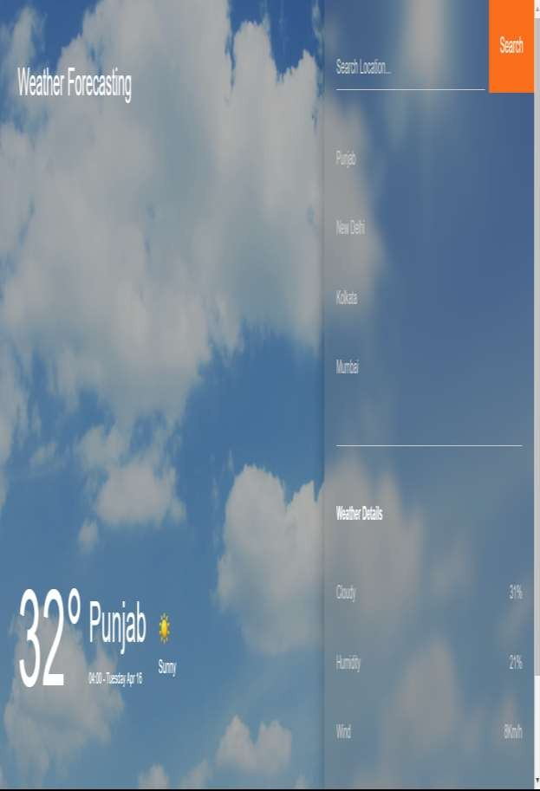

# 11. Bibliography:

Node.js Documentation. (n.d.). Node.js API Reference. Retrieved from https://nodejs.org/docs/latest/api/.

MongoDB Documentation. (n.d.). MongoDB Documentation. Retrieved from https:/[/www.mongodb.com/docs/.](http://www.mongodb.com/docs/)

React Documentation. (n.d.). React Getting Started. Retrieved from https://legacy.reactjs.org/docs/getting-started.html.

GeeksforGeeks. (n.d.). How to Create a Simple Server using Express.js. Retrieved from https:/[/www.ge](http://www.geeksforgeeks.org/how-to-create-a-simple-server-using-express-js/)e[ksforgeeks.org/how-to-create-a-simple-server-using-express-js/.](http://www.geeksforgeeks.org/how-to-create-a-simple-server-using-express-js/)

Mern.io. (n.d.). MERN.io Tutorial. Retrieved from https://mern.io/.

DigitalOcean. (n.d.). How To Build a MERN Stack App: A Complete Guide. Retrieved from https:/[/www.digitaloc](http://www.digitalocean.com/community/tutorials/mern-stack-application-1)e[an.com/community/tutorials/mern-stack-application-1.](http://www.digitalocean.com/community/tutorials/mern-stack-application-1)

Codecademy. (n.d.). Learn the MERN Stack. Retrieved from https:/[/www.code](http://www.codecademy.com/learn/learn-mern-stack)c[ademy.com/learn/learn-mern-stack.](http://www.codecademy.com/learn/learn-mern-stack)