**Chapter 1**

**Introduction**

W

ith rise of population, it is expected in the near future, that the demand for energy will grow faster than the finding out of new available fossil resources. There is a need for finding an alternative source of energy. The international scientific community has devoted intense efforts to develop and promote Solar Energy due to availability without any limit. In this project a solar panel installation guide for efficiency maximization referring solar energy production is developed. The solution developed is to figure out the finest position and direction angle of a solar panel to capture maximum sunlight and give the optimal results all year round. However, to maximize their energy efficiency, it is crucial to understand the significance of solar panel tilt angle. This mini-project delves into the critical aspect of optimizing the tilt angle of solar panels, exploring its impact on energy generation, environmental benefits, and economic considerations.

Solar panel tilt angle, also known as the solar panel's inclination or tilt angle, plays a pivotal role in determining the efficiency of a solar energy system. It affects the angle at which sunlight strikes the solar panels and, consequently, the amount of energy that can be harvested. By adjusting the tilt angle, we can harness the sun's energy more effectively, increasing the overall performance of the solar panel system. This project aims to investigate how different geographical locations, seasons, and panel orientations influence the optimal tilt angle and its potential benefits.

By gaining insights into the optimal tilt angle for solar panels, this mini-project aims to contribute to the growing body of knowledge surrounding sustainable energy solutions. Additionally, we will delve into the economic aspects, evaluating the cost-effectiveness of adjusting panel tilt angles and the potential return on investment for homeowners and businesses. Ultimately, this research seeks to empower individuals and organizations to make informed decisions about their solar energy systems, contributing to a more sustainable and greener future.

**Chapter 2**

**Literature Review**

Optimizing the tilt angle of solar panels has been a subject of considerable research interest in the field of photovoltaic systems. Numerous studies have focused on the influence of solar panel tilt angles on energy production and system efficiency. One common finding across various geographic locations is that the optimal tilt angle often deviates from the panel's latitude angle. For instance, research by Esen and Inalli [1] demonstrated that in locations with higher solar radiation, setting the tilt angle to be higher than the latitude angle can lead to a significant increase in energy yield. Conversely, locations with lower solar radiation may benefit from a tilt angle lower than the latitude angle. Such findings underscore the importance of considering local climatic conditions when determining optimal tilt angles, as it can have a substantial impact on the economic viability of solar installations.

Moreover, advances in technology, including tracking systems and smart controllers, have enabled dynamic tilt angle adjustments that follow the sun's position throughout the day. Studies like that by Skoplaki and Palyvos (2009) have shown that tracking systems can further enhance energy generation by consistently aligning the panels with the sun. However, the increased complexity and cost associated with tracking systems need to be weighed against the additional energy gains. Overall, this literature review highlights the significance of optimizing solar panel tilt angles for maximizing energy output and provides a foundation for the design and analysis of our mini-project, which aims to contribute to the growing body of knowledge on this subject.

**Chapter 3**

**Problem Formulation**

**3.1 Problem Statement**

From the past two decades it is observed that, energy consumption is increased by 50 per cent, with the bulk of the demand coming from developing countries. Oil, coal and gas, which are Fossil Fuels, together account for the majority of global primary energy consumption. There is a need for finding an alternative source of energy. Solar Energy is considered to be the best contender to tackle the energy needs of population. However, on the consumer level the knowledge of different types of solar panels and the installation methodology is over whelming for a person. The maintenance and improvement activity poses another challenge to the consumers.

**3.2 Objectives**

* Our primary objective is to maximize the output coming from the solar panels by obtaining the optimum tilt angle for the solar panels.
* To develop a module for computing the optimum solar panel tilt angle.
* To design a module which provides the static data of the average tilt angle of the five major cities of India i.e., Delhi, Mumbai, Bengaluru, Kolkata, Chennai.
* To design a module which also asks the user to prompt the latitude of your location which will further provide the tilt angle for different seasons at that particular location

**Chapter 4**

**Requirement Specification**

Requirements specification is a specification of software requirements and hardware requirements required to do the project. Requirements analysis encompasses those tasks that go into determining the needs or conditions to meet for a new or altered product or project, taking account of the possibly conflicting requirements of the various stakeholders, analyzing, documenting, validating and managing software or system requirements.

**4.1 Software Requirements**

* **C++ Compiler**: You need a C++ compiler to compile and run C++ programs. There are several C++ compilers available, and you can choose one based on your preference and platform. Some popular C++ compilers include:
* **GCC (GNU Compiler Collection)**: Available on Linux and can also be installed on Windows using MinGW or MSYS2.
* **Microsoft Visual C++ (MSVC)**: Available on Windows.
* **Visual Studio Code**: A free and highly extensible code editor with C++ support through extensions.
* **Code: Blocks**: An open-source, cross-platform IDE.
* **Operating System**: You can write and run C++ code on various operating systems, including Windows, Linux, and macOS. Ensure you have a compatible development environment for your chosen OS.
* **Text Editor or IDE Configuration**: If you're using an IDE, you may need to configure it to use the C++ compiler and set up project properties.
* **C++ Standard Library**: Typically, the C++ standard library comes bundled with the compiler. You don't need to install it separately.
* **Make sure the C++ compiler is in your system's PATH environment variable** so that you can run it from the command line.

**Chapter 5**

**System Architecture**

System design is an important phase in software or system development. System design can be defined as method of defining different modules required for software or system to fulfill all requirements.

**5.1 Block Diagram**

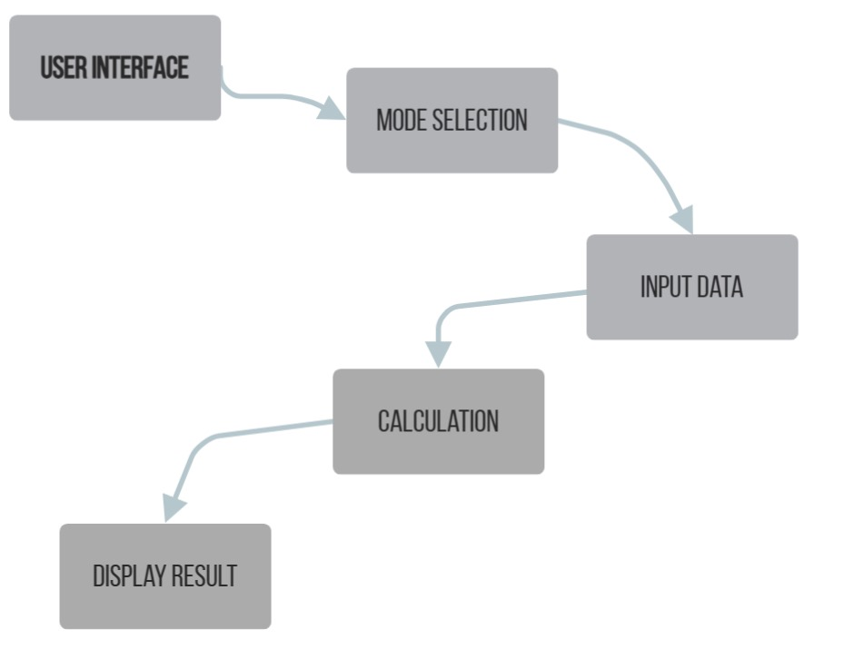

Fig 5.1:

The *fig.5.1* illustrates how the optimal solar angle changes month by month

**5.2 Flowchart/class diagram**

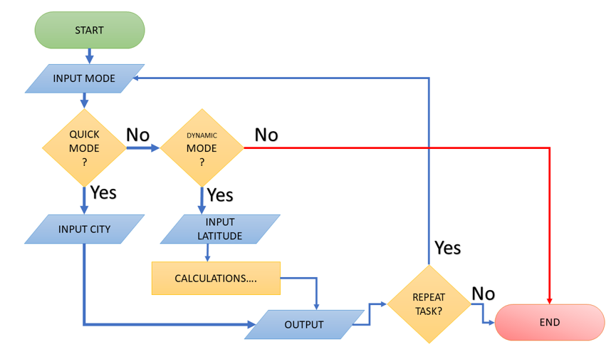

**Chapter 6**

**Implementation**

Implementation is the process of development of an application. Once the system design is completed then actual development of the system will start. The development of applications using system design is called the implementation phase. In this phase, largest system is divided into small modules. For each module, algorithms are developed, and each algorithm is coded using programming languages.

Implementing a solar panel tilt angle calculator program involves creating a software application or script that calculates the optimal tilt angle for solar panels based on various factors such as location, season, and solar panel efficiency. Here's a step-by-step guide on how to create such a program

**1.Gather Input Data:**

Latitude of the solar panel installation location. Desired optimization criteria (e.g., year/seasonal optimal angle).

**2.Calculate Solar Declination Angle:**

The solar declination angle varies throughout the year and depends on the latitude of the location. Use trigonometric functions to calculate it for each day of the year. Also, displays pre-updated values for the whole year on the monthly basis for some selected cities. This list also contains an averaged-out value on the season basis in Quick Mode

**3.Determine Optimal Tilt Angle:**

Calculate the optimal tilt angle using mathematical formulas or algorithms. Common methods include Fixed Tilt Angle: For simplicity, you can use a fixed tilt angle based on the latitude (e.g., latitude + 10 degrees for maximum yearly production).

**4.Seasonal Adjustment:**

Adjust the tilt angle for each season to maximize energy production during specific times of the year.

**5.Output Results:**

Display the calculated optimal tilt angle or angles for various time periods (e.g., monthly, seasonal) to the user.

**Chapter 7**

**Results & Snapshots**

Results basically refer to any output that comes as a result of the completion of the activities that have been performed as part of the project or a particular project component.

Our Program display the calculated optimal tilt angle or angles for various time periods (e.g., monthly, seasonal) to the user depending upon mode of operation selected and latitude or city entered.

Our program operates in two different modes namely: -

Quick Mode

Dynamic Mode

Illustrations (Dynamic Mode)

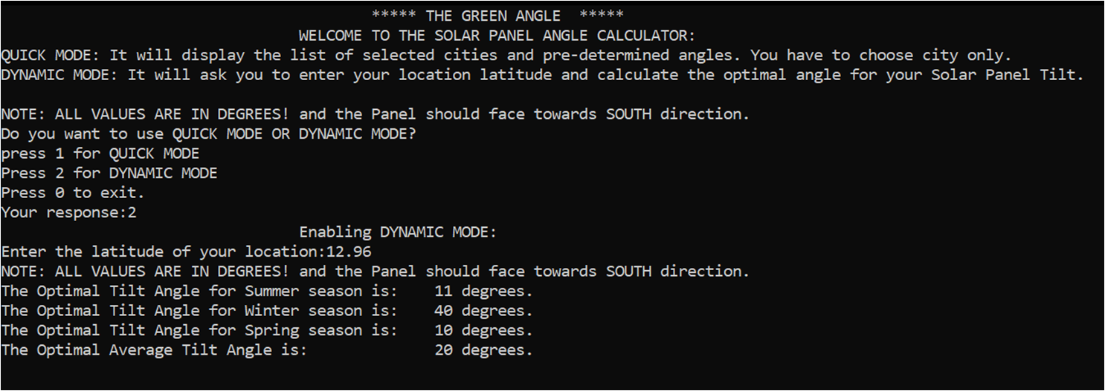

Fig. 7.1 Dynamic Mode

Illustrations (QUICK Mode)

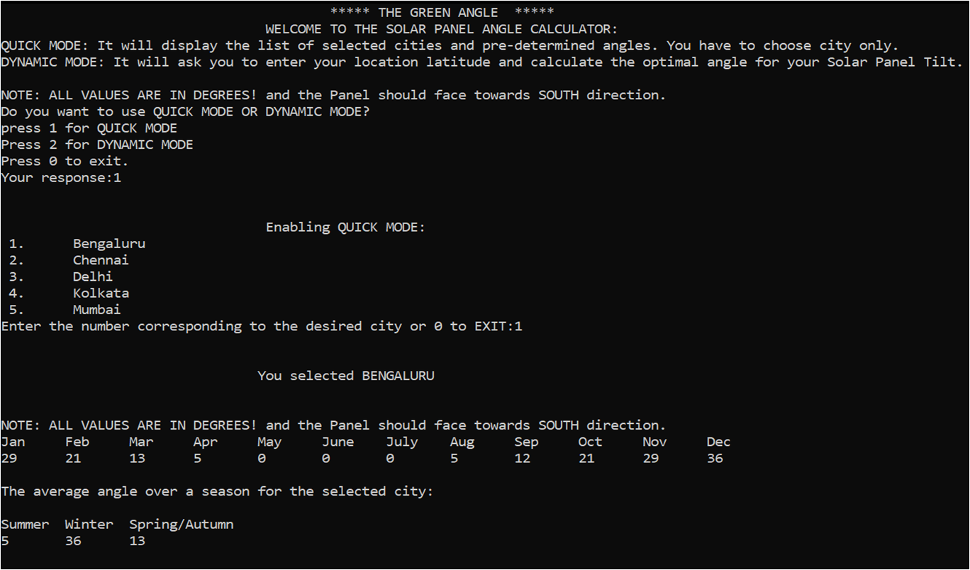

Fig. 7.2 Quick mode

**Chapter 8**

**Conclusions and Future Work**

In conclusion, the "Solar Angle Calculator" mini project has successfully addressed the critical need for optimizing solar panel tilt angles to maximize energy generation efficiency. Solar panels are a key component of the renewable energy landscape, and their performance hinges on their orientation towards the sun. This project has developed a user-friendly C++ based calculator that empowers users to determine the ideal panel tilt angle by considering their geographical latitude, date, and hour angle.

By leveraging mathematical formulas for solar declination and solar zenith angles, this calculator provides users with a precise and location-specific optimal tilt angle. This information is invaluable for solar panel installation, maintenance, and system design, as it contributes to optimizing energy generation and improving the financial viability of solar installations.

Ultimately, the "Solar Angle Calculator" mini project contributes to the broader mission of promoting sustainable and efficient energy solutions. By making this tool accessible to a wide range of users, we enable individuals, businesses, and organizations to harness the full potential of solar energy, reduce their environmental footprint, and make informed decisions that lead to a brighter and more sustainable future.

**Future Work**

* The program can be integrated with appropriate hardware to automatically change the tilt of solar panel according to optimal solar angle to optimize the power output.
* Program can be made more user friendly by changing the input method from latitude of city to name of city directly by integrating an API which gives the latitude of the entered city to the program, which is taken as an input to calculate the optimal solar angle in dynamic mode

**Bibliography**

International Journal of Energy and Environment (IJEE), Volume 6, Issue 4, 2015, pp.367-376

ISSN 2076-2895 (Print), ISSN 2076-2909 (Online) ©2015 International Energy & Environment Foundation. All rights reserved.

376

7. Conclusion

The priceless feature of solar energy applications, it consumes free fuel which is the solar radiation.

Unfortunately, the sun is moving continuously. So, Sun Tracking systems are used to keep the sun rays

perpendicular on the solar collector as possible. Trackers add cost and maintenance to the system depend

on if they are simple, complicated and so on. Choosing the right tracker is made after studying the sun

position and how much gain will be earned by installing the tracker.

A solar path and angles simulation was taken for

[1] Jae-Sub Ko and Dong-Hwa Chung, “Control of a Novel PV Tracking System Considering the Shadow Influence” Journal of Electrical Engineering & Technology Vol. 7, No. 4, pp. 524~529, 2012,524.

[2] Haberlin, H. (2012). Photovoltaics system design and practice, John Wiley & Sons, Chichester, West Sussex, United Kingdom. ISBN 978-1-119-99285.

[3] J.A. Duffie, and W.A. Beckman, Solar engineering of thermal processes, John Wiley and Sons Inc., New York, 2013.

[4] D. H., W. Li. and T. N., T. Lam. (Determining the Optimum Tilt Angle and Orientation for Solar Energy Collection Based on Measured Solar Radiance Data); Hindawi Publishing Corporation International Journal of Photoenergy-Volume 2007, Article ID 85402, 9 pages doi:10.1155/2007/85402

[5] R. Perez, P. Ineichen, R. Seals, J. Michalsky, and R. Stewart, “Modeling daylight availability and irradiance components from direct and global irradiance,” Solar Energy, vol. 44, no. 5, pp. 271- 289, 1990.

[6] Kalogirou S. Solar Energy Engineering: Processes and Systems. – Academic Press, 2009.