I didn’t find a suitable help or tutorial on how to create a fresh FreeRTOS project for nRF52840 so it is preferred to copy any FreeRTOS based example project from the nrf/example and modify the project as needed. The same project will be used to test FreeRTOS features until unless a change or update is not mentioned for a specific project.

**Use nRF5 SDK from External path**

Usually, the nRF5 SDK directory structure should be followed to build a project but the absolute external path to SDK can be assigned to User Include Directories so that the created projects can be moved to other folders easily.

1. Copy any FreeRTOS based project to any folder such as Blinky RTOS for nRF52840.
2. Navigate to the ‘**ses**’ folder such as

“D:\FreeRTOS\01-SES-create-freeRTOS-project\blinky_freertos\**pca10056**\blank\**ses**”.

1. Delete “**.emSession**” file.
2. Open “**.emProject**” file in notepad to edit it.
3. Create a new MACRO named SDK after CMSIS_CONFIG_TOOL macro and don’t forget to put a semi-colon before creating the SDK macro:

macros="CMSIS_CONFIG_TOOL=**D:/nrfsdk/nRF5_SDK_17.1.0_ddde560**/external_tools/cmsisconfig/CMSIS_Configuration_Wizard.jar;**SDK=D:/nrfsdk/nRF5_SDK_17.1.0_ddde560**"

1. Use the newly created SDK macro as $(SDK) to replace most of the occurrences of ../../../ in the paths of include directories such as:

<folder Name="Segger Startup Files">

<file file_name="$(StudioDir)/source/thumb_crt0.s" />

</folder>

<folder Name="nRF_Log">

<file file_name="**$(SDK)**/components/libraries/log/src/nrf_log_frontend.c" />

<file file_name="**$(SDK)/**components/libraries/log/src/nrf_log_str_formatter.c" />

</folder>

<folder Name="Board Definition">

<file file_name="**$(SDK)**/components/boards/boards.c" />

</folder>

<folder Name="Third Parties">

<file file_name="**$(SDK)**/external/freertos/source/croutine.c" />

<file file_name="**$(SDK)**/external/freertos/source/event_groups.c" />

<file file_name="**$(SDK)**/external/freertos/source/portable/MemMang/heap_1.c" />

<file file_name="**$(SDK)**/external/freertos/source/list.c" />

<file file_name="**$(SDK)**/external/freertos/portable/GCC/nrf52/port.c" />

<file file_name="**$(SDK)**/external/freertos/portable/CMSIS/nrf52/port_cmsis.c" />

<file file_name="**$(SDK)**/external/freertos/portable/CMSIS/nrf52/port_cmsis_systick.c" />

<file file_name="**$(SDK)**/external/freertos/source/queue.c" />

<file file_name="**$(SDK)**/external/freertos/source/stream_buffer.c" />

<file file_name="**$(SDK)**/external/freertos/source/tasks.c" />

<file file_name="**$(SDK)**/external/freertos/source/timers.c" />

</folder>

<folder Name="nRF_Libraries">

<file file_name="**$(SDK)**/components/libraries/button/app_button.c" />

<file file_name="**$(SDK)**/components/libraries/util/app_error.c" />

<file file_name="**$(SDK)**/components/libraries/util/app_error_handler_gcc.c" />

<file file_name="**$(SDK)**/components/libraries/util/app_error_weak.c" />

<file file_name="**$(SDK)**/components/libraries/timer/app_timer_freertos.c" />

<file file_name="**$(SDK)**/components/libraries/util/app_util_platform.c" />

<file file_name="**$(SDK)**/components/libraries/util/nrf_assert.c" />

<file file_name="**$(SDK)**/components/libraries/atomic/nrf_atomic.c" />

<file file_name="**$(SDK)**/components/libraries/balloc/nrf_balloc.c" />

<file file_name="**$(SDK)**/external/fprintf/nrf_fprintf.c" />

<file file_name="**$(SDK)**/external/fprintf/nrf_fprintf_format.c" />

<file file_name="**$(SDK)**/components/libraries/memobj/nrf_memobj.c" />

<file file_name="**$(SDK)**/components/libraries/ringbuf/nrf_ringbuf.c" />

<file file_name="**$(SDK)**/components/libraries/strerror/nrf_strerror.c" />

</folder>

<folder Name="nRF_Drivers">

<file file_name="**$(SDK)**/integration/nrfx/legacy/nrf_drv_clock.c" />

<file file_name="**$(SDK)**/components/drivers_nrf/nrf_soc_nosd/nrf_nvic.c" />

<file file_name="**$(SDK)**/components/drivers_nrf/nrf_soc_nosd/nrf_soc.c" />

<file file_name="**$(SDK)**/modules/nrfx/soc/nrfx_atomic.c" />

<file file_name="**$(SDK)**/modules/nrfx/drivers/src/nrfx_clock.c" />

<file file_name="**$(SDK)**/modules/nrfx/drivers/src/nrfx_gpiote.c" />

</folder>

<folder Name="Board Support">

<file file_name="**$(SDK)**/components/libraries/bsp/bsp.c" />

</folder>

<folder Name="Application">

<file file_name="../../../main.c" />

<file file_name="../config/sdk_config.h" />

</folder>

<folder Name="None">

<file file_name="**$(SDK)**/modules/nrfx/mdk/ses_startup_nrf52840.s" />

<file file_name="**$(SDK)**/modules/nrfx/mdk/ses_startup_nrf_common.s" />

<file file_name="**$(SDK)**/modules/nrfx/mdk/system_nrf52840.c" />

</folder>

</project>

1. There is no change in the highlighted part because those file paths are local to application or project. The “**main.c**” is the main source file path and other is “**sdk_config.h**”.
2. There is another important thing to notice in the file during editing is the C User Include Directories as following:

c_user_include_directories="**../../../config;**$(SDK)/components;$(SDK)/components/boards;$(SDK)/components/drivers_nrf/nrf_soc_nosd;$(SDK)/components/libraries/atomic;$(SDK)/components/libraries/balloc;$(SDK)/components/libraries/bsp;$(SDK)/components/libraries/button;$(SDK)/components/libraries/experimental_section_vars;$(SDK)/components/libraries/log;$(SDK)/components/libraries/log/src;$(SDK)/components/libraries/memobj;$(SDK)/components/libraries/ringbuf;$(SDK)/components/libraries/strerror;$(SDK)/components/libraries/timer;$(SDK)/components/libraries/util;$(SDK)/components/toolchain/cmsis/include;$(SDK)/;$(SDK)/external/fprintf;$(SDK)/external/freertos/config;$(SDK)/external/freertos/portable/CMSIS/nrf52;$(SDK)/external/freertos/portable/GCC/nrf52;$(SDK)/external/freertos/source/include;$(SDK)/integration/nrfx;$(SDK)/integration/nrfx/legacy;$(SDK)/modules/nrfx;$(SDK)/modules/nrfx/drivers/include;$(SDK)/modules/nrfx/hal;$(SDK)/modules/nrfx/mdk;**../config**"

1. The first highlighted path is for FreeRTOS config “**FreeRTOSConfig.h**” in the project’s local directory and no need to add $(SDK) macro.

D:\FreeRTOS\01-SES-create-freeRTOS-project\blinky_freertos\config

1. Save the file and double click on it to open the Segger Embedded Studio with modified file.
2. Right Click on Project name from left side Project Explorer.

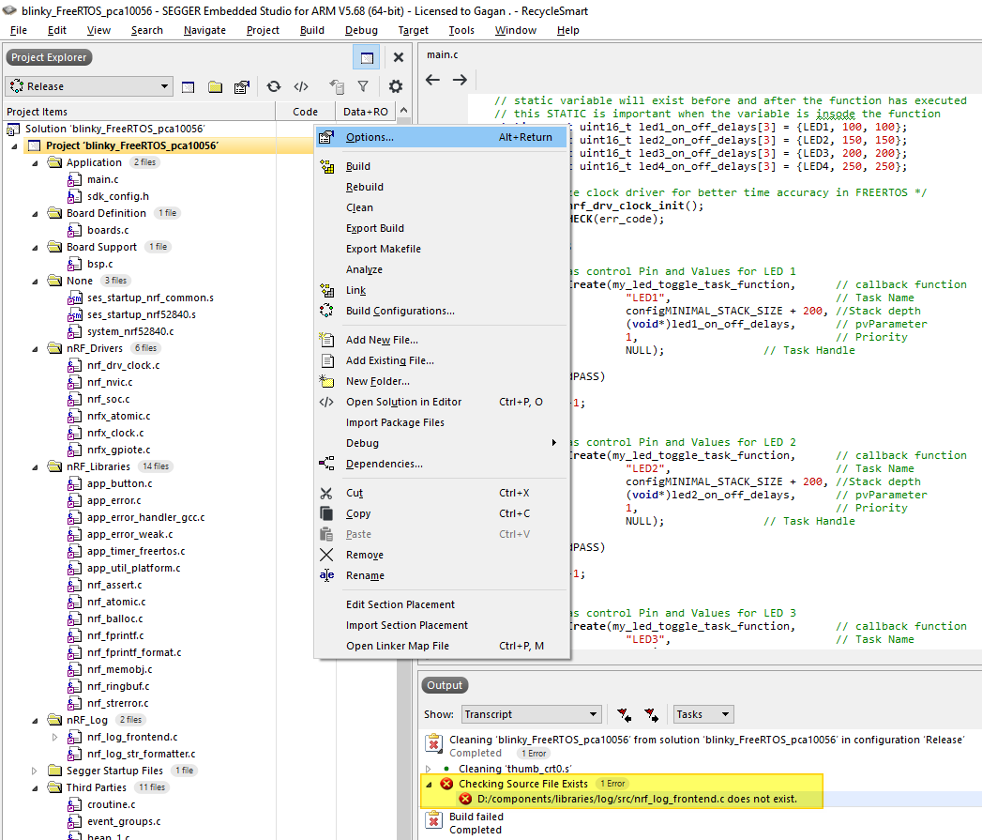

1. Select Common config and then Preprocessor under Code and User Include Directories.

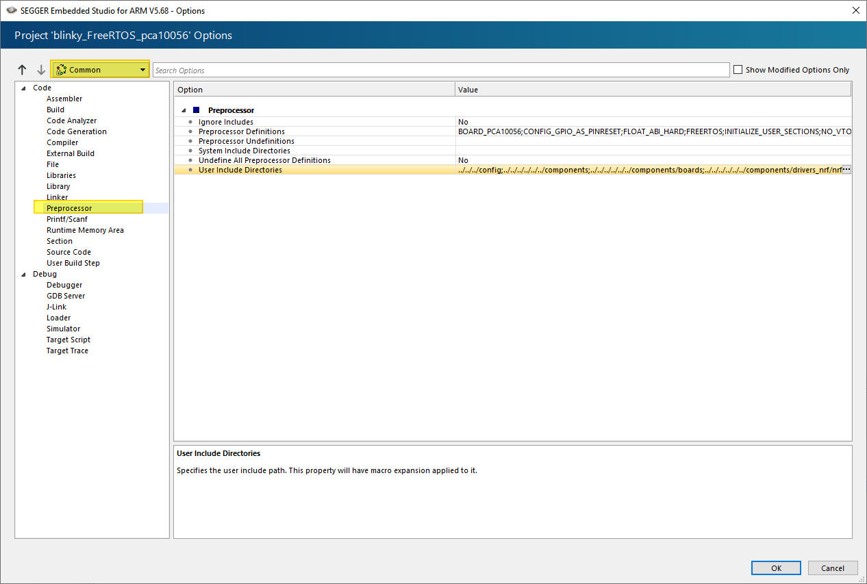

1. Use the $(SDK) macro to replace ../../../ most of the occurrences but not all.

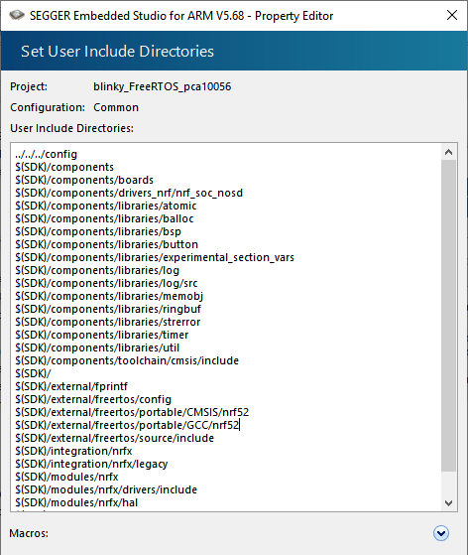

../../../config

$(SDK)/components

$(SDK)/components/boards

$(SDK)/components/drivers_nrf/nrf_soc_nosd

$(SDK)/components/libraries/atomic

$(SDK)/components/libraries/balloc

$(SDK)/components/libraries/bsp

$(SDK)/components/libraries/button

$(SDK)/components/libraries/experimental_section_vars

$(SDK)/components/libraries/log

$(SDK)/components/libraries/log/src

$(SDK)/components/libraries/memobj

$(SDK)/components/libraries/ringbuf

$(SDK)/components/libraries/strerror

$(SDK)/components/libraries/timer

$(SDK)/components/libraries/util

$(SDK)/components/toolchain/cmsis/include

$(SDK)/

$(SDK)/external/fprintf

$(SDK)/external/freertos/config

$(SDK)/external/freertos/portable/CMSIS/nrf52

$(SDK)/external/freertos/portable/GCC/nrf52

$(SDK)/external/freertos/source/include

$(SDK)/integration/nrfx

$(SDK)/integration/nrfx/legacy

$(SDK)/modules/nrfx

$(SDK)/modules/nrfx/drivers/include

$(SDK)/modules/nrfx/hal

$(SDK)/modules/nrfx/mdk

../config

1. Click OK and select the Release build config. Clean the project. The project should build uploaded to nRF52 DevKit successfully.

