Software Requirements Specification (SRS)
Project: Demand Forecasting System (DFS)
Version: 1.0
Authors: Bandugula Sai Rithesh Reddy, Dhyeya Aneesh, G Ganikhasri, Gagana C
Date: 28-10-2026
Status: Draft
Methodology: Agile (Scrum, 1-week sprints)

Team members
Name | SRN
Bandugula Sai Rithesh Reddy | PES1UG24AM064
Dhyeya Aneesh | PES1UG24AM091
G Ganikhasri | PES1UG24AM098
Gagana C | PES1UG24AM099

Revision history
Version | Date | Author | Change summary | Approval
1.0 | 28-10-2026 | DFS Team | Initial SRS with use-case diagrams and RTM

Approvals
Role | Name | Signature / Email | Date
Course Coordinator

Table of Contents
1. Introduction
2. Overall Description
3. External Interface Requirements
4. System Features (Functional Requirements)
5. Non-Functional Requirements (5.1 Security)
6. Quality Attributes and Acceptance Tests
7. System Models and Diagrams (Use-Case Diagrams)
8. Requirements Traceability Matrix (RTM)

1. Introduction

1.1 Purpose
This document is the Software Requirements Specification (SRS) for the Demand Forecasting System (DFS), a web application that helps a product manufacturing company forecast the demand for its products and plan the purchase of raw materials from multiple suppliers. It defines the functional, non-functional and security requirements, the external interfaces and the acceptance criteria. It is the baseline for the Software Architecture and Design Specification (SAD) and the Software Test Plan (STP).

1.2 Scope
A manufacturer buys raw materials from several suppliers, each with different lead times, minimum order quantities, prices and reliability. Buying too little stops production; buying too much ties up money and storage. DFS forecasts product demand from historical sales, current inventory and market indicators (promotions, price changes, seasonality, market trend), converts the forecast into raw-material requirements using the bill of materials, and recommends what to order, from which supplier and by when.
In scope: user and role management; product, raw-material, BOM and supplier master data; import of sales history; inventory tracking; market indicators; statistical demand forecasting with automatic model selection; forecast review and approval; raw-material requirement planning; safety stock and reorder points; supplier-wise purchase recommendations; alerts; dashboards and CSV/PDF reports.
Out of scope: sending purchase orders to suppliers electronically (EDI), payments and invoicing, production scheduling on the shop floor, direct integration with a commercial ERP system (data is exchanged through CSV/Excel files in v1.0), and deep-learning forecasting models.

1.3 Audience
Developers, QA engineers, DevOps engineers, the course instructor and project evaluators, and the business users (demand planners, inventory and procurement managers) who validate the requirements.

1.4 Definitions
Term | Meaning
DFS | Demand Forecasting System (this product)
SKU | Stock Keeping Unit: one distinct product or raw material
BOM | Bill of Materials: the quantity of each raw material needed to make one unit of a product
MRP | Material Requirements Planning: converting product demand into raw-material requirements
Lead time | Days between placing an order with a supplier and receiving the goods
MOQ | Minimum Order Quantity accepted by a supplier
Safety stock / ROP | Extra stock kept against demand uncertainty / Reorder Point: stock level at which a new order must be placed
MAPE / MAE | Mean Absolute Percentage Error / Mean Absolute Error: forecast accuracy measures
SARIMAX / Holt-Winters | Statistical time-series forecasting models (seasonal ARIMA with external inputs / triple exponential smoothing)
Back-test | Testing a model by forecasting past periods that were hidden from it and comparing with actual demand
RBAC, TLS, JWT | Role-Based Access Control, Transport Layer Security, JSON Web Token
SRS, SAD, STP, RTM | Requirements Specification, Architecture & Design Specification, Test Plan, Requirements Traceability Matrix

1.5 Development Approach
The project follows Agile (Scrum) with 1-week sprints. Requirements are kept as a product backlog: each functional requirement maps to a user story, and stories are grouped into epics (Auth, Master Data, Data, Forecasting, Inventory, Procurement, Alerts, Reporting). Sprint 0 sets up the repository, CI pipeline and environments; Sprints 1 to 5 deliver the epics as shown in the RTM (Section 8).

2. Overall Description

2.1 Product Perspective
DFS is a standalone web application with a browser front end, a REST back-end API, a background worker that runs forecasting jobs, and a relational database. It takes data from the company's existing systems as CSV/Excel files, sends email alerts through an external SMTP service, and is built and deployed through a CI/CD pipeline using open-source tools.

2.2 Major Product Functions
- Log in and access features according to role
- Maintain products, raw materials, bills of materials and suppliers
- Import historical sales and record inventory movements and market indicators
- Forecast product demand with several statistical models and automatically choose the most accurate one
- Review, adjust and approve forecasts with a full audit trail
- Convert the approved forecast into raw-material requirements (BOM explosion)
- Calculate safety stock and reorder points and alert on stock-out risk
- Recommend purchase quantities and dates split across suppliers, and approve them as draft purchase orders
- Show dashboards and export reports as CSV and PDF

2.3 User Roles and Characteristics
Role | Description | Main tasks
Administrator | IT or operations staff member; technically confident. | Manage users and roles, products, materials, BOMs, suppliers and system settings
Demand Planner | Sales/planning analyst; understands sales trends but not statistics in depth. | Import sales data, enter market indicators, run, review, adjust and approve forecasts
Inventory Manager | Stores/warehouse lead; needs quick, clear stock information. | Record stock movements, monitor safety stock and reorder points, act on alerts
Procurement Manager | Buyer responsible for suppliers and purchase orders. | Review material requirements, generate, edit and approve purchase recommendations, export reports

2.4 Operating Environment
- Client: latest Chrome, Edge and Firefox on desktop or tablet
- Server: Linux containers (Docker) on a cloud virtual machine
- Database: PostgreSQL relational database; Redis for the job queue
- Network: HTTPS over the public internet

2.5 Constraints
- Only open-source languages, libraries and tools are used.
- Source code is kept in Git and every change is delivered through the CI/CD pipeline.
- Forecasting must use explainable statistical models so that planners can understand and trust the result.
- The system is built by a four-person student team within the course timeline.

2.6 Assumptions and Dependencies
- The company can provide at least 24 months of monthly sales history for most products.
- BOM and supplier data (lead time, MOQ, price) are available and kept up to date by the Administrator.
- An SMTP service is available for alert and password-reset emails.

3. External Interface Requirements

3.1 User Interfaces
A responsive web UI with a menu per role: a dashboard, master-data screens, a data-import wizard with an error report, a forecast workspace (chart of actual vs forecast with prediction intervals, editable table for overrides, approve button), a purchase-planning screen and a reports page. Charts always have a data table next to them. The UI must meet DFS-NF-005.

3.2 Hardware Interfaces
None. DFS runs on standard servers and is used from ordinary desktop and tablet browsers.

3.3 Software Interfaces
- REST API over HTTPS using JSON between front end and back end
- CSV/Excel file import and export for exchanging data with the company's existing ERP or spreadsheets
- PostgreSQL database access through an ORM
- Redis message queue between the API and the forecast worker
- SMTP interface for alert and password-reset emails

3.4 Communications
All client-server traffic uses HTTPS with TLS 1.2 or higher (DFS-SR-001). Email is sent over SMTP with STARTTLS. Internal traffic between containers stays on a private network.

4. System Features (Functional Requirements)
Each requirement below includes acceptance criteria and a reference test case. IDs follow DFS-F-###. In total there are 21 functional requirements.

4.1 Authentication and Access Control
Description: Login, role-based access and password recovery for the four user roles.
Req ID | Requirement (the system shall...) | Type | Priority | Source / Stakeholder | Acceptance criteria / Test case | Comments / Dependencies
DFS-F-001 | Allow a user to log in with an email address and password and start an authenticated session that expires after 30 minutes of inactivity. | Functional | High | All users | AC-001: Valid credentials open the dashboard; invalid credentials show a generic error; an idle session is logged out after 30 min. Test: TC-Auth-01 | Depends on DFS-SR-002
DFS-F-002 | Enforce role-based access control (RBAC) with the roles Administrator, Demand Planner, Inventory Manager and Procurement Manager. | Functional | High | Administrator | AC-002: Each role sees only its menus; e.g. an Inventory Manager cannot open forecast-override or purchase-approval pages. Test: TC-Auth-02 | Depends on DFS-SR-003
DFS-F-003 | Allow a user to reset a forgotten password through a single-use link sent to the registered email. | Functional | Medium | All users | AC-003: The link works once and expires after 30 minutes; the old password stops working after reset. Test: TC-Auth-03 | Requires SMTP service

4.2 Master Data Management
Description: Products, raw materials, bill of materials (BOM) and the supplier base that the forecasts and purchase plans depend on.
Req ID | Requirement (the system shall...) | Type | Priority | Source / Stakeholder | Acceptance criteria / Test case | Comments / Dependencies
DFS-F-004 | Let an Administrator create, edit and deactivate products and raw materials (code, name, unit of measure, category) and define each product's bill of materials (quantity of each raw material per unit of product). | Functional | High | Administrator, Planner | AC-004: Duplicate codes are rejected; BOM quantities must be > 0; a deactivated item no longer appears in new forecasts. Test: TC-MD-01 | -
DFS-F-005 | Let an Administrator manage suppliers with lead time (days), minimum order quantity (MOQ), unit price, monthly capacity and reliability rating (on-time delivery %). | Functional | High | Procurement Manager | AC-005: A supplier is saved only with lead time >= 1 day, MOQ >= 1 and price > 0; edits are visible in the next recommendation run. Test: TC-MD-02 | -
DFS-F-006 | Let an Administrator link each raw material to one or more approved suppliers and mark one as preferred. | Functional | High | Procurement Manager | AC-006: A material can have many suppliers; exactly one is preferred; a material without an active supplier is flagged in purchase planning. Test: TC-MD-03 | Used by DFS-F-017

4.3 Data Collection (Sales, Inventory and Market Data)
Description: Inputs used by the forecasting engine: historical demand, inventory levels and market indicators.
Req ID | Requirement (the system shall...) | Type | Priority | Source / Stakeholder | Acceptance criteria / Test case | Comments / Dependencies
DFS-F-007 | Allow a Demand Planner to import historical sales/demand data from CSV or Excel files (date, product code, quantity, optional region) with row-level validation and a downloadable error report. | Functional | High | Demand Planner | AC-007: Valid rows are stored; rows with unknown product codes, bad dates or negative quantities are rejected and listed in the error report; re-importing the same period updates instead of duplicating. Test: TC-Data-01 | Depends on DFS-F-004, DFS-SR-004
DFS-F-008 | Record inventory levels and stock movements (receipts, issues, adjustments) for products and raw materials and compute the current on-hand quantity. | Functional | High | Inventory Manager | AC-008: On-hand equals opening stock + receipts - issues +/- adjustments; an issue larger than on-hand is rejected. Test: TC-Data-02 | -
DFS-F-009 | Allow a Demand Planner to record market indicators per period (planned promotions, price changes, holiday/festival flags and a market trend index) for use as forecast inputs. | Functional | Medium | Demand Planner | AC-009: Indicators are saved per product (or product category) and period and appear as inputs in the next forecast run. Test: TC-Data-03 | Used by DFS-F-010

4.4 Demand Forecasting
Description: Generates product demand forecasts from history and market indicators, selects the best model and lets planners review and approve the result.
Req ID | Requirement (the system shall...) | Type | Priority | Source / Stakeholder | Acceptance criteria / Test case | Comments / Dependencies
DFS-F-010 | Generate a demand forecast per product for a chosen horizon (1 to 12 months, or 4 to 52 weeks) using at least three models: moving average, Holt-Winters exponential smoothing and SARIMAX (with market indicators as external inputs). | Functional | High | Demand Planner | AC-010: A forecast run for selected products produces one value per period for the full horizon; the run status moves QUEUED -> RUNNING -> DONE (or FAILED with a reason). Test: TC-Fc-01 | Depends on DFS-F-007, DFS-F-009
DFS-F-011 | Back-test each model on the most recent periods held out from training and automatically select, per product, the model with the lowest MAPE; store MAPE, MAE and bias for each run. | Functional | High | Demand Planner | AC-011: For the reference data set, the selected model equals the model with the lowest hand-checked back-test MAPE; metrics are visible on the forecast page. Test: TC-Fc-02 | Depends on DFS-F-010
DFS-F-012 | Display each forecast as a chart of actual vs forecast demand with 80% and 95% prediction intervals and a data table. | Functional | High | Demand Planner | AC-012: The chart and the table show the same values; lower bound <= forecast <= upper bound for every period. Test: TC-Fc-03 | Depends on DFS-F-010
DFS-F-013 | Allow a Demand Planner to adjust (override) forecast values with a mandatory reason and then approve the forecast version; both system and adjusted values are kept. | Functional | High | Demand Planner | AC-013: An override without a reason is rejected; the approved version is read-only; the audit log shows user, time, old and new value. Test: TC-Fc-04 | Depends on DFS-SR-005
DFS-F-014 | Handle products with short history (fewer than 12 periods) by using a moving-average fallback and flagging the forecast as 'Low confidence'. | Functional | Medium | Demand Planner | AC-014: A product with 6 months of history gets a moving-average forecast labelled 'Low confidence'; no run fails because of short history. Test: TC-Fc-05 | -

4.5 Inventory and Procurement Planning
Description: Turns the approved product forecast into raw-material requirements and supplier-wise purchase recommendations.
Req ID | Requirement (the system shall...) | Type | Priority | Source / Stakeholder | Acceptance criteria / Test case | Comments / Dependencies
DFS-F-015 | Calculate raw-material requirements per period by exploding the approved product forecast through the BOM (gross requirement) and subtracting on-hand stock and open purchase orders (net requirement). | Functional | High | Procurement Manager | AC-015: For the reference data set, gross and net requirements match the hand calculation exactly. Test: TC-Proc-01 | Depends on DFS-F-004, DFS-F-008, DFS-F-013
DFS-F-016 | Calculate safety stock and reorder point for each raw material from demand variability, supplier lead time and a configurable service level (default 95%). | Functional | High | Inventory Manager | AC-016: Safety stock = z x sigma(daily demand) x sqrt(lead time) and reorder point = average daily demand x lead time + safety stock, matching a spreadsheet calculation. Test: TC-Inv-01 | Depends on DFS-F-005
DFS-F-017 | Generate purchase recommendations stating order quantity (rounded up to MOQ), order-by date (need date minus lead time) and the supplier split, based on preferred supplier, price, reliability and capacity. | Functional | High | Procurement Manager | AC-017: Every net requirement is covered; no line is below the supplier's MOQ or above its monthly capacity; order-by date = need date - lead time. Test: TC-Proc-02 | Depends on DFS-F-006, DFS-F-015
DFS-F-018 | Allow a Procurement Manager to edit, approve or reject a recommendation; approved lines become draft purchase orders that can be exported. | Functional | High | Procurement Manager | AC-018: Approved lines create draft POs; rejected lines need a comment; a decided recommendation cannot be approved again. Test: TC-Proc-03 | Depends on DFS-F-017
DFS-F-019 | Raise alerts on the dashboard and by email when projected stock of a material falls below its reorder point, when a stock-out is expected within the supplier lead time, or when forecast MAPE exceeds a configured threshold. | Functional | Medium | Inventory Manager, Planner | AC-019: Lowering stock below the reorder point creates one alert (no duplicates) within 5 minutes and sends one email to subscribed users. Test: TC-Inv-02 | Requires SMTP service

4.6 Dashboard and Reporting
Description: Summary views and exports for management.
Req ID | Requirement (the system shall...) | Type | Priority | Source / Stakeholder | Acceptance criteria / Test case | Comments / Dependencies
DFS-F-020 | Provide a dashboard with key indicators: forecast accuracy (MAPE) trend, materials below reorder point, upcoming purchase orders and planned spend per supplier. | Functional | Medium | All roles | AC-020: Dashboard figures match the underlying data for the reference data set; the dashboard loads within the time in DFS-NF-001. Test: TC-Rep-01 | Depends on DFS-F-011, DFS-F-017
DFS-F-021 | Allow users to export forecasts, material requirements and purchase recommendations as CSV and PDF files. | Functional | Medium | Planner, Procurement Manager | AC-021: Exported files open correctly and contain all rows and totals shown on screen; users can export only data their role can view. Test: TC-Rep-02 | Depends on DFS-SR-003

5. Non-Functional Requirements
NFRs below are measurable and tied to the test plan. IDs follow DFS-NF-###.
Req ID | Requirement | Category | Priority | Acceptance criteria / Measurement
DFS-NF-001 | Dashboard pages and API calls shall respond within 2 seconds for 95% of requests with 50 concurrent users. | Performance | High | 95th percentile <= 2 s in a load test. Test: TC-Perf-01
DFS-NF-002 | A forecast run for 500 products with 36 months of history shall complete within 5 minutes without slowing down other users (runs execute in the background). | Performance | High | Run time measured on staging <= 5 min; DFS-NF-001 still met during the run. Test: TC-Perf-02
DFS-NF-003 | On the reference data set, the selected models shall achieve a mean MAPE of at most 20% for products with at least 24 months of history and shall beat a naive (last value) forecast. | Forecast quality | High | Back-test report shows mean MAPE <= 20% and lower error than the naive baseline. Test: TC-Fc-06
DFS-NF-004 | The system shall provide 99.5% monthly availability excluding planned maintenance, with daily database backups (recovery point <= 24 h, recovery time <= 4 h). | Reliability | High | Uptime monitor report >= 99.5%; restore drill completes within 4 h. Test: TC-Rel-01
DFS-NF-005 | The web UI shall be usable on desktop (1280 to 1920 px) and tablet (768 px and above) on the latest Chrome, Edge and Firefox and follow WCAG 2.1 AA (keyboard navigation, contrast, labelled charts). | Usability | Medium | Layout and accessibility checks pass (Lighthouse accessibility score >= 90). Test: TC-UX-01
DFS-NF-006 | Back-end code shall have at least 80% unit-test coverage, checked automatically on every build, and forecasting models shall plug in through one common interface. | Maintainability | Medium | CI build fails if coverage < 80%. Test: CI coverage report
DFS-NF-007 | The system shall handle at least 1 million sales records and 2,000 products without breaking DFS-NF-001. | Scalability | Medium | Load test on a database seeded with 1 M rows meets DFS-NF-001. Test: TC-Perf-03

5.1 Security

5.1.1 Security Objectives
ID | Objective | Description
SO-1 | Confidentiality | Sales history, costs and supplier prices are commercially sensitive. Only authenticated users with the right role can view or export them.
SO-2 | Integrity | Forecast inputs, forecast overrides and purchase decisions cannot be changed by unauthorised users or by malicious input, so purchase plans are based on correct data.
SO-3 | Accountability | Every data import, forecast override and purchase approval can be traced to the user who made it and the time it was made.

5.1.2 Security Requirements
Req ID | Requirement (the system shall...) | Type | Priority | Acceptance criteria / Test case
DFS-SR-001 | Use TLS 1.2 or higher for all network connections and redirect HTTP to HTTPS. | Security | High | HTTP redirects to HTTPS; TLS 1.0/1.1 are refused. Test: TC-Sec-01
DFS-SR-002 | Store passwords only as salted Argon2 (or bcrypt) hashes and lock an account for 15 minutes after 5 consecutive failed logins. | Security | High | Database contains no plaintext passwords; 6th attempt within 15 min is blocked. Test: TC-Sec-02
DFS-SR-003 | Check authorisation on the server for every API endpoint (deny by default), based on the user's role. | Security | High | Calling an endpoint outside the user's role returns 403 and no data. Test: TC-Sec-03
DFS-SR-004 | Validate all input and uploaded files: only .csv/.xlsx up to 10 MB with checked content type and no macros; use parameterised queries against SQL injection; encode output against XSS; neutralise spreadsheet formula injection (=, +, -, @) in exports. | Security | High | Malicious files and payloads are rejected or neutralised; no script runs and no DB error is shown. Test: TC-Sec-04
DFS-SR-005 | Write an append-only audit log of logins, data imports, master-data changes, forecast overrides and purchase approvals (user, time, old and new value), kept for at least 1 year. | Security | High | Each listed action creates an audit entry; the application has no update/delete operation on the audit table. Test: TC-Sec-05
DFS-SR-006 | Apply rate limiting to login (10 requests/minute per IP) and to the API (100 requests/minute per user), returning HTTP 429 when exceeded. | Security | Medium | Requests beyond the limit receive HTTP 429. Test: TC-Sec-06

Mapping to objectives: SO-1 Confidentiality is met by DFS-SR-001, 002, 003 and 006; SO-2 Integrity by DFS-SR-003 and 004; SO-3 Accountability by DFS-SR-005.

6. Quality Attributes and Acceptance Tests
- Exit criteria for acceptance: all High-priority functional requirements are implemented and verified, no critical NFR failures remain, the forecast accuracy target (DFS-NF-003) is met on the reference data set, and the RTM shows all test cases passed.
- Acceptance test suites: Authentication, Master Data, Data Import, Forecasting (functional and accuracy), Inventory, Procurement, Alerts, Reporting, Performance, Security and Accessibility.
- Reference data set: a synthetic data set of 50 products, 30 raw materials and 10 suppliers with 36 months of sales generated with known trend, seasonality and noise, so that expected forecasts, requirements and purchase quantities can be calculated by hand.

7. System Models and Diagrams

7.1 Use-Case Diagram 1: Data Management and Demand Forecasting
Shows how the Demand Planner prepares data and produces forecasts, and how the Administrator maintains the master data they depend on.
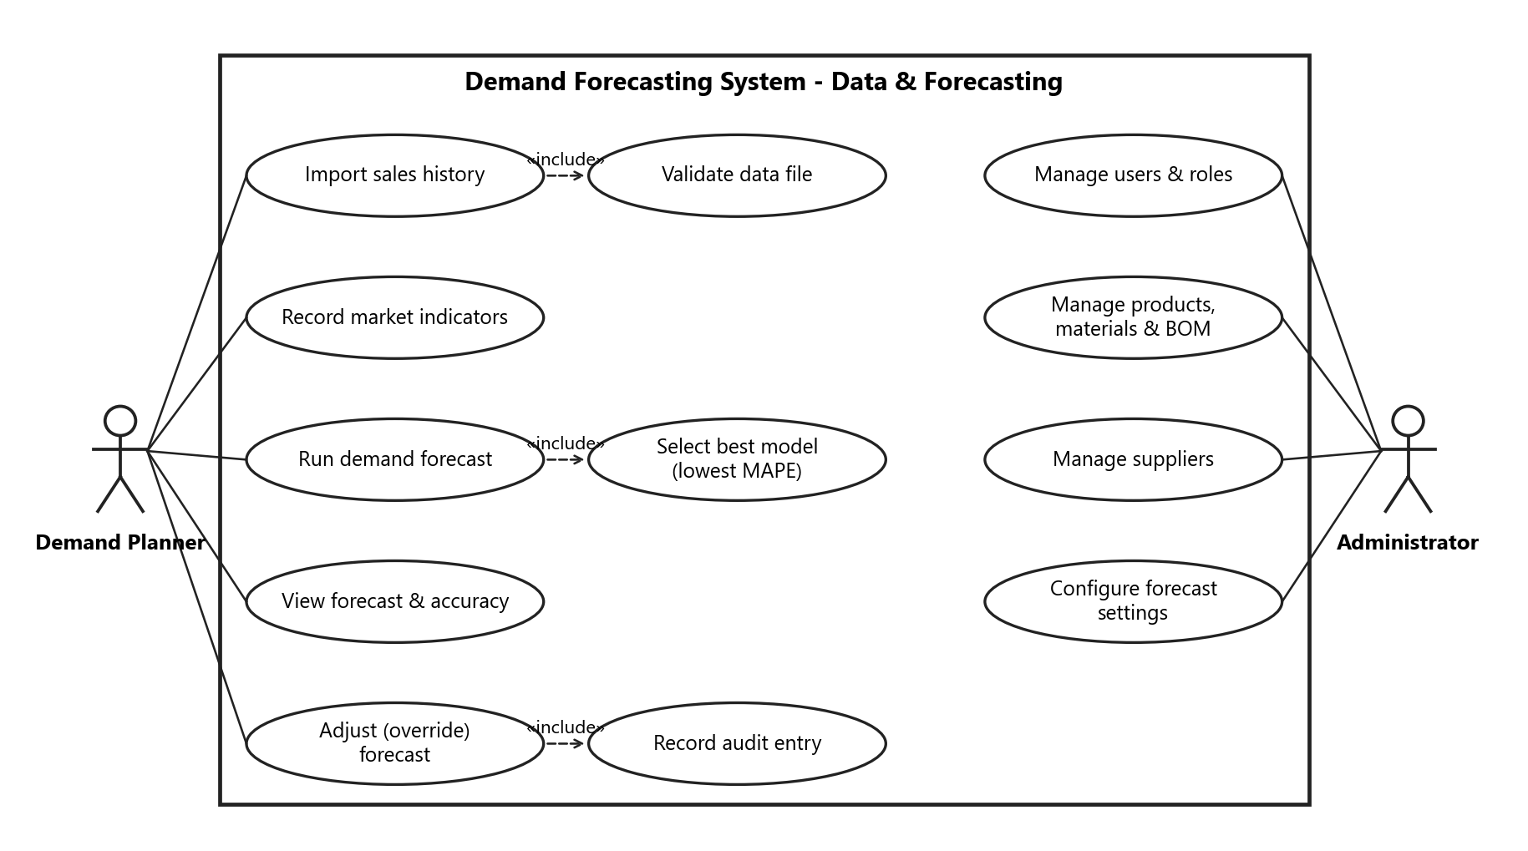
Figure 1: Use cases for data management and forecasting

7.2 Use-Case Diagram 2: Inventory and Procurement Planning
Shows how the Inventory Manager monitors stock and how the Procurement Manager turns the forecast into supplier-wise purchase decisions.
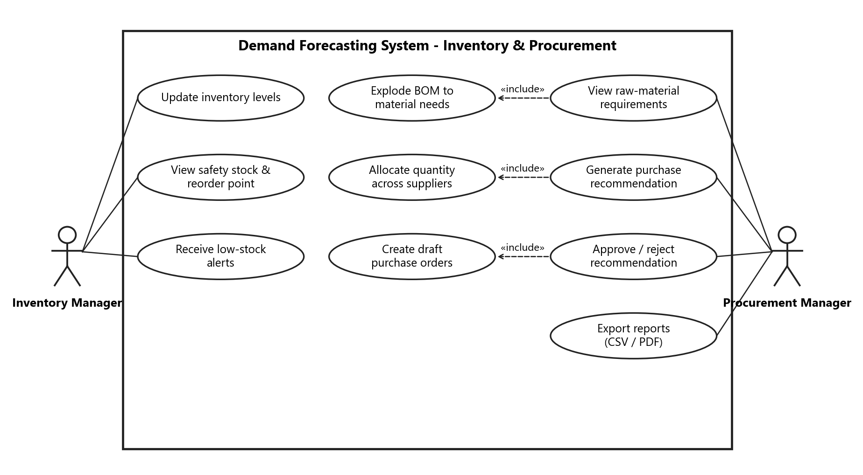
Figure 2: Use cases for inventory and procurement planning

8. Requirements Traceability Matrix (RTM)
Status: N = Not started, P = In progress, A = Accepted.
Req ID | Requirement (short) | Section | Epic / Sprint | Module | Test case(s) | Status
DFS-F-001 | Login and session timeout | 4.1 | Auth / Sprint 1 | AuthModule | TC-Auth-01 | N
DFS-F-002 | Role-based access | 4.1 | Auth / Sprint 1 | AuthModule | TC-Auth-02 | N
DFS-F-003 | Password reset | 4.1 | Auth / Sprint 1 | AuthModule | TC-Auth-03 | N
DFS-F-004 | Products, materials and BOM | 4.2 | Master data / Sprint 1 | MasterDataModule | TC-MD-01 | N
DFS-F-005 | Supplier management | 4.2 | Master data / Sprint 1 | MasterDataModule | TC-MD-02 | N
DFS-F-006 | Material-supplier mapping | 4.2 | Master data / Sprint 1 | MasterDataModule | TC-MD-03 | N
DFS-F-007 | Import sales history | 4.3 | Data / Sprint 2 | IngestionModule | TC-Data-01 | N
DFS-F-008 | Inventory and stock movements | 4.3 | Inventory / Sprint 2 | InventoryModule | TC-Data-02 | N
DFS-F-009 | Market indicators | 4.3 | Data / Sprint 2 | IngestionModule | TC-Data-03 | N
DFS-F-010 | Generate forecast | 4.4 | Forecasting / Sprint 3 | ForecastEngine | TC-Fc-01 | N
DFS-F-011 | Back-test and best-model selection | 4.4 | Forecasting / Sprint 3 | ForecastEngine | TC-Fc-02 | N
DFS-F-012 | Forecast chart and intervals | 4.4 | Forecasting / Sprint 3 | Web UI, ReportingModule | TC-Fc-03 | N
DFS-F-013 | Forecast override and approval | 4.4 | Forecasting / Sprint 3 | ForecastEngine | TC-Fc-04 | N
DFS-F-014 | Short-history fallback | 4.4 | Forecasting / Sprint 3 | ForecastEngine | TC-Fc-05 | N
DFS-F-015 | BOM explosion (MRP) | 4.5 | Procurement / Sprint 4 | MRPModule | TC-Proc-01 | N
DFS-F-016 | Safety stock and reorder point | 4.5 | Inventory / Sprint 4 | InventoryModule | TC-Inv-01 | N
DFS-F-017 | Purchase recommendations | 4.5 | Procurement / Sprint 4 | ProcurementModule | TC-Proc-02 | N
DFS-F-018 | Approve recommendation / draft PO | 4.5 | Procurement / Sprint 4 | ProcurementModule | TC-Proc-03 | N
DFS-F-019 | Low-stock and accuracy alerts | 4.5 | Alerts / Sprint 4 | AlertModule | TC-Inv-02 | N
DFS-F-020 | Dashboard KPIs | 4.6 | Reporting / Sprint 5 | ReportingModule | TC-Rep-01 | N
DFS-F-021 | CSV / PDF export | 4.6 | Reporting / Sprint 5 | ReportingModule | TC-Rep-02 | N
DFS-NF-001 | Response time | 5 | Hardening / Sprint 5 | All | TC-Perf-01 | N
DFS-NF-002 | Forecast run time | 5 | Hardening / Sprint 5 | ForecastEngine, Worker | TC-Perf-02 | N
DFS-NF-003 | Forecast accuracy | 5 | Forecasting / Sprint 3 | ForecastEngine | TC-Fc-06 | N
DFS-NF-004 | Availability and backup | 5 | Deployment / Sprint 5 | Infrastructure | TC-Rel-01 | N
DFS-NF-005 | Responsive and accessible UI | 5 | All sprints | Web UI | TC-UX-01 | N
DFS-NF-006 | 80% test coverage | 5 | Sprint 0 onward | CI pipeline | CI coverage report | N
DFS-NF-007 | Data volume | 5 | Hardening / Sprint 5 | Database, All | TC-Perf-03 | N
DFS-SR-001 | TLS 1.2+ | 5.1 | Sprint 5 | Infrastructure | TC-Sec-01 | N
DFS-SR-002 | Password hashing and lockout | 5.1 | Sprint 1 | AuthModule | TC-Sec-02 | N
DFS-SR-003 | Server-side authorisation | 5.1 | Sprint 1 | API Gateway | TC-Sec-03 | N
DFS-SR-004 | Input and file validation | 5.1 | Sprint 2 | Gateway, IngestionModule, ReportingModule | TC-Sec-04 | N
DFS-SR-005 | Audit log | 5.1 | Sprint 3 | All modules | TC-Sec-05 | N
DFS-SR-006 | Rate limiting | 5.1 | Sprint 5 | API Gateway | TC-Sec-06 | N

