

Distribution Layer –Understanding Document

**Contents**

1. Introduction 3

2. Understandings 3

2.1 AS-IS 3

2.1.1 Customer Channel……………………………………………………………………………………………………3

2.1.2 Staff Channel……………………………………………………………………………………………………………3

2.1.3 Mortgages………………………………………………………………………………………………………………..4

2.1.4 Insurance Distribution………………………………………………………………………………………………5

2.2 Architecture 5

2.3 Software Tools 6

2.4 Communication Protocols 6

2.5 Security and Policies 7

3. Current Pain Area 7

# **Introduction**

This document describes the understanding of HSBC’s current application landscape. This will cover Insurance Product for UK and Singapore region. In each of the locations at UK, China, France and Hongkong, HSBC have their own regional CIOs who looks after the delivery of that area and in addition to that, h their IT centres located in China, India and Hongkong. There are three different layers in HSBC’s architecture. This document will mainly focus on the Distribution layer.

# **Understandings**

This section covers LTI’s understandings over the HSBC’s current landscape on Distribution Layer.

## **AS-IS**

Distribution Layer is basically the front-end layer of HSBC which has different UIs developed for the different types of channels. Gateway is connected to the channels and channels in return are connected to the Integration Layer using https. Gateway and Channels comprises of Front end. HSBC has developed microservices using spring boot and have exposed them on mulesoft gateways. Using the ideology of microservices, large complex applications can be divided up into smaller building blocks of executables. These when recomposed, they offer all of the functionality of a large scale and a highly complex application.

Distribution Layer is divided into two channels.

* Customer Channel
* Staff Channel

### **Customer Channel**

HSBC has three brands in UK named as **First Direct internet banking**, **Marks and Spencer Bank**, **HSBC**. All three are owned by HSBC but they individually retain their own brands. Among these, FD internet banking and HSBC provides life insurance whereas Mark and Spencer provides general insurance named as AVIVA. This document will focus on UK Life insurance part of HSBC .

* **FD Internet Banking**- FD sells life insurance and it has its own internet banking site. Functionality of maintaining the quote is done inside the FD internet banking site. For application and processing of policy, it gets redirected to a third-party site named as FD life insurance microsite. it doesn’t make use of IIP BSL system.
* **Personal Internet Banking**: It is the online banking of HSBC and it gets redirected to IIP Customer front End
* **Public Web Site(PWS)**- PWS is similar to FD and is the HSBC brand. It also gets redirected to IIP Customer Front End.

### **Staff Channel**

Staff channel is the front-end application which is developed using realJS. When a Staff channel application is launched and CIN is provided, Integration layer pulls the customer details based on the CIN provided. Integration layer makes a MQ call to CDU(customer database) to submit the request. Staff channel is for OHB, internet channel is for OHI. Staff channel is divided into two different applications named as **Browser main menu (BMM)** and **Staff front end** **(SFE).**

* **Browser Main menu (BMM):** It is the legacy version of SFE which will be decommissioned soon.
* **Staff Front End(SFE)** : SFE is the new version of Browser main menu. Currently all SFE applications are internal facing.

There are 4 staff channel applications as a part of UK Insurance:

* Life Insurance Cover
* Life & Critical Insurance Cover
* Critical Insurance cover
* Income Insurance cover

**Income Insurance cover:**

* Income Cover policy is for securing customers’ monthly income in case of losing their job.
* There are 2 type of policies.

a.      2 years Premium

b.      Premium till 58 years

* Customer profiles are maintained in CDU (Customer Data Utility) within LifePen Manufacturing system.
* Staff must feed branch code, agent code and KYC reference number for creating the policy for the customer.
* SFE fetches customer details from the CDU using CIN (Customer Identification) number.
* Staff (Agent) code is tagged as part of Customer profile.

For ex: If a customer has account in one branch and he/she wants to take insurance from another branch, then the branch code will be same (the branch code in which account is there) but agent code will be different (it will be staff code tagged related to that insurance).

* Only the primary data type validations are done at SFE application level. All critical validations are done by the backend system.
* Promotional code is dynamic and is defined by the sales and marketing team on the basis of the history of the customers. SFE team doesn’t get involved in it.

### **Mortgages**

* Staff Channel’s Mortgages Application is for processing the loan related services for the customers.
* During the loan process it can suggest the customer, various life insurance offer that the customer can opt for based on selected loan criteria. If the customer wants to go for a suggested life insurance, it will be done through one of the staff channels.
* Mortgage Application uses GIIL(API) in the integration layer for getting the suggested life insurance information.

### **Insurance Distribution**

* **FD Life Insurance Microsite:** It is a third-party site which gets the input from FD Internet Banking.
* **IIP Customer Front End:** Customer Channel’s middleware services by IIP Customer Front End make use IIP and BSL to process policy related workflow with LifePen and back & forth through API calls.
* **IIP Staff Front End:** Customer/Staff Channel’s middleware services by IIP Staff Front End make use IIP and BSL to process policy related workflow with lifePen and  back & forth through API calls.
* **Customer Needs System(CNS):** It is the legacy system of the current web based applications in distribution layer which will get decommissioned soon.
* **OPAL:** OPAL is an external provider and hence it is processed externally for the premium users. It is not handled by HSBC’s IIP system.

## **Architecture**

Below given is the pictorial representation of Application landscape architecture -.

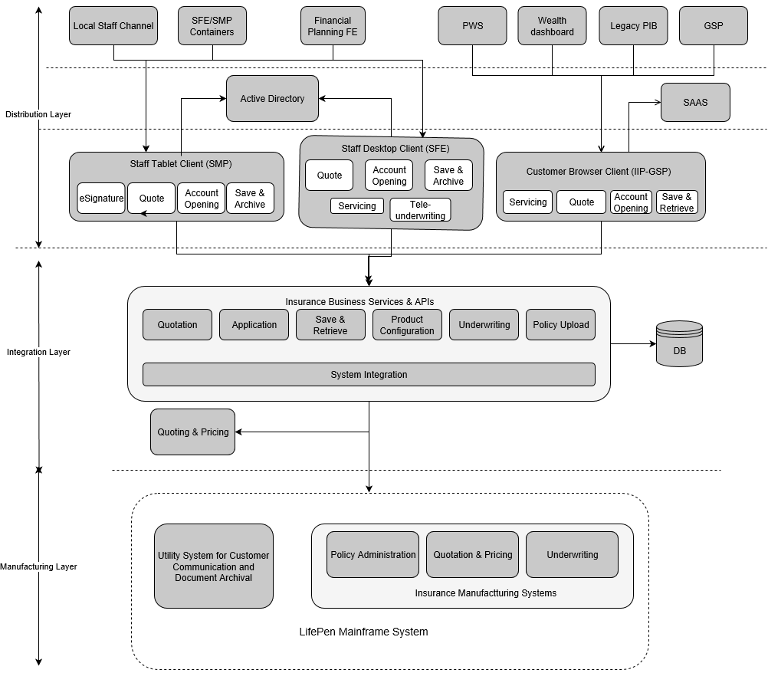

## **Software Tools**

SFE application is built on React JS and Java in the backend which in turns interacts with the Business service layer i.e. Integration layer.

## **Communication Protocols**

Below given is the flow diagram which depicts protocols and interaction of distribution layer with the other layers.

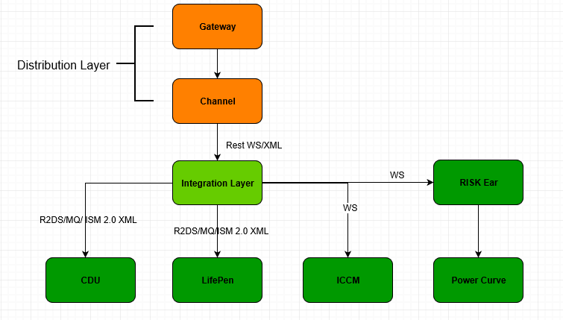

## **Security and Policies**

# **Current Pain Area**

* In SFE currently documenting customer signature on policy agreement is done manually.  Implementing digital signature is in the plan.
* There is no mobile version of these applications.