Contents

1. Introduction 3

2. Understandings 3

2.1 AS-IS 3

2.2 Architecture 3

2.3 Software Tools 4

2.4 Communication Protocols 5

2.5 Security and Policies 6

3. Current Pain Area 6

# Introduction

This document describes Understanding of HSBC’s current application landscape. This will cover Insurance Product for UK and Singapore region. There are different layers in HSBC’s architecture, this document will mainly focus on the Integration layer.

# Understandings

This section covers LTI’s understandings over the HSBC’s current landscape.

## AS-IS

Insurance Products like Income Cover, Life Risk Cover, and Critical Illness Cover etc. are offered by HSBC through their Staff Channels (e.g. **BMM, DFE**) and Customer Facing channels (e.g. **FD Internet Banking, Personal Internet Banking, Public Web Site**).

Insurance Products are used by HSBC current account holder or credit card holder. The Policy Quotation offered by HSBC depends on several factors like Health conditions of a customer, customer’s smoking habit etc. Customers can get quotation for different policy product through HSBC’ customer care or bank agents (i.e. Staff Channels). Also, there is a separate customer browsing channel through which a customer can buy a Policy.

There are different layers in current landscape. **Business Service Layer (BSL) or Integration layer** act as a middleware layer which interacts with SFE i.e. Staff Front End systems and Customer Channels and connects them with **LifePen** which is the Mainframe system which holds all data related to Policy Product, Agents and Customers. BSL also connects other systems like database.

## Architecture

The BSL is responsible for all API calls and integration between LifePen and different database like Risk DB, Customer data base, CRM system, CDM (Customer Data Management), Payment System, Claims System, etc.

There are different components associated with the Integration Layer or BSL:

* Product Configuration: When a customer select Insurance Product, they are redirected to First Page of quotation journey, which will display basic details of Product, also Min and Max amount selector for cover they want to select.
* Quotation: Once the customer click on “Get Quote” button, complete details of customer is retrieved from CDU. Afterwards an eligibility check is performed at Integration layer based on Customer data available in CDU and LifePen, a Quotation is generated after it passes all checks and if any check fail due to some reason then the appropriate message is displayed on Front End Applications.
* Save and Retrieve: Each and every step is saved in DB and if any systems goes down due to connectivity issue or any other issue, then the customer can retrieve previous step from where it left once the system is UP and running.
* Underwriting: Once a general quotation is ready. Data related to customer’s lifestyle, habit and medical history is captured from Front End. Integration layer then calls the PowerCurve system in manufacturing layer via RISK Ear which act as message broker in this case. PowerCurve engine recalculates the quotation based on this different factors and counter offer is given to the customer. The quotation in counter offer can be same or different from quotation offered at first place.
* Application: After Quotation is generated, customer can see two types of Premium Payment Plans i.e. monthly and yearly. Customer can select between this two, and once they agree an application is generated which will have all details regarding Policy. Payment related data like account number or card details from which they want to do payment is also captured from customer in this step and saved into LifePen. Customer can go through all the T&C in this step.
* Policy Upload: After all steps are completed the Application of policy is reviewed and then submitted to LifePen through Integration Layer. Customer can also download a PDF document of this application for their reference.

Below is High level Architecture diagram of current landscape:

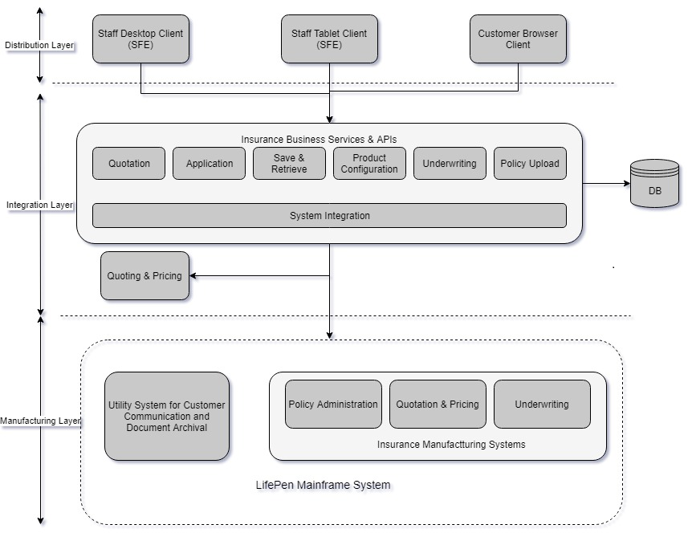

## Software Tools

* Legacy Integration layer is built on **Spring** framework.
* HSBC has put some additional standards on spring framework to make it futuristic architecture
* All the transactions are handled through in-built Spring based transaction management and also using JPA for DML.
* On DevOps side they using Jenkins, Sonar, Confluence etc.
* They are currently using PCF to deploy new APIs.
* They are using single DB for all the APIs which is **Oracle** based DB.
* For some APIs they are **JPA** and for some they are using **stored procedure** to call DB.
* They are using in-built connection Pool of Spring.
* They have two instances for every API on production for managing the Scalability and managing the load.

## Communication Protocols

Below is flow diagram depicts the different protocols used to and from Integration layer to other systems.

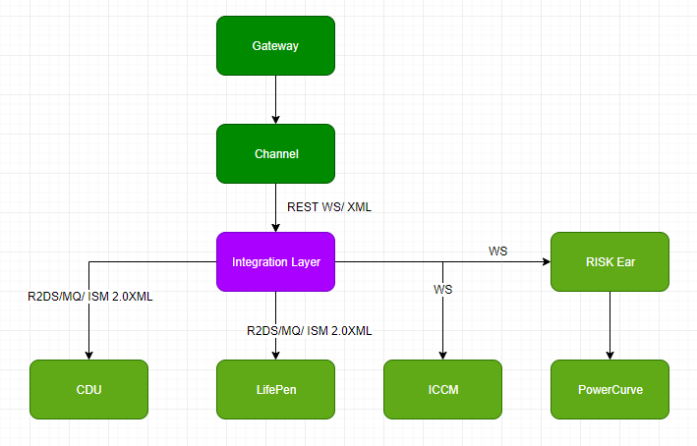

|  |  |  |
| --- | --- | --- |
| Source System | Target System | Protocol/Data Format |
| Channels (Staff or Customer) | Integration Layer | REST WS/ XML |
| Integration Layer | Mainframe System via R2DS* (CDU, LifePen) | MQ/ISM 2.0 XML |
| Integration Layer | ICCM | REST WS/XML |
| Integration Layer | PowerCurve via Risk Ear | REST WS/XML |

**R2DS:** It’s a common layer which routes messages from Integration layer to mainframe systems like CDU and LifePen.

* R2DS decides which function of mainframe systems (e.g. CDU, LifePen, etc.) needs to be called based on Service ID and Operation Id and version number of service and operation Ids.
* Consumer Id is also required by R2DS to determine from where to send the request-response.
* Requests from Integration Layer are pushed into MQ (WebSphere MQ) in standard ISM 2.0 XML.
* R2DS picks up this requests from MQ and based on Service ID and Operation Id it determines the function to be called in LifePen and CDU and transform it into required format.

## Security and Policies

* For legacy Integration layer, no proxy server is present and token based policies are also not there.
* HSBC has three network layer i.e. eDMZ, IDMZ and DRN. eDMZ and iDMZ are present for external and internal application respectively.
* Channel layer interacts with Integration layer over secured HTTPS network.
* In UK they are moving slowly from Legacy to API based architecture. SAML Token based security applied on these APIs. At every step token is validated using C4E jar.
* Token is generated using **C4E MuleSoft API Gateway.** An E2E (end to end) token is generated by C4E.
* For Validating the Token at Integration side, C4E jars are used.
* C4E is generates SAML token by using application Client ID and client Secret which are sending request to integration layer.

# Current Pain Area

* Integration layer is a Legacy Application which is tightly coupled with LifePen System and other system like Risk DB, CDM (Customer Data Management), CRM, etc.
* Also currently **First Direct** workflow uses a manual process to book Insurance which involve creating Memos and submitting to HSBC Data unit for Policy creation. HSBC is planning to move this manual workflow to Integration Layer itself.
* HSBC last year has started breaking Monolithic Application into fine grained API using **SpringBoot**. Currently they have around 60 API’s running in production which are deployed on PCF cloud. In UK only as of now only for Mortgages workflow, **Restful APIs** has been created.