**Contents**

1. Introduction 3

2. Understandings 3

2.1 AS-IS 3

2.2 Architecture 3

2.3 Software Tools 3

2.4 Communication Protocols 3

2.5 Security and Policies 3

3. Current Pain Area 3

# **Introduction**

This document describes the understanding of HSBC’s current application landscape. This will cover Insurance Product for UK and Singapore region. There are three different layers in HSBC’s architecture- Distribution, Integration and Manufacturing. This document will mainly focus on the Manufacturing layer.

# **Understandings**

This section covers LTI’s understandings over the HSBC’s current landscape on Manufacturing Layer.

## **AS-IS**

Manufacturing Layer is basically the back-end layer of HSBC which is mainly based on mainframe system.

**Lifepen** is main back end for BSL. It is built on mainframe system and it's very old system (around 20-25 years old). When any policy purchased by customer, then it got confirmed from LifePen only. LifePen will send information immediately to CDU (Customer Data Unit) when any policy or claim made. If any update is there in existing policy, then it will go in batch. Below are the mainframe systems that LifePen integrates to:

* CDM (Customer Data Management)
* Payments
* Accounting
* Customer Communications
* Operational MI
* Customer Service:
* Insurance Risk:
* Fund Management:
* Audit
* Operation & Investigating
* **CDM (Customer Data Management)**: It stores all information related to customer like which policy is purchased.
* **Payments:** It contains payment related information.
  + VOCA/BACS: It contains all the details of payments based on policy purchased.
  + MMS-BC: It contains details about rejected payments due to any reason like insufficient balance in account, incorrect information related to payment etc.
* **Accounting:** 
  + FTP: gets data from different system like LifePen, CDU, etc. and mainly used for accounting purpose.
* **Customer Communications:**
* DPS- Paper documents sent here then staff prints hard copy and send to relevant people.
* KANA- It is mainly used by front end and it sends mail also to customer if they want.
* ICCM- It is mainly used to generate pdf.
* **Operational MI:**
* UK Data Warehouse: It is mainly used for data ware housing purpose. Harmony, Big Data Lake and Minerva are mainly used for this purpose.
* Callidus: It contains the details of bonus for sales person.
* **Customer Service**:
  + - * FVQ: Let's suppose any payment is rejected due to any reason and we have to send letter to customer with reason of failure. So, when payment fails, memo will be generated and go to FVQ. Then staff will check the memo and if it is valid then will send letter to customer.
* **Insurance Risk:** 
  + - * Moses: It is going to deprecate till mid-year. Now, this functionality will move to operational MI.
* **Fund Management:** 
  + - * Fund Prices: It needs to update on daily basis. If any fund changes happen, the price will also change and then it goes to LifePen and then LifePen generates new price.

## **Architecture**

Below given is the pictorial representation of architecture diagram.

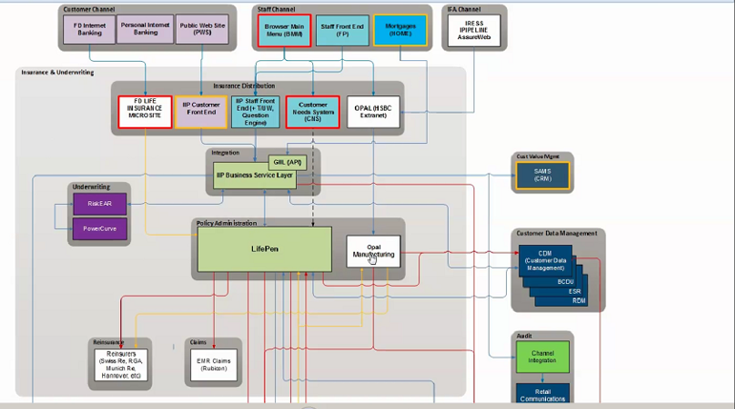

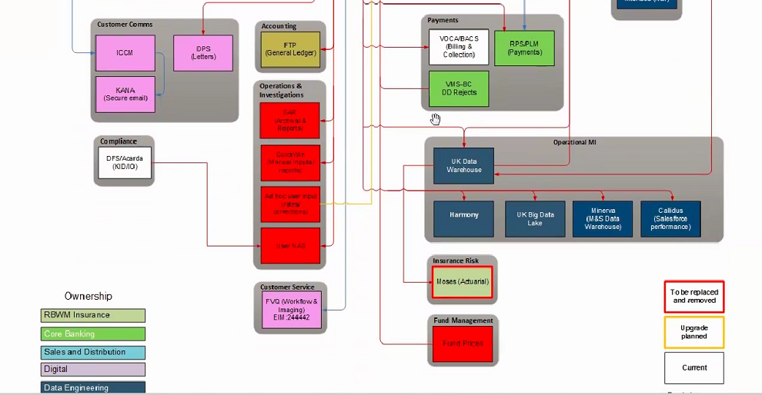

## **Software Tools**

LifePen System is built on mainframe (COBOL) which in turns interacts with other manufacturing systems like CRM, CDM, Payment systems etc.

## **Communication Protocols**

## **Security and Policies**

# **Current Pain Area**