**PRACTICAL – 12**

**Submitted By: Ridam Singhal(5040)**

**AIM:** To fit logistic growth model using Hotelling’s method, and estimate the trend values.

**EXPERIMENT:**

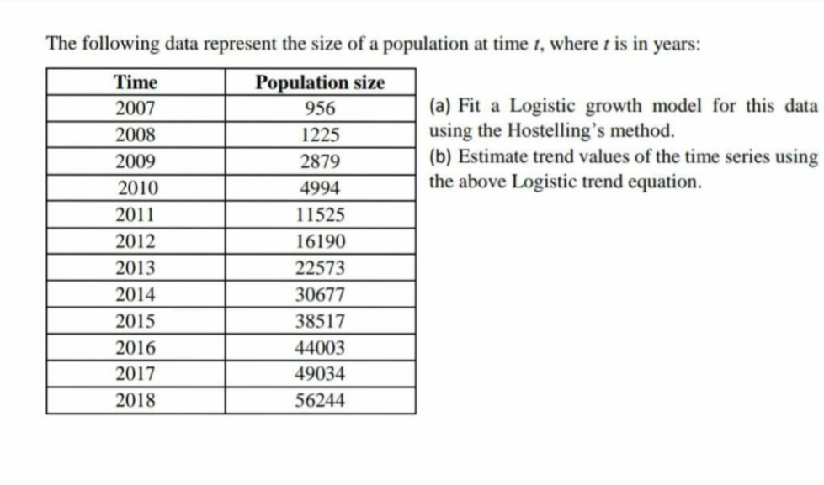

**THEORY:**

Logistic Curve:

1. A particular form of complex type of growth curves.
2. Given by: y = yt = , b>0
3. a, b, k are constants and yt is the value of the given time series, at time t.

Hotelling’s Method:

1. An elegant and indigenous method to fit a logistic curve.
2. We have, $\frac{1}{y_{t}} . \frac{∆y_{t}}{∆t}= -b+ \frac{b}{k} y_{t}$ OR U = A + By, where $U= \frac{1}{y_{t}} . \frac{∆y_{t}}{∆t}$, A = -b, and B = $\frac{b}{k}$
3. A and B, and this b and k can be obtained by principle of least square.
4. a is obtained by assuming that the curve passes through mean of Y and mean of t.

**CALCULATIONS:** (an excel file has been attached for reference to detailed calulations)

Table-12.1







Graph-12.1

**RESULT:**

* Values for the constants a, b, and k have been computed and shown under

Table 12.1, along with the values of A and B.

* Hence the logistic curve equation comes out to be: yt =
* Trend values have been computed and shown in Table 12.1.
* Logistic growth model is shown in Graph 12.1.