**PRACTICAL – 13**

**Submitted By: Ridam Singhal(5040)**

**AIM:** To fit logistic growth model using Yule’s method, and estimate the trend values.

**EXPERIMENT:**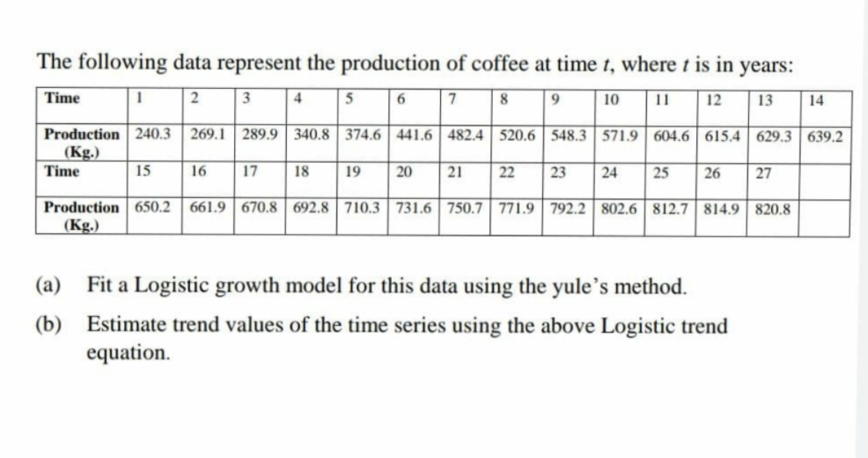

**THEORY:**

Logistic Curve:

1. A particular form of complex type of growth curves.
2. Given by: y = yt = , b>0
3. a, b, k are constants and yt is the value of the given time series, at time t.

Yule’s Method:

1. We assume that the value of k is approximately known or obtained through any other method. Therefore there are two parameters a, and b, and two variables t and yt.
2. We use the principle of least square to estimate a and b. We have:

$a+bt=\log\left(\left(\frac{k}{y}\right)-1\right)$ OR $v=a+bt$, => $v =\log\left(\left(\frac{k}{y}\right)-1\right)$

1. To find the value of k, we use method of three selected points. Hence the formula for k is given by: $k=\frac{y_{2}^{2} \left(y_{1}+y_{3}\right)-2y_{1}y_{2}y_{3}}{y_{2}^{2}-y_{1}y_{3}}$

**CALCULATIONS:** (an excel file has been attached for reference to detailed calculations)

Table 13.1

 

Graph 13.1

Graph 13.2

**RESULT:**

* Value of k was computed using the method of three selected points. Its value has been shown with Table 13.1. (k=858.29791).
* Value of v was computed using the value of k, and has been shown in Table 13.1.
* As v = a + bt represents a linear equation, hence a graph was plotted for v, and a linear trend-line was fitted to get the values of a and b. Values of a and b have been shown along with Table 13.1. (a = 0.9488, and b = -0.1455)
* We thus fit the values of k, a, and b so obtained in the equation of logistic curve, to compute trend values that have been shown in Table 13.1.
* Hence the logistic curve equation comes out to be: yt =