**PRACTICAL – 14**

**Submitted By: Ridam Singhal(5040)**

**AIM:** To plot a correlogram for the given moving average process.

**EXPERIMENT:**

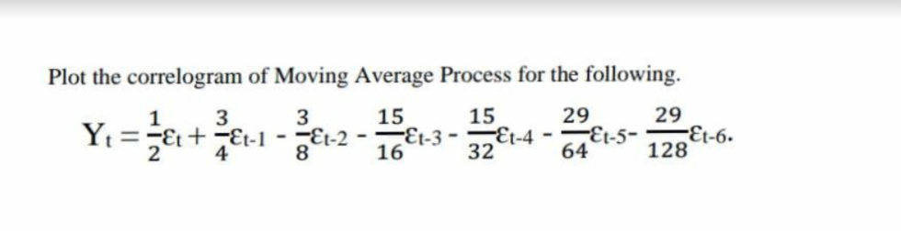

**THEORY:**

Correlogram: A correlogram is a visual way to show autocorrelation in the data that changes over time (i.e. time series data).

Correlogram of Moving Average: For a moving average of extent m, with weights

(a1, a2, …am) of random components (εi ; i=1,2,…), the generated series is given by:

$y_{i}=a_{1}ε_{i+1}+a_{2}ε_{i+2}+…+a_{k+1}ε_{i+k+1}+…+a_{m}ε_{i+m}$

$y_{i+k}=a_{1}ε_{i+k+1}+a_{2}ε_{i+k+2}+…+a_{m-k}ε_{i+m-k}+…+a_{m}ε_{i+k+m}$

Where εi’s are iid N(0, σ2). Thus,

E(yi) = 0 = E(yi+k)

And ${Var(y_{i})= E(y_{i}^{2})=\left(a_{1}^{2} + a_{2}^{2} + … + a_{m}^{2}\right)σ^{2} = σ}^{2}\sum_{j=1}^{m}{a_{j}^{2} ∀ i=1, 2,.. .}$

Similarly, ${Var(y_{i+k})= E(y_{i+k}^{2})= σ}^{2}\sum_{j=1}^{m}{a_{j}^{2} }$



$$E\left(y_{i}y_{i+k}\right)=\left(a_{1}a_{k+1}+a_{2}a_{k+2}+…+a_{m-k}a_{m}\right)σ^{2}=σ^{2}\sum_{j=1}^{m-k}{a_{j}a_{j+k}, k<m }$$

**CALCULATIONS:**

Table 14.1

|  |  |  |  |  |  |  |  |  |
| --- | --- | --- | --- | --- | --- | --- | --- | --- |
| m | a | a2 | k | | | | | |
| 1 | 2 | 3 | 4 | 5 | 6 |
| 1 | 0.5 | 0.25 |  |  |  |  |  |  |
| 2 | 0.75 | 0.5625 | 0.375 |  |  |  |  |  |
| 3 | -0.375 | 0.140625 | -0.28125 | -0.1875 |  |  |  |  |
| 4 | -0.9375 | 0.878906 | 0.351563 | -0.70313 | -0.46875 |  |  |  |
| 5 | -0.46875 | 0.219727 | 0.439453 | 0.175781 | -0.35156 | -0.23438 |  |  |
| 6 | -0.45313 | 0.205322 | 0.212402 | 0.424805 | 0.169922 | -0.33984 | -0.22656 |  |
| 7 | -0.22656 | 0.051331 | 0.102661 | 0.106201 | 0.212402 | 0.084961 | -0.16992 | -0.11328 |
| SUM | -1.21094 | 2.308411 | 1.199829 | -0.18384 | -0.43799 | -0.48926 | -0.39648 | -0.11328 |

Table 14.2

|  |  |  |  |  |  |  |
| --- | --- | --- | --- | --- | --- | --- |
| k | 1 | 2 | 3 | 4 | 5 | 6 |
| r | 0.519764 | 0.07964 | 0.18974 | 0.21195 | 0.17176 | 0.04907 |

Graph 14.1

**RESULT:**

* The value of autocorrelation (rk)for the order k have been shown in Table 14.2
* Graph 14.1 shows the correlogram plotted for the moving average.