**PRACTICAL – 16**

**Submitted By: Ridam Singhal(5040)**

**AIM:** To obtain 1-step ahead forecasted values for the next three months using exponential smoothing method.

**EXPERIMENT:**



**THEORY:**

* Exponential smoothing is a time series forecasting method for univariate data. Forecasts produced using exponential smoothing methods are weighted averages of past observations, with the weights decaying exponentially as the observations get older.
* Equation Ft+1 = αDt + (1- α)Ft, is used to forecast the values for the next months. Here, F is forecasted value, D is demand and α is smoothing constant.
* For t=1, Ft is the first forecasting value, obtained by calculating median of the first 6 observations.

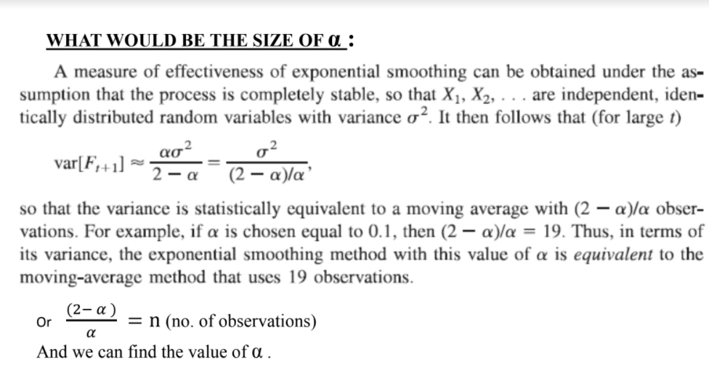

* Here, the values of α have been already given as 0.15, 0.25 and 0.35

**CALCULATIONS:**

Table 16.1 Table 16.2

|  |  |
| --- | --- |
| Given Data | |
| t | yt |
| 1 | 810 |
| 2 | 920 |
| 3 | 980 |
| 4 | 1100 |
| 5 | 970 |
| 6 | 1110 |
| 7 | 1080 |
| 8 | 1150 |
| 9 | 1340 |
| 10 | 1560 |
| 11 | 1420 |
| 12 | 1590 |
| 13 |  |
| 14 |  |
| 15 |  |

|  |  |  |
| --- | --- | --- |
| Exponential Smoothing | | |
| ɑ= 0.15 | ɑ= 0.25 | ɑ= 0.35 |
| 975 | 975 | 975 |
| 950.25 | 933.75 | 917.25 |
| 945.7125 | 930.3125 | 918.2125 |
| 950.8556 | 942.7344 | 939.8381 |
| 973.2273 | 982.0508 | 995.8948 |
| 972.7432 | 979.0381 | 986.8316 |
| 993.3317 | 1011.779 | 1029.941 |
| 1006.332 | 1028.834 | 1047.461 |
| 1027.882 | 1059.125 | 1083.35 |
| 1074.7 | 1129.344 | 1173.177 |
| 1147.495 | 1237.008 | 1308.565 |
| 1188.371 | 1282.756 | 1347.567 |
| 1248.615 | 1359.567 | 1432.419 |
| 1299.823 | 1417.175 | 1487.572 |
| 1343.349 | 1460.381 | 1523.422 |

Graph 16.1

**RESULT:**

* Table 16.2 shows the exponential smoothing done for the data given in Table 16.1, for the given values of α (0.15, 0.25, and 0.35).
* Graph 16.1 has been plotted to compare the values obtained for different smoothing constants.
* Value forecasted for the next 3 months is:

|  |  |  |  |
| --- | --- | --- | --- |
| t | ɑ= 0.15 | ɑ= 0.25 | ɑ= 0.35 |
| 13 | 1248.615 | 1359.567 | 1432.419 |
| 14 | 1299.823 | 1417.175 | 1487.572 |
| 15 | 1343.349 | 1460.381 | 1523.422 |

**CONCLUSION:**

* Result obtained for α = 0.15 will give a better forecast.
* The logical weights are assigned to all the variables, means more weight has been given to recent values and less to previous.
* Hence we can say that the value of α should be minimum and logical to get the best forecast value.