**TIME SERIES ANALYSIS**

**PRACTICAL – 4**

**Submitted By: Ridam Singhal(5040)**

**AIM:** To compute monthly seasonal indices by ratio seasonal method.

**PRACTICAL:**

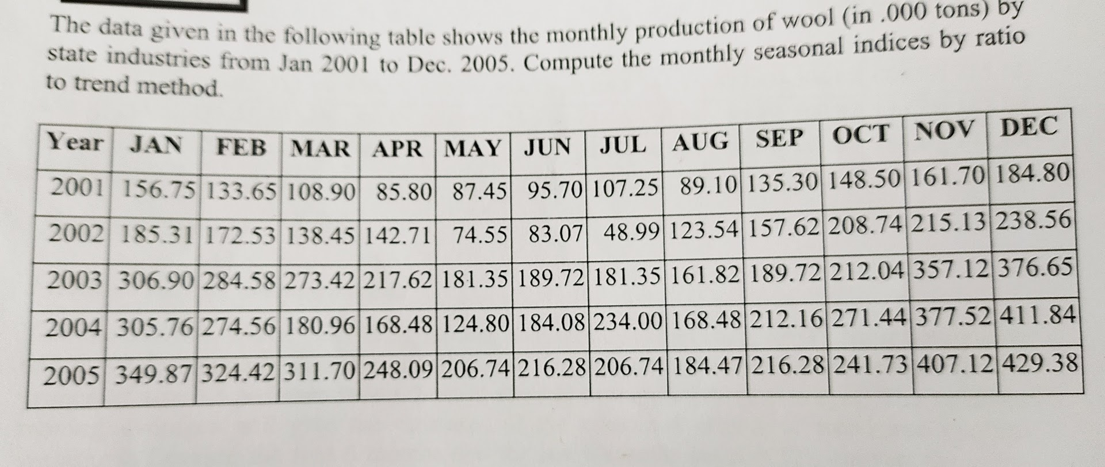

**THEORY:**

RATIO TO TREND METHOD

1. Based on Multiple models of Time Series.
2. We assume that seasonal variation for any given month is constant factor of trend.

STEPS:

1. Calculate the trend values for various time durations (Quarterly/Monthly) using Least Square method and fitting the appropriate mathematical curve.
2. Express all the original data as the percentage of trend on the basis of the following formula. (Original Data/Trend Value)*100.
3. Calculate the seasonal variation indices.

Linear Equation:

* y=ax+b.

**CALCULATIONS:**

Table 4.1



As

y=ax+b

Therefore,

|  |  |
| --- | --- |
|  | *Coefficients* |
| Intercept | 207.902 |
| X | 40.18033 |

We get,



Table 4.2



Table 4.3





Graph 4.1

**RESULT:**

* Sum of seasonal indices is observed to be 1195.653037. We obtain the value of k by diving 1200 by the sum of average seasonal indices.
* Adjusted seasonal indices are obtained by multiplying the average seasonal indices by the correlation factor k.
* Graph for average and adjusted indices has been plotted in Graph 4.1.

**CONCLUSION:**

* The positive value of monthly increment (3.348361111) indicates that there is an increasing trend.
* Average production of wool for years 2001-2005 is maximum in the month of January. After that, it gradually decreases from February to August and then starts increasing from September. It achieves a maximum in December.
* For year 2001, maximum production is observed in the month of January, whereas for years 2002- 2005, maximum production month is December.